How to Calculate Speeds and Feeds for CNC Machining
This procedure explains how to calculate speeds and feeds for any tool and material combination in CNC machining. It walks through the formula used to determine the correct spindle speed (RPM) for your CNC program, along with the calculation used to establish the correct feed rate. All values and examples in this procedure use metric units; a separate reference is available if you require inch-based values.
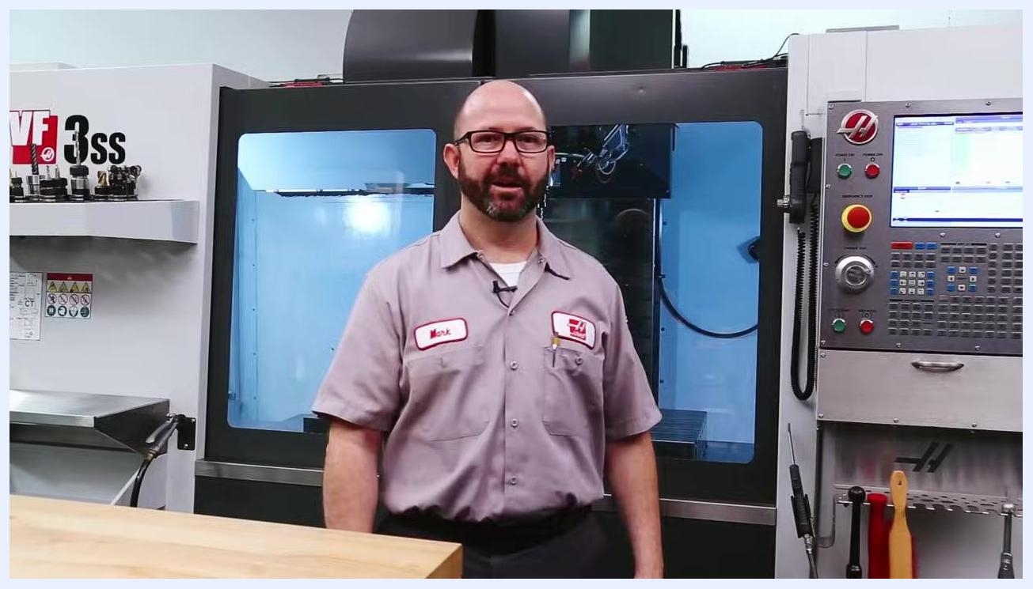
Whiteboard diagram showing a path from a house icon down to two labeled points, SPEED and FEED, drawn in a machine shop with CNC equipment and tool cabinets in the background.
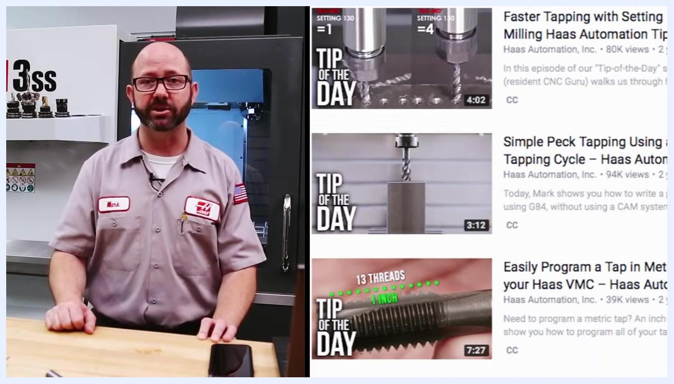
Instructor seated at workbench, smiling, with laptop, model tractor, and machining tools visible, CNC machine in background

Purpose
This procedure provides a repeatable method for calculating reliable starting spindle speed (RPM) and feed rate (F-code) values before running a CNC program, so that tools are neither underused nor damaged by excessive cutting speeds.
Instructor next to a list of "Tip of the Day" videos, including tapping and feed rate calculation topics

Scope
This procedure applies to any CNC milling job where you need to determine the S-code (spindle speed) and F-code (feed rate) for a given tool and workpiece material. All calculations shown use metric units (mm, m/min, RPM).
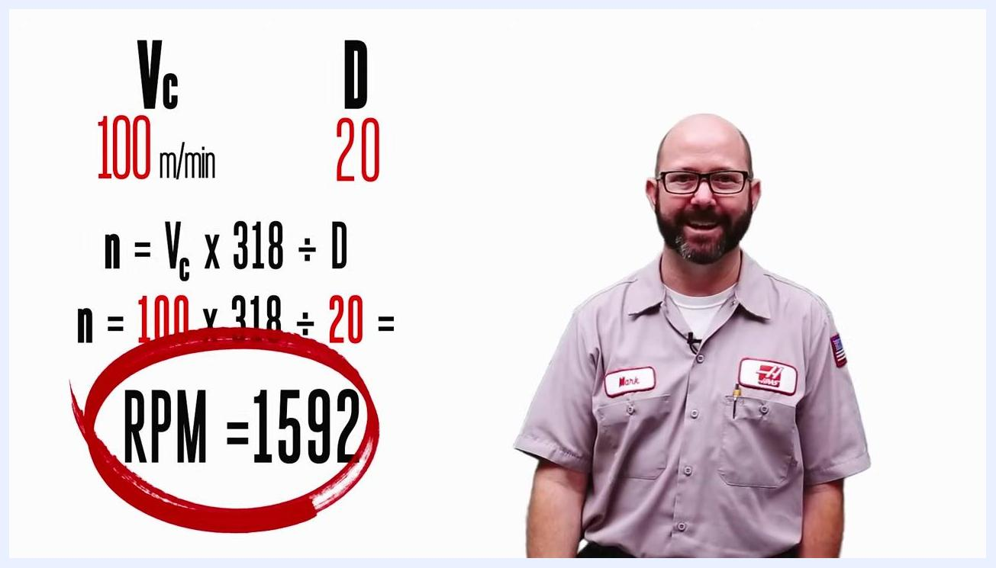
Instructor celebrating with an explosion animation in the background, confirming the spindle speed calculation.

Required reference materials
Before you begin, gather the following:
Tip of the Day branding with Haas logo, host's name, caliper, and markers on a whiteboard background
- The job setup sheet, since all calculations and planning begin here.
- The tool manufacturer's catalog or manual, ideally in digital (PDF) form.
- The exact tool being used, including its diameter and number of teeth/flutes, and whether it has a coating (coatings can double allowable cutting speeds).
- A calculator, or a digital speeds-and-feeds app, or access to your CNC control's built-in milling calculator.
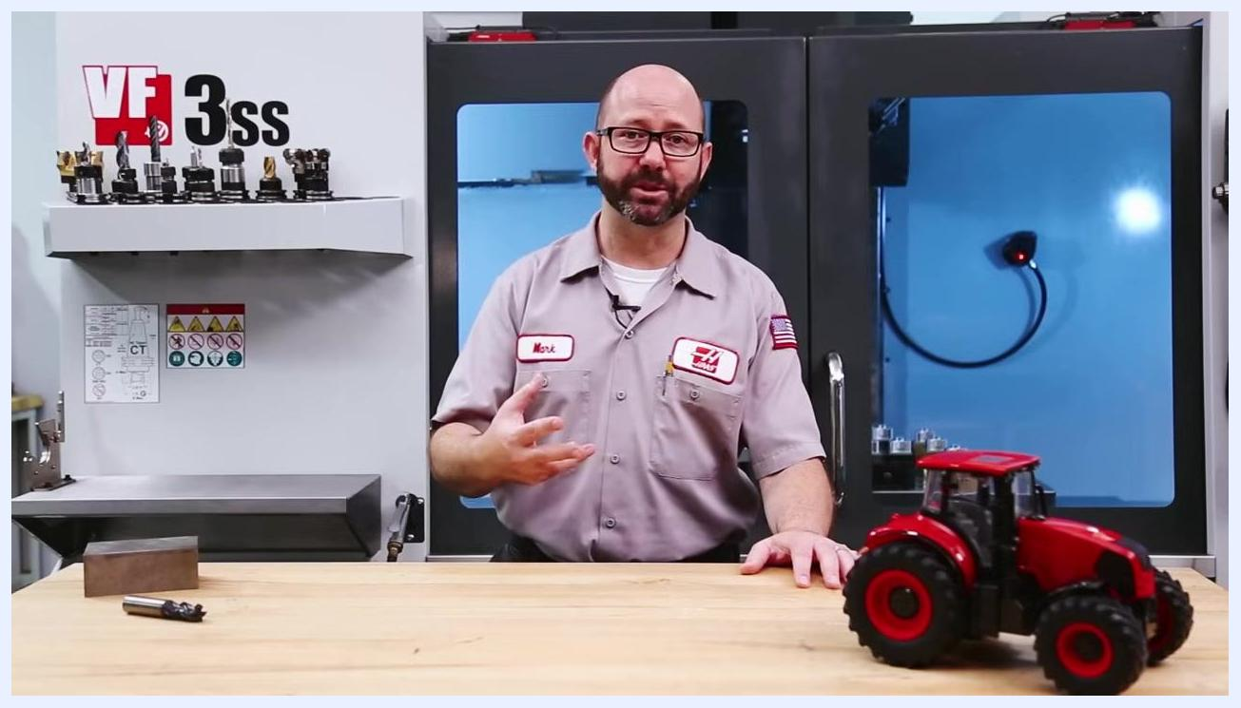
Instructor gesturing while explaining the importance of knowing the tool and its coating in a machine shop setting.

Understanding surface speed

- Review the overall path from setup to speed and feed values. All calculations begin with your setup sheet and lead first to determining spindle speed, then feed rate.
- Consider the surface speed analogy. If a tractor moves at 1 kilometer per hour (about 17 meters per minute), both the small front tire and the large rear tire travel at the same surface speed where the rubber meets the road, even though the tires are different sizes.
Model tractor with large rear tires and small front tires on a wooden table, illustrating the surface speed analogy in a workshop setting.

- Confirm the result of the analogy. Both tires travel at 17 surface meters per minute. This shows that surface speed is independent of the diameter of the rotating object, which applies directly to tool surface speed in machining.
- Remember the key takeaway: surface speed (meters per minute) stays the same at the contact point, regardless of the diameter of the tire or tool.

Calculating circumference and identifying maximum cutting speed

- Recognize that RPM differs even though surface speed is the same. The smaller tire (or tool) must rotate more times per minute than the larger one to cover the same ground. In the tractor example, the small front tire turns at 54 RPM while the large rear tire turns at 42 RPM to cover the same distance.

Animated scene with a tractor, grass, a chicken, and a cow holding a sign that reads "17 SURFACE METERS PER MINUTE."

- Calculate circumference using diameter × π. Pi (π) is the constant ratio between a circle's diameter and its circumference, approximately 3.14.
- Work through the example calculations:
- For a 100 mm diameter tire: Circumference = 100 mm × 3.14 = 314 mm.
- For a 1 meter diameter tire: Circumference = 1 m × 3.14 = 3.14 m.

- Note the safety and tooling limit implied by this concept. Just as a tire can overheat and fail if spun too fast, a cutting tool has a maximum surface speed for each material. Exceeding it causes overheating and rapid tool wear. Always check the recommended maximum cutting speed for your specific tool and material combination.
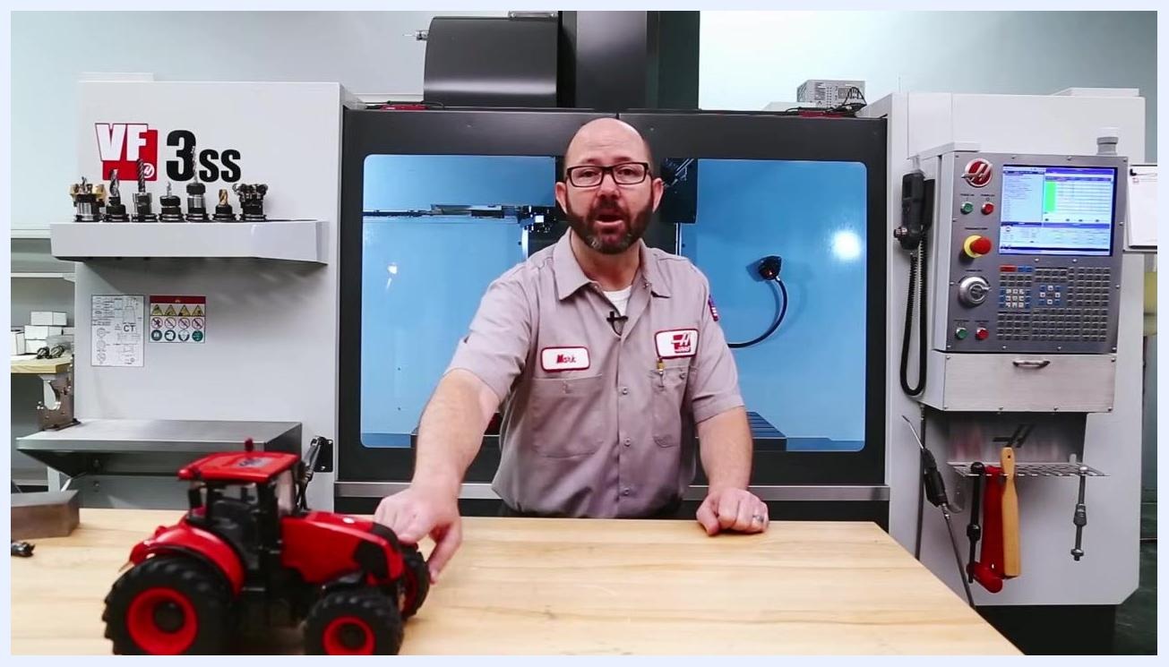
Split-view close-up of a tractor's front and rear tires. The larger rear tire is labeled 42 RPM, and the smaller front tire is labeled 54 RPM.

- Summarize the two rules to carry forward:
- Use Circumference = Diameter × π (3.14) to find how much material is covered per revolution.
- Never exceed the maximum recommended cutting speed for your tool and material, to avoid premature tool failure.
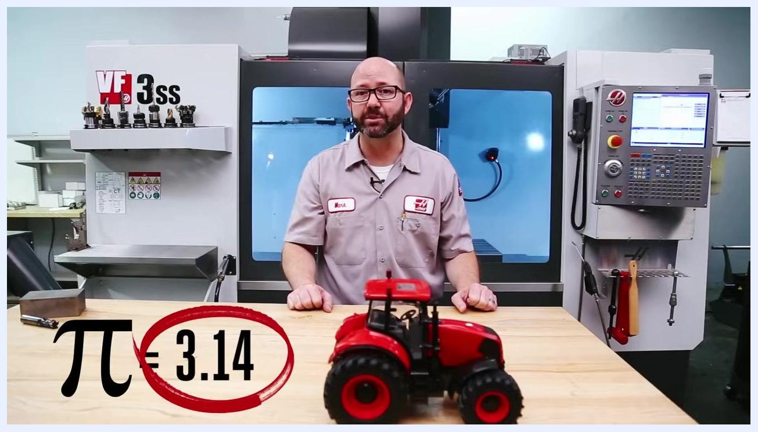
Workbench view with a model tractor and a large tire, overlaid with the calculation 1 m × 3.14 = 3.14 m CIRCUMFERENCE.

Converting cutting speed to spindle speed (RPM)

- Distinguish between the two key speeds in machining. Cutting speed (Vc) is the surface speed where the tool meets the part, measured in meters per minute (m/min). Spindle speed (n) is the number of revolutions per minute the spindle turns — the value your CNC control needs, entered as the S-code.
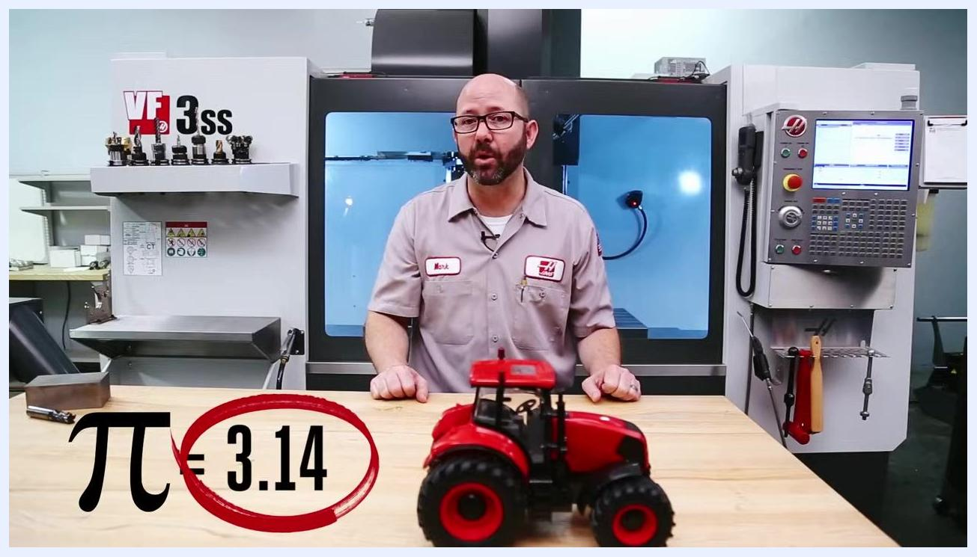
Machine shop workbench with a model tractor and on-screen text showing π = 3.14 circled in red, reinforcing the constant value used in the calculations.

- Confirm the units for each variable:
- Cutting speed (Vc): meters per minute (m/min)
- Spindle speed (n): revolutions per minute (RPM)
- Tool diameter (D): millimeters (mm)
- Pi (π): 3.14

- Locate where RPM and feed values are entered in your G-code. Spindle speed is set with the S-code (for example, S1500 for 1500 RPM), and feed rate is set with the F-code (for example, F1000 for 1000 mm/min). Calculate both values before running the program.
- Apply the spindle speed formula:

n = (Vc × 1000) / (D × π)
- n = spindle speed (RPM, S-code)
- Vc = cutting speed (m/min)
- D = tool diameter (mm)
- π = 3.14
This formula converts the surface speed from the tool catalog and the tool diameter into the RPM value your CNC machine needs.

- Reference the standard symbols used by tool suppliers:
Symbol | Meaning
n | rev/min (RPM, S-Code)
Vc | Cutting Speed (m/min)
D | Tool Diameter (mm)
π | Pi (3.14, diameter-to-circumference ratio)
- Pay particular attention to Vc and D, since these are the two values you will need to obtain from the catalog or measure directly before you can calculate spindle speed.
- Simplify the formula for faster calculation. Dividing 1000 by π gives approximately 318, allowing the formula to be simplified as follows:

n = (Vc × 1000) / (D × π)
n = (Vc / D) × (1000 / π)
n = (Vc / D) × 318
n = Vc × 318 ÷ D
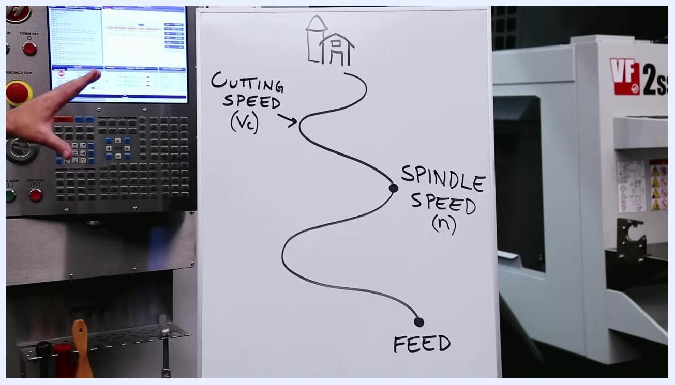
Whiteboard diagram showing the relationship between Cutting Speed (Vc), Spindle Speed (n), and Feed, with a CNC control panel and part of a VF 2ss machine visible.
Close-up of a whiteboard showing "Cutting Speed (Vc) m/min" and "Spindle Speed (RPM) (n)" with a connecting path.
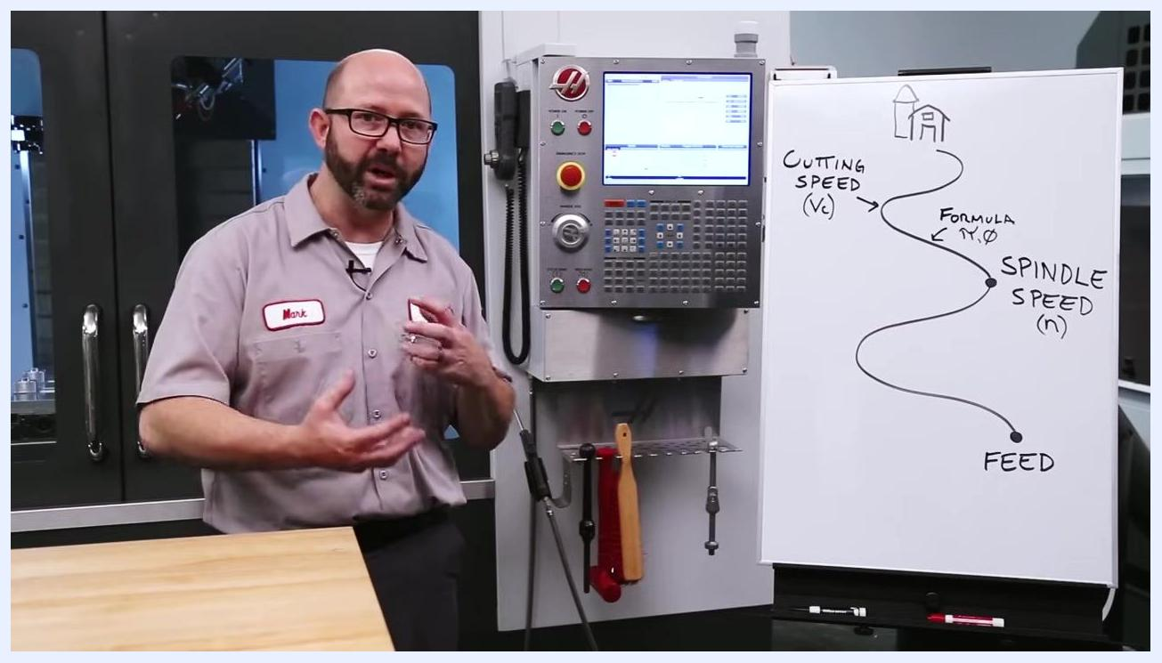
G-code snippet with the S-code and F-code locations circled in red, indicating where RPM and feed values should be entered.
Whiteboard formula path showing the conversion from cutting speed to spindle speed, with the word "Formula" and the symbols π and Ø marked at the conversion point.
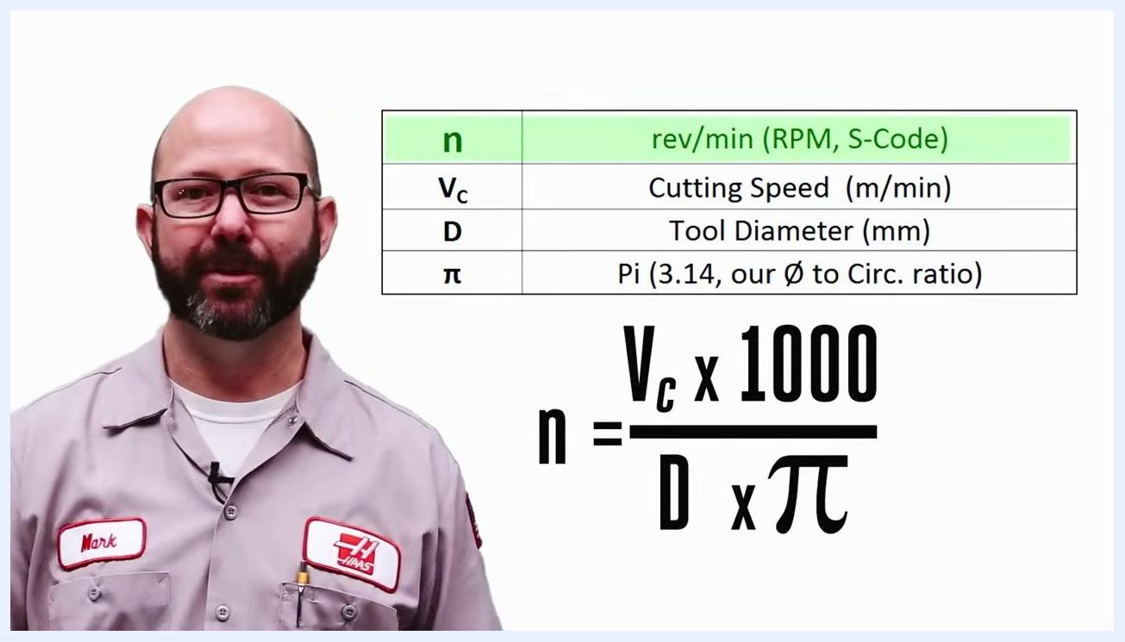
On-screen formula n = (Vc × 1000) / (D × π) with a table defining each symbol.
Table of symbol definitions with the spindle speed formula displayed below; the row for n is highlighted in green.
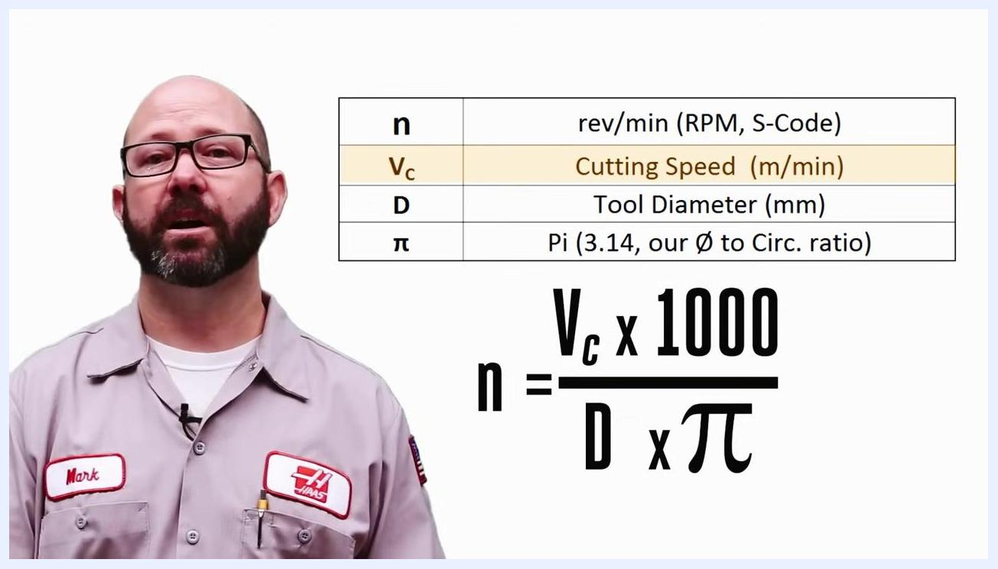
Table defining n, Vc, D, and π next to the spindle speed formula n = (Vc × 1000) / (D × π), with the Vc row highlighted.

Selecting the correct cutting speed from the tool catalog

- Confirm the workpiece material before opening the catalog. In this example, the workpiece is labeled STEEL 4140, and the cutting tool is marked SD99-200.

 | Caution: Modern cutting tools may have coatings that can double their allowable cutting speeds. Know the exact tool you are using so that you don't rely on outdated or overly conservative speed values.

- Access the tool manufacturer's catalog, downloading the manual or catalog in PDF form when possible.
- Use the color-coded material chart to quickly identify your material group:
- P (Blue): Non-Alloy Steel and Cast Steel, Low-Alloy Steel and Cast Steel, High-Alloy Steel and Cast Steel, Stainless Steel and Cast Steel
- M (Yellow): Stainless Steel
- K (Red): Grey Cast Iron, Ductile Cast Iron, Nodular Cast Iron
- N (Green): Non-Ferrous Metals, Aluminum and Aluminum Alloys
- S (Brown): Superalloys, Titanium and Titanium Alloys
- H (Gray): Hard Cast Iron, Hardened Steel
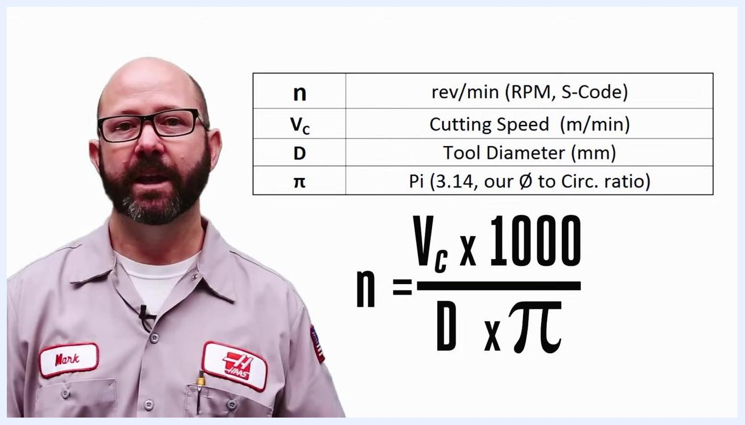
Table of variables and the spindle speed formula displayed on screen in the workshop, showing the progression to the simplified version using 318.
Four versions of the spindle speed formula, showing the progression from the full formula to the simplified version using 318.
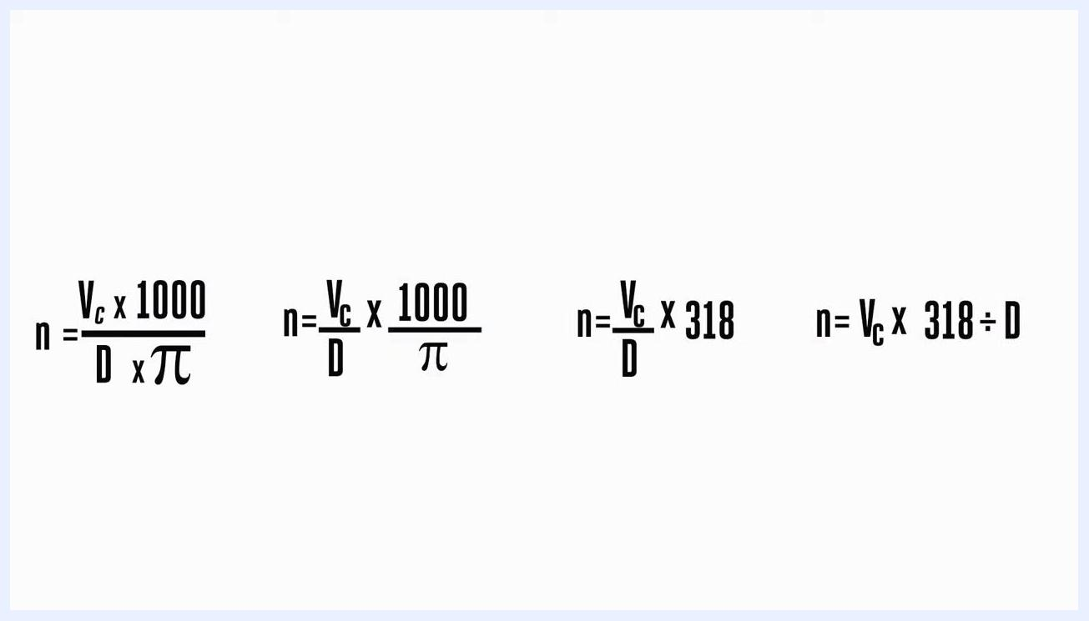
Close-up of a metal block labeled "STEEL 4140" and a cutting tool marked "SD99-200" on a wooden workbench.
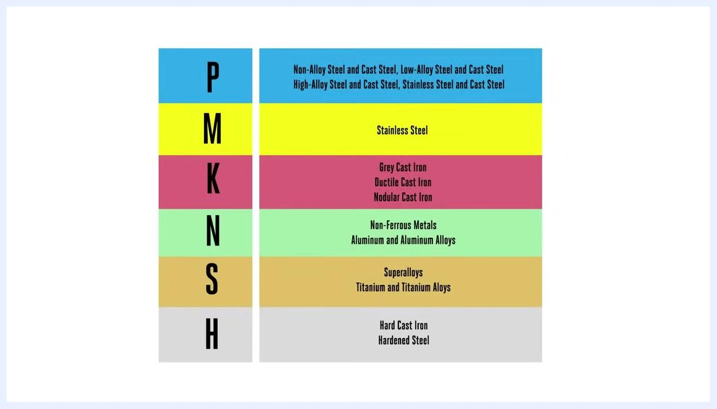
A laptop being placed on the workbench to access a digital tool catalog.
Color-coded chart listing material groups (P, M, K, N, S, H) and their corresponding materials.

Matching your material to the ISO group and catalog code

- Identify your material group on the chart. The ISO groups are: N (Green) Non-Ferrous Metals/Aluminum Alloys, S (Brown) Superalloys/Titanium Alloys, K (Red) Cast Irons, M (Yellow) Stainless Steel, P (Blue) Steels, and H (Gray) Hardened Materials.
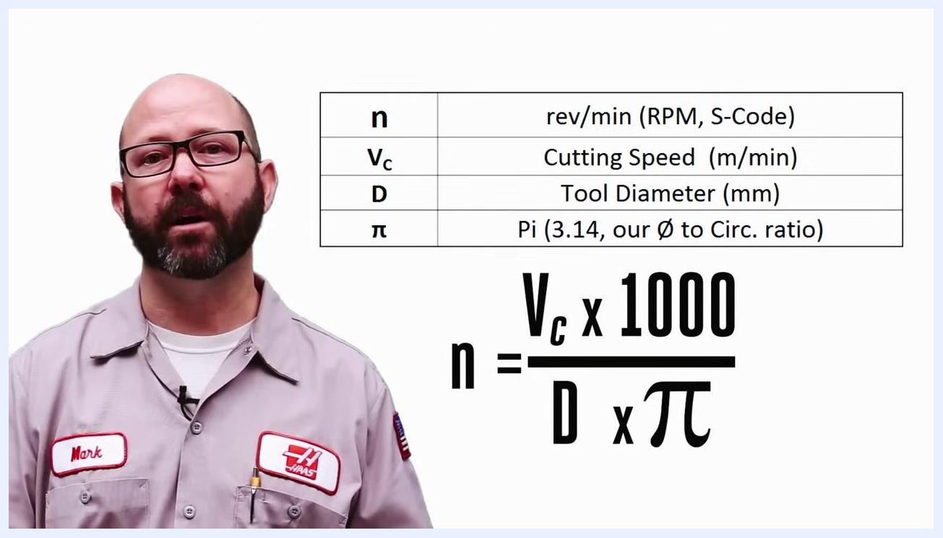
Machine shop workbench with a CNC machine labeled VF 3ss, a metal block, a cutting tool, and a model tractor.

- Confirm your specific workpiece material. In this example, the material is 4140 steel, a common alloy steel used in machining.
- Be aware that material names vary by country. 4140 is a U.S. designation for this material; other regions may use a different name for the same alloy.
- Match your material to the ISO group regardless of local naming. Worldwide, 4140 steel falls under the P (blue) ISO material group for steels. Reference the full chart for all groups and descriptions.
- Look up your material in the manufacturer's catalog. For Kennametal, 4140 steel is listed as P4 (P4 Alloy Steels and Tool Steels). The catalog cross-references international standards (AISI, DIN, JIS, etc.), tensile strength, and hardness.
- Note that the code following the ISO letter varies by manufacturer. For the same material, Sandvik uses P2.1, and Iscar/Widia use P6 or P7. Use the material cross-reference list to match your material to the correct code in each catalog.

Caution: Choosing the wrong material group or code can lead to improper speeds and feeds, causing rapid tool wear or failure.

- Never apply cutting speeds for one material group to another. For example, running a drill or end mill in titanium at speeds meant for mild steel will damage the tool.
- Contact your tooling representative if you are unsure which material group or catalog code applies to your job.
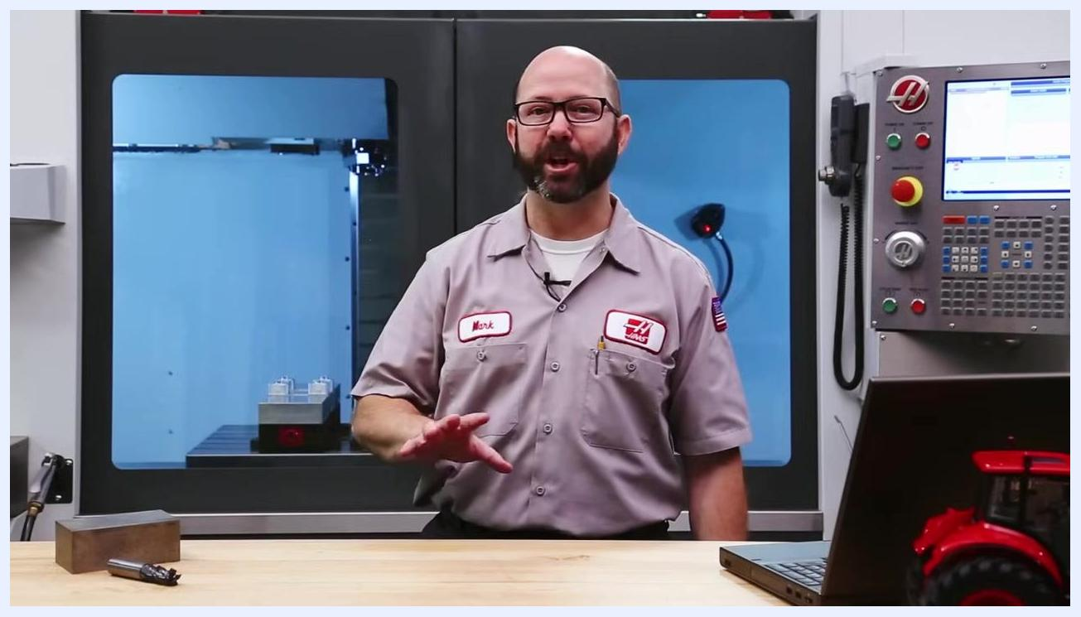
Highlighted chart section showing "N" for Non-Ferrous Metals and Aluminum Alloys, with "S" for Superalloys below.
Machine shop workbench with a block of 4140 steel and cutting tool, the material used for this example.
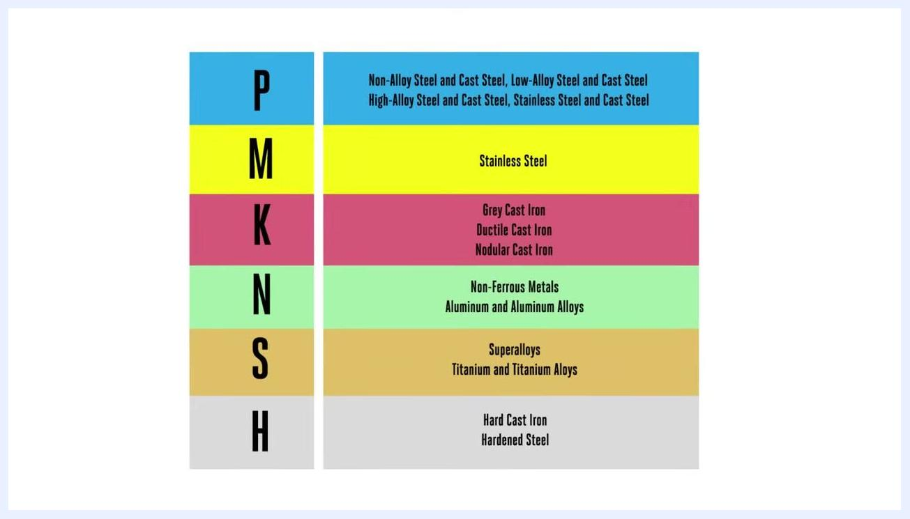
A hand resting on the steel block while noting that material names such as 4140 steel can vary by country.
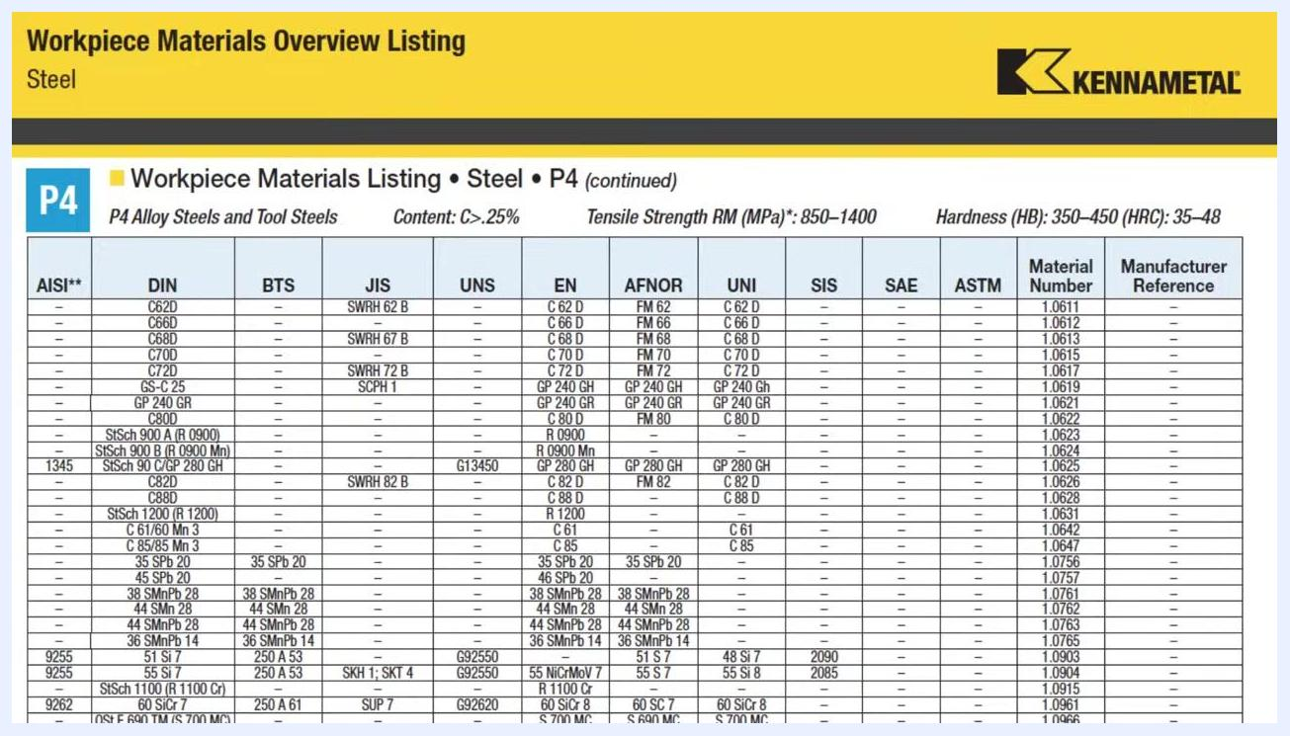
Full color-coded chart listing all ISO material groups and their corresponding materials.
Kennametal catalog page showing P4 workpiece materials listing, including 4140 steel and cross-references.
Material cross-reference list showing ISO group P and various manufacturer codes for steels.
Workbench view emphasizing that choosing the wrong material group can lead to premature tool failure.
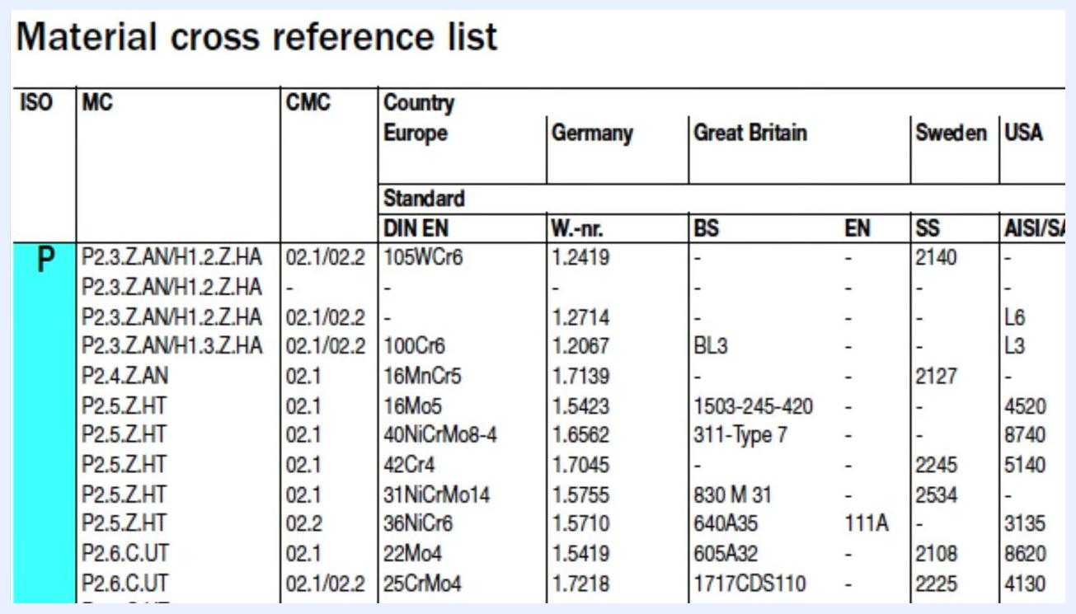
On-screen comparison of "P: Low-alloy Steel" and "S: Titanium Ti6AlV4" material groups.
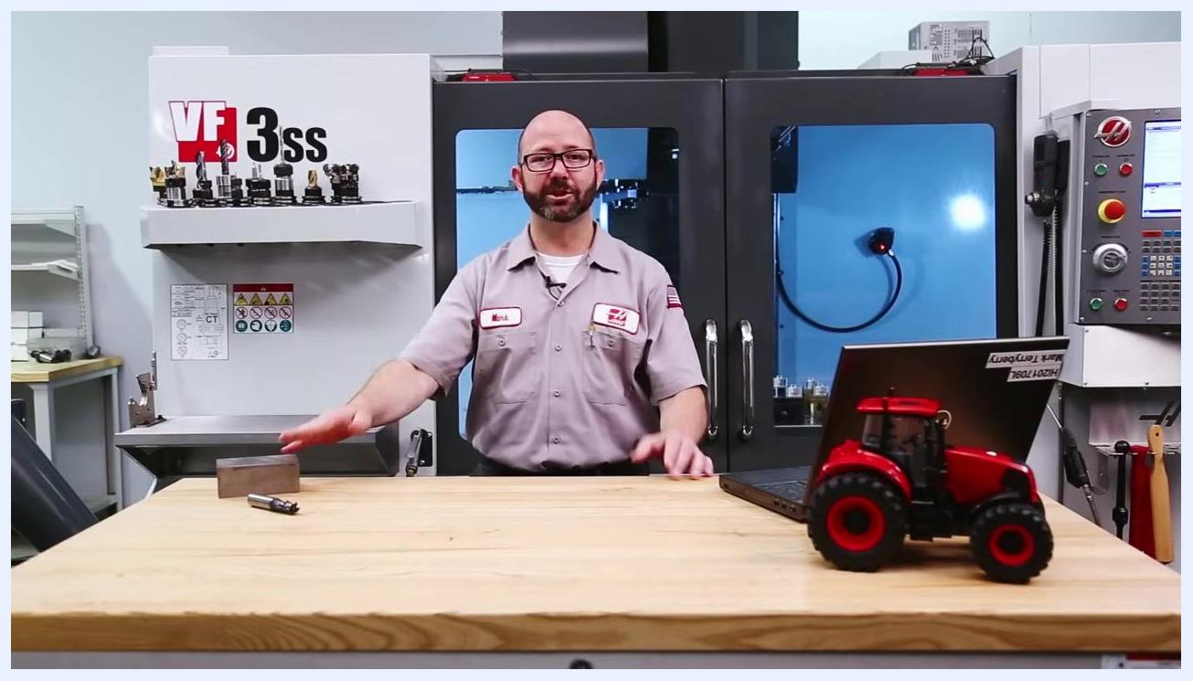
Workbench view accompanying the recommendation to contact your tooling representative if you are unsure of the correct material group.

Calculating spindle speed (RPM) for your job

- Locate the recommended cutting speed for your material group and code in the cutting speed chart. Values are listed in meters per minute (Vc). Example values from an ISO 513 chart:
- P1: 150 m/min
- P2: 130 m/min
- P3: 115 m/min
- P4: 105 m/min
- P5: 100 m/min
- P6: 50 m/min
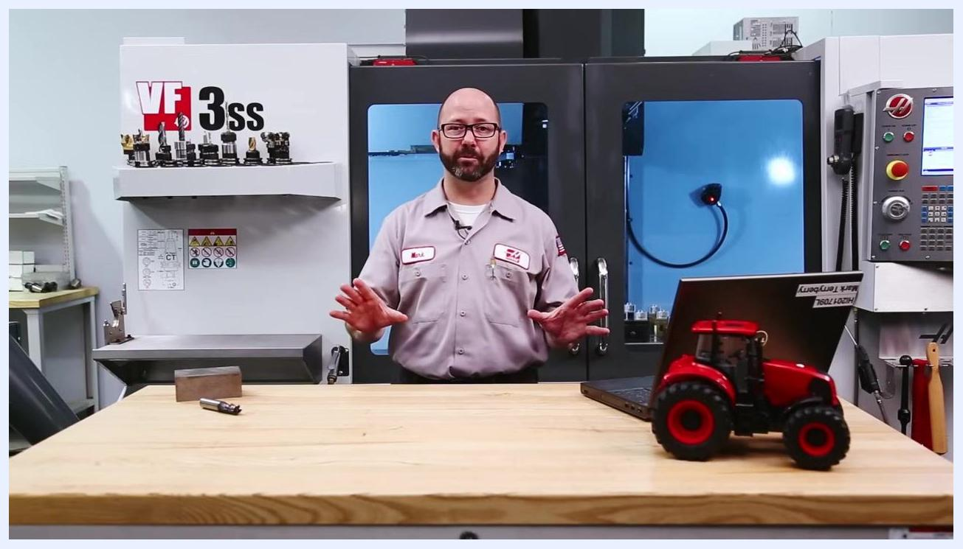
Workbench with a block of steel, cutting tool, laptop, and model tractor, set up in front of the CNC machine.

- Select the appropriate cutting speed for your setup, taking into account tool length, setup rigidity, and how aggressively you plan to cut. A more rigid setup allows for higher cutting speeds; a less rigid setup calls for a lower cutting speed to avoid tool chatter or breakage.
- Record your chosen cutting speed. For this example, 100 m/min is selected for the P5 group, 4140 steel job.
- Apply the simplified spindle speed formula:

n = Vc × 318 ÷ D
- n = spindle speed (RPM)
- Vc = cutting speed (m/min)
- D = tool diameter (mm)

- Substitute your values into the formula. For this example, using a 20 mm end mill:
- Vc = 100 m/min
- D = 20 mm
- n = 100 × 318 ÷ 20

- Calculate the result. n = 100 × 318 ÷ 20 = 1592 RPM.
- Confirm the outcome: you now know how fast to spin your tool — your spindle speed is 1592 RPM.
Cutting speed chart showing ISO 513 material groups (P, M) and recommended cutting speeds in m/min; P5 is 100 m/min.
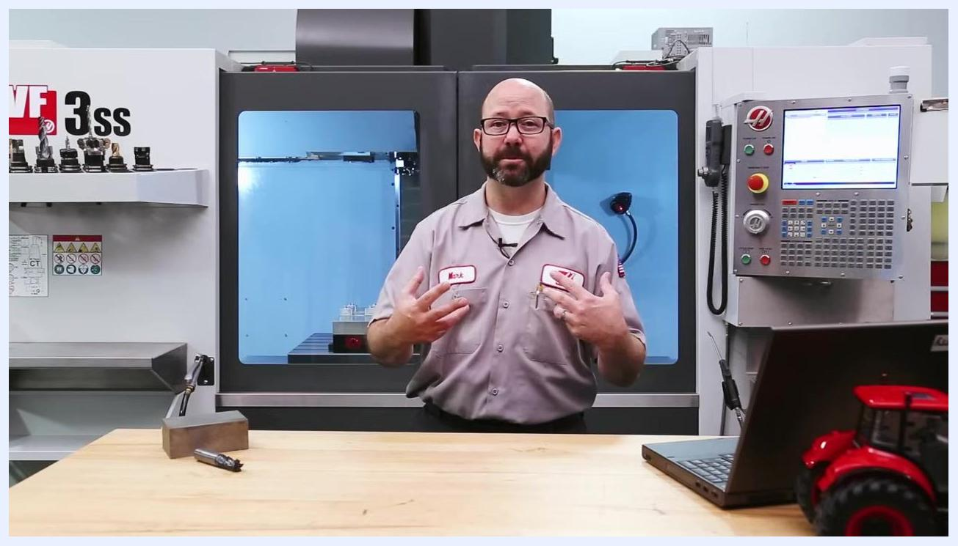
Workbench setup illustrating how tool length, setup rigidity, and cutting aggressiveness affect the choice of cutting speed.
On-screen spindle speed formula: n = Vc × 318 ÷ D.
Cutting speed and tool diameter values (Vc = 100 m/min, D = 20 mm), formula, and calculated RPM = 1592 circled in red.
Block of steel and 20 mm end mill shown together, representing the workpiece and tool used in the calculation.
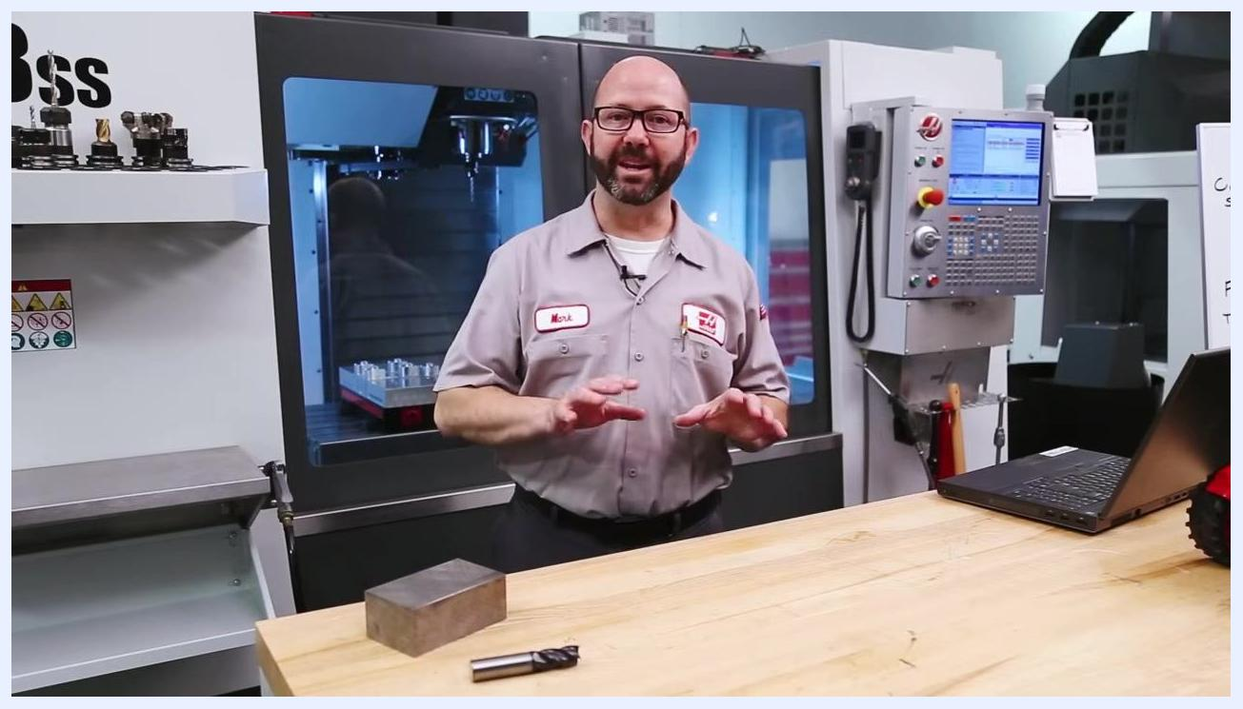
Workbench with the block of steel and end mill, ready for the next calculation step now that spindle speed is known.

Calculating feed rate for end mills

- Apply the feed rate formula for end mills:

Vf = fz × Zn × n
- Vf = Table Feed (mm/min, F-Code)
- fz = Feed per Tooth (mm)
- Zn = Number of Teeth
- n = Revolutions per minute (RPM, S-Code)

- Read the formula in plain terms: table feed (mm/min) equals feed per tooth times the number of teeth times RPM.
- Confirm what "n" represents in the formula — revolutions per minute (RPM, S-Code), the spindle speed you already calculated.
- Count the number of teeth on your tool. Different end mills have different tooth counts — for example, one tool may have six teeth and another four. This number (Zn) is required for the formula.
- Understand why feed per tooth matters: the goal is for each tooth to take a specific, controlled "bite" of material with every pass.
- Reference the manufacturer's cutting feed chart for recommended starting values of feed per tooth (fz) and number of teeth (Zn) by tool diameter. Example values:
- SD99-030: D = 3.0 mm, Zn = 4, Roughing fz = 0.020 mm, Finishing fz = 0.013 mm
- SD99-120: D = 12.0 mm, Zn = 4, Roughing fz = 0.085 mm, Finishing fz = 0.055 mm
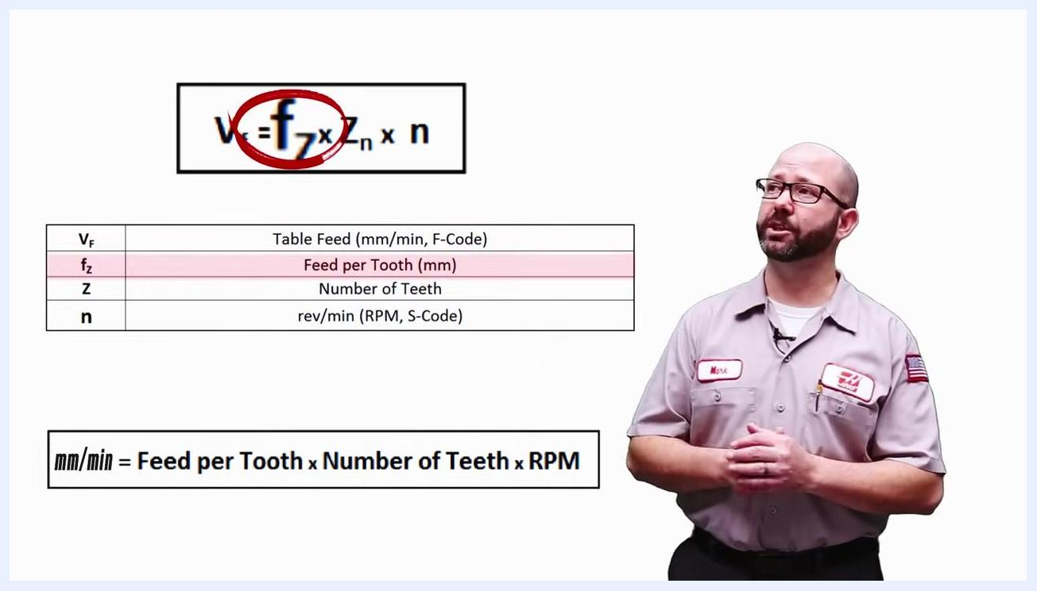
Feed rate formula and variable definitions displayed on screen in the workshop.

- Substitute your values into the formula. Using fz = 0.08 mm, Zn = 4, and n = 1592 RPM:

Vf = 0.08 mm × 4 × 1592

- Calculate the final feed rate. Vf = 0.08 × 4 × 1592 = 509.44, giving a feed rate of F509.44. This represents how far the centerline of the tool moves along its programmed path, in mm per minute.
- Note that manufacturer recommendations vary. Some manuals provide a single feed rate for all cutting conditions, but most provide separate values depending on the operation — always consult the specific manufacturer data for your tool.
Feed rate formula with the feed-per-tooth variable and its table row both highlighted.
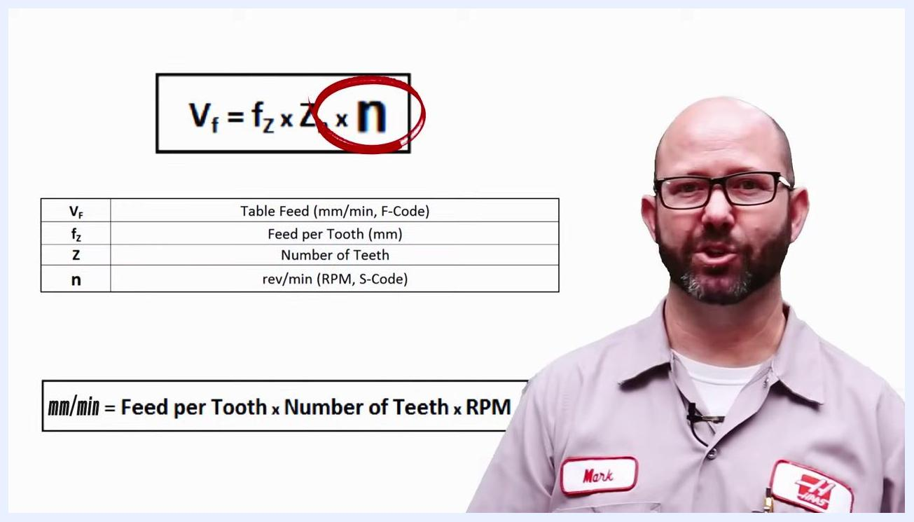
Feed rate formula with the n (RPM) variable highlighted.
Close-up of end mills and cutting tools on the workbench, showing tools with different numbers of teeth.
Workbench view with the CNC machine labeled VF 3ss, tool holders, and a laptop in the background.
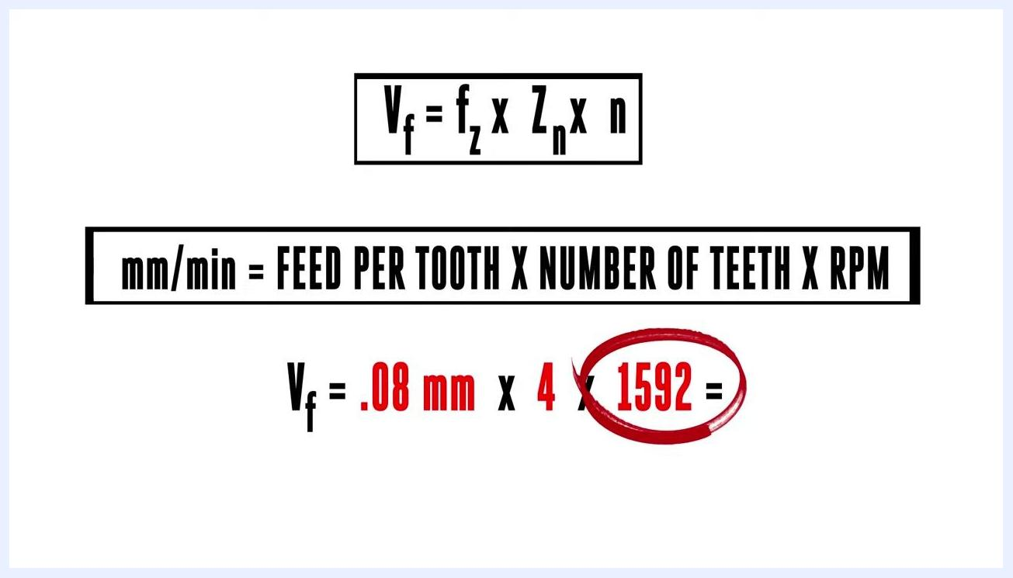
Manufacturer's chart showing tool part numbers, diameters, number of teeth, and recommended feed per tooth values for roughing and finishing.
Feed rate formula with example values: Vf = 0.08 mm × 4 × 1592.
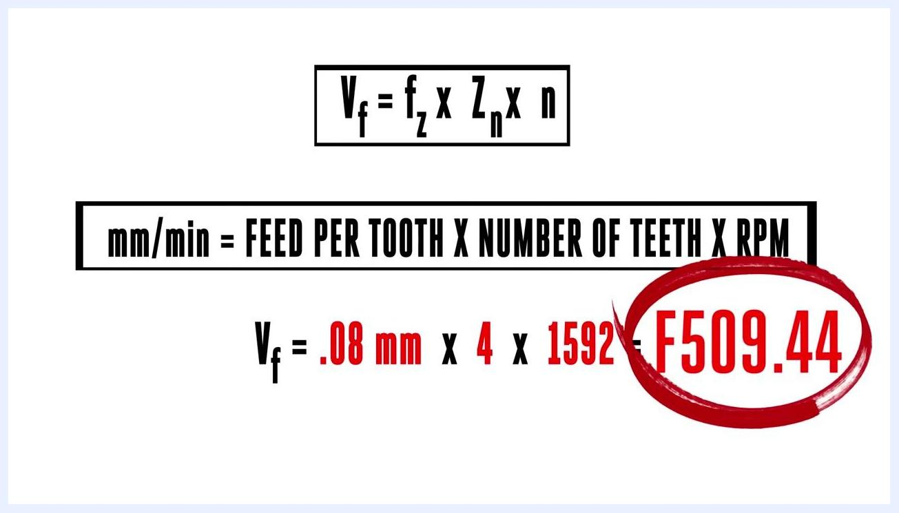
Feed rate formula with calculated result: Vf = 0.08 mm × 4 × 1592 = F509.44, result circled in red.
CNC machine and control panel, a reminder to always consult manufacturer data for specific cutting conditions.

Adjusting feed rate for slotting, side milling, and feed per revolution

- Recognize that manufacturers typically provide at least two feed rate recommendations for end mills: one for slotting operations and one for side milling operations.
- Reference the manufacturer's application data chart for specific values. A typical chart (for example, Kennametal's "General Purpose Solid Carbide End Mills – GOmill GP") provides:
- Tool type and specifications (e.g., 4 flute, short, regular)
- Material group codes
- Cutting speed ranges (SFM)
- Feed per tooth (IPT) by tool diameter
- Separate columns for side milling (A) and slotting (B)
- A note that, for slotting (B), IPT should be reduced by 20% compared to side milling (A)
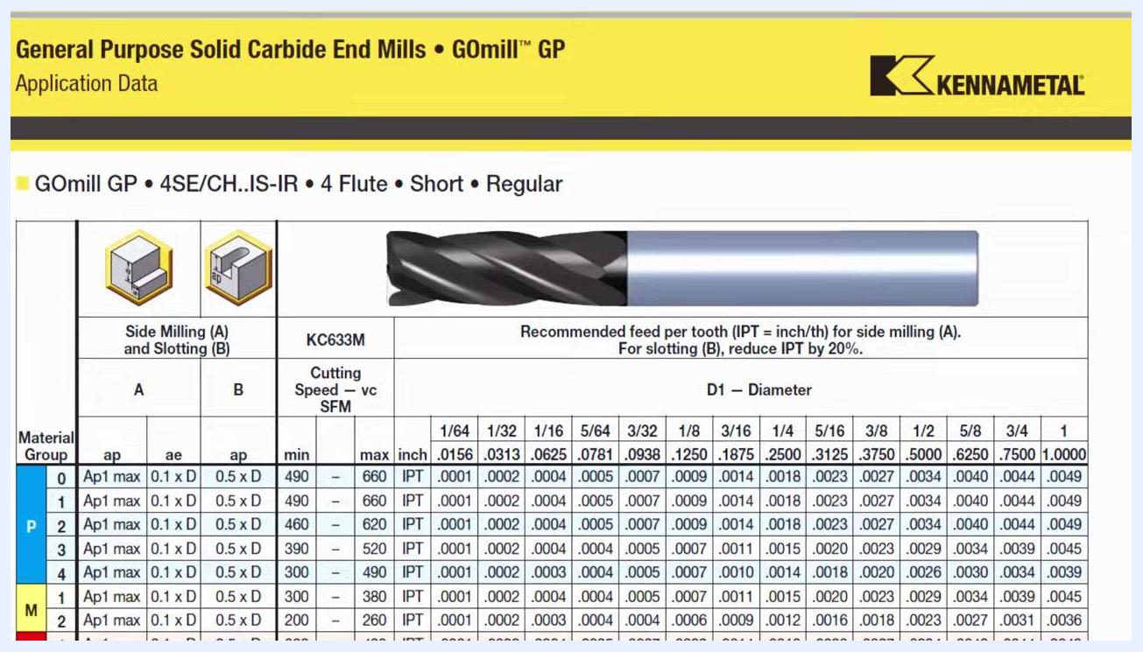
CNC shop with a machine, control panel, workbench, and laptop, set up to compare slotting and side milling feed recommendations.

- Reduce feed per tooth when slotting. When slotting, the feed per tooth ("bite") should typically be about 25% less than when side milling.

Caution: Always follow the manufacturer's speed and feed recommendations rather than estimating, to achieve optimal results and tool life.

- Recognize when a chart provides feed per revolution instead of feed per tooth. This is common for tools like drills.
- Apply the feed-per-revolution formula:

Vf = fn × n
- Vf = Table Feed (mm/min)
- fn = Feed per Revolution (mm)
- n = RPM

- Review the complete legend of variables used across all speed and feed calculations:
Symbol | Meaning
Vc | Cutting Speed (m/min)
π | Pi (3.14, diameter-to-circumference ratio)
D | Tool Diameter (mm)
n | rev/min (RPM, S-Code)
VF | Table Feed (mm/min, F-Code)
fz | Feed per Tooth (mm)
fn | Feed per Revolution (mm)
Z | Number of Flutes
ae | Width of Cut, Radial Depth of Cut
ap | Depth of Cut, Axial Depth of Cut
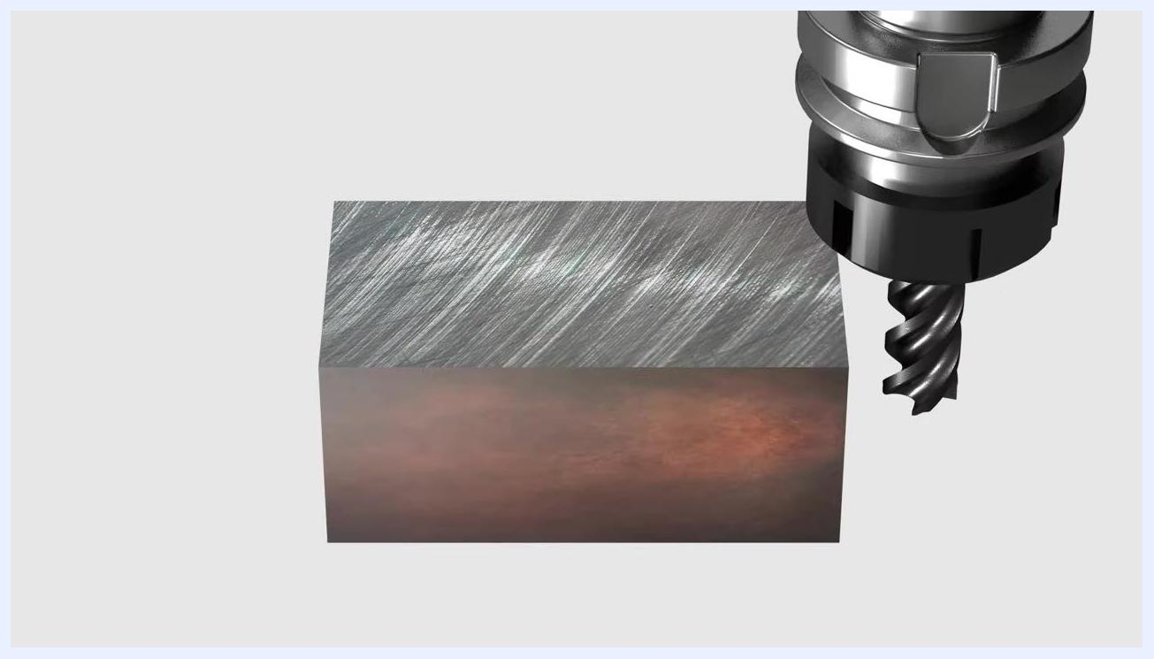
Rendered image showing an end mill approaching a metal block from above, emphasizing the cutting interface where overheating can occur.

- Keep the three key formulas together for quick reference:
- Spindle Speed: n = Vc × 318 ÷ D
- Table Feed (End Mill): Vf = fz × Z × n
- Table Feed (Drills): Vf = fn × n
Manufacturer's application data chart for solid carbide end mills, showing feed per tooth, cutting speed, and diameter for side milling and slotting.
CNC shop workbench illustrating the feed-per-tooth adjustment needed for slotting operations.
Workbench with the CNC machine and tool holders, reinforcing the importance of following manufacturer speed and feed recommendations.
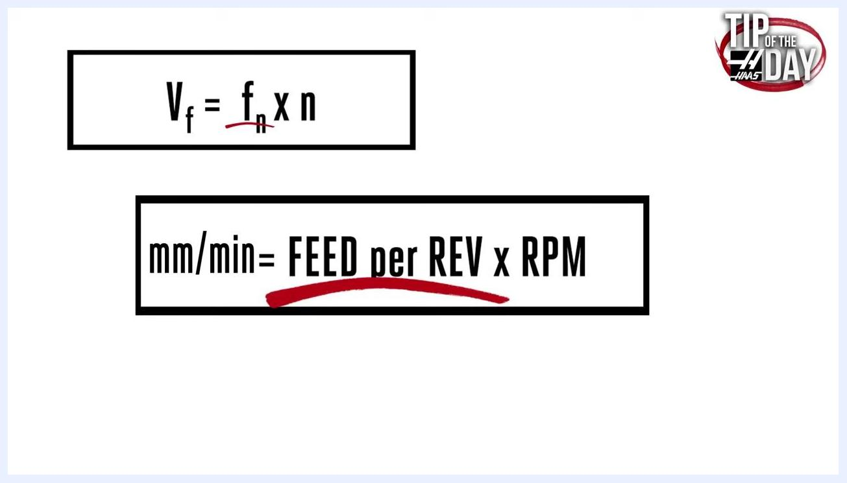
Workbench with a large drill and a standard end mill, used to illustrate feed per revolution versus feed per tooth.
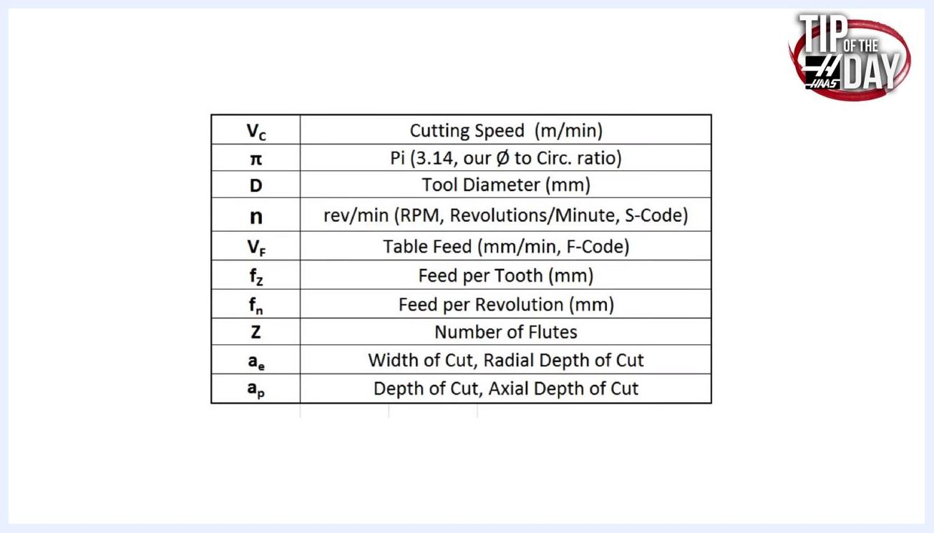
Feed rate formula graphic: Vf = fn × n and mm/min = FEED per REV × RPM, with FEED per REV underlined.
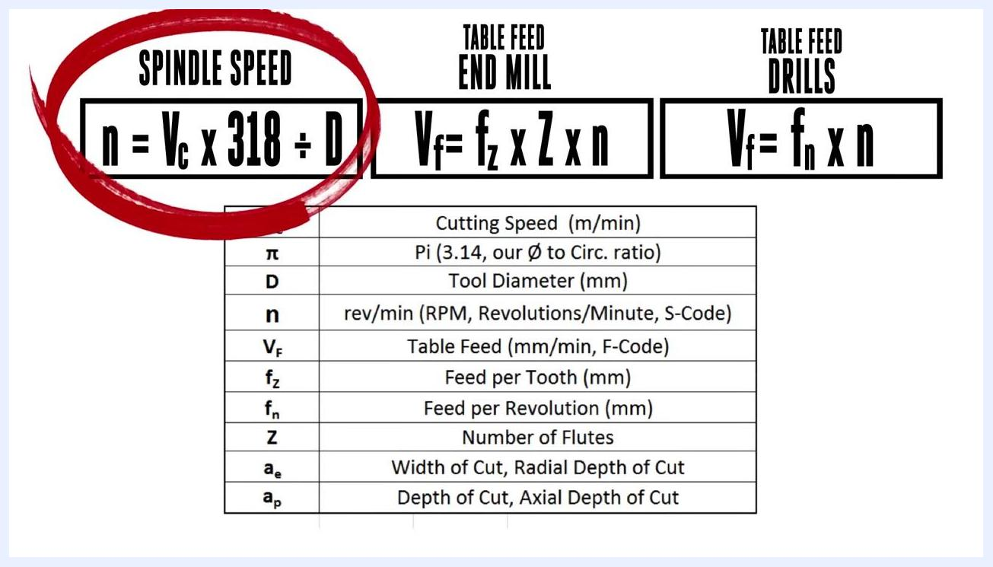
Feed rate formula graphic: Vf = fn × n and mm/min = FEED per REV × RPM, with RPM circled in red.
Legend table listing all variables and their definitions for feed and speed calculations.
Feed rate and spindle speed formulas for end mills and drills, with the spindle speed formula circled in red and a legend of variables below.

Using catalogs and digital tools instead of manual calculation

- Review the same three core formulas for spindle speed and table feed before moving to catalog- or software-based methods.
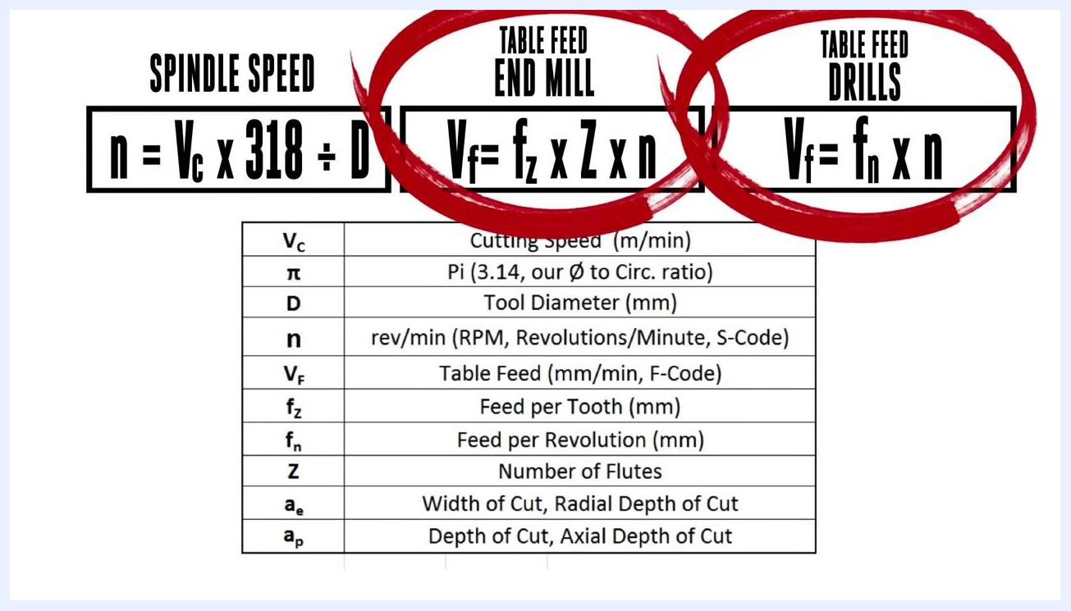
Feed rate and spindle speed formulas for end mills and drills, with table feed formulas circled in red and a legend of variables below.

- Check whether your tooling catalog already provides RPM and feed rate directly. Many catalogs eliminate manual calculation entirely. For example, a "Z-Carb-HPR" series chart for carbon and alloy steels lists material type, hardness, operation type (profile or slot), cutting speed (Vc), tool diameter (6–20 mm), RPM, feed per tooth (Fz), and feed rate (mm/min) for each diameter.
Close-up of a tractor tire with the calculation "100 mm × 3.14 mm = 314 mm" and "314 mm CIRCUMFERENCE" circled in red.
Tooling catalog chart for the Z-Carb-HPR series, showing recommended RPM, feed per tooth, and feed rate for various tool diameters and materials.

- Use the table values directly when provided, without applying the formulas. For example, for a 12 mm tool in alloy steel at a 96 m/min cutting speed:
- RPM = 2545
- Feed per tooth (Fz) = 0.055 mm
- Feed rate = 702 mm/min
Close-up of a feed rate table for alloy steel, showing RPM, feed per tooth, and feed rate for diameters 6–25 mm.

- Consider using a digital speeds-and-feeds tool. Smartphone apps or PC software can calculate feed rates and speeds quickly and accurately as an alternative to manual formulas.
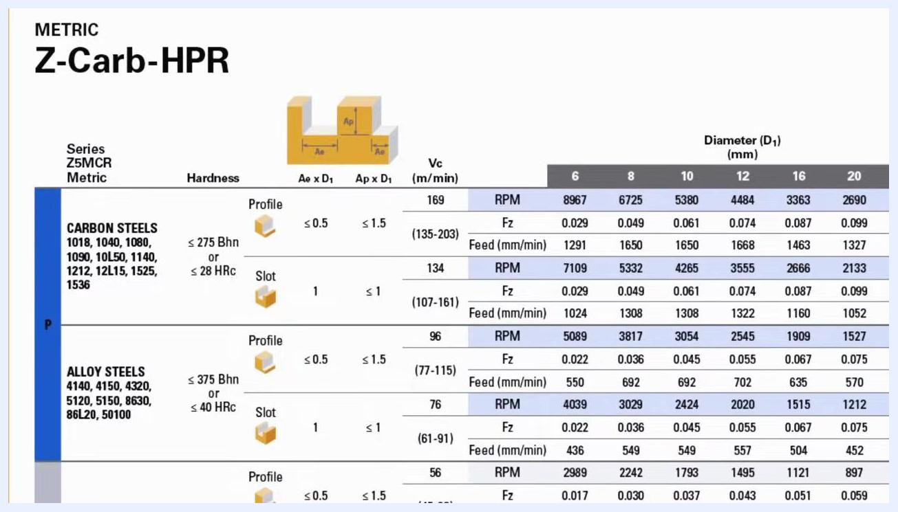
CNC shop workbench, representing the use of digital apps or software to calculate feed rates and speeds quickly.

- On machines with next-generation controls, use the built-in milling calculator by pressing the Current Commands button.
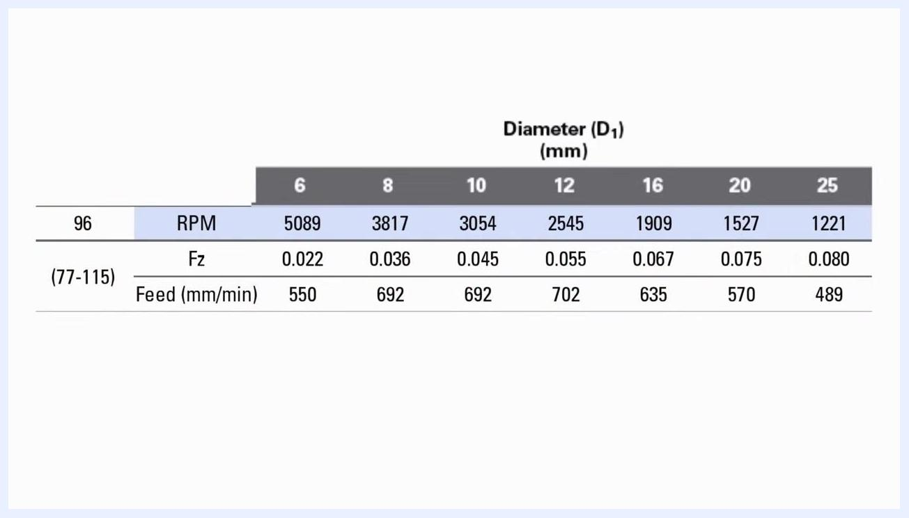
CNC machine control panel where the built-in milling calculator can be accessed via the Current Commands button.

- Consult additional resources for tapping feed rate calculations, since tapping uses its own set of considerations not covered by the end mill and drill formulas above.

Verification and summary
Before running your CNC program, confirm the following:
- You have identified the correct ISO material group and manufacturer catalog code for your workpiece material.
- You have selected a cutting speed (Vc) appropriate to your material, tool coating, and setup rigidity.
- You have calculated spindle speed using n = Vc × 318 ÷ D and entered it as the S-code.
- You have calculated feed rate using Vf = fz × Zn × n (end mills) or Vf = fn × n (feed per revolution) and entered it as the F-code, adjusting fz downward for slotting versus side milling as recommended.
- Where available, you have cross-checked your calculated values against direct RPM and feed rate tables in the tooling catalog.
Rendered image of a metal block and an end mill, illustrating the concept of tool and material interaction in machining.

What's next
With spindle speed (S-code) and feed rate (F-code) calculated and entered into your program, you are ready to proceed with running the CNC job. For tapping operations specifically, consult additional resources on tapping feed rate calculations, as tapping requires separate considerations beyond the end mill and drill formulas covered in this procedure.
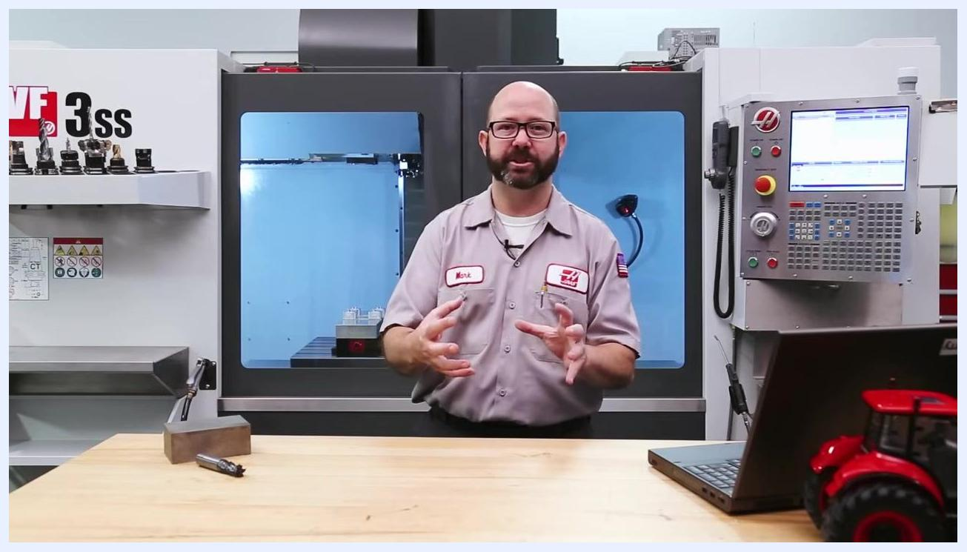
Instructor gesturing to illustrate the importance of setup rigidity for cutting speed selection.
CNC shop workbench, indicating that additional resources are available for tapping feed rate calculations.

