How to Adjust a Torque Wrench
Knowing how to adjust a torque wrench correctly ensures that fasteners are tightened to the exact specification required for your vehicle, preventing both under-tightening and over-tightening. This guide walks you through identifying a DeWalt Micro-Adjusting Torque Wrench, reading its scales, setting it to a precise torque value, and using it safely to tighten lug nuts.

Purpose
This procedure explains how to read the scales on a torque wrench, adjust the dial to a specific torque value, and apply that setting correctly when tightening fasteners such as wheel lug nuts.

Scope
This procedure applies to the DeWalt 1/2" DR Micro-Adjusting Torque Wrench (part number DWMT75462), with a torque range of 50–250 foot-pounds (ft-lb) or 74.6–345.7 Newton-meters (Nm). The steps also apply generally to similar micro-adjusting torque wrenches.

Required equipment
- DeWalt Micro-Adjusting Torque Wrench (or equivalent)
- Extension bar sized to fit the torque wrench drive
- Socket matching your lug nut size
- Vehicle jack (if lifting the wheel)
- Manufacturer's torque specification for your vehicle

Step-by-step procedure

1. Identify your torque wrench packaging
Check the box for the yellow-and-black DEWALT branding at the top. The packaging identifies the product as a "Micro-Adjusting Torque Wrench" in English, Spanish, and French, with a 1/2" DR drive size and a torque range of 50–250 ft-lb (74.6–345.7 Nm). The box also highlights "High Accuracy with Control Mechanism."
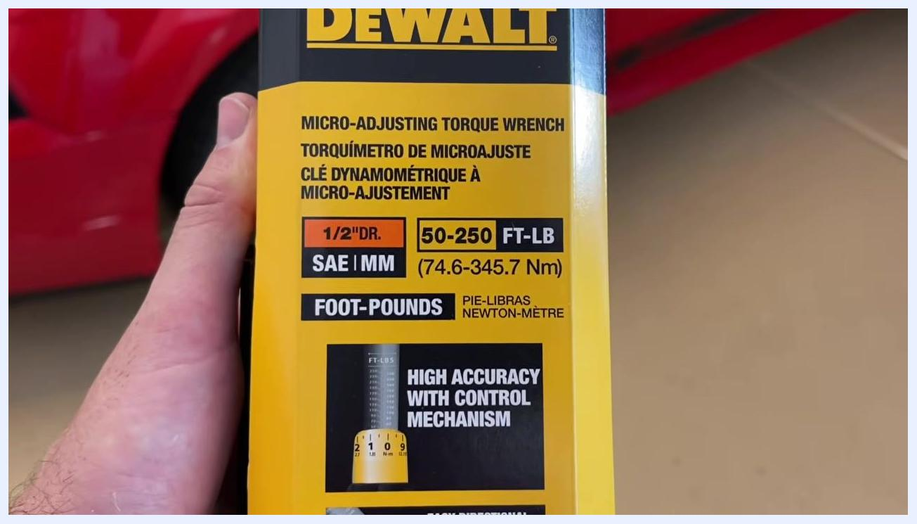
Front of the DeWalt torque wrench box showing the product name, torque range (50–250 ft-lb / 74.6–345.7 Nm), drive size (1/2" DR), and high-accuracy feature.

2. Locate the part number and warranty information
Find the part number "DWMT75462" printed at the bottom of the box, along with the "1 Year Limited Warranty" and "Hassle Free Replacement" details. The box also includes diagrams showing the reversing switch for directional change and the "click" indicator used for the torque limit.
Bottom of the DeWalt torque wrench box showing the part number (DWMT75462), one-year limited warranty, and diagrams for directional change and click indicator.

3. Unbox the torque wrench
Open the yellow DeWalt-branded plastic case to find the torque wrench secured in a molded tray.
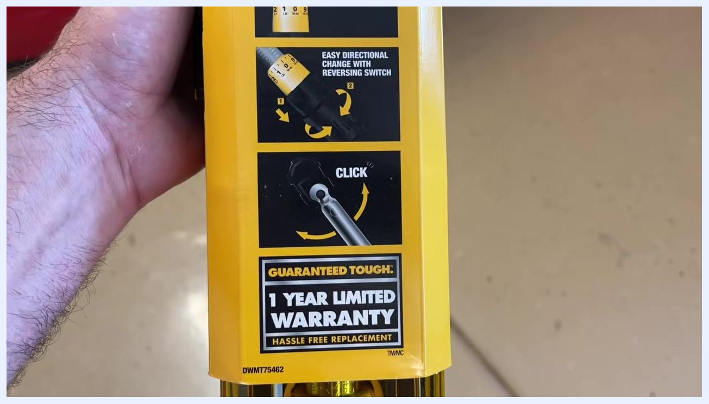
DeWalt torque wrench in its yellow plastic case, placed on a garage floor with a car visible in the background.

4. Understand the function of a torque wrench
A torque wrench does not increase the power you apply; it limits the amount of torque delivered to the fastener. The wrench "clicks" once the preset torque value is reached, which prevents over-tightening.

5. Handle the torque wrench carefully
Use the torque wrench primarily for tightening in the forward direction. Safety note: Avoid using it to break loose fasteners, since torque wrenches are more delicate than breaker bars and can be damaged by excessive force in the wrong application.

Reading the torque scales

6. Locate the foot-pound (FT-LBS) scale
On one side of the wrench shaft, find the engraved scale marked in foot-pounds, ranging from 50 to 250 ft-lb in increments of 20.
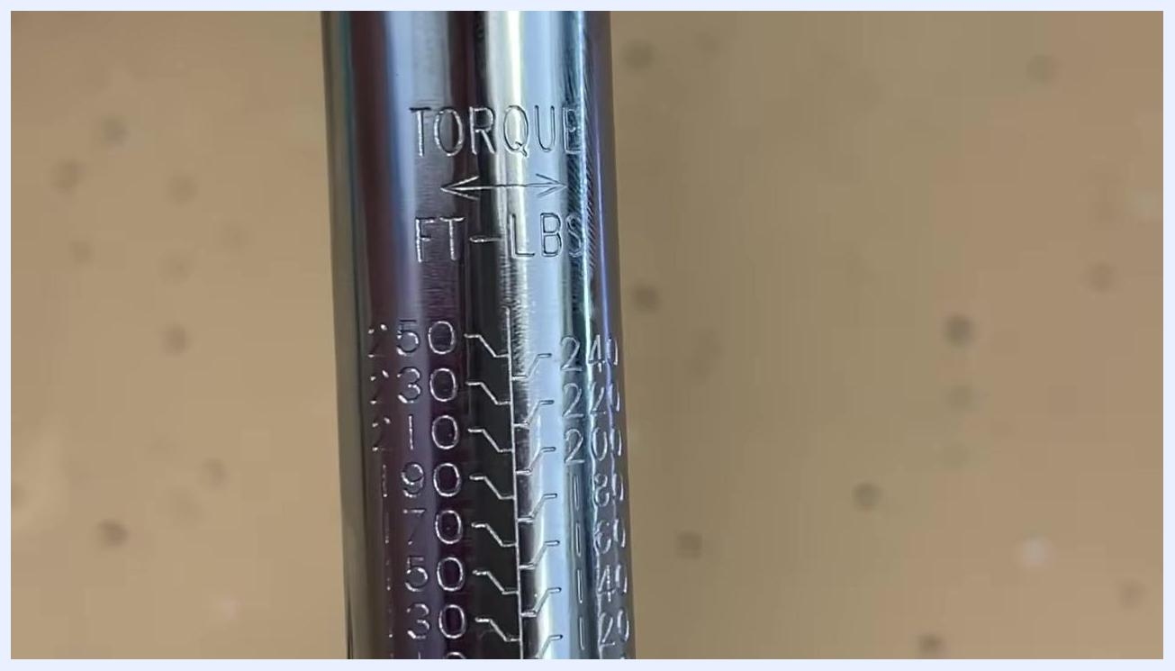
Close-up of the torque wrench shaft showing the FT-LBS scale, with values from 50 to 250 foot-pounds.

7. Locate the Newton-meter (Nm) scale
On the opposite side of the shaft, find the engraved Newton-meter scale, ranging from 74.6 to 345.7 Nm in corresponding increments.
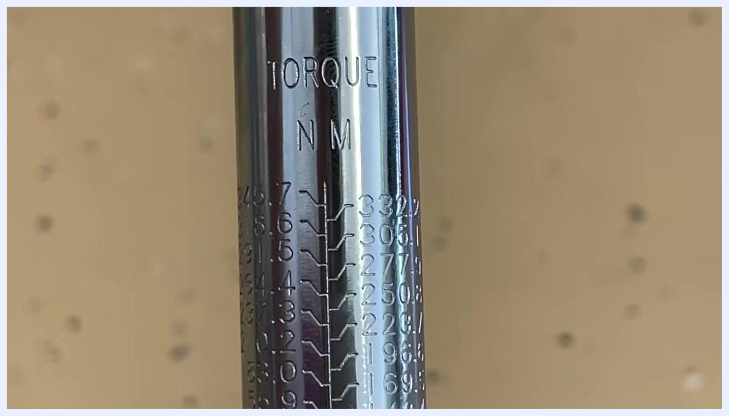
Close-up of the torque wrench shaft showing the Newton-meter (Nm) scale, with values from 74.6 to 345.7 Nm.

8. Match the scale to your specification
Always use the same unit—ft-lb or Nm—as specified for your application. Safety note: Mixing units can result in over-tightening or under-tightening the fastener.

9. Identify the adjustment dial
At the base of the wrench, locate the yellow adjustment dial marked from 0 to 9, which also displays corresponding Newton-meter values. To adjust it, pull down on the sleeve to unlock the dial before turning it.
Close-up of the yellow adjustment dial at the base of the torque wrench, showing numbers 0–9 and Nm values.

Setting the desired torque value

10. Unlock and rotate the adjustment dial
With the sleeve unlocked, spin the yellow adjustment dial. As you rotate it, the torque value indicated on the shaft changes accordingly.
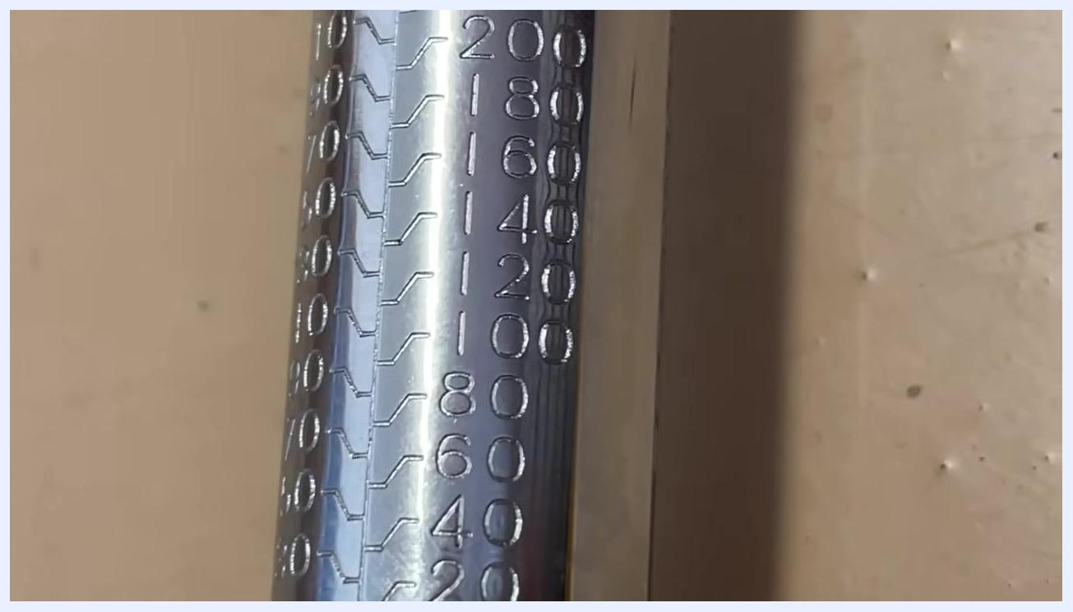
Close-up of the yellow adjustment dial on the torque wrench, showing numbers 0–9 and Nm values.

11. Align the target value on the shaft
For example, to set the wrench to 100 ft-lb, rotate the dial until the 100 mark on the shaft becomes visible and aligns with the reference line. The engraved shaft scale shows increments of 20 ft-lb (for example, 80, 100, 120).
Close-up of the torque wrench shaft showing the FT-LBS scale, with values from 80 to 120 foot-pounds, and the adjustment dial set near 0.

12. Observe the drop-down reference line
The 100 ft-lb mark includes a line that drops down and remains visible as you rotate the dial, so you can always confirm the set value.
Close-up of the torque wrench shaft showing the 100 ft-lb mark and its drop-down reference line.

13. Rotate until only the target value is visible
Continue turning the dial until the 100 mark sits at the top and the previous value (for example, 90) is no longer visible. The zero mark on the dial should align with the drop-down line from the 100 mark.
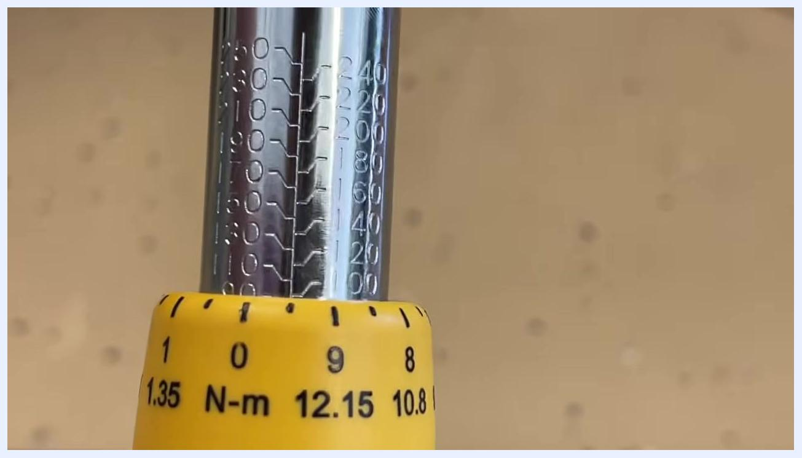
Torque wrench with the adjustment dial rotated so the 100 ft-lb mark is aligned at the top, and the zero mark on the dial aligns with the drop-down line.

14. Fine-tune the setting
As you approach the target value, the dial passes through 97, 98, 99, and finally 100 ft-lb as the zero mark aligns perfectly. Turning the dial further will increase the setting to 101, 102, 103, and so on.
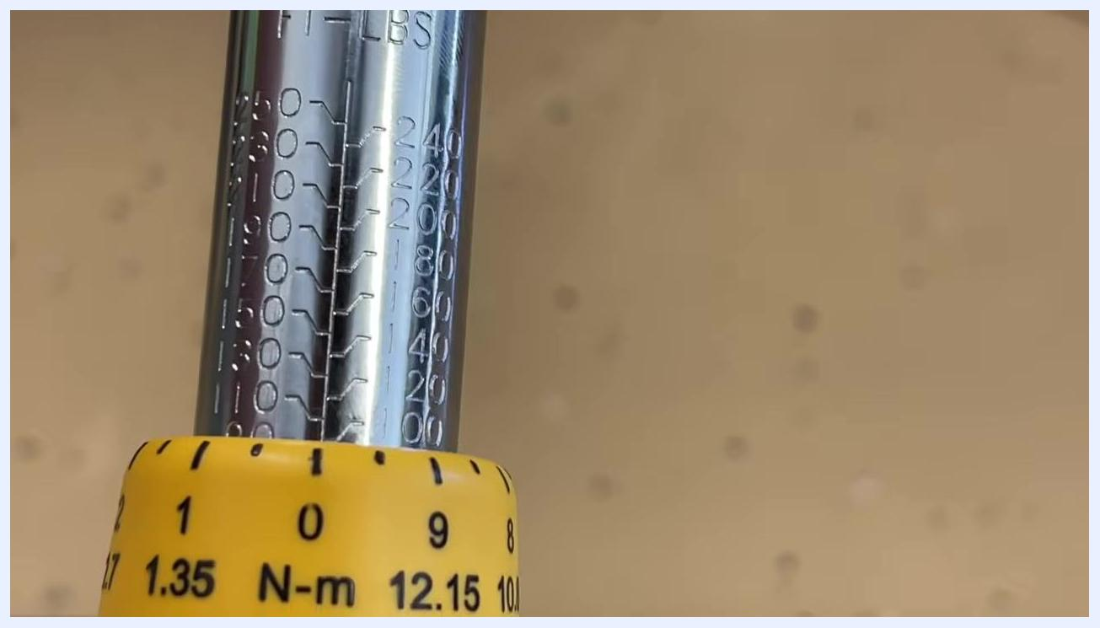
Torque wrench set exactly to 100 ft-lb, with the zero mark on the dial aligned with the drop-down line from the 100 mark.

15. Confirm the torque setting
Double-check that the zero mark on the dial is perfectly aligned with the drop-down line from the 100 ft-lb mark on the shaft before proceeding.
Torque wrench set to 100 ft-lb, with the zero mark on the dial aligned with the 100 mark on the shaft.

Checking vehicle torque specifications

16. Verify the manufacturer's specification
Always confirm the required torque value for your specific application before tightening. For example, Ford Mustangs typically require 95–100 ft-lb for wheel lug nuts, while trucks may require a different value. Refer to the manufacturer's manual or service guide for the correct specification.
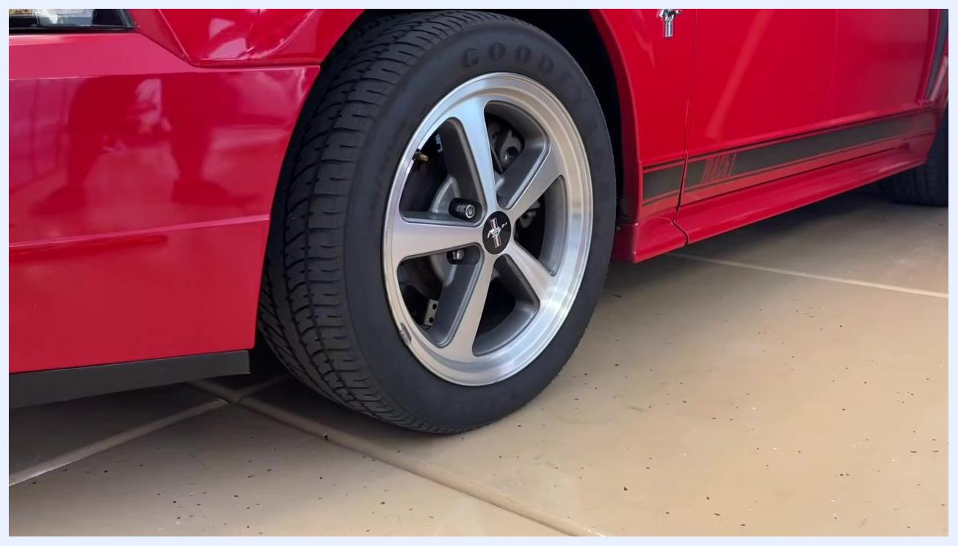
Red Ford Mustang wheel, illustrating the context for checking and applying the correct torque specification.

Using the torque wrench to tighten lug nuts

17. Attach an extension
Insert a small extension bar into the drive end of the torque wrench. This keeps the handle away from the vehicle fender, especially with longer torque wrenches, and does not significantly affect the accuracy of your torque reading.
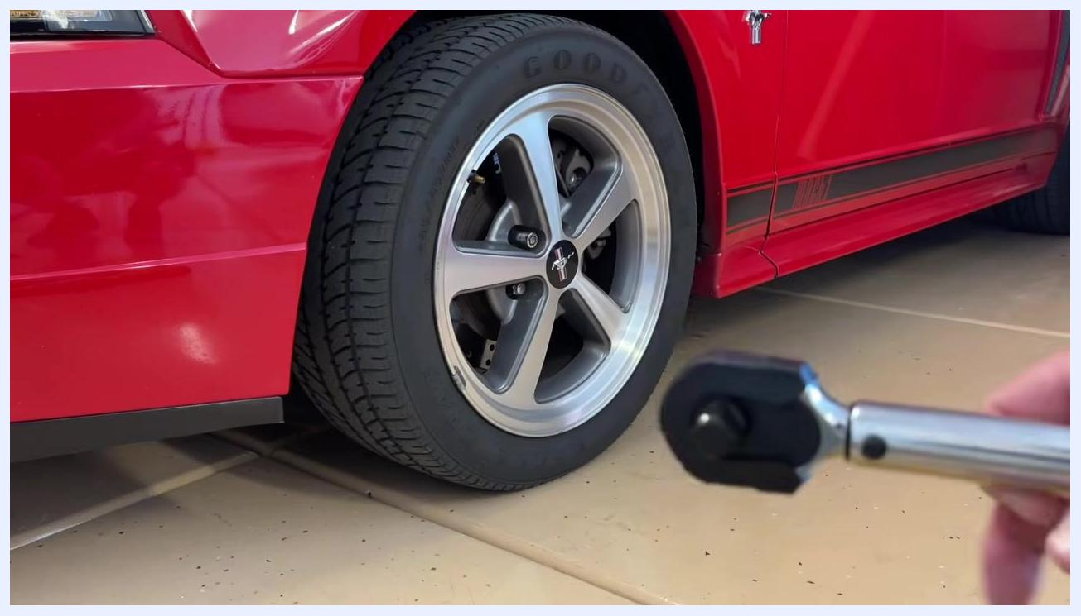
A person holding a torque wrench and a small extension bar in front of a red Mustang wheel, preparing to attach the extension.

18. Attach the correct socket
Choose a socket that matches the size of your vehicle's lug nuts and securely fit it onto the end of the extension.
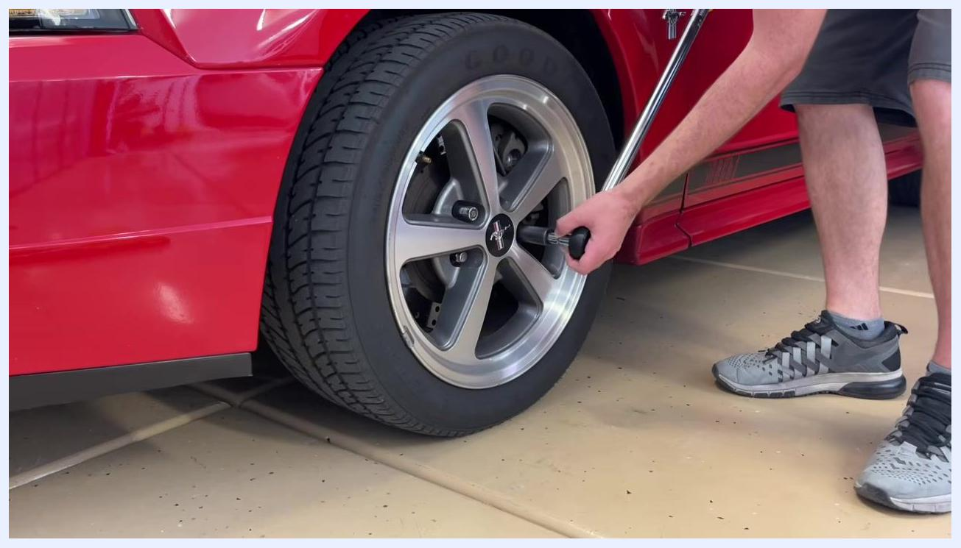
A torque wrench with a small extension and socket attached, held in front of the Mustang wheel.

19. Confirm the tightening direction
Set the wrench to the "tighten" (clockwise) setting. Remember: righty-tighty (clockwise to tighten), lefty-loosey (counterclockwise to loosen).
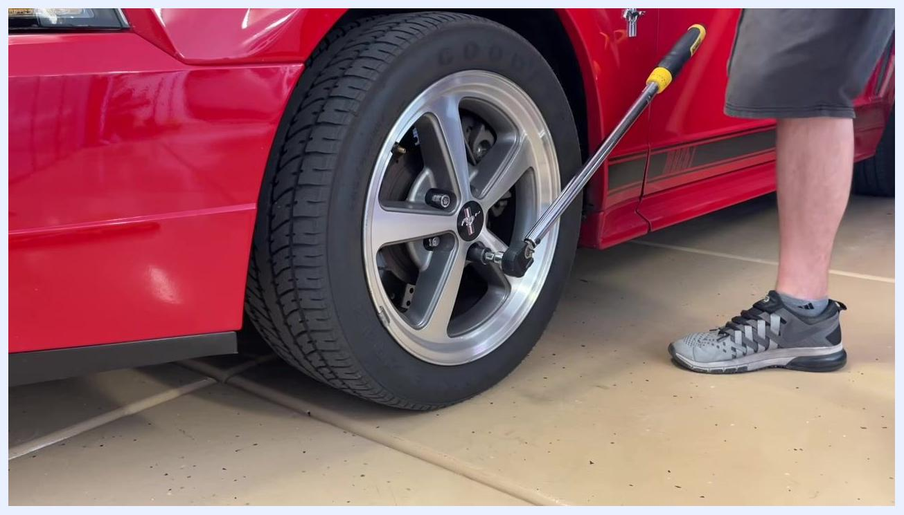
The torque wrench with extension and socket attached, positioned near the wheel and ready to use.

20. Prepare the vehicle
Safety note: Ideally, have the wheel slightly off the ground using a jack. If the wheel is in the air, have someone hold the brakes to prevent the wheel from spinning. Alternatively, let the tire just touch the ground for stability, but avoid torquing with the full weight of the vehicle on the wheel.

21. Tighten the first lug nut until it clicks
Position the socket over a lug nut and apply steady, clockwise pressure to the wrench handle. Tighten until you hear and feel the click, indicating the set torque value (for example, 100 ft-lb) has been reached.
A person using a torque wrench with extension and socket to tighten a lug nut on the Mustang wheel.

22. Continue in a star pattern
Move to the lug nut directly across from the one you just tightened, then continue tightening each remaining lug nut in a star (crisscross) pattern to ensure even pressure distribution.
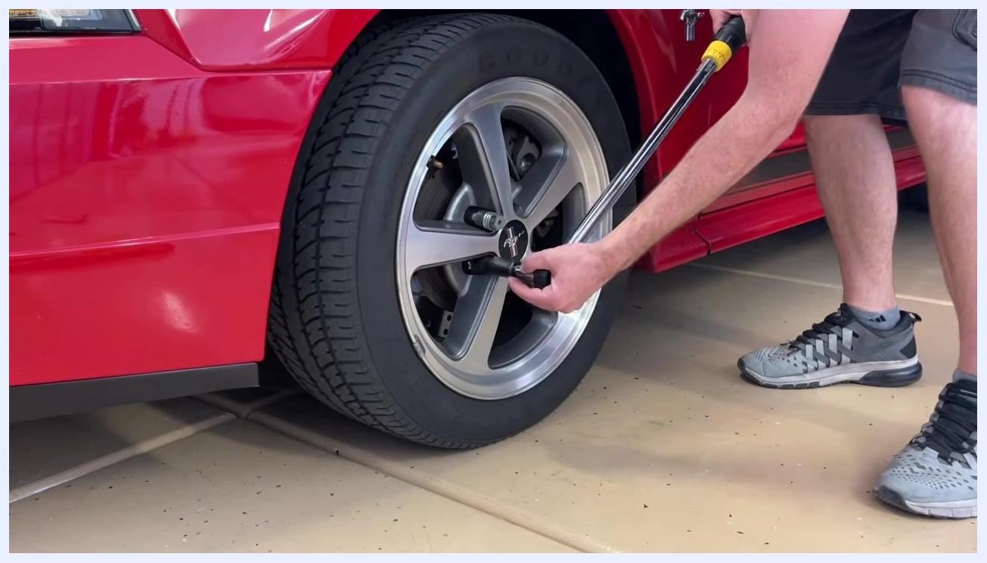
A person using a torque wrench to tighten another lug nut in a star pattern on the Mustang wheel.

23. Stop tightening at each click
Do not continue tightening after the click. Safety note: Continuing past the click can exceed the specified torque and damage the fastener or wheel.
A person finishing tightening a lug nut with a torque wrench, hand resting on the wrench after the click.

24. Reset the torque wrench after use
Once all lug nuts are torqued, spin the adjustment dial all the way back down to zero and store the wrench with no load to maintain its accuracy.

Example: Setting a torque wrench to 145 ft-lb

25. Avoid over-spinning the dial
Safety note: Do not spin the adjustment dial quickly past its zero marker, as over-spinning can damage the tool. Handle the dial gently and stop at the desired setting.
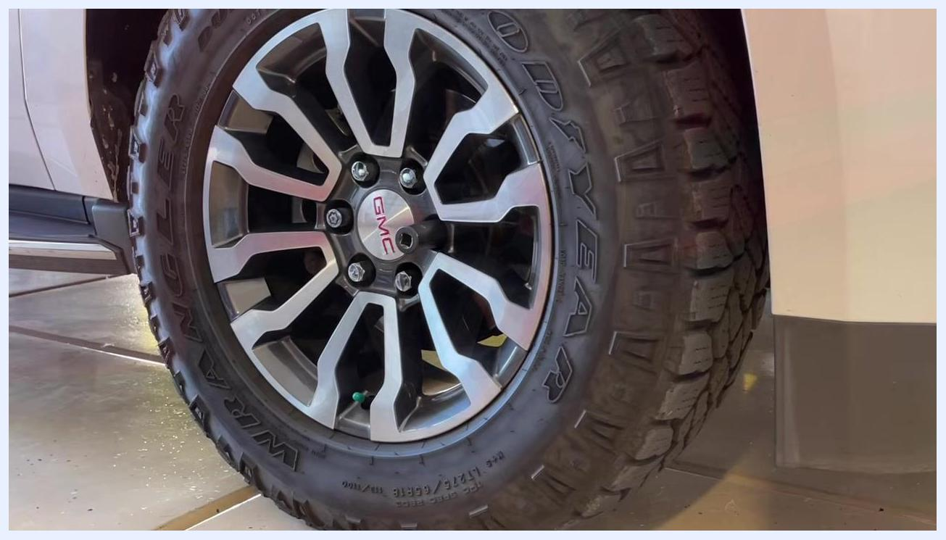
Close-up of a GMC vehicle wheel and tire, showing the lug nuts and rim before any tools are used.

26. Set the main scale
Identify the required torque value for your lug nuts—in this example, 145 ft-lb. Begin by setting the main scale on the shaft to 140 ft-lb, then rotate the yellow adjustment ring to add 5 more units, reaching a total of 145 ft-lb.
Hand holding a torque wrench, with a close-up on the scale showing ft-lb and Nm markings, the yellow adjustment ring visible, and the main scale set near 140. The vehicle wheel is in the background.

27. Fine-tune to the exact value
Continue rotating the adjustment ring until the indicator passes 140 and reaches the 5 mark, confirming a setting of 145 ft-lb. Double-check that the zero on the ring aligns with the correct value on the main scale.
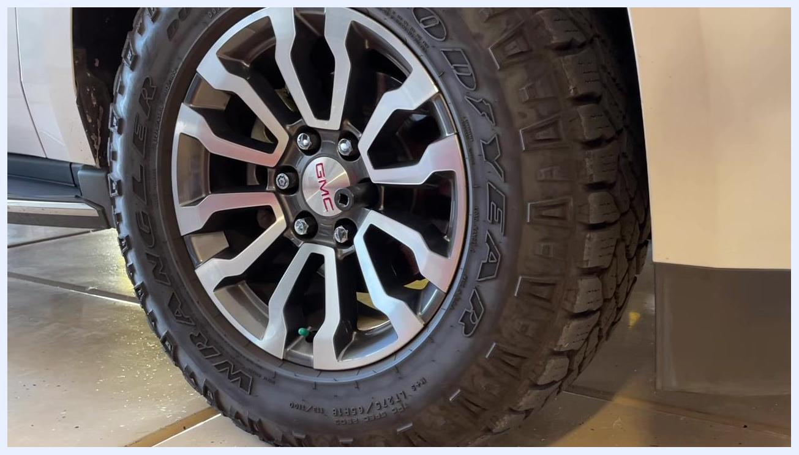
Close-up of the torque wrench scale showing the indicator at 145 ft-lb, with the yellow adjustment ring set to 5 and the main scale past 140. The vehicle wheel is visible in the background.
Another close-up of the torque wrench clearly showing the yellow adjustment ring set to 5 and the main scale at 140, confirming a total of 145 ft-lb.

28. Tighten lug nuts in a star pattern
Place the torque wrench on a lug nut and tighten each lug nut in a star (crisscross) pattern to distribute pressure evenly across the wheel. This prevents warping and ensures a secure fit.
GMC wheel with lug nuts, no tool in use yet, illustrating the tightening pattern.

29. Apply torque until the wrench clicks
Slowly apply force to the torque wrench and stop tightening immediately when you hear or feel the click, which indicates the set torque has been reached. Safety note: Do not continue tightening after the click to avoid over-torquing.
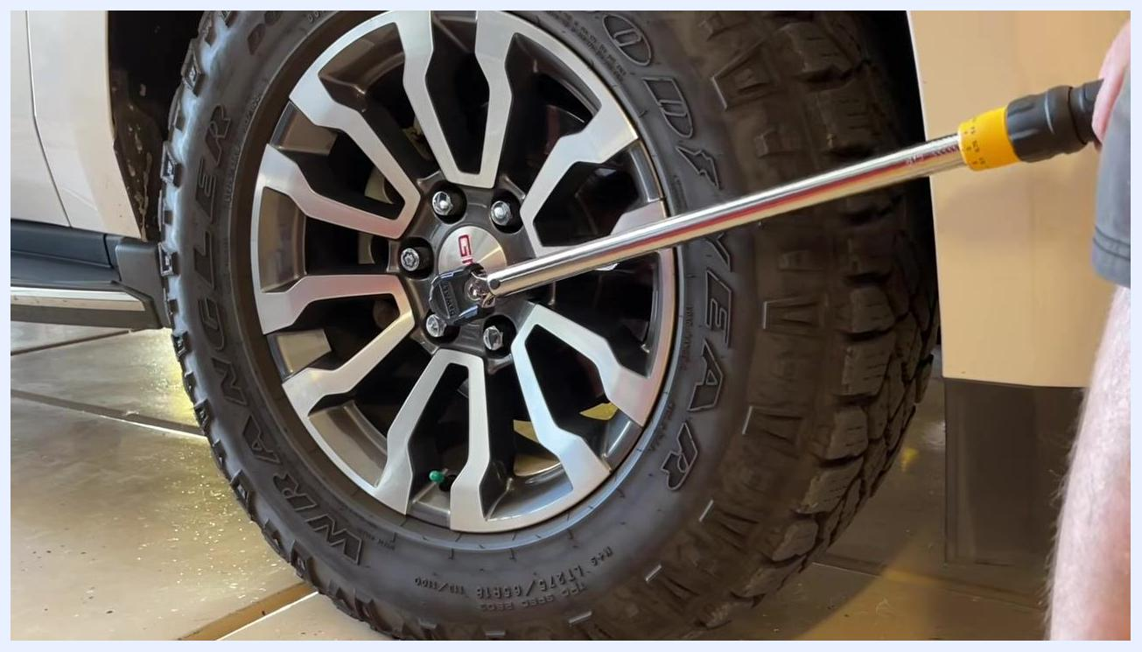
Torque wrench being used on a lug nut, with the user applying force to tighten it.

30. Understand torque wrench limitations
A torque wrench is not designed to apply more torque than a standard wrench; its purpose is to alert you when the specified torque is reached, not to act as a breaker bar. Safety note: Use a breaker bar first if you need to loosen very tight nuts, then switch to the torque wrench for final tightening.
Person using a torque wrench on a lug nut, showing proper hand placement and body position while applying force.

31. Stop tightening when the threshold is reached
Once the torque wrench clicks, do not continue tightening. Move to the next lug nut and repeat the process, always following the star pattern.
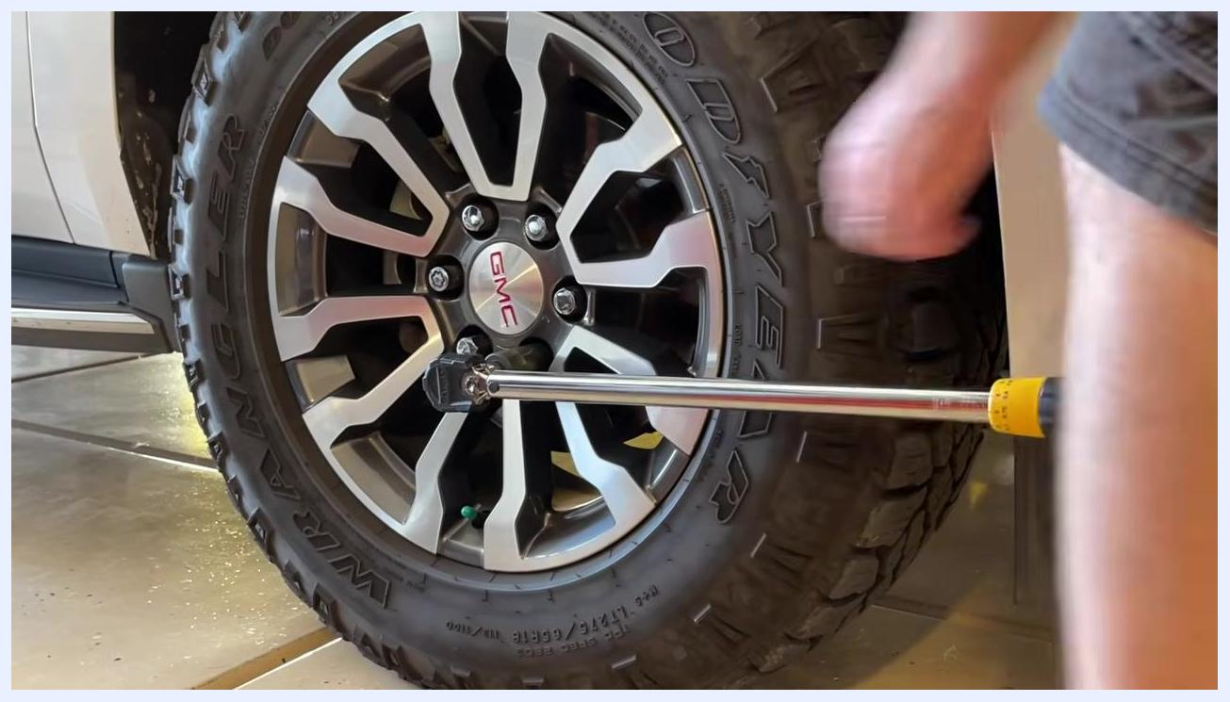
Torque wrench on a lug nut, with the user's hand off the wrench after tightening, showing the process is complete for that nut.

32. Repeat for all lug nuts
Continue tightening each remaining lug nut to the specified torque, following the star pattern, until all lug nuts are properly torqued.

Verification
Before considering the job complete, confirm the following:
- The torque wrench dial is set to the exact value specified by the manufacturer.
- Each lug nut has been tightened until the wrench clicked, with no additional force applied afterward.
- All lug nuts were tightened in a star (crisscross) pattern for even pressure distribution.
- The torque wrench dial has been reset to zero and the wrench stored with no load.
Following these steps ensures your vehicle's wheels are safely and accurately torqued to the manufacturer's specifications.
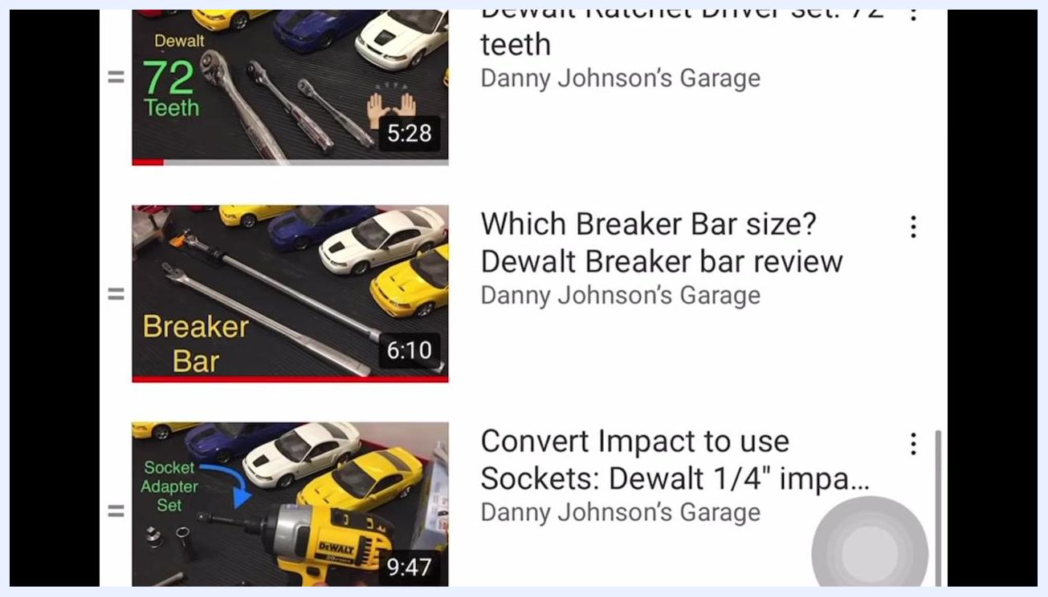
YouTube video recommendations showing thumbnails of tool review videos, including ratchets, breaker bars, and impact drivers, with model cars and tool names visible.
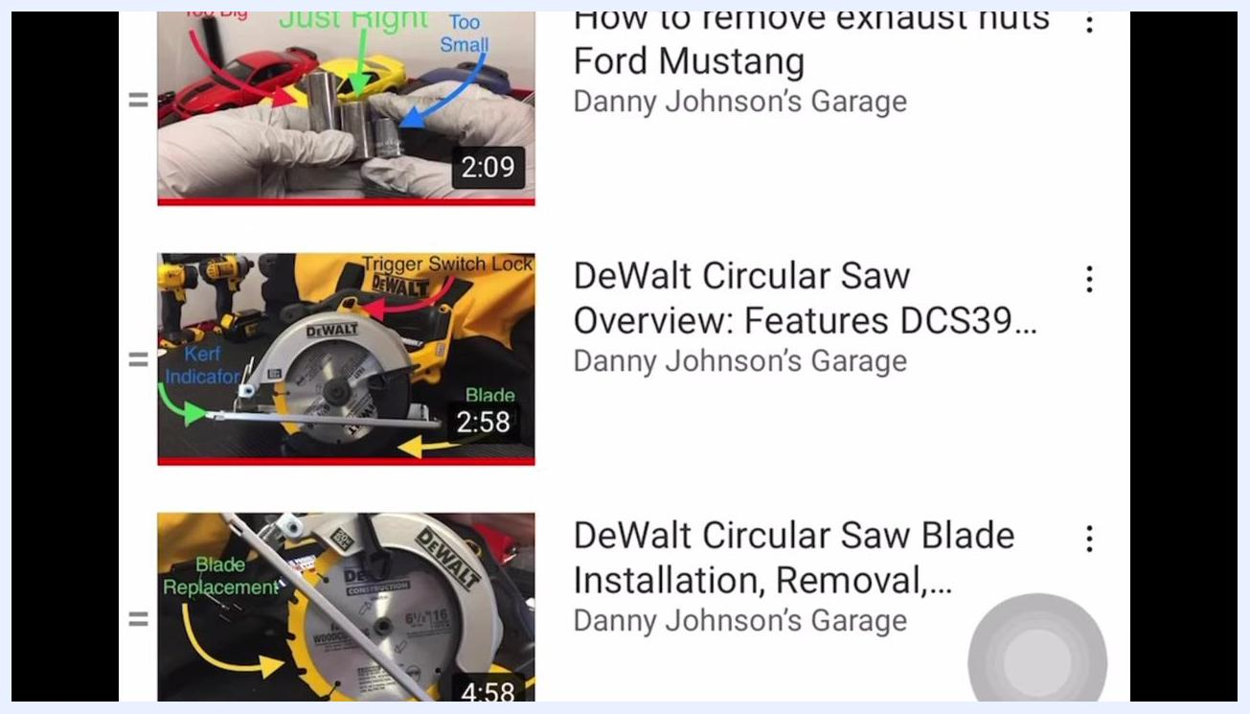
YouTube video recommendations showing thumbnails of tool and repair videos, including socket selection, circular saw features, and blade replacement, with clear labels and tool images.

