How to Use a Spectrophotometer
This document explains how to use a spectrophotometer to measure the transmittance and absorbance of a solution. It walks through identifying the instrument's key parts, preparing your cuvettes and solutions, calibrating the device at a chosen wavelength, taking measurements, and recalibrating whenever you switch wavelengths.
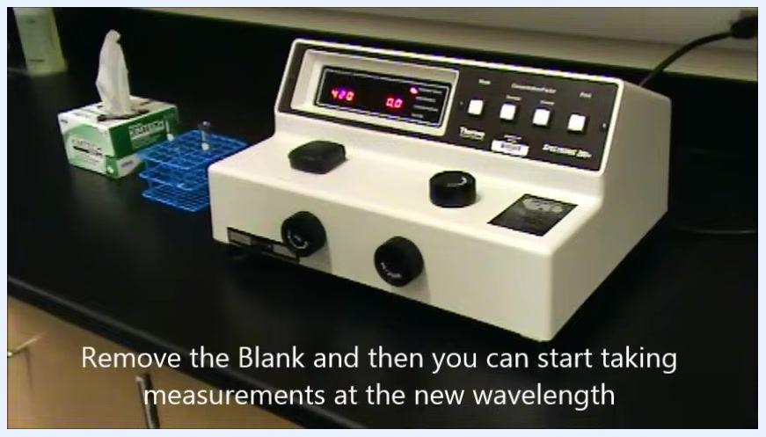
Spectrophotometer display showing 480 nm and 0.0 after removing the blank cuvette, ready for a measurement at the new wavelength

Purpose
This procedure ensures that spectrophotometric readings are taken accurately and consistently. Following these steps helps you avoid common errors such as skipping calibration or misreading the display.

Scope
This procedure applies to any laboratory setting where a spectrophotometer is used to measure transmittance or absorbance of a solution at a set wavelength. It covers initial setup, solution preparation, calibration, measurement, and recalibration for a new wavelength.
Red screen with white text: "Thank You for Watching. How to Use a Spectrophotometer"

Required equipment and materials
- Spectrophotometer with a sample compartment, wavelength control knob, transmittance/absorbance control knob, mode select button, and zero control knob
- Cuvettes (at least two: one for the blank solution, one for the sample solution)
- Blank solution (containing all components except the molecule or compound you wish to measure)
- Sample solution (containing the molecule or compound you wish to measure)
- Lint-free wipes (e.g., Kimtech wipes) for cleaning cuvettes
- A stable laboratory bench for the instrument
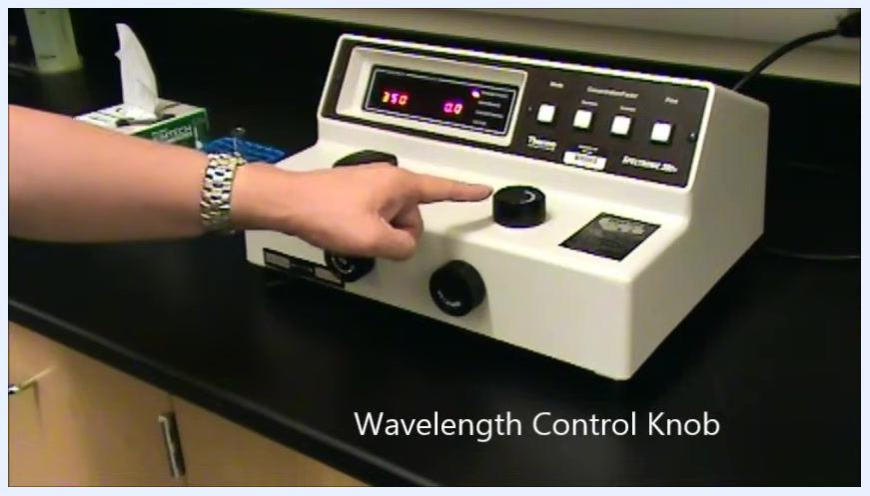
A hand points to the Wavelength Control Knob on the spectrophotometer
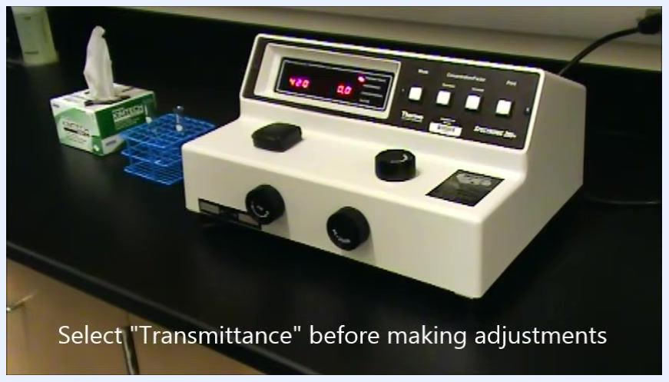
Spectrophotometer display instructing you to select Transmittance before making adjustments

Step 1: Identify the spectrophotometer parts

- Locate the sample compartment. This is where you place your cuvette for measurement, and the lid opens and closes to allow access. On a typical setup, the spectrophotometer sits on a lab bench near a box of lint-free wipes and a cuvette rack.
Spectrophotometer on a lab bench with the sample compartment visible, lint-free wipes, and a cuvette rack nearby

- Locate the Wavelength Control Knob, positioned on the top surface of the device to the right of the sample compartment. You use this knob to change the wavelength setting.
- Locate the Transmittance/Absorbance Control Knob on the right-hand side of the front panel. You use this knob to adjust the transmittance or absorbance readings.
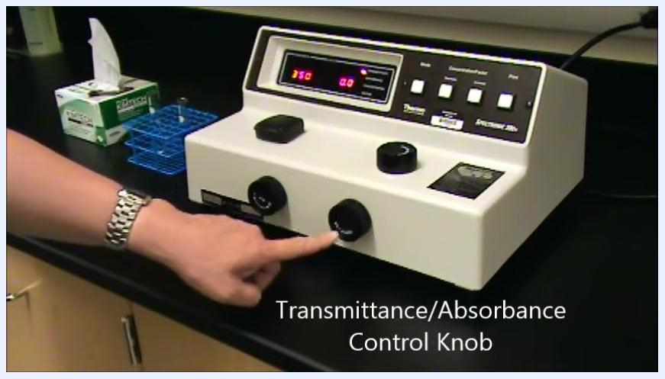
A hand points to the Mode Select button area on the spectrophotometer

- Locate the Mode Select button on the top panel, above the control knobs. Pressing this button switches between measurement modes (such as transmittance and absorbance), and the display updates to reflect the mode you select.

Step 2: Prepare your cuvettes and solutions

- Before using the spectrophotometer, prepare both a blank solution and your sample solution. The blank solution must contain all components except the molecule or compound you intend to measure.
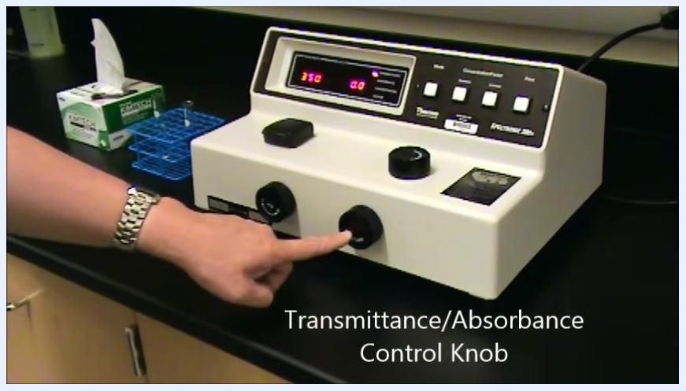
Spectrophotometer on a lab bench with an on-screen introduction to preparing cuvettes and solutions

- Fill one cuvette with the blank solution and fill a separate cuvette with the sample solution containing the compound you wish to measure. Keep the two cuvettes clearly distinguished so you do not mix them up later in the procedure.
A hand holds a cuvette filled with the blank solution

Step 3: Set the spectrophotometer to transmittance mode

- Select Transmittance mode before making any adjustments. The transmittance scale is linear, which makes it easier to set the zero and 100% values accurately. Confirm the spectrophotometer is set to Transmittance before you calibrate or take readings.
Spectrophotometer display instructing you to press Mode Select to choose Transmittance
Spectrophotometer display with instruction "Press the Mode Select Button to select Transmittance"

- Press the Mode Select button repeatedly until the transmittance value is highlighted on the display.

Step 4: Calibrate the spectrophotometer and insert the blank

- Turn the Wavelength Control Knob until the display shows the wavelength you want to measure. For this procedure, set the wavelength to 420 nanometers.
- Confirm the display now reads 420 for the wavelength. The spectrophotometer is now ready for zeroing at this wavelength.
- Turn the zero control knob, located on the front left of the device, until the display reads 0.0% for transmittance. This step ensures the instrument is properly zeroed before you insert any cuvette.
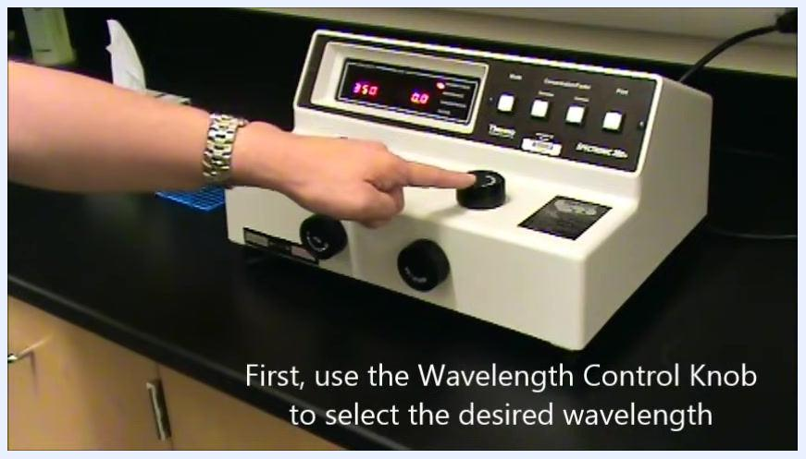
Hand adjusting the Wavelength Control Knob while the display shows 350 nm and 0.0

- Continue adjusting the zero control knob until the display reads exactly 0.0.
- Lift the lid of the sample compartment to prepare it for cuvette insertion.
- Wipe the bottom of the blank cuvette with a lint-free wipe. This step prevents residue or fingerprints from interfering with the reading.
- Align the line on the cuvette with the dash at the front edge of the sample compartment, insert the blank cuvette fully, and close the lid.
- Turn the Transmittance/Absorbance Control Knob, located on the front right of the device, until the display reads 100.0% for transmittance.
- Continue adjusting the knob until the display reads exactly 100.0.
- Once the display reads 100.0%, open the sample compartment and remove the blank cuvette. The spectrophotometer is now calibrated and ready for sample measurement.
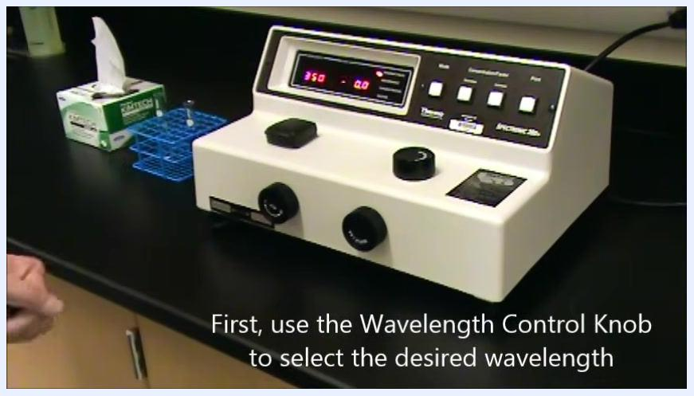
Spectrophotometer display confirming the wavelength setting
Hand turning the zero control knob while the display shows 420 nm and 0.1
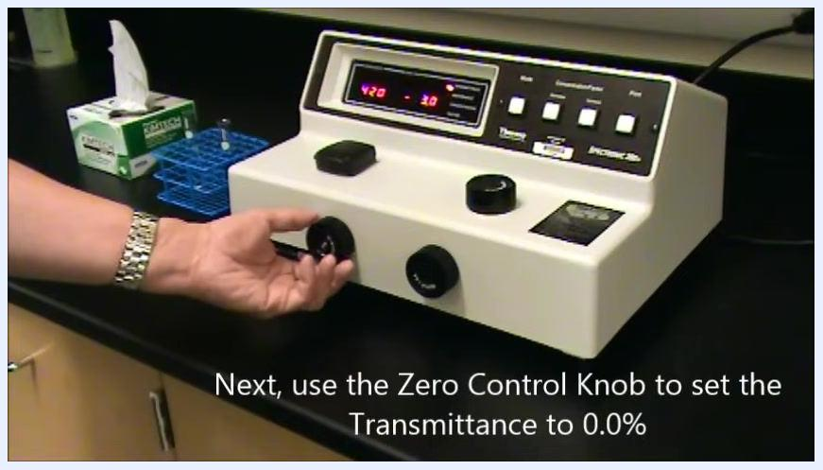
Hand turning the zero control knob while the display shows 420 nm and 0.0
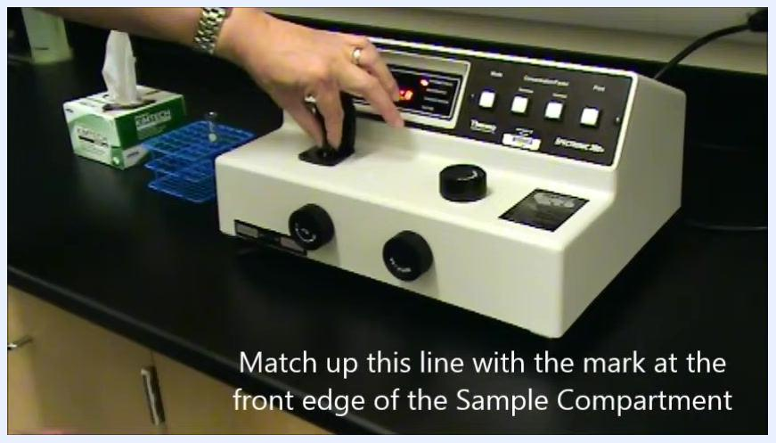
Spectrophotometer with the sample compartment open, display showing 420 nm and 0.0
Hand aligning and inserting the cuvette into the sample compartment
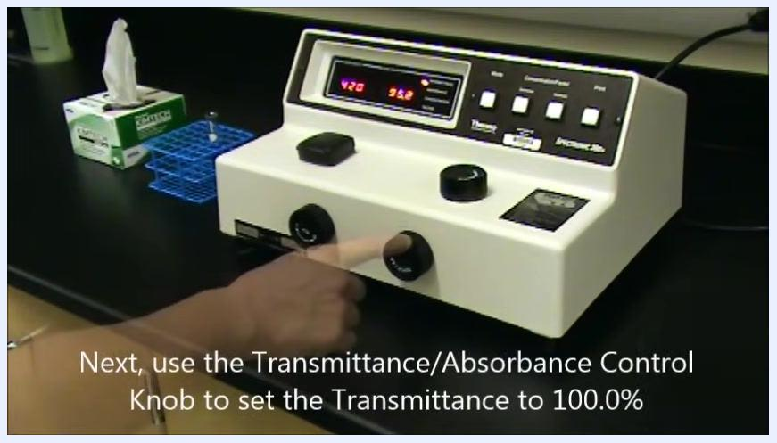
Hand turning the Transmittance/Absorbance Control Knob while the display shows 420 nm and 95.2
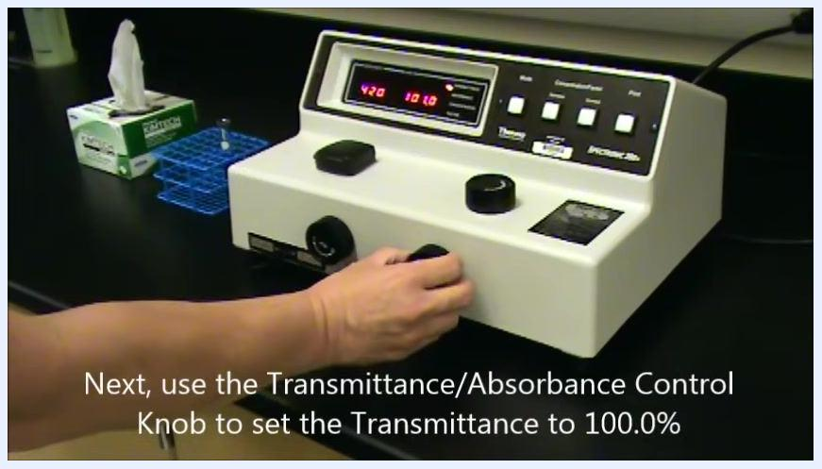
Hand turning the Transmittance/Absorbance Control Knob while the display shows 420 nm and 101.0
Spectrophotometer with the blank cuvette removed, display showing 420 nm and 100.2

Step 5: Measure sample solutions and interpret readings

- Hold the sample cuvette so its clear sides align with the light path, line up the mark on the cuvette with the mark on the sample compartment, and gently insert it.
- Read the transmittance value on the digital display, shown as a percentage. For example, the display may read 93.0% transmittance at 420 nm.
- If you need the absorbance value instead, press the Mode button to toggle to Absorbance. When the Absorbance LED is lit, the display shows the absorbance value for the same wavelength — for example, 0.032 at 420 nm.
- Important: Do not record the concentration value unless the machine has been specifically programmed with the correct factor for your compound. The concentration and factor features require special programming and calibration, so only use the transmittance and absorbance values for your measurements.
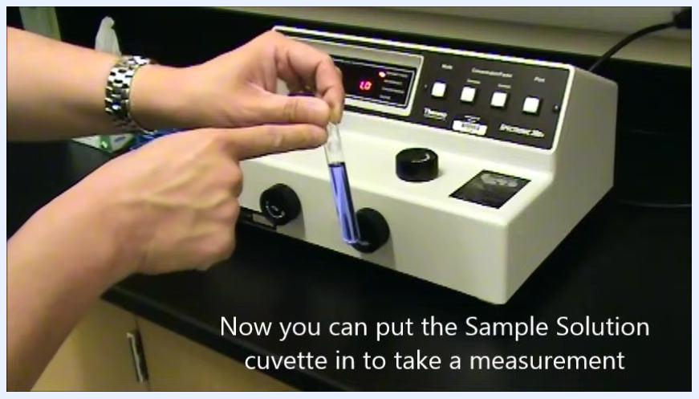
Hand aligning a sample solution cuvette with the sample compartment

- Open the sample compartment and carefully remove the cuvette. The transmittance display should return to 0.0% once the compartment is empty.
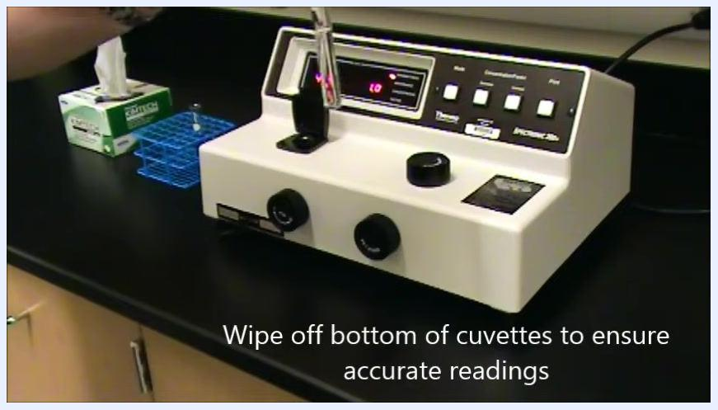
Hand wiping the bottom of a cuvette above the open sample compartment

- To measure additional samples at the same wavelength, insert each new sample cuvette one at a time, aligning the marks as before, and record the transmittance and/or absorbance value shown for each.
- Note: If you need to measure at a different wavelength, you must recalibrate the spectrophotometer before taking any new readings.
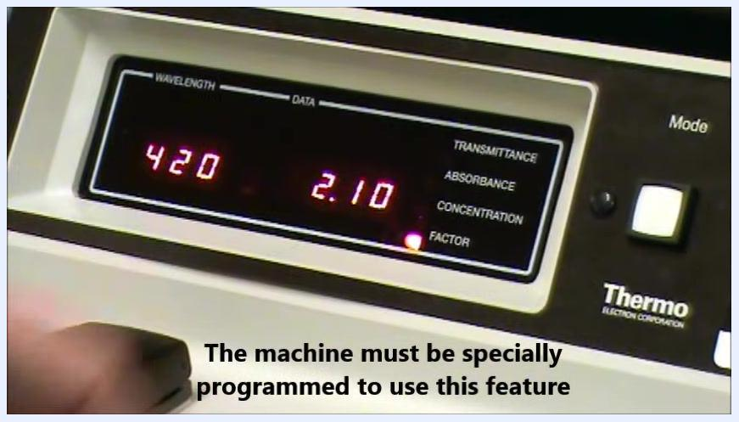
Close-up of the display showing 420 nm and 0.032 absorbance with the Absorbance LED lit
Close-up of the display showing 420 nm and 0.07 concentration with the Concentration LED lit
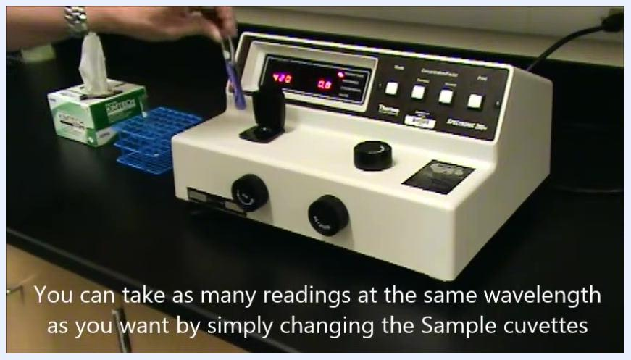
Close-up of the display showing 420 nm and 2.10 factor with the Factor LED lit
Spectrophotometer with an empty sample compartment, display showing 420 nm and 0.0
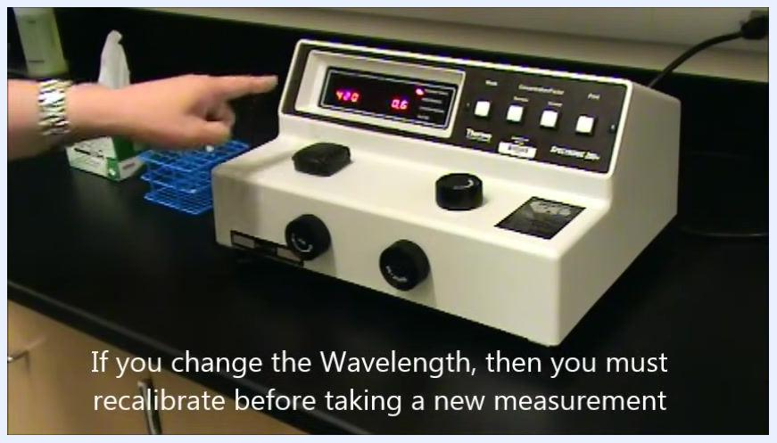
Hand inserting a new sample cuvette while the display shows 420 nm and 0.0
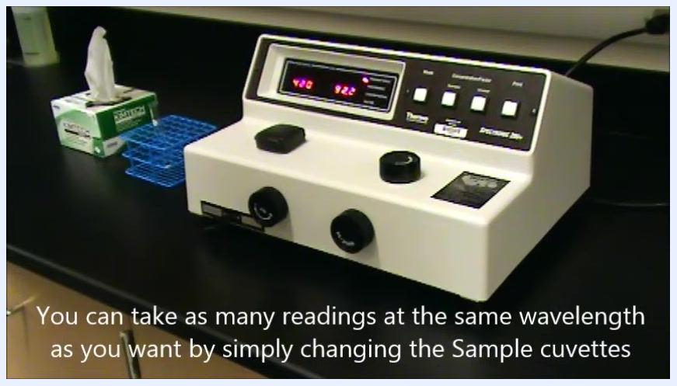
Spectrophotometer with a sample cuvette inserted, display showing 420 nm and 92.2
Hand pointing to the display, showing 420 nm and 0.6, with a reminder to recalibrate after changing the wavelength

Step 6: Recalibrate for a new wavelength

- Turn the Wavelength Control Knob until the display shows the new desired wavelength — for example, 480 nm.
- With the sample compartment empty, turn the zero control knob on the left side of the device until the transmittance display reads 0.0%.
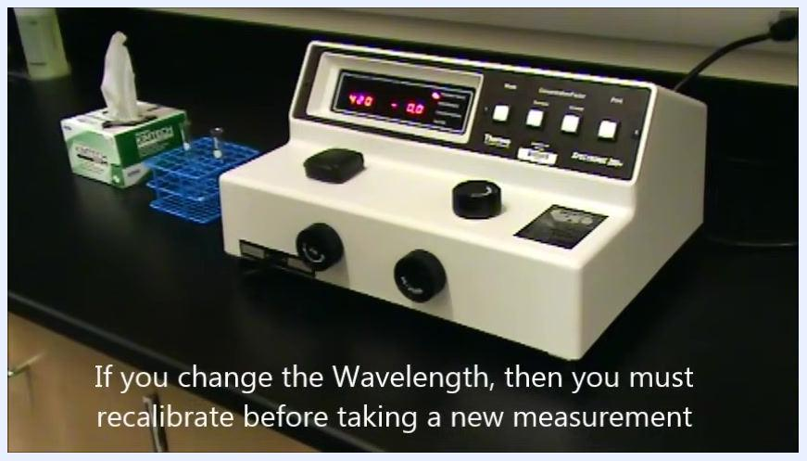
Spectrophotometer display showing 480 nm and 0.0 with a reminder to recalibrate after changing the wavelength

- Insert the blank cuvette (containing only the solvent) into the sample compartment, aligning the marks as before.
- Turn the Transmittance/Absorbance Control Knob on the right side of the device until the display reads 100.0%.
- Open the sample compartment and carefully remove the blank cuvette.
- Insert your sample cuvette, aligning the marks, and read and record the absorbance or transmittance value at the new wavelength.
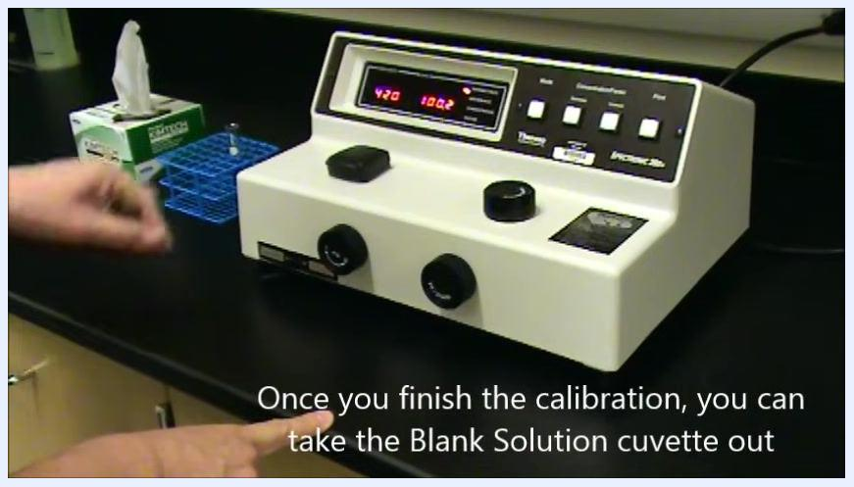
Close-up of the spectrophotometer display showing 420 nm and 93.0% transmittance
Hand pointing to the right control knob while the display shows 480 nm and 100.0

Verification and summary
- Confirm that the sample compartment is empty and the transmittance display reads 0.0% before starting any new zeroing step.
- Confirm the blank cuvette produces a 100.0% transmittance reading before you remove it and begin measuring samples.
- Record only the transmittance and absorbance values from the display; do not use the concentration or factor readings unless the machine is specifically programmed and calibrated for those features.
- Always recalibrate the spectrophotometer whenever you change the measurement wavelength, before taking any new readings.
A hand points to the Transmittance/Absorbance Control Knob on the front panel
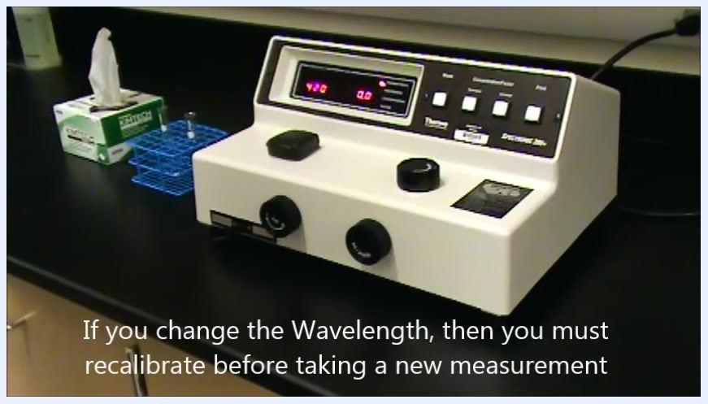
Hand pointing to the left control knob while the display shows 480 nm and 0.0
By following this procedure, you can identify the key parts of the spectrophotometer, prepare your solutions correctly, calibrate the instrument at any wavelength, and take accurate, reliable transmittance and absorbance measurements for your samples.

