How to Streak a Plate for Isolation: Pure Colony Isolation by Streak Plate Technique

Purpose
This standard operating procedure describes how to streak a plate for isolation of pure bacterial colonies from a mixed population using the four-quadrant streak plate technique. The method is intended for microbiology laboratories that need to separate individual bacterial colonies from a mixed culture in order to obtain a pure isolate for further identification, subculturing, or downstream testing.
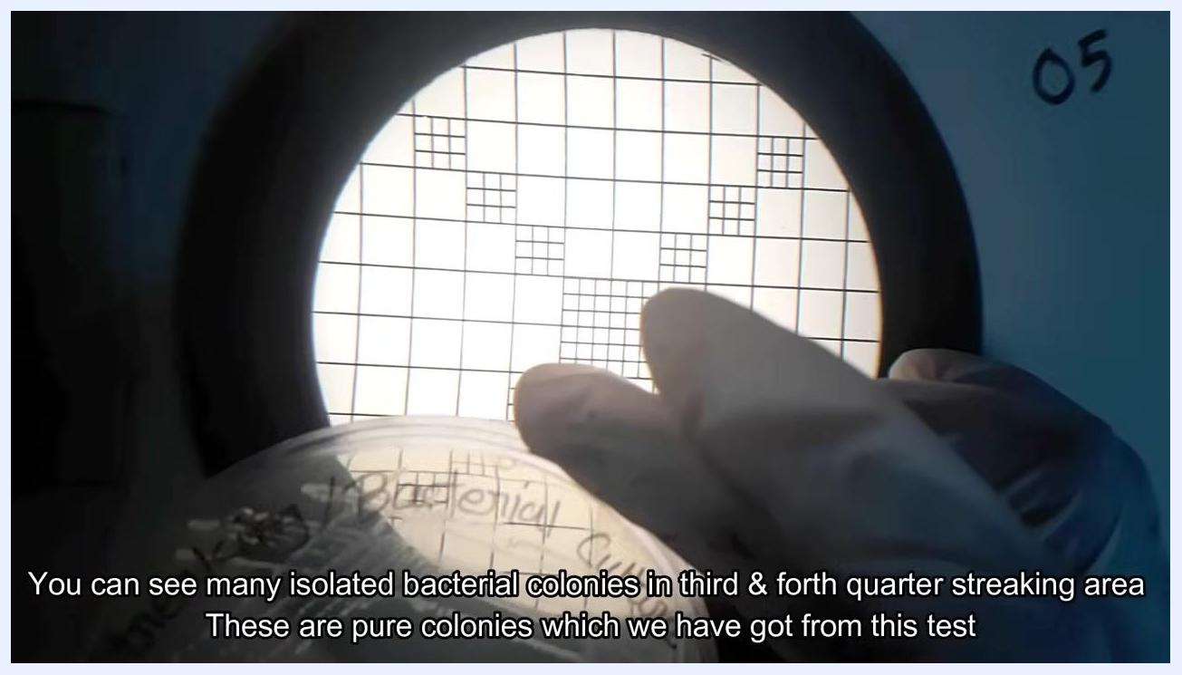
A gloved hand holding a petri dish with isolated colonies over a grid background.

Scope
This procedure applies to the isolation of bacteria from a mixed bacterial culture onto Tryptic Soya Agar (TSA) plates. It covers:
- Sample type: mixed bacterial culture supplied on a culture plate.
- Matrix: solid agar culture media (TSA), prepared in sterile petri dishes.
- Equipment: biological safety cabinet, incubator, Bunsen burner or spirit lamp, inoculating loop, colony counter.
- Analysts: laboratory personnel trained in aseptic technique and biological safety cabinet operation.

Title screen showing "Microbiological Inoculation Technique: Pure Colony Isolation by Streak Plate Technique" with a background of a magnified cell or bacterium.
This procedure does not cover species identification, biochemical confirmation testing, or quantitative colony counting beyond visual assessment of isolation quality. Media preparation is included only to the extent needed to produce a suitable plate for streaking.

Principle
The streak plate technique physically dilutes a mixed bacterial population across the surface of an agar plate by repeatedly dragging a sterile loop through progressively smaller amounts of inoculum. As the loop is re-sterilized and dragged through fewer bacterial cells at each stage, the density of bacteria deposited on the agar decreases from the first quadrant to the fourth quadrant.
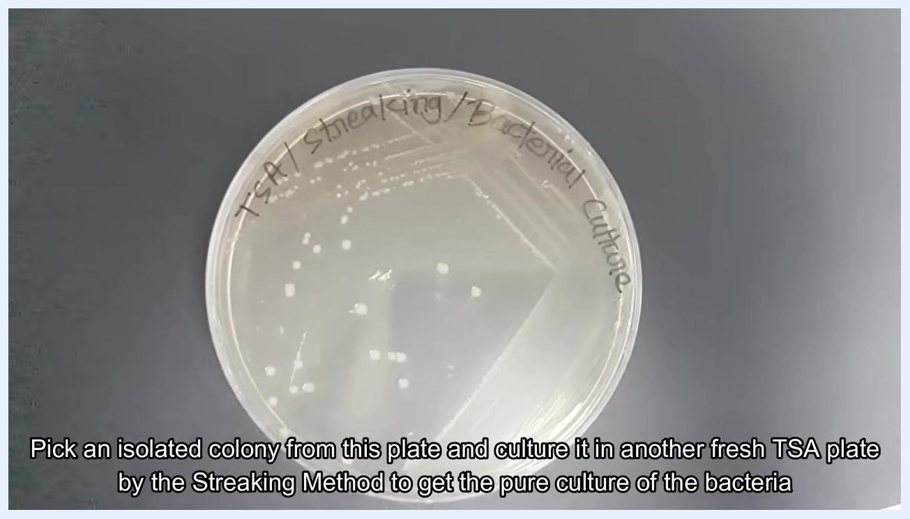
A petri dish labeled "TSA/Streaking/Bacterial Culture" with isolated colonies visible on the agar surface.
After incubation, this dilution effect produces confluent growth in the early quadrants and well-separated, individual colonies in the later quadrants. Each well-isolated colony visible in the third and fourth quadrants represents the growth of a single bacterial cell, allowing it to be picked and subcultured as a pure isolate.
A slide with "THANKS FOR WATCHING" in large text, a question mark, and a partially visible message: "If you have any question, le..."

Materials and Reagents
The following equipment, consumables, and media are required to perform the streak plate procedure.
Item | Purpose / Description
Biological safety cabinet | Provides an aseptic work area for handling cultures and performing the streak
Incubator | Used to grow media quality-control plates and inoculated streak plates at a controlled temperature (e.g., 37°C)
Bunsen burner / spirit lamp | Used to sterilize the inoculating loop by flaming it until red hot
Inoculating loop (nichrome wire) | Transfers bacterial culture onto the agar surface during streaking
Colony counter | Assists in observing and assessing isolated colonies after incubation
Prepared TSA (Tryptic Soya Agar) culture media plate | Solid growth medium onto which the mixed culture is streaked
Agar media powder and distilled water | Combined and weighed according to label instructions to prepare the growth medium
Digital thermostatic water bath or autoclave | Sterilizes the prepared media (boiling at 100°C, autoclaving at 121°C/15 lb for 15 minutes, or microwave boiling for 2 minutes, depending on manufacturer instructions)
Sterile petri dishes | Receive the hot, sterilized media before it cools and solidifies
Permanent marker | Used to label the fresh plate with media name, test name, date, and method
Mixed bacterial culture plate | Source culture to be isolated
Pink/red tube rack | Holds the loop and supporting items inside the cabinet during the procedure
Side-by-side images of a Biological Safety Cabinet (left) and an Incubator (right), labeled accordingly.
Side-by-side images of a Digital Colony Counter (left) and a stack of Culture Media Plates labeled "TSA" (right), labeled accordingly.

Procedure

Preparing the culture media

- Weigh the required amount of agar media and mix it with distilled water, following the label instructions on the media container.
- Sterilize the media according to the manufacturer's instructions. Depending on the product, this may require boiling at 100°C, autoclaving at 121°C and 15 pounds pressure for 15 minutes, or boiling in a microwave oven for 2 minutes.
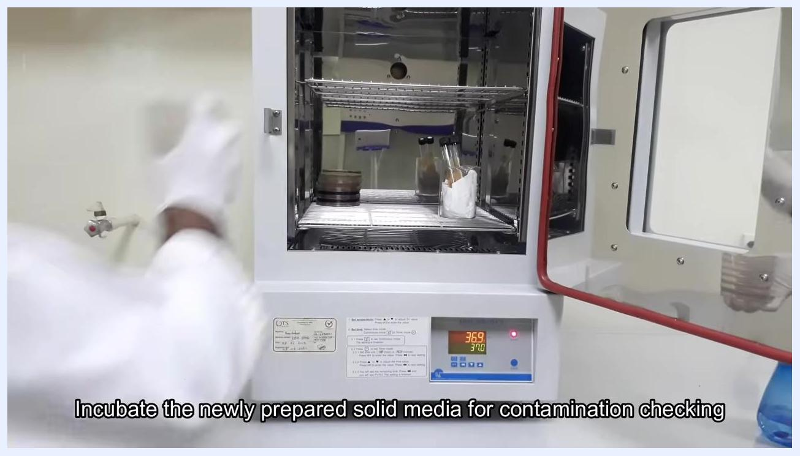
A gloved hand places a bottle with a blue cap into a digital thermostatic water bath set at 98.6°C.
A laboratory worker places media containers into a sterile autoclave.

- Pour the hot, sterilized media aseptically into sterile petri dishes and allow it to cool and solidify.

Quality control of prepared media

- Place the solidified media plates in the incubator and set it to the appropriate temperature (e.g., 37°C) to check the newly prepared media for contamination.
A gloved hand places petri dishes and test tubes into an incubator for contamination checking.

- After incubation, remove the plates from the incubator and inspect them, selecting only the fresh plates that show no signs of contamination for use in the test.

Setting up for inoculation

- Clean your workstation inside the biological safety cabinet to maintain aseptic conditions.
- Bring the mixed bacterial culture you wish to isolate into the biological safety cabinet.
A gloved hand holds a petri dish labeled "Bacterial Culture" inside a biological safety cabinet.

- Bring a previously prepared, fresh TSA culture plate into the biological safety cabinet alongside the bacterial culture plate.
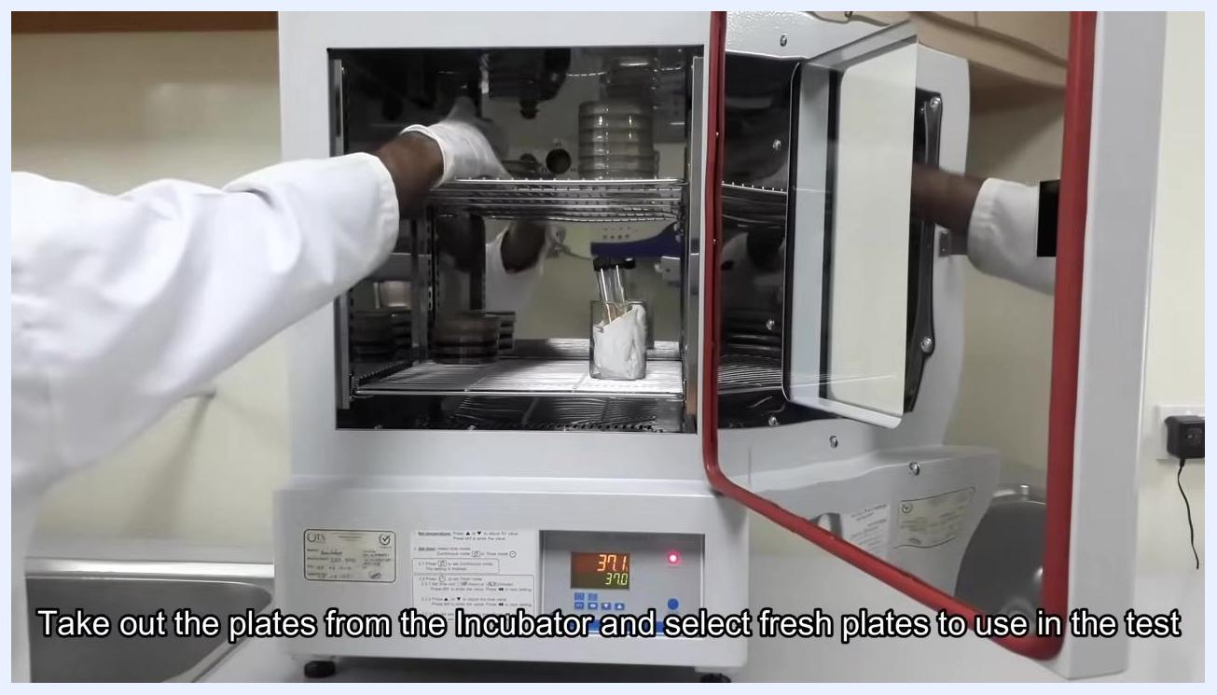
A fresh TSA culture plate and a bacterial culture plate placed inside the biological safety cabinet, with a red tube rack.

Sterilizing and labeling before streaking

- Take an inoculating loop made of nichrome wire and sterilize it by holding it in the flame of a Bunsen burner or spirit lamp until it becomes red hot.
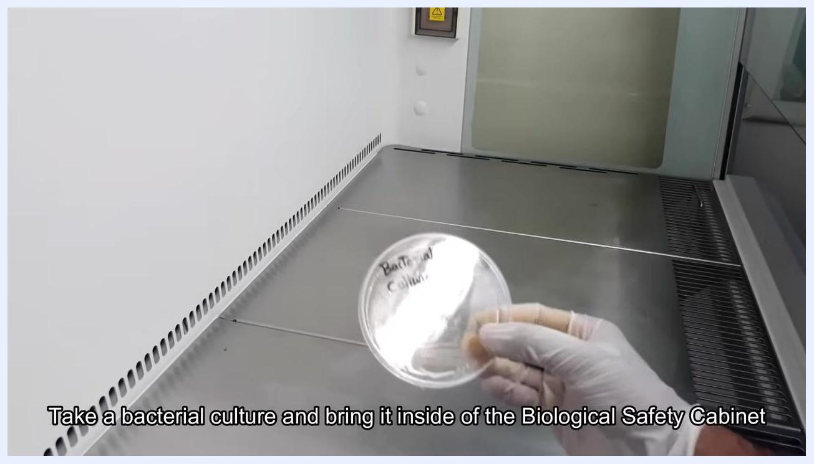
A gloved hand holds an inoculating loop near the flame of a Bunsen burner.

- Hold the loop in the hottest part of the flame and rotate it so that all surfaces are sterilized, waiting until it glows red to confirm complete sterilization.
- Immediately bring the sterile loop inside the biological safety cabinet to avoid contamination, and allow it to cool at room temperature inside the cabinet before touching it to any surface.
- Label the bottom (agar side) of the fresh media plate with a permanent marker, recording the media name (e.g., TSA), test name, date, and method for traceability.
- Set the labeled plate aside in a clean area within the cabinet, ready for inoculation.
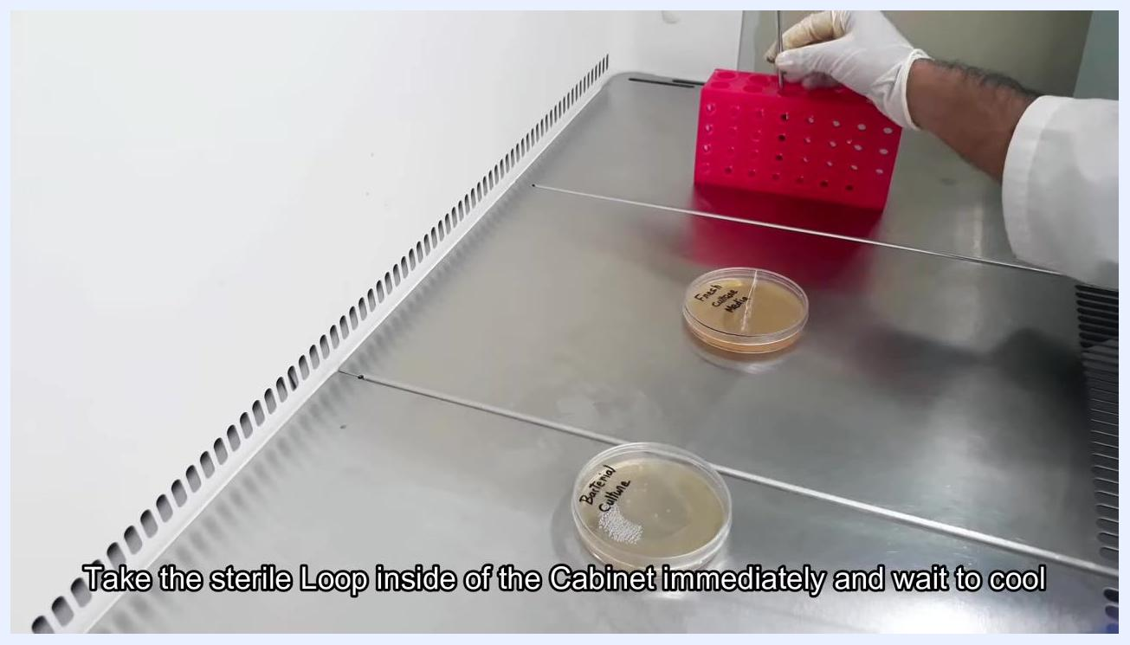
A gloved hand holds a nichrome wire inoculating loop in the flame of a spirit lamp, sterilizing it until red hot.
A gloved hand places the sterile inoculating loop into a pink tube rack inside the biological safety cabinet.
A gloved hand labels a petri dish with a marker inside the biological safety cabinet.
A gloved hand sets aside a labeled petri dish inside the biological safety cabinet.

Creating the initial smear

- Gently touch the cooled, sterile loop to the surface of the bacterial culture plate to pick up one loopful of bacterial culture — just enough to fill the loop.
- Gently touch the loop to the surface of the fresh TSA plate and smear the collected bacteria in a small area in one corner of the plate. Keep the smear thin and even to support good isolation.
- If the first smear is insufficient, gently repeat the process in the same corner area to ensure an even initial inoculum.
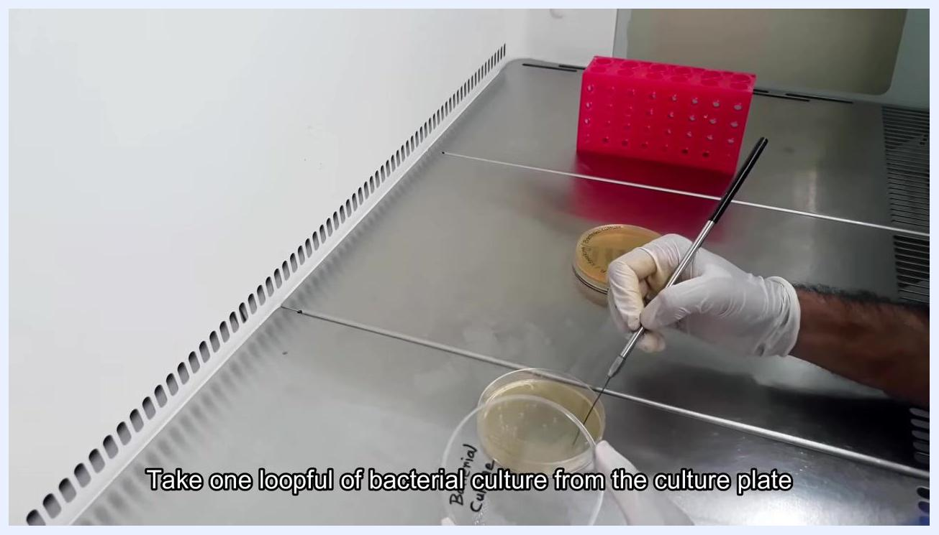
A gloved hand uses the inoculating loop to collect bacteria from a petri dish labeled "Bacterial Culture."
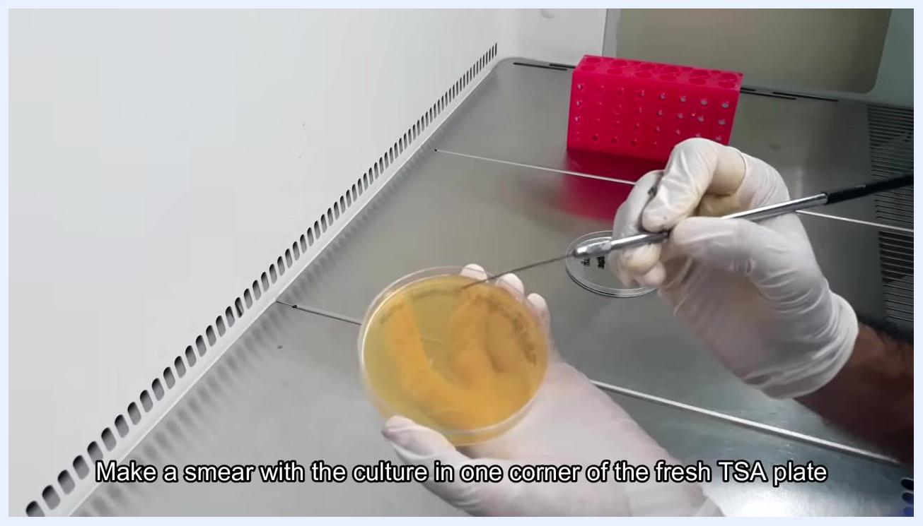
A gloved hand uses the inoculating loop to make a smear with the bacterial culture in one corner of a fresh TSA plate.
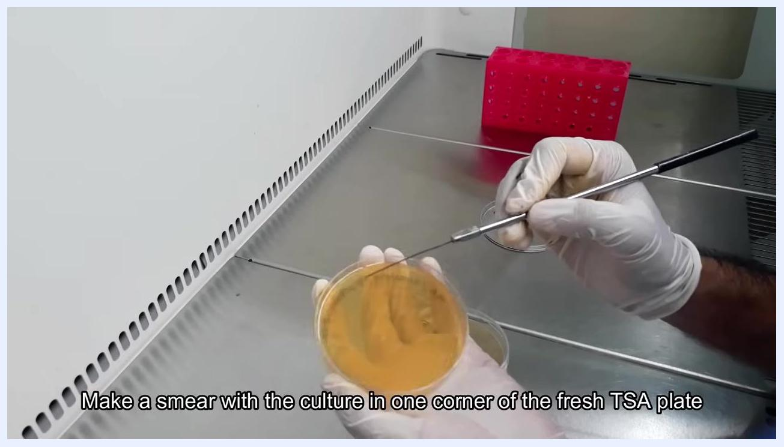
A gloved hand continues to make a smear with the inoculating loop in one corner of the TSA plate.

Streaking the first quadrant

- After sterilizing the loop again, place it inside the biological safety cabinet and allow it to cool for approximately five minutes without touching any surfaces.
- Hold the fresh TSA plate with one hand and the cooled loop with the other. Starting from the initial bacterial smear, streak the loop in a zigzag pattern across the first quarter of the plate, ensuring the loop touches the smear to transfer bacteria.
- Confirm that the streaking lines are visible on the agar surface, indicating that bacteria have been properly transferred.
- Place the lid back on the TSA plate to prevent contamination, then re-sterilize the inoculating loop by holding it in the flame until red hot.
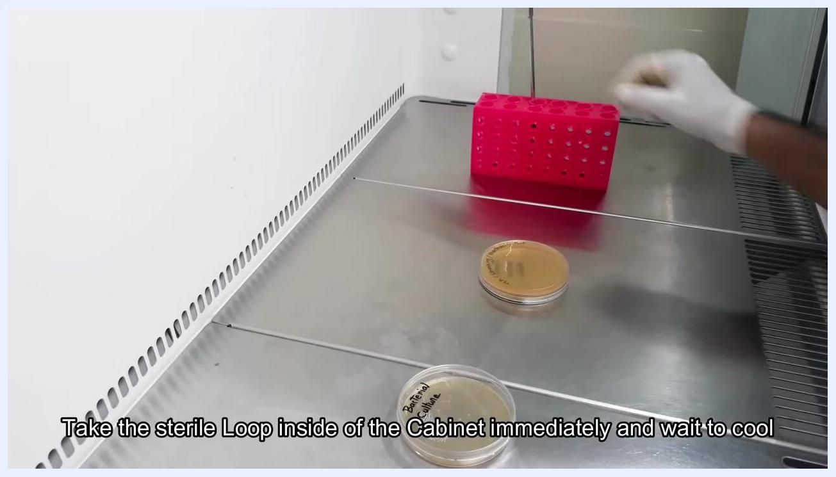
A spirit lamp with a visible flame placed inside the biological safety cabinet, with a pink tube rack visible in the background.
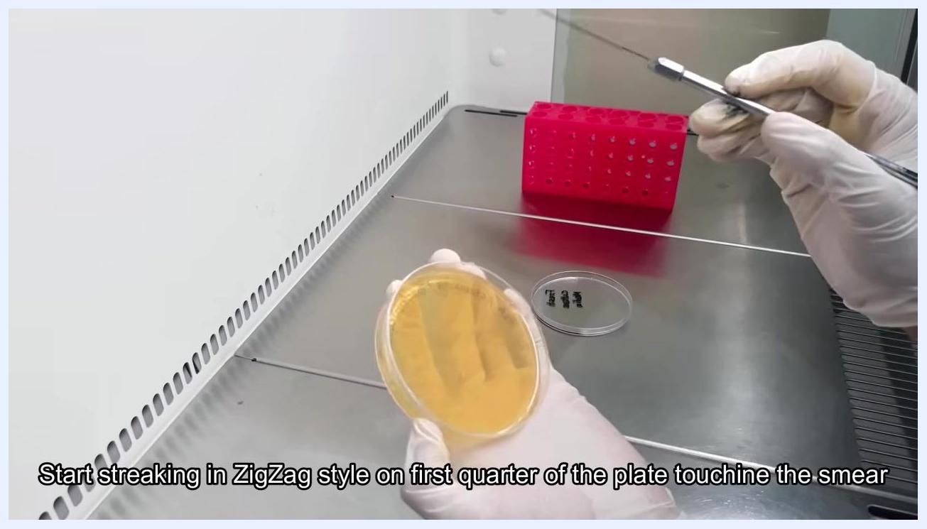
A gloved hand holds a TSA plate while the other hand uses a sterile inoculating loop to streak in a zigzag pattern on the first quarter of the plate.
A gloved hand holds a TSA plate showing visible streaking lines on the agar surface.

Streaking the second quadrant

- Immediately return the sterile loop to the biological safety cabinet and allow it to cool to room temperature before proceeding.
- Once cool, pick up the loop and begin streaking the second quarter of the plate, starting from the edge of the first streaked area. Use a zigzag motion, touching the loop to the previous streaking lines to drag bacteria into the new quadrant.
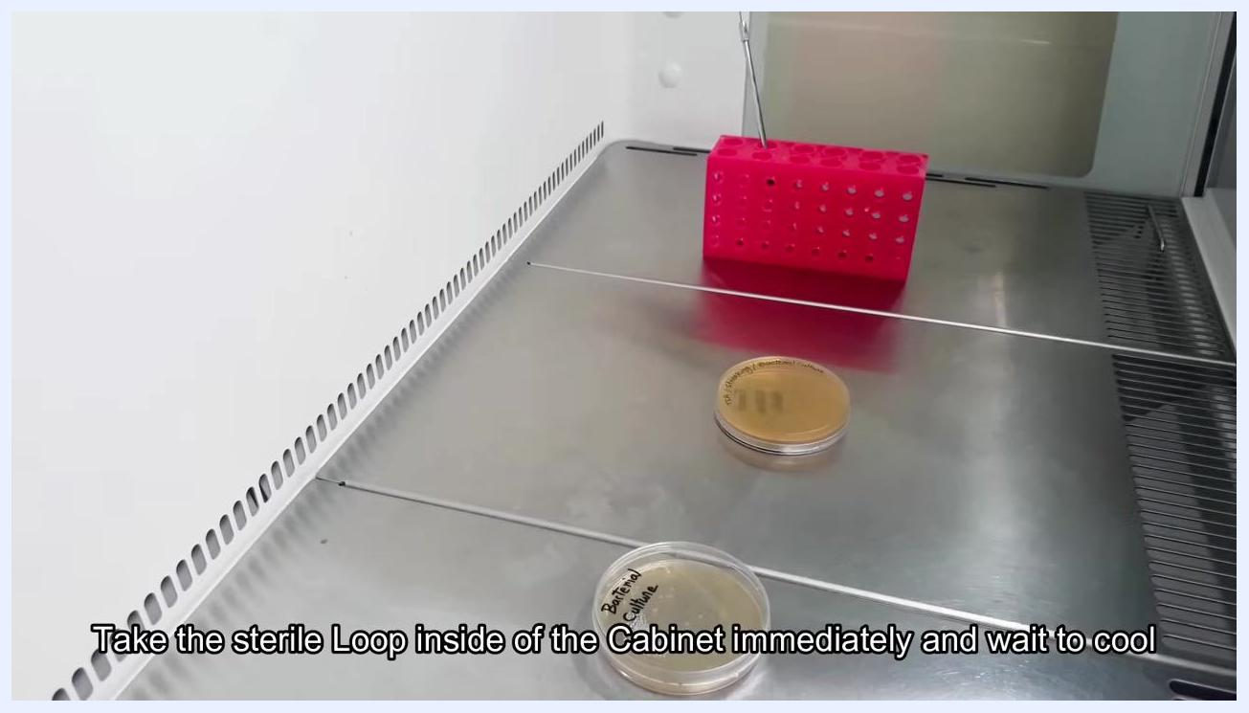
A gloved hand places the sterile inoculating loop into a pink tube rack inside the biological safety cabinet.
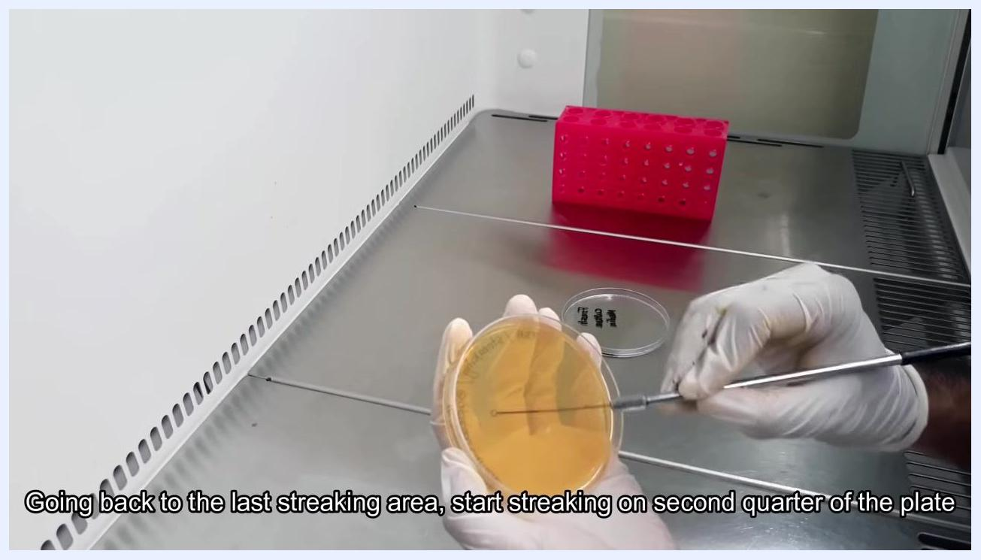
A gloved hand uses the inoculating loop to streak the second quarter of the TSA plate, starting from the last streaking area.

Streaking the third and fourth quadrants

- Without re-sterilizing the loop, continue the zigzag streaking process for the third and fourth quarters. Each time, start from the edge of the previously streaked area and drag the loop into the new quadrant, ensuring the loop touches the prior streaking lines. This four-quadrant streaking method is what allows individual bacterial colonies to be isolated.
- Continue streaking the third and fourth quarters in a similar manner, without burning or sterilizing the loop between these two quadrants, working gently to avoid damaging the agar surface. This step is performed inside the biological safety cabinet using aseptic technique.
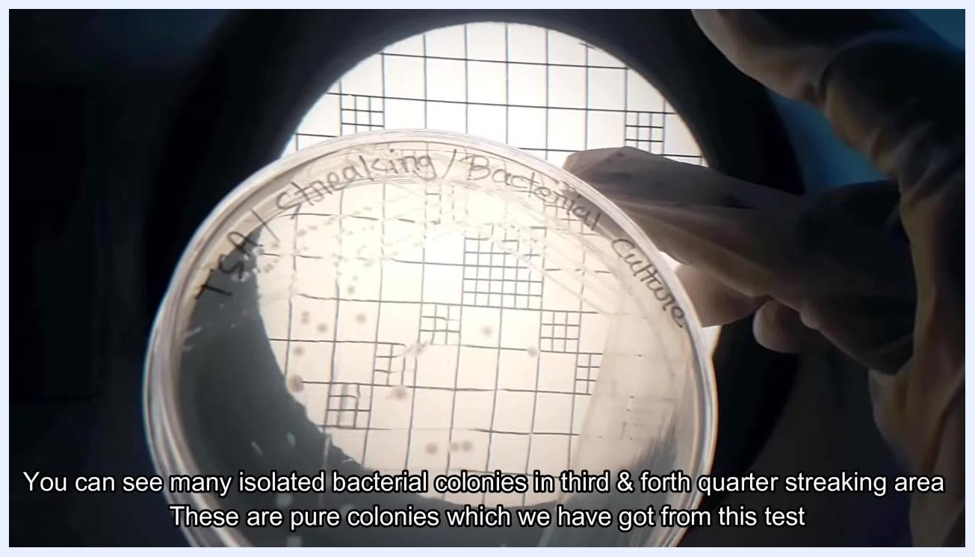
A gloved hand reaching into an open incubator to remove a petri dish, with the display showing 36.4°C.

- Once all four quadrants have been streaked, place the lid back on the TSA plate to prevent contamination.
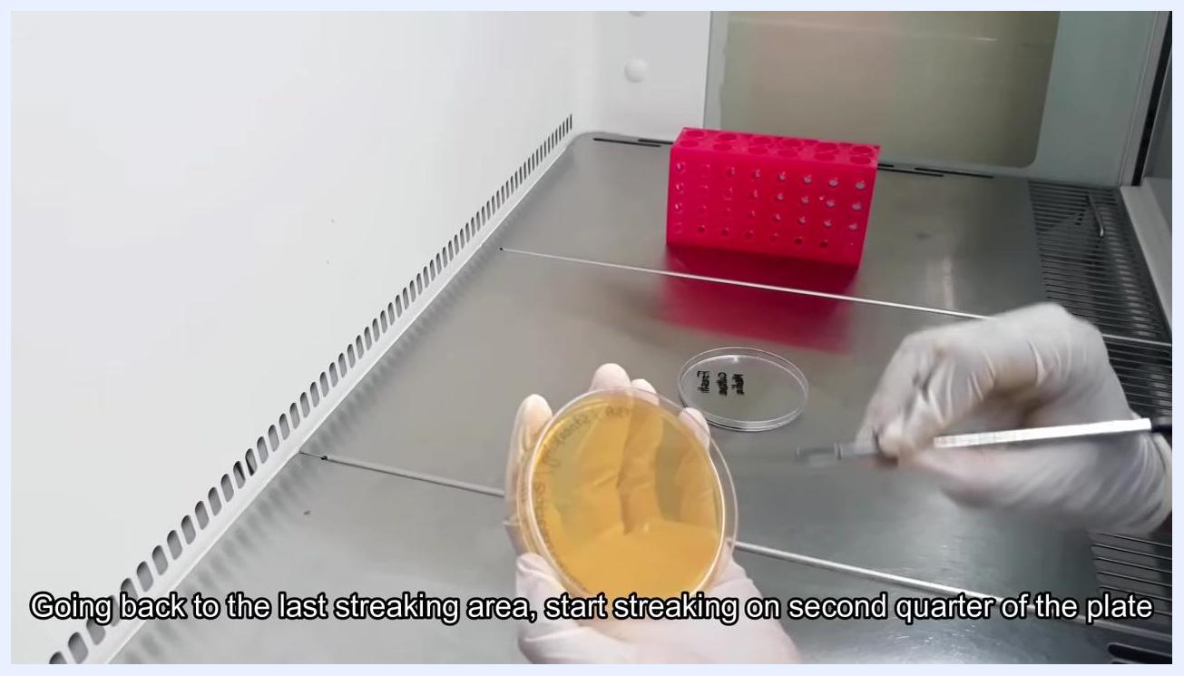
A gloved hand holds a TSA plate while the other hand uses a sterile inoculating loop to streak the third and fourth quarters of the agar.

Incubating and observing results

- Invert the streaked plate (agar side up, lid side down) and place it inside an incubator set to 37°C. Incubate for 24 hours to allow bacterial colonies to grow.
A gloved hand holding a petri dish labeled "TSA Streaking/Bacterial Culture" over a grid background, with numerous colonies visible in the third and fourth quadrants.

- After 24 hours, open the incubator and carefully remove the plate using gloves to maintain aseptic conditions.
- Examine the plate for bacterial colony growth. Colony density will be higher in the first quarter and progressively lower toward the fourth quarter. Use a colony counter or a grid background to make isolated colonies easier to observe.
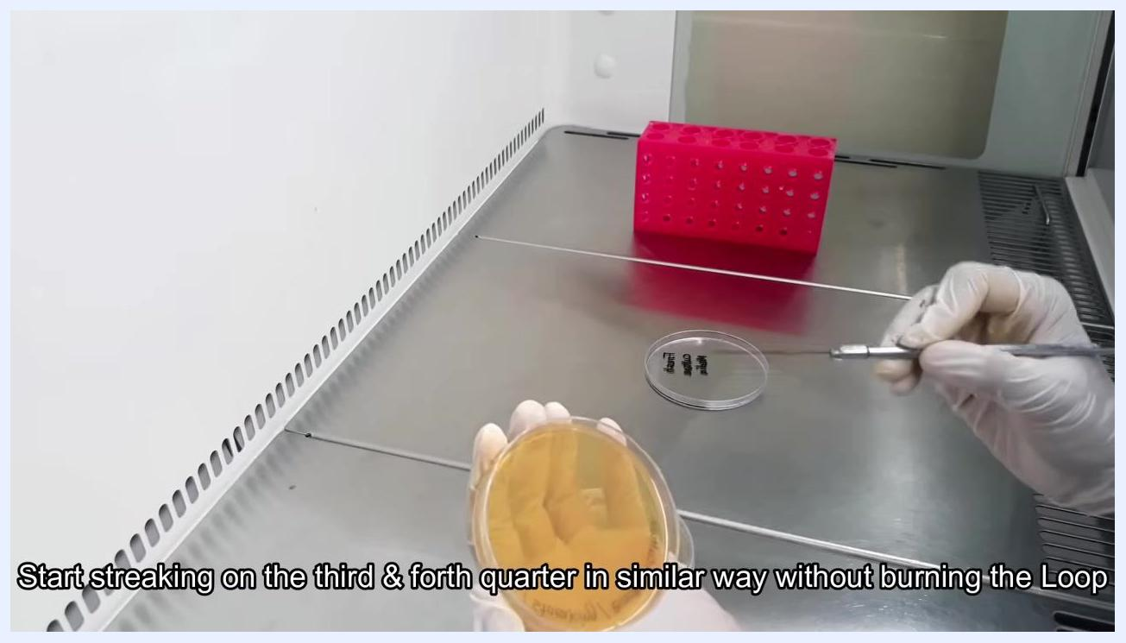
A gloved hand holding a petri dish with agar and another gloved hand holding an inoculating loop on a stainless steel work surface inside the biological safety cabinet.

- Focus on the third and fourth quarters of the plate to identify well-isolated, single colonies. These isolated colonies are considered pure and suitable for further culturing.

Subculturing for a pure culture

- Pick an isolated colony from the plate using a sterile loop and streak it onto a fresh TSA plate using the same streaking method described above. This step establishes a pure bacterial culture from the isolated colony.
A gloved hand placing an inverted petri dish into a laboratory incubator, with the display showing 36.4°C.

Calculations
No numerical calculations, dilution factors, or reporting formulas are used in this qualitative isolation procedure. Where a laboratory's protocol requires colony counts or dilution reporting, this section should document the counting formula, applicable dilution factor, reporting units (e.g., colonies per plate), and the significant figures to be used when recording results.
A slide with "MicroChem's EXPERIMENTS" and buttons labeled "Be with us" and "Be a Scientist"

Quality Controls
The following checks confirm that media and technique are suitable for reliable isolation.
Control point | Description | Acceptance criteria
Media contamination check | Incubate newly prepared, solidified media plates before use | Select only plates that show no visible signs of contamination for use in the test
Aseptic loop sterilization | Flame the inoculating loop until red hot before each new streaking stage (except between the third and fourth quadrants) | Loop must glow red to confirm sterilization; loop must be allowed to cool before contacting bacteria
Streak isolation quality | Visual inspection of colony distribution after incubation | Colony density should decrease progressively from the first to the fourth quadrant, with well-separated, single colonies present in the third and fourth quadrants
Aseptic environment | All inoculation steps performed inside a biological safety cabinet | Workstation cleaned before use; culture and media plates handled only inside the cabinet
A gloved hand removes plates from the incubator to select fresh, uncontaminated plates.
If the incubated plate fails to show well-isolated colonies in the third or fourth quadrant (for example, due to overcrowding or contamination), repeat the streak plate procedure using a freshly sterilized loop and a new fresh TSA plate before proceeding to subculturing.

A slide showing Facebook and YouTube icons with the handles "@microchems.experiments" and "MicroChem's Experiments"

A completely black screen, indicating the end of the video. No objects, people, text, or actions are visible.

