How to Prepare a Wet Mount Slide for Microscopy
This SOP describes how to prepare a wet mount slide for microscopy using an Elodea (freshwater plant) leaf as the test specimen. Follow this procedure to produce a slide suitable for light microscope observation, such as for a photosynthesis lab.

Purpose
This method describes the preparation of a wet mount slide for direct microscopic observation of a plant specimen. The intended analytical use is qualitative visual examination of Elodea leaf structure under a light microscope, as required for photosynthesis lab work.

Scope
This procedure applies to fresh, thin plant specimens such as Elodea leaves mounted in water on a glass slide with a cover slip. It covers materials preparation, mounting, and final slide inspection prior to microscope use.
- Sample type: Elodea (freshwater plant) leaf
- Matrix: Water (used as the mounting medium)
- Instrument: Light microscope (slide is prepared for placement on the microscope stage; observation itself is outside this procedure)
- Analysts: Any individual performing microscopy specimen preparation, such as lab students
- Exclusions: This procedure does not cover dry mounts, permanent (fixed) mounts, or specimens other than thin plant leaf tissue

Principle
A wet mount slide suspends a thin specimen in a drop of water between a glass slide and a cover slip. The water medium keeps the specimen hydrated and allows light to pass through it for observation under a microscope. Minimizing trapped air bubbles is essential, since bubbles can be mistaken for cells or other structures during observation.

Materials and Reagents
Item | Description | Preparation/Storage Notes
Glass slide | Clean, rectangular transparent glass piece | Must be clean and free of dust or debris before use
Cover slip | Small, square plastic piece | Handle carefully to avoid cracking
Dropper bottle with water | Bottle fitted with a dropper, filled with water | Recap after use
Elodea specimen | Sample of Elodea (freshwater plant), kept in a bowl of water | Return unused portion to the bowl after use
Tweezers | Used to handle the Elodea leaf | Keep clean between uses
Pencil or pen | Sharp pencil or pen used as a support tool | Any standard pencil or pen is suitable
Arrange all materials on a clean, flat surface within easy reach before beginning.
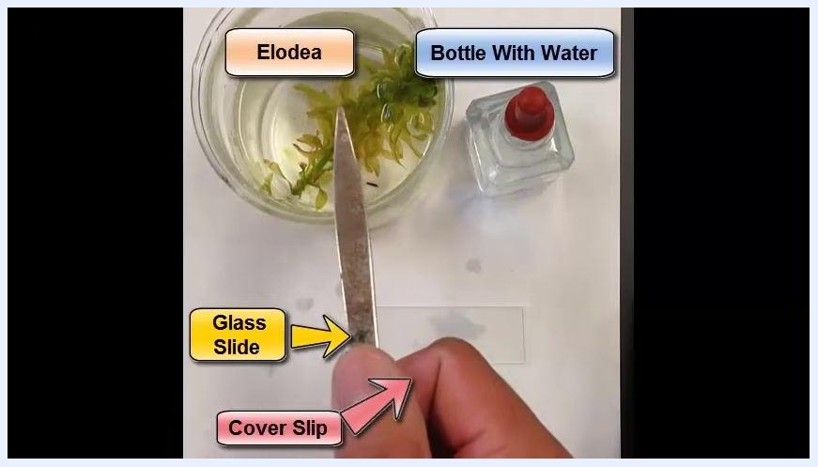
Top-down view of a bowl with Elodea plant in water, a dropper bottle with a red cap, a glass slide, and a cover slip on a white surface.
Confirm the identity of each labeled component before starting the procedure:
- Glass Slide: the rectangular transparent piece
- Cover Slip: the small square plastic piece
- Bottle With Water: the dropper bottle
- Elodea: the green plant in the bowl
All prepared components labeled: Elodea, water bottle, glass slide, and cover slip, with a hand holding tweezers.

Procedure

Step 1: Add water to the glass slide
- Use the dropper bottle to place 2–3 drops of water onto the center of the glass slide.
- Add an extra drop if the specimen is thick, such as with Elodea leaves, to ensure adequate coverage.
- Confirm the water forms a neat bead centered on the slide, not off to the sides.
A hand uses a dropper to add water to the center of the glass slide, with instructional text reading: "First, add 2-3 drops of water on the glass slide."

Step 2: Prepare and place the specimen
- Use tweezers to gently pick a single leaf from the Elodea plant.
- Carefully lower the leaf into the water drops on the slide.
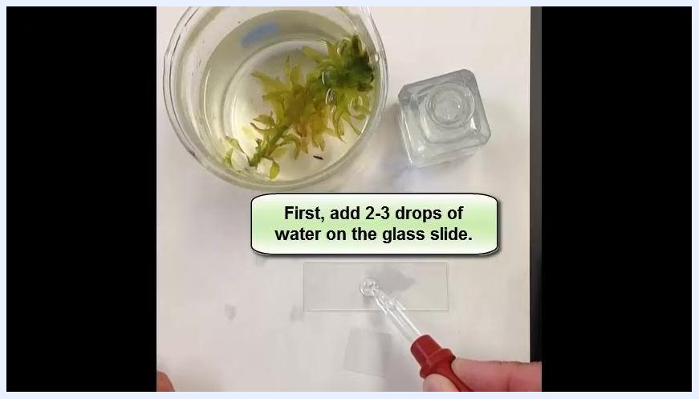
A hand uses tweezers to lower an Elodea leaf into the water drops on the glass slide, with instructional text reading: "Second, lower specimen into the water drops."

Step 3: Position the cover slip
- Hold the cover slip upright so that one edge touches the slide next to the water drop.
- Rest the cover slip on a pencil or pen for control as you lower it onto the specimen.
- Lower the cover slip gradually to avoid trapping air bubbles.
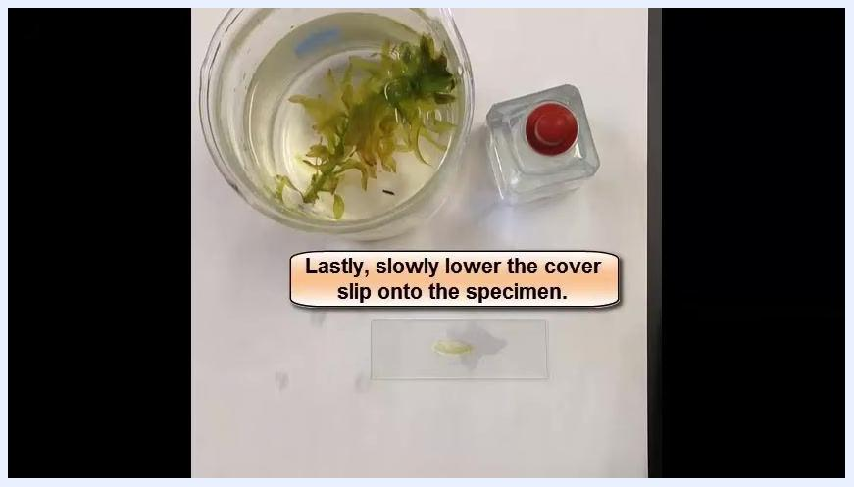
A hand positions the cover slip at an angle, ready to lower it onto the specimen, with instructional text reading: "Lastly, slowly lower the cover slip onto the specimen."

Step 4: Use a pencil or pen to guide placement
- Rest the cover slip on the pencil or pen while lowering it for a gentle, controlled placement.
- This technique helps prevent air bubbles and keeps the specimen in place.
A hand uses a yellow pencil to help lower the cover slip onto the specimen on the glass slide.

Step 5: Allow the water to spread and remove the support tool
- Observe the water spreading beneath the cover slip as it is lowered; this helps fully immerse the specimen and reduces the chance of air bubbles.
- Once the cover slip is nearly flat against the slide, gently pull the pencil or pen away to let the cover slip settle onto the specimen.
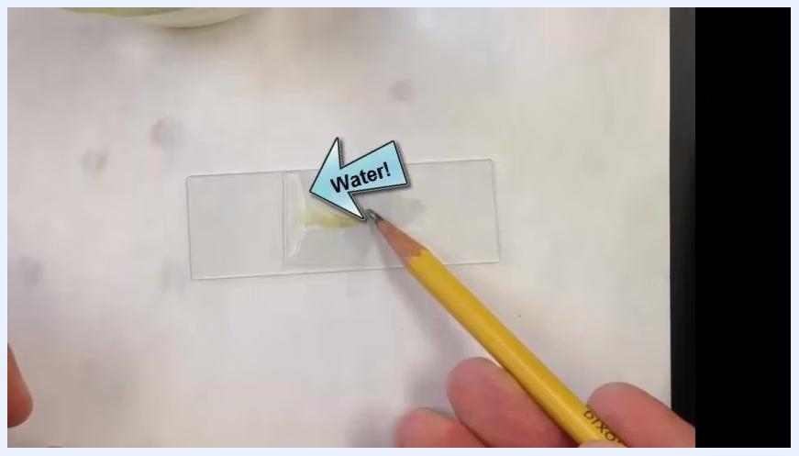
A hand uses a yellow pencil to support the cover slip as water spreads underneath it, with the word "Water!" labeled by an arrow pointing to the water on the slide.

Step 6: Adjust for thick specimens
- If the Elodea leaf is thick and holds the cover slip up slightly, do not force the cover slip down abruptly.
- Use the pencil or pen to softly and gradually press down on the cover slip.
- Apply gentle, even pressure to avoid cracking the cover slip, and let air escape slowly from beneath it as you press.
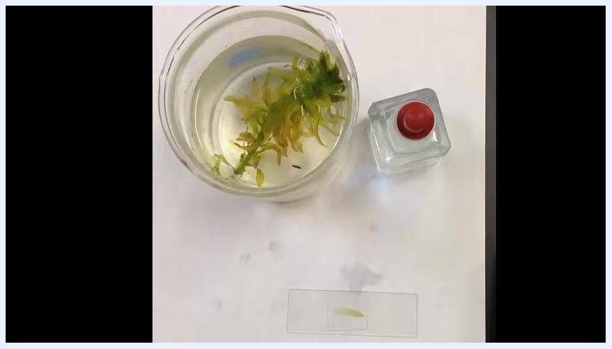
A hand uses a yellow pencil to gently press down on the cover slip, ensuring it lies flat while air escapes.

Step 7: Finalize and clean up
- Inspect the slide to confirm there are no, or very few, air bubbles trapped under the cover slip.
- Once the cover slip is flat and the specimen is fully immersed, the wet mount slide is ready. Carefully move it to the microscope stage for observation.
A hand has finished adjusting the cover slip; the wet mount slide is complete and ready for observation.
- Return unused Elodea to the bowl, recap the water dropper bottle, dispose of any waste, and wipe down the work area.
Top-down view of the completed wet mount slide, the bowl of Elodea, and the water dropper bottle on a clean workspace.

Calculations
This procedure is qualitative and does not involve numerical calculations, dilution factors, or reported measurement values; the wet mount slide is prepared for direct visual observation only.

Quality Controls
- Air bubble check: Inspect the finished slide for trapped air bubbles under the cover slip before observation.
- Acceptance criteria: The slide should contain no, or very few, air bubbles, since bubbles can be mistaken for cells or other structures during microscopic examination.
- Failed-preparation handling: If air bubbles are present, gently tap or press the cover slip to release them; if bubbles persist or the specimen is not fully immersed, remove the cover slip and repeat the mounting steps with fresh water drops.
- Always lower the cover slip slowly and use the pencil-or-pen support technique to minimize the risk of trapped air.

