How to Operate an Autoclave for Laboratory Sterilization
This document describes how to operate an autoclave to sterilize laboratory solutions, culture media, empty glassware, and related materials. It provides the ordered steps for preparing samples, setting sterilization parameters, running the sterilization cycle, and verifying that sterilization was successful.
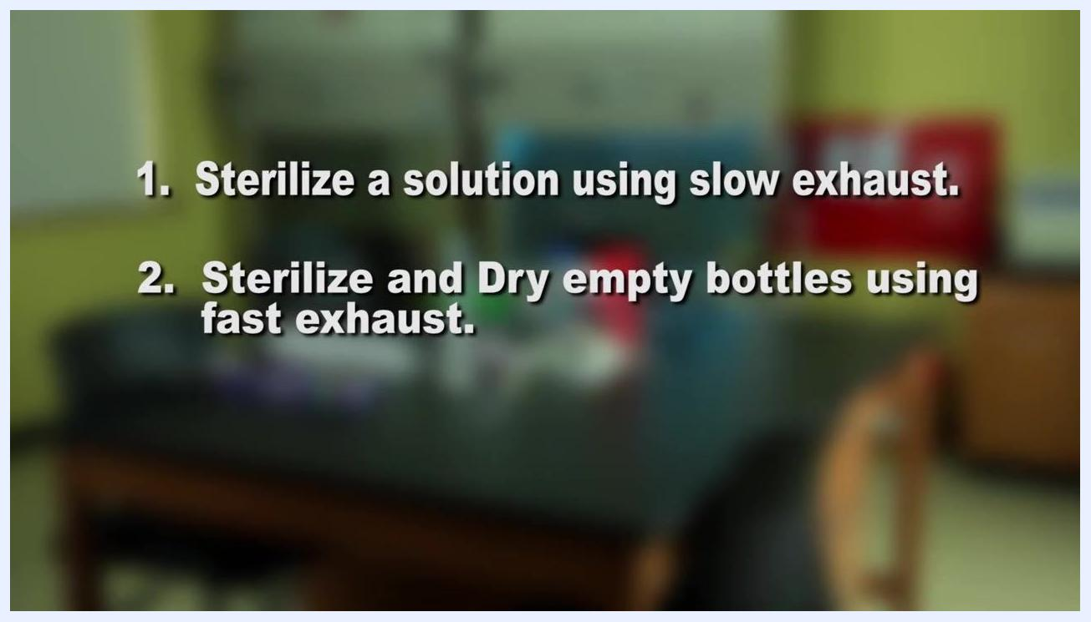
Text overlay listing the two autoclave cycles: sterilizing a solution using slow exhaust, and sterilizing and drying empty bottles using fast exhaust, with a laboratory background visible

Purpose
This method describes how to operate an autoclave to eliminate living organisms — including bacteria, fungi, and viruses — from laboratory instruments, solutions, and containers. Sterilization performed with this method is intended for use in pharmaceutical preparation, laboratory equipment reprocessing, solution sterilization, medical waste treatment, and other applications where contamination must be prevented, such as tattoo needle processing.
An autoclave functions like a powerful pressure cooker, using heat, steam, and pressure to destroy microorganisms on the materials placed inside it.

Scope
This method applies to two categories of materials:
- Liquids, such as agar bacterial culture media and other solutions, which are sterilized using the slow exhaust cycle.
- Empty glassware and instruments, such as glass bottles, which are sterilized and dried using the fast exhaust cycle.
Sterilization by this method is also relevant to medical waste treatment and other applications requiring contamination control.
The specific list of authorized analysts, additional excluded sample types, and matrix restrictions beyond what is described above are not detailed in this material and should be defined by laboratory-specific policy.

Principle
The autoclave applies heat, steam, and pressure to destroy microorganisms present on or in the loaded materials. Successful sterilization is confirmed using autoclave tape, which resembles ordinary masking tape but contains special heat-sensitive ink. When the tape is exposed to sufficiently high temperature during the cycle, it displays black diagonal lines, providing a visual indicator that the required sterilization temperature was reached.
Two bottles with blue caps and tape; the right bottle's tape has black diagonal lines, highlighted with a green arrow, indicating successful sterilization

Materials and reagents
Item | Purpose
Autoclave | Sterilization device using heat, steam, and pressure
Deionized water | Filled into the autoclave up to the level indicator line to generate steam
Flask with agar bacterial media | Solution to be sterilized
Aluminum foil | Covers the top of the flask to prevent contamination
Autoclave tape | Applied over the foil or bottle cap; displays black diagonal lines when exposed to high temperature, confirming sterilization
100 mL glass bottles with caps | Empty glassware to be sterilized and dried
Wire basket | Holds the flask or bottles for loading into the autoclave chamber
Heat-resistant gloves | Worn when opening the autoclave and removing sterilized materials
Logbook | Used to record date, time, and operation details for each cycle
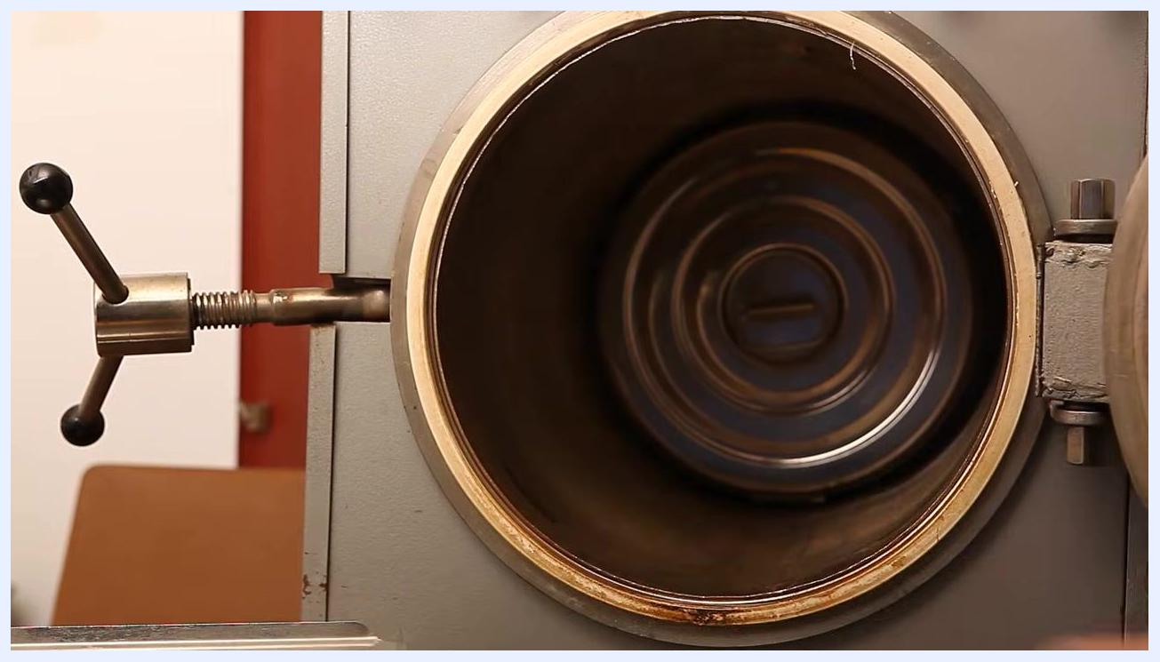
A laboratory autoclave shown as a vertical, metallic device with a control knob and indicator window, standing on wheels in a sterile environment
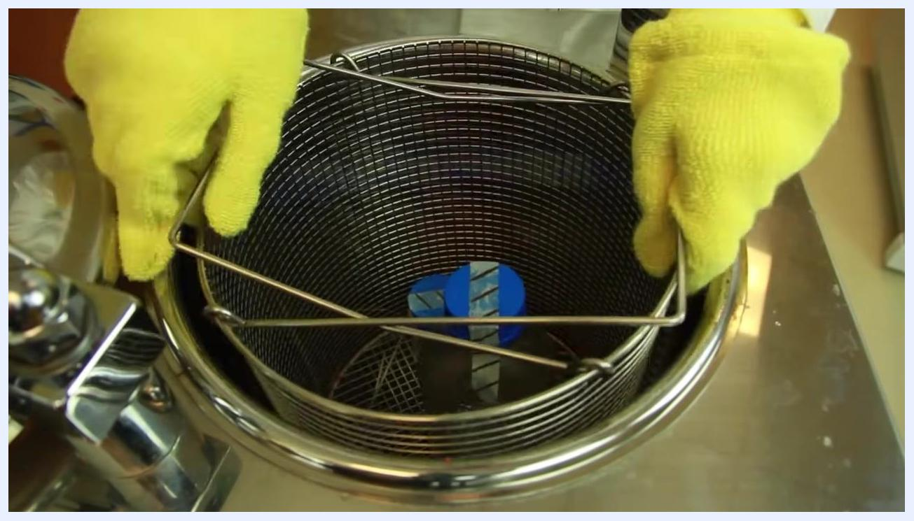
Autoclave control panel set to 121°C, "Sterilize & Dry" mode, with a green arrow and "Fast Exhaust Mode" text overlay, and an inset showing the pressure gauge at zero psi

Procedure

Preparing materials for sterilization

- Obtain a flask containing agar bacterial media for sterilization.
- Cover the top of the flask with aluminum foil to prevent contamination.
- Place a piece of autoclave tape over the foil. The tape will display black diagonal lines after exposure to high temperature, indicating successful sterilization.
Two 100 mL glass bottles with blue caps: the left bottle has plain tape, and the right bottle has tape with black diagonal lines indicating exposure to high temperature

Setting up and loading the autoclave

- Turn on the autoclave power and ensure the drain valve is closed before proceeding.
- Pour deionized water into the autoclave up to the level indicator line.
- Place the flask of culture media into the autoclave basket.
- Carefully lower the basket containing the flask into the autoclave chamber.
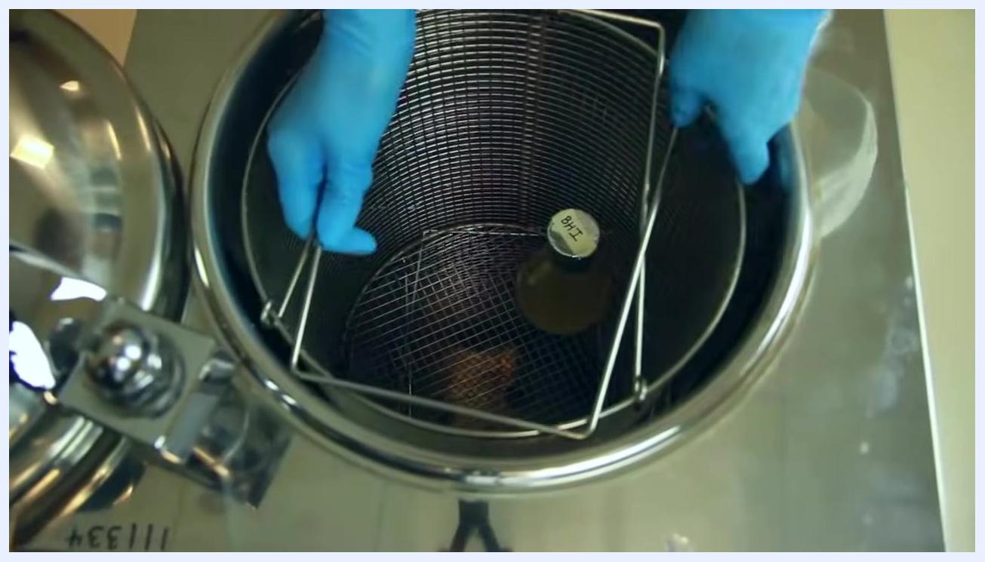
A person in a white lab coat and blue gloves stands next to a closed autoclave in a laboratory, preparing to operate it

- Close the lid securely and turn the handle to create an airtight seal.
- Use the control panel to set the sterilization parameters: Mode: Sterilize, Temperature: 121°C, Pressure: 15 psi.
Gloved hands lowering a wire basket containing a flask labeled "BHI" into the open chamber of an autoclave

Running the slow exhaust cycle for liquids

- Confirm the autoclave is set to Sterilize mode, with temperature at 121°C and pressure at 15 psi.
- Select the Slow Exhaust mode to prevent liquids from boiling over and out of the flask.
- Start the autoclave and run the cycle for at least 15 minutes.
- While the autoclave is running, enter the date, time, and operation details in the logbook, and initial the entry to confirm your actions.
- Wait until the cycle ends and the pressure gauge reads zero psi.
- Put on heat-resistant gloves and slowly open the autoclave door to avoid a sudden release of steam.
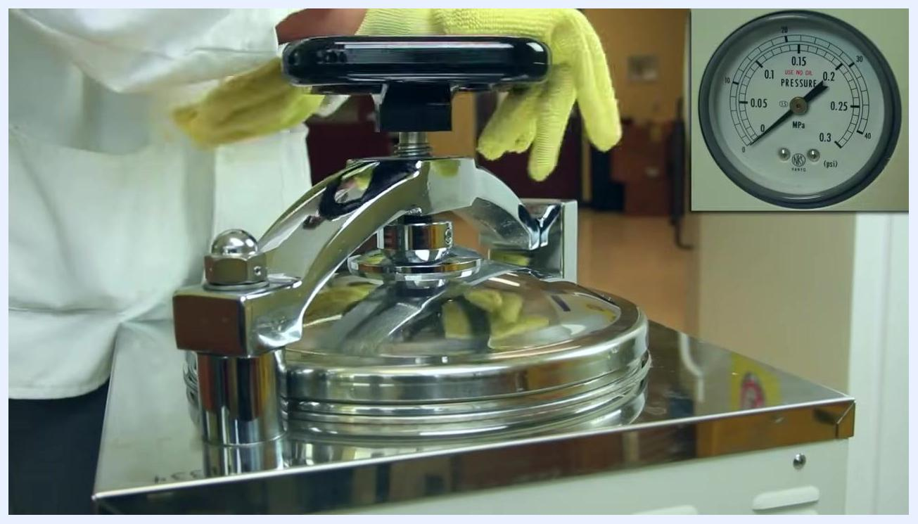
Autoclave control panel displaying 121°C, "Sterilize" mode selected, and a green arrow pointing to "Slow Exhaust Mode" text overlay
A person wearing yellow heat-resistant gloves slowly opening the autoclave lid in a laboratory setting

- Inspect the autoclave tape for black diagonal lines to confirm the proper temperature was reached.
- Allow the culture media to cool to about 45°C before pouring it into petri dishes.

Running the fast exhaust cycle for empty glassware

- Place empty glass bottles on a clean surface. Tighten the cap, then loosen it about halfway to allow pressure equalization during sterilization. Place autoclave tape over the lid.
Gloved hands placing bottles with blue caps and autoclave tape into the autoclave basket

- Place the prepared bottles into the autoclave basket.
- Set the autoclave to: Mode: Sterilize & Dry, Temperature: 121°C, Pressure: 15 psi, Time: 20 minutes, and select the Fast Exhaust mode.
Hands in yellow heat-resistant gloves removing the basket with bottles from the autoclave

- Enter the date, time, and operation details in the logbook, and initial the entry.
- Wait until the cycle ends and the pressure gauge reads zero psi.
- Wearing heat-resistant gloves, slowly open the autoclave door and remove the basket.
A scientist in a lab coat and gloves preparing empty glass bottles, loosening the cap, with a "Fast Exhaust" text overlay

- Confirm that the autoclave tape on the bottles shows black diagonal lines, indicating successful sterilization.

Choosing the correct exhaust mode
- Slow Exhaust: use for liquids and medical waste.
- Fast Exhaust: use for empty glassware and instruments.
Text overlay reading "Slow Exhaust – Liquids & medical waste. Fast Exhaust – Empty glassware & instruments" over a blurred background of an autoclave

Calculations
This method does not involve numerical calculations, dilution factors, or reported analytical values. The operator instead sets fixed sterilization parameters on the control panel — mode, temperature (121°C), pressure (15 psi), and, for the fast exhaust cycle, run time (20 minutes) — rather than calculating results from measured data.

Quality controls
- Sterilization indicator (autoclave tape): Inspect the tape on the flask or bottle after each cycle. Black diagonal lines confirm the material was exposed to the required sterilization temperature.
Text: "Filmed At Rowan-Cabarrus Community College" on a black background.
- Logbook entry: For every cycle, record the date, time, and operation details, and initial the entry to confirm the operation was performed and reviewed.
- Acceptance criteria: A cycle is considered successful when the autoclave tape displays black diagonal lines and the pressure gauge reads zero psi before the door is opened.
- Failed-run handling: This material does not describe a specific corrective procedure for a failed cycle (for example, tape showing no diagonal lines); laboratories should define and document a corrective action and re-sterilization procedure for this scenario.
Close-up of the autoclave lid being opened with yellow gloves, with an inset showing the pressure gauge at zero psi

What's next
After sterilization, cooled culture media can be poured into petri dishes, and sterilized empty glassware or instruments can be stored or used according to laboratory protocol. You are now ready to safely and effectively operate an autoclave in the laboratory.

