How to Clean an Autoclave: Tuttnauer EZ-10 Cleaning and Maintenance SOP

Purpose
This Standard Operating Procedure describes how to clean an autoclave — specifically the Tuttnauer EZ-10 automatic autoclave — using Chamber Brite, the cleaning agent recommended by Tuttnauer Corporation. The intended use of this method is to remove residue from the reservoir, pipes, valves, and chamber so that the unit continues to operate reliably. Following this procedure regularly protects the autoclave from internal buildup that can compromise performance and shorten its service life.
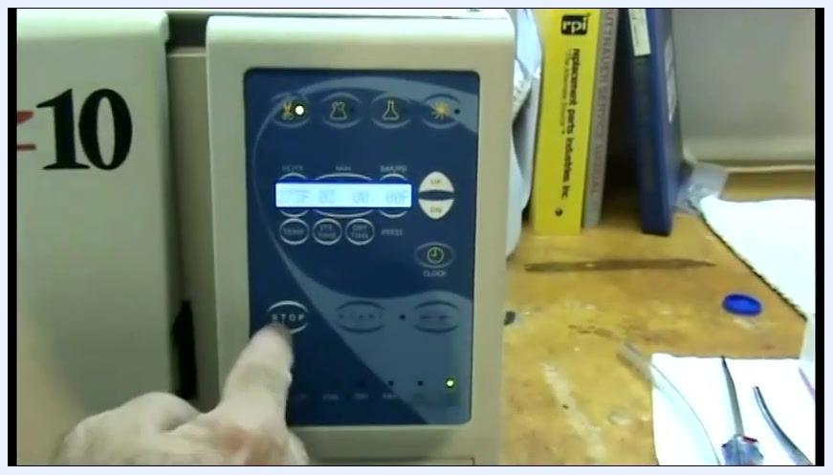
The operator's finger on the control panel selecting the appropriate cycle, with the display and buttons visible.
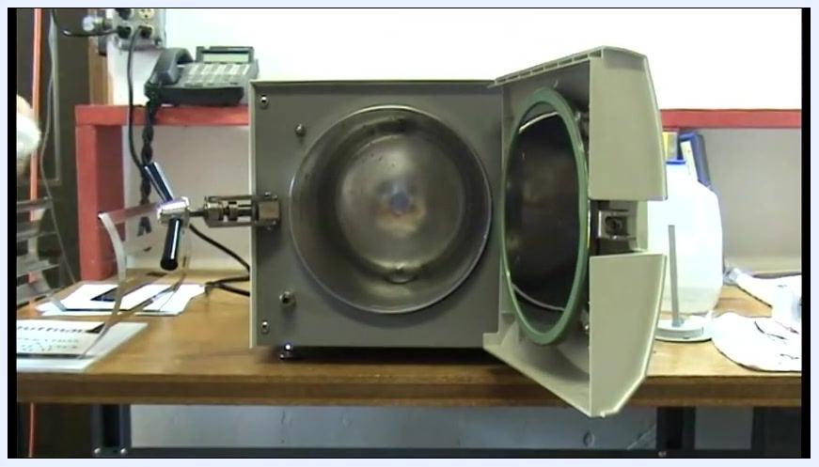
Screen displaying: 'Click Here to Go to Part 2 of How to clean and maintain your tuttnauer automatic autoclave'
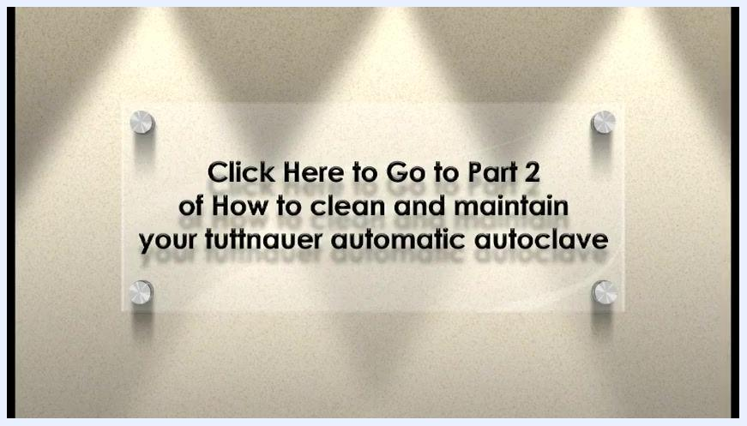
Screen displaying: 'Click Here to Go to Part 2 of How to clean and maintain your tuttnauer automatic autoclave'

Scope
This SOP applies to the Tuttnauer EZ-10 automatic autoclave and covers cleaning of the following components:
- Reservoir
- Internal pipes and valves
- Sterilization chamber and trays
- Water sensor and its plastic collar
- Chamber door gasket
The procedure is intended for personnel responsible for autoclave maintenance who have access to Chamber Brite, distilled water, and the standard cleaning supplies listed below. It does not cover other autoclave models, electrical servicing, or repair of mechanical faults; those activities fall outside the scope of this cleaning method.
The autoclave chamber open with a person wiping the interior with a cloth.

Principle
Chamber Brite is a cleaning powder that dissolves and flushes residue from the reservoir, internal pipes, and valves of the autoclave. Running an "Unwrap" cycle with no drying time circulates the Chamber Brite solution through the system without introducing the excess heat that a drying phase would add. This distinction matters because heat can bake Chamber Brite residue onto internal surfaces, causing buildup rather than removing it. After the cleaning cycle, the reservoir is drained, rinsed, and refilled with distilled water to flush out any remaining solution and restore the system to normal operating condition.
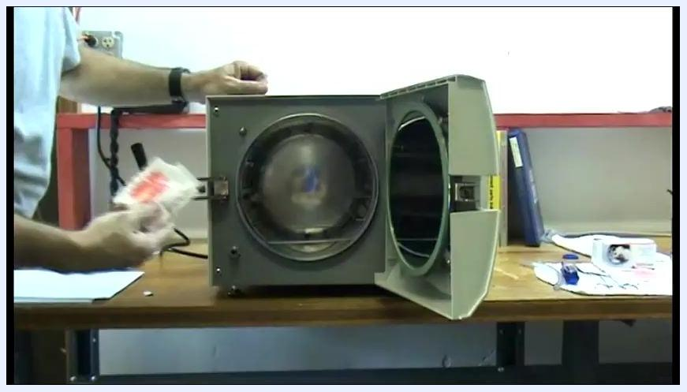
The chamber open with the operator holding a Chamber Brite packet, preparing to pour it in.

Materials and Reagents
Item | Purpose | Notes
Chamber Brite (packet) | Cleaning agent for reservoir, pipes, and valves | One packet per cleaning cycle; pour the entire contents
Distilled water | Rinsing and refilling the reservoir | Must be labeled "Distilled Water" and free of contaminants; tap or mineral water can damage the autoclave
Dipstick | Checking reservoir water level | Used before starting the cleaning process
Clean, lint-free cloths/towels | Wiping trays, chamber interior, and spills | Dispose of or launder after use
Collection container (e.g., empty distilled water jug) | Collecting drained Chamber Brite solution | Position under the drain hose outlet
Drain hose | Connecting the reservoir outlet valve to the collection container | Attach securely before opening the drain valve
Autoclave trays/rack | Chamber contents removed for cleaning | Wipe down and reinsert after cleaning is complete
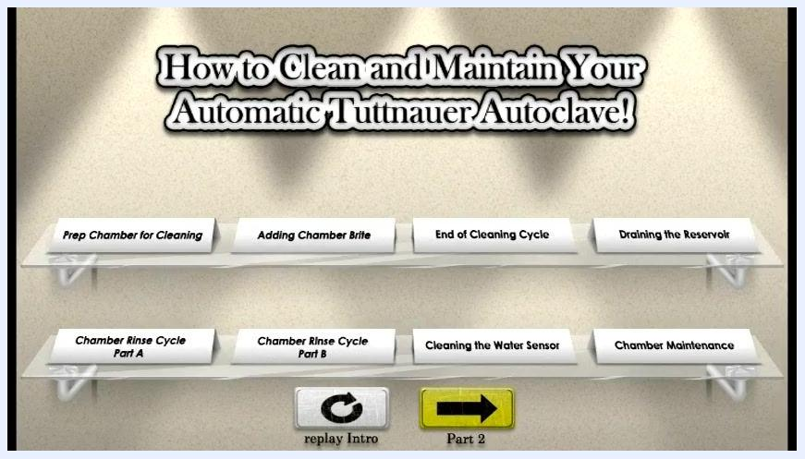
Main menu showing all cleaning and maintenance steps: Prep Chamber for Cleaning, Adding Chamber Brite, End of Cleaning Cycle, Draining the Reservoir, Chamber Rinse Cycle Part A, Chamber Rinse Cycle Part B, Cleaning the Water Sensor, and Chamber Maintenance, with navigation buttons for Replay Intro and Part 2.
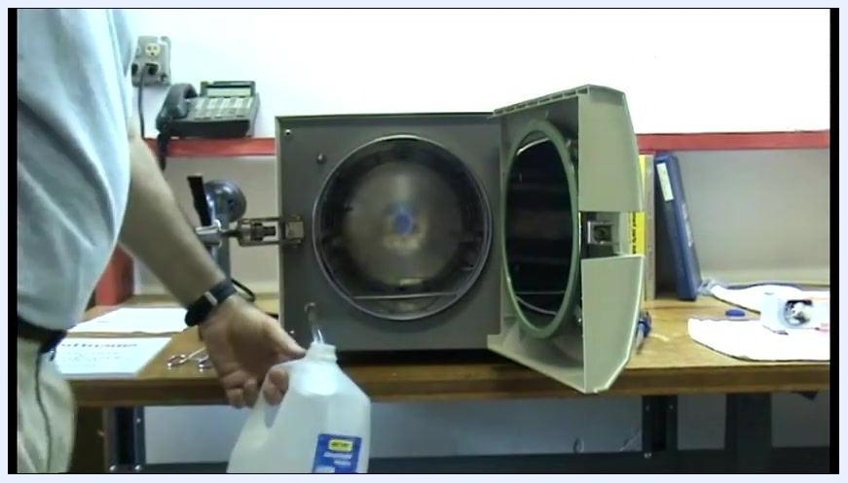
The operator connecting the drain hose and positioning a distilled water jug under the outlet as a collection container.

Procedure

1. Prepare the work area
- Set up the cleaning area near the autoclave with all supplies within reach.
- Confirm the autoclave is powered off and cool before beginning any cleaning or maintenance.
- Ensure you have enough Chamber Brite on hand for the full procedure before proceeding.
The full sequence of cleaning and maintenance steps is displayed on the unit's main menu, covering chamber preparation, Chamber Brite addition, the cleaning cycle, reservoir draining, rinse cycles, water sensor cleaning, and chamber maintenance.
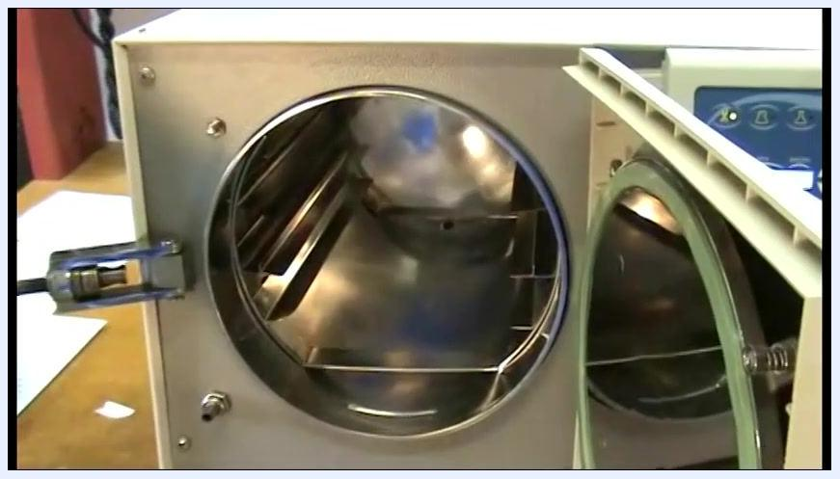
A hand inside the chamber confirming all Chamber Brite powder is emptied along the bottom.

2. Prep the chamber and add Chamber Brite

- Check the water level in the reservoir. Use the dipstick to confirm there is an ample supply of water before proceeding.
- Open the autoclave door. Unlock and open it fully, confirming the unit is powered off and cool.
- Remove the trays from the chamber. Slide out all trays and wipe them down with a clean cloth to remove residuals.
- Prepare the Chamber Brite packet. Open the packet and hold it ready to pour into the chamber.
- Add Chamber Brite to the chamber. Pour the entire contents down the center of the chamber floor, starting from the back and moving toward the front to create one continuous line of powder along the bottom.
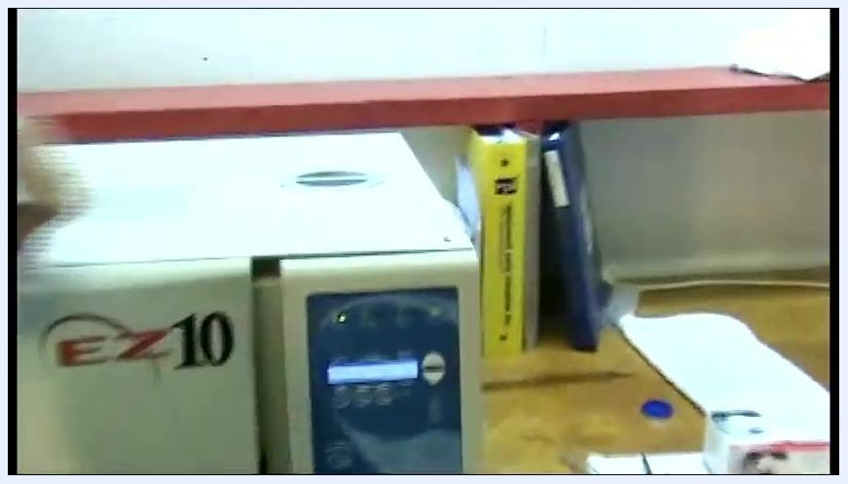
The autoclave closed and running, with the operator monitoring the process.

- Empty the entire packet. Make sure all the powder is emptied into the chamber, covering the full length from back to front.
- Close the autoclave door securely in preparation for the cleaning cycle.
- Select the "Unwrap" cycle with no drying time. Setting drying time to zero is critical, since drying introduces excess heat that can bake Chamber Brite onto the system and cause residue buildup.
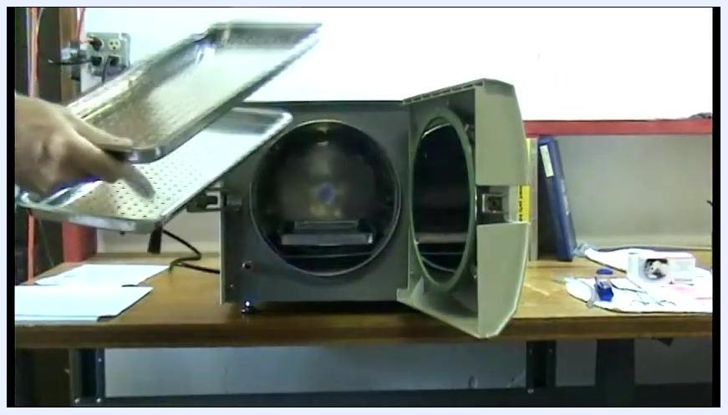
The autoclave door open with trays being removed by hand, revealing the chamber interior.

- Press "Start" to begin the cleaning cycle. The autoclave runs the cleaning process using Chamber Brite.
- Wait for the cycle to complete. The system exhausts the chamber at the end of the process.

3. Drain the reservoir and remove the Chamber Brite mixture

- Wait for pressure to drop. Watch the display and pressure gauge until the chamber vents back into the reservoir and pressure reaches zero, confirming the cleaning cycle is complete.
- Open the autoclave door once the unit is cool and not under pressure. Do not apply heat at any point; the drying cycle must remain at zero to avoid baking residue inside the system.
- Locate the drain valve and hose, and prepare a suitable container (such as an empty distilled water jug) to collect the waste solution.
- Connect the drain hose to the reservoir outlet valve and position the other end into the collection container.
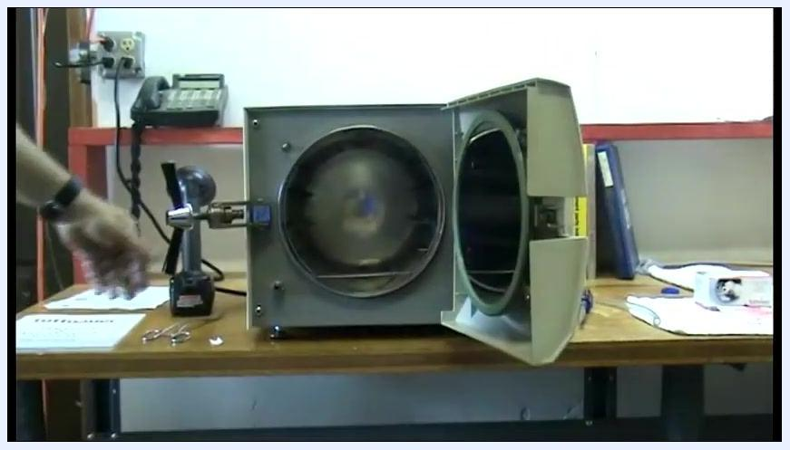
The autoclave door open, chamber visible, and the operator preparing for the next step.

- Open the drain valve slowly, allowing the Chamber Brite solution to flow out by gravity into the container. Monitor the process to avoid spills or overfilling.
- Dispose of the waste solution. Close the drain valve once draining is complete and dispose of the collected mixture according to facility waste disposal guidelines.
- Inspect for debris. Lint from sterilization pouches may be present in the drained solution; if found, ensure valves and pipes are clear before proceeding.
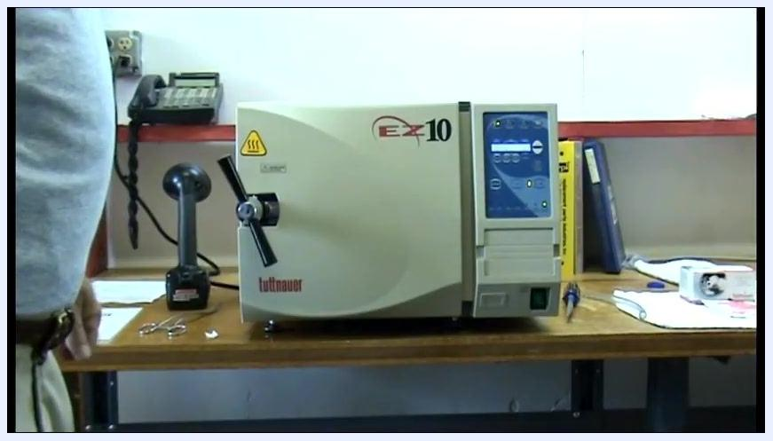
The autoclave display showing the cycle is complete, with the unit closed and idle on the workbench.

4. Rinse the system and refill the reservoir with distilled water

- Prepare fresh distilled water. Confirm the container is labeled "Distilled Water" and free from contaminants.
- Keep the autoclave door open, and confirm the chamber is cool, depressurized, empty, and free of debris.
- Position the distilled water container near the reservoir fill port, avoiding spills inside the chamber or onto electrical components.
- Pour distilled water into the reservoir slowly, filling to the level recommended in the autoclave's user manual. Do not overfill.
- Check for leaks and cleanliness. Inspect the area around the reservoir and chamber, and wipe up excess water immediately with a clean, lint-free cloth.
- Close the reservoir cap securely to prevent contamination.
- Inspect the chamber and door gasket for remaining residue or debris. Repeat rinsing if debris is present.
- Exercise caution throughout. Use only distilled water, as tap or mineral water can damage the autoclave.
Close-up of the chamber interior as Chamber Brite is poured in a line along the bottom.
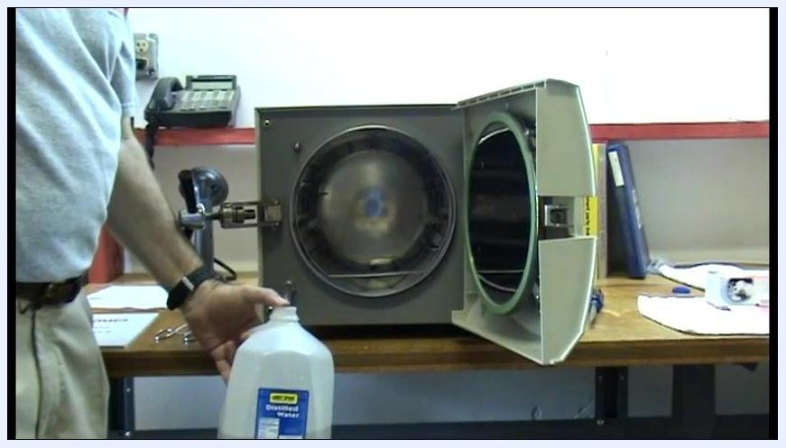
The operator holding a labeled distilled water jug near the open autoclave chamber, preparing to refill the reservoir, with tools and paperwork nearby on the workbench.

5. Post-reservoir drain procedures

- Confirm the reservoir is fully drained and the autoclave is powered off and cool, with tools and supplies within reach.
- Close the autoclave door, ensuring it is properly aligned with the chamber opening.
- Secure the door by rotating the handle to the locked position, double-checking it is fully closed and latched.
- Initiate the first cycle with "No Dry." Select this option on the control panel and press Start to flush the system after draining.
- Wait for the cycle to complete. Do not open the door or interrupt the process until it finishes.
- Open the autoclave door once the cycle is complete and the chamber is safe to open, using caution as it may still be warm.
- Prepare for cleaning by gathering a clean, lint-free cloth and having access to the exhaust hose and drain valve if further draining is needed.
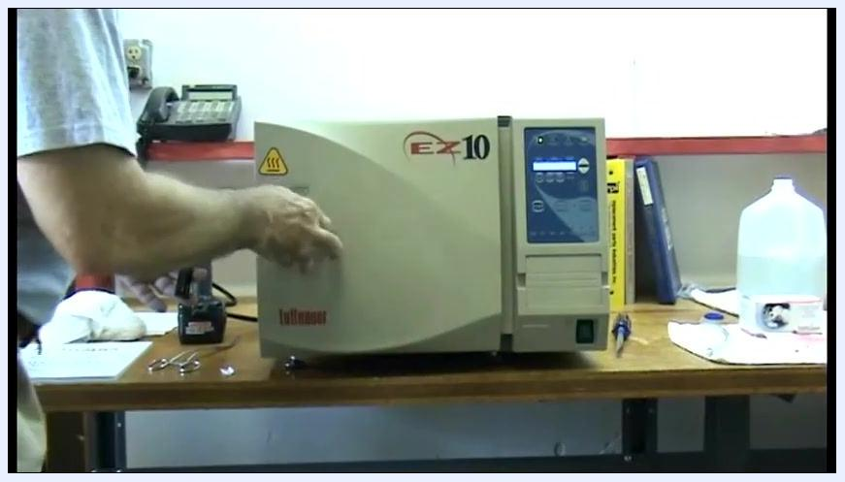
A person closing the autoclave door, with the EZ-10 logo visible and the control panel illuminated.
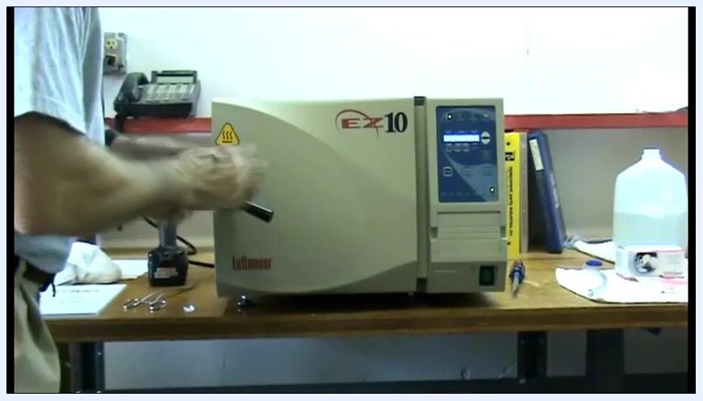
A person turning the handle to lock the autoclave door, with the control panel illuminated.
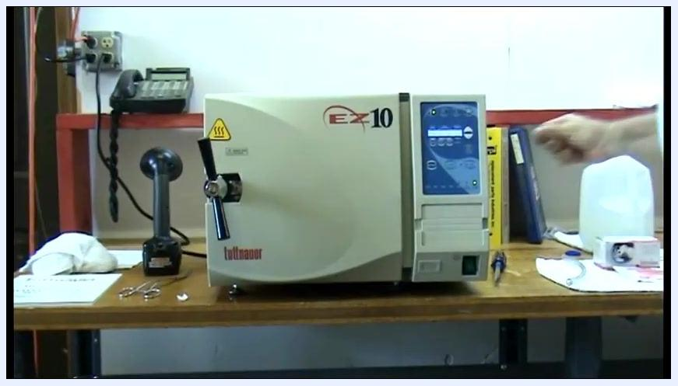
The autoclave door locked, control panel active, and a hand positioned near the panel.
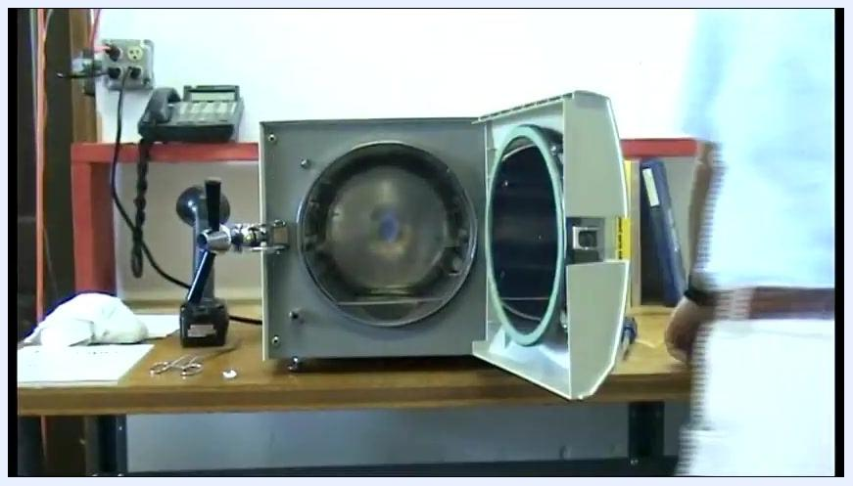
The autoclave running with the door locked and the control panel illuminated.
The autoclave door open, chamber exposed, and a hand near the chamber.
The autoclave chamber open with a person moving away from the unit, workbench with cleaning supplies visible.

6. Clean the chamber interior and water sensor

- Wipe the interior of the chamber thoroughly with a clean cloth, paying special attention to the water sensor, which sits on top of a plastic collar at the bottom of the chamber.
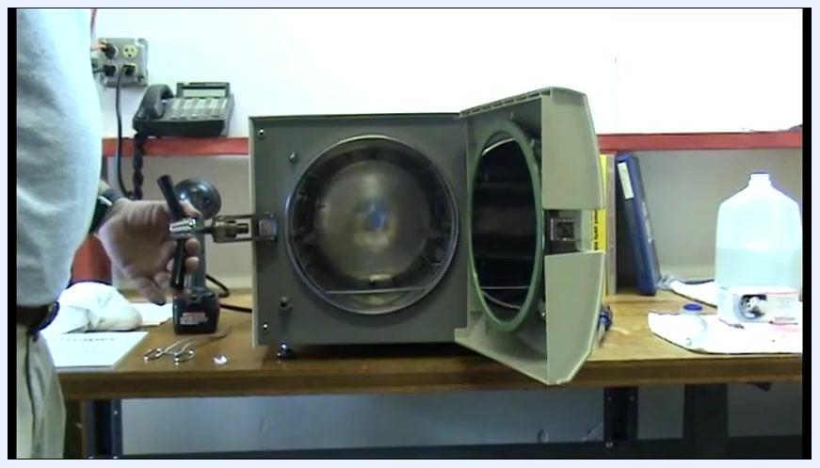
The autoclave with its door open, chamber exposed, and tools and cleaning supplies on the workbench as a person holds a tool near the unit.

- Clean the water sensor carefully, removing any residue or buildup without dislodging it from its plastic collar.
- Finish cleaning around the sensor, ensuring the sensor and surrounding area are dry and free of debris.
A person holding a white cloth, preparing to clean the interior of the fully open autoclave chamber.
A person cleaning the water sensor inside the autoclave chamber with a cloth.
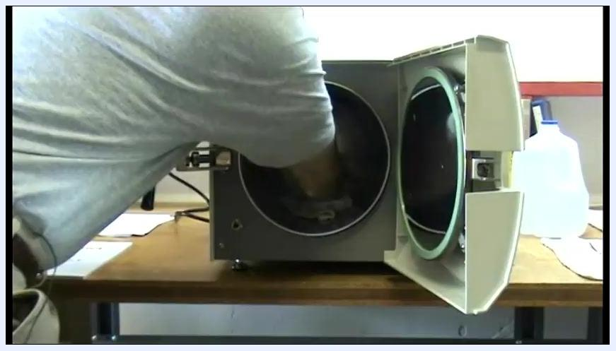
A person reaching into the chamber with a cloth to clean around the water sensor.

7. Final chamber flush and reassembly

- Activate the water fill function by pressing the Water Fill button for one to two seconds. This flushes remaining residue from the chamber, especially from the small inlet at the bottom. Keep the door open during this step.
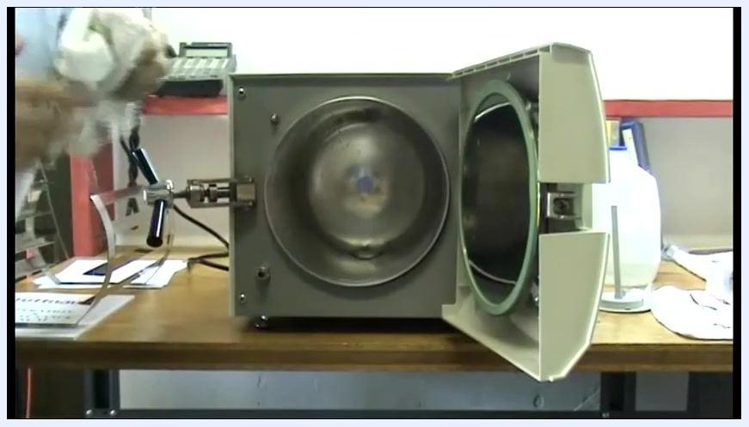
The autoclave chamber open with a person holding a cloth, ready to manage excess water.

- Allow water to rinse the inlet. Observe as water briefly enters the chamber and flushes loosened debris from the bottom inlet. Keep a cloth ready to wipe up excess water.
- Wipe away excess water with a clean, lint-free cloth, paying special attention to the area around the water sensor and the bottom inlet.
- Reinsert the chamber rack. Place the metal rack back inside the chamber, ensuring it is properly seated and stable for future use.
- Complete the cleaning process. Confirm the chamber is wiped, the water sensor is cleaned, the inlet is flushed, and the rack is reinserted. Close the autoclave door if the unit will not be used immediately, and dispose of or launder cleaning cloths as appropriate.
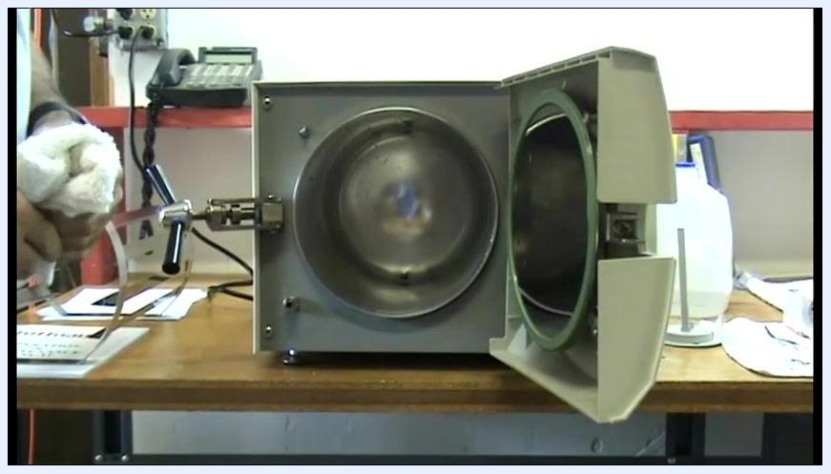
The autoclave chamber open with a person holding a white cloth nearby, control panel and supplies visible on the workbench.
A person reinserting the metal rack into the autoclave chamber, with the distilled water jug and supplies visible on the workbench.

Calculations
This cleaning method does not involve analytical calculations. For record-keeping purposes, document the volume of distilled water used to refill the reservoir, the cycle type and duration selected (Unwrap/No Dry), and the date and time each cleaning cycle was completed.

Quality Controls
- Drying time check: Confirm the drying time is set to zero for both the Chamber Brite cleaning cycle and the post-drain flush cycle; drying time introduces heat that can bake residue onto the system.
- Water quality check: Confirm only labeled distilled water, free of contaminants, is used for rinsing and refilling; tap or mineral water can damage the autoclave.
- Leak and spill check: Inspect the area around the reservoir and chamber for leaks or spills after refilling, and wipe up excess water immediately.
- Residue and debris check: Visually inspect the chamber interior, door gasket, and water sensor for remaining residue after rinsing. If debris is present, repeat the rinsing process before returning the unit to service.
- Drained solution check: Inspect the drained Chamber Brite solution for debris such as lint from sterilization pouches; if found, verify valves and pipes are clear before continuing.
- Failed-run handling: If residue, debris, or leaks are detected during inspection, repeat the affected rinsing or cleaning step before proceeding to the next stage of the procedure.
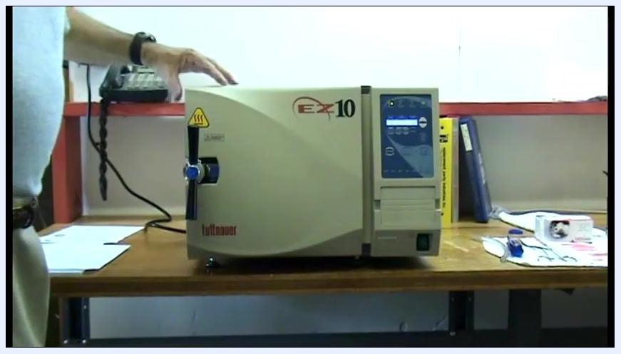
The autoclave closed and ready to be opened, with the operator's hand on the door handle and the EZ-10 unit set up on a workbench with supplies nearby.
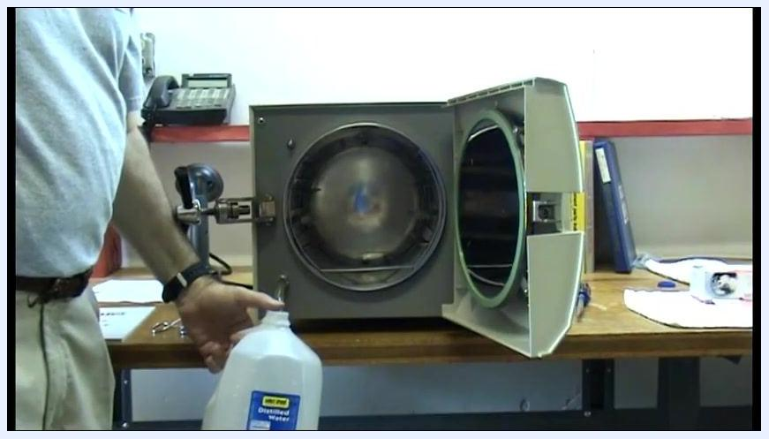
The operator holding the collection container as the solution drains from the reservoir.

