How to Calibrate a Pipette: Instrument Calibration Log
This log documents how to calibrate a pipette in a regulated laboratory setting. Reliable pipetting results depend on three factors — the equipment used, the procedures followed, and the environment in which calibration is performed. Use this log to record instrument details, the calibration procedure, reference standards, measured results, maintenance activity, out-of-tolerance actions, and final approval for each calibration event.
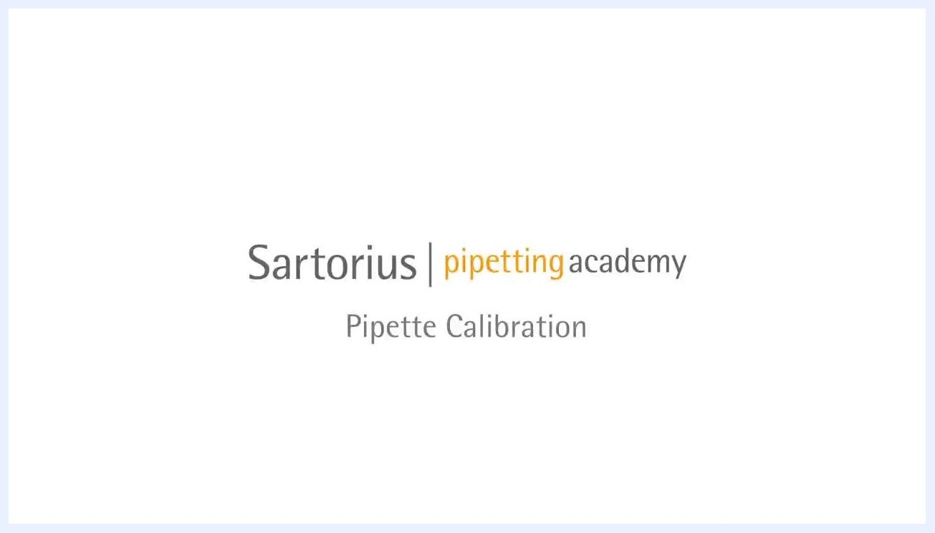
A gloved hand holding a pipette in a laboratory setting, with pipettes, a balance, and a laptop visible in the background
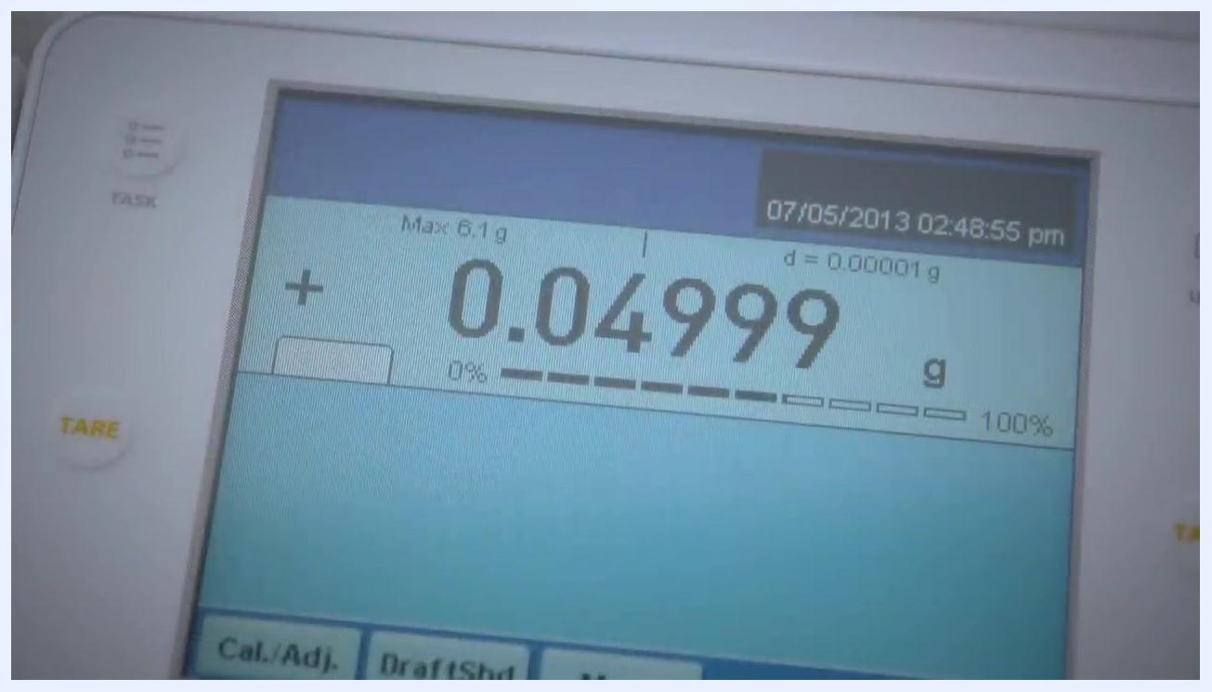
Two laboratory technicians at a calibration station; one holds a pipette over a balance while the other observes and listens

Instrument Details
Record the identifying information for the specific pipette under calibration before you begin. Capture these details from the pipette label and your lab's equipment inventory.
A completely white screen, indicating the end of the video or a transition to a new section. No objects, people, or equipment are visible.
Field | Details
Instrument ID | Unique identifier assigned to the pipette
Model | Pipette model under calibration
Serial Number | Manufacturer serial number
Location | Workstation or lab bench where calibration is performed
Owner | Department, lab, or technician responsible for the pipette
Intended Use | Application for which the pipette is used
Two laboratory technicians working at a calibration station; one uses a pipette over a balance while the other observes, in a clean, organized, well-lit lab

Calibration Schedule
Before starting, confirm your calibration frequency, due date, procedure reference, and the role responsible for performing the work. Set up your workspace so that all required equipment is within easy reach.
Frequency | Due Date | Procedure Reference | Responsible Role
Record your lab's defined calibration interval | Record the date the next calibration is due | Pipette Calibration Procedure (below) | Calibration technician / lab analyst
Pipette calibration procedure

- Pre-wet the pipette tip by aspirating and dispensing distilled water three to five times before starting calibration. This eliminates evaporation of water into the airspace inside the pipette.
- Place the balance, pipette tips, and water within reach.
- Hold the pipette vertically when aspirating water to ensure the correct volume is drawn.
- Tare (zero) the balance before starting. Calibration software may perform this step automatically.
- Hold the pipette at a 45-degree angle when dispensing water onto the balance for optimal accuracy.
- Hold the pipette tip against the wall of the vessel and expel the entire sample. This is especially important for small sample volumes.
- Maintain an even rhythm and consistent timing throughout the process to ensure reliable results.
Title screen displaying "Sartorius pipetting academy - Pipette Calibration"
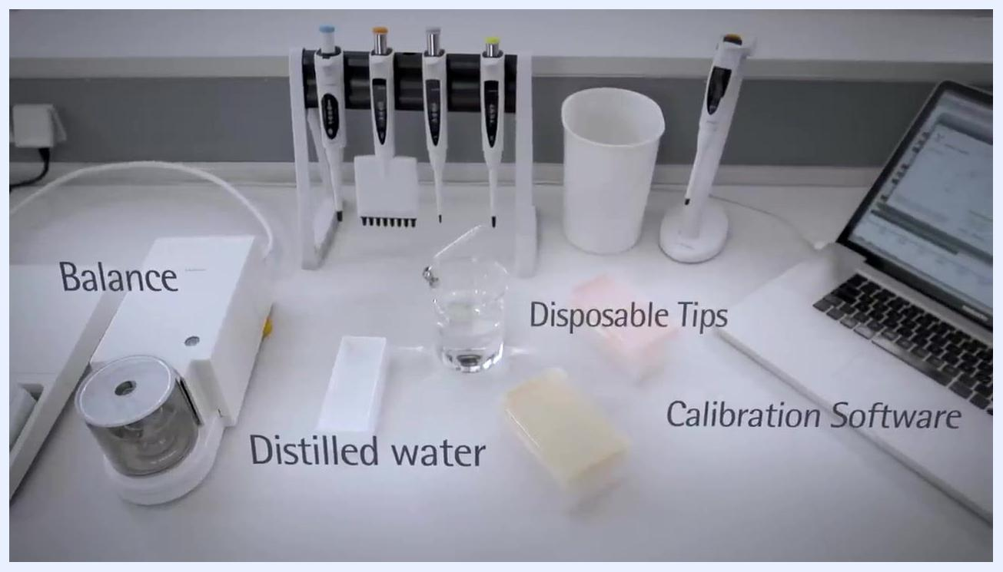
Lab bench with labeled items: balance, distilled water, disposable tips, calibration software, pipettes, and other calibration tools
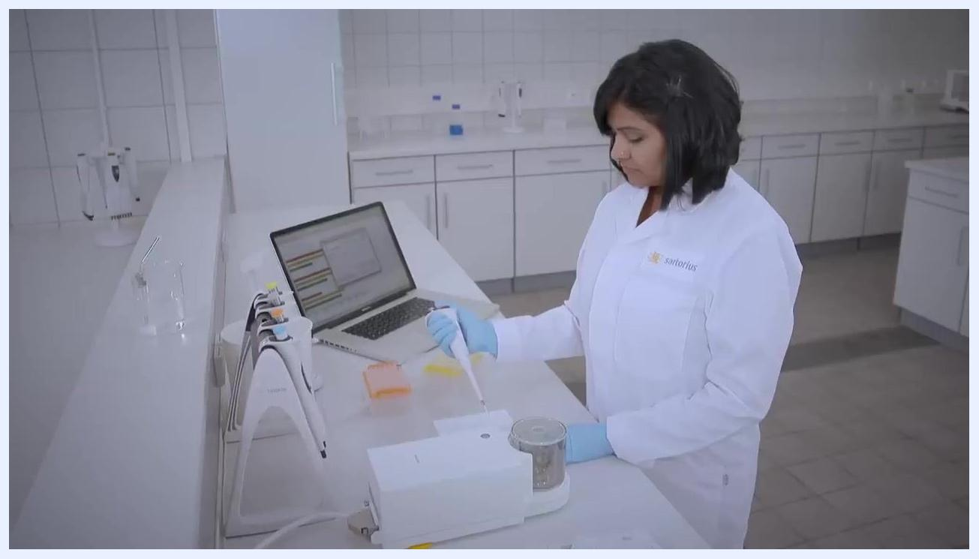
A person in a lab coat and gloves using a pipette at a balance, with a laptop and calibration equipment visible
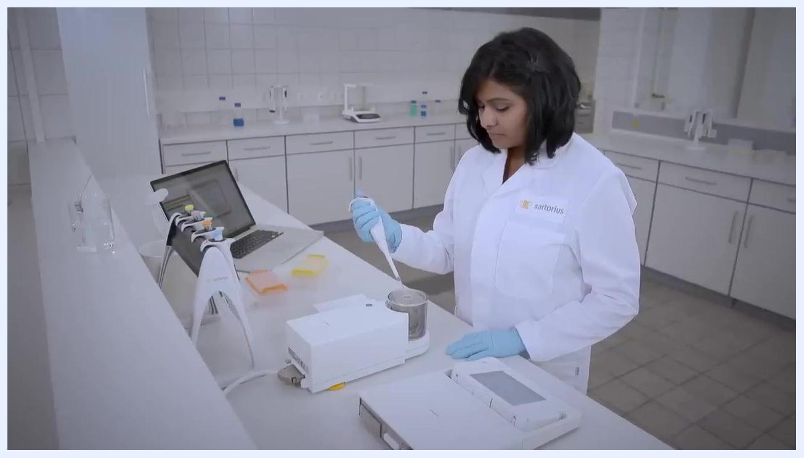
A person in a lab coat and gloves holding a pipette at a 45-degree angle over a balance, performing calibration
Perform calibration in a stable, draft-free environment with constant temperature and humidity to reduce environmental effects on your measurements.
Use the same procedure for every calibration session. Consistency in technique is essential for achieving the best calibration results.
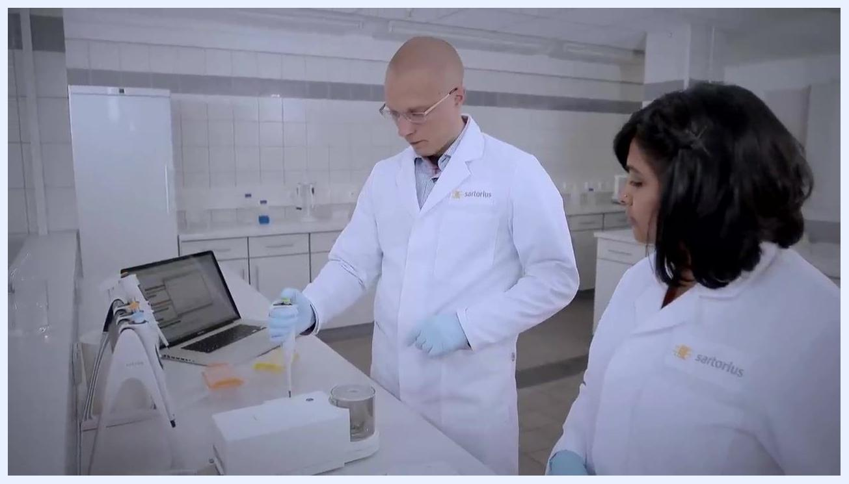
A technician using a pipette at a calibration station, demonstrating a consistent calibration procedure

Standards Used
List the reference tools and materials used to perform calibration, along with their traceability information (certificates, expiration dates, lot numbers as applicable).
Reference Standard / Tool | Purpose | Certificate / Traceability
Analytical balance | Weighing dispensed water to verify volume | Record certificate number and expiration date
Distilled water | Reference liquid for pipetting | Record lot number where applicable
Calibration software | Recording and calculating measurements | Record version and configuration
Disposable pipette tips | Single-use tips for each pipette tested | Record lot number
A laboratory bench with a balance, distilled water, pipettes in a stand, disposable tips, and a laptop with calibration software
Confirm the presence of the balance, distilled water, disposable tips, and calibration software running on a computer at your workstation before proceeding.

Calibration Results
Record the measured values, acceptance limits, pass/fail status, and analyst initials for each calibration run.
Run # | Volume Tested | Measured Mass (g) | Acceptance Limit | Pass/Fail | Analyst Initials
1 | Record target volume | 0.04999 | Record per manufacturer/lab specification | Record result | Record initials
2
3
Maintain an even rhythm and consistent timing throughout each run to minimize variability and improve measurement accuracy.
Follow the correct technique throughout: pre-wet the tip, hold the pipette vertically when aspirating, and position it at a 45-degree angle when dispensing into the vessel on the balance. These steps are crucial for minimizing errors caused by evaporation and for ensuring accurate volume delivery.
A laboratory technician working at a calibration station, maintaining a steady workflow in a clean, organized lab environment
In addition to accuracy, evaluate the pipette for precision — the consistency of dispensed volumes across repeated runs. Precision is affected by the calibration environment, the repeatability of the procedure, and the skill of the person performing the calibration.
Use the analytical balance and calibration software to record each measurement for traceability. For example, a balance reading of 0.04999 g should be documented as shown.
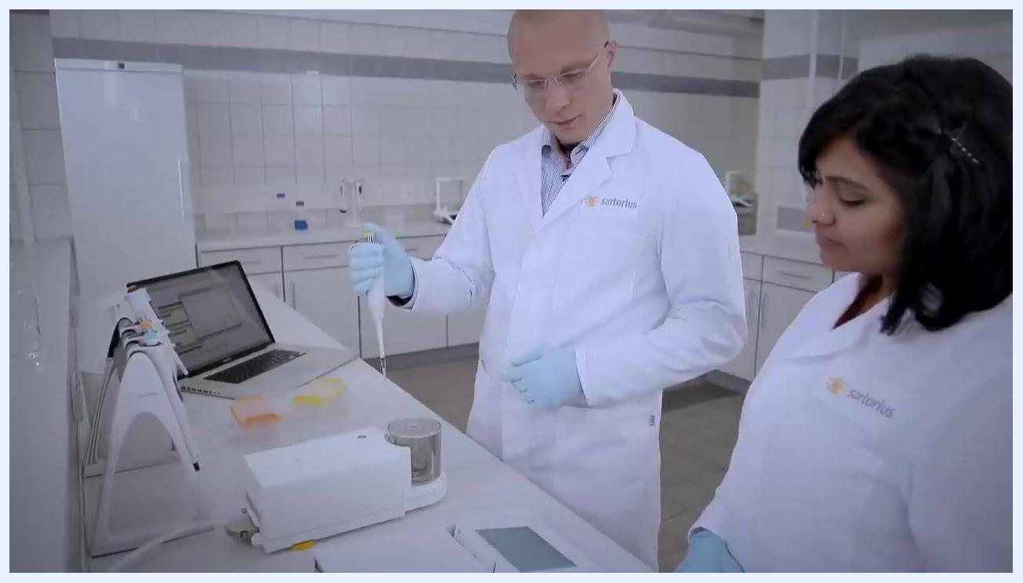
A technician holding a pipette vertically and at a 45-degree angle, demonstrating correct pipetting technique during calibration
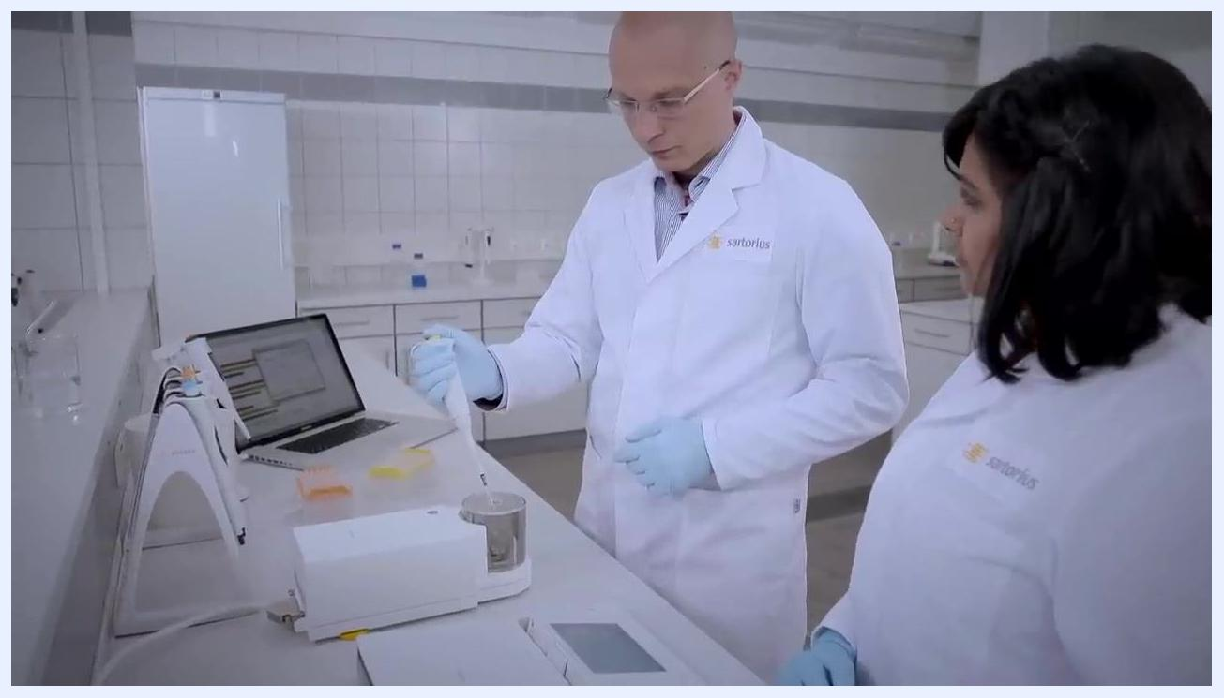
A technician dispensing liquid with a pipette into a vessel on a balance, focusing on precision and repeatability
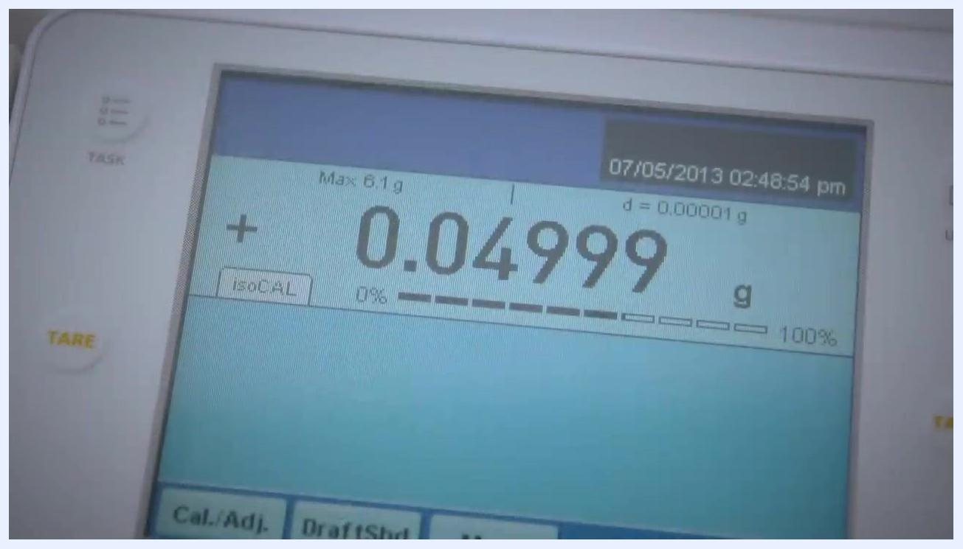
Close-up of an analytical balance display showing a reading of 0.04999 g, with calibration controls visible

Maintenance
Document any preventive maintenance, adjustments, repairs, or parts replaced, along with the service provider responsible.
Date | Maintenance/Adjustment Performed | Parts Replaced | Service Provider
 | Record any volume adjustment made | Record parts replaced, if any | Record technician or provider
If accuracy cannot be achieved through adjustment, use a calibration tool to adjust the pipette: turn the adjustment mechanism clockwise to increase the dispensed volume, or counterclockwise to decrease it.
When attaching tips to the pipette, do not twist the pipette — only press down to connect the tip securely. Twisting can damage the pipette or the tip and affect accuracy.
A laboratory technician in a white coat and gloves working at a calibration station, maintaining a steady workflow
Close-up of gloved hands adjusting the volume of a pipette using a calibration tool

Out-of-Tolerance Actions
If you cannot adjust the pipette sufficiently to correct an accuracy error, inspect it for leakage, wear, damage, or mechanical malfunction. Do not proceed with calibration or return the pipette to service until it is confirmed to be in good working order.
Field | Details
Impact Assessment | Record whether the deviation affects prior results generated with this pipette
Affected Data Review | Record which batches or tests used this pipette during the out-of-tolerance period
Quarantine | Record quarantine status of the pipette until repaired and re-verified
Corrective Action | Record repair, adjustment, or replacement action taken
Always consider the three critical factors for reliable calibration when investigating an out-of-tolerance result:
- Equipment: Properly maintained and calibrated pipettes, analytical balances, and calibration tools.
- Procedures: Standardized, validated calibration protocols followed consistently.
- Environment: A stable, draft-free, clean laboratory with controlled temperature and humidity.
A gloved hand holding a pipette in a laboratory setting, with pipettes, a balance, and a laptop visible in the background

Approval
Always obtain a calibration certificate after performing calibration. The certificate documents the results, the equipment used, and the personnel involved. An accredited certificate will also indicate the measurement uncertainty of the instrument.
Two technicians in lab coats and gloves working at a calibration station with pipettes, a balance, and a laptop, demonstrating a properly controlled calibration environment
Reviewer | Date | Release-to-Use Decision
Collaborate with colleagues during calibration to ensure procedures are followed correctly and to cross-check results. Discuss any issues or uncertainties with your team to maintain high standards of accuracy and reliability.
Once all calibration steps are complete and results are documented, power down the equipment, clean the workspace, and store all tools and pipettes properly for future use.
Close-up of an analytical balance display showing a reading of 0.04999 g, with maximum capacity, resolution, and timestamp visible; the interface shows the **TARE**, **Cal./Adj.**, and **Draft Shd** buttons

