How to Delete a Ticket (Issue) in Jira
This guide walks you through logging in to Jira and safely deleting a ticket (issue) from your project backlog. It also covers an alternative deletion method and what to do if you run into problems.

Prerequisites
- A web browser with access to the Jira homepage.
- A Jira account (existing or newly created).
- Access to a project with a backlog containing issues.

Step 1: Access the Jira website
Open your web browser and navigate to the Jira homepage. You will see the main landing page with the message "All great projects start with Jira," along with options such as Try Jira Free, Explore for Project Management, and navigation links including Features, Product guide, Templates, Pricing, and Enterprise.

Jira homepage displaying the message "All great projects start with Jira" along with navigation options

Step 2: Log in or sign up
If you already have Jira credentials, click Sign in at the top right and enter your login details.
If this is your first time using Jira, click Get Jira free (yellow button) or a similar sign-up option, then follow the on-screen instructions to create your account.
Jira sign-up screen with the "Get Jira free" button and a testimonial section

Step 3: Navigate to your project backlog
Once logged in, select your project from the dashboard. Go to the Backlog section in the left sidebar under PLANNING. You will see a list of issues in your backlog, each showing its title, status, and other details.
Jira backlog view showing listed issues and an open issue details panel

Step 4: Understand the implications of deleting a ticket
Before proceeding, keep the following in mind:
- Deleting a ticket in Jira is permanent and cannot be undone.
- All comments, attachments, and history associated with the issue will be lost.
- Only proceed if you are certain, and keep a backup if necessary.

Step 5: Create or select the ticket to delete
If you need to create a new issue for demonstration or testing, click + Create issue, enter the required details (for example, "What needs to be done?"), and press Enter to add it to your backlog.
Select the issue you wish to delete by clicking the checkbox next to its title.
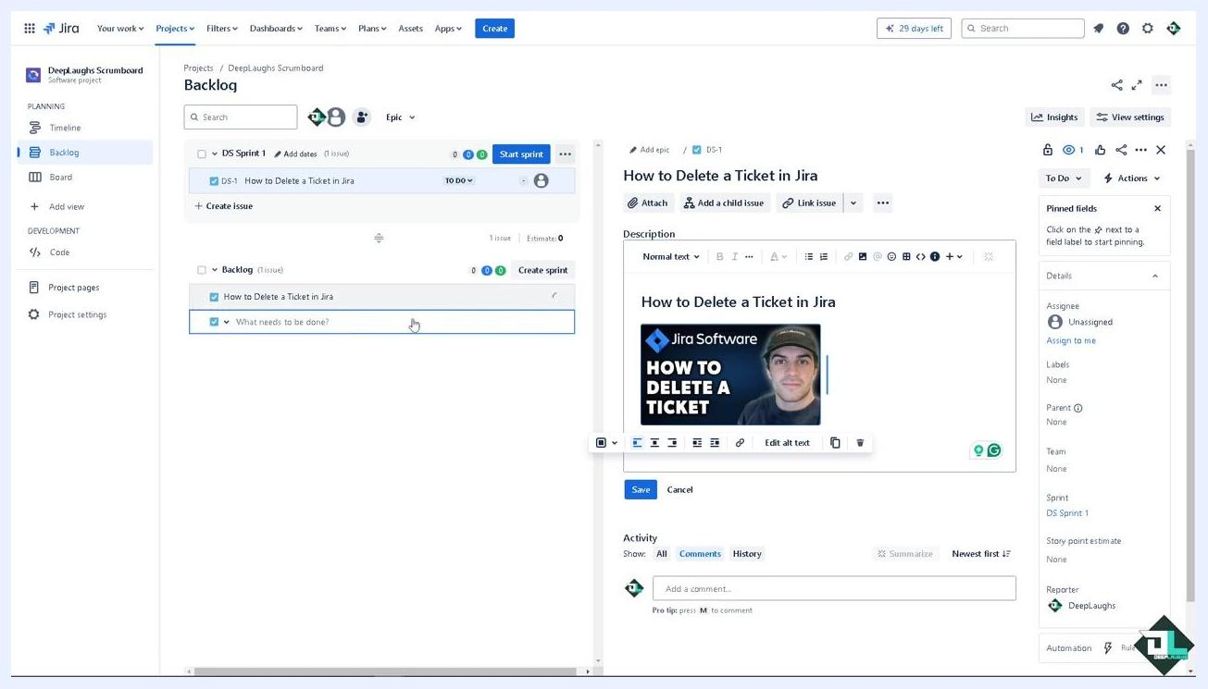
Jira backlog showing multiple issues, with one selected for deletion

Step 6: Open the issue actions menu
With the issue selected, locate the ellipsis button (three dots) on the right side of the issue row and click it to open the actions menu.
Jira backlog with the ellipsis menu open, displaying issue actions

Step 7: Delete the issue
In the actions menu, click Delete. A confirmation dialog appears, warning that this action is permanent and will remove all data associated with the issue.
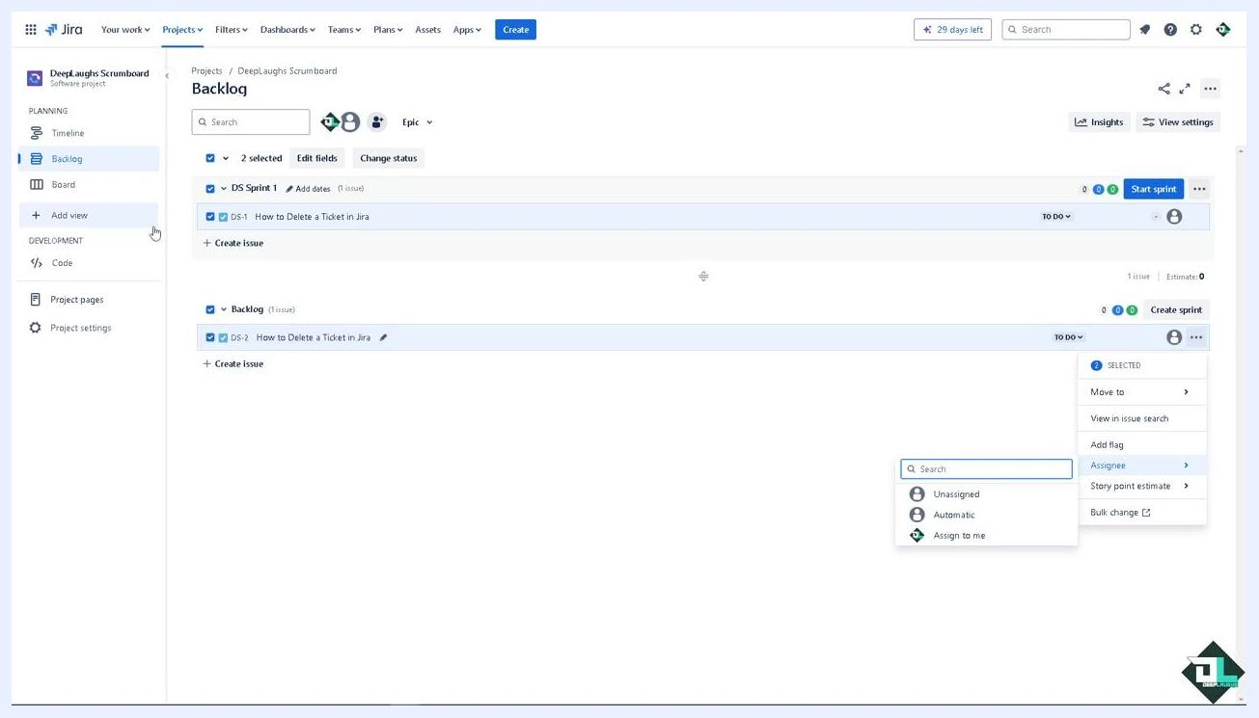
Jira confirmation dialog for deleting an issue, showing Delete and Cancel buttons

Step 8: Confirm deletion
Review the warning message carefully. If you are sure, click Delete in the confirmation dialog. The issue will be permanently removed from your backlog.

Important notes
- Always ensure you have a backup or have exported any necessary information before deleting an issue.
- Only delete issues when absolutely necessary to maintain the integrity and quality of your project backlog.

Alternative method: Deleting another ticket
You can also delete a ticket through the issue details panel:
- Click + Create issue, enter the details (for example, "What needs to be done?"), and press Enter to add it to your backlog.
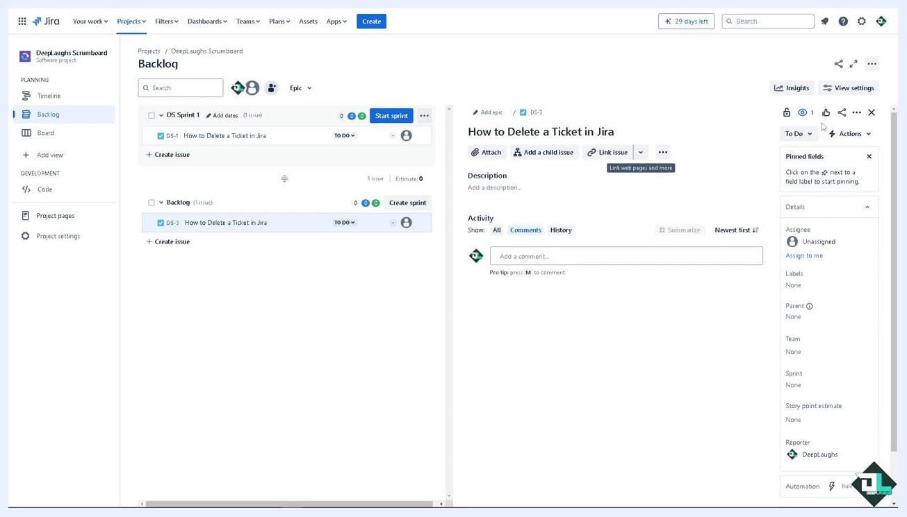
Jira backlog with a new issue being created and "What needs to be done?" entered in the issue field
- Click on the issue you want to delete to open its details panel.
Jira backlog with the issue "How to Delete a Ticket in Jira" selected and its details panel open
- In the issue details panel, click the Actions button (three dots) in the upper right corner and select Delete from the dropdown menu.
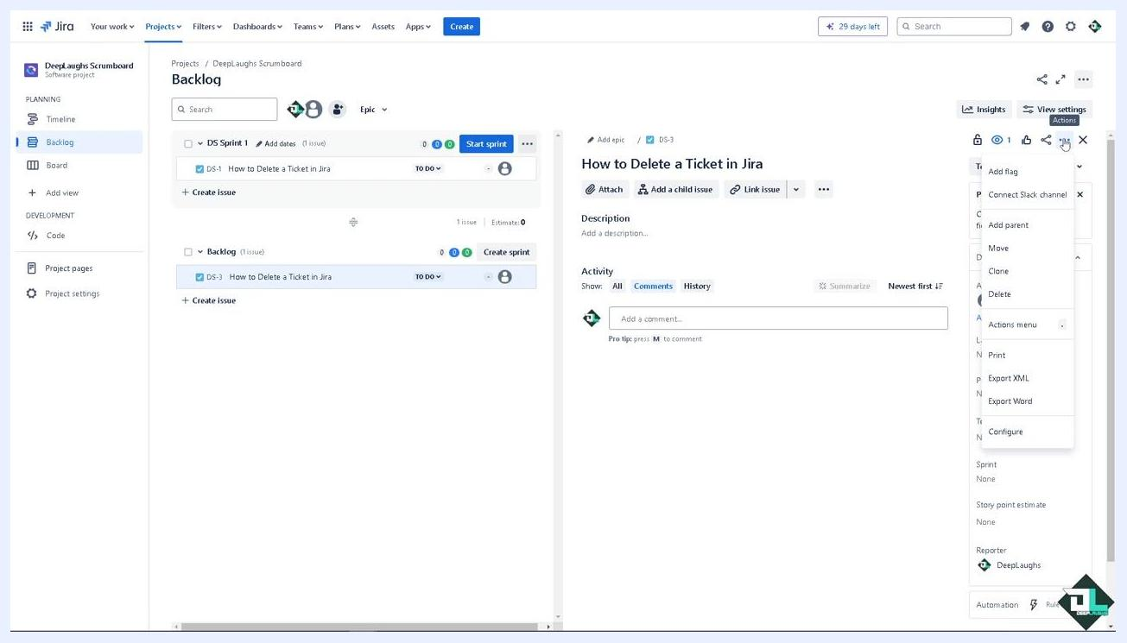
Jira issue details panel with the Actions menu open and the Delete option visible
- Confirm the deletion in the dialog that appears. Remember, this action is permanent and will remove all comments, attachments, and data associated with the issue.

Troubleshooting deletion problems
If you encounter a bug or glitch while trying to delete a ticket, go to the Help section in Jira and type your question to search the help documentation.
If self-help does not resolve the issue, visit the Atlassian support page to contact the Jira customer support team. You can raise a support ticket for technical issues or bugs.
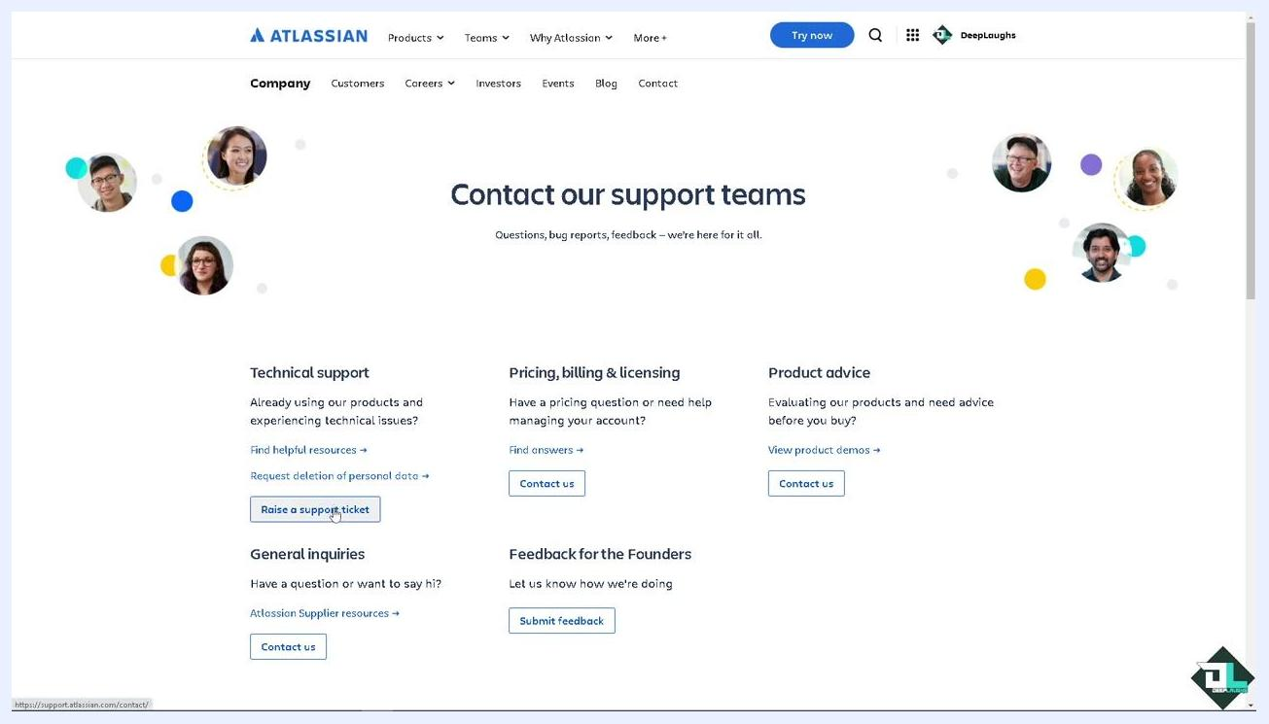
Atlassian support page showing options to raise a support ticket, or contact support for billing, product advice, and general inquiries
When raising a support ticket, provide specific details about your problem, including:
- The user, project, or issue impacted.
- Steps to reproduce the problem.
- When you first noticed the issue.
- Any relevant screenshots or videos.
Atlassian Support contact form with fields for issue details, business impact, and a description filled in with "How to Delete a Ticket in Jira"
The support staff will provide troubleshooting steps and insights to help resolve your issue.

What's next
- If you want to learn how to recover deleted issues or tickets in Jira, refer to the separate video or resource mentioned on the channel.
- If you are unsure about deleting an issue, consider resolving or closing it instead.
By following these steps, you can delete tickets in Jira, troubleshoot any issues you encounter, and contact support for further assistance.

