How to create a subtask in Jira
Subtasks help you break down a Jira issue into smaller, trackable pieces of work. This guide walks you through how to create a subtask in Jira, from locating the parent issue to confirming that the subtask has been added successfully.

Prerequisites
- Access to a Jira instance with an active login.
- A project containing at least one existing issue to which you want to add a subtask.

Step 1: Open your Jira dashboard
Open your Jira instance in your web browser and make sure you are logged in and on the main dashboard. The dashboard displays a For you section with your recent projects and a list of recent work items.
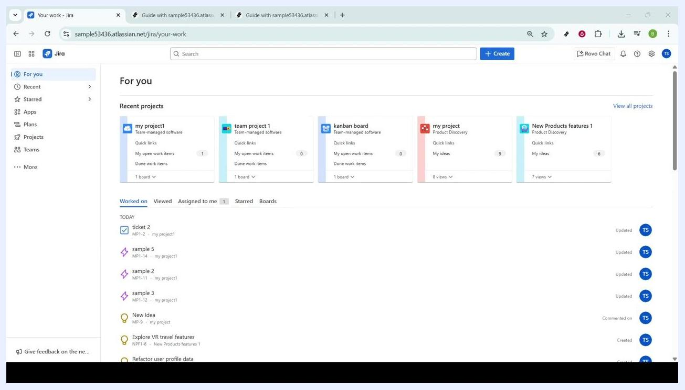
Jira dashboard showing recent projects and work items

Step 2: Select the project
In the left sidebar, locate the Projects section. Under Recent, click on the project you want to manage (for example, "my project1" or "team project 1"). Selecting the correct project ensures that any subtasks you create are associated with the right objectives.
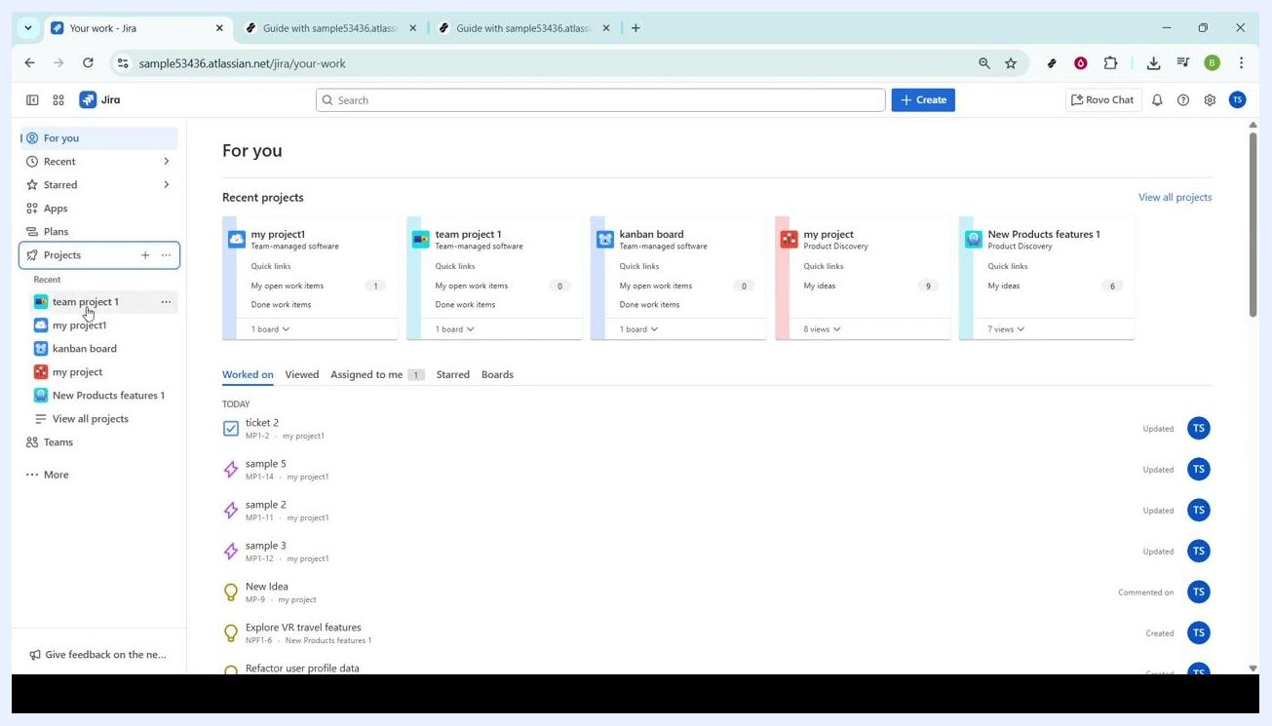
Sidebar with Projects menu expanded and cursor over a project

Step 3: Open the project board
Once inside your chosen project, use the navigation menu at the top of the screen and click on the All work tab. This view lists all issues, tasks, subtasks, bugs, and other issue types within the project, giving you a full overview of the project's current status.
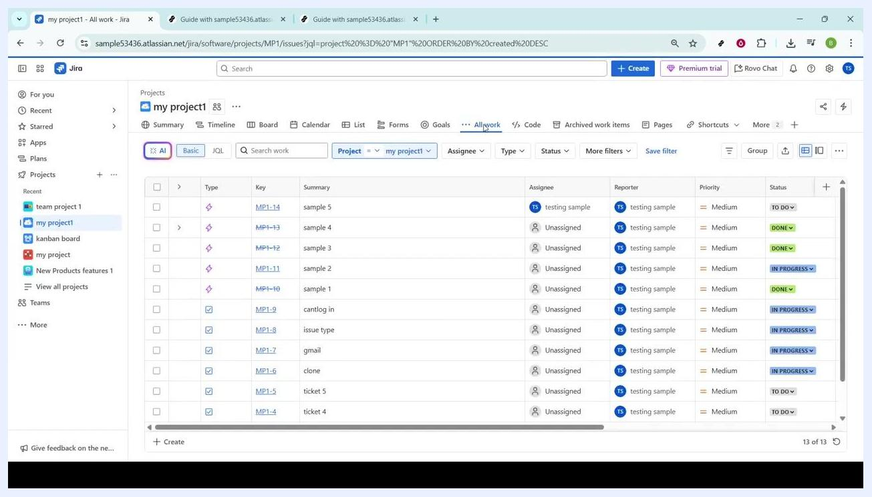
Project board with navigation tabs and All work selected

Step 4: Find and open the parent issue
In the All work view, locate the specific issue to which you want to add a subtask. Issues are listed with columns such as Type, Key, Summary, Assignee, Reporter, Priority, and Status. Click on the issue key (for example, "MP1-14" for "sample 5") to open its detailed page.
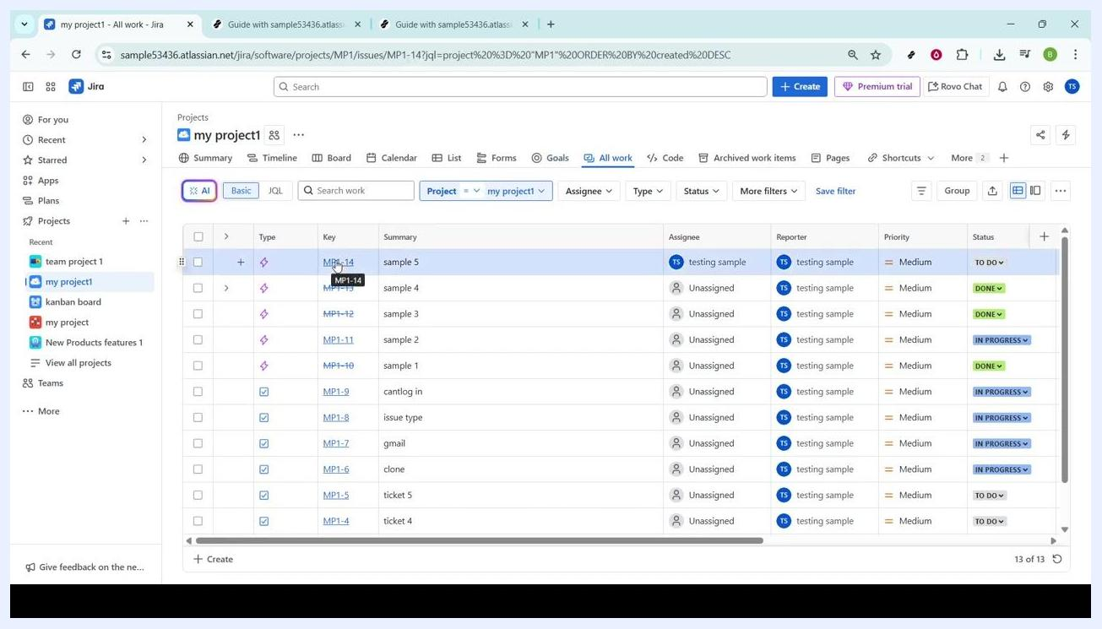
All work view with issue key being selected

Step 5: Review the issue details page
The issue details page displays the issue name, description, and various action buttons. Before adding a subtask, confirm you are viewing the correct issue by checking the summary and key shown at the top.
Issue details page for a selected Jira issue

Step 6: Click the Add button
Under the issue name, find the + Add button. This button lets you add various elements to the issue, including subtasks. Click + Add to open a dropdown menu with the available options.
Cursor hovering over the Add button on the issue details page

Step 7: Select Child work item
After clicking + Add, a dropdown menu appears. Locate and select Child work item (this may also be labeled "Child Issue" or "Subtask" depending on your Jira configuration). This links the new item directly to the parent issue as a subtask, keeping your project organized.
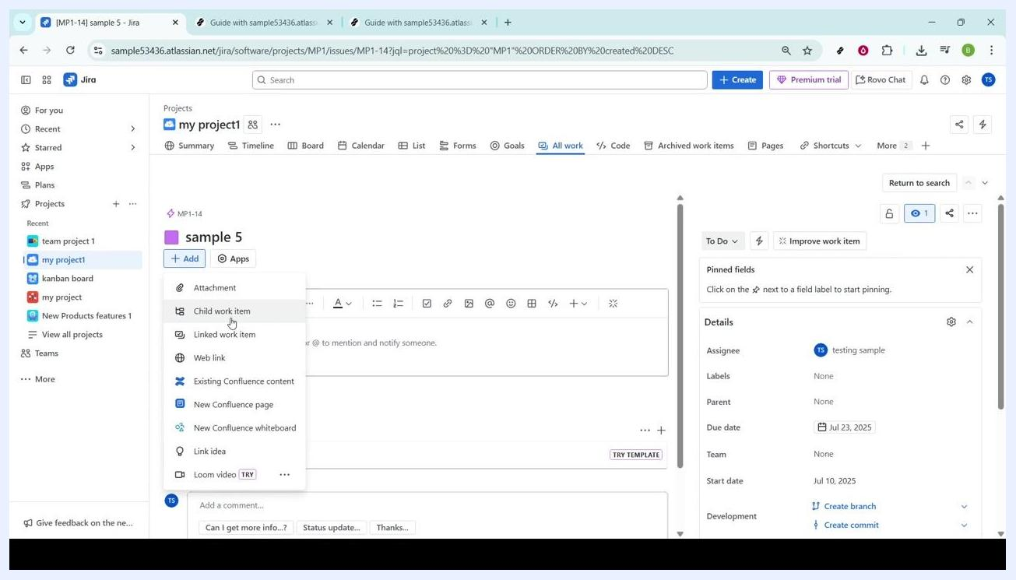
Dropdown menu under + Add with Child work item highlighted

Step 8: Enter the subtask details
The Child work items section opens below the issue description. In the What needs to be done? field, enter a clear and specific description for the subtask (for example, "please delete once done"). You can also click on additional fields to:
- Assign the subtask to a specific team member.
- Set a priority (for example, Medium).
- Add labels or a due date for better categorization and tracking.
The more detailed your description and metadata, the easier it will be for your team to understand and complete the subtask.
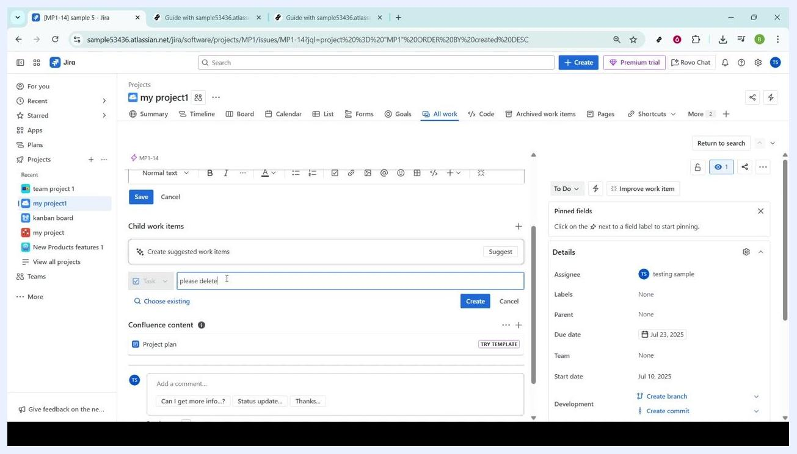
Child work items section open with a description being typed

Step 9: Create the subtask
Once all necessary information is filled out, locate the blue Create button to the right of the description field. Click Create to save the subtask. This adds the subtask under the parent issue and integrates it into your project's workflow.
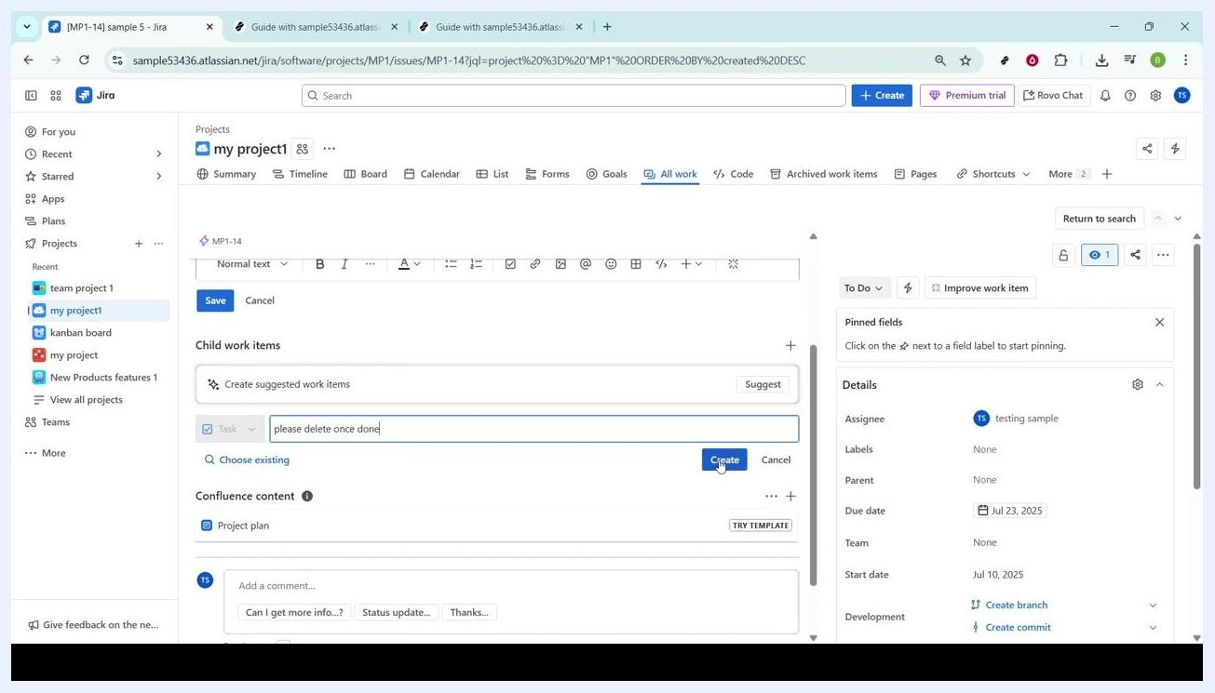
Create button being clicked to add the subtask

Step 10: Verify that the subtask was created
After creation, the new subtask appears in the Child work items list under the parent issue, showing its key (for example, "MP1-15"), summary, priority, assignee, and status. A confirmation message such as "You've created 'MP1-15' work item" may appear, with options to view or copy the link to the subtask. Confirm that the subtask is listed and all details are correct.
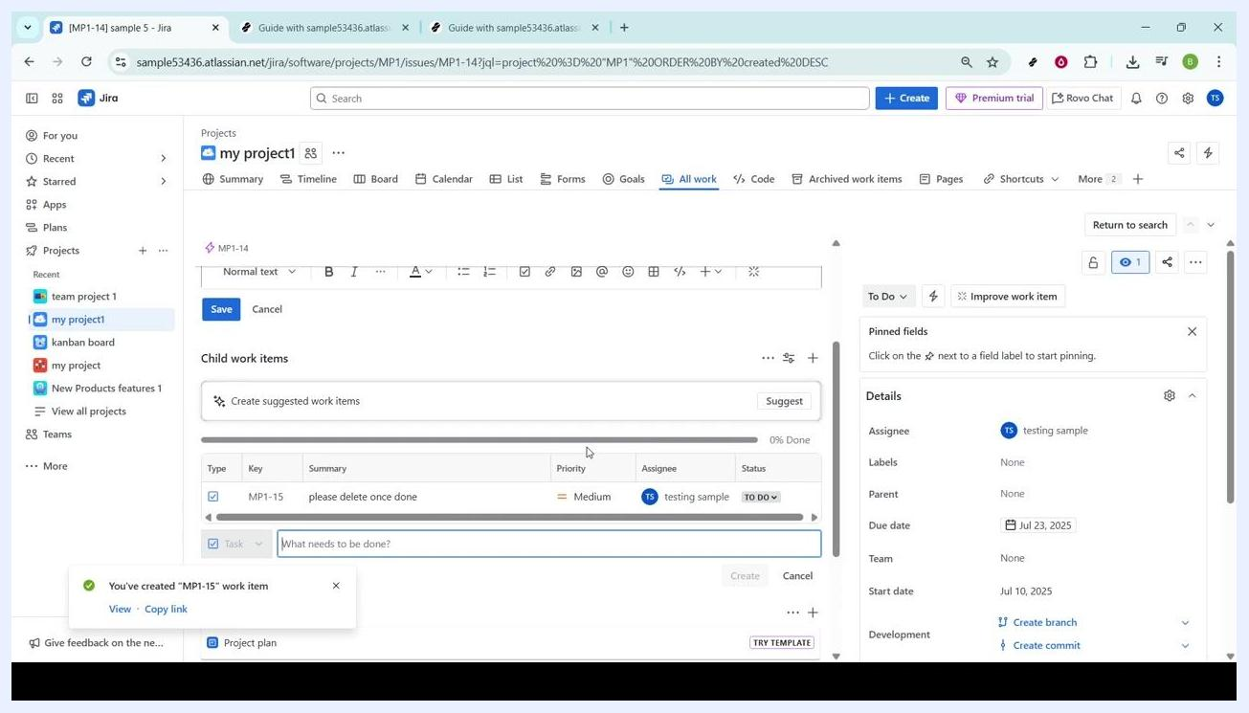
Subtask appears in the Child work items list with confirmation message

Reviewing the confirmation and details
Once your subtask is created, take a moment to review the confirmation and surrounding details:
- Confirmation message: A message at the bottom left of the interface reads "You've created 'MP1-15' work item," with options to View or Copy link. This confirms the subtask was successfully added to the parent issue.
- Child work items list: Confirm the new subtask's details are accurate:
- Type: Task
- Key: MP1-15
- Summary: please delete once done
- Priority: Medium
- Assignee: testing sample
- Status: TO DO
- Parent issue panel: On the right panel, verify the parent issue's fields, including:
- Assignee: testing sample
- Labels: None
- Parent: None
- Due date: Jul 23, 2025
- Team: None
- Start date: Jul 10, 2025
- Development: Options to Create branch and Create commit are available.
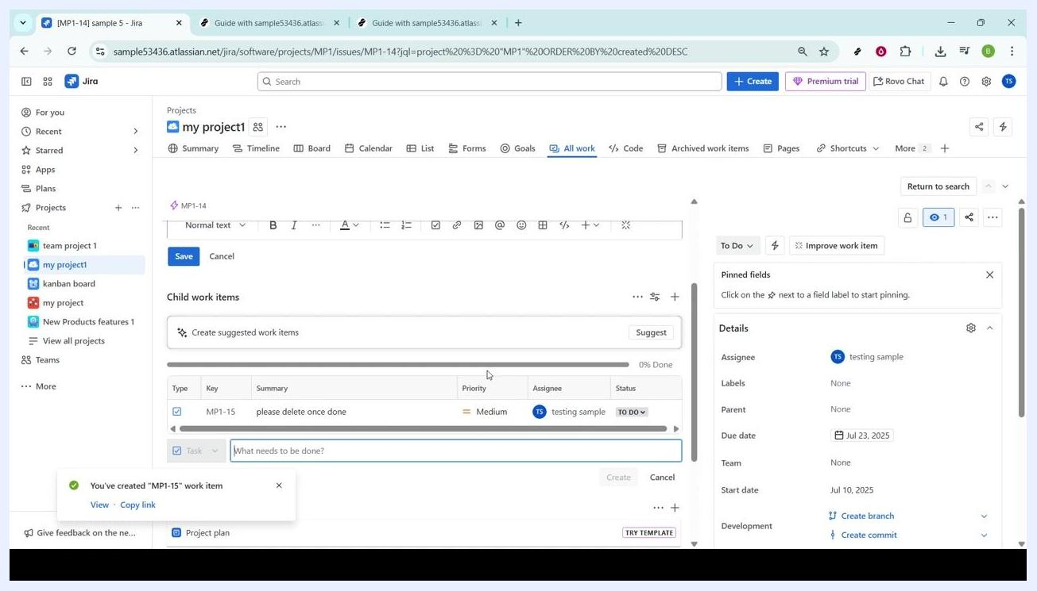
Jira interface showing the confirmation message for subtask creation, child work items list, and issue details panel

What's next
You can continue managing your project by adding more child work items — simply enter a new description in the What needs to be done? field and click Create. Use the Save button at the top of the issue page to save any changes to the parent issue, or Cancel to discard them.
By completing these steps, you now know how to create a subtask in Jira and verify it was added correctly. Using subtasks this way keeps your project organized and helps your team stay clear on responsibilities, improving clarity, accountability, and progress tracking.

