How to create a project in Jira
This guide walks you through how to create a project in Jira Cloud, from opening the Projects menu to picking a template, naming your project, and setting access permissions. By the end, you'll have a fully configured project ready for your team to use.

Before you begin
A project in Jira is a collection of tasks that need to be completed to achieve a specific outcome. Projects act as containers that help you organize and track work across your team. Jira projects are highly configurable, so you can adapt them to fit any organizational structure, workflow, or team maturity level.

Step 1: Open the Projects menu
In the top navigation bar, select the Projects dropdown menu. This menu shows projects you've been working on and any recent projects you've accessed. To start a new one, select Create project from the dropdown.
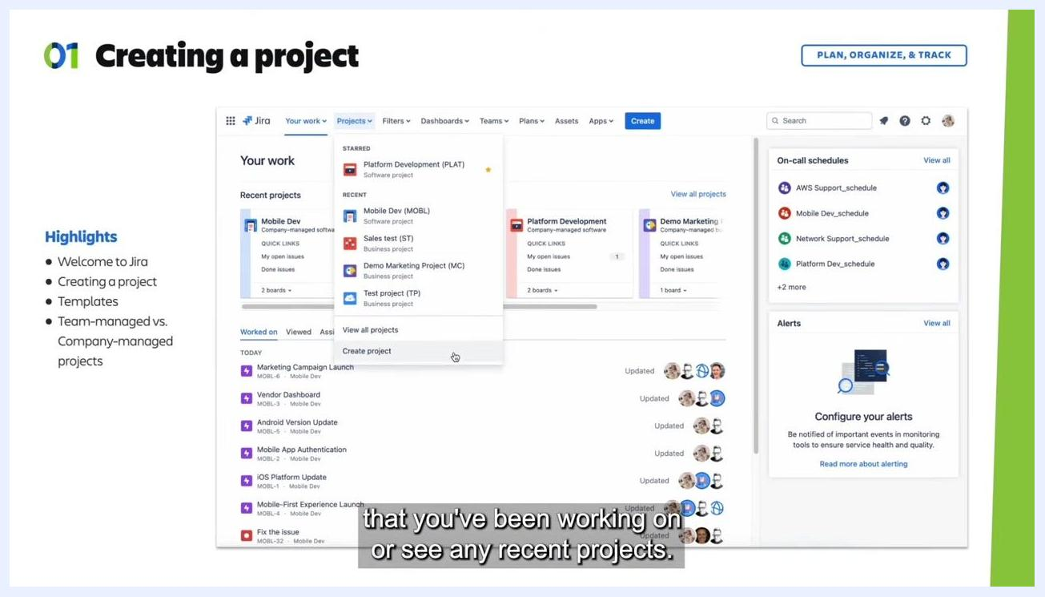
Jira dashboard with the Projects dropdown open, showing recent projects and the highlighted "Create project" button.

Step 2: Choose a project template
After selecting Create project, Jira presents a list of templates organized by team type, including Software development, Service management, Work management, Product management, Marketing, Human resources, Finance, Design, Personal, Operations, Legal, Sales, Analytics, IT, Facilities, and Nonprofit.
Select the category that best fits your team's needs. For example, under Software development, you can choose between Kanban, Scrum, or Top-level planning templates. Click on any template to read its description and see how it's typically used.
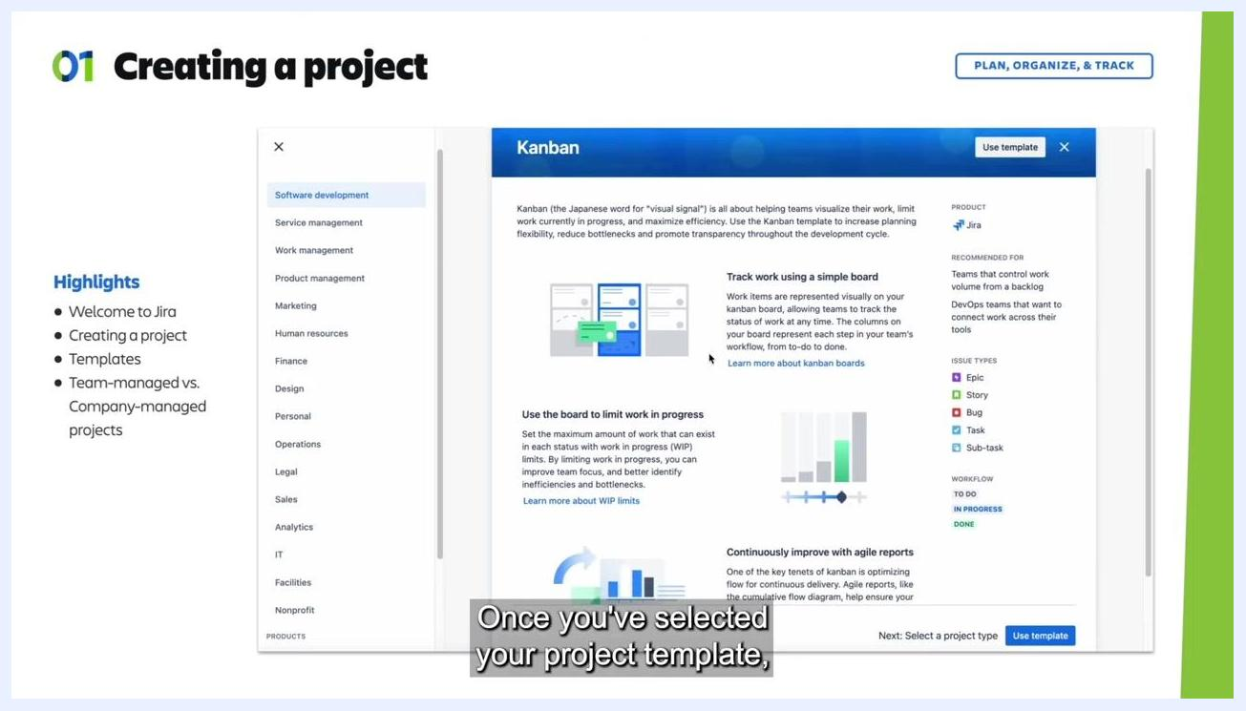
Jira project template selection screen showing categories such as Software development, Service management, and Work management, with templates like Kanban, Scrum, and Top-level planning.

Step 3: Review the template details
Once you select a template, such as Kanban, a detailed description appears. Review the following before proceeding:
- What the template is for, such as visualizing work, limiting work in progress, or maximizing efficiency
- Recommended use cases, such as teams that control work volume from a backlog
- Issue types included, such as Epic, Story, Bug, Task, and Sub-task
- Workflow stages, such as To Do, In Progress, and Done
Once you've reviewed the details, click Use template to proceed.
Detailed Kanban template description showing workflow stages, issue types, recommended use cases, and the "Use template" button.

Step 4: Select a project type
After choosing your template, Jira asks you to pick between two project types:
- Team-managed projects: Managed by project administrators, without needing a Jira admin. This option offers simplified configuration, easy setup for issue types and custom fields, and doesn't affect other projects. It's ideal for small teams that want to get started quickly.
- Company-managed projects: Managed by Jira admins, promoting organizational best practices through shared configuration. This option offers expert configuration, standardized workflows, and detailed permission schemes. It's suited to larger teams that need standardization across multiple projects.
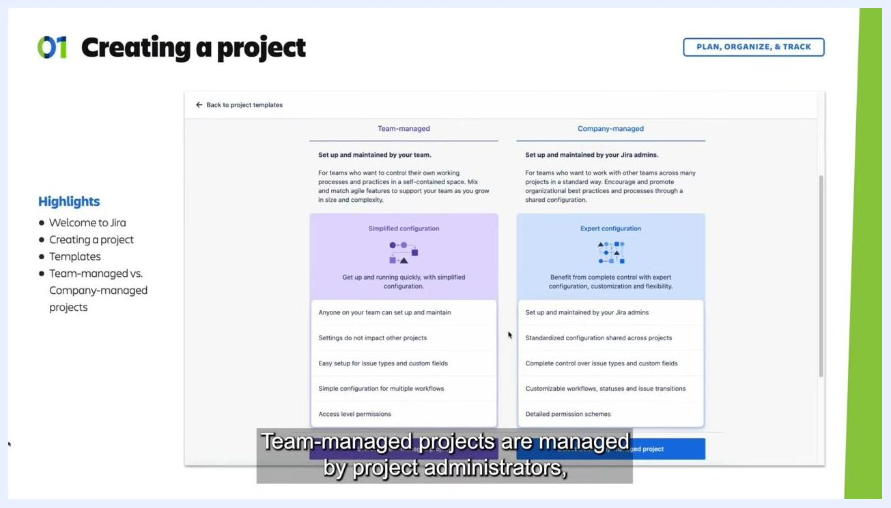
Jira screen comparing team-managed and company-managed project types, with configuration details highlighted for each option.
For this walkthrough, select Team-managed project to proceed with a simplified setup.
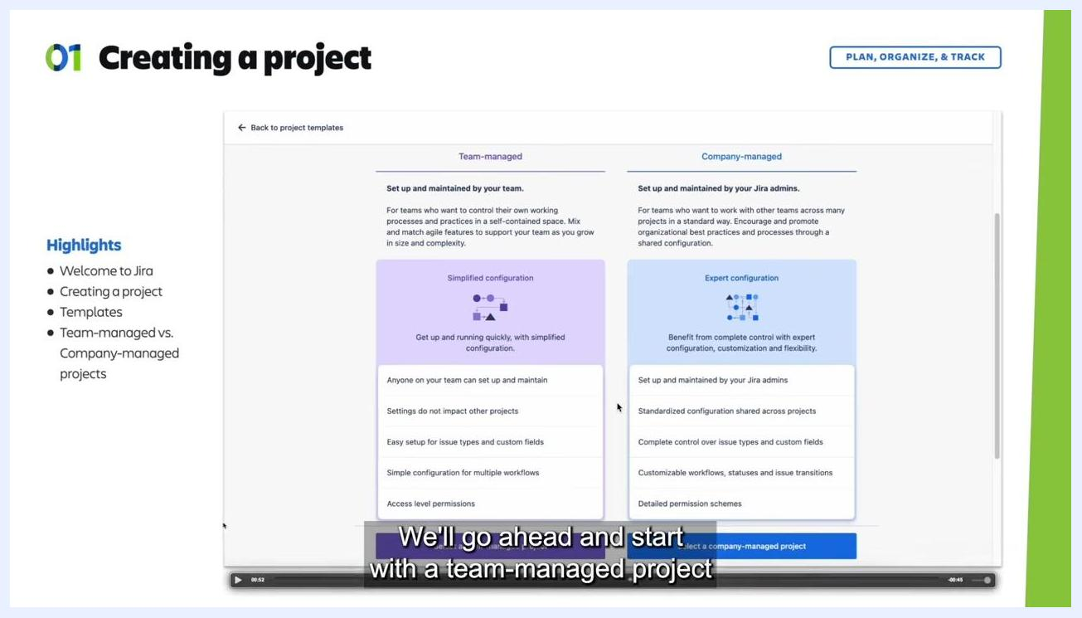
Jira screen with the team-managed project type selected, ready to proceed.

Step 5: Name your project and set the access level
Enter your project name in the Name field (for example, "Space Project"). Then choose an access level from the dropdown:
- Private: Only admins and people added to the project can search for, view, create, or edit its issues.
- Limited: Anyone with access to the Jira site can search for, view, and comment on the project's issues, but only people added to the project can create or edit them.
- Open: Anyone with access to the Jira site can view, create, and edit issues in the project.
For this walkthrough, select Private, then click Next to continue.
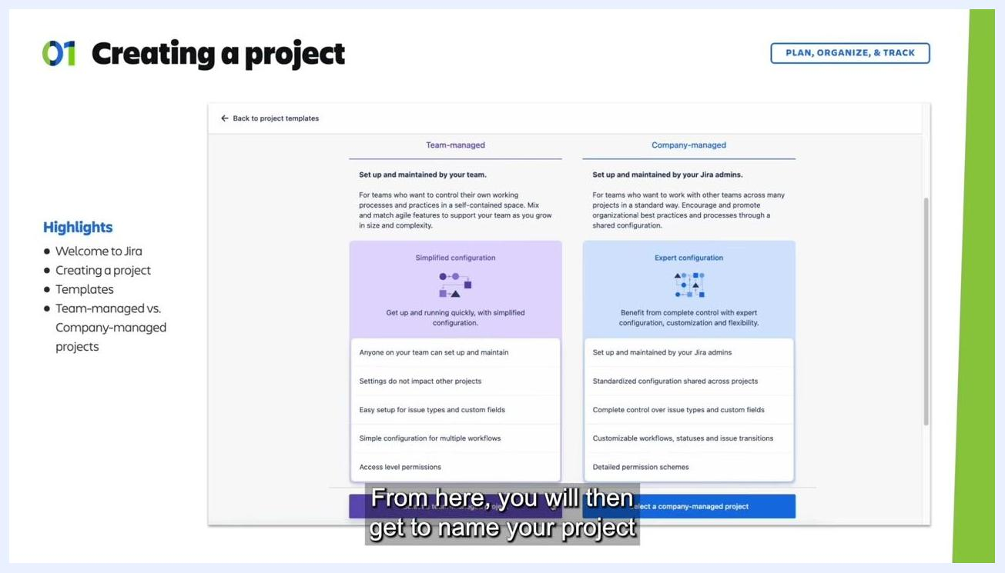
Jira "Add project details" screen showing "Space Project" as the name with "Private" access selected.

Step 6: Connect Jira to other Atlassian products (optional)
On the Connect your work screen, you can link your project to other Atlassian products:
- Project pages: Connect to Confluence spaces for documentation.
- Security: Connect to Snyk for security container integration.
You can skip these integrations if you don't need them yet. Click Continue to proceed.
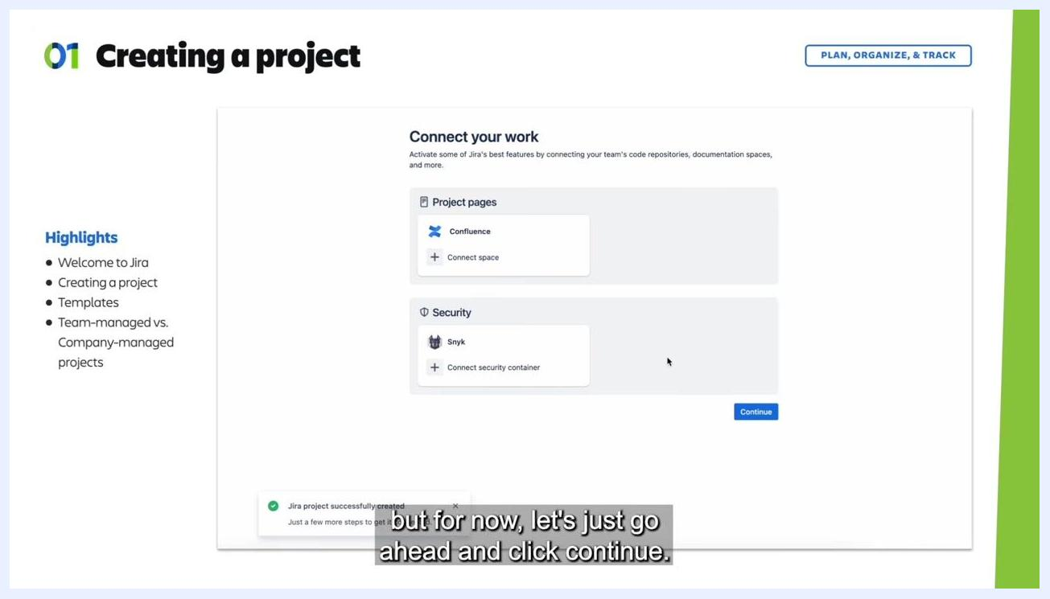
Jira "Connect your work" screen showing options to connect Confluence and Snyk, with the "Continue" button highlighted.

What's next
Once you complete these steps, your Jira project is created and ready for your team to start managing work. You can revisit the access level and integrations at any time as your team's needs evolve, and you can create additional projects using a different template or project type whenever a new initiative requires it.
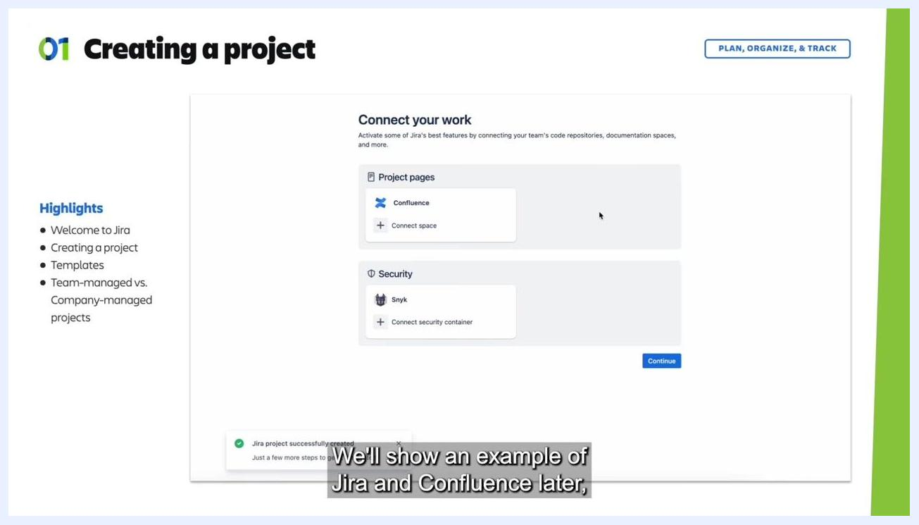
Atlassian Jira confirmation screen with logo, "Software to manage any project," and "Try it for free" message.

