How to Build a Sprint Dashboard in Jira Software
Jira dashboards are configurable pages where you can set up gauges or gadgets to display high-level, important information about your team's performance. Much like a car's dashboard, a Jira dashboard gives you an at-a-glance overview of key metrics and statuses. This guide walks you through creating a dashboard for a Scrum team, adding sprint-specific gadgets, building filters, and arranging everything into a comprehensive sprint overview.

Prerequisites
- Access to Jira Software Cloud (dashboards are also available in all other Jira products and deployment types).
- A Scrum project with an active sprint and backlog you can view.
- Permission to create dashboards and filters in your Jira instance.
This guide uses a "Teams in Space" Scrum board as an example, but the same steps apply to any team or use case.

Step 1: Access your Scrum board
Before building a dashboard, confirm you can see your team's backlog and active sprint.

- Navigate to your project in Jira Software.
- Confirm that you can see the backlog and the active sprint for your team. In the example, the "Teams in Space" Scrum board shows the backlog and sprint issues.
- Note the navigation options available:
- The left sidebar includes Backlog, Active sprints, Reports, Releases, Issues and filters, Pages, Components, Add item, and Project settings.
- The main panel displays the current sprint (for example, "Sprint 7") along with its issues, as well as the backlog.
- The top navigation bar includes Projects, Your work, Filters, Dashboards, People, Apps, and a Create button.
- The user avatar and search bar appear in the top right, along with the current time.
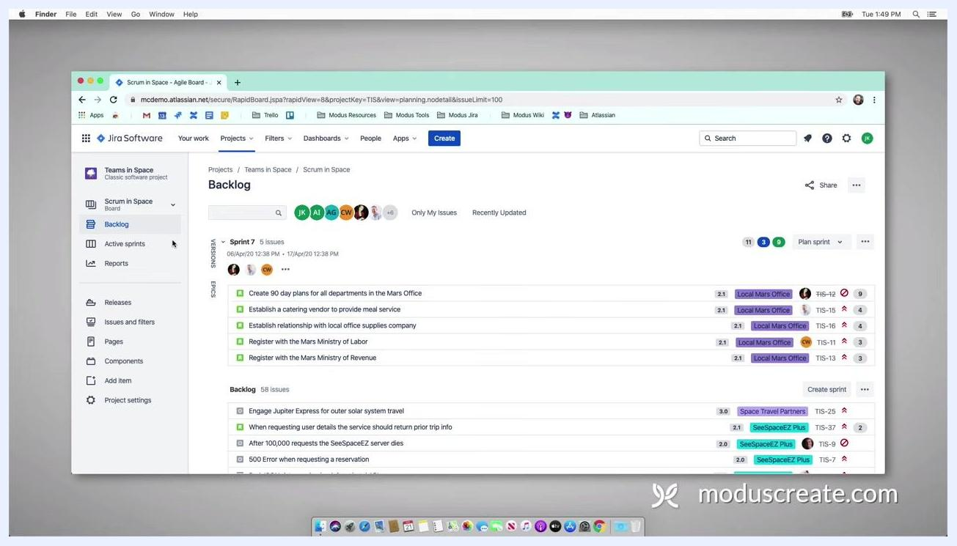
Jira Software Scrum board with backlog and active sprint visible, showing issues, the navigation sidebar, and the top menu

Step 2: Create a new dashboard

- Go to the Dashboards menu in the top navigation bar.
- Select Create Dashboard from the dropdown menu.
- In the Create dashboard dialog, enter a dashboard name (for example, "Sprint in Space").
- Optionally, add a description for your dashboard.
- In the Access section, choose who can view the dashboard. The available options are:
- Project: Restrict access to a specific project.
- Group: Restrict access to a specific group.
- Open: Allow any logged-in user to access the dashboard.
- Private: Keep the dashboard visible only to yourself.

- For this example, select Open so that any logged-in user can access the dashboard.
Create dashboard dialog in Jira showing name, description, and access options (Project, Group, Open, Private)

- Click Add to confirm the access setting.
- Click Save to create the dashboard.
You now have a new, accessible dashboard in Jira Software Cloud, ready to be customized for your Scrum team's needs.

Step 3: Add sprint gadgets to your dashboard
Your newly created "Sprint in Space" dashboard starts out empty, prompting you to add gadgets.

- Navigate to the top right of the dashboard and click Add gadget.
- In the Add a gadget dialog, use the search bar to type sprint.
- Review the available gadgets, which are provided to all Jira Software users by default:
- Days Remaining in Sprint Gadget
- Sprint Burndown Gadget
- Sprint Health Gadget
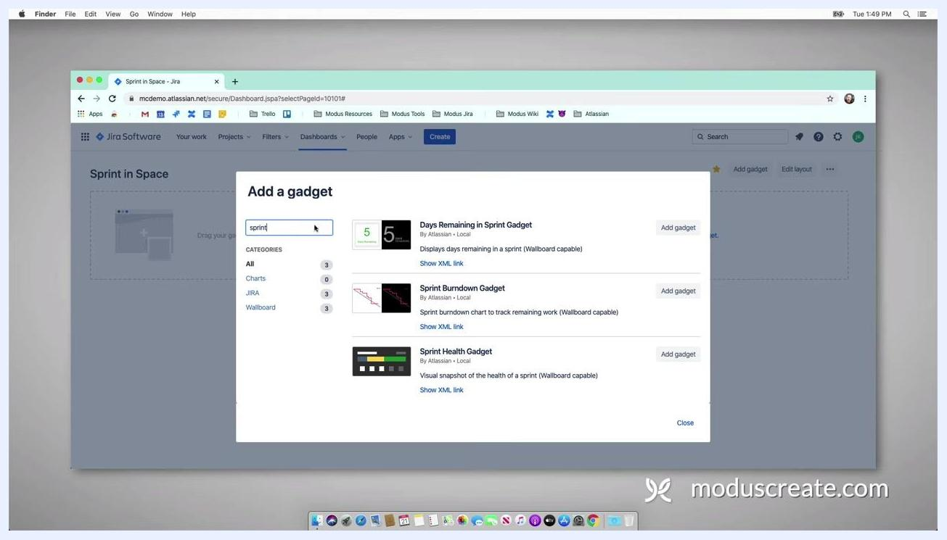
Add a gadget dialog in Jira with a search for "sprint" listing three gadgets: Days Remaining in Sprint, Sprint Burndown, and Sprint Health

- Click Add gadget next to each of the three gadgets listed above.
- After adding the gadgets, click Close at the bottom of the dialog.
- Rearrange the gadgets on your dashboard:
- Move the Sprint Health Gadget to a lower position.
- Move the Days Remaining in Sprint Gadget to the top position.

Step 4: Configure the Days Remaining in Sprint gadget

- In the gadget settings, select Board = Scrum in Space from the dropdown.
- Check Show board name.
- For Sprint, select Next Sprint Due (auto).
- Optionally, enable Update every 15 minutes for auto-refresh.
- Click Save to apply the settings.
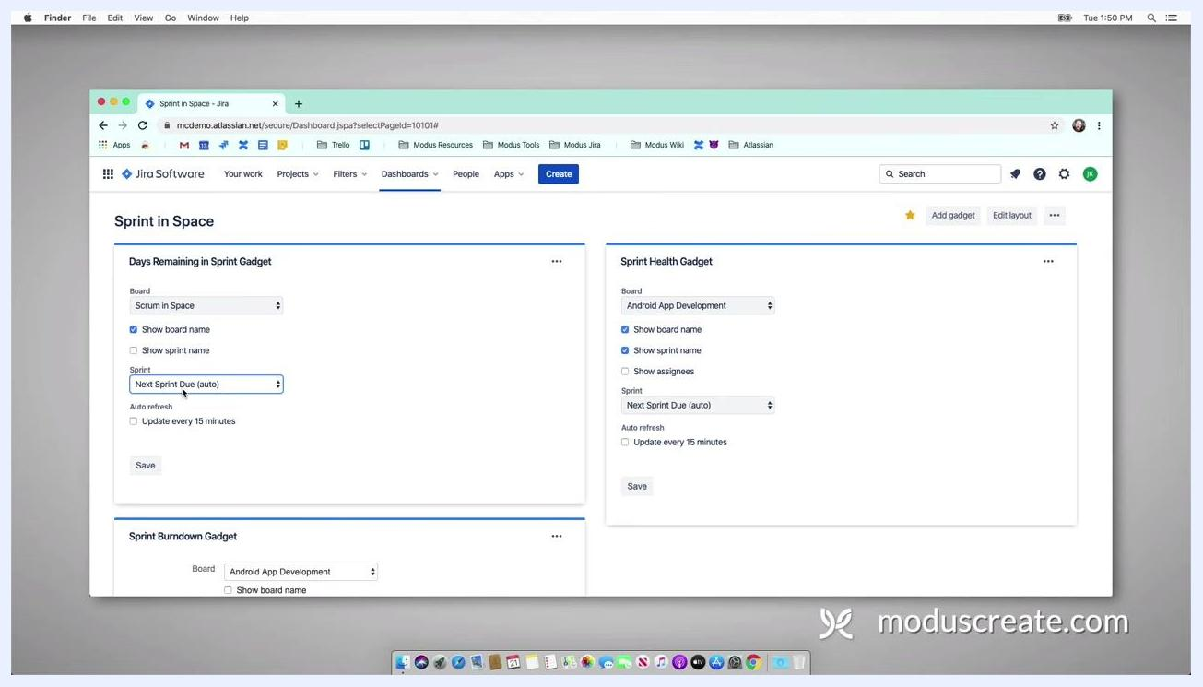
Configuring the Days Remaining in Sprint gadget with board set to "Scrum in Space," Show board name checked, sprint set to "Next Sprint Due (auto)," and the Save button visible

Step 5: Configure the Sprint Health gadget

- In the gadget settings, select Board = Scrum in Space from the dropdown.
- Check the following options:
- Show board name
- Show sprint name
- Show assignees

- For Sprint, select Next Sprint Due (auto).
- Enable Update every 15 minutes for auto-refresh.
- Click Save to apply the settings.
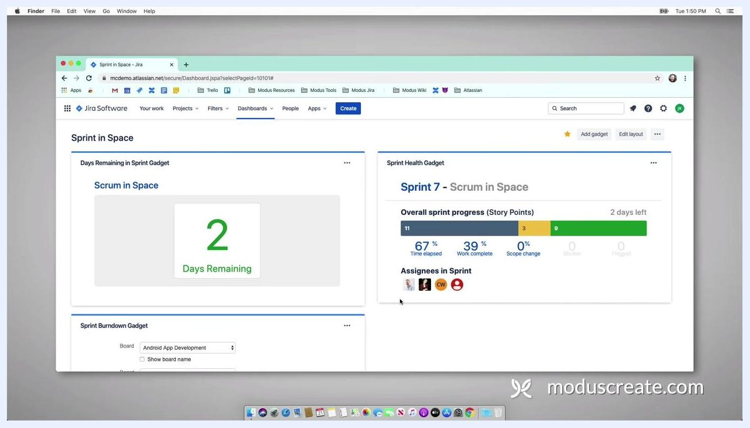
Sprint Health gadget configured for the "Scrum in Space" board, showing board name, sprint name, assignees, and auto-refresh enabled

Step 6: Configure the Sprint Burndown gadget

- In the gadget settings, select Board = Scrum in Space from the dropdown.
- For Sprint, select Next Sprint Due (auto).
- Optionally, enable Show board name and Show sprint name as needed.
- Set the Refresh Interval to your preference (for example, every 15 minutes).
- Click Save to apply the settings.
Sprint Burndown gadget being configured with the board dropdown open and "Scrum in Space" being selected
With these three gadgets in place, your dashboard will dynamically update with each new sprint and provide your team with real-time, actionable insights.

Step 7: Customize the dashboard layout

- Click the Edit layout button at the top right of your Jira dashboard.
- Review the available layout options, such as resizing columns or switching to a three-column layout.
- Select your preferred layout (for example, a three-column layout) to better organize your gadgets.
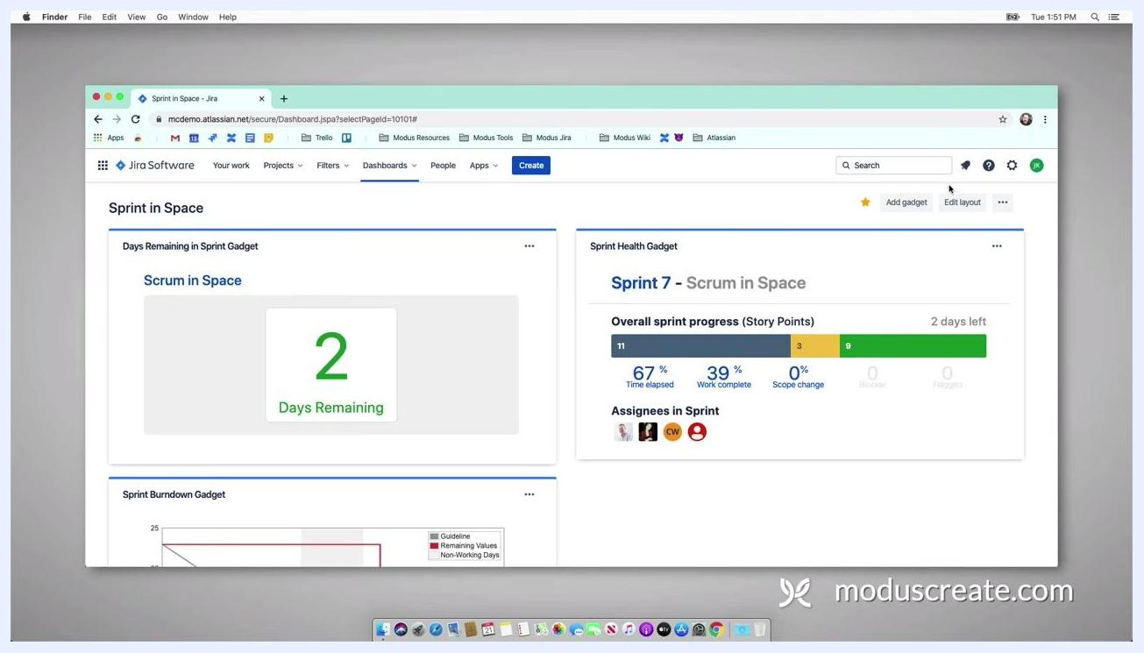
Jira dashboard with gadgets displayed and the Edit layout button visible, showing options to customize the dashboard layout

- Assess your dashboard after changing the layout and decide whether additional gadgets are needed to enhance its usefulness.

Step 8: Create a filter for your active sprint

- Navigate to the top menu and click Filters.
- In the dropdown, select Advanced issue search to open the issue navigator.
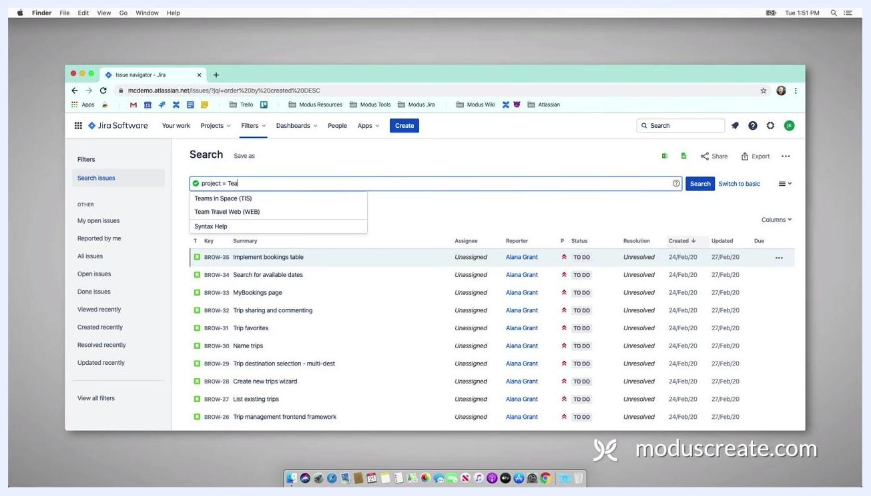
Jira dashboard with the Filters menu open, showing options for View all filters and Advanced issue search

- In the search bar, enter the following JQL (Jira Query Language) to filter issues:
- project = "Teams in Space"

- Wait for Jira to auto-populate project options, then select Teams in Space.
Jira issue navigator with the search bar partially filled ("project = Tea"), showing auto-suggestions for Teams in Space and Team Travel Web

- Continue your JQL query by adding a sprint condition:
- project = "Teams in Space" and sprint in

- Review Jira's auto-suggestions for dynamic sprint values:
- closedSprints() for closed sprints
- futureSprints() for sprints not yet started
- openSprints() for the current active sprint

- Select openSprints() to focus on the current sprint.
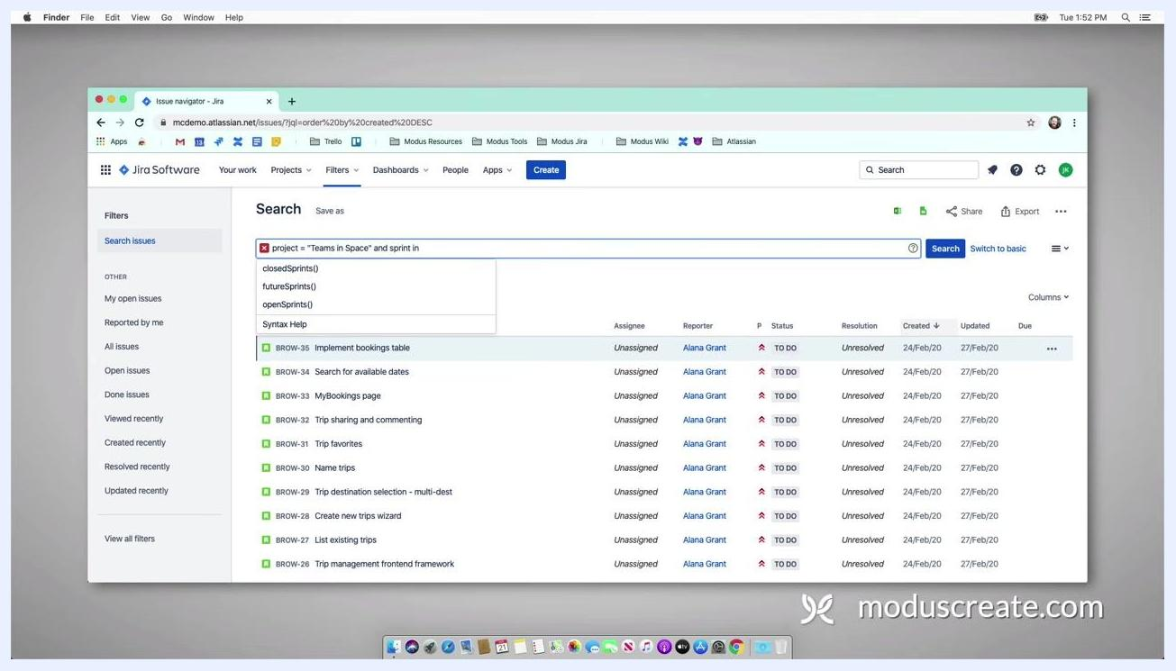
Jira issue navigator with the JQL query being typed ("project = \"Teams in Space\" and sprint in"), showing auto-suggestions for closedSprints(), futureSprints(), and openSprints()

- Click Search to run your query.
- Review the list of issues that match your filter criteria.
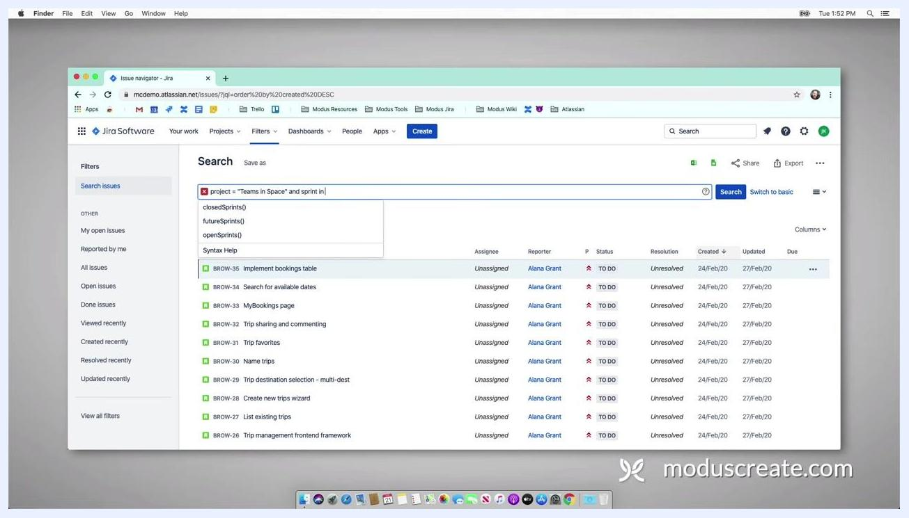
Jira issue navigator with the JQL query "project = \"Teams in Space\" and sprint in openSprints()," showing filtered issues

Step 9: Save and share your filter

- Click the Save as button above the search bar.
- Enter a filter name, such as TIS - Active Sprint.
- Confirm and save the filter.
Jira issue navigator with the Save as button highlighted, ready to save the filter for active sprints

- After saving, click the Details link next to your filter name.
- Click Edit permissions.
- In the permissions dialog, select Open to allow anyone with access to the dashboard to view this filter.
- Click Add to apply the permission changes.
Jira filter details screen for TIS - Active Sprint, showing the saved filter and options to edit permissions
This filter can now be used to power gadgets and ensure all dashboard viewers have access to the relevant issues.

Step 10: Confirm filter permissions

- In the TIS - Active Sprint filter view, click the Details link next to the filter name.
- In the pop-up window, locate the Permissions section.
- Click Edit permissions to modify who can view the filter.
- Review the available sharing options in the permissions dialog.
- Select Open to make the filter visible to anyone with access to the dashboard.
- Click Add to apply the new permission setting.
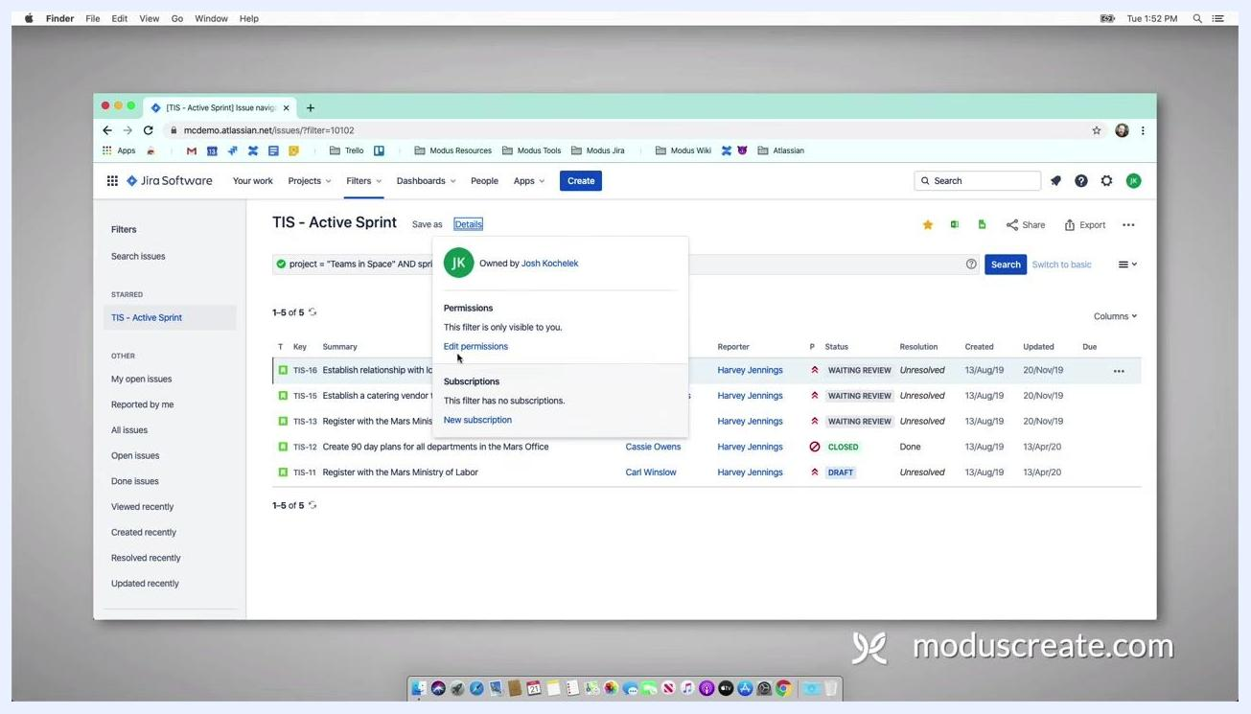
Jira filter details pop-up for TIS - Active Sprint, showing the Edit permissions option being selected, with filter ownership and subscription details visible
In this view, the filter TIS - Active Sprint is selected in the left sidebar under "Starred." The details pop-up shows the owner's initials and name, a permissions section indicating the filter is currently visible only to the owner, a highlighted Edit permissions link, and a subscriptions section with no subscriptions yet. The main issue list displays five issues with their keys, summaries, reporters, statuses, resolutions, and dates.
Completing this step ensures that your saved filter is accessible to all intended dashboard viewers, enabling effective sharing and collaboration within Jira.

Step 11: Select your dashboard and review existing gadgets

- Open Jira Software and navigate to your project.
- Click on the Dashboards menu at the top.
- In the dropdown, select your starred dashboard, for example, Sprint in Space. If it hasn't been created yet, choose Create dashboard to make a new one.
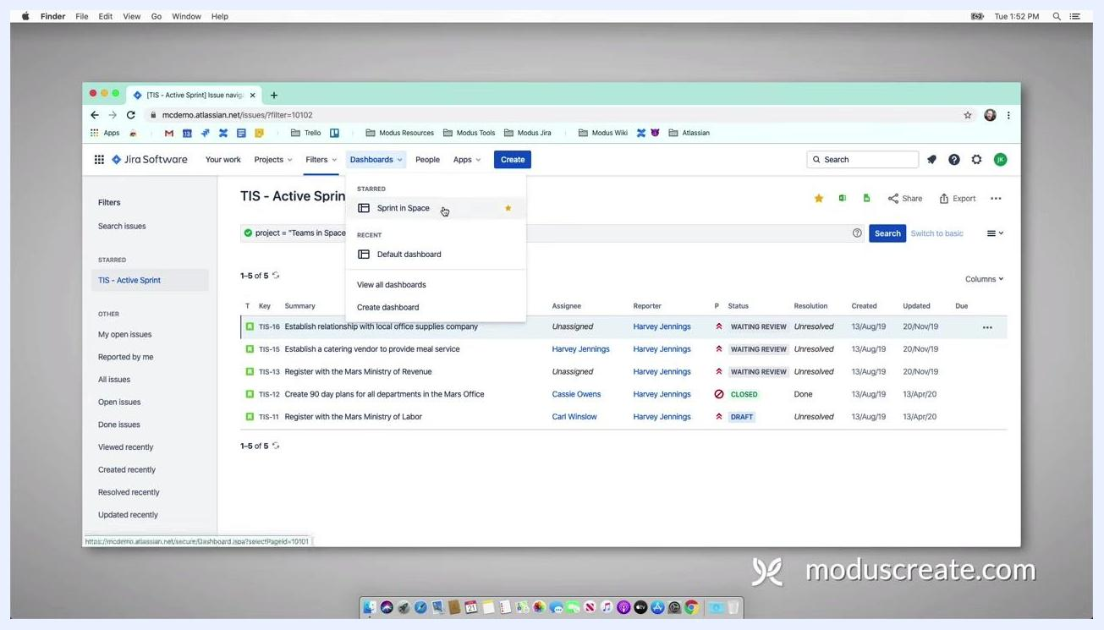
Jira dashboard selection dropdown open, showing "Sprint in Space" starred and "Default dashboard" under Recent. The main screen lists issues for "TIS - Active Sprint" with columns for Key, Summary, Assignee, Reporter, Status, Resolution, Created, Updated, and Due

- On the dashboard, observe the existing gadgets:
- Pie Chart (not yet configured)
- Sprint Health Gadget (showing Sprint 7 - Scrum in Space)
- Days Remaining in Sprint Gadget

- Note that the Sprint Health gadget displays overall sprint progress in story points (11 points, 67% time elapsed, 39% work complete, 0% scope change), assignees in the sprint with their avatars, and the number of days left in the sprint (2 days).
Dashboard titled "Sprint in Space" with a Pie Chart gadget (no filter/project selected), a Sprint Health gadget (Sprint 7 - Scrum in Space), and a Days Remaining in Sprint gadget

Step 12: Configure the Pie Chart gadget

- In the Pie Chart gadget, click the Search field under "Project or Saved Filter."
- Enter or select the filter for your current sprint, for example, TIS - Active Sprint.
- Ensure Statistic Type is set to Assignee.
- Optionally, check Update every 15 minutes for auto-refresh.
- Click Save to apply the configuration.
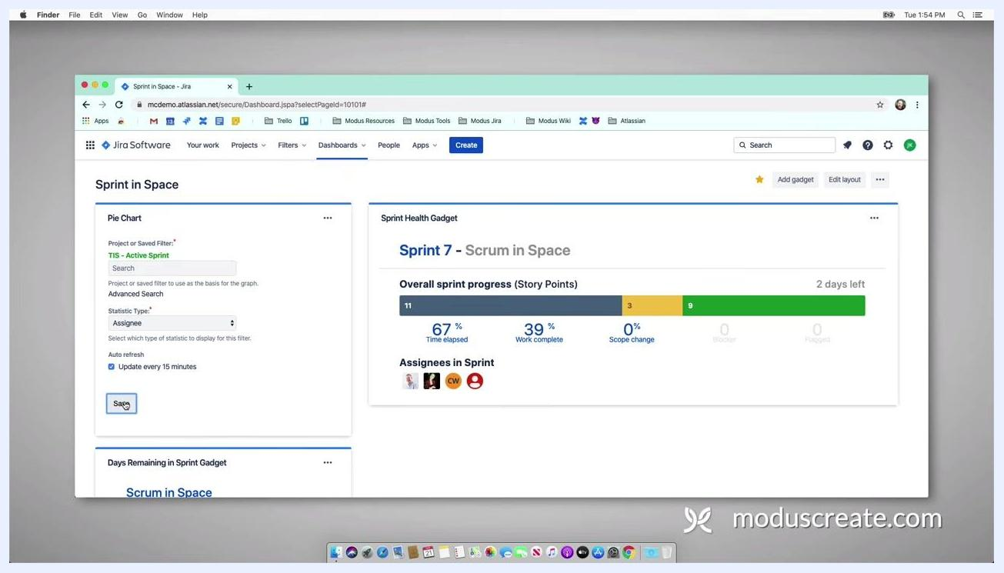
Pie Chart gadget being configured, with "TIS - Active Sprint" selected as the filter, Statistic Type set to Assignee, and the Save button highlighted; the Sprint Health gadget is visible on the right

- Confirm that the Pie Chart gadget now uses the "TIS - Active Sprint" filter. The gadget will display a pie chart breaking down issues by assignee for the current sprint.

Step 13: Review the Days Remaining and Sprint Health gadgets

- Check the Days Remaining in Sprint Gadget, which shows the number of days left (for example, "2 Days Remaining").
- Confirm that the Sprint Health Gadget continues to display sprint progress and assignees.
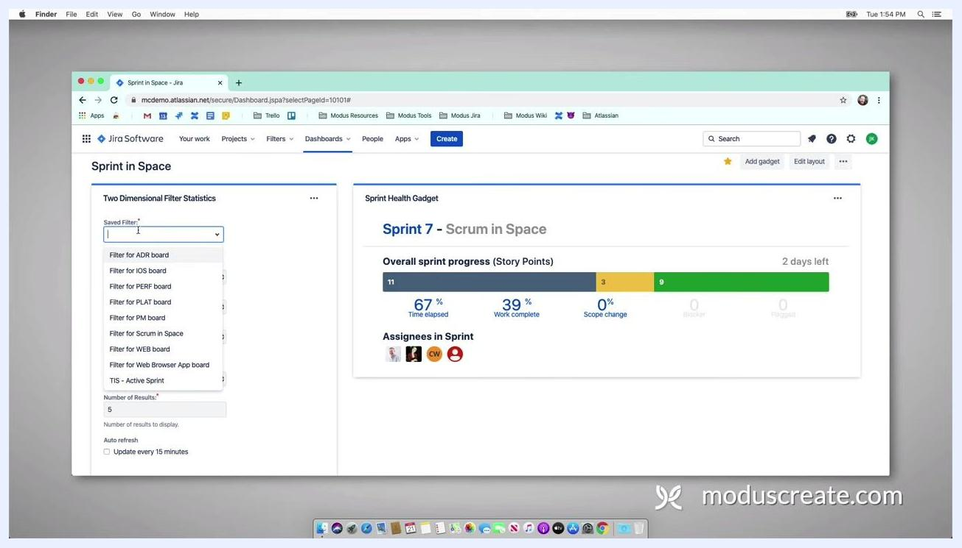
Dashboard showing the Days Remaining in Sprint gadget ("2 Days Remaining"), the Sprint Health gadget, and the Sprint Burndown gadget partially visible

Step 14: Configure the Two Dimensional Filter Statistics gadget

- Locate the Two Dimensional Filter Statistics gadget on your dashboard.
- In the Saved Filter dropdown, select TIS - Active Sprint.
- In the next dropdown, choose the first dimension (for example, Assignee).
- In the second dropdown, select the second dimension (for example, Sprint or another relevant field).
- Set the Number of Results (for example, 5).
- Optionally, enable Update every 15 minutes.
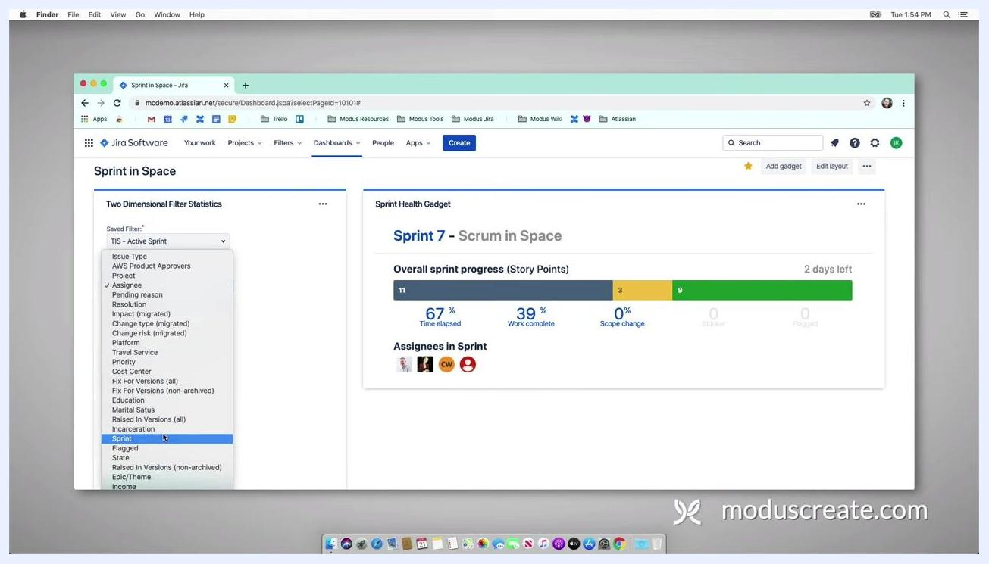
Two Dimensional Filter Statistics gadget being configured, with "TIS - Active Sprint" selected and a dropdown for dimension selection open showing options like Issue Type, Assignee, and Sprint

- After configuration, review the gadget's output table, which breaks down issues by Assignee and Status (for example, WAITING REVIEW, DRAFT, CLOSED). In the example:
- Carl Winslow: 1 Draft, 1 Closed
- Cassie Owens: 1 Closed
- Harvey Jennings: 1 Closed
- Unassigned: 2 Waiting Review, 1 Draft, 2 Total

- Note that the table is grouped by status and shows the total number of unique issues.
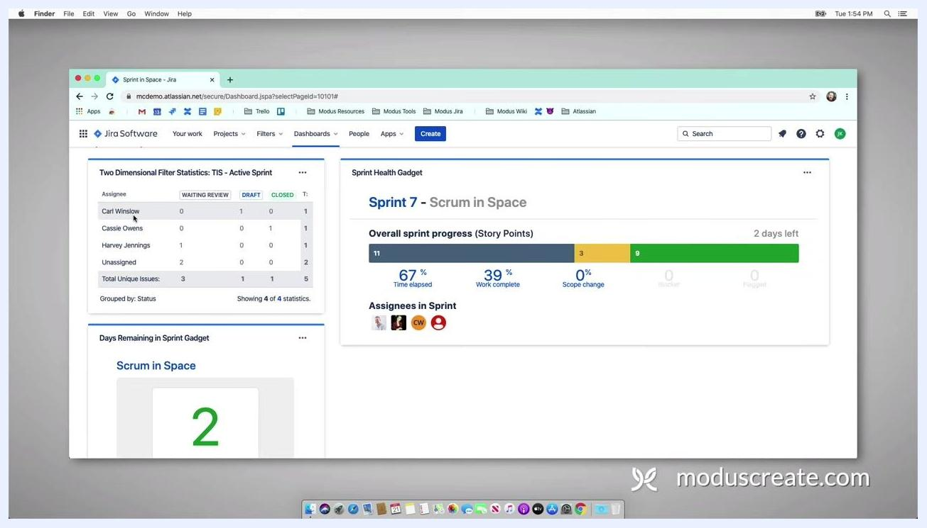
Two Dimensional Filter Statistics gadget showing a table with assignees (Carl Winslow, Cassie Owens, Harvey Jennings, Unassigned) and statuses (WAITING REVIEW, DRAFT, CLOSED) with counts for each

- Drag and arrange gadgets as needed for optimal visibility, and review the dashboard to confirm all gadgets display the correct data for the current sprint.
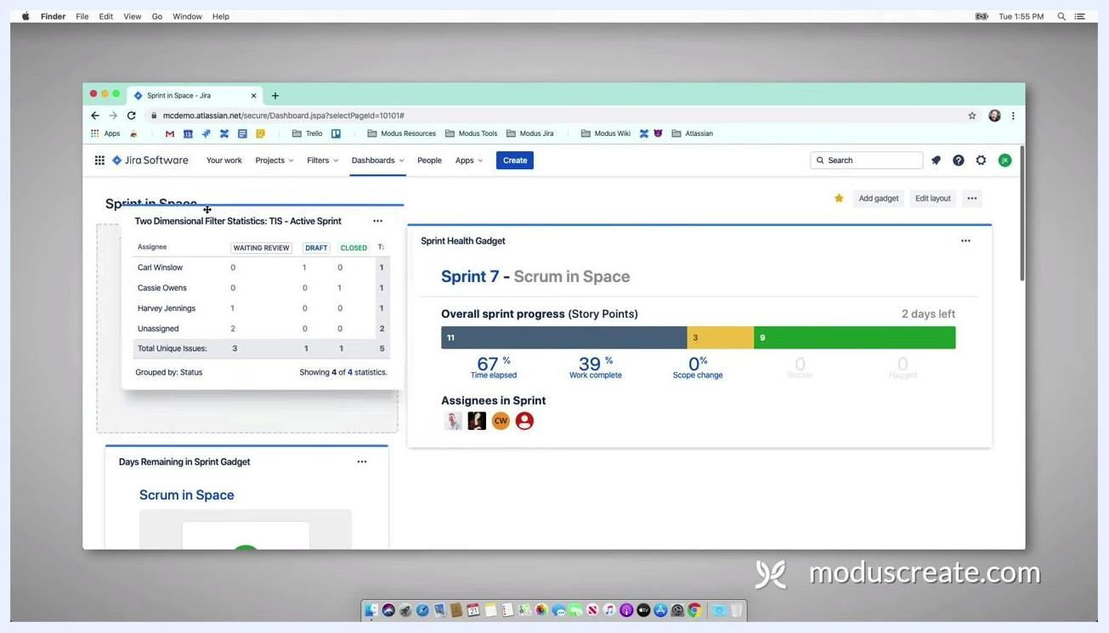
Dashboard overview with the Two Dimensional Filter Statistics gadget, the Days Remaining in Sprint gadget, and the Sprint Health gadget all visible and populated
At this point, your dashboard provides a comprehensive overview of sprint progress, issue breakdown by assignee and status, and days remaining.

Step 15: Add the Filter Results gadget

- On your Jira dashboard, click the Add gadget button at the top right of the dashboard screen.
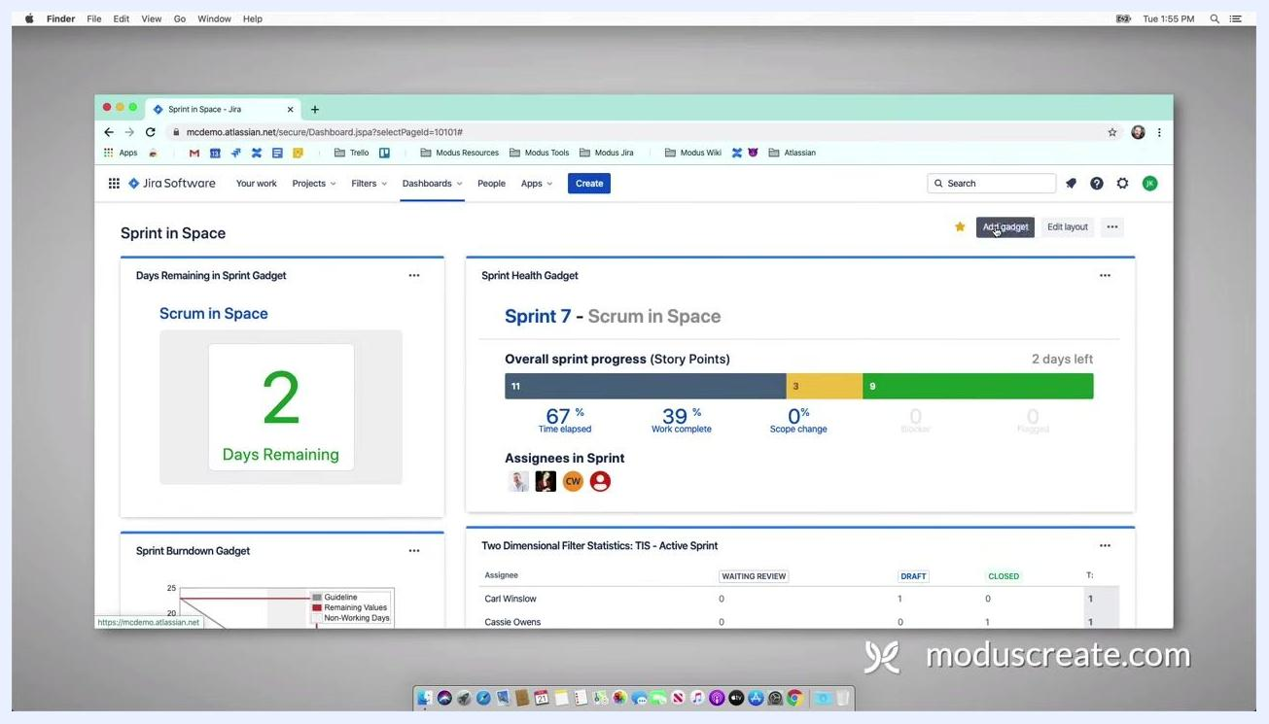
Jira dashboard with the "Add gadget" button highlighted, showing existing gadgets: Days Remaining in Sprint, Sprint Health, Sprint Burndown, and Two Dimensional Filter Statistics

- In the gadget selection menu, locate and add the Filter Results gadget to your dashboard.

Step 16: Configure the Filter Results gadget

- In the Filter Results gadget, click the Saved Filter dropdown.
- Select the filter for your current sprint, for example, TIS - Active Sprint. The dropdown lists available filters such as "Filter for ADR board," "Filter for iOS board," "Filter for Scrum in Space," and "TIS - Active Sprint."
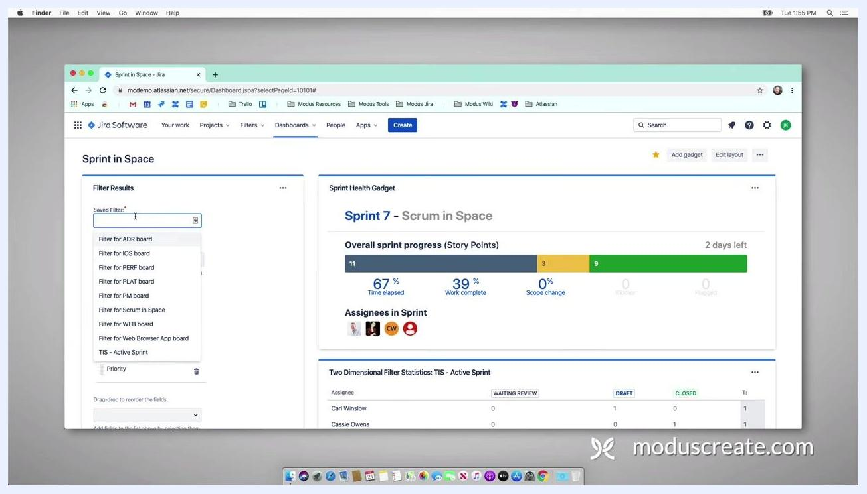
Filter Results gadget being configured, with the Saved Filter dropdown open showing options like "TIS - Active Sprint" and others; the Sprint Health gadget is visible on the right

- Enter the Number of Results to display (for example, 10).
- In the Columns to display section, select the fields you want to show, such as:
- Issue Type
- Key
- Summary
- Priority
- Optionally, add more fields such as Story Points by selecting them from the dropdown.

- Drag and drop fields to reorder them as needed.
- Optionally, check Update every 15 minutes to enable auto-refresh.
- Click Save to apply your configuration.
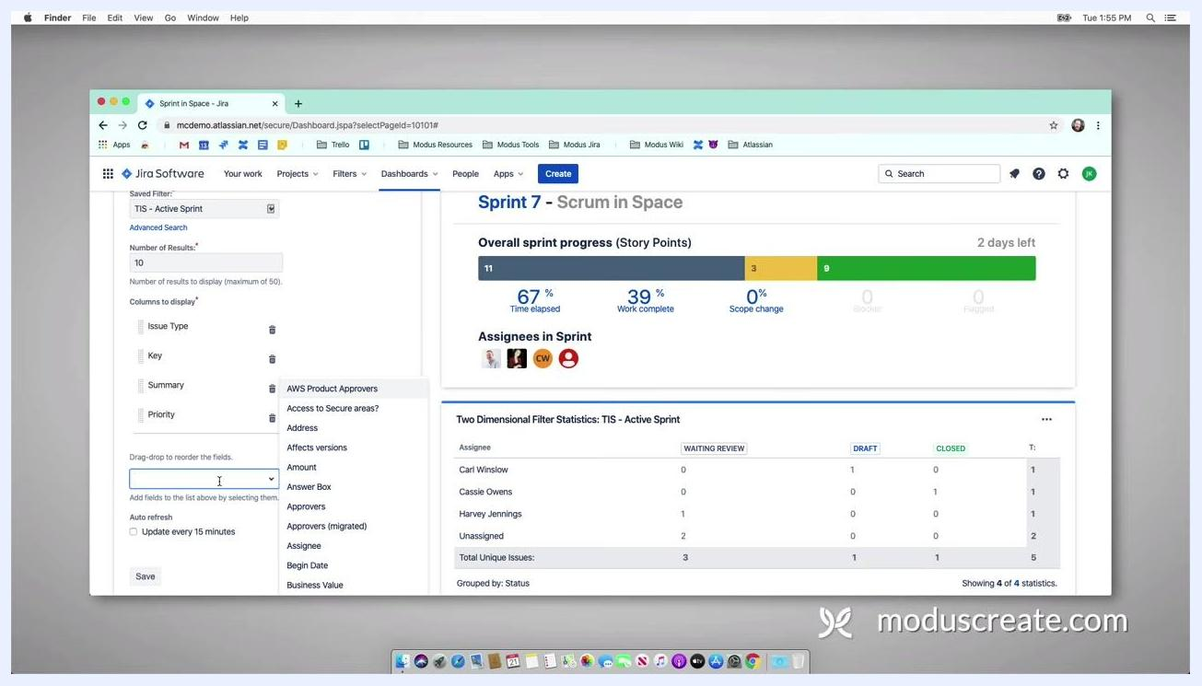
Filter Results gadget configuration with "TIS - Active Sprint" selected, 10 results, columns for Issue Type, Key, Summary, and Priority, and the field selection dropdown open

- Review the gadget's output, which now displays a list of issues for the active sprint with the selected columns. In the example, the Key column shows TIS-16, TIS-15, TIS-13, TIS-12, and TIS-11, with corresponding summaries and story points of 4, 4, 3, 9, and 3. This list provides a clear, sortable view of sprint issues and their details.
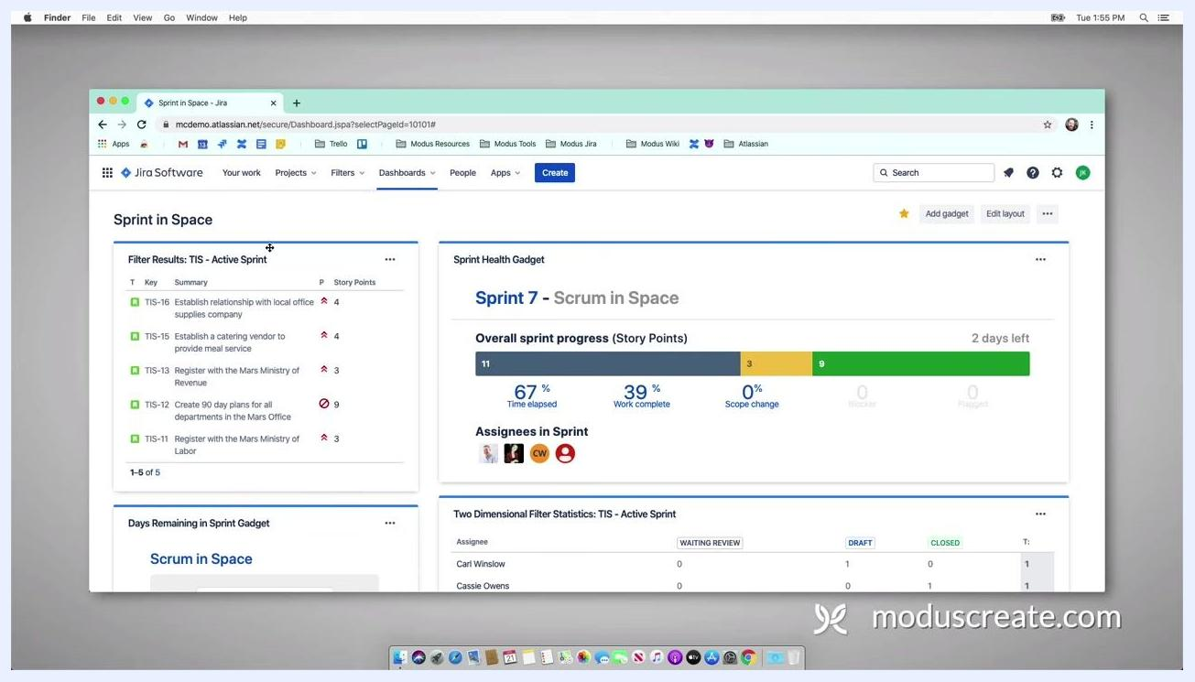
Filter Results gadget displaying issues for "TIS - Active Sprint" with columns for Key, Summary, and Story Points

Step 17: Review your completed dashboard
Observe the dashboard with all configured gadgets in place:
- Days Remaining in Sprint Gadget (shows days left)
- Sprint Health Gadget (shows sprint progress and assignees)
- Sprint Burndown Gadget (shows progress against sprint timeline)
- Two Dimensional Filter Statistics Gadget (breakdown by assignee and status)
- Pie Chart Gadget (issue distribution by assignee)
- Filter Results Gadget (detailed issue list)
Dashboard showing the Sprint Burndown gadget, Two Dimensional Filter Statistics gadget, and Filter Results gadget together
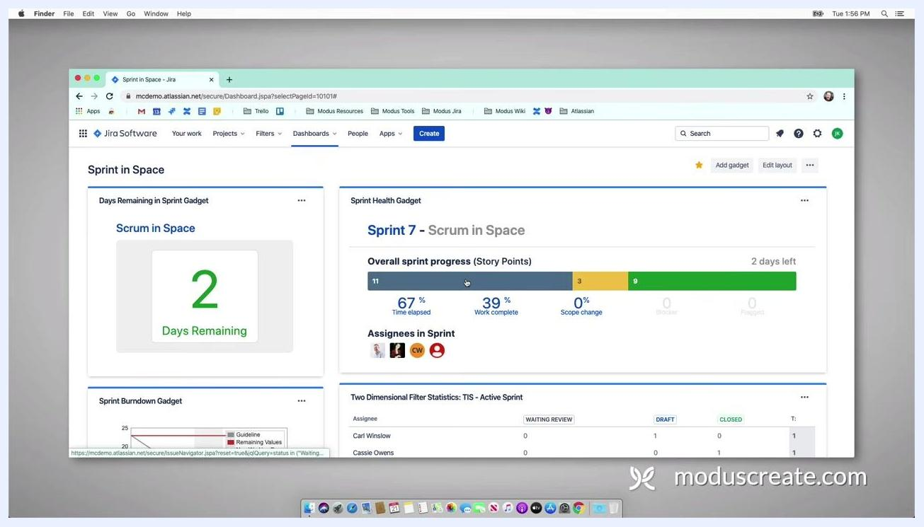
Dashboard with Days Remaining, Sprint Health, Sprint Burndown, Two Dimensional Filter Statistics, and Filter Results gadgets all visible
Pie Chart gadget (TIS - Active Sprint) and Filter Results gadget side by side, showing issue breakdown and a detailed list
The dashboard now provides a comprehensive overview of sprint status, workload, and progress.

Getting help
If your team is new to Jira, has been using Jira for a while, or wants to maximize the value from the application, consider reaching out for expert guidance and support.
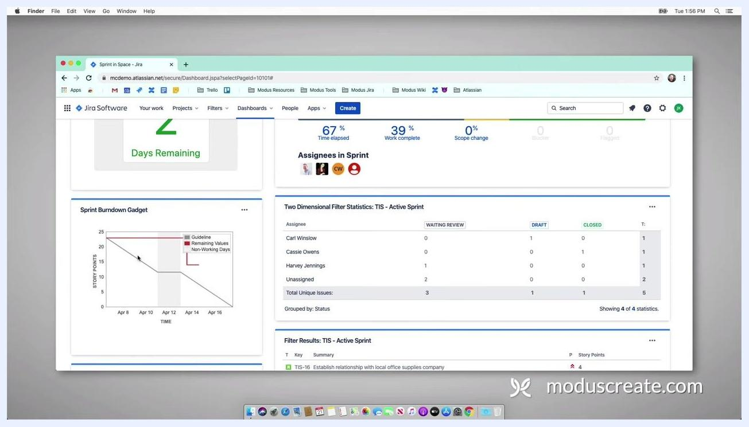
Presenter in a home/office setting speaking directly to the camera, offering Jira support, with a whiteboard and office equipment visible in the background
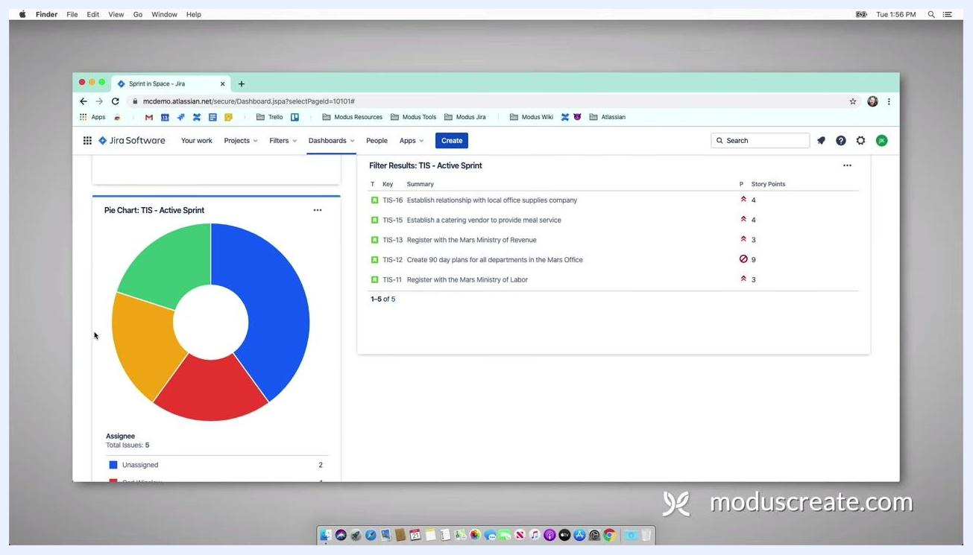
Presenter smiling, continuing to offer support and encouraging viewers to reach out for Jira assistance

What's next
By following these steps, you now have a Jira dashboard that visualizes sprint progress, workload distribution, and days remaining, while also providing detailed, actionable lists of sprint issues. For further assistance or to optimize your Jira setup, consider reaching out to a Jira expert or your Jira administrator.

Black background with a large, stylized white logo centered above the word "MODUS" in bold, uppercase letters, with no other objects, people, or UI elements present

