How to create a board in Jira
Jira lets you build boards that fit the way your team works, whether that's a simple project board, a portfolio view spanning several projects, or a filtered board for specialized tracking. This guide walks you through how to create a board in Jira, from opening the board menu to configuring a Kanban board with issues pulled from multiple projects. It also covers how to track progress and use quick filters once your board is live.

Prerequisites
- Access to an existing Jira project.
- A company-managed project, if you plan to create more than one board. Team-managed projects support only one board per project.

Step 1: Navigate to your project
Open Jira and go to one of your existing projects. This is your starting point for creating a new board.

Step 2: Open the board menu
At the top of the project screen, click the Board dropdown menu. This menu lists your available boards and includes the option to create a new one at the bottom.
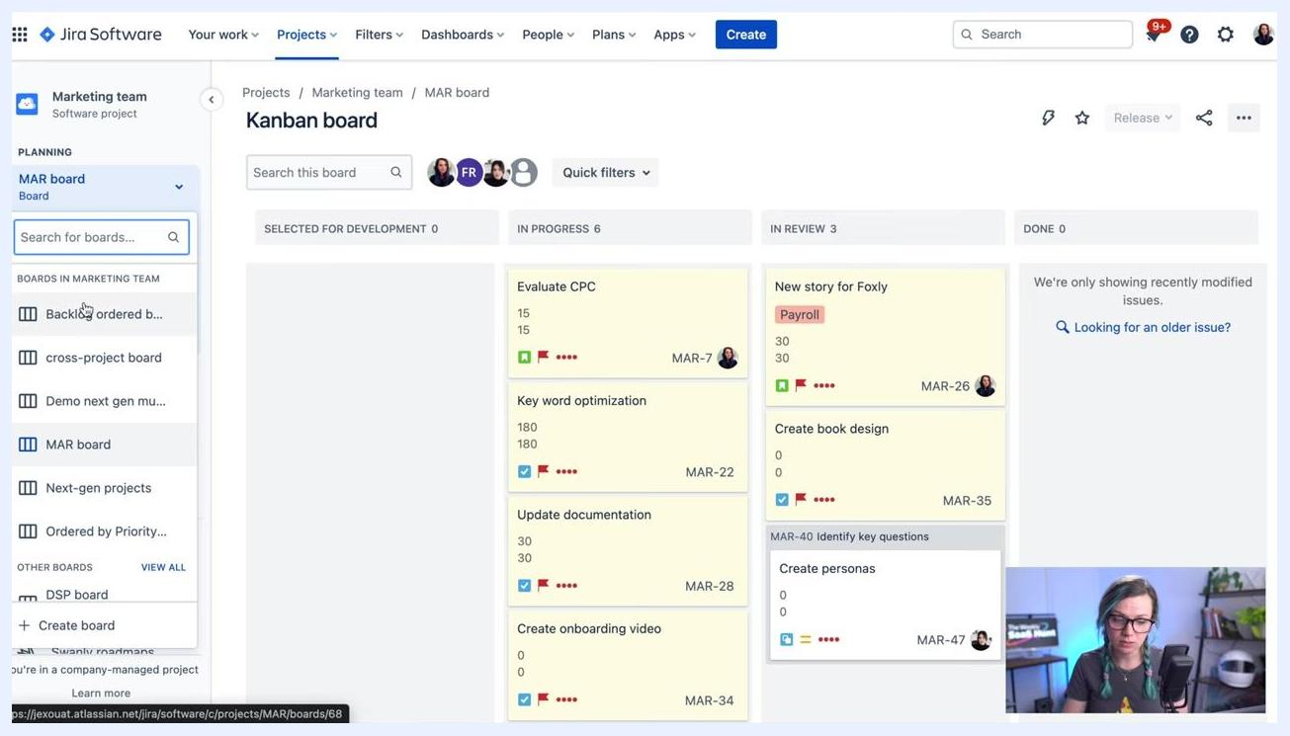
Jira project screen showing the Kanban board with the board dropdown menu open, listing available boards and the "+ Create board" option at the bottom

Step 3: Confirm your project type
Check the bottom left of the sidebar to confirm you're working in a company-managed project. If the sidebar shows this message, you can proceed to create additional boards. Only company-managed projects support multiple boards; team-managed projects allow just one.

Step 4: Open the create board dialog
In the Board dropdown, click + Create board to start the board creation process.

Step 5: Choose a board type
A dialog appears with two board type options: Scrum and Kanban. Scrum boards focus on planning, committing to, and delivering time-boxed chunks of work called Sprints. Kanban boards focus on visualizing your workflow and limiting work in progress to support incremental improvements.
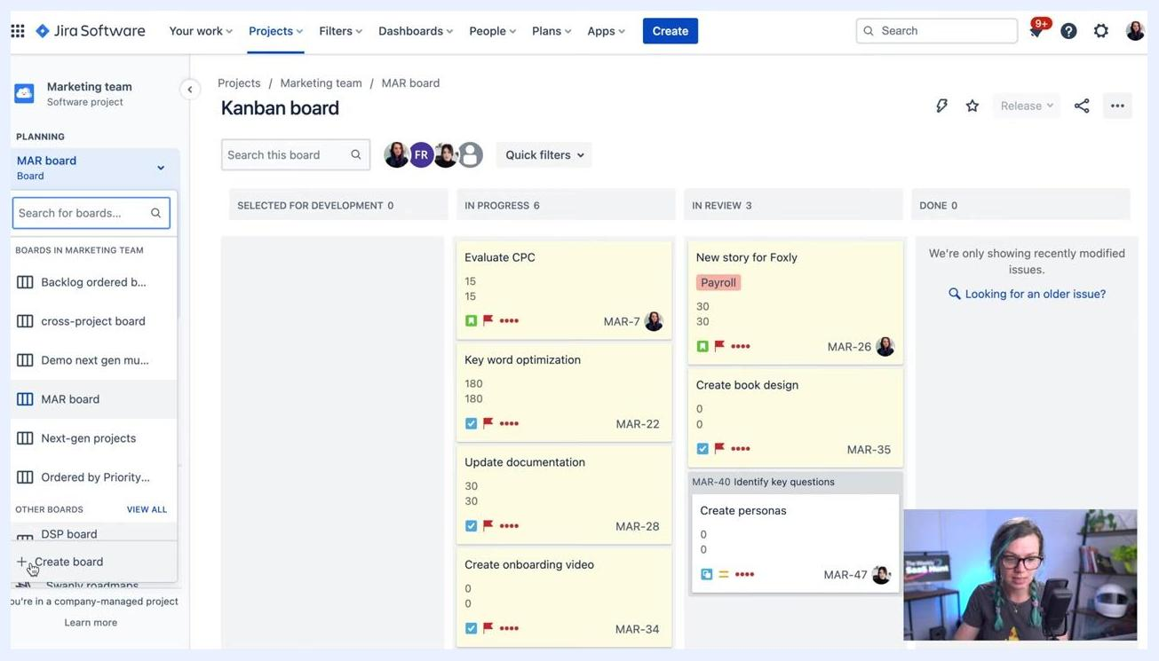
Jira dialog box offering options to create a Scrum board or a Kanban board, with descriptions and buttons for each type

Step 6: Select Kanban board
Click Create a Kanban board to continue with the Kanban option.
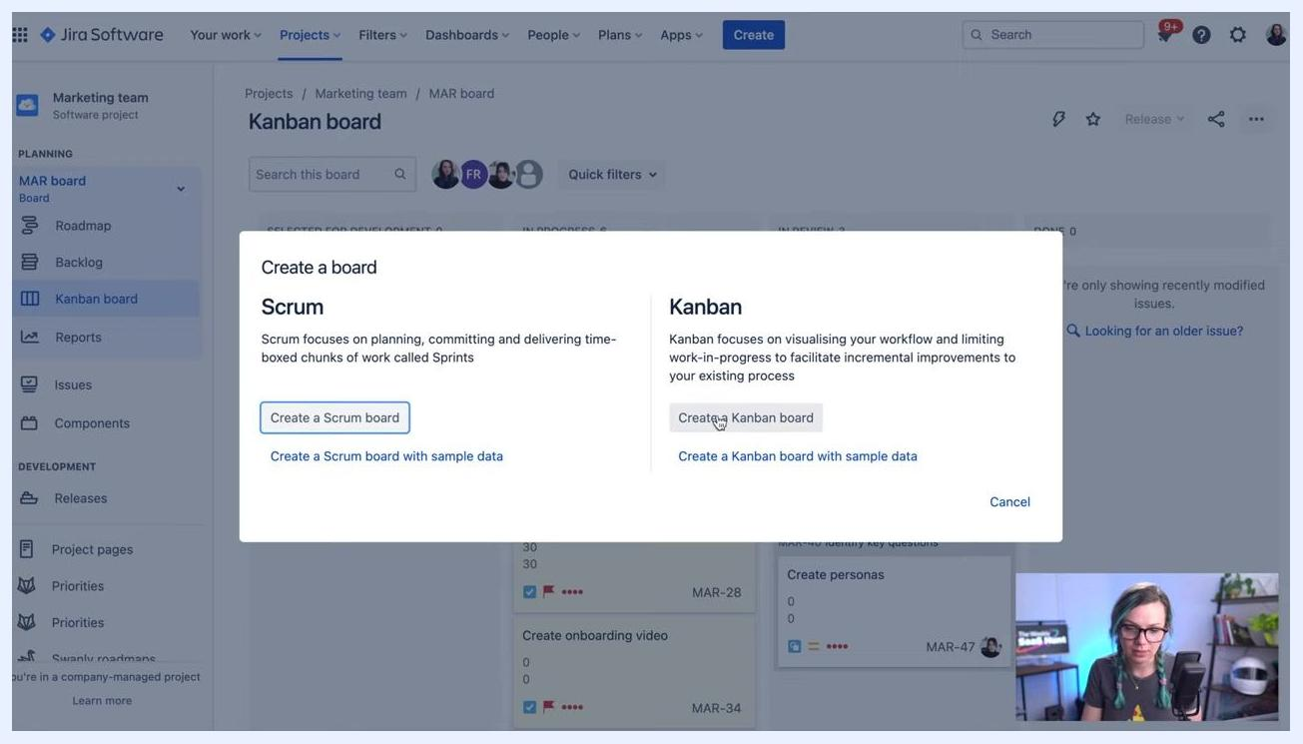
Jira dialog box with the "Create a Kanban board" button selected, ready to proceed to the next step

Step 7: Choose how to create your Kanban board
A Create a board dialog appears with three options, each suited to a different use case:
- Board created with new Software project: starts a new board based on a brand-new Software project, ideal when you don't want to mix in existing data.
- Board from an existing project: pulls issues from one or more existing projects into a single board.
- Board from an existing Saved Filter: an advanced option that uses a JQL filter to define which issues appear on the board.
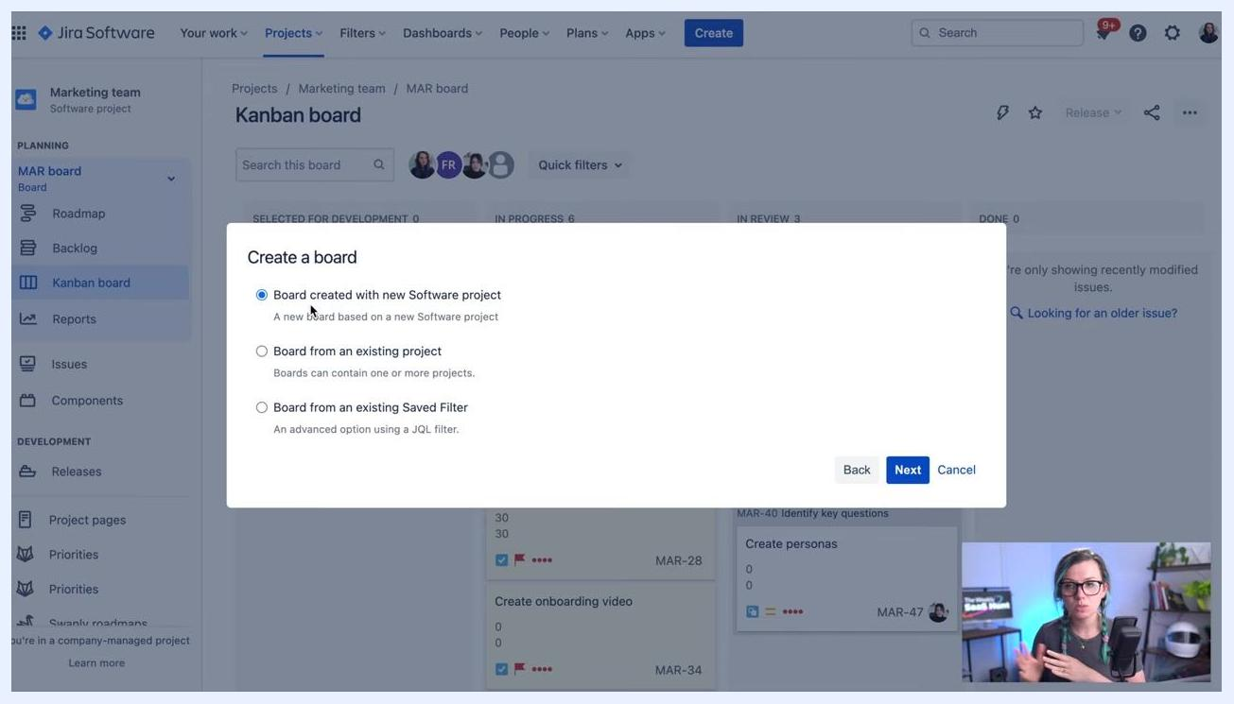
Jira "Create a board" dialog with three options: Board created with new Software project, Board from an existing project, and Board from an existing Saved Filter, with the first option selected

Step 8: Review the "board from an existing project" option
Select Board from an existing project if you want a Kanban board that aggregates issues from multiple software projects, such as one board per application you develop. This option works well for activities like stand-up meetings or portfolio overviews.
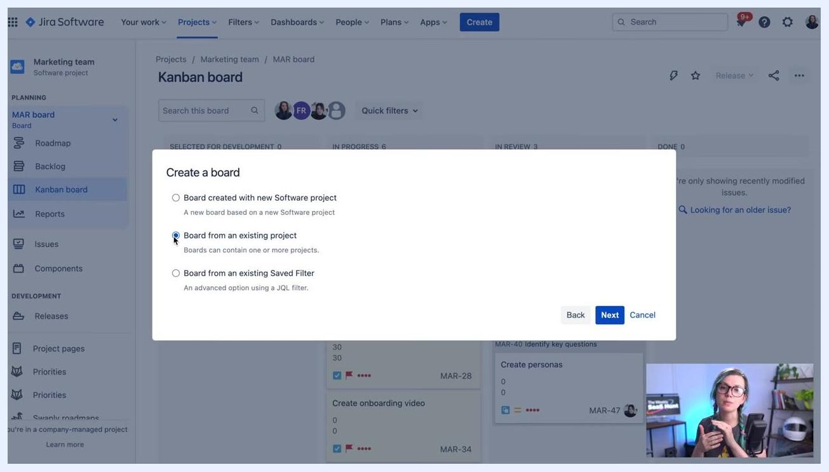
Jira "Create a board" dialog with "Board from an existing project" selected

Step 9: Review the "saved filter" option
Select Board from an existing Saved Filter for advanced tracking needs, such as showing only bugs for QA purposes. This option lets you filter issues across one or multiple projects using criteria like labels, creation date, custom fields, or any JQL expression.
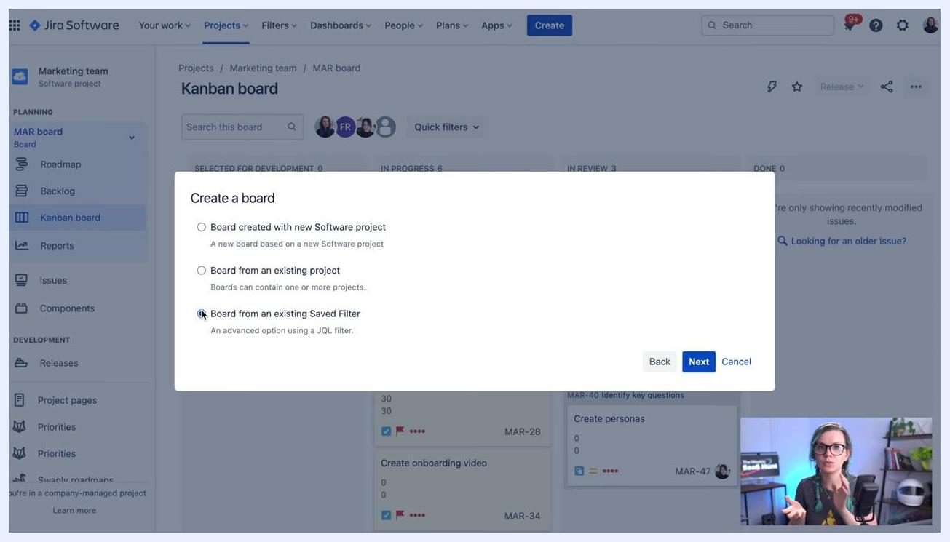
Jira "Create a board" dialog with "Board from an existing Saved Filter" selected

Step 10: Select "board from an existing project" and continue
Choose Board from an existing project by clicking its radio button, then click Next to move forward with configuring your board.
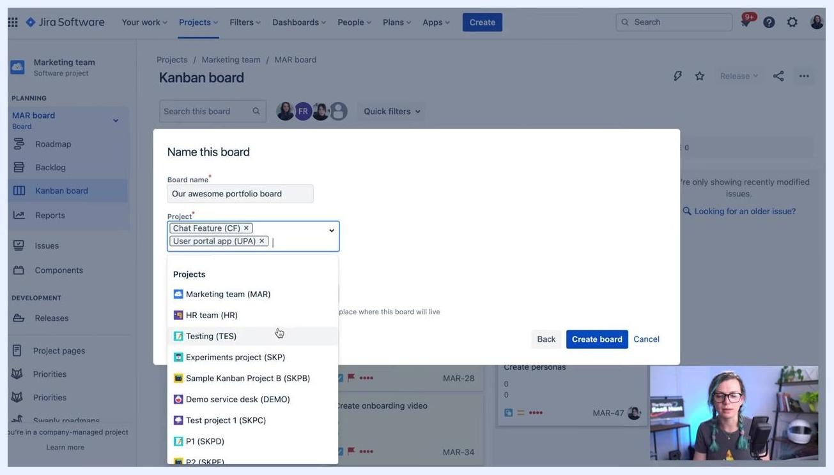
Jira "Create a board" dialog with "Board from an existing project" selected, ready to proceed

Step 11: Name your board and select projects
In the Name this board dialog, enter a name in the Board name field, such as Our awesome portfolio board. In the Project field, select one or more projects to include, for example: Chat Feature (CF), User portal app (UPA), and Marketing team (MAR). You can add as many projects as needed to aggregate their issues onto this board.
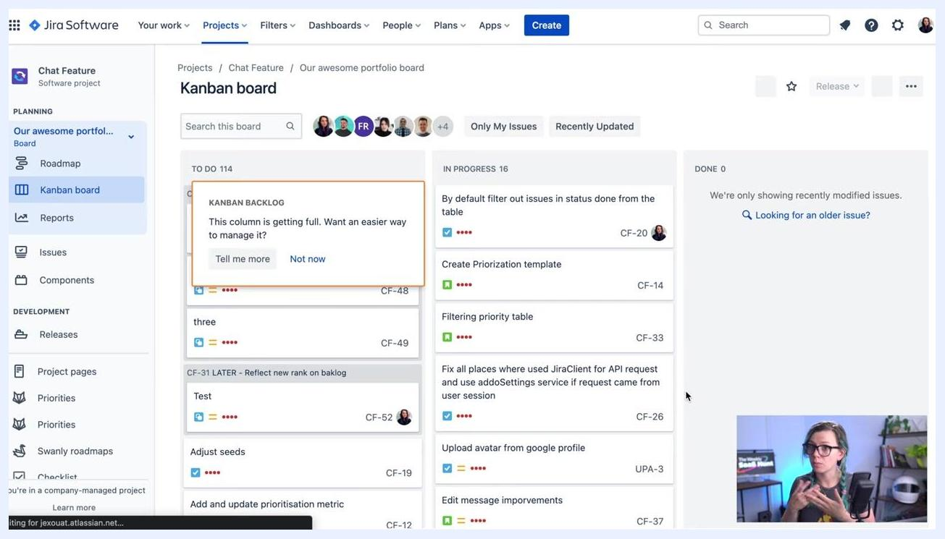
Jira "Name this board" dialog with multiple projects selected: Chat Feature (CF), User portal app (UPA), and Marketing team (MAR)

Step 12: Choose the board location
In the Location field, select where the board will be accessible from, either a software project or your own profile. For example, selecting Chat Feature (CF) determines where you'll find and access this board later.

Step 13: Create and view your board
Click Create board to finalize your new Kanban board. Jira displays the board with issues from all selected projects, organized into columns such as To Do, In Progress, and Done. You may see a notification if a column, such as the Kanban Backlog, is getting full, with options like Tell me more or Not now.
Jira Kanban board view showing issues from multiple projects, a Kanban Backlog notification, and multiple user avatars

Step 14: Switch between boards
Use the board selector in the left sidebar to switch views. The top section lists boards related to the current project, while other boards appear below under Other Boards. Use the search bar to quickly locate a specific board, and click any board name to switch to it, even if it belongs to a different project.
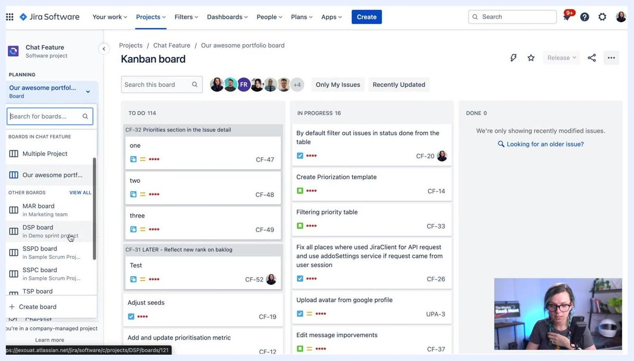
Jira sidebar showing multiple boards, a search bar, and board categories

Step 15: Find boards across projects
If you're unsure where a board is located, use the sidebar search or scroll through Other Boards. Selecting a board from another project automatically switches your context to that project and displays the selected board.
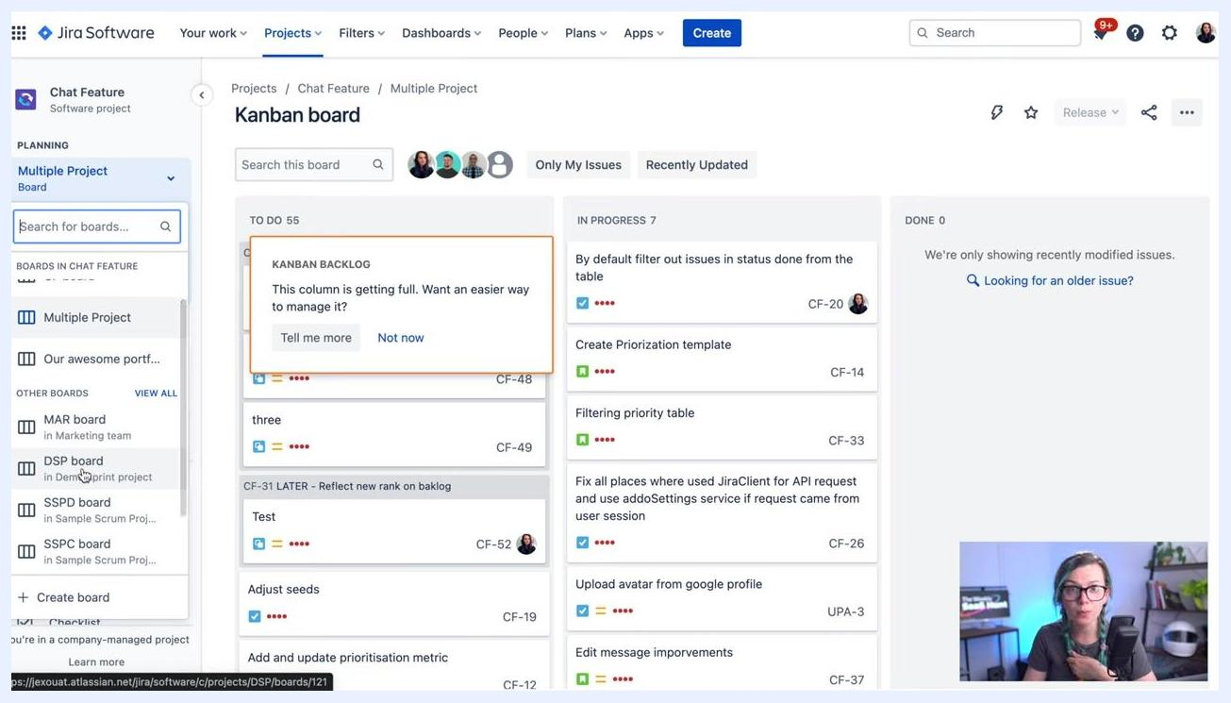
Jira board selector with "Multiple Project" board selected and other boards listed below

Step 16: Track progress on your Kanban board
Open your Jira project and go to the Kanban board under the Product Development board. Review the columns—TO DO, IN PROGRESS, CODE REVIEW, TEST, and DONE—and the cards within each one, which show task name, project, assignee, and issue key (for example, TEC-83 or SW3-986). Team member avatars at the top of the board indicate who is involved.
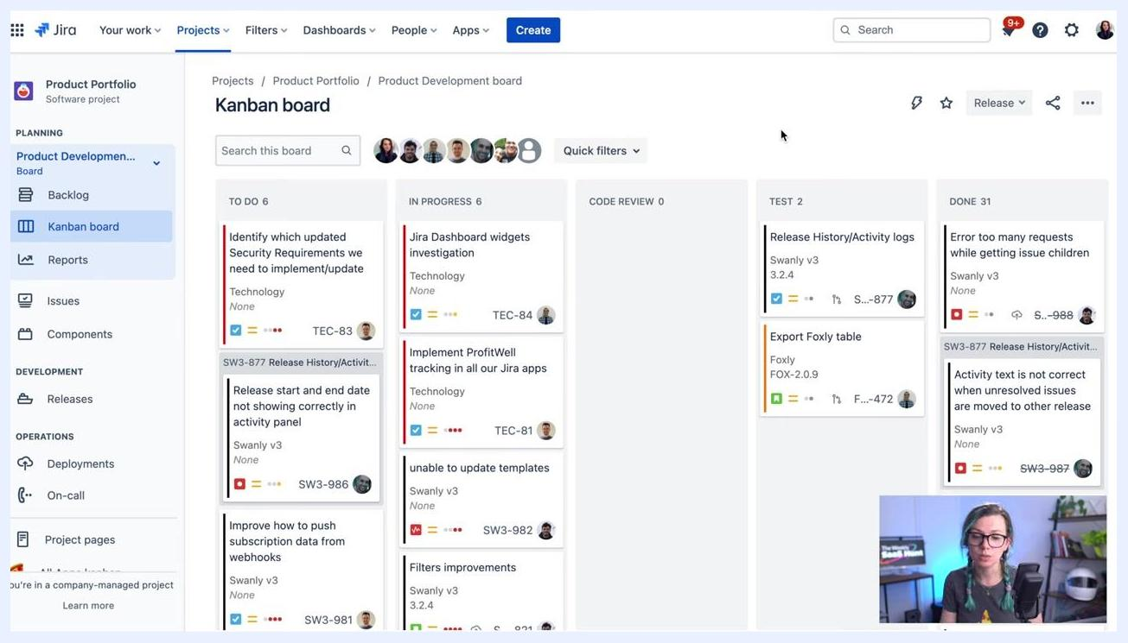
Jira Kanban board showing columns for TO DO, IN PROGRESS, CODE REVIEW, TEST, and DONE, with task cards, team member avatars, and a navigation sidebar

Step 17: Access quick filters
Locate the Quick filters dropdown above the Kanban board columns and click it to reveal available filters. The three-dot menu in the upper right also provides options such as Board settings, Create board, Hide menus, and Open issues in sidebar.
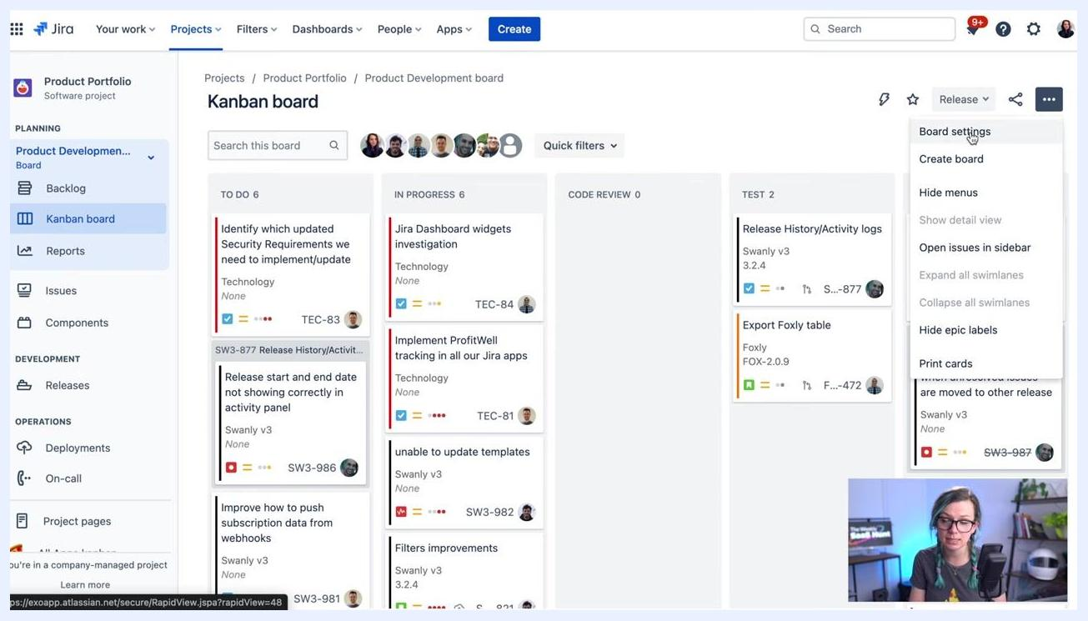
Jira Kanban board with the Quick filters dropdown open and the board settings menu visible

Step 18: Filter the board by app
Click any quick filter button, such as Foxly, Suri, Goosly, Stories, Bugs, Tech, Hedge, Octo, Pijen, Swanly, Only My Issues, or Recently Updated, to filter the board by that category. For example, selecting Foxly updates the board to show only issues related to the Foxly app.
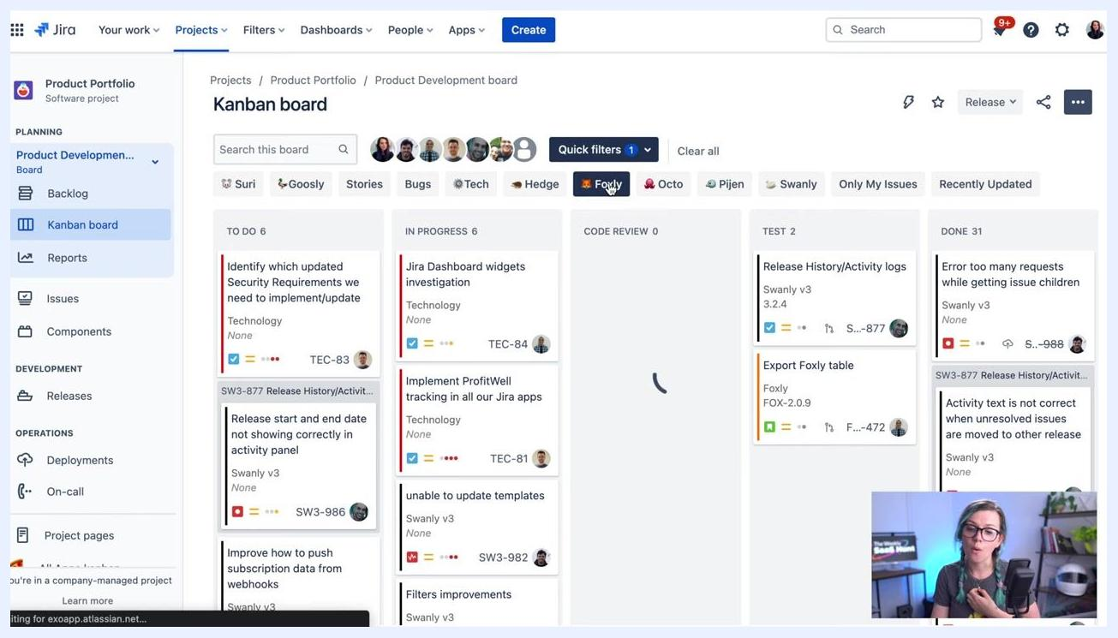
Jira Kanban board with multiple quick filter buttons above the columns, the "Foxly" filter selected, and the board showing filtered results

Step 19: Filter by specific issue types
Click filters like Stories or Bugs to focus on particular issue types. The board refreshes to show only issues matching the selected type, letting you quickly isolate stories, bugs, or other custom issue types.
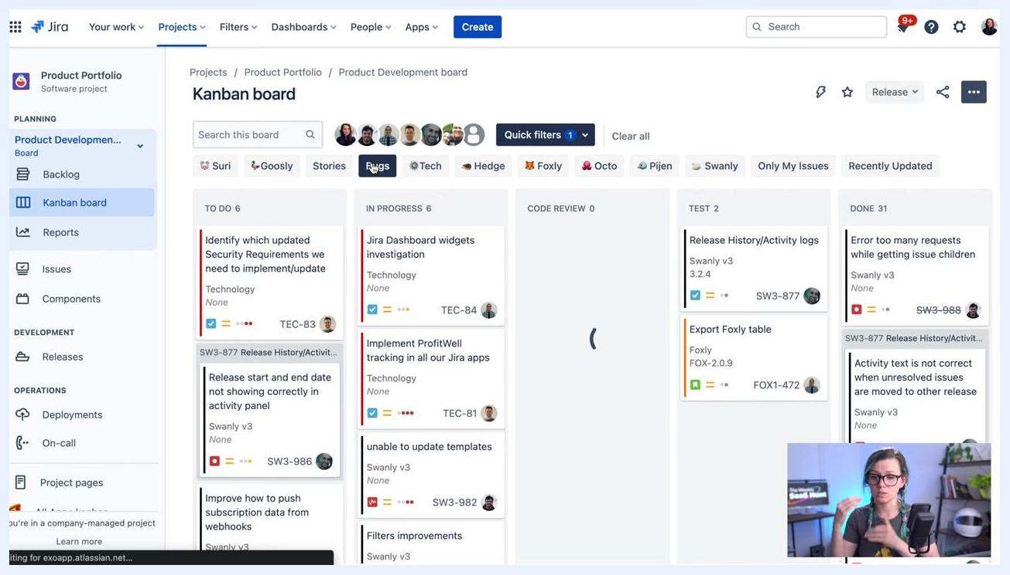
Jira Kanban board with "Stories" and "Bugs" quick filters visible, cursor hovering over the "Bugs" filter

Step 20: Predefine and manage quick filters
To customize quick filters, click the three-dot menu, select Board settings, then choose Quick Filters from the left-hand settings menu. Here you can view, add, or delete filters. To add a new filter, enter a label in the Name field, enter a JQL expression in the JQL field to define the filter logic (for example, project = SURI), optionally add a description, and click Add to save it.
Jira board settings screen showing Quick Filters configuration, with Name, JQL, and Description fields alongside a list of existing filters

Step 21: See your quick filters on the board
Once created, your quick filters appear as buttons at the top of the Kanban board. Use these buttons to instantly filter the board according to your predefined criteria, helping your team focus on relevant issues quickly.
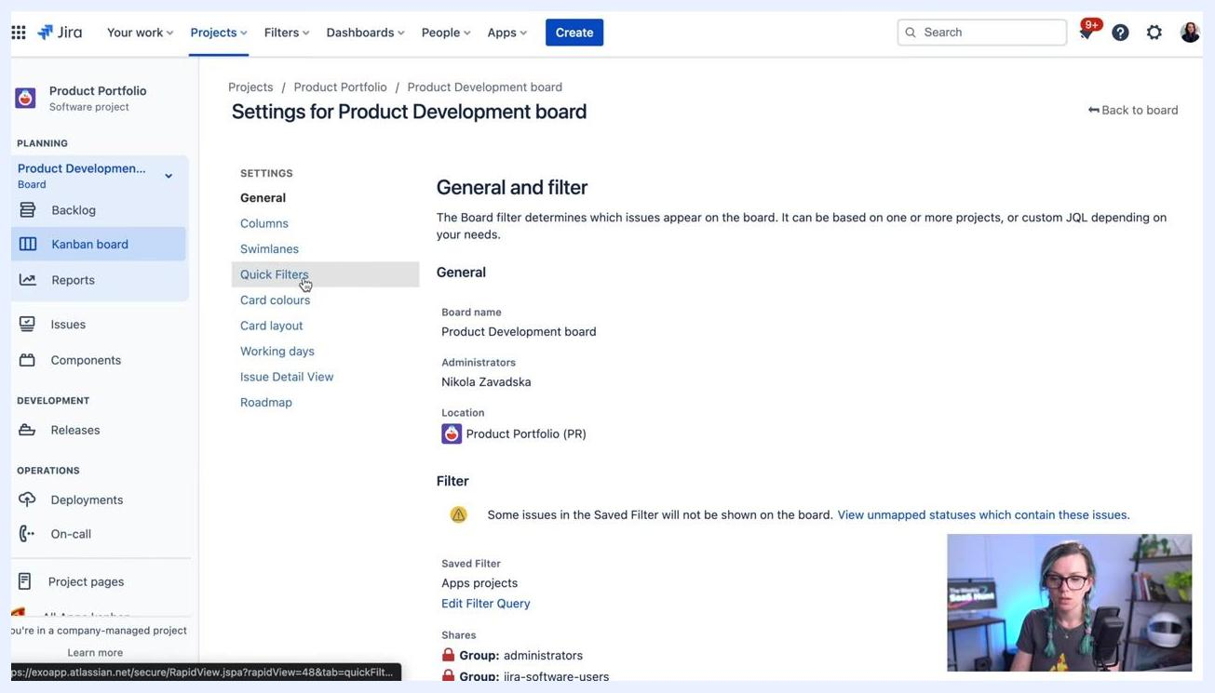
Jira Quick Filters settings screen showing the process of adding a new filter alongside a list of existing filters

Summary
You now know how to create a board in Jira, whether starting from a new Software project, aggregating issues from existing projects, or building a board from a saved filter. You've also seen how to name and locate a board, switch between boards, track progress across Kanban columns, and set up quick filters to streamline navigation.

What's next
- Explore Scrum boards and Sprints if your team plans work in time-boxed cycles.
- Set up additional quick filters using JQL to match your team's specific tracking needs.
- Use the board settings menu to further customize columns, swimlanes, and other board configurations.
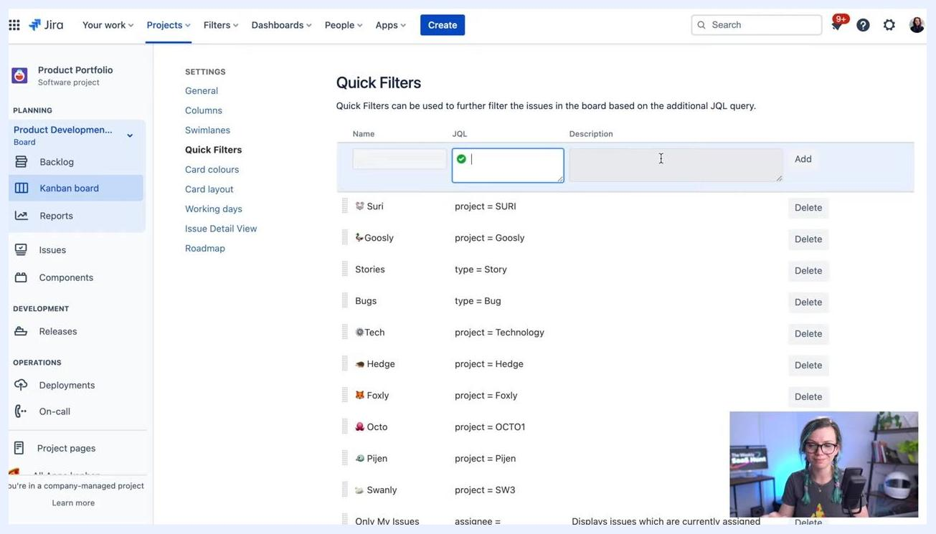
Jira Quick Filters settings screen with the presenter in the corner, indicating the end of the tutorial

JIRA HOW TOs outro screen with gradient background, large text, logo, and subscribe message

JIRA HOW TOs outro screen with gradient background, large text, logo, and subscribe message

JIRA HOW TOs outro screen with gradient background, large text, logo, and subscribe message
JIRA HOW TOs outro screen with gradient background, large text, logo, and subscribe message

