How to create a blanket sales order in JD Edwards EnterpriseOne
This guide walks you through how to create a blanket sales order in JD Edwards EnterpriseOne, from navigating to the correct menu to entering order details and confirming the record in Customer Service Inquiry. Follow the steps below to set up a blanket order with quantity, item, and customer information.
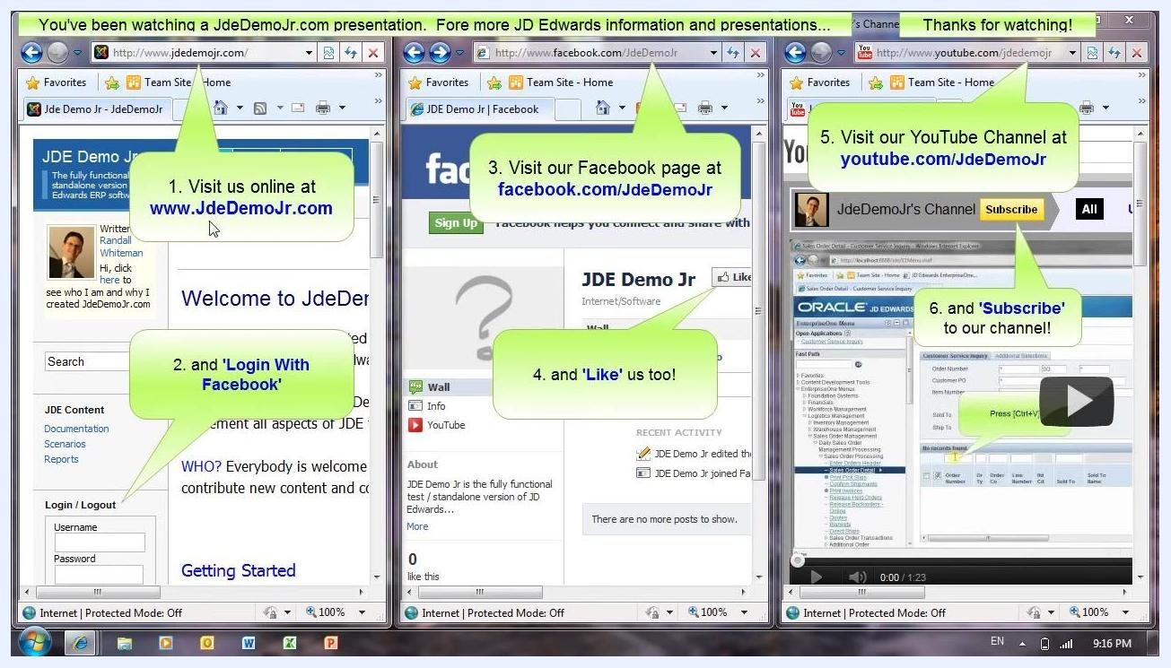
Three browser windows showing JadidemoJr.com, Facebook page, and YouTube channel with callouts for visiting, liking, and subscribing

Prerequisites
- Access to JD Edwards EnterpriseOne through your web browser.
- Permissions to navigate the Logistics Management and Sales Order Management menus.
- Customer and item information ready for entry (Sold To, Ship To, Branch/Plant, Item Number, and Quantity).

Step-by-step instructions

1. Open JD Edwards EnterpriseOne
Open JD Edwards EnterpriseOne in your web browser. The application displays the EnterpriseOne Menu on the left side of the screen and a welcome message in the main panel.

2. Open Logistics Management
In the left navigation pane, locate EnterpriseOne Menus. Click on the Logistics Management text box to expand this section.
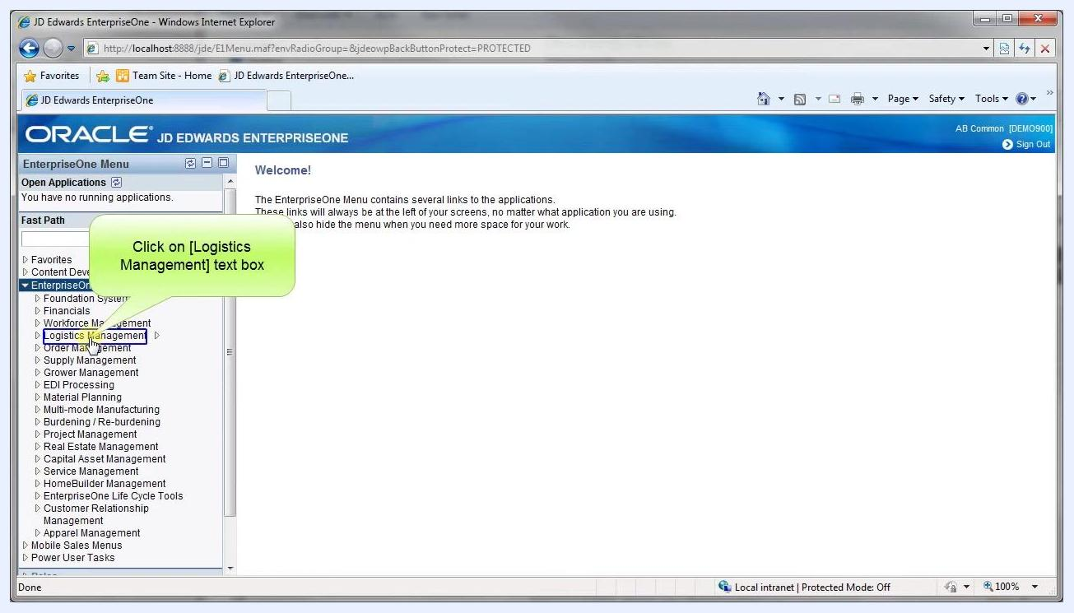
JD Edwards EnterpriseOne main menu with Logistics Management highlighted and a callout instructing to click it

3. Navigate to Sales Order Processing
Under Logistics Management, expand Sales Order Management, then click Daily Sales Order Management Processing, and select Sales Order Processing.
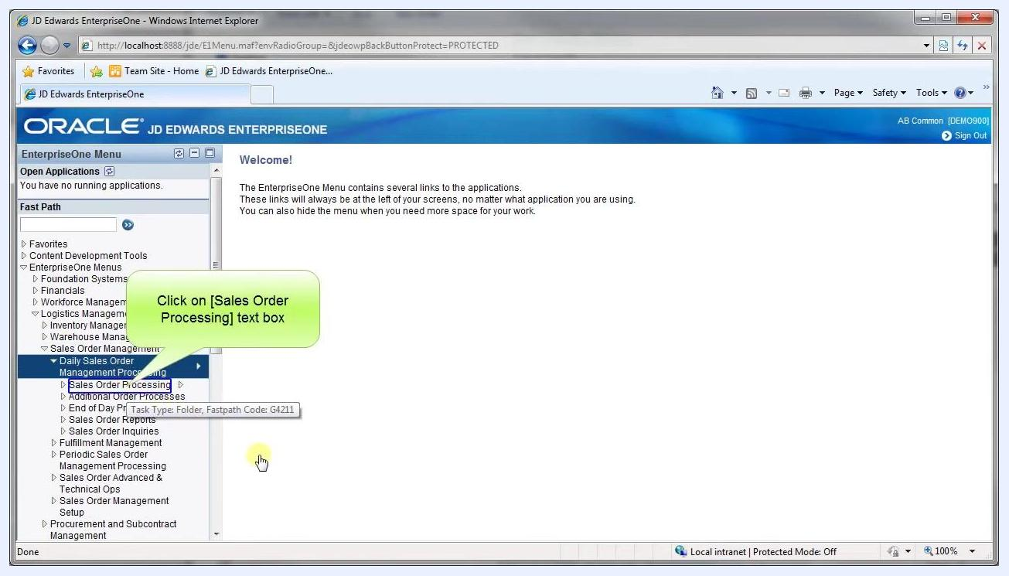
Sales Order Management expanded, Sales Order Processing highlighted with a callout

4. Add a new blanket order record
The application navigates to the Blankets - Customer Service Inquiry screen. The top menu bar displays options including Select, Find, Add, Copy, Close, Form, Row, and Tools. Click the Add button (or press Ctrl+Alt+A) to create a new record.
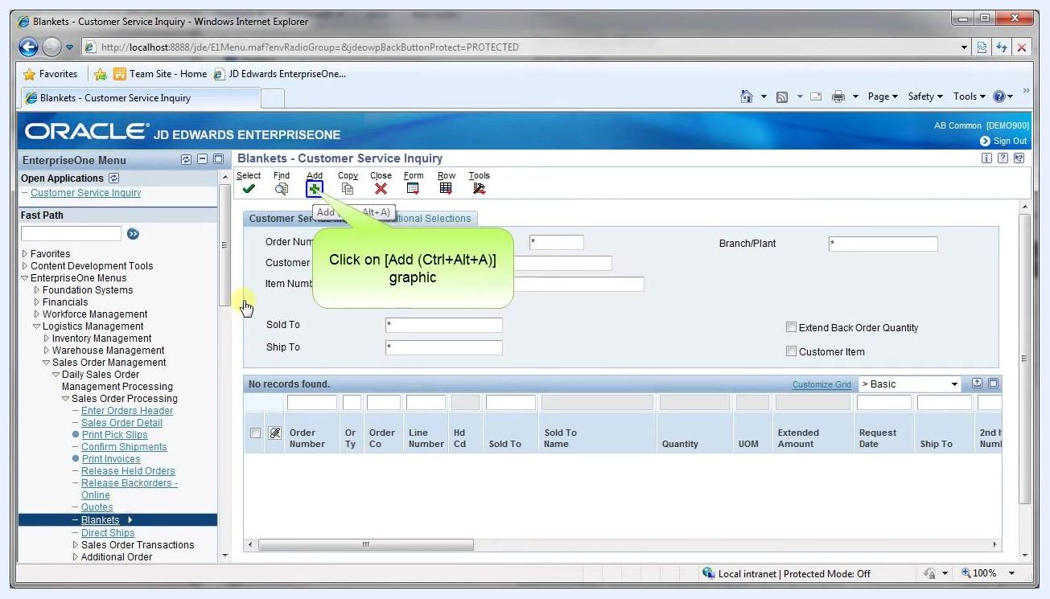
Blankets - Customer Service Inquiry screen with Add button highlighted

5. Enter sales order header and detail information
The screen title changes to Blankets - Sales Order Detail Revisions. Enter the following header details:
- Order Number: 262
- Sold To: 4242 (Capital System)
- Ship To: 4242 (Capital System)
- Currency: USD
- Branch/Plant: 30
- Order Date: 12/05/2011
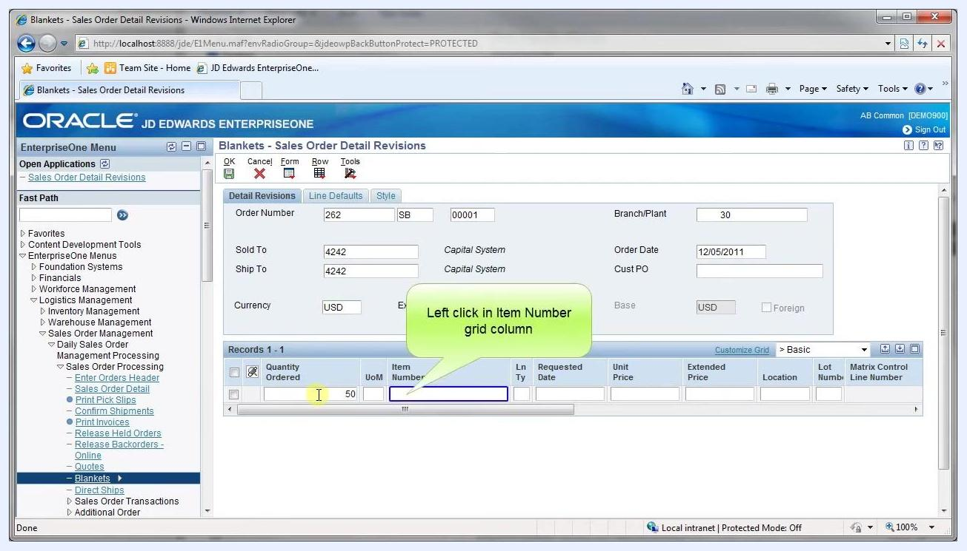
Sales Order Detail Revisions screen with Item Number grid column highlighted
In the grid below, enter Quantity Ordered: 50, leave UoM as default, and click in the Item Number column to proceed.

6. Populate the item number and complete the grid row
Enter Item Number: 210. Click on the next grid row to populate the remaining fields in the row you just entered.
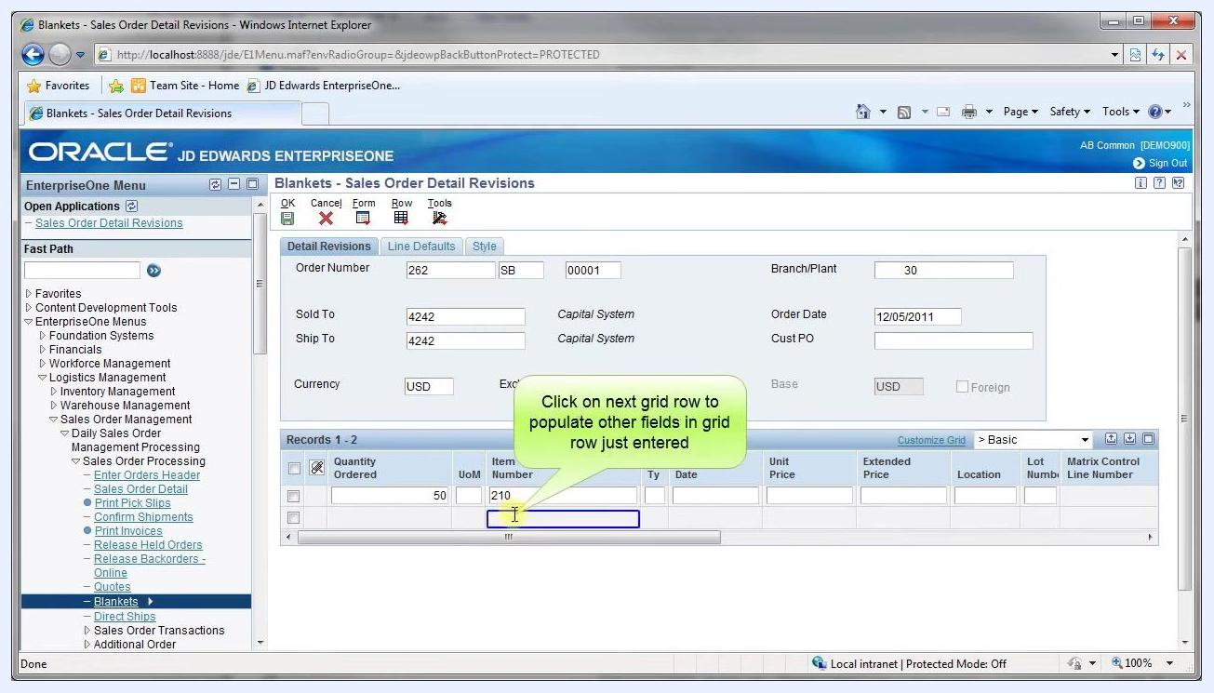
Sales Order Detail Revisions screen with grid row being populated

7. Query the order in Customer Service Inquiry
The application returns to the Blankets - Customer Service Inquiry screen. Click in the Order Number field in the grid to query or select your order.
Customer Service Inquiry screen with Order Number grid query field highlighted

8. Confirm and select the order row
The grid displays the completed record with the following details:
- Order Number: 262
- Order Type: SB
- Order Co: 00001
- Sold To: 4242 (Capital System)
- Quantity: 50 EA
- Extended Amount: 39,900.00
- Request Date: 12/05/2011
- Ship To: 4242, Item Number: 210
Customer Service Inquiry screen with Row 1 checkbox highlighted
Click the checkbox in the first row to select it and confirm your blanket sales order.

What's next
With your blanket sales order created, you can continue managing it through the Sales Order Processing menu, including reviewing order details or processing releases against the blanket order as needed.

