How to take attendance in Infinite Campus
This guide explains how to take attendance in Infinite Campus from the Teaching Center. You will open the Attendance screen, choose the correct date, mark each student as present, absent, or tardy, and save your work. You will also learn how to update attendance later in the day.

Prerequisites
Before you begin, make sure you have the following:
- A login for Infinite Campus
- At least one class assigned to you for the current school year and term

Open the Attendance screen

1. Log in to Infinite Campus
Log in and make sure you are on the Teaching Center screen. You will see a list of your classes for the current school year and term.
This example shows two sample classes: "101-1 ENGLISH 9" at Peekskill High School and "1 HR SECOND-1 GRADE" at Oakside Elementary.
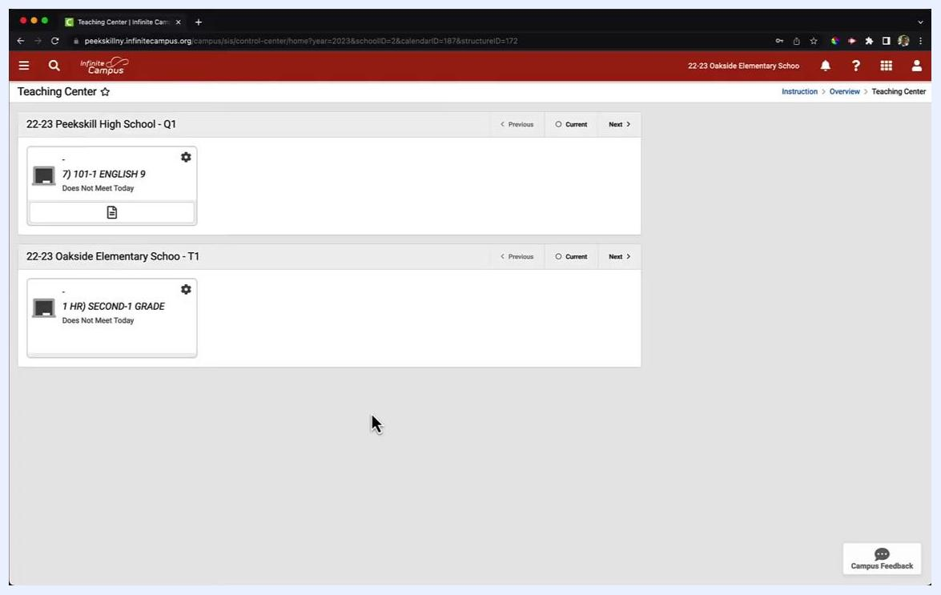
Teaching Center screen showing two sample classes, 101-1 ENGLISH 9 and 1 HR SECOND-1 GRADE, both labeled "Does Not Meet Today"

2. Verify your class list
Confirm that all the classes you teach appear in the list. If you do not see the sidebar on the left, go to the next step to open it.

3. Open the main menu
Click the menu icon (three horizontal lines) at the top left of the screen. The sidebar menu expands.
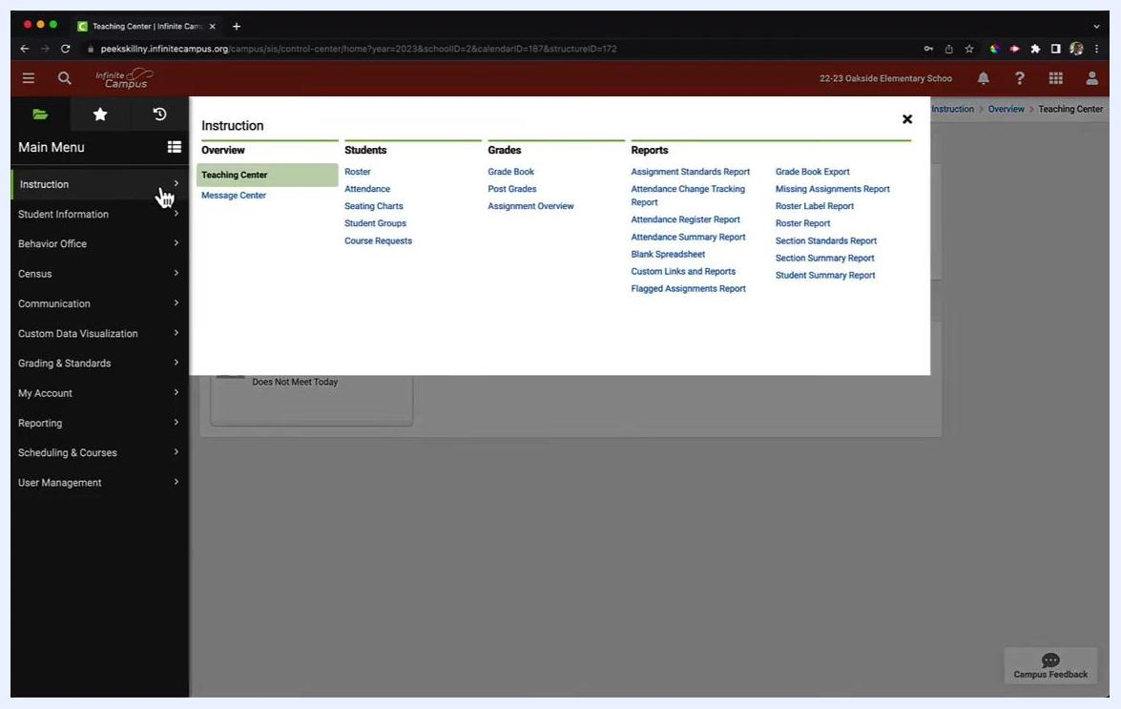
Sidebar menu expanded after clicking the three-line menu icon at the top left

4. Go to Attendance
In the sidebar, click Instruction. In the expanded menu, click Attendance under the Students column.
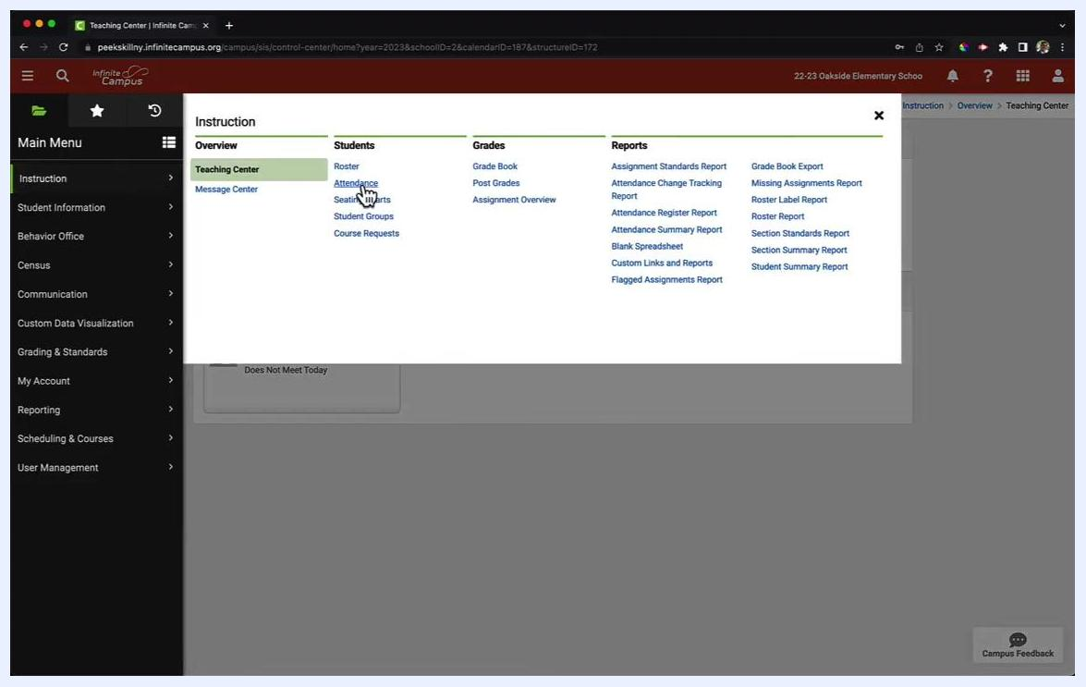
Main Menu expanded with the cursor on Instruction, and the Instruction menu showing Attendance under Students

Take attendance

5. Select the correct date
If you see a message such as "attendance is not taken today or section does not meet today," you may need to choose a different date.
Click the calendar icon next to the Date field, then choose the date you need. In this example, the date is 08/31/2022, the first day of school.
Attendance screen with the calendar dropdown open and August 31, 2022 selected

6. Review your class roster
The roster for the selected class and date appears. All students are listed, and each is marked P (Present) by default.
The top of the roster shows the total number of students (for example, 19). Columns are available for Present (P), Absent (A), Tardy (T), and Comments.
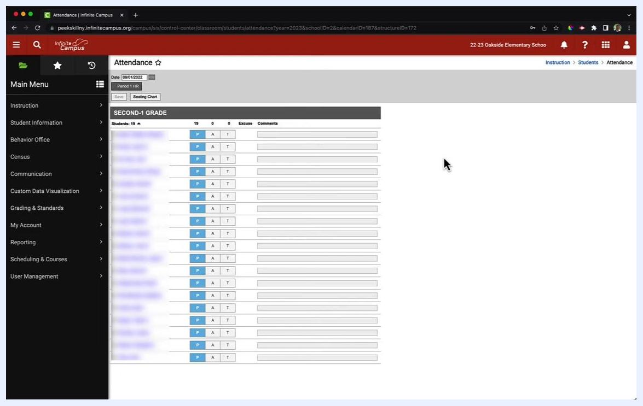
Attendance roster for SECOND-1 GRADE showing 19 students, each with P, A, and T buttons and a Comments field

7. Mark attendance for each student
Use the buttons next to each student's name:
- Click P to mark a student as Present.
- Click A to mark a student as Absent.
- Click T to mark a student as Tardy.
You can also enter a note for any student in the Comments field.
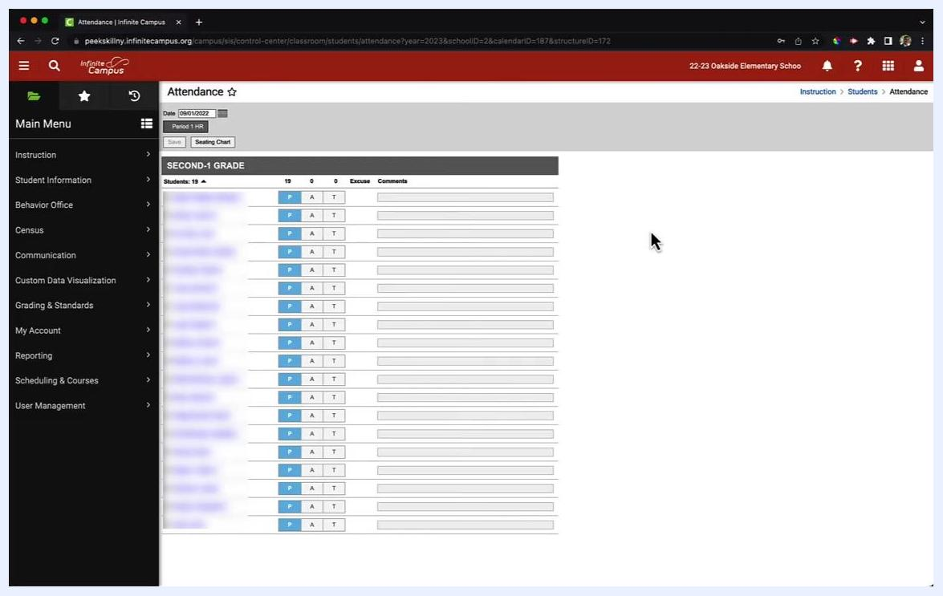
Attendance roster with P, A, and T buttons and a comment field for each student

8. Save your attendance
When you finish marking attendance and adding comments, click Save at the top of the screen.
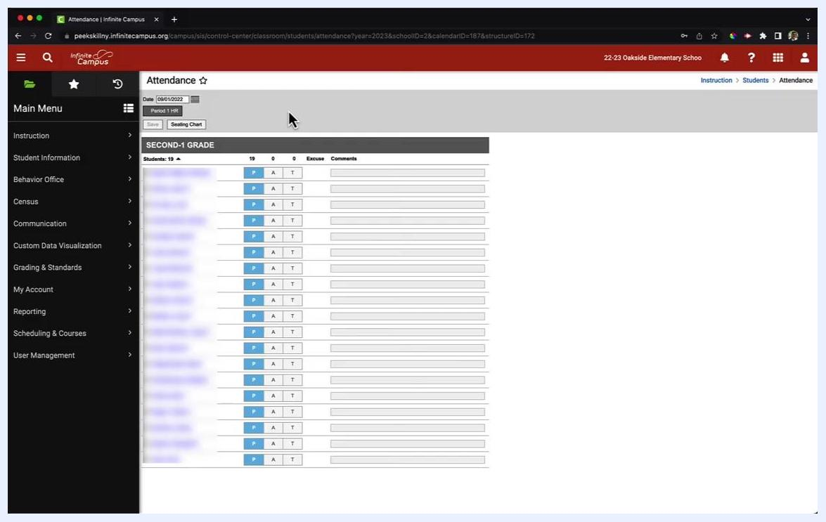
Attendance screen with the Save button at the top left, above the roster

Update attendance

9. Return to the Attendance screen
If a student arrives late or you made an error, go back to Attendance using the sidebar menu. The screen shows your class roster for the selected date and period.
Each student has options for Present (P), Absent (A), or Tardy (T), plus a Comments field. The top of the roster shows the total number of students (for example, 19), with columns for Present, Absent, Tardy, Excuse, and Comments.
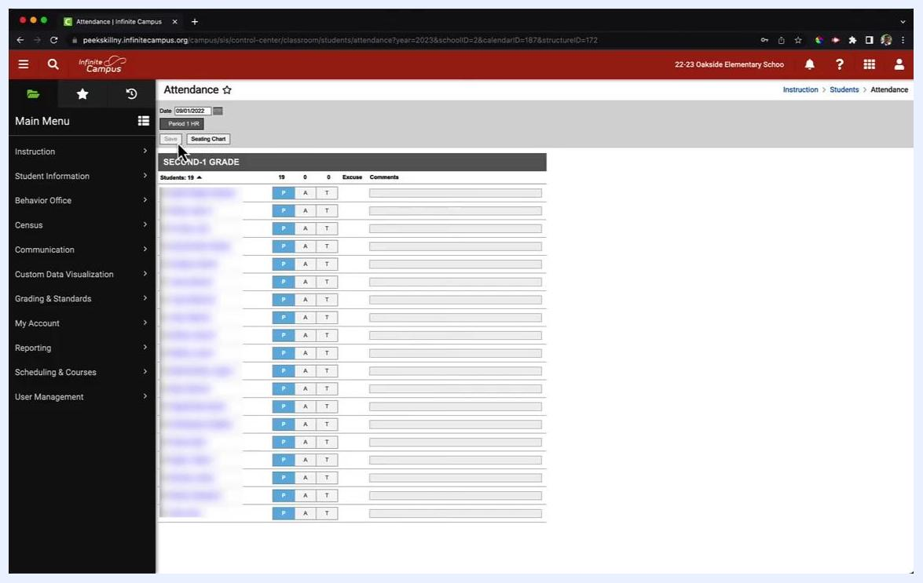
Attendance screen for SECOND-1 GRADE showing 19 students with P, A, and T buttons, comment fields, and the Save button at the top

10. Edit attendance as needed
Click P, A, or T next to a student's name to change their status. You can also enter or update comments in the Comments field.

11. Re-save your changes
Click Save at the top of the screen to record your updates. You can repeat this process as often as needed throughout the day if attendance statuses change.

Summary
To take attendance in Infinite Campus, open the sidebar menu, go to Instruction > Attendance, and select the correct date. Mark each student P, A, or T, add comments if needed, and click Save. To make changes later, return to the Attendance screen, update the roster, and save again.

