How to send a message in Infinite Campus
This guide shows you how to send a message in Infinite Campus using the Message Center. You can send a general message to students and parents, or send an automated Missing Assignment Message that lists each student's missing work. The steps below cover both.

Prerequisites
- You have an Infinite Campus login.
- You can access the Message Center from the main menu.

Send a general message

Step 1: Open the Message Center
Log in to Infinite Campus. From the main menu, go to Message Center. The screen lists your previous messages and shows a New button at the top.
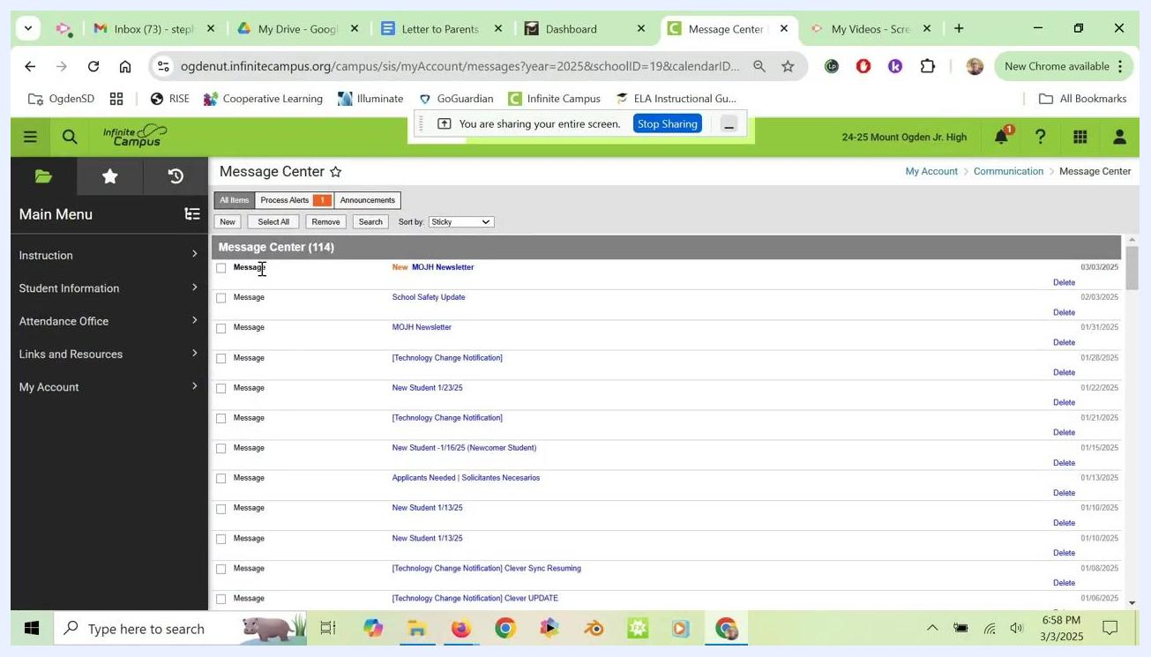
Message Center screen with a list of previous messages, the navigation menu on the left, and the New button at the top

Step 2: Create a new message
Click New at the top of the Message Center to start a new message.
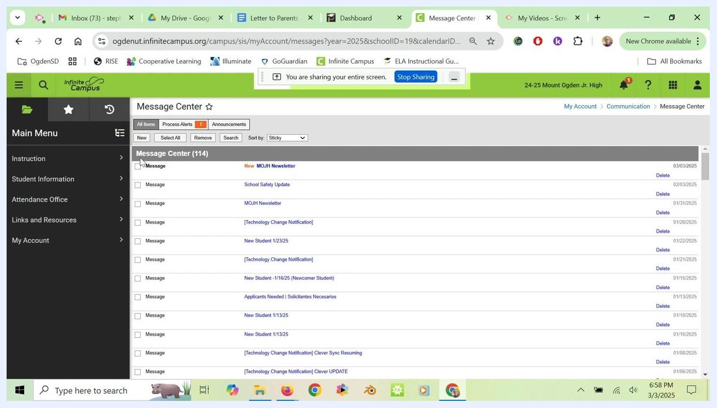
Message Center with the cursor near the New button, showing where to start a new message

Step 3: Enter the message details
Fill in the Subject Line and Message fields. Then scroll down and click Next to continue to recipient selection.

Step 4: Select the term and classes
Choose the current term, for example Term Q3. Then select the classes you want to message. For example, select "ADVJ 06101-3 Advisory 07A (Fri-Min A)" to message your advisory class.
Recipient selection screen showing terms, class sections, and options for Messenger Contacts and Students

Step 5: Choose the recipients
Under "Recipients," select both Messenger Contacts and Students. This ensures the message reaches both students and parents. Click Next.

Step 6: Review and send the message
Review your message for accuracy. When it is correct, click Send to deliver it.

Send missing assignment notifications
You can also use the Message Center to notify students and parents about missing assignments.

Step 7: Select the message type
In the "Message Type" drop-down, choose Missing Assignment Message.

Step 8: Review the notification template
Infinite Campus automatically generates an email template that includes:
- The student's name.
- A list of the student's missing assignments.
- A link to the Campus Parent or Campus Student portal for more information.
You can review or edit the subject (for example, "Missing Assignment") and the message body.
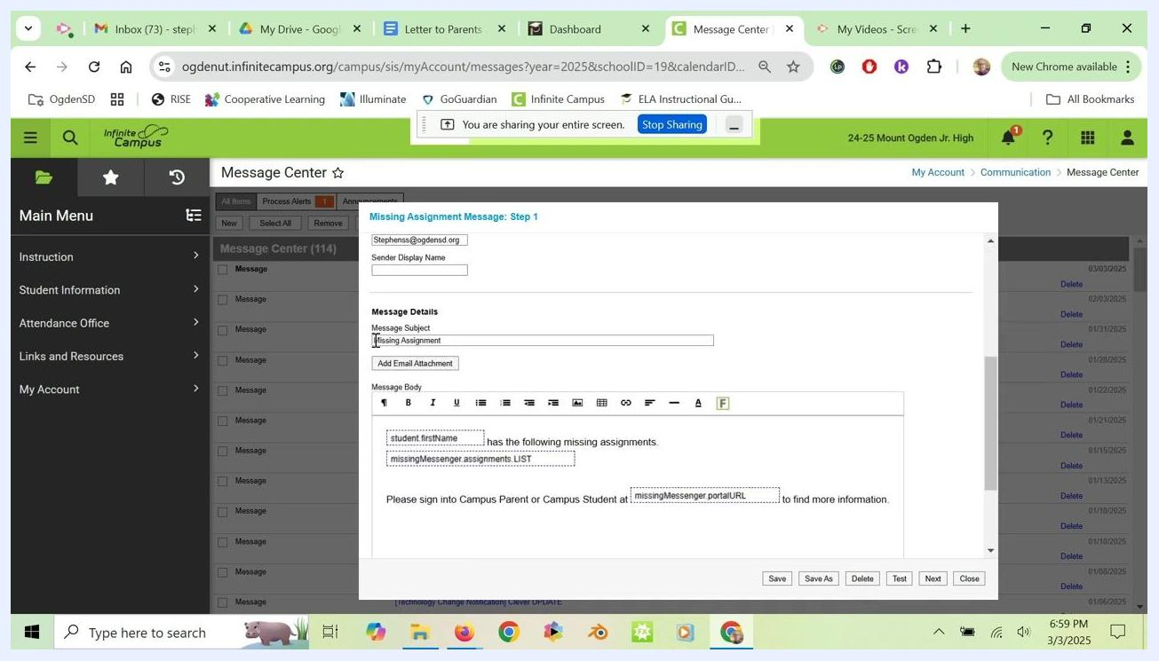
Missing Assignment Message template with auto-filled fields for the student name, missing assignments list, and portal URL

Step 9: Continue and select a class
Click Next to continue. Then choose the class you want to notify about missing assignments.

Step 10: Select the class section
Send missing assignment notifications to each class separately, and repeat the process for every class. Select the class from the "Sections" drop-down, for example "ADVJ 06101-3 Advisory 07A (Fri-Min A)". Make sure you are on the "Missing Assignment Message: Step 2" screen.
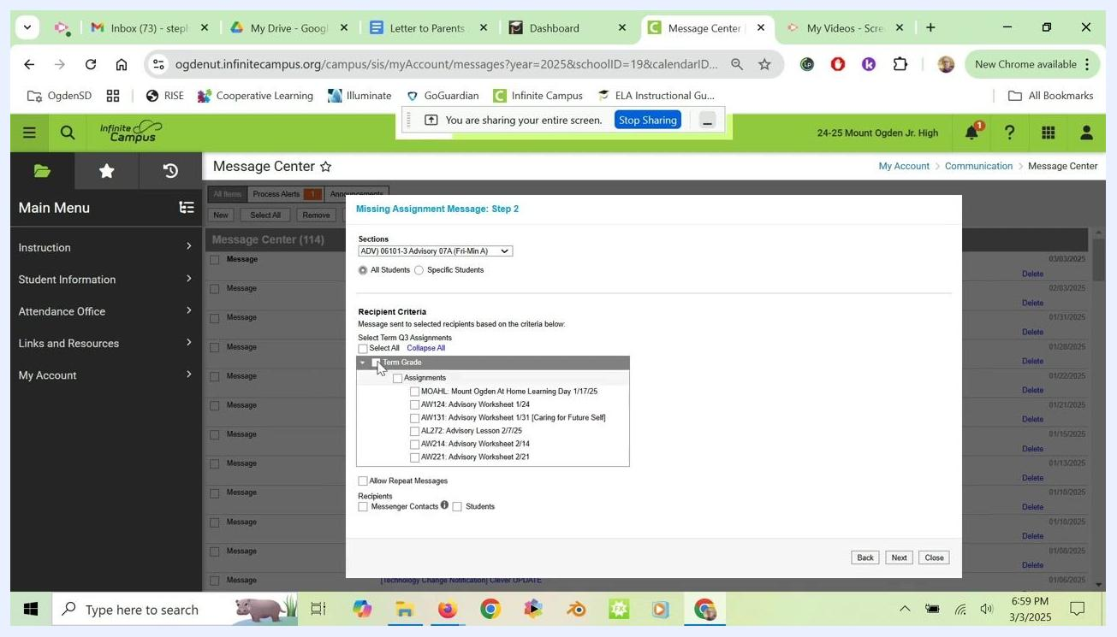
Missing Assignment Message: Step 2 screen showing class section selection, term grade, assignment checkboxes, and recipient options

Step 11: Include all missing assignments with Term Grade
Under "Recipient Criteria," check the Term Grade box. This includes all missing assignments for the selected term.
Review the list under "Assignments" and make sure all relevant assignments are checked. If needed, use Select All to include every assignment for the term.

Step 12: Choose the recipients
Under "Recipients," select both Messenger Contacts and Students. This sends the notification to both parents and students. Confirm both boxes are checked before you continue.
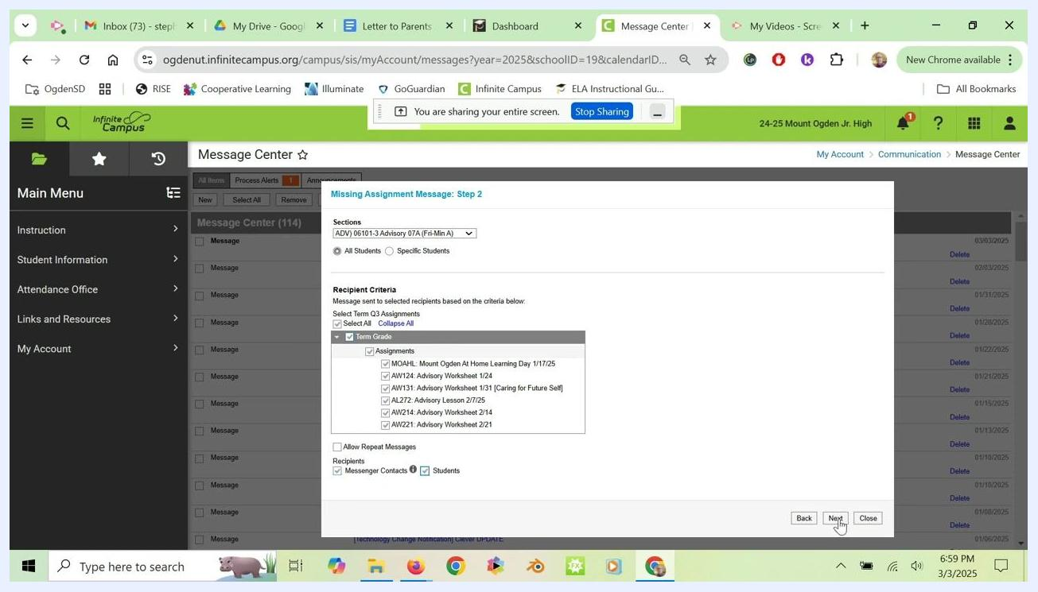
All assignments selected, Messenger Contacts and Students both checked, and the cursor on the Next button

Step 13: Continue to the review screen
Click Next to go to the message review screen. Wait for the system to process your selections. A loading indicator may appear.
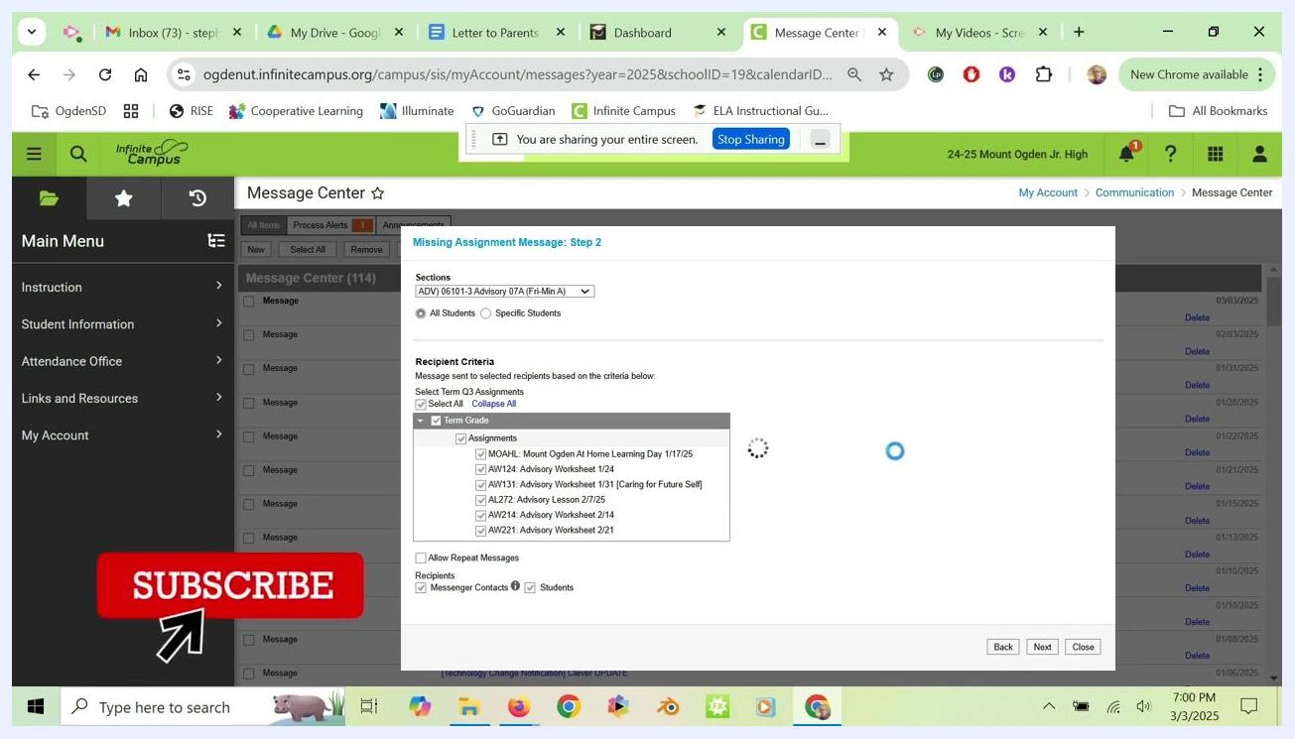
The system processing after you click Next, with a loading spinner visible

Step 14: Review the delivery summary and message preview
On the "Missing Assignment Message: Step 3" screen, review the Delivery Summary and Message Preview:
- Confirm the Delivery Date and Inbox/Email Delivery Time.
- Check the Recipient Count to make sure all intended recipients are included.
- Review the Message Subject, for example "Missing Assignment".
- Review the Message Body to confirm it includes the student's name, a list of missing assignments, and a link to the Campus Parent or Campus Student portal.

Step 15: Send the notification
If everything is correct, click Send to deliver the notification.
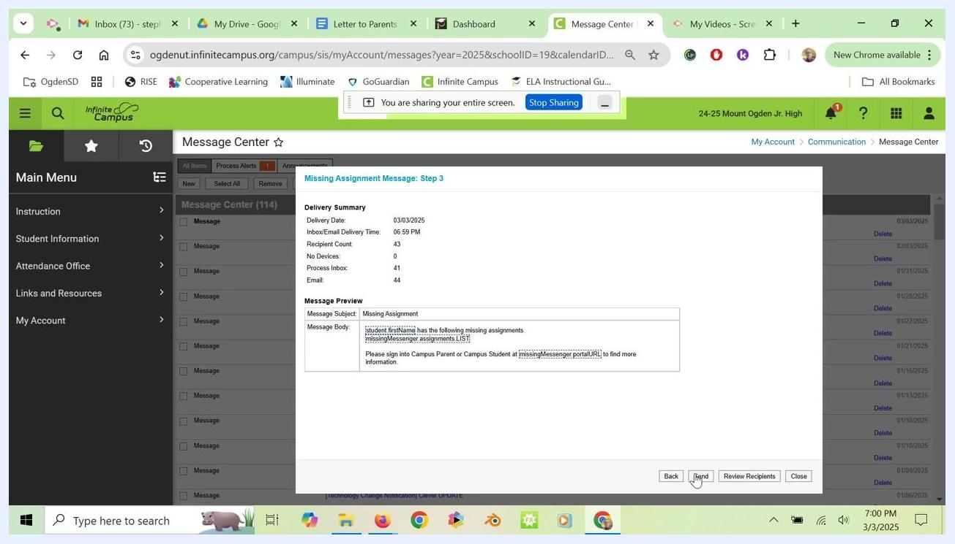
Missing Assignment Message: Step 3 screen showing the delivery summary, message preview, and the cursor on the Send button

What's next
You have now sent both a general message and an automated missing assignment message through Infinite Campus. Repeat the missing assignment steps for each class as needed so all students and parents receive accurate notifications.

