How to create assignments in Infinite Campus
This guide shows you how to create assignments in Infinite Campus using the Gradebook in the Teaching Center. You open your class, add a new assignment, set its visibility, dates, students, and grading options, and then save and review it. The example creates a 100-point test called "Unit 1 Test 2."

Prerequisites
Before you begin, make sure you have the following:
- A login for Infinite Campus
- A class listed under Teaching Center on your main dashboard, such as "101-1 ENGLISH 9" or "1 HR SECOND-1 GRADE"

Open the Gradebook and add an assignment

Step 1. Access the Teaching Center
Open Infinite Campus and log in. On the main dashboard, find your available classes under Teaching Center, and identify the class you want to work with.
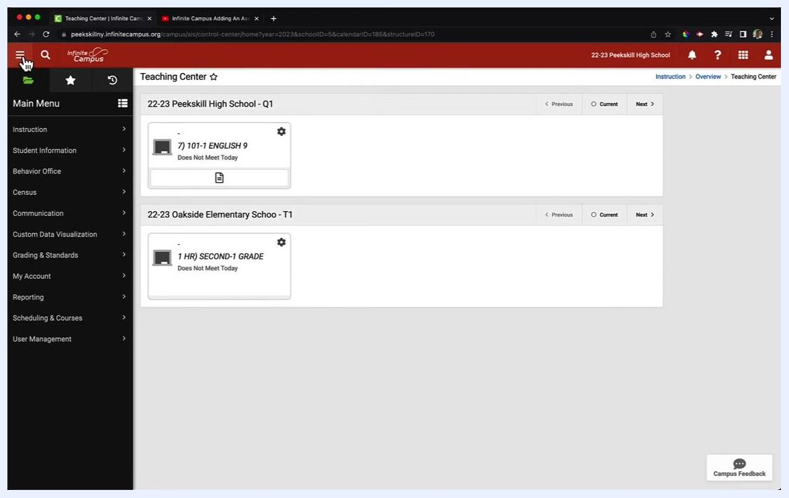
Teaching Center screen showing demo classes for Peekskill High School and Oakside Elementary, with class cards and a navigation bar

Step 2. Expand the main menu and open the Gradebook
If the left-side menu is not visible, click the three horizontal lines (menu icon) at the top left of the screen to expand the main menu.
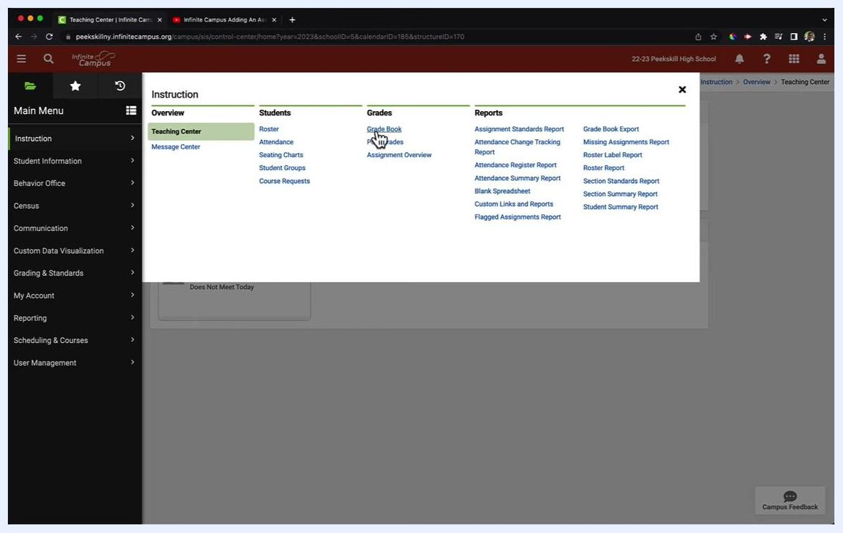
Expanded main menu on the left showing options such as Instruction, Student Information, and Behavior Office
In the main menu, click Instruction. Then, under the Grades column, click Grade Book.
The Gradebook screen shows two areas:
- The student roster on the left, listing all students in alphabetical order by last name
- The main grade entry area on the right, where assignment titles and grades appear as you add assignments

Step 3. Add a new assignment
Click the Add button above the student roster on the Gradebook screen.
Gradebook screen with the cursor on the Add button above the student roster

Step 4. Enter the assignment title
After you click Add, a menu for assignment details appears on the right side of the screen. Enter the assignment name in the Title field. In this example, type Unit 1 Test 2.
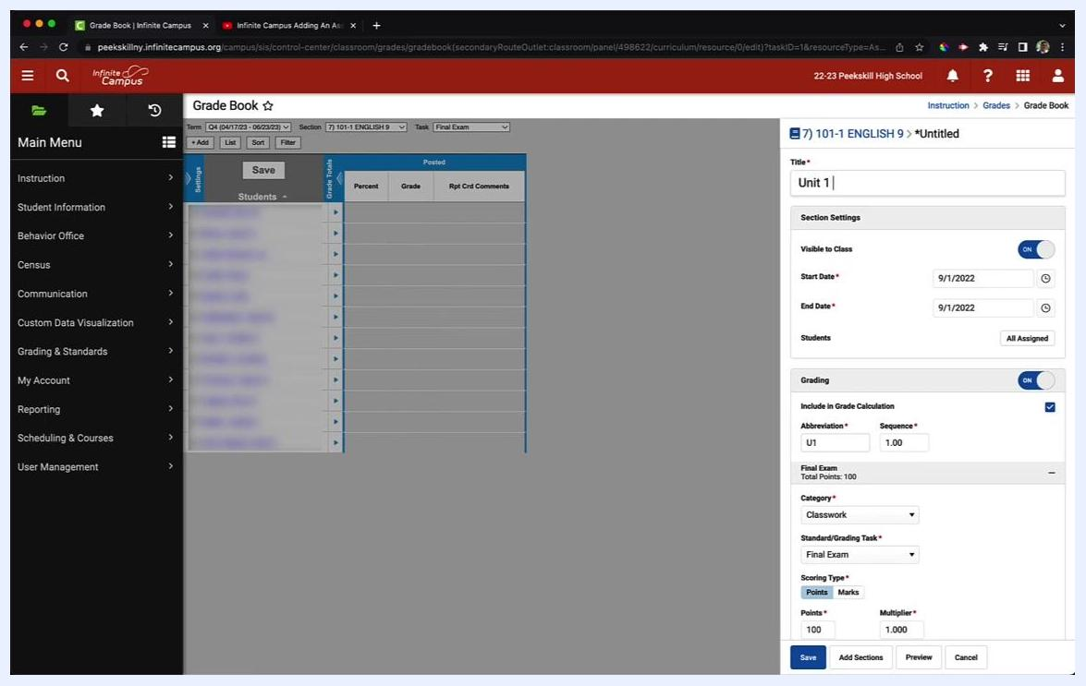
Assignment creation panel with Unit 1 Test 2 entered as the title and other settings visible

Configure assignment details

Step 5. Set assignment visibility
Make sure the Visible to Class toggle is set to ON so students can see the assignment.
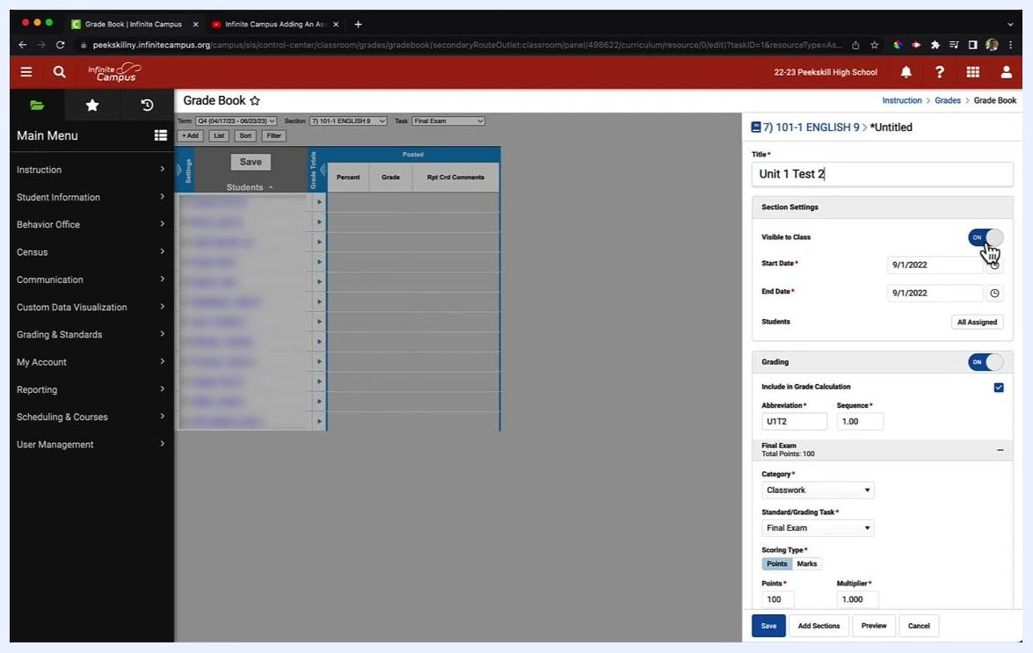
Assignment creation panel with the Visible to Class toggle set to ON

Step 6. Set the assignment dates
Set the Start Date and End Date for the assignment. In this example, use 9/1/2022 for both dates.

Step 7. Assign to specific students (optional)
By default, the assignment is set to All Assigned in the Students section. To assign it to only some students, click the All Assigned button and deselect the students who should not receive it. In this example, leave it as All Assigned.
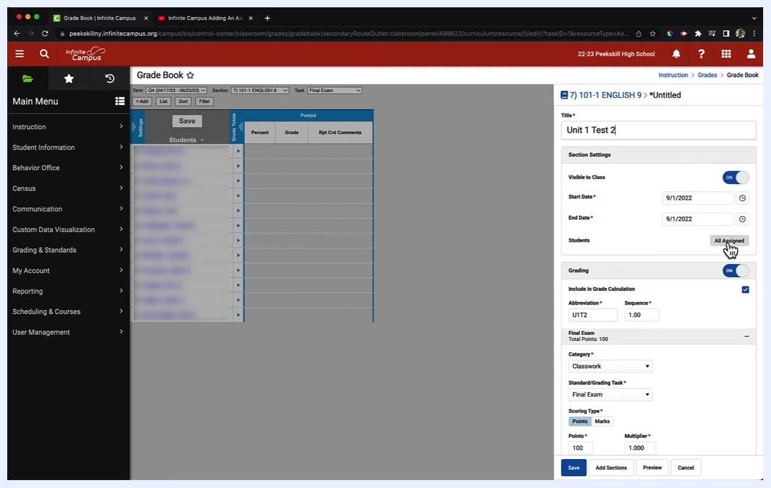
Assignment creation panel with the All Assigned button highlighted under Students and the cursor pointing to it

Step 8. Configure grading options
Find the Grading section. Keep the Grading toggle ON if you want the assignment to be graded.
If you turn the toggle OFF, all grading options collapse and the assignment is not included in grade calculations. In this example, keep Grading on and keep Include in Grade Calculation checked.
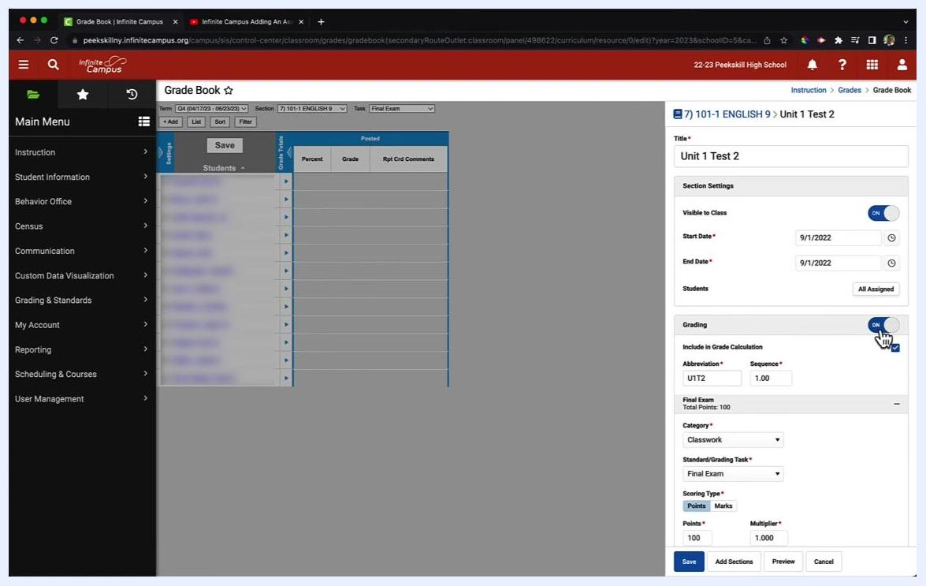
Grading section with the toggle set to ON and Include in Grade Calculation checked

Step 9. Review the abbreviation and sequence
In the Abbreviation field, review the automatically generated abbreviation, such as U1T2. Edit it if needed for clarity, especially when you manage multiple assignments.
Leave the Sequence field at its default value, such as 1.00, unless you need to change the order.
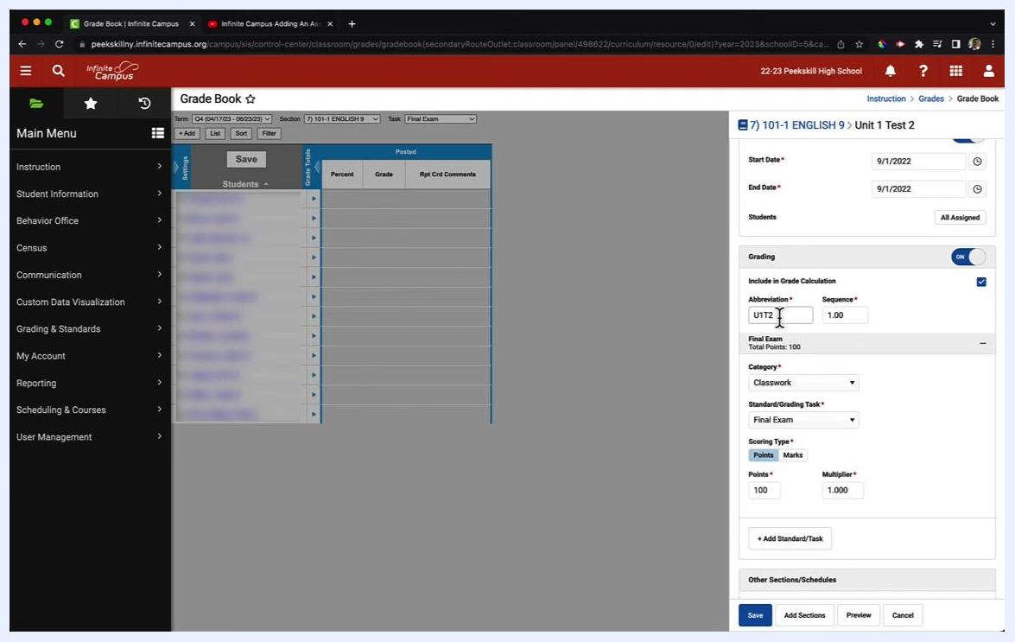
Abbreviation field set to U1T2 and Sequence set to 1.00 in the Grading section

Step 10. Select the assignment category
Click the Category dropdown menu and choose the category for your assignment. Available options may include:
- Classwork
- Homework/Participation
- Tests/Quizzes/Projects
In this example, select Tests/Quizzes/Projects.
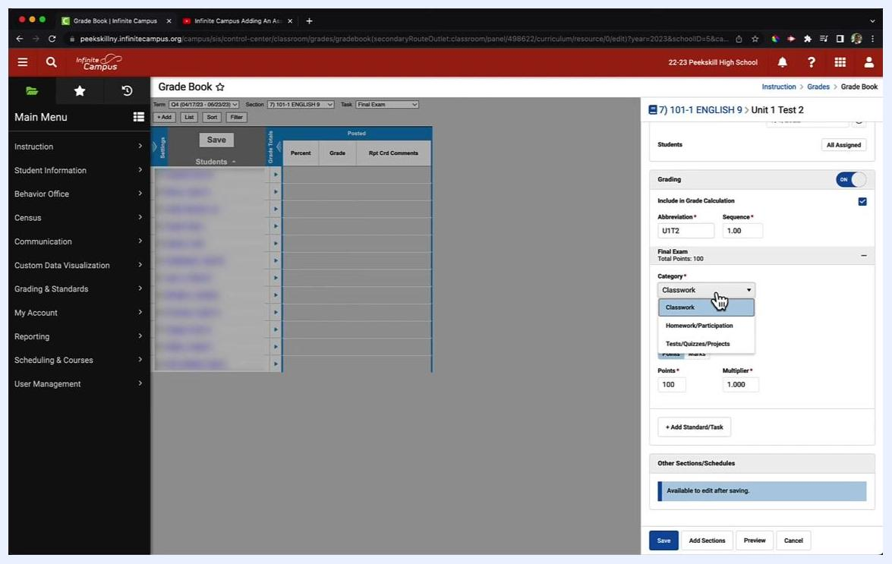
Category dropdown open showing Classwork, Homework/Participation, and Tests/Quizzes/Projects

Step 11. Choose the standard or grading task
Click the Standard/Grading Task dropdown menu and select the grading task. Common options include:
- Final Exam
- Report Card Grade (the default for most systems)
- Progress Report
- Final Grade
In this example, select Report Card Grade.
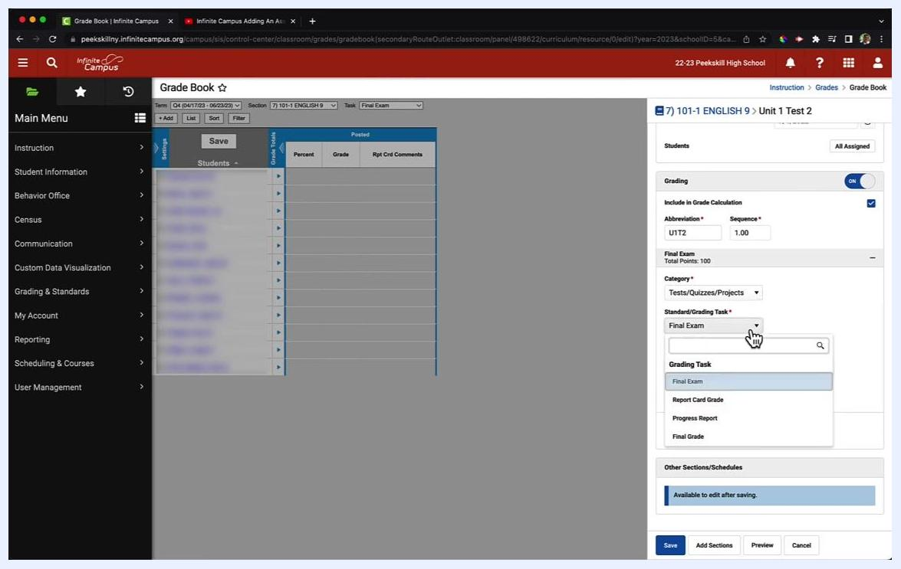
Standard/Grading Task dropdown open showing Final Exam, Report Card Grade, Progress Report, and Final Grade

Step 12. Set the scoring type and points
In the Scoring Type section, select Points as the grading method. Enter 100 in the Points field to make this a 100-point assignment.
Make sure the Multiplier field is set to 1.000 to use the default weighting. Confirm that all grading settings are correct before you save.
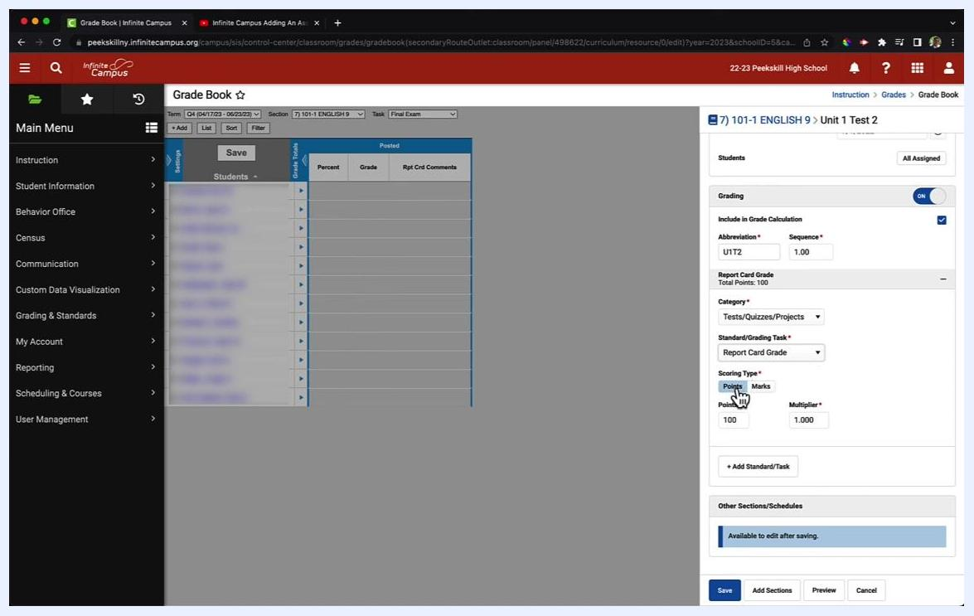
Assignment creation panel showing Points selected as the scoring type, 100 points entered, and the multiplier set to 1.000

Save and review the assignment

Step 13. Save the assignment
Click the blue Save button at the bottom of the assignment panel. Wait for the system to process and save your assignment.
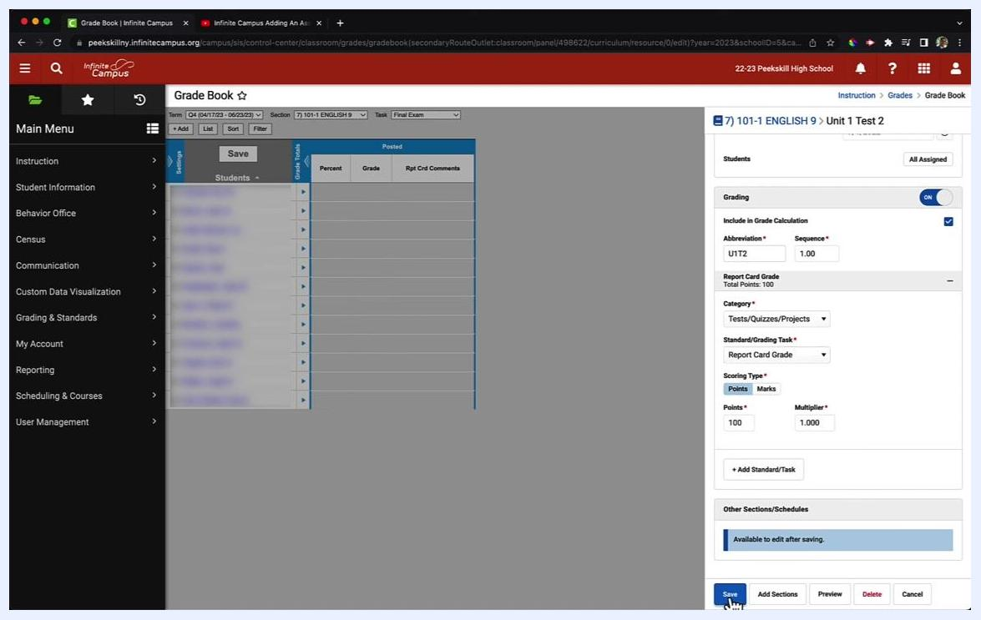
Cursor hovering over the Save button in the assignment panel with all fields filled out

Step 14. Review the saved assignment details
After you save, review the summary panel for your assignment. Confirm that the following details are correct:
- Assignment title, such as "Unit 1 Test 2"
- Start Date: 09/01/2022 12:00 AM
- End Date: 09/01/2022 11:59 PM
- Visibility: Visible to Class
- Students: All Assigned
- Abbreviation: U1T2
- Sequence: 1
- Report Card Grade: Total Points: 100
If any information is incorrect, click the Edit button to make changes.
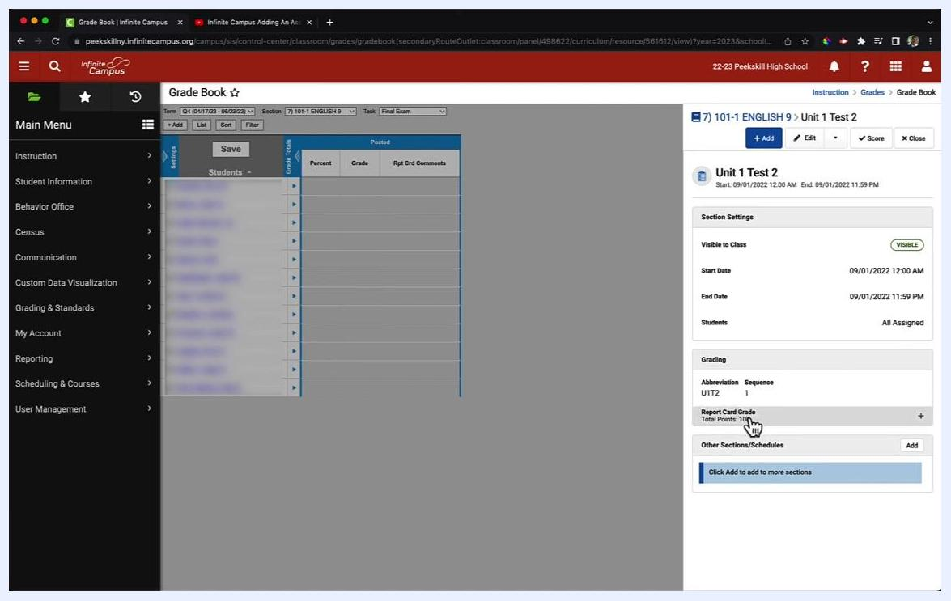
Assignment summary panel showing the title, dates, visibility, students, abbreviation, and total points

Summary
You now know how to create assignments in Infinite Campus. You opened the Gradebook from the Teaching Center and added an assignment. You then set its title, visibility, dates, student assignment, category, grading task, and point value. Finally, you saved the assignment and reviewed its summary. Repeat these steps for each new assignment you add to the Gradebook.

