How to Create a List in HubSpot
Lists in HubSpot let you organize your contacts and companies based on shared traits. Once created, you can use these lists in workflows, marketing emails, customer satisfaction surveys, and other processes. This guide walks you through how to create a list in HubSpot, set criteria for it, and manage it afterward.
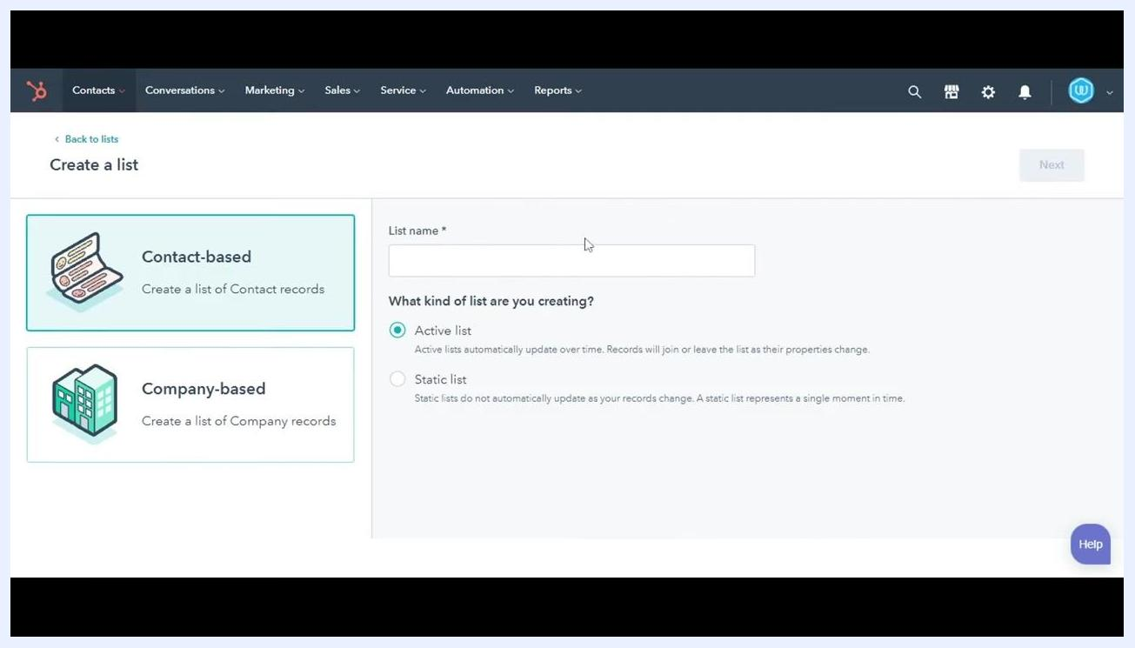
HubSpot dashboard displaying the navigation bar with Contacts, Conversations, Marketing, Sales, Service, Automation, and Reports options, with the Web Analytics Dashboard visible

Prerequisites
- An active HubSpot account with access to the Contacts tool.
- Permissions to create and manage lists (some actions, such as exporting, may depend on your account permissions).
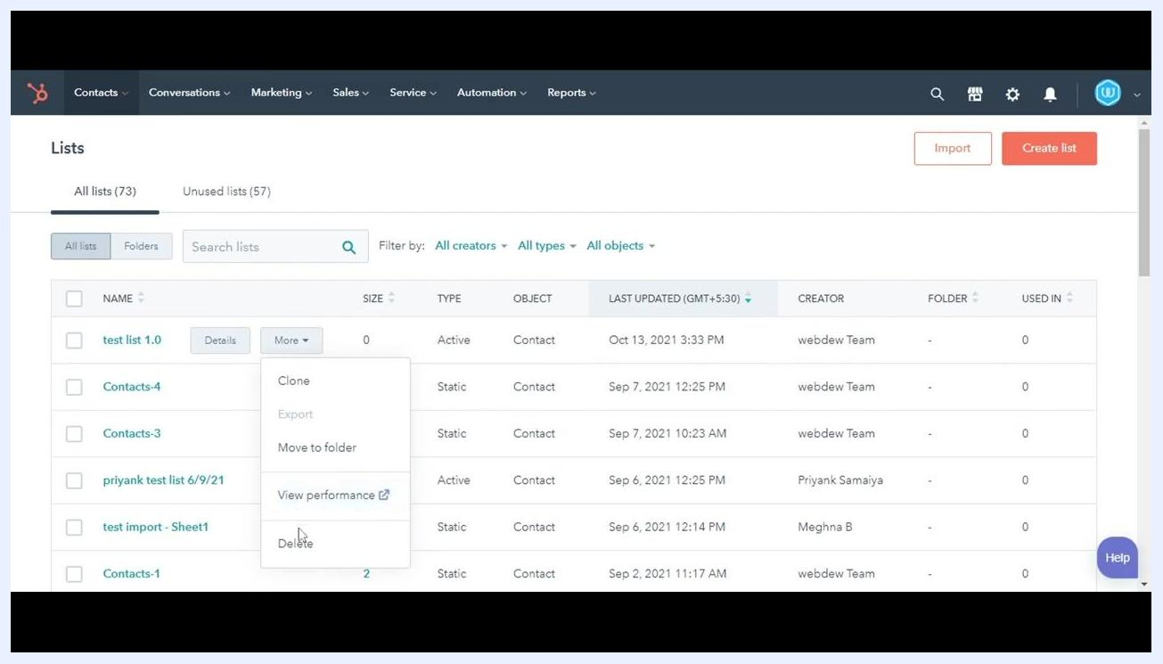
Thank you screen with thumbs up icon, "Thank You!", and large red Subscribe button with bell icon, cartoon character on left

Step 1: Navigate to the Lists tool
Log in to your HubSpot account. In the main navigation bar, click Contacts, then select Lists from the dropdown menu.

Step 2: Start creating a new list
On the Lists page, click the Create list button located in the upper right corner to begin.

Step 3: Choose the list type and name your list
Select whether you want to create a Contact-based list (for contact records) or a Company-based list (for company records). Then enter a name for your list in the List name field—for example, test list 1.0.
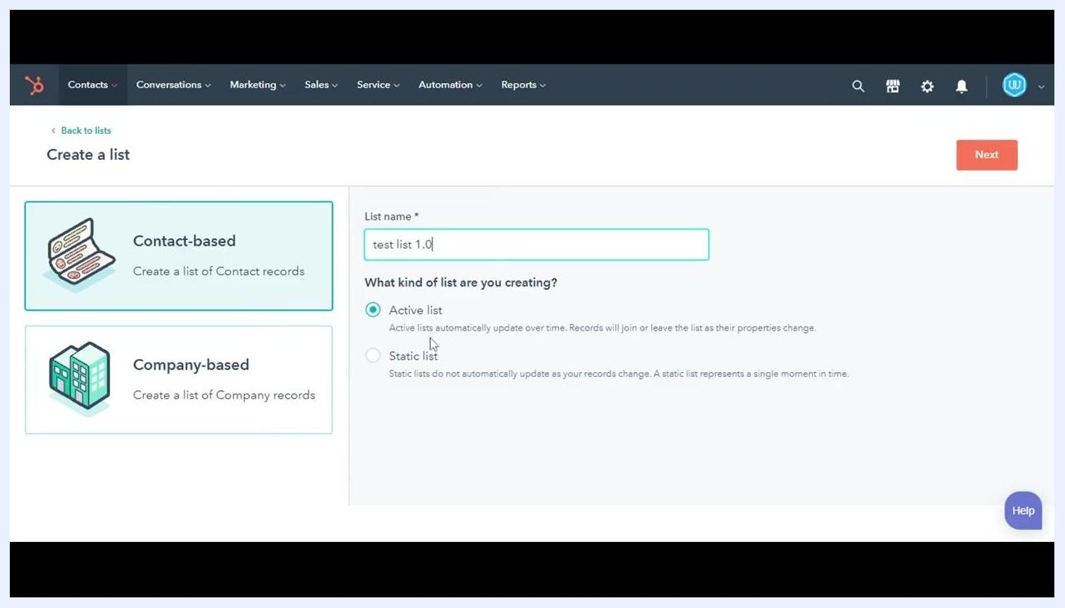
Create a list screen showing Contact-based or Company-based options, the list name field filled in with "test list 1.0," and Active list selected
Below the name field, choose the type of list:
- Active list: Updates automatically as records meet or no longer meet the criteria.
- Static list: Remains fixed and does not update even if new records match the criteria.
For this example, select Active list, then click Next to continue.

Step 4: Set your list criteria
On the next screen, use the left panel to select a filter type and define the criteria for your list. Search for and select a property—for example, "First name is known." Click Apply filter to preview the contacts or companies that match your chosen criteria.
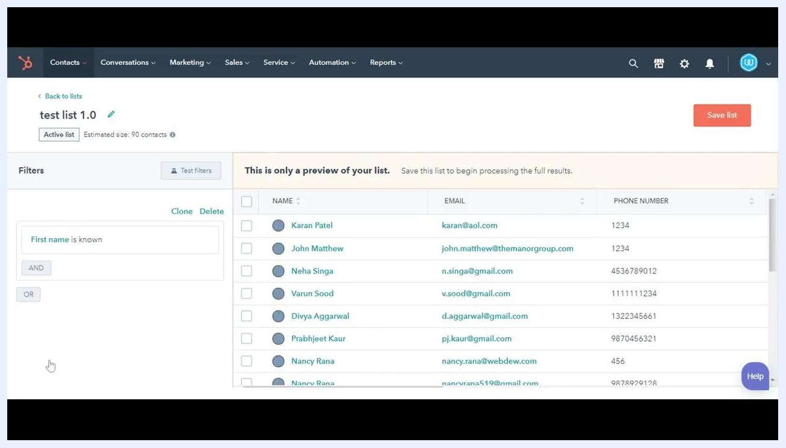
List preview showing the filter "First name is known," the list name "test list 1.0," and a table of matching contacts with names, emails, and phone numbers

Step 5: Save your list
Review the preview in the main panel, which shows the records currently meeting your criteria. When you're ready, click Save list in the upper right corner to finalize your new list.
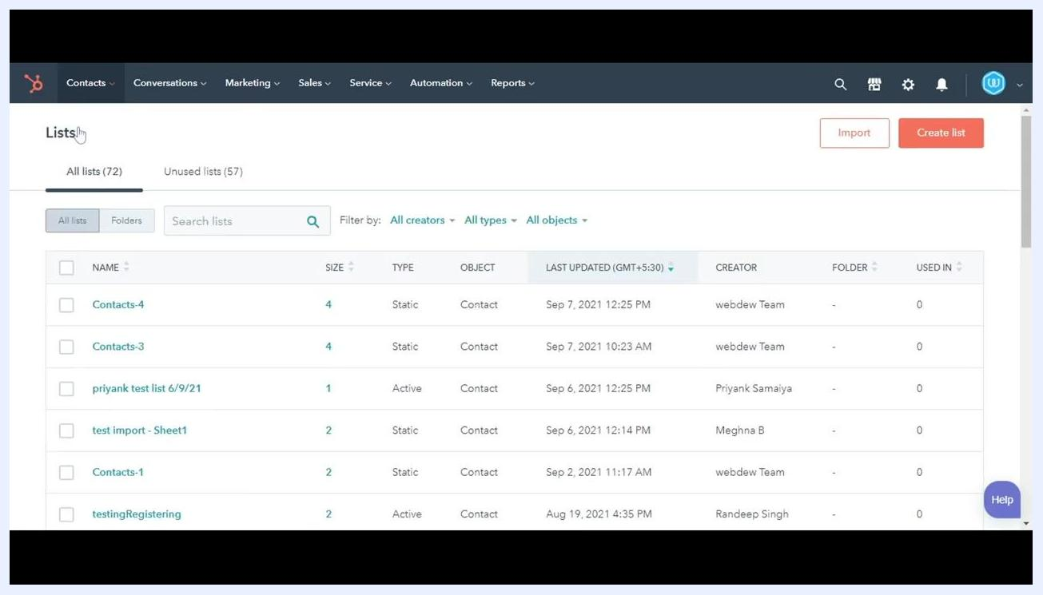
Lists overview page showing multiple lists with columns for name, size, type, object, last updated, creator, folder, and used in

Step 6: Review your list in the Lists overview
After saving, you'll return to the main Lists page, where you can see all your lists, including the one you just created. This overview displays details such as list name, size, type (active or static), object (contact or company), last updated date, creator, and usage.
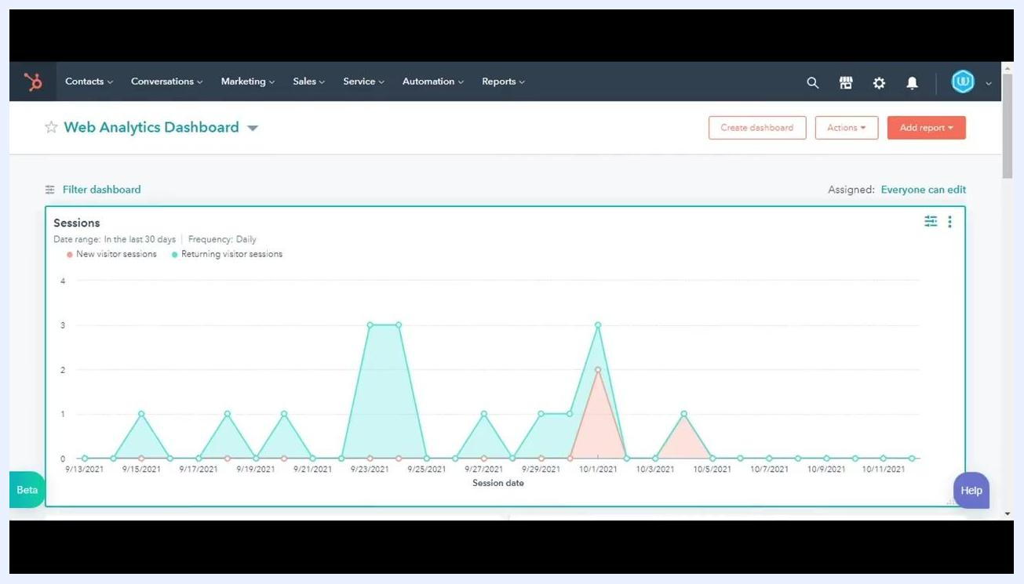
Welcome screen with "Welcome to HubSpot Tutorials" and Webdew logo, cartoon character on left

Managing your list with additional actions
Once your list is created, you can perform further actions directly from the Lists overview page.
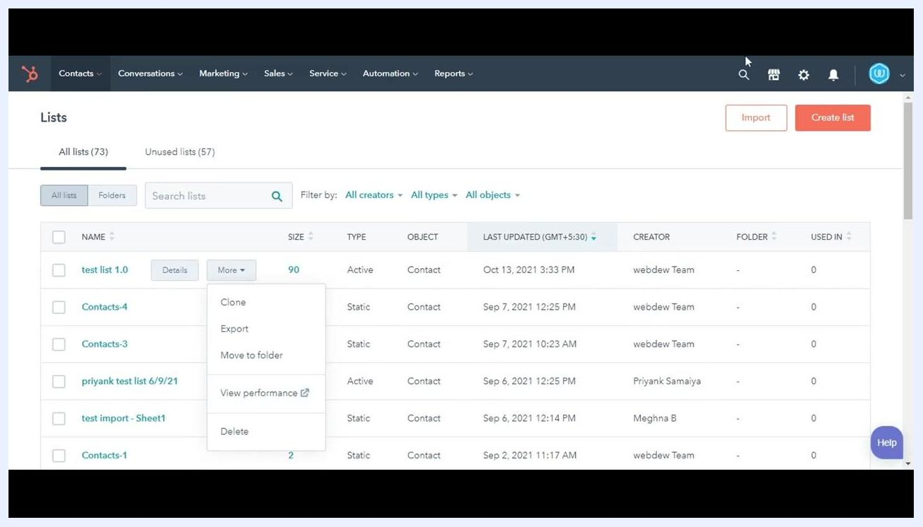
Webdew website promo with www.webdew.com in a search bar and a clicking cursor
Hover over your list's name (for example, test list 1.0) and click the More dropdown button next to it. This reveals the following options:
- Clone: Create a duplicate of the list.
- Export: Export the list data (this option may be disabled depending on your permissions).
- Move to folder: Organize the list into a folder.
- View performance: Open a new tab to view the list's performance analytics.
- Delete: Permanently remove the list from your account.
Lists overview page with "test list 1.0" selected and the More dropdown open, showing Clone, Export, Move to folder, View performance, and Delete options

Summary
You now know how to create a list in HubSpot and manage it using the available actions. With your list set up, you can organize your contacts and companies for use in workflows, marketing emails, and other processes across your HubSpot account.
What's next: To learn more about HubSpot services, visit .

