How to Use a Nebulizer: Standard Operating Procedure
This SOP explains how to use a nebulizer to administer prescribed respiratory medication safely and effectively. A nebulizer converts liquid medication into a fine mist that you inhale directly into your lungs, making it a helpful option for patients who have difficulty using standard inhalers.

Purpose
The purpose of this procedure is to guide you through assembling, operating, and completing a nebulizer treatment correctly, ensuring the medication reaches your lungs as intended.

Scope
This procedure applies to any patient prescribed nebulizer therapy who needs step-by-step guidance on setup and use. It covers home, travel, and portable use scenarios. Nebulizers are particularly recommended for patients who struggle to inhale deeply or cannot use inhalers due to health conditions. Different types of nebulizers exist, so consult your healthcare provider to confirm which type is best suited to your needs.

Required equipment
Before beginning, gather the following components:
- Medicine cup – holds the liquid medication
- Top piece or cap – seals the medicine cup
- Mask or mouthpiece – attaches to the medicine cup for inhalation
- Thin plastic tubing – connects the mouthpiece or mask assembly to the compressor
- Compressor – the air machine that powers the nebulizer
Confirm that all five parts are on hand before starting assembly.

Power source options
The compressor can be powered in one of the following ways, depending on your location:
- Plug into an electrical socket for indoor use
- Use a car adapter for on-the-go use
- Use battery operation for portable use away from home

Procedure

Step 1: Prepare for medication administration
Wash your hands thoroughly before handling any nebulizer parts or medication. This reduces the risk of contamination during treatment.

Step 2: Pour medication into the medicine cup
Take the prescribed medication as directed by your healthcare provider, then pour it into the medicine cup.
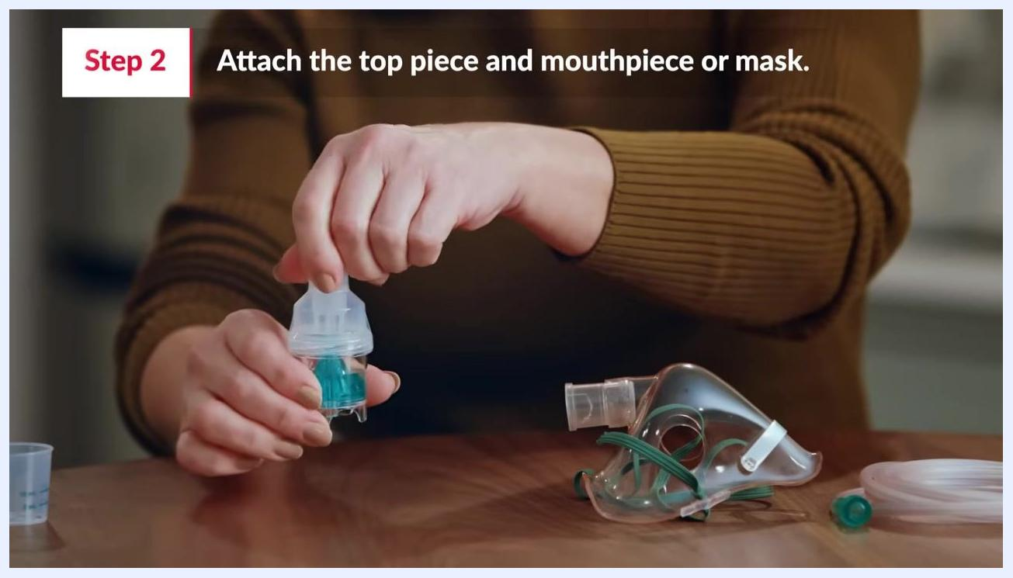
Pouring medicine into the medicine cup: a hand pours liquid from a small measuring cup into a clear medicine cup, with the top piece and mask nearby on a table.

Step 3: Assemble the top piece and mouthpiece
Attach the top piece or cap to the medicine cup, then attach the mouthpiece to the top piece.
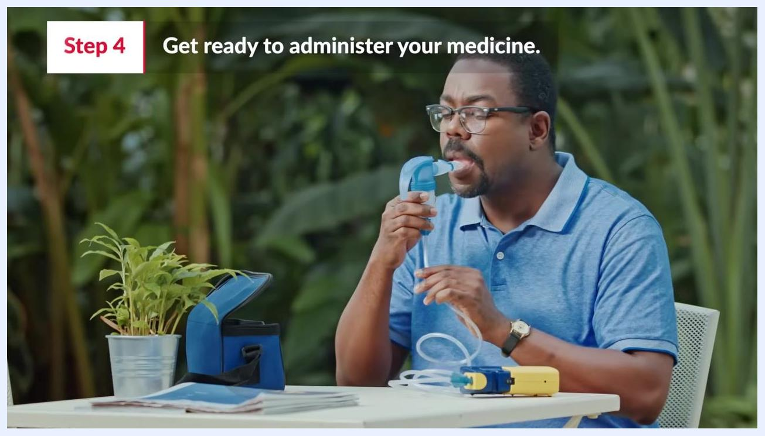
Attaching the top piece and mouthpiece: hands assemble the top piece onto the medicine cup, with the mask and tubing visible on the table.

Step 4: Attach the mask (if applicable)
If you are using a mask instead of a mouthpiece, secure it to the medicine cup as shown.
Attaching the mask to the medicine cup: hands connect the mask to the assembled medicine cup and top piece.

Step 5: Connect the tubing
Connect one end of the tubing to the compressor and the other end to the bottom of the medicine cup. Ensure both connections are secure before proceeding.

Step 6: Position the mask or mouthpiece and start the compressor
If using a mask, place it over your nose and mouth. If using a mouthpiece, place it in your mouth between your teeth and close your lips tightly around it. Hold the nebulizer in an upright position to prevent spilling and ensure proper medication delivery. Turn on the compressor to begin treatment.
Getting ready to administer medicine: a person holds the mouthpiece in their mouth, with the nebulizer and compressor set up on a table outdoors.

Step 7: Breathe normally during treatment
Take normal, regular breaths in through your mouth while wearing the mask or using the mouthpiece. Continue breathing in the mist so the medicine can reach deep into your lungs, and keep going until all the medicine is gone from the cup.
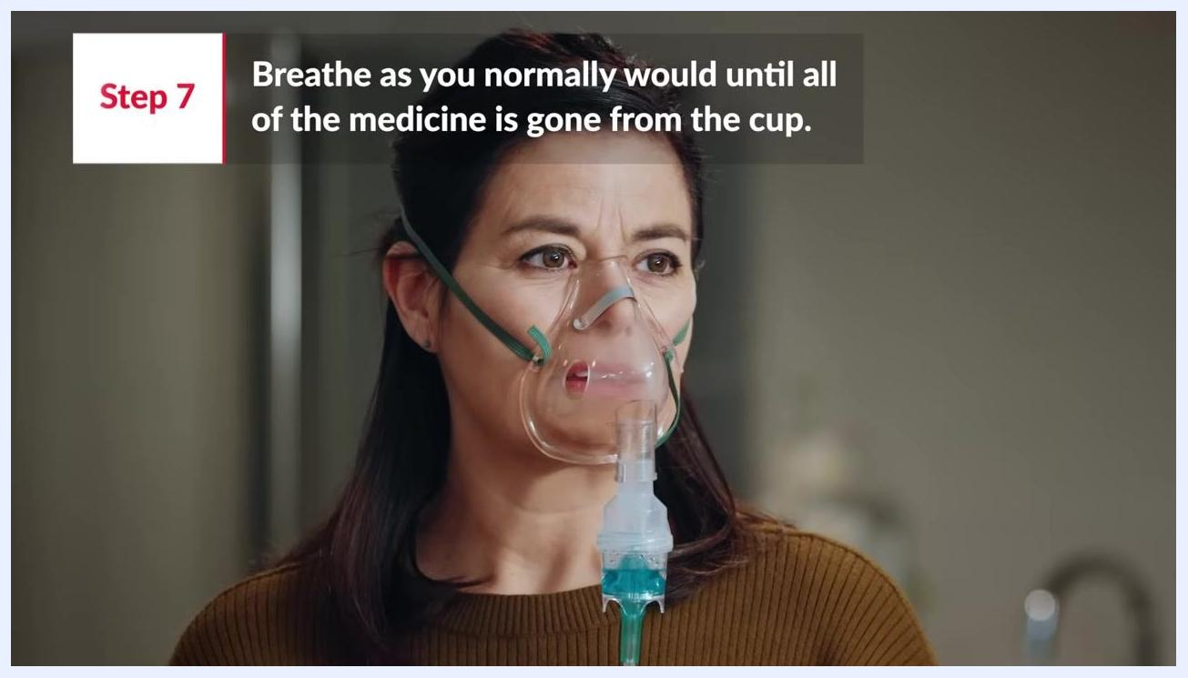
Breathing normally during nebulizer treatment: a person wears a nebulizer mask and breathes as usual until all medicine is used.

Step 8: Finish the treatment
Remain seated and relaxed, continuing to breathe in the medication mist until the nebulizer cup is completely empty. Do not remove the mask or mouthpiece until the treatment is finished, as breathing in the full dose ensures the medication is delivered effectively.

Verification
Confirm the treatment is complete once the medicine cup is empty and you have breathed in all of the mist. At this point, you can turn off the compressor and remove the mask or mouthpiece.

Additional resources
For more demonstration videos and detailed information on cleaning and caring for your nebulizer, visit the American Lung Association's website or contact them by phone.
- Website:
- Phone: 1-800-LUNGUSA
American Lung Association contact information: the organization's logo, website address (Lung.org/nebulizer), and phone number (1-800-LUNGUSA) displayed on a white background.

Summary
By following these steps, you can safely and effectively use a nebulizer to administer your prescribed medication. Always consult your healthcare provider for specific instructions related to your treatment, and refer to trusted resources such as the American Lung Association for further guidance, maintenance tips, and troubleshooting.

