How to Use a Blood Glucose Meter
This standard operating procedure explains how to use a blood glucose meter to test your blood glucose levels safely and accurately. Following these steps will help you obtain a reliable reading, dispose of sharps safely, and maintain accurate records for ongoing diabetes management.

Purpose
This procedure describes the correct method for using a blood glucose meter, from preparing your equipment to recording your results in a monitoring diary.

Scope
This procedure applies to anyone who needs to test their blood glucose levels using a blood glucose meter, test strips, and a lancing device.

Required equipment
Before you begin, gather the following items:
- Blood glucose meter
- Test strips
- Finger pricker or lancing device
- Lancet
- Cotton wool
- Monitoring diary and pen to record results
- Handwash or soap
- Paper towels or tissue
- A clean bowl (optional, for handwashing)

A person sitting at a table with all required items for blood glucose testing: handwash bottle, bowl, paper towels, cotton wool, lancing device, lancet, test strip container, blood glucose meter, monitoring diary, and pen

Step 1: Wash your hands
Wash your hands thoroughly with soap and water, using the handwash and bowl if available. Dry your hands completely with a paper towel or tissue before proceeding.
Person drying hands with a paper towel, with all testing equipment laid out on the table

Step 2: Confirm your hands are dry
Rub your hands together with the towel to remove all moisture. Your hands must be thoroughly dry before you start the test.
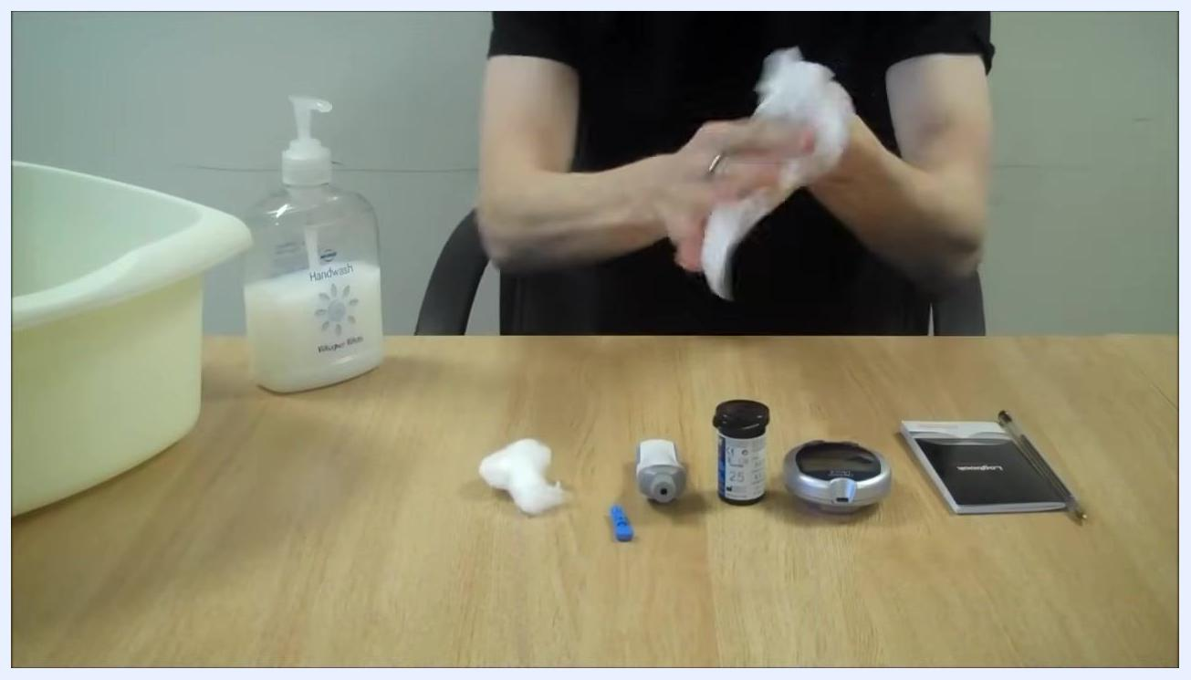
Person rubbing hands with a paper towel to ensure dryness, with equipment visible on the table

Step 3: Load the lancet
Remove the cap from the lancing device and insert the lancet firmly until it snaps into place. Replace the cap on the lancing device once the lancet is loaded.
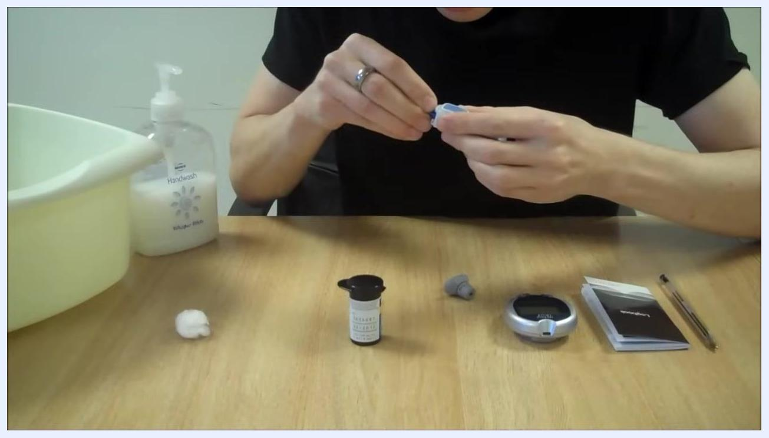
Person inserting a blue lancet into the lancing device, focusing on the loading process

Step 4: Prepare the blood glucose meter
Open the test strip container and remove one test strip. Insert the test strip into the blood glucose meter; the meter should automatically switch on when the strip is inserted.
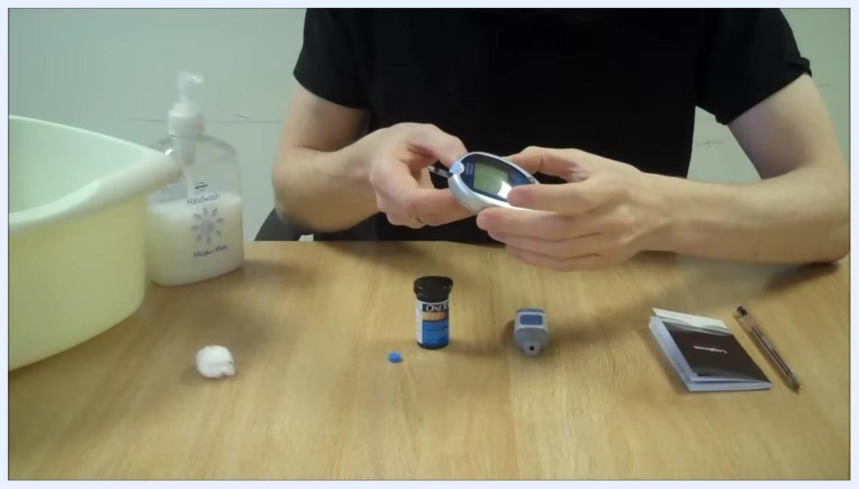
Person inserting a test strip into the blood glucose meter, with the test strip container open and the meter on the table

Step 5: Choose a finger for testing
Select the side of your fingertip, not the pad or tip, for pricking, as this is less painful. Hold your hand steady and position the lancing device on the side of your chosen finger.
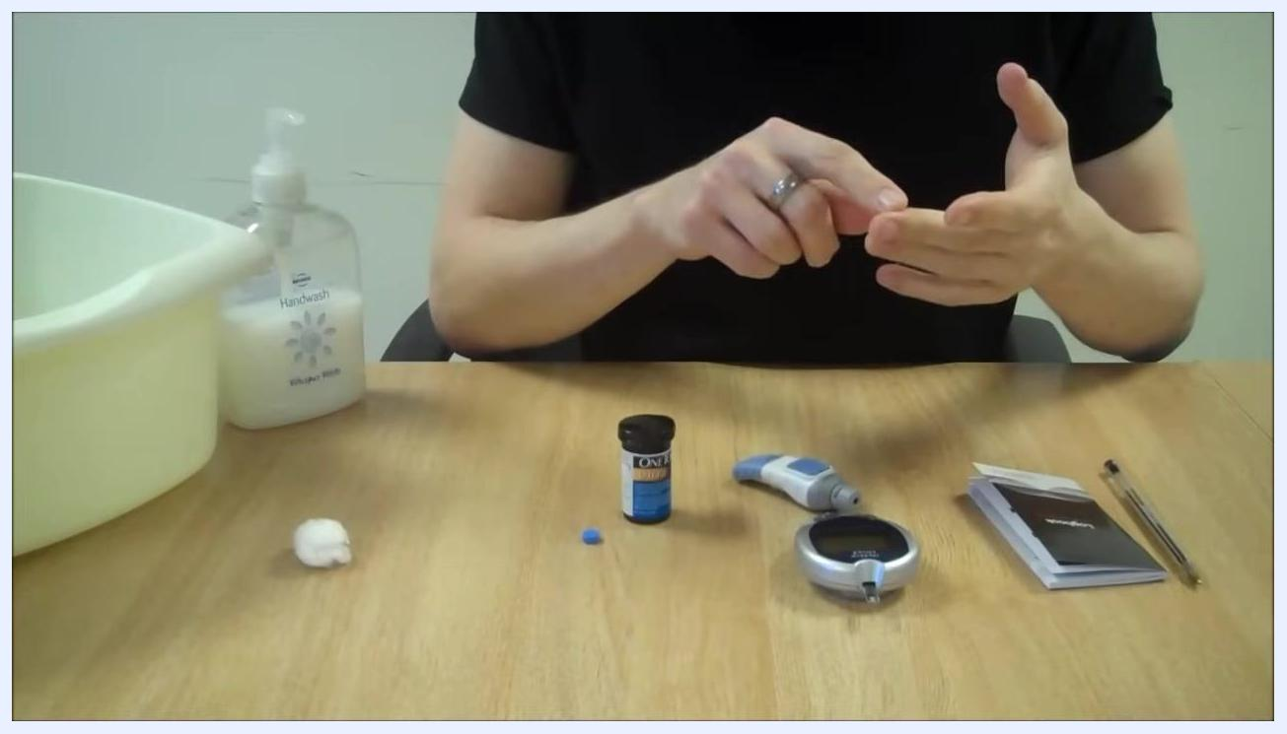
Person indicating the side of their finger, preparing for the finger prick, with the meter and lancing device on the table

Step 6: Prick your finger
Prick the side of your finger with the lancing device. If necessary, gently squeeze your finger to obtain a drop of blood.
Safety note: If you need to squeeze too hard to get a blood drop, repeat the test with a new lancet and a different finger.
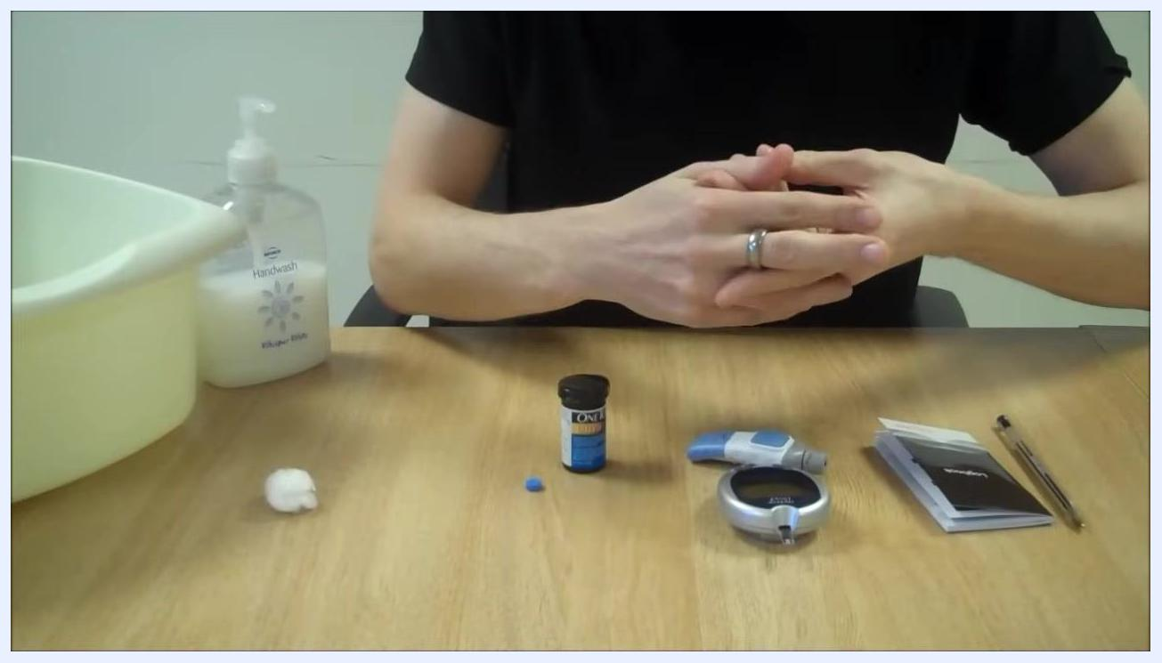
Person gently squeezing their finger after pricking, preparing to collect a blood sample

Step 7: Apply blood to the test strip
Apply the drop of blood to the test strip in the meter, ensuring the meter is on and ready to read the sample. The result should appear on the meter within a few seconds.
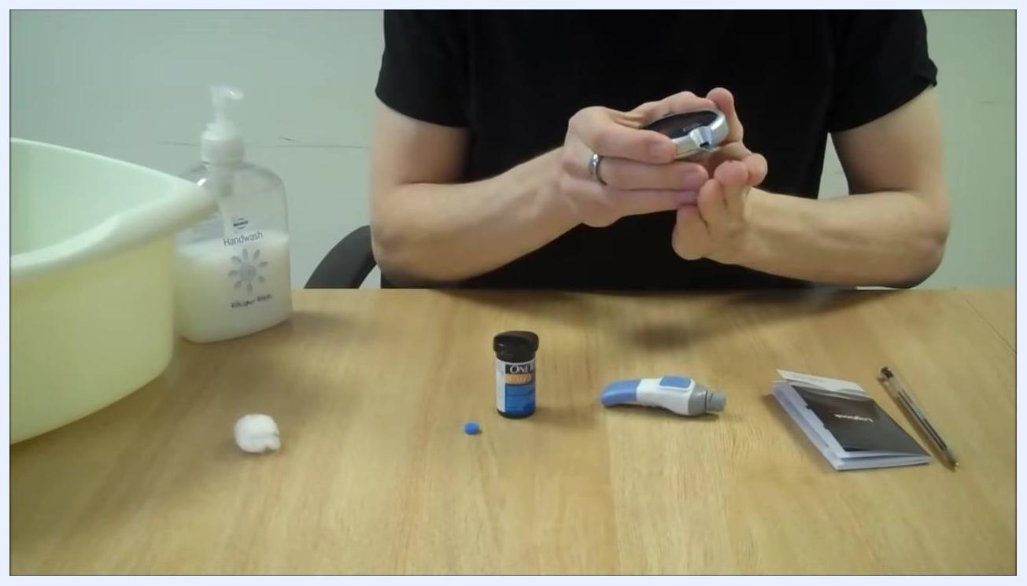
Person holding the blood glucose meter to their finger, applying blood to the test strip while awaiting the result

Step 8: Read your result
Observe the meter screen for your reading. In this example, the result shown is 3.6 mmol/L.
Safety note: If your reading is low (such as 3.6 mmol/L), treat immediately with glucose tablets or another fast-acting carbohydrate as recommended by your healthcare provider.
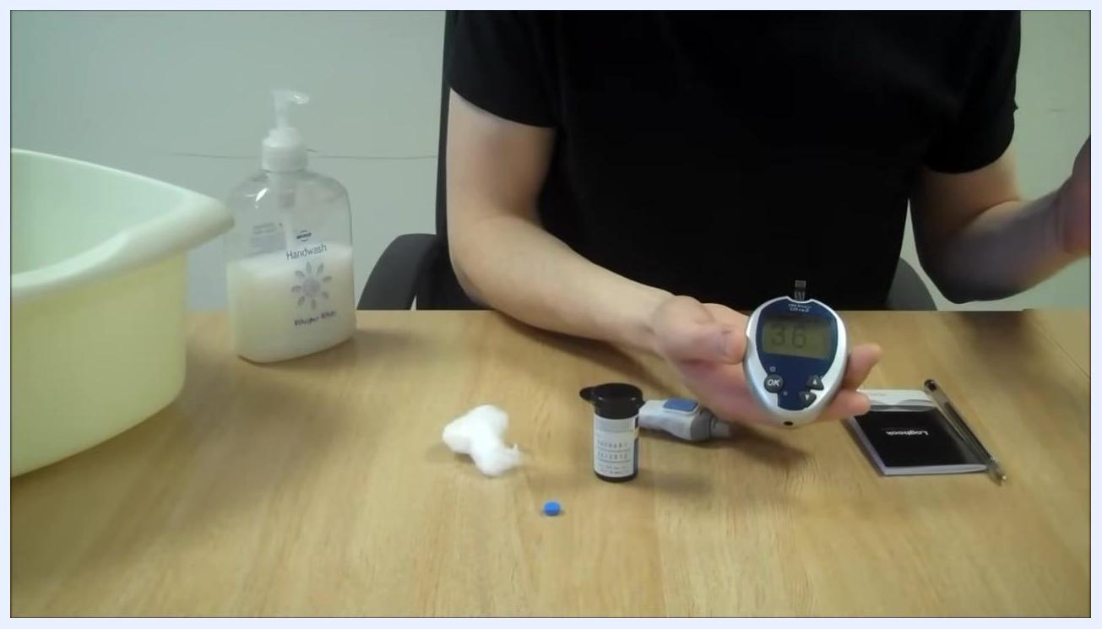
Person holding the blood glucose meter with the result displayed as 3.6 mmol/L, with all testing equipment visible on the table: handwash, bowl, cotton wool, test strip container, lancing device, monitoring diary, and pen

Step 9: Clean your finger
Use a piece of cotton wool or tissue to gently wipe away any remaining blood from your fingertip.

Step 10: Dispose of the test strip
Remove the used test strip from the meter and dispose of it in the regular trash.

Step 11: Safely dispose of the lancet
Remove the lancet from the lancing device and place it into a designated sharps bin for safe disposal.
Safety note: Always dispose of used lancets in a sharps bin, never in regular trash.
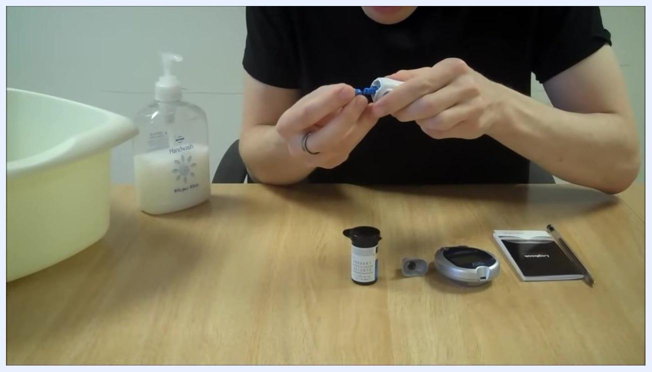
Person removing the lancet from the lancing device, preparing for safe disposal, with all equipment visible on the table

Step 12: Record your result
Write down the value shown on the meter (for example, 3.6 mmol/L) in your monitoring diary. Note the time of the test and any relevant details, such as "after lunch."
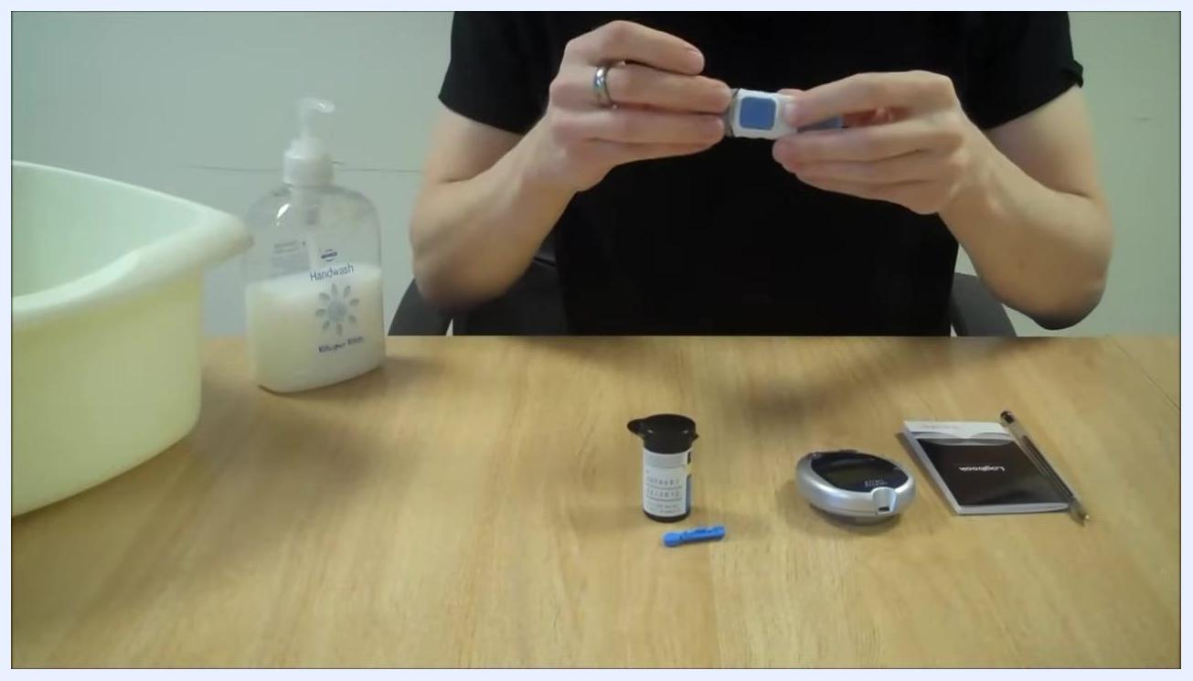
Person writing in the blood glucose monitoring diary, with pen in hand and all equipment visible on the table

Summary
By following these steps, you will complete your blood glucose test accurately, ensure safe disposal of sharps, and maintain accurate records for ongoing diabetes management.

