How to Transfer a Patient from Bed to Wheelchair Using a Transfer Belt
This procedure describes how to transfer a patient from bed to wheelchair safely using a transfer (gait) belt. It covers preparation of the client and environment, the standing transfer itself, and the final safety checks needed to protect both the client and the caregiver throughout the process.

Purpose
The purpose of this procedure is to provide a standardized, safe method for moving a client from a lying or seated position in bed into a wheelchair. Following these steps helps prevent falls, protects client dignity, and ensures the client is comfortable and secure once seated.

Scope
This procedure applies to caregivers assisting a client who is able to bear some weight and cooperate with a standing transfer using a transfer (gait) belt. It covers the full transfer sequence from initial privacy setup through final documentation of task completion.

Required equipment
- Transfer (gait) belt
- Wheelchair with functioning wheel locks and footrests
- Appropriate footwear (shoes or non-slip socks)
- Privacy curtain, screen, or door
- Signaling device (call light)

Procedure

Step 1: Ensure privacy for the client
Provide privacy using a curtain, screen, or door before beginning any transfer procedures. This protects the client's dignity throughout the transfer.

Step 2: Explain the procedure
Communicate with the client to explain the upcoming transfer. Confirm the client understands what will happen and is prepared to cooperate.

Step 3: Assist the client into a sitting position
Help the client move from lying down to a sitting position on the edge of the bed. Ensure the client's feet are flat on the floor and confirm they are stable and comfortable in this position.

A healthcare worker in blue scrubs stands beside a client lying in a hospital bed, preparing to assist. The environment includes a hospital sink, medical equipment, and privacy curtains.

Step 4: Ensure the client is wearing shoes
Before assisting the client to stand, confirm they are wearing appropriate footwear, such as shoes or non-slip socks, to prevent slipping during the transfer.

The client is now sitting on the edge of the bed, and the healthcare worker is bent down, checking or assisting with footwear. A wheelchair is visible nearby.

Step 5: Position the wheelchair correctly
Place the wheelchair along the side of the bed, positioned either at the head of the bed facing the foot, or at the foot of the bed facing the head. Ensure it is close enough to allow a safe transfer.
The wheelchair is positioned next to the bed, and the healthcare worker is adjusting it. The client sits on the bed, feet flat on the floor, ready for transfer.

Step 6: Prepare the wheelchair
Fold up or remove the footrests to prevent tripping during the transfer. Lock the wheelchair wheels to ensure stability before proceeding.
Safety note: Locked wheels on both the bed and wheelchair are essential to prevent movement during the transfer.

Step 7: Apply the transfer (gait) belt
Place the transfer belt securely around the client's waist, over their clothing or gown, and fasten it snugly. Check the fit by slipping three or four fingers under the belt — it should be snug but allow this amount of space.
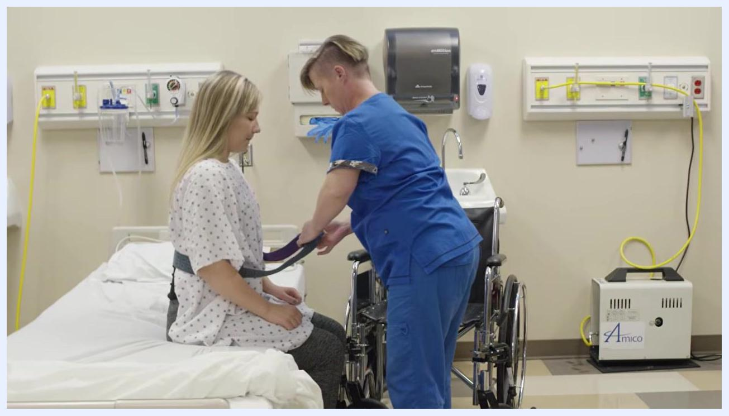
The healthcare worker is securing a transfer (gait) belt around the client's waist while the client sits on the edge of the bed, ready for transfer.

Step 8: Double-check all safety measures
Before assisting the client to stand, verify the following:
- Bed wheels are locked
- Wheelchair wheels are locked
- Client's feet are flat on the floor and shoes are on
- Transfer belt is properly secured and snug

Step 9: Prepare for the transfer
Stand in front of the client, ready to assist with the transfer using the gait belt.

Step 10: Instruct the client to stand on the count of three
Stand directly in front of the client, holding the transfer belt securely. Clearly communicate: "On the count of three, I want you to push up with your hands, and we're going to stand." Count aloud, "One, two, three," and assist the client to stand, ensuring they push up with their hands as instructed.
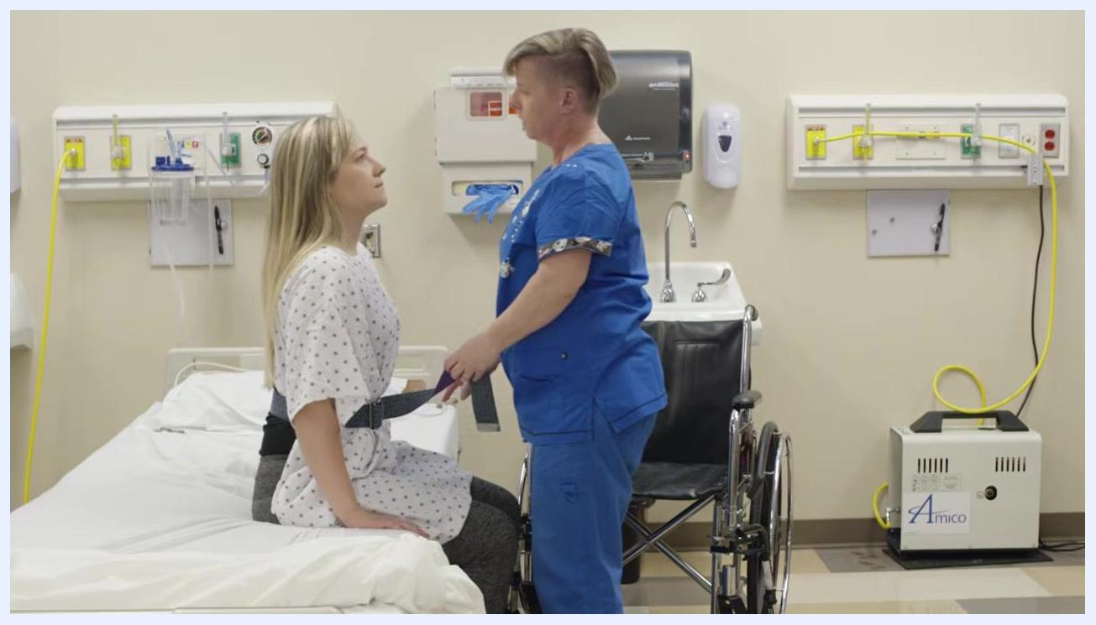
A healthcare worker in blue scrubs stands directly in front of a client sitting on the edge of a hospital bed, holding the transfer belt and preparing to assist the client to stand. The environment includes a wheelchair positioned next to the bed, a hospital sink, and medical equipment on the wall.

Step 11: Turn and position the client in front of the wheelchair
Guide the client to turn so that the back of their legs touch the seat of the wheelchair. Ensure the client is stable and standing directly in front of the wheelchair, and maintain a secure grip on the transfer belt throughout this maneuver.

The healthcare worker assists the client, who is now standing and turning in front of the wheelchair. The worker maintains a secure hold on the transfer belt, and the back of the client's legs are positioned against the wheelchair seat.

Step 12: Lower the client safely into the wheelchair
Instruct the client to reach back for the wheelchair armrests if able. Slowly and safely lower the client into the wheelchair, ensuring their hips touch the back of the seat. Confirm verbally, "Are your hips back far enough?" and wait for the client's response, adjusting their position as needed for proper alignment and comfort.
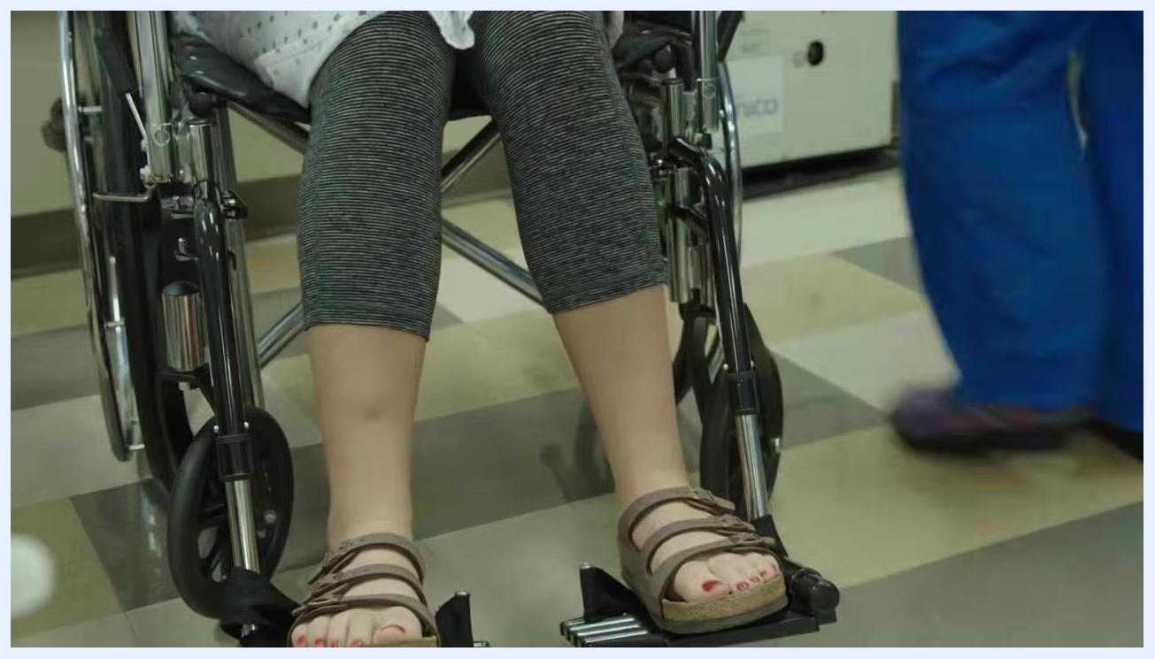
The healthcare worker is bent over, removing the transfer belt from the client who is now seated in the wheelchair. The client is positioned with her hips against the back of the wheelchair.

Step 13: Remove the transfer (gait) belt
Once the client is safely seated with their hips against the back of the wheelchair, unfasten and remove the transfer belt. Ensure the client remains stable and comfortable during this process.
The healthcare worker has removed the transfer belt and is stepping away, while the client sits securely in the wheelchair.

Step 14: Position the client's feet on the footrests
Place both of the client's feet securely on the wheelchair footrests, ensuring they are flat and comfortably supported to prevent injury or discomfort.
Close-up of the client's feet, now positioned securely on the wheelchair footrests. The healthcare worker is visible in blue scrubs, walking away.

Step 15: Ensure the signaling device is within reach
Place the signaling device (call light) in the client's hand or within easy reach, and confirm with the client that they can access it if they need assistance.

Step 16: Restore privacy and complete the procedure
Open or remove the privacy curtain to restore the client's privacy and dignity. Inform the client that the procedure is complete and ask if they need anything else. Perform hand hygiene to complete the task.
The healthcare worker opens the privacy curtain while the client sits in the wheelchair, holding the call light. The environment is a hospital room with medical equipment and a bed visible.

Verification and completion
Stand back and visually confirm that the client is safe, comfortable, and has access to the call light. This confirms the transfer procedure is complete.
The healthcare worker stands in front of the closed privacy curtain, hands together, while the client sits in the wheelchair. The procedure is finished.
By following these steps, you ensure a safe, respectful, and effective transfer of a client from bed to wheelchair using a transfer belt, maintaining both client safety and dignity throughout the process.

