How to take an apical pulse
This patient care procedure explains how to take an apical pulse in adult patients, describing each step from initial preparation through auscultation, interpretation, and documentation. It is intended for nursing and allied health staff who need a reliable, repeatable technique for locating and counting the apical pulse at the bedside.

RegisteredNurseRN.com end screen with options for more videos, subscribe button, and reminder to give a thumbs up and share

Purpose and scope
You take an apical pulse to obtain an accurate heart rate directly over the apex of the heart rather than at a peripheral site. This assessment applies to adult patients and is performed before administering certain cardiac medications, such as digoxin, to confirm the heart rate is safe for dosing. For a healthy adult, the normal apical pulse rate falls between 60 and 100 beats per minute. A stethoscope is the only equipment required.
Nurse educator in purple scrubs, standing against a plain background, addressing the viewer with a stethoscope around her neck

Patient assessment
Complete the following checklist before you begin locating and auscultating the apical pulse.
Step | Action
Equipment | Obtain a stethoscope for the assessment.
Stethoscope hygiene | Clean the diaphragm, bell, ear pieces, and tubing before use, and clean the stethoscope again between each patient to prevent cross-contamination.
Hand hygiene | Wash your hands thoroughly or use hand sanitizer before beginning the procedure.
Patient explanation | Tell the patient what you are about to do, for example: "I am going to listen to your heart at the apex to check your pulse."
Indication check | Confirm whether the assessment is needed before a cardiac medication, such as digoxin.
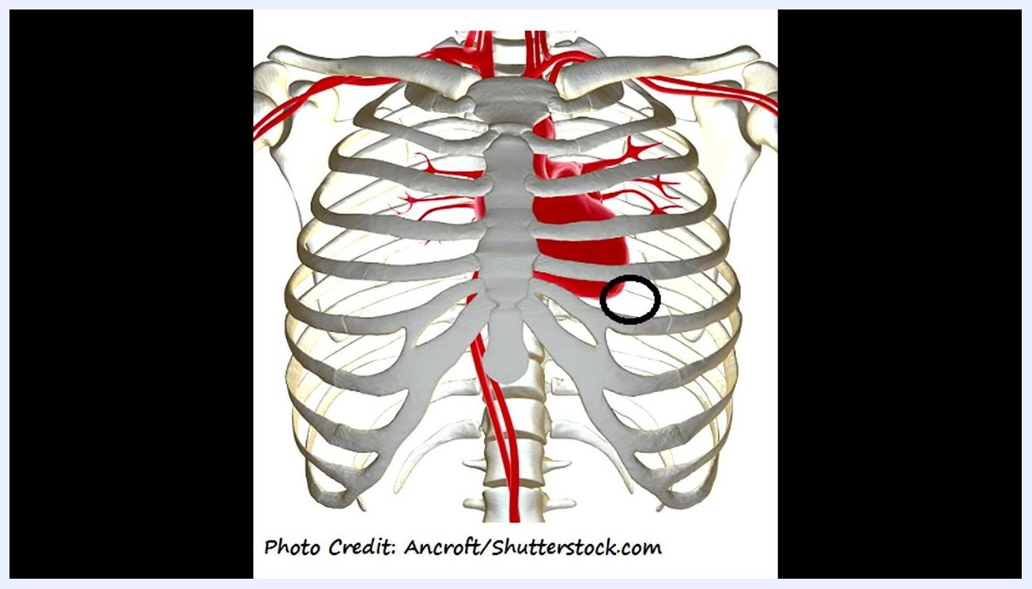
Anatomical diagram of the rib cage and heart, with the apical pulse location circled at the fifth intercostal space, midclavicular line
Vital sign monitoring frequency: the apical pulse is counted over one full minute at the point of assessment; the source material does not specify a routine monitoring interval beyond this single reading.
Pain assessment tool: the source material does not describe a pain assessment tool for this procedure, since taking an apical pulse is a non-invasive auscultation technique.
Neurovascular checks: the source material does not include neurovascular checks as part of this procedure; document those separately according to facility protocol if required for the patient's overall care.

Care protocol
Perform the assessment in the following phases.

Phase 1: Position the patient and identify the apical pulse location
Have the patient lie back comfortably; they may sit up slightly, but lying back is preferred. The apical pulse is found at the point of maximal impulse (PMI), located at the fifth intercostal space, midclavicular line, on the left side of the chest — the apex of the heart, at its bottom.
Patient lying back with the examiner's hand at the sternal notch, preparing to palpate down to the angle of Louis

Phase 2: Locate the landmarks by palpation
Find the sternal notch, a visible and palpable notch between the clavicles at the top of the sternum, then place your hand there before moving downward.
Move your fingers down from the sternal notch until you feel a slight protrusion — the angle of Louis, also called the sternal angle.
From the angle of Louis, move your fingers slightly left to find the second intercostal space, feeling for the gap between two ribs.
Starting at the second intercostal space, count down along the midclavicular line — an imaginary line running down from the middle of the clavicle — through the third, fourth, and fifth intercostal spaces.
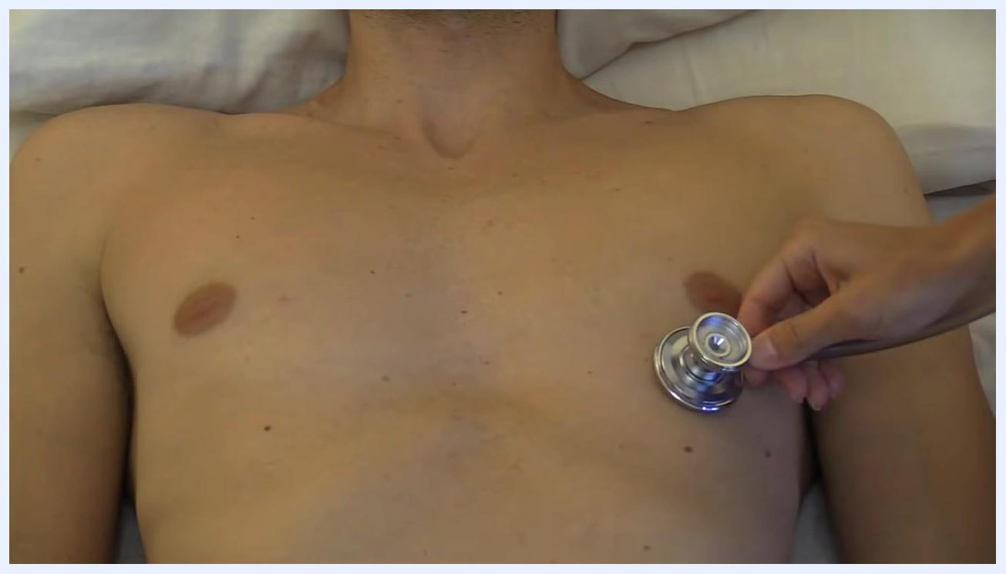
Examiner's hand remains in position, continuing to palpate for the apical impulse
Intercostal space | Landmark reference
Second | Just left of the angle of Louis
Third | Continue counting down the midclavicular line
Fourth | Continue counting down the midclavicular line
Fifth | Midclavicular line — apical pulse location
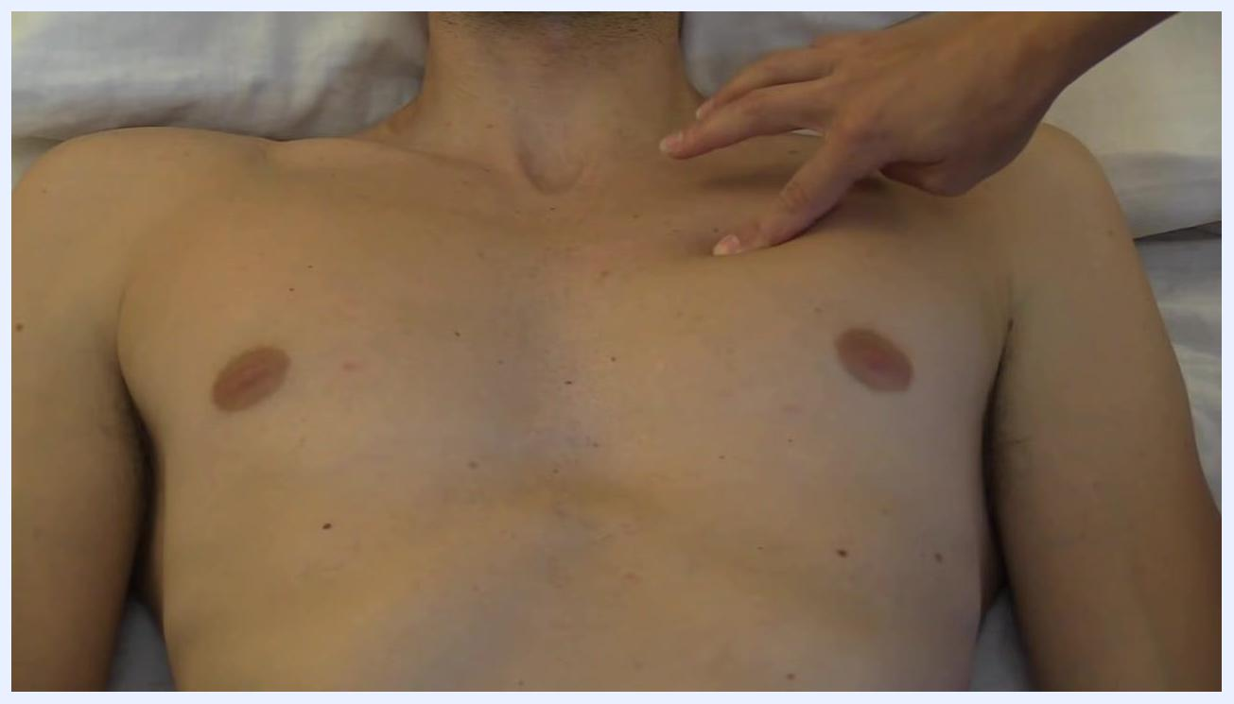
Examiner's fingers positioned in the second intercostal space, just left of the sternum
For female patients with large breasts, ask the patient to lift the breast to allow access to the fifth intercostal space, since you cannot accurately auscultate through thick tissue.

Phase 3: Palpate for the apical impulse
Once at the fifth intercostal space, midclavicular line, use your hand to feel for the apical impulse. You may feel a light thumping sensation, though this is not always palpable — it is more often felt in patients with a thin chest wall and less often in patients with a large chest or obesity. If you cannot feel the impulse, proceed to auscultation.
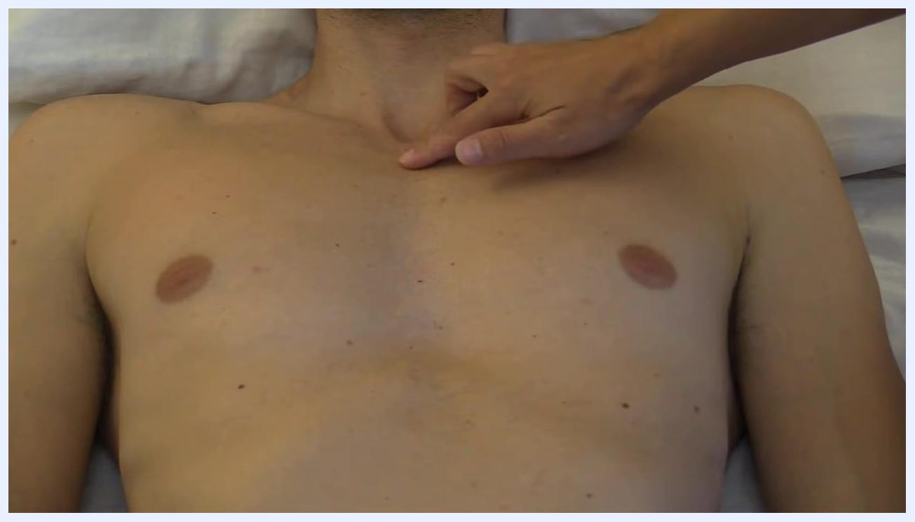
Examiner's hand palpating the upper chest, with fingers at the sternal notch and angle of Louis on a supine patient
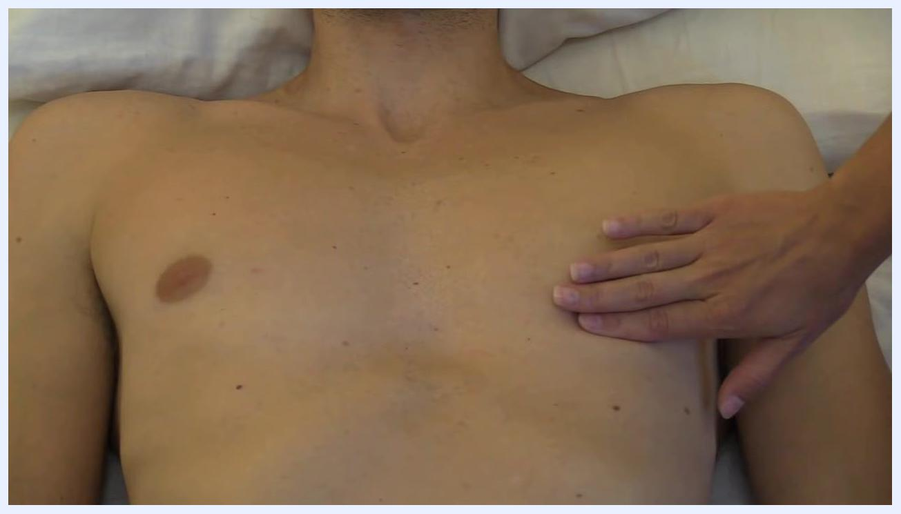
Examiner's hand flat on the left chest, palpating for the apical impulse at the fifth intercostal space

Phase 4: Auscultate and count the apical pulse
Prepare your stethoscope and use the diaphragm for auscultation. Place the diaphragm at the fifth intercostal space, midclavicular line, and listen for one full minute, counting each heartbeat.
Examiner's fingers counting down intercostal spaces along the midclavicular line
In one demonstrated assessment, the counted apical pulse was 61 beats per minute, within the normal adult range of 60 to 100 beats per minute.
Stethoscope diaphragm placed at the fifth intercostal space, midclavicular line, ready for auscultation

Phase 5: Conclude and document
Inform the patient that the assessment is complete, ensure they are comfortable and covered, clean your stethoscope, and wash your hands according to infection control guidelines. Record the apical pulse rate, the location of auscultation, and any notable observations, such as an irregular rhythm or difficulty palpating the impulse.
Examiner using a stethoscope and digital watch to count the apical pulse on a patient's bare chest, focusing on the fifth intercostal space, midclavicular line

Pain management
This section would normally outline a multimodal pain management plan with a medication table listing drug, dose, route, and frequency, along with pain score targets and an escalation pathway. The source material does not include this information, since taking an apical pulse is a non-invasive auscultation procedure.

Mobility milestones
This section would normally set out progressive mobility goals on a timeline. The source material does not describe mobility milestones, as it covers only the technique for assessing the apical pulse.

Complication monitoring
After counting the apical pulse, interpret the result against the normal adult range of 60 to 100 beats per minute.
Finding | Interpretation | Action
60–100 bpm | Within normal range | Document as normal
Below 60 bpm | Bradycardia | Note the finding and follow your facility's protocol for further assessment or intervention
Above 100 bpm | Tachycardia | Note the finding and follow your facility's protocol for further assessment or intervention

Discharge criteria
The source material does not describe discharge criteria in the sense of ending a patient's care episode. It does describe the criteria for completing the apical pulse assessment itself:
- The apical pulse has been counted for one full minute at the fifth intercostal space, midclavicular line.
- The patient has been informed that the assessment is finished and is comfortable and covered.
- The stethoscope has been cleaned and hand hygiene performed.
- The apical pulse rate, location, and any notable observations have been documented.
Examiner's finger positioned at the fifth intercostal space, just below the left nipple, demonstrating the location for auscultation

Patient education
Before beginning, explain the procedure clearly to the patient, for example: "I am going to listen to your heart at the apex to check your pulse." Throughout the assessment, ensure proper hygiene and clear communication, and adapt your technique as needed for different body types, such as asking a patient with large breasts to lift the breast tissue so you can access the fifth intercostal space. After the assessment, confirm the patient understands that the check is complete and that findings within the normal range of 60–100 beats per minute are expected for a healthy adult.
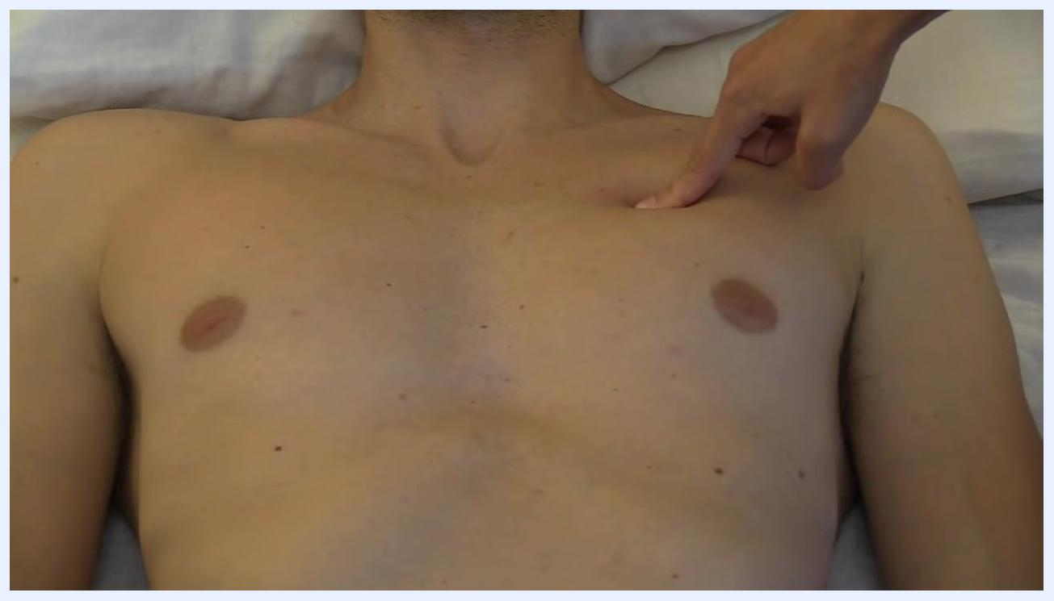
Examiner's finger pointing to the third intercostal space, continuing to count down

