How to Start an IV: A Step-by-Step SOP for IV Insertion and Securement
This standard operating procedure explains how to start an IV, from initial preparation and site disinfection through catheter insertion, flushing, cap management, and securement with a transparent dressing. Follow each step in sequence to maintain aseptic technique and reduce the risk of infiltration, infection, or accidental dislodgement.
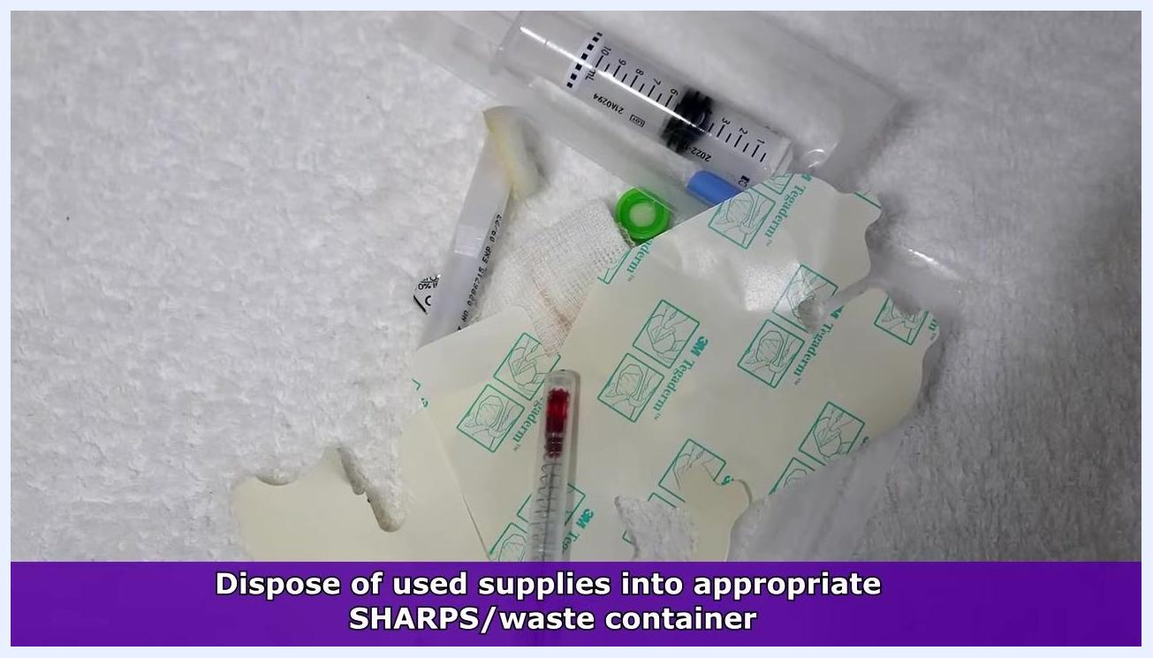
A nurse in purple scrubs stands in front of a gray background. A purple banner at the bottom lists social media links: Instagram: registerednursern_com, Facebook: RegisteredNurseRNs, Twitter: @NursesRN.

Purpose
This SOP provides a consistent, step-by-step method for performing peripheral IV insertion, connecting the access device, flushing the catheter, and securing the site with a transparent dressing. It is intended to support safe, standardized practice during IV starts.

Scope
This procedure applies to any clinical setting where peripheral IV insertion is performed. It covers site preparation, disinfection, catheter insertion, device connection, flushing, cap management, dressing application, and disposal of used supplies.

Prerequisites and safety notes
- Always follow your hospital's protocols and the latest clinical guidelines before performing any nursing skill.
- Confirm you are up to date on any changes to insertion or securement procedures.
- This documentation is for educational reference only and is not a substitute for facility-specific medical guidance. Always verify your facility's protocols before practicing IV insertion.
- Maintain aseptic technique throughout the entire procedure.
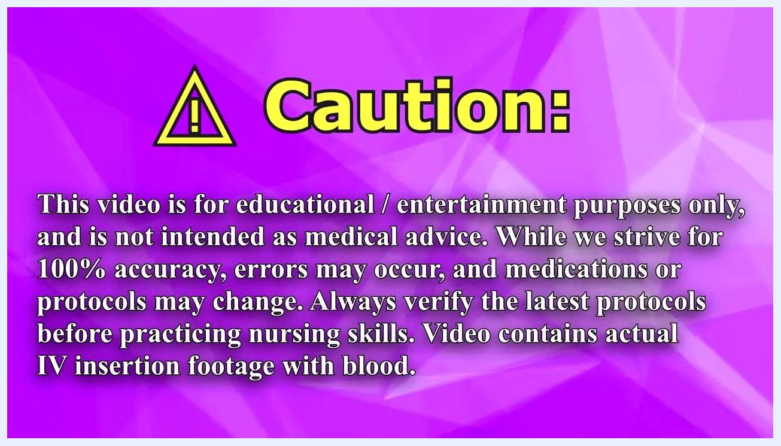
Caution screen with an educational disclaimer and warning about IV insertion footage containing blood

Required equipment and PPE
- IV insertion kit (catheter, extension set or saline lock, dressing)
- Syringe and saline for flushing
- Chloroprep or antiseptic swab
- Tourniquet
- Clean gloves
- Trimmers (not a straight razor), if needed for excessive hair at the site
- Transparent dressing with notched area (e.g., labeled "33CNPL")
- Curos cap or similar protective cap
- Secondary securement tape
- Labeling system for documentation
- Clean white towel
- SHARPS container and appropriate medical waste container
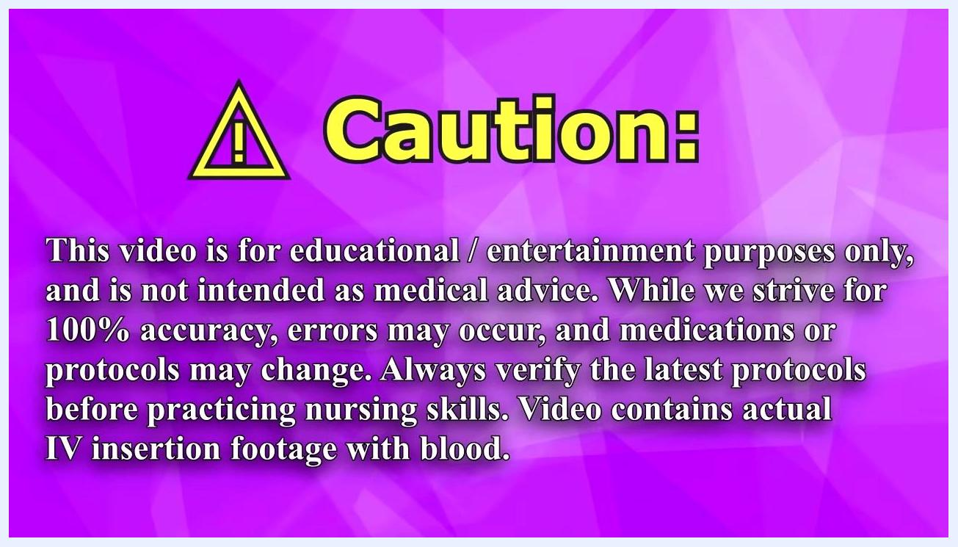
Preparing IV supplies on a white towel, with an on-screen checklist covering opening packages, priming the flush, flushing the extension set, rotating and reseating the catheter, and preparing the labeling system

Step 1: Gather supplies and perform initial hand hygiene
Collect all IV insertion supplies required by your facility before starting the procedure. Perform hand hygiene thoroughly before handling any equipment.
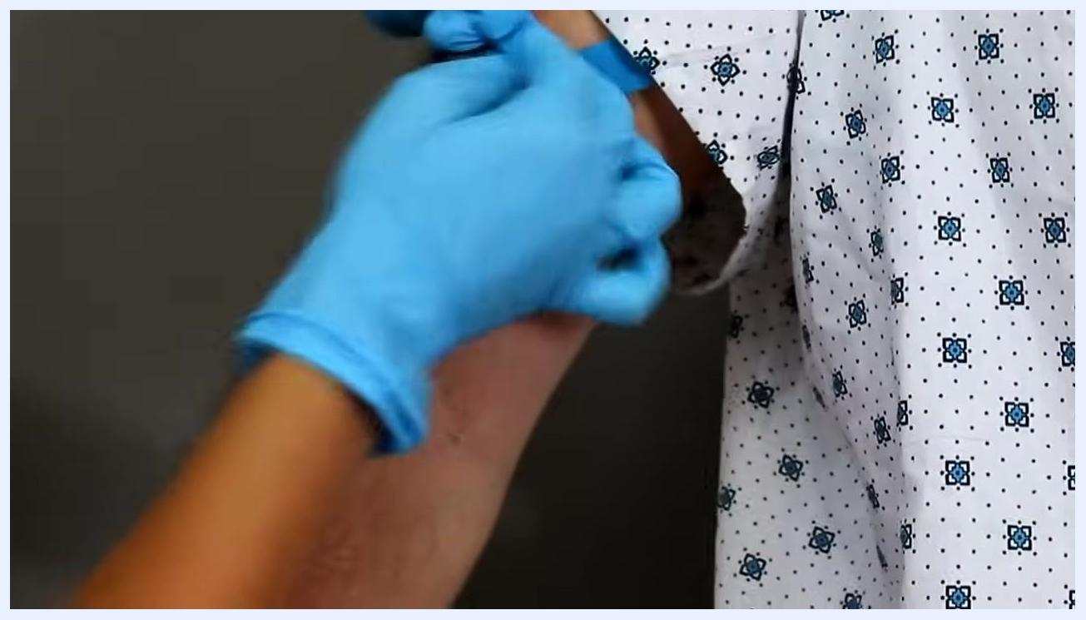
Gloved hands applying a blue tourniquet to a patient's arm; the patient is wearing a hospital gown

Step 2: Prepare your supplies
Open all IV supply packages and prime the flush by removing air from the syringe. Flush the extension set with saline to confirm patency, and rotate and reseat the IV catheter if the manufacturer recommends it. Prepare your labeling system for documentation and complete any other preparatory steps your facility requires.
Hands being washed under running water at a sink, labeled "Perform Hand Hygiene"

Step 3: Perform hand hygiene again and don gloves
Wash your hands thoroughly with soap and water, dry them, and put on clean gloves before proceeding to the patient.

Step 4: Prepare the insertion site
If the patient has excessive hair at the insertion site, use trimmers—never a straight razor—to trim the area. This helps tape adhere better and reduces discomfort during removal. Confirm the trimmed area is clean and ready for insertion.

Gloved hands holding a patient's hand with visibly trimmed hair, prepared for IV insertion

Step 5: Apply the tourniquet and select a vein
Apply a tourniquet above the intended insertion site to engorge the veins, then identify a suitable vein—commonly on the hand or forearm.
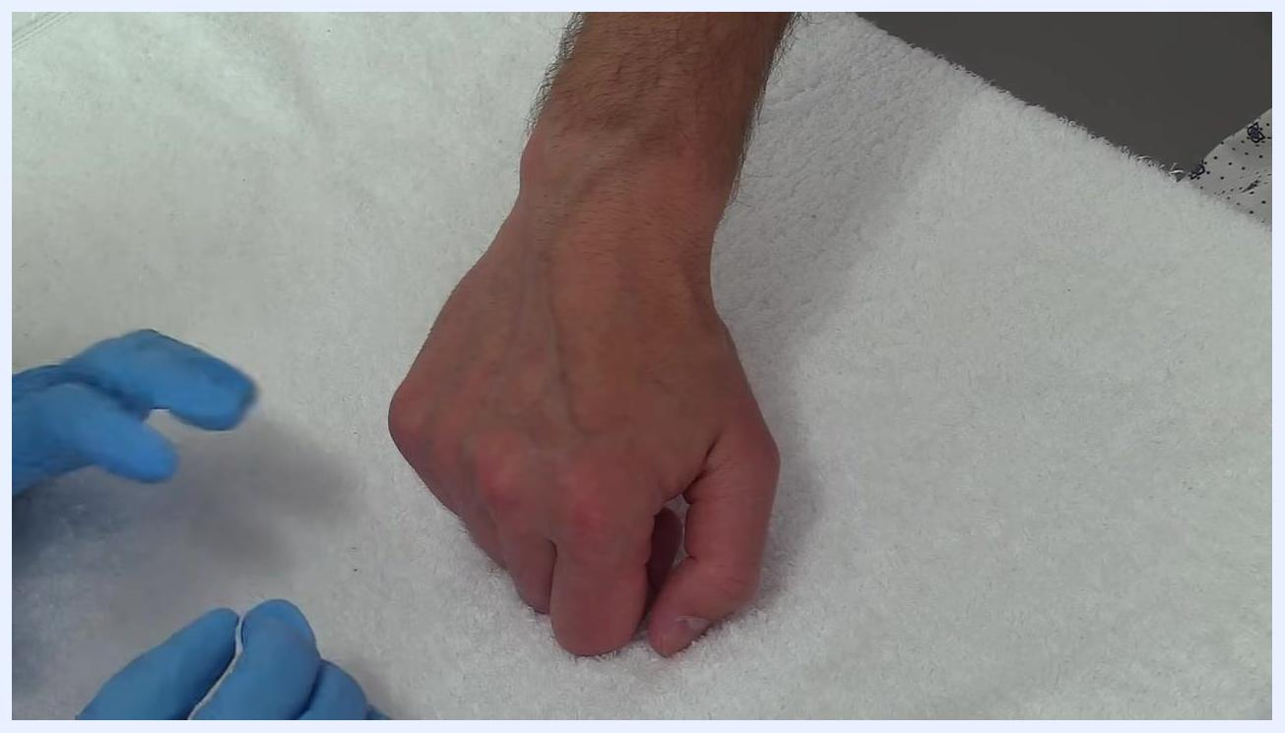
Using a chloroprep swab to disinfect the back of a patient's hand, starting at the center and moving outward

Step 6: Disinfect the insertion site
Use the chloroprep or antiseptic swab provided in your IV kit and activate it per the manufacturer's instructions (for example, squeezing until you hear a crack to release the solution). Start cleaning at the center of the site and work outward in a circular motion, scrubbing for at least 30 seconds. Allow the site to air dry completely before proceeding.
Caution screen with an educational disclaimer and warning about IV insertion footage containing blood
Safety note: Do not insert the catheter until the site has fully air-dried.

Step 7: Stabilize the vein
Once the site is dry, use your non-dominant hand to gently pull the skin below the cleaned area. This stabilizes the vein and prevents it from rolling during insertion. Keep your gloved hands positioned to maintain control and visibility.
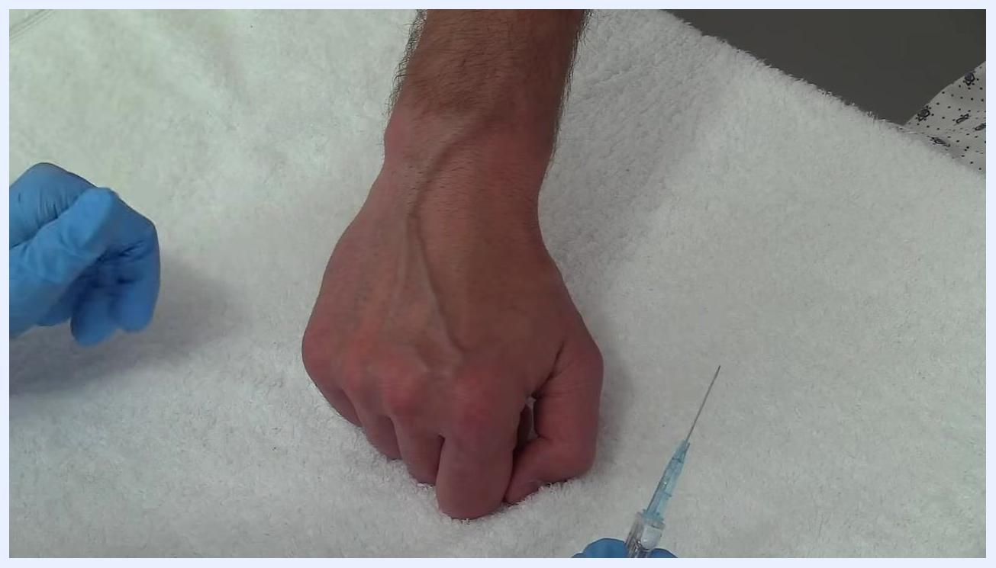
Advancing the IV catheter into the vein while maintaining stabilization and insertion technique

Step 8: Insert the IV catheter at the correct angle
Grasp the catheter with your dominant hand using your thumb and index finger, positioning it with the bevel facing up. Align the catheter with the vein's natural path and insert the needle at approximately a 20-degree angle to the skin.
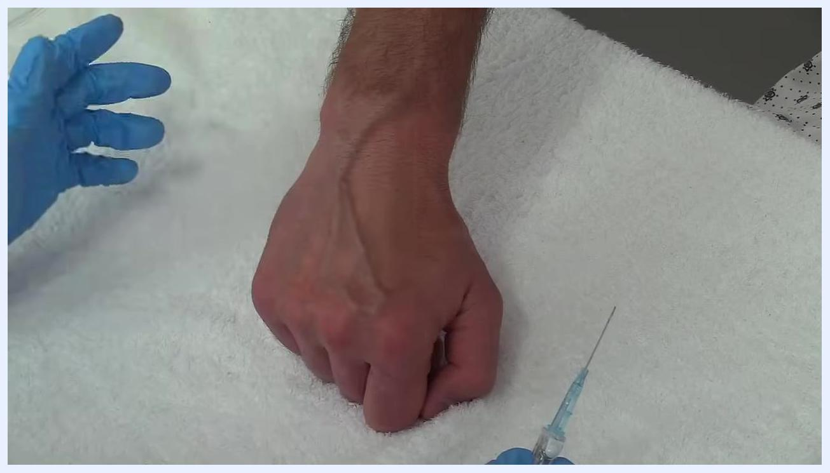
Inserting the IV catheter at a 20-degree angle into the hand vein

Step 9: Advance the catheter into the vein
Gently advance the catheter, following the vein's natural direction, and watch for blood return in the flashback chamber, which indicates successful vein entry.
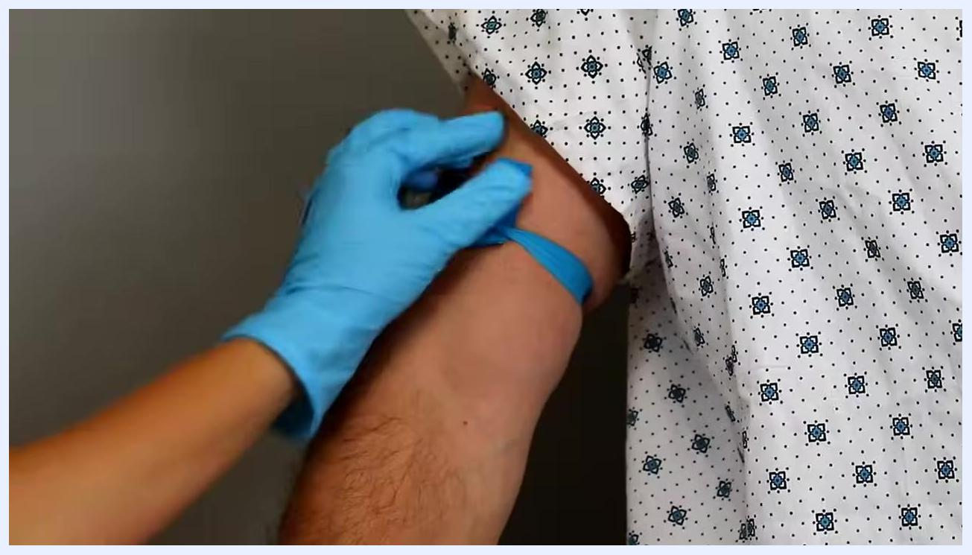
Advancing the catheter slightly further after blood return, with gloved hands maintaining control

Step 10: Advance slightly further after blood return
Once you observe blood return, advance the catheter just a small amount further to ensure the tip is fully within the vein.
Connecting and twisting the access device onto the IV catheter hub, with a blue tourniquet visible on the towel

Step 11: Release the tourniquet
Remove the tourniquet from the patient's arm to restore normal blood flow.
Safety note: Use a gloved finger to apply firm pressure just above the insertion site to prevent blood from leaking out of the vein, then activate the needle safety mechanism by pressing the safety button on the catheter device per the manufacturer's instructions.
Gloved hands preparing to stabilize the vein on the patient's hand, with the IV catheter ready for insertion; the hand rests on a white towel

Step 12: Connect the access device
Attach the prepared access device—such as an extension set or saline lock—to the catheter hub and twist the connection securely so it will not loosen during use.
Releasing the blue tourniquet from the patient's upper arm; the patient is wearing a hospital gown

Step 13: Check for blood return and flush the catheter
Confirm blood return is present to verify correct placement, then attach a syringe with saline to the catheter hub. Use the push-pause flush technique: inject 1–2 cc (or ml) of saline, pause, inject another 1–2 cc, pause again, and continue until you have flushed a total of 3–5 cc. Observe the insertion site for swelling or bubbling, which could indicate infiltration, and ask the patient how the site feels to confirm there is no pain or discomfort.
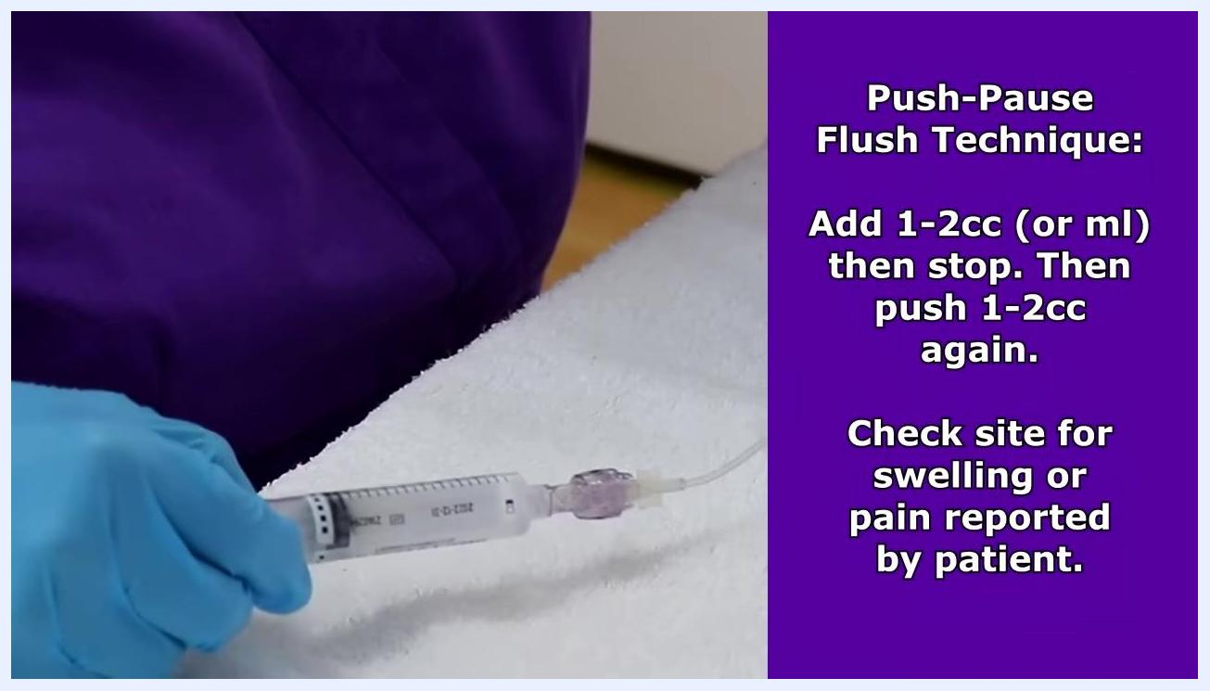
Holding a syringe attached to an IV extension set while demonstrating the push-pause flush technique, with on-screen text explaining the procedure and instructing to check the site for swelling or reported pain

Step 14: Clamp the line and manage the cap correctly
If using a neutral displacement cap, no specific clamping sequence is required—simply clamp the IV line after flushing per the manufacturer's instructions, then disconnect the syringe.
Safety note: Different cap types require different sequences:
- Neutral displacement cap: Clamp after flushing; disconnect the syringe in any order.
- Positive pressure cap: Flush, disconnect the syringe, then clamp.
- Negative pressure cap: Flush, clamp, then disconnect the syringe.

On-screen text noting that different cap types may require a different clamping sequence, per the manufacturer's instructions
Always follow the manufacturer's instructions for the specific cap type in use.
For negative pressure caps specifically, follow the sequence of flush, clamp, then disconnect.

Step 15: Place the initial dressing and protective cap
Place a sterile dressing over the IV insertion site to secure the catheter and prevent infection. Apply a Curos cap, or similar protective cap, to the end of the extension set to protect against contamination. Apply the dressing according to your facility's protocol and the kit's instructions. Review your specific IV kit's contents beforehand, as kits vary between facilities and manufacturers.
Clamping the IV line with a neutral displacement cap attached; on-screen text notes that this cap type requires no specific clamping sequence

Step 16: Align the transparent dressing over the site
Identify the transparent dressing with a notched area (labeled "33CNPL" in this example). Hold it above the IV insertion site on the back of the patient's hand so the notched part will lay directly over the top of the IV cap. Keep the patient's hand resting on a clean, white towel and wear gloves throughout.
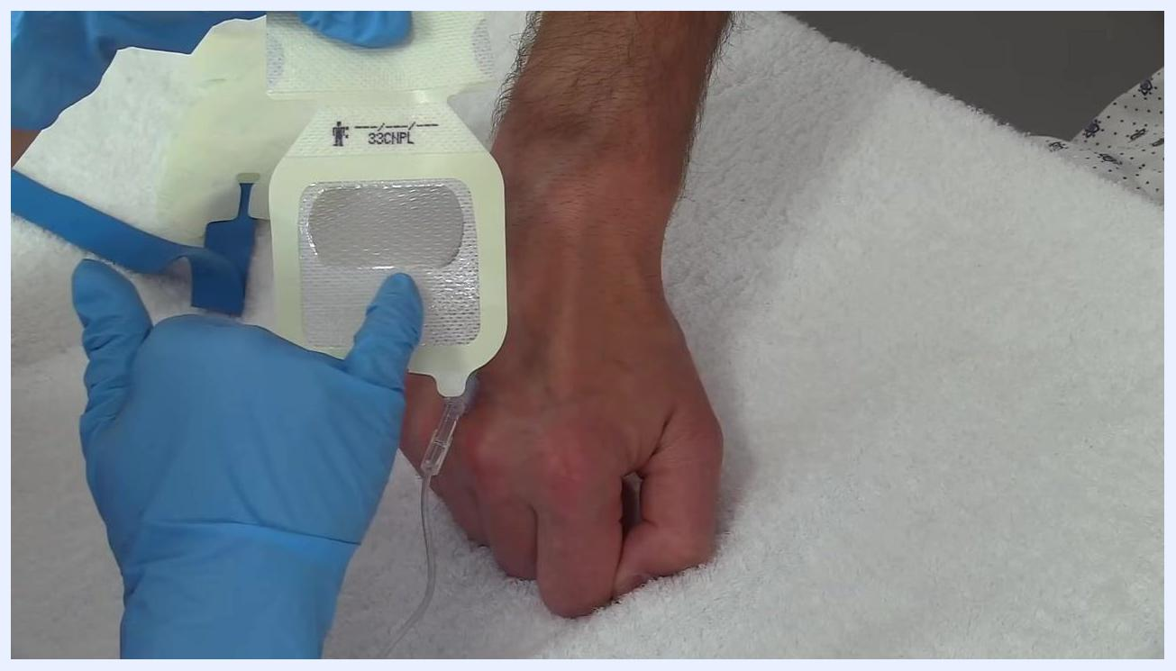
Positioning a transparent dressing with a notched area labeled "33CNPL" above the IV site on the back of the patient's hand; the catheter and tubing are visible and the hand rests on a white towel

Step 17: Lay the dressing over the IV site
Gently lay the dressing down so the notched area fits around the IV cap. Center the dressing so it completely covers the insertion site.

Step 18: Press the dressing to secure it
Use your gloved fingers to press down on the dressing, securing it to the skin. Smooth out any air bubbles or wrinkles to ensure full contact with the skin.
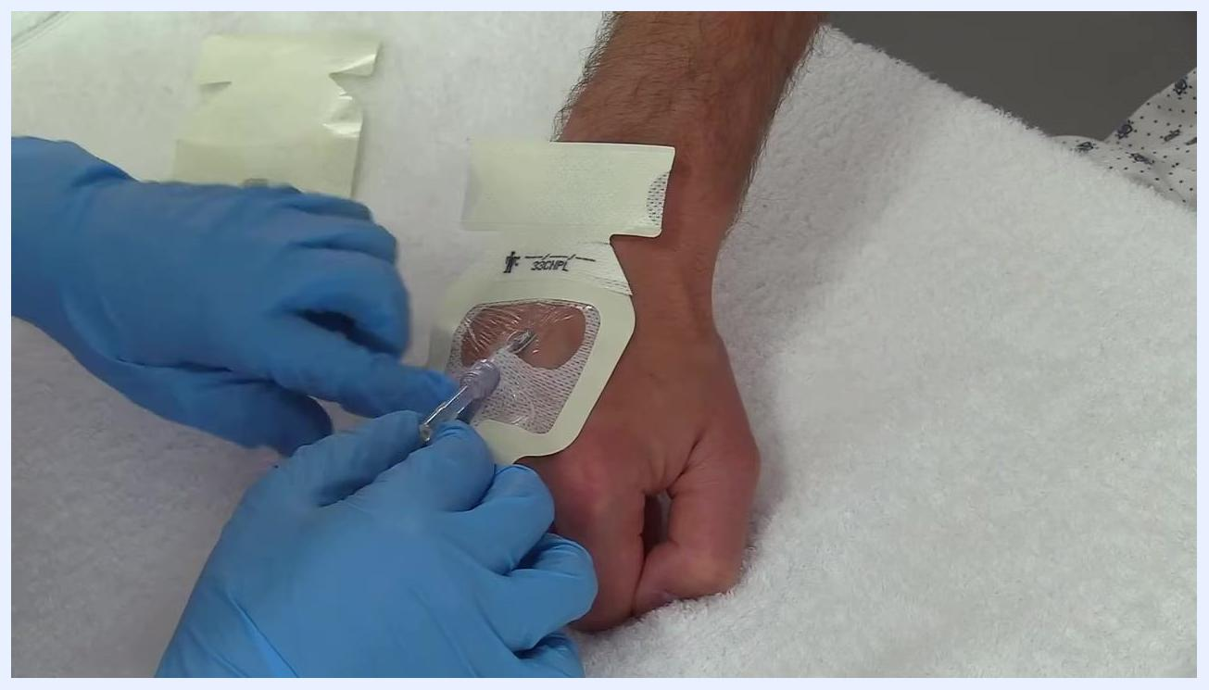
Adjusting the dressing around the IV catheter to ensure the notched area fits securely

Step 19: Lift the tubing and fit the notch
Carefully lift the IV tubing just enough to allow the notched parts of the dressing to slide underneath it, ensuring the dressing fits snugly around the base of the catheter.
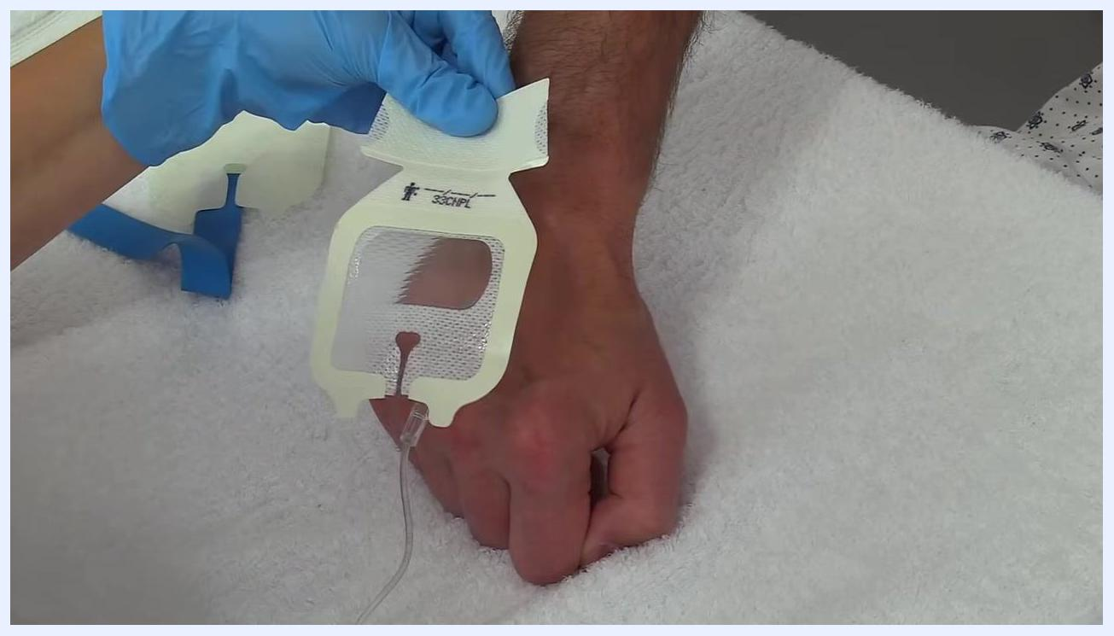
Lifting the IV tubing while adjusting the dressing so the notched parts fit underneath the tubing

Step 20: Adjust the dressing around the catheter
Confirm the notched area is properly positioned around the catheter and tubing, then continue pressing the dressing down to secure it in place.

Step 21: Remove the dressing backing edges
Tear off the small edges of the dressing backing around the perimeter one at a time, pressing the dressing down after each removal to ensure it adheres well to the skin. Continue until all edges are removed and the dressing is fully secured.
Laying the transparent dressing over the IV site, aligning the notched area with the IV cap; the dressing is not yet fully adhered
Removing the edges of the dressing backing while pressing the dressing down over the IV site

Step 22: Confirm the dressing is firmly adhered
Press down on the dressing to make sure it sticks securely to the skin, and double-check that it is smooth and fully sealed around the IV site.
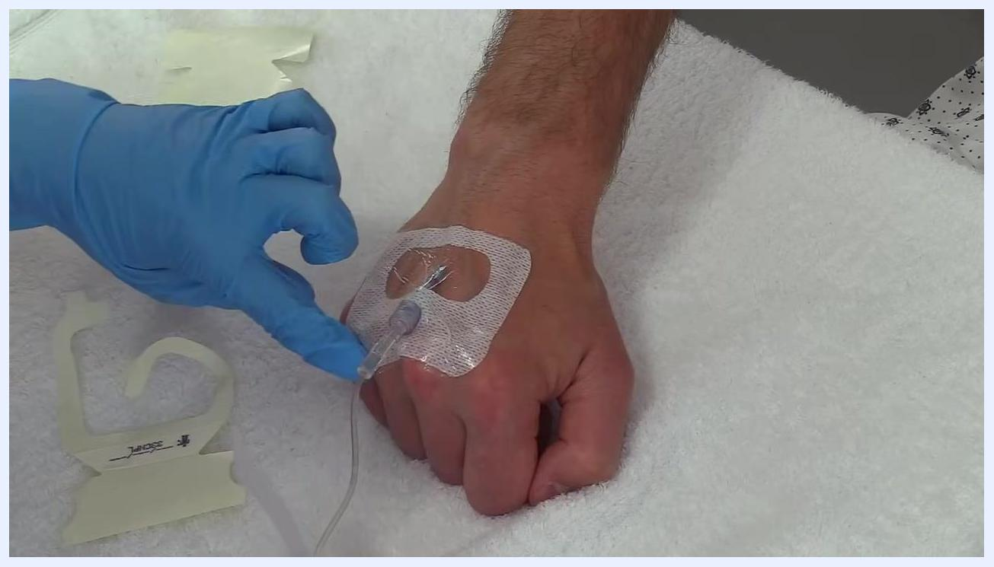
The dressing fully adhered to the skin and covering the IV site securely, with a gloved hand pressing down to confirm adhesion

Step 23: Apply the secondary securement strip
Take the larger remaining piece of the dressing backing and lay it across the IV tubing and dressing to provide extra securement. Apply gentle pressure to adhere the strip firmly.
Pressing down on the transparent dressing with both hands to secure it over the IV site, smoothing it onto the skin
Positioning the secondary securement strip across the IV tubing and dressing for additional support

Step 24: Press the strip for final securement
Press down on the newly applied strip to ensure it is firmly attached, and confirm the IV site is stable with no dressing edges lifting.
Applying pressure to the secondary securement strip to ensure the IV site is stable and secure

Step 25: Arrange the tubing in a "J" shape
Arrange the IV tubing in a gentle "J" shape as you secure it down with the dressing. This helps prevent accidental pulling or dislodgement of the IV.
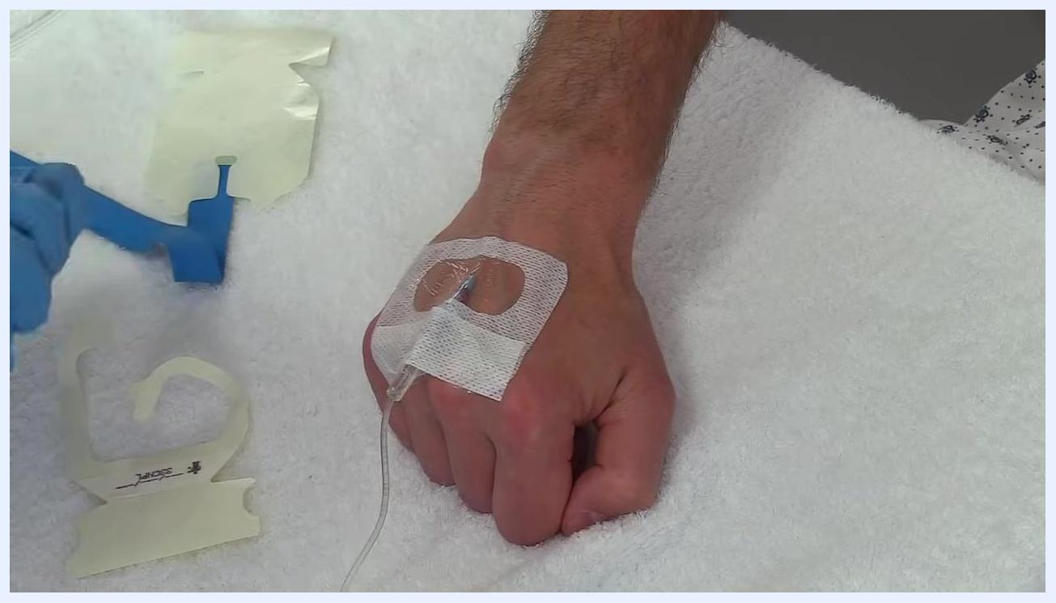
The IV site fully secured with the dressing and secondary strip; the tubing is arranged in a "J" shape and secured to the hand

Step 26: Check tubing arrangement and securement
Inspect the IV site to confirm the tubing remains in a gentle "J" shape and that the transparent dressing is fully adhered with a stable catheter. Gently hold the extension set and check for slack or tension in the tubing.
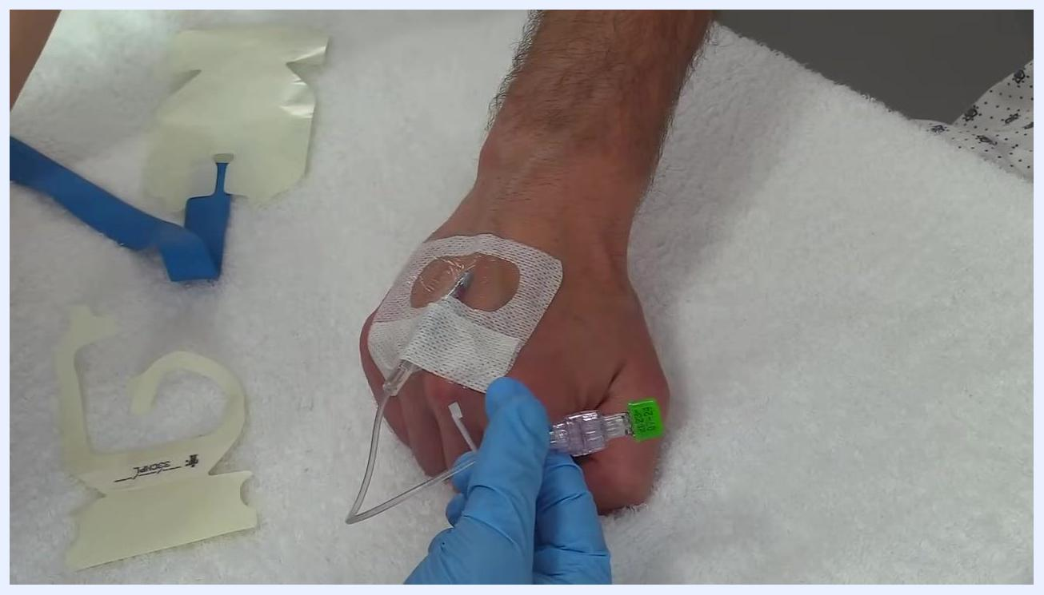
Holding the IV extension set near the insertion site to check the securement and tubing arrangement; the site is covered with a transparent notched dressing, and used dressing backings and a blue tourniquet are visible nearby

Step 27: Prepare the secondary securement tape
Identify the additional piece of securement tape provided in the dressing kit. Note any facility-required information, such as date or initials, written on the tape, and hold it above the IV site ready to apply.
Holding a labeled piece of securement tape above the IV site, ready for application; the tape has handwritten notes

Step 28: Peel and position the tape
Peel the securement tape from its backing while maintaining the "J" shape of the tubing. Position the tape so it will hold the tail of the tubing in place.
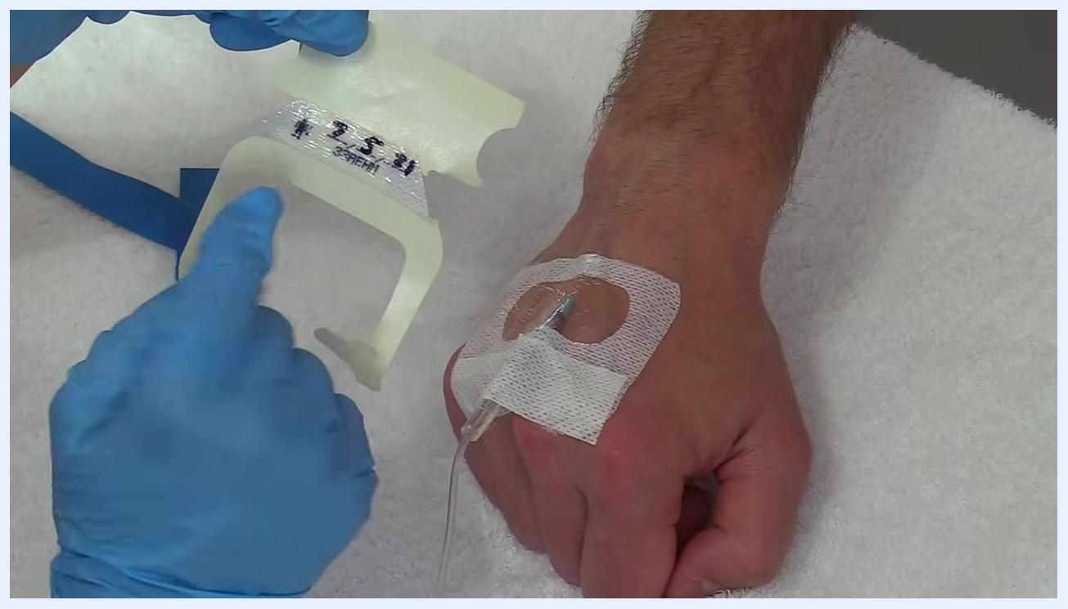
Peeling the securement tape from its backing while holding the IV tubing in a "J" shape above the secured IV site

Step 29: Apply the securement tape
Lay the tape over the IV tubing, securing it to the patient's hand while maintaining the "J" shape. Press the tape down gently but firmly to ensure adhesion.
Applying the securement tape over the IV tubing with both hands, pressing it down for adhesion and stability; the tape is labeled and the tubing is arranged in a "J" shape

Step 30: Smooth the tape edges
Smooth the edges of the securement tape to ensure full contact with the skin and dressing. Double-check that all edges are sealed and the IV site is stable.
Smoothing the edges of the securement tape over the IV site with both hands to ensure it is fully adhered

Step 31: Dispose of used supplies
Gather all used supplies, including dressing backings, syringes, and other disposable materials. Dispose of sharps, such as needles, in an approved SHARPS container, and place all other waste in the appropriate medical waste container as required by your facility. Always refer to your facility's protocols for specific disposal instructions.
Used medical supplies—including syringes, dressing backings, and a blood-contaminated cap—on a white towel, with a banner reading "Dispose of used supplies into appropriate SHARPS/waste container"

Verification and summary
- Confirm the IV site is free of swelling, bubbling, or reported pain during and after flushing.
- Confirm the transparent dressing is fully adhered with no lifting edges, and the notched area sits correctly around the catheter and tubing.
- Confirm the tubing is arranged in a "J" shape and secured with the secondary securement tape to prevent tension on the insertion site.
- Confirm all sharps and used materials have been disposed of in the correct SHARPS or medical waste containers per facility protocol.
- Document the procedure according to your facility's guidelines.
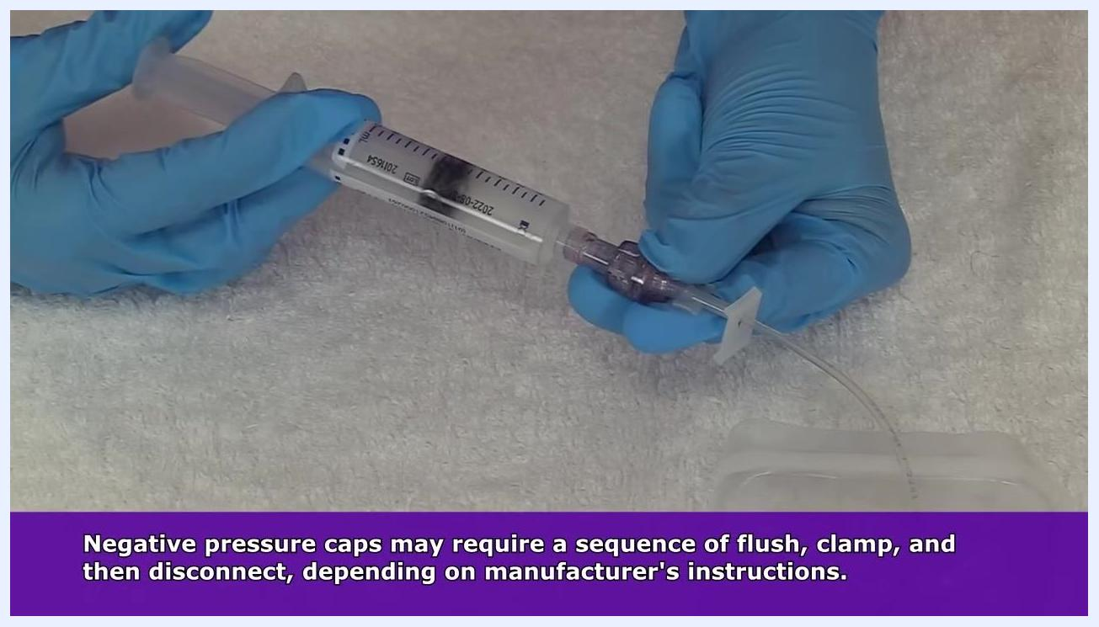
Applying a sterile dressing over the IV site on the patient's hand, with the extension set and Curos cap visible and a blue tourniquet in the background

What's next
Continue to follow your facility's specific protocols for ongoing IV site care and maintenance, and familiarize yourself with the contents and instructions of your facility's specific IV kit, as kits and cap types may vary between manufacturers. Always maintain aseptic technique for any subsequent access, flushing, or dressing changes at the site.
Demonstrating the flush, clamp, and disconnect sequence used for negative pressure caps, per manufacturer instructions

