How to Set Up Oxygen with a Nasal Cannula
This documentation describes how to set up oxygen with a nasal cannula when converting a patient from a Venturi mask, including the clinical rationale, required equipment, and the oxygen conversion reference used to determine the correct flow rate. Follow these steps to ensure the patient remains adequately oxygenated throughout the transition.

Device overview
The nasal cannula is a low-flow oxygen delivery accessory consisting of two soft prongs that sit in the patient's nostrils, connected by tubing that loops over the ears and is secured with a slider under the chin. The tubing connects directly to the hospital wall oxygen flow meter, replacing the Venturi mask as the oxygen delivery interface.
The nasal cannula delivers a set litres-per-minute (L/min) flow of oxygen directly into the nostrils, rather than the percentage-based delivery of a Venturi mask. Because the two devices use different measurement systems, the "Titrating Oxygen up and down" conversion chart is used to translate a Venturi percentage setting into an equivalent nasal cannula flow rate.
A labeled diagram would typically show the nasal prongs, the curved underside that faces downward into the nostrils, the tubing path over each ear, and the chin slider used to secure the fit; this is not provided in the source material.

Indications & contraindications
Consider setting up oxygen with a nasal cannula instead of a Venturi mask when:
- The patient needs to eat or drink throughout the day and cannot be left without oxygen support.
- The patient is using nebulisers and requires oxygen entrainment.
- The patient cannot tolerate the mask, for example due to claustrophobia.
Before converting, confirm that the patient is hypoxic and requires continuous oxygen support, as this determines whether uninterrupted delivery is clinically necessary.

 | Caution: Do not leave the patient without oxygen at any point during the transition from Venturi mask to nasal cannula.
The source material does not specify additional absolute or relative contraindications for nasal cannula use; any such conditions should be confirmed against local clinical policy before proceeding.

Setup & installation

- Assess the current oxygen delivery. Identify the oxygen concentration and flow rate currently being delivered via the Venturi mask. For example, a patient may be on 35% oxygen (yellow Venturi) at 8 litres per minute (L/min).
- Locate the oxygen conversion chart. Reference the "Titrating Oxygen up and down" chart to determine the equivalent nasal cannula flow rate for the current Venturi setting. The chart is available on the hospital intranet, within Medicines Management, and is often attached directly to observation (OBS) machines for quick reference. For a 35% Venturi setting (yellow, 8–12 L/min), the equivalent nasal cannula flow is 4 L/min.
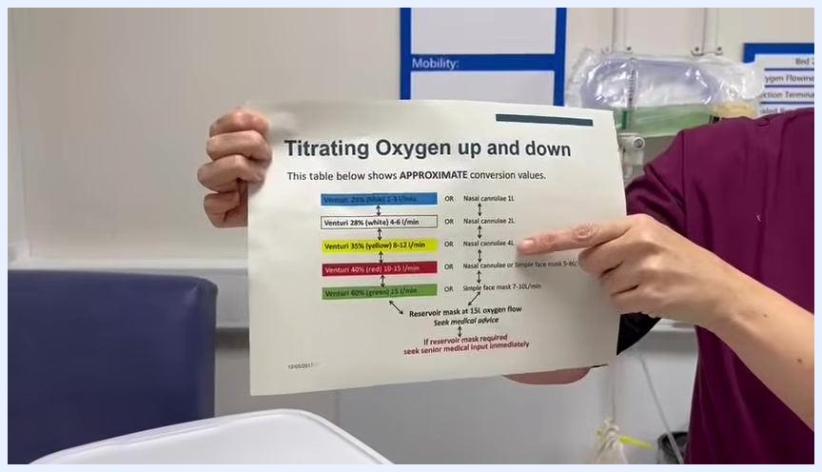
A healthcare professional in scrubs stands beside a hospital bed with a mannequin patient wearing a Venturi mask. On the table is a nasal cannula and a printed oxygen conversion chart. The professional is holding and pointing to the chart, which lists Venturi mask percentages and corresponding nasal cannula flow rates.

- Gather the required equipment before starting the change:
- Nasal cannula tubing
- Access to the oxygen flow meter
- The oxygen conversion chart, for reference

- Verify the target nasal cannula flow rate against the chart before making any changes. For a patient previously on 35% Venturi at 8 L/min, confirm the target setting of 4 L/min.
- Prepare for a rapid switch. Keep all equipment within reach so the oxygen delivery method can be changed quickly and efficiently, avoiding any risk of hypoxia during the transition.

Programming & operation

- Open and prepare the nasal cannula. Take a new nasal cannula from its packaging and ensure the tubing is untangled and ready for immediate use. Explain to the patient that you will be switching their oxygen delivery method.
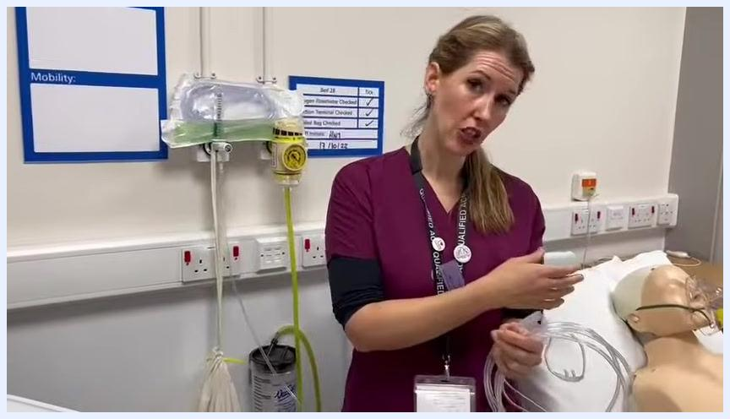
A healthcare professional in scrubs stands beside a hospital bed, holding a nasal cannula and explaining the procedure. The patient mannequin is on the bed, and oxygen equipment is visible on the wall.

- Adjust the oxygen flow meter. Approach the flow meter on the wall and reduce the setting to the target rate determined by the conversion chart — 4 L/min for a patient previously on 35% Venturi. Confirm the new setting visually on the meter.
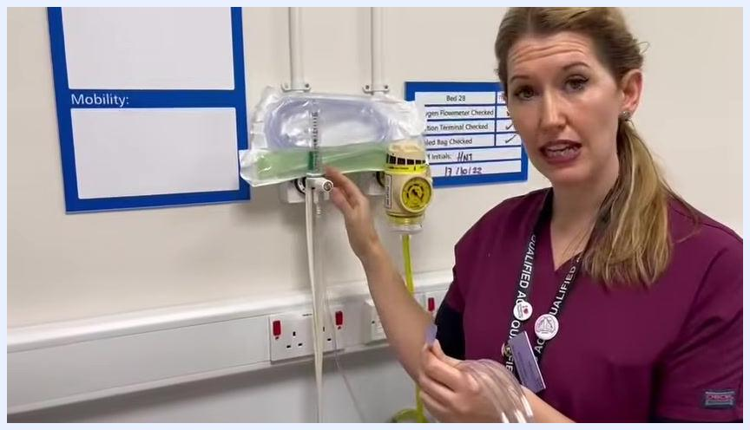
The healthcare professional points to and adjusts the oxygen flow meter on the wall, with a Venturi mask and tubing visible above.

- Remove the Venturi mask and attach the nasal cannula. Disconnect the Venturi mask from the oxygen supply and immediately connect the nasal cannula tubing to the oxygen outlet. Confirm the connection is secure and oxygen is flowing through the cannula.
The healthcare professional connects the nasal cannula tubing to the oxygen flow meter, with the Venturi mask set aside.

- Fit the nasal cannula to the patient. Insert the prongs gently into the nostrils with the curved side facing downward. Hook the tubing over both ears, then adjust the slider under the chin to secure the cannula comfortably.
The healthcare professional demonstrates fitting the nasal cannula to the mannequin patient, preparing to hook the tubing behind the ears.

- Secure and adjust the cannula. Ensure the fit is snug but not too tight under the chin, and confirm correct positioning in the nostrils and behind the ears.
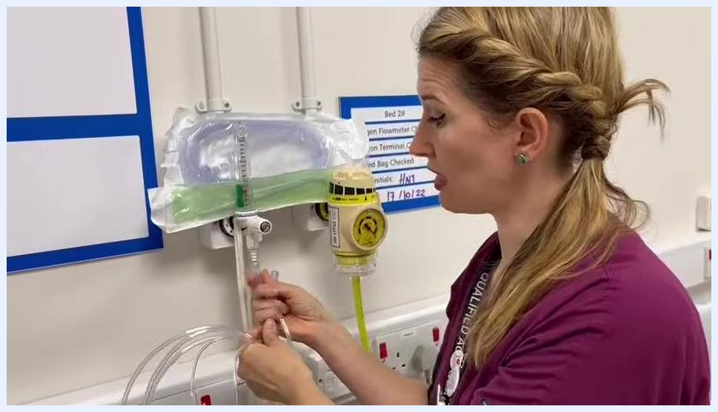
The healthcare professional leans over the mannequin patient, adjusting and securing the nasal cannula under the chin.

- Monitor the patient after the change. Once the nasal cannula is in place, monitor the patient's oxygen saturation (SpO2) to confirm it remains within the target range.
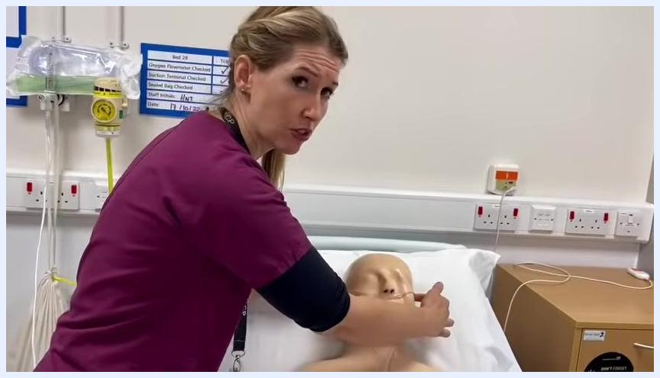
The healthcare professional checks the fit of the nasal cannula on the mannequin patient, ensuring proper placement and patient comfort.

- Adjust the flow rate if necessary. If the patient's SpO2 falls outside the desired range, increase the nasal cannula flow rate as needed, up to a maximum of 6 L/min, based on the patient's needs and the conversion chart.
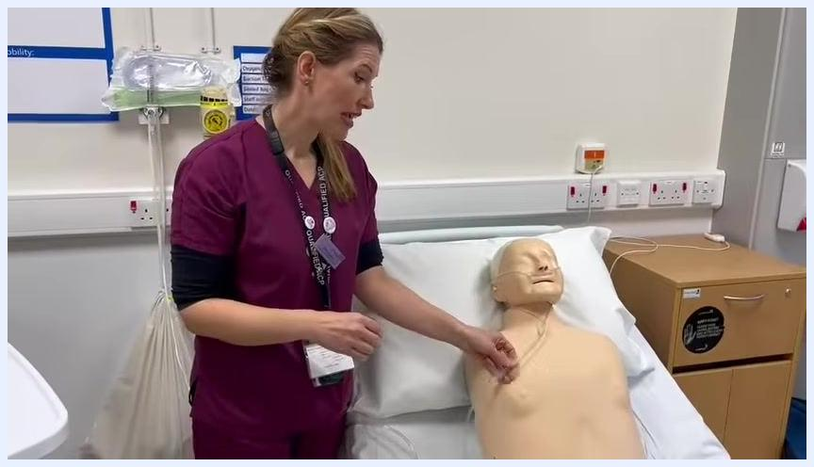
The healthcare professional stands beside the mannequin patient, holding the nasal cannula tubing and discussing flow rate adjustments.

- Reference the conversion chart when uncertain. Consult the "Titrating Oxygen up and down" chart on the observation machine or hospital intranet to verify the patient is receiving the appropriate oxygen flow for their clinical needs.
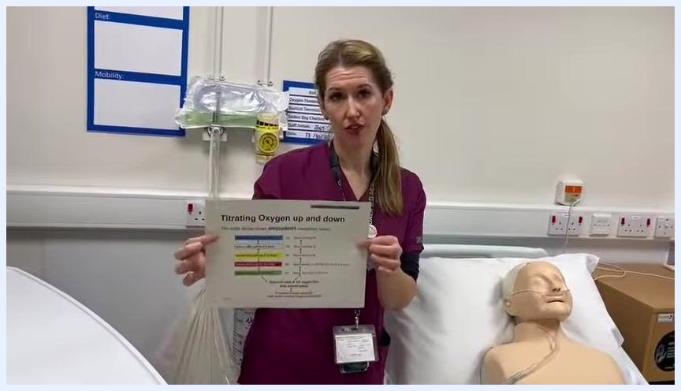
The healthcare professional holds up the "Titrating Oxygen up and down" chart, pointing to it for reference, with the mannequin patient in the background.

- Complete the procedure. Confirm the patient is comfortable, and document the change in oxygen delivery method and flow rate in the patient's records.
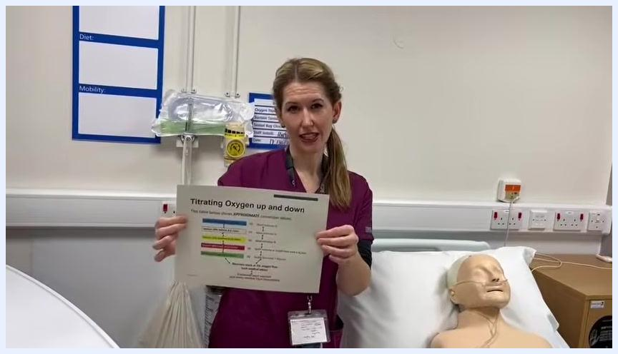
The healthcare professional concludes the demonstration, holding the oxygen conversion chart and standing beside the mannequin patient.
Operational parameters referenced in this procedure:
Venturi mask setting | Flow rate (Venturi) | Equivalent nasal cannula flow
35% (yellow) | 8–12 L/min | 4 L/min
Increased requirement | — | Up to 6 L/min maximum

Alarms & alerts
The source material does not describe device alarm conditions. In practice, this section would document SpO2 desaturation alerts and any oxygen flow meter alarms, with their priority level, probable cause, and corrective action; monitoring of SpO2 after the switch is the only alert-related activity described in the source.

Cleaning & maintenance
The source material does not provide cleaning agents, methods, or a maintenance schedule for the nasal cannula or flow meter. This section would normally list approved cleaning products, cleaning frequency, and any calibration requirements for the oxygen flow meter.

Troubleshooting
Issue | Possible cause | Solution
Patient cannot tolerate the mask | Claustrophobia or discomfort with Venturi mask | Convert to nasal cannula using the conversion chart
Pressure marks behind the ears | Prolonged nasal cannula use with tubing routed over the ears | Check fit regularly and add cushioning if needed for long-term use
SpO2 falls outside target range after switch | Nasal cannula flow rate too low for patient's needs | Increase flow rate up to a maximum of 6 L/min, referencing the conversion chart
Uncertainty over correct flow rate | Incorrect or unclear Venturi-to-cannula conversion | Consult the "Titrating Oxygen up and down" chart on the intranet or OBS machine

Technical specifications
Parameter | Value
Venturi reference setting | 35% (yellow), 8–12 L/min
Equivalent nasal cannula flow | 4 L/min
Maximum nasal cannula flow (per source) | 6 L/min
The source material does not include physical dimensions, electrical specifications, environmental requirements, or regulatory classification for the nasal cannula or flow meter equipment; these would be documented in this section from the manufacturer's technical data when available.

What's next
After completing the conversion, continue to monitor the patient's SpO2 and adjust the nasal cannula flow rate as clinically indicated, referring back to the "Titrating Oxygen up and down" chart whenever the patient's oxygen requirements change.

