How to Set Up an IV Infusion: A Step-by-Step SOP
This standard operating procedure explains how to set up an IV infusion safely, from patient preparation through to documentation. Follow each step in sequence to maintain sterility, confirm the correct prescription, and ensure the patient receives fluids safely and comfortably.

Purpose
This SOP provides a consistent, safe method for preparing, priming, and connecting an intravenous (IV) infusion to a patient, while maintaining aseptic technique throughout the process.

Scope
This procedure applies to any healthcare professional responsible for administering IV fluids to a patient, from initial patient confirmation through to final documentation of the infusion.
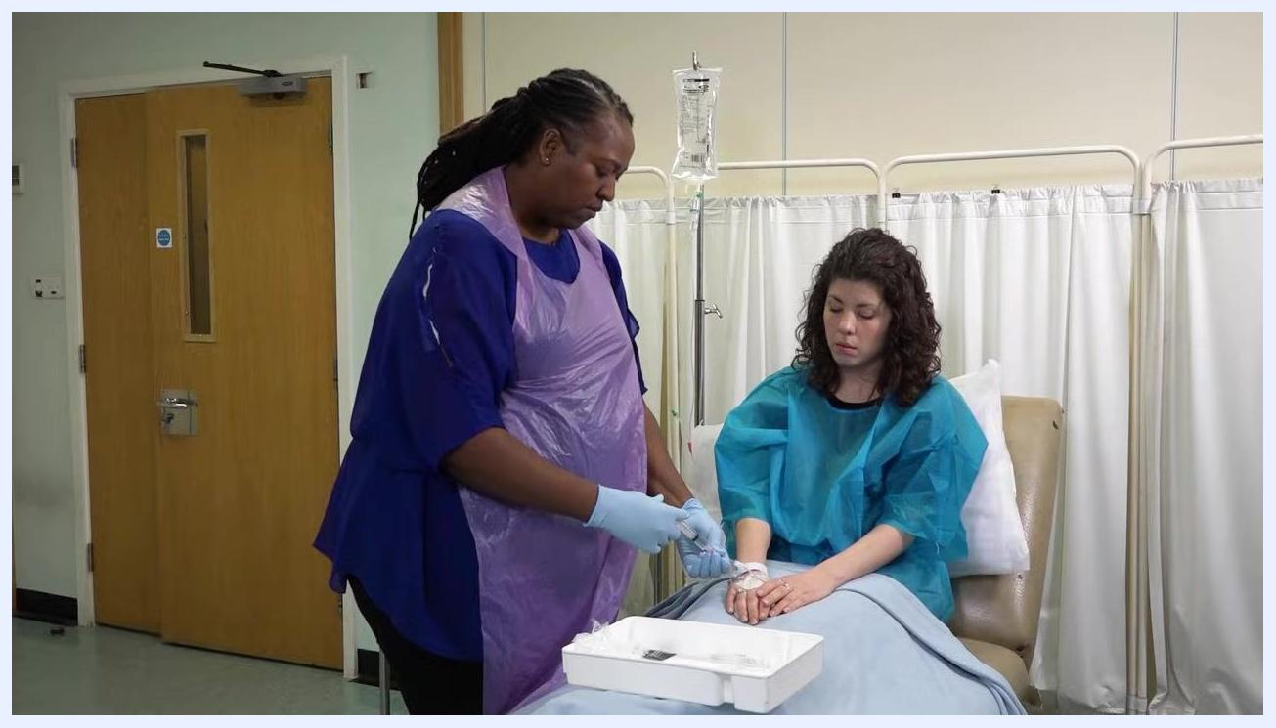
The healthcare professional is closing the clamp on the IV line while the patient sits with her arm extended, IV in place.

Required equipment and PPE
Before you begin, clean a dressing trolley with an alcohol wipe and gather the following equipment, checking expiry dates as you go:
- Plastic tray
- Correct bag of fluid
- Correct administration set
- Saline flush
- Alcohol wipe
- Sharps bin
- Alcohol hand gel
- Gloves
- Apron
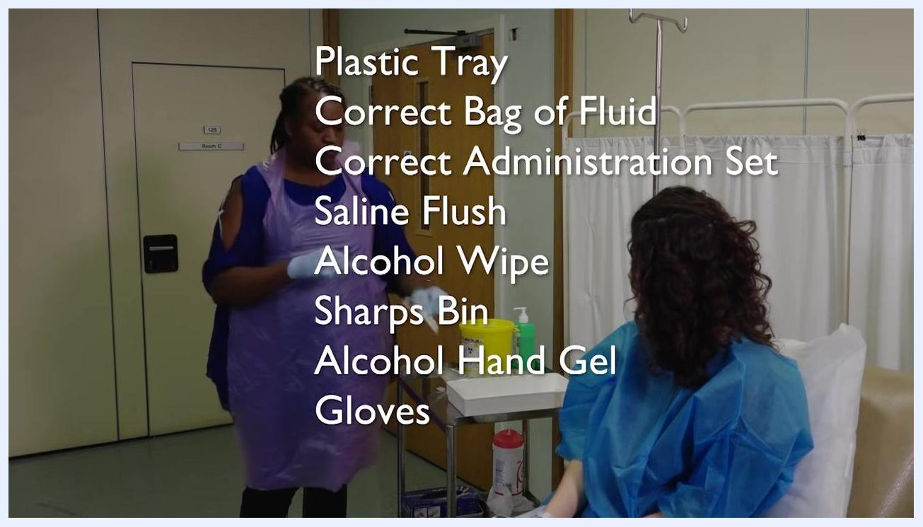
A staff member in a purple apron and gloves stands by a trolley with supplies. The equipment list is overlaid: Plastic Tray, Correct Bag of Fluid, Correct Administration Set, Saline Flush, Alcohol Wipe, Sharps Bin, Alcohol Hand Gel, Gloves.
Close-up of hands holding a fluid bag and prescription chart, with "THE FIVE RIGHTS" and the corresponding checklist overlaid.

Step 1: Confirm and introduce yourself to the patient
Confirm with the patient that IV fluids are to be administered, then welcome the patient and introduce yourself and any assisting staff.
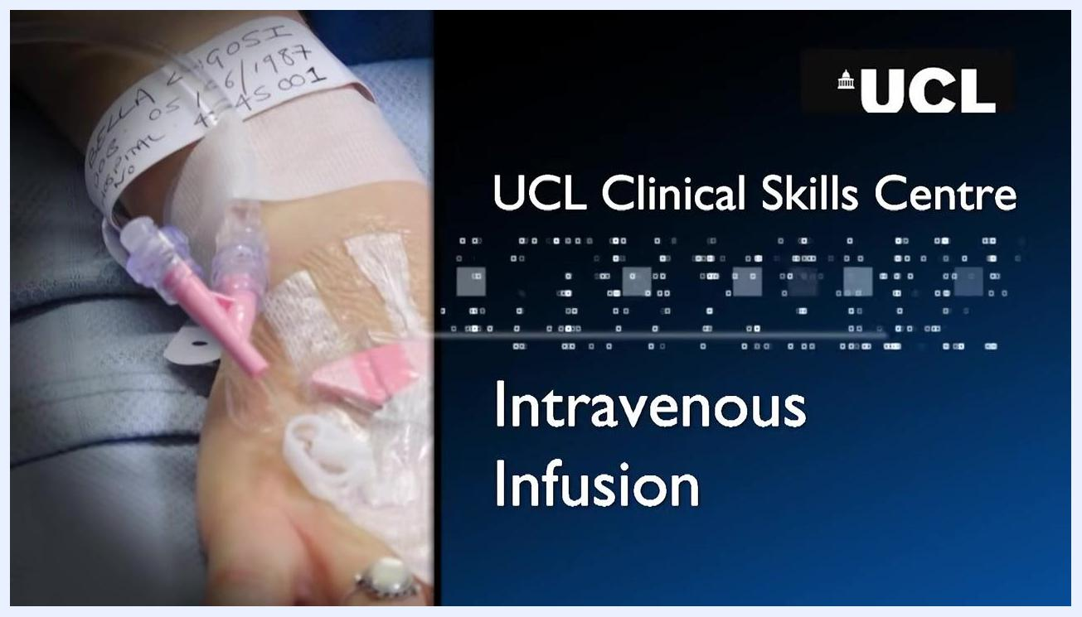
A patient with an IV cannula in their hand, wearing a wristband with identifying information. The screen displays "UCL Clinical Skills Centre" and "Intravenous Infusion".

Step 2: Perform the WIPER protocol – wash hands and introduce yourself
Start the WIPER protocol by washing your hands thoroughly using appropriate hand hygiene technique, then introducing yourself to the patient.
- Wash your hands thoroughly using appropriate hand hygiene technique
- Introduce yourself to the patient

Step 3: Complete the WIPER protocol – permission, exposure, and repositioning
Continue the WIPER protocol by confirming permission and completing patient preparation.
- Permission & Pain: Confirm the patient's name, date of birth, and check for any allergies. Explain the procedure and seek permission to proceed.
- Expose the patient's arm as needed for the procedure.
- Reposition the patient for optimal access to the cannula site.
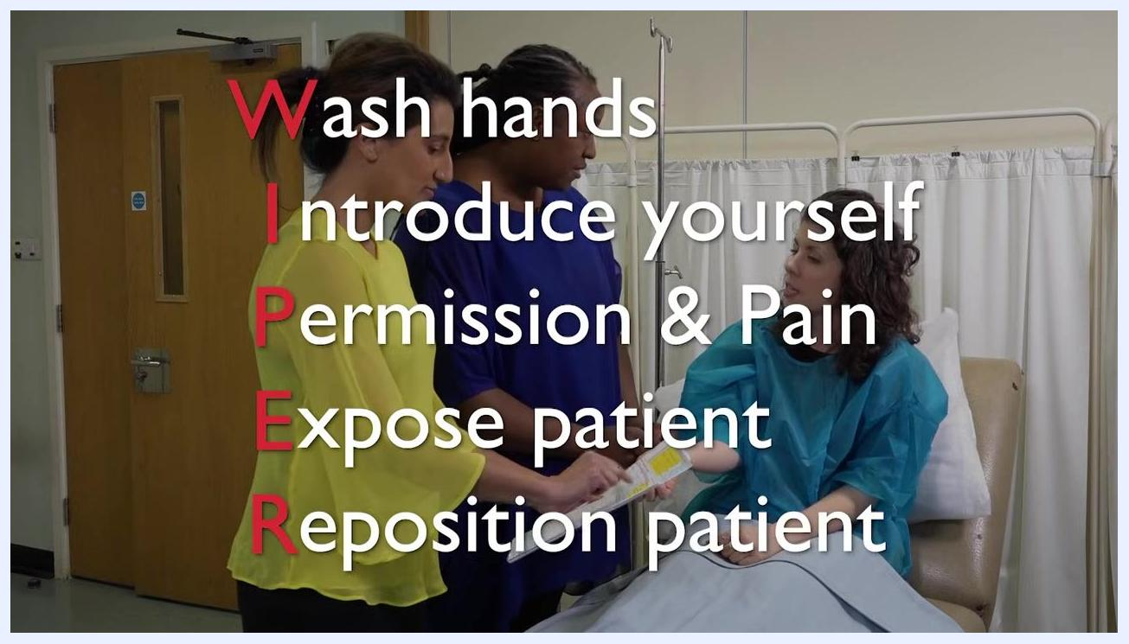
Two staff members, one in yellow and one in blue, interacting with a patient in a blue gown. The overlay text reads "Wash hands, Introduce yourself".
The same three people, with the full WIPER protocol overlaid: "Wash hands, Introduce yourself, Permission & Pain, Expose patient, Reposition patient".

Step 4: Assess the cannula site
Inspect the cannula site for any signs of inflammation or misplacement. Depending on your professional role, you may need to double-check the prescription and patient details with a second qualified staff member.
Two staff members and the patient; one staff member is holding the patient's arm and checking the cannula site.

Step 5: Verify the prescription using the Five Rights
Ensure the IV fluids are prescribed correctly by checking:
- Right Patient
- Right Drug/Fluid
- Right Dose
- Right Route
- Right Time

Step 6: Check the fluid bag before use
Remove the outer wrapper from the fluid bag and inspect the fluid for transparency, ensuring there are no particulates or discoloration. Check the expiry date on the fluid bag and all equipment to confirm they are in date.
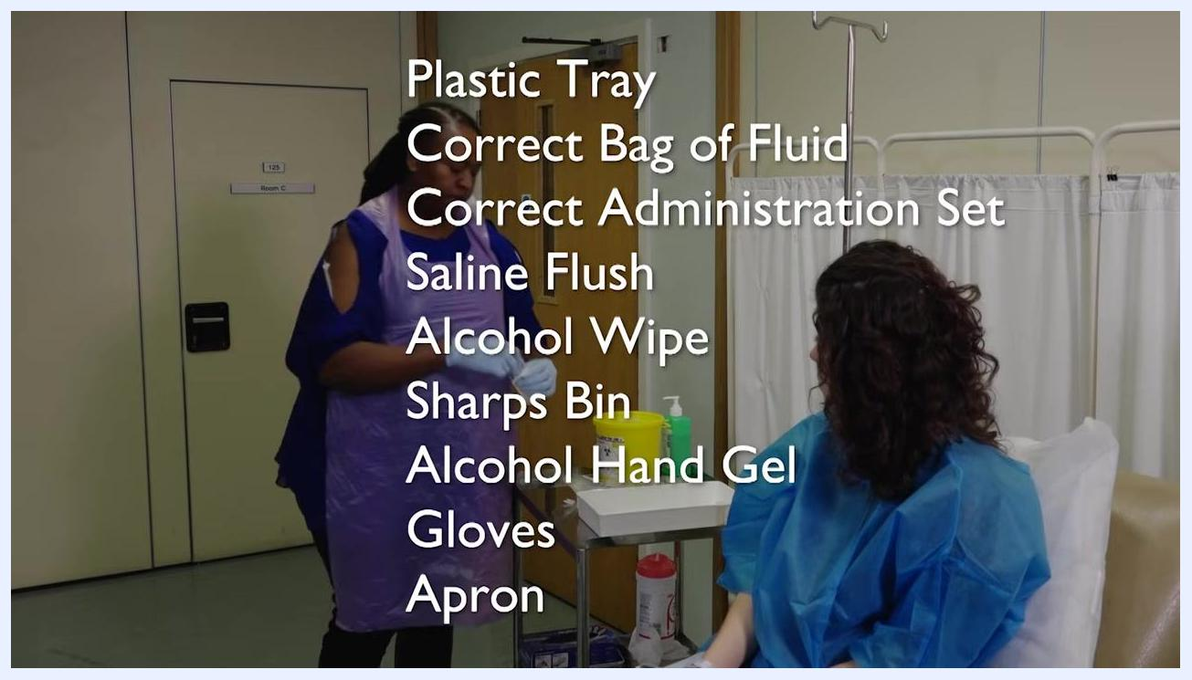
A staff member in gloves and a purple apron holds a fluid bag, visually inspecting it. The text "Check Expiry Date" is overlaid.

Step 7: Hang the fluid bag
Hang the fluid bag securely on the drip stand.
A staff member in gloves and a purple apron hangs a clear fluid bag on a metal drip stand, preparing for IV setup.

Step 8: Open the administration set
Open the sterile packaging of the fluid administration set, taking care not to touch any key parts.
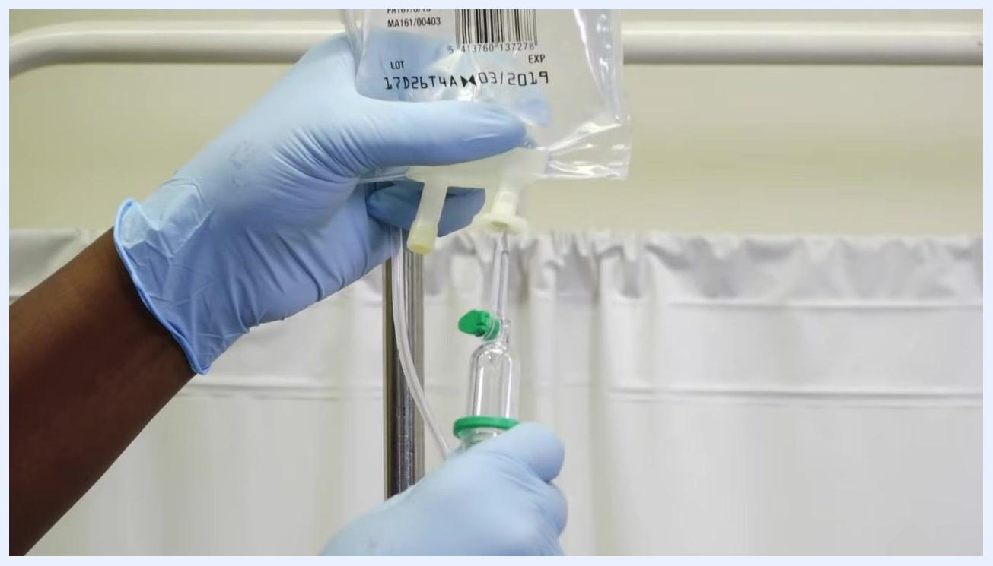
A staff member in gloves and a purple apron carefully unravels the IV administration set, holding both ends to maintain sterility.

Step 9: Unravel the administration tubing
Unravel the administration tubing, keeping hold of both ends. These ends are key parts and must remain sterile at all times.
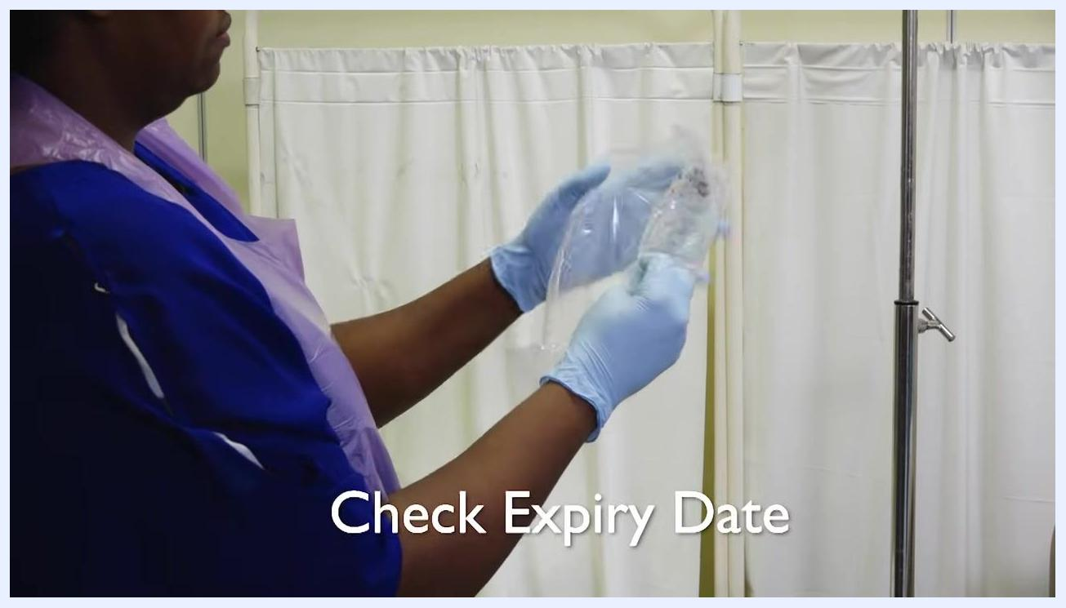
Gloved hands opening a sterile administration set package labeled "Intrafix SafeSet" by B. Braun.
Safety note: Use the roller clamp on the administration set to clamp the tube before proceeding. Roll the wheel downwards to prevent fluid from flowing prematurely.

Step 10: Remove the protective cap from the spike
Remove the protective cap from the spike of the administration set. This is a key part and must remain sterile.

Step 11: Insert the spike into the fluid bag
Insert the spike firmly into the port of the fluid bag using a twisting motion. Ensure the opposite end of the tube remains safely in your hand and does not touch any non-sterile surfaces.
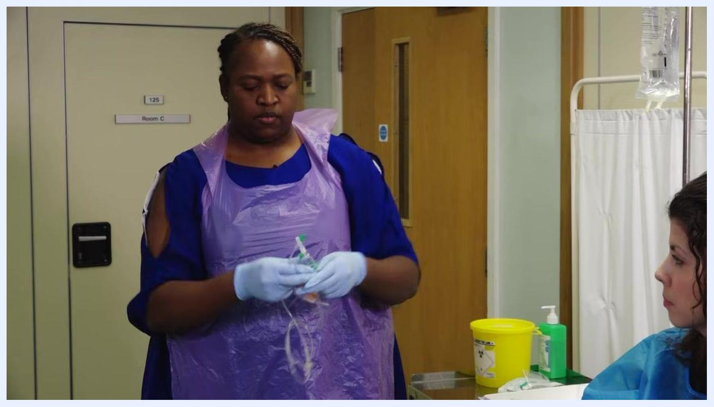
A staff member in gloves and a purple apron removes the cap from the spike of the IV administration set, holding it carefully to maintain sterility.
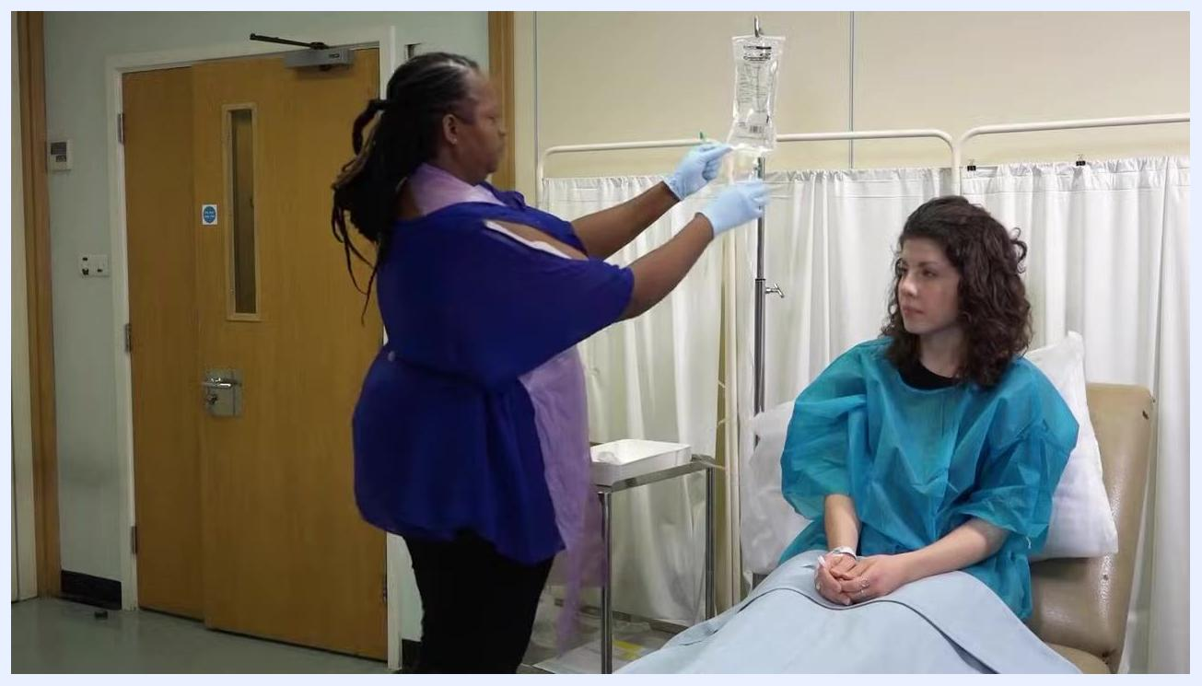
Close-up of gloved hands inserting the administration set spike into the fluid bag port, maintaining sterility.

Step 12: Prime the drip chamber
Squeeze the drip chamber several times until it fills halfway with fluid.
A staff member in gloves and a purple apron stands by the patient, adjusting the IV fluid bag and administration set on the drip stand.

Step 13: Prime the administration line
Slowly open the roller clamp to allow fluid to flow through the tubing, priming the line and removing any air bubbles.
The IV fluid bag is hanging on the stand, and the drip chamber is being filled halfway with fluid.

Step 14: Allow fluid to reach the end of the tube
Open the roller clamp slightly to allow the IV fluid to flow slowly along the tube until it reaches the distal end. Hold the end of the tubing, ensuring it remains sterile and does not touch any surfaces.
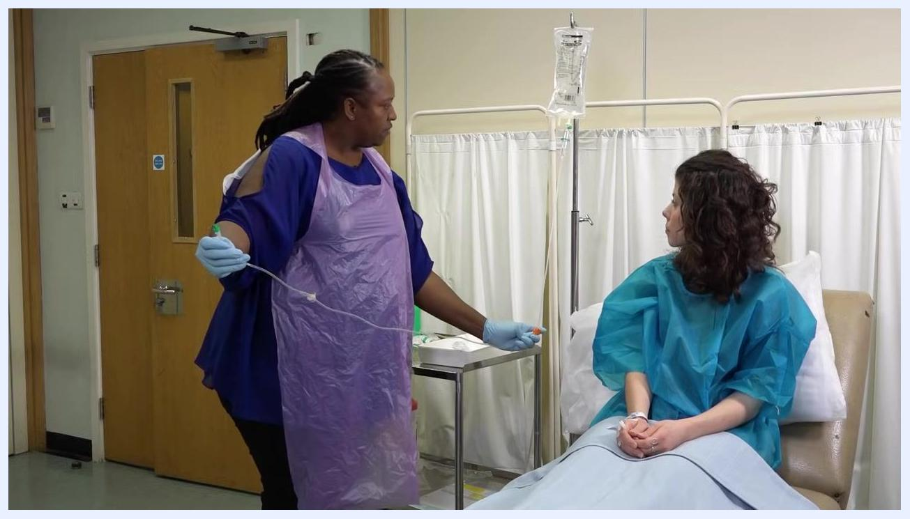
A staff member in gloves and a purple apron holds the end of the IV tubing, watching the fluid progress through the line while standing next to a seated patient. The IV bag is hanging on a drip stand.

Step 15: Inspect the line for air bubbles
Carefully observe the IV tubing for any air bubbles as the fluid moves through.
Close-up of a gloved hand holding IV tubing, showing the clear tube where air bubbles may be visible.
Safety note: Air bubbles must not be infused into the patient.

Step 16: Remove small air bubbles
If small air bubbles are present, stretch the tube tightly and flick it with your finger. This encourages the bubbles to rise to the end of the tube.
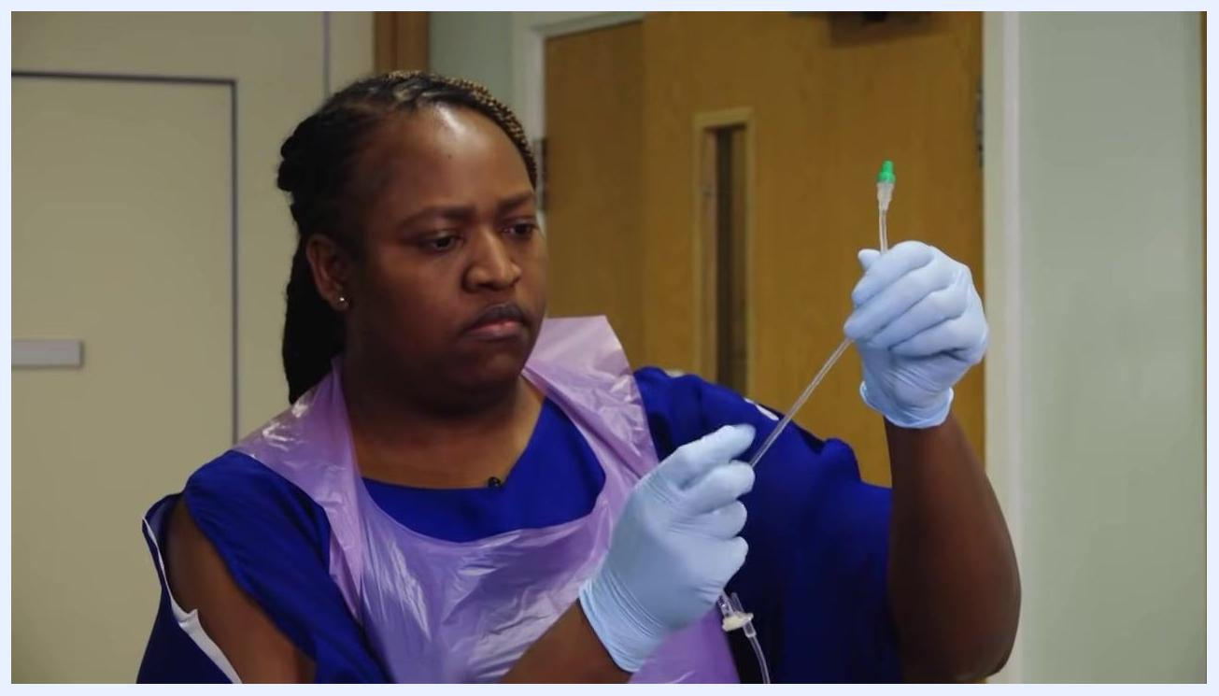
A staff member in gloves and a purple apron stretches and flicks the IV tubing to remove air bubbles, focusing on the process.

Step 17: Clear large air bubbles and close the clamp
For large air bubbles, allow some saline to drain into a sink or pot until the bubbles are cleared. Once all bubbles are removed, close the roller clamp to stop the flow of fluid.
A staff member in gloves and a purple apron holds the IV tubing, preparing to flick it to remove air bubbles.

Step 18: Remove gloves and wash your hands
Remove your gloves and dispose of them appropriately, then wash your hands thoroughly according to clinical guidelines.
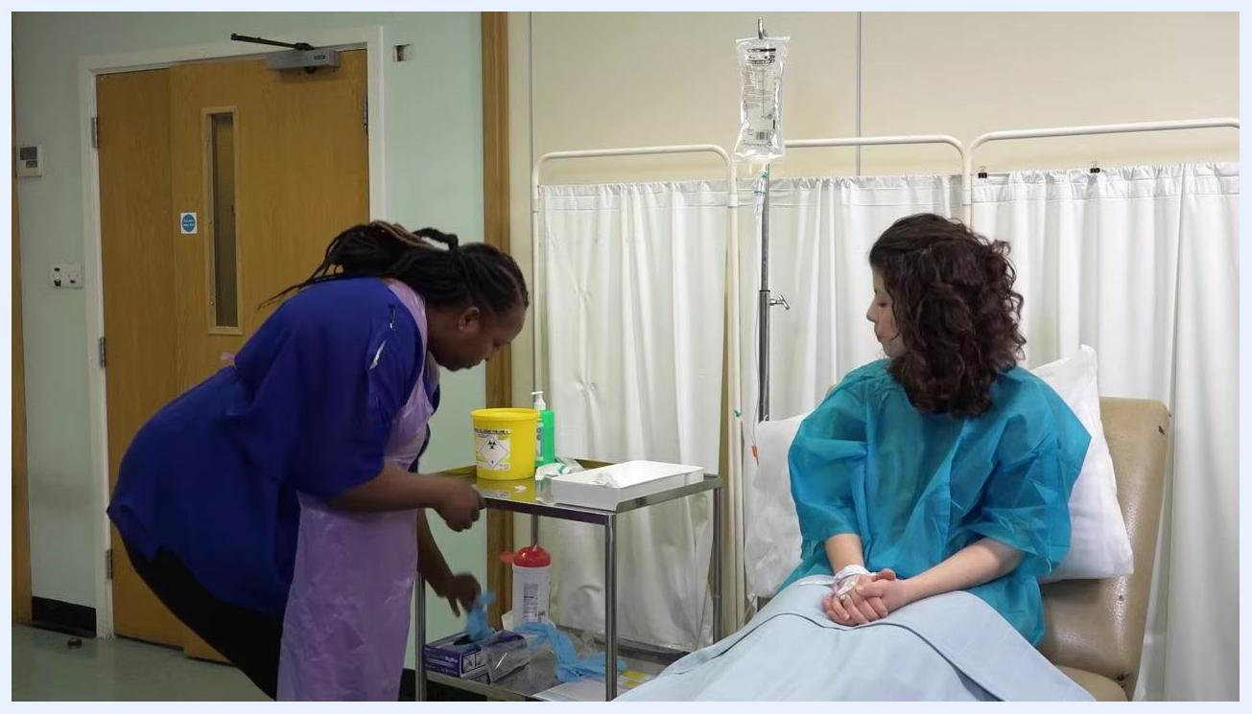
A staff member in gloves removes the orange protective cap from the IV tubing, preparing for the next step.
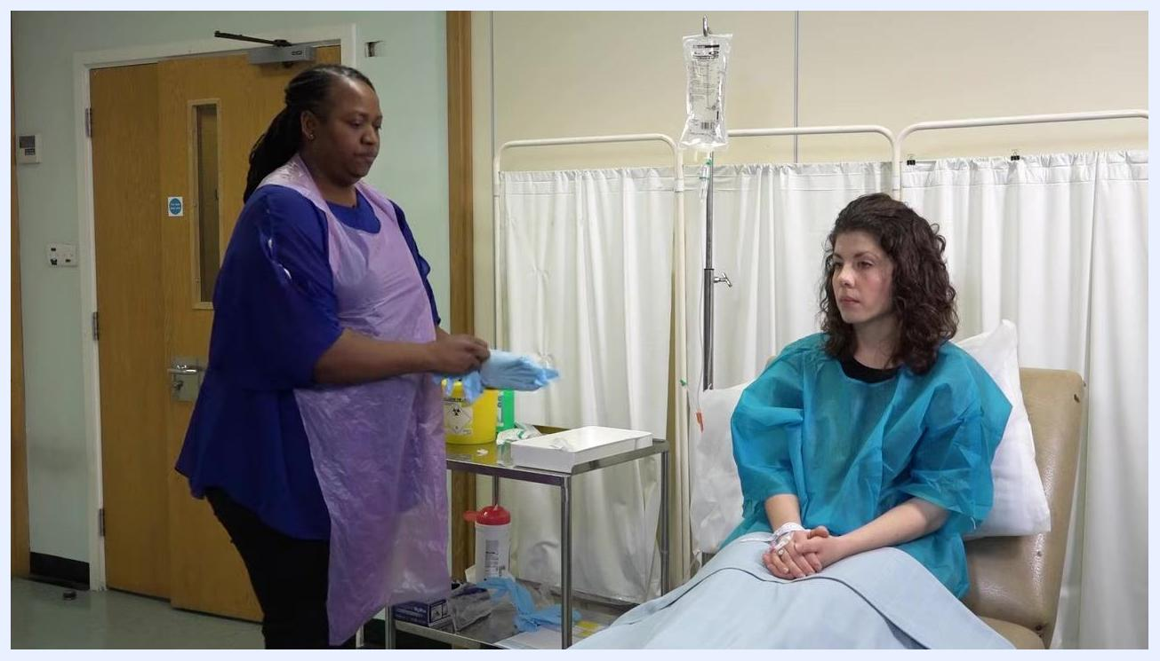
A staff member in a purple apron puts on a new pair of gloves, standing next to a tray with supplies and the patient.

Step 19: Prepare to put on clean gloves
Put on a clean pair of gloves before proceeding to connect the IV line to the patient's cannula.
A staff member in a purple apron bends over a tray, preparing to put on a new pair of gloves. The patient sits nearby with a cannula in her hand.

Step 20: Put on clean gloves
Complete putting on the new pair of gloves before handling any patient-connected equipment.

Step 21: Bring your supplies to the patient
Bring your tray containing an alcohol wipe and saline flush closer to the patient for easy access.
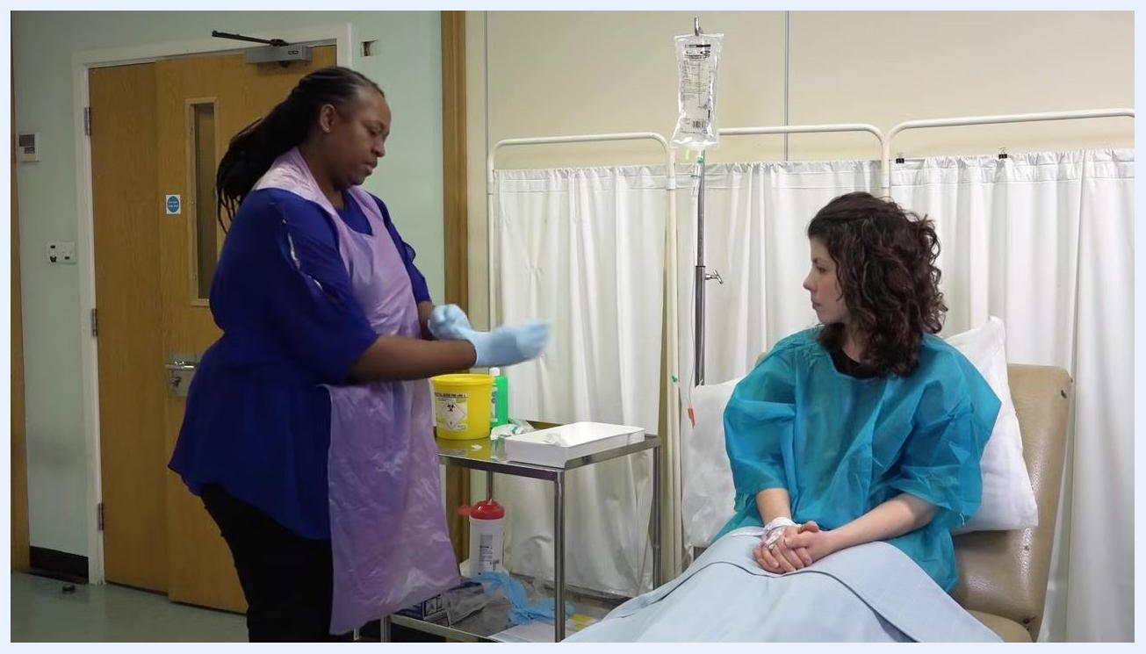
A staff member in a purple apron and gloves brings the tray with supplies closer to the patient, preparing for the next steps.

Step 22: Clean the cannula cap
Clean the cap on the patient's cannula thoroughly with an alcohol wipe to ensure sterility before connecting the IV line.

Step 23: Disinfect the cannula cap thoroughly
Take an alcohol wipe from the prepared tray and thoroughly clean the cap on the patient's cannula, using a firm, circular motion to ensure all surfaces are disinfected. Maintain sterility by avoiding contact between the cleaned cap and any non-sterile surfaces, and confirm that the patient's arm and cannula remain steady during cleaning.
A staff member in a purple apron and gloves cleans the cap on the patient's cannula with an alcohol wipe, while the patient sits with her arm ready.
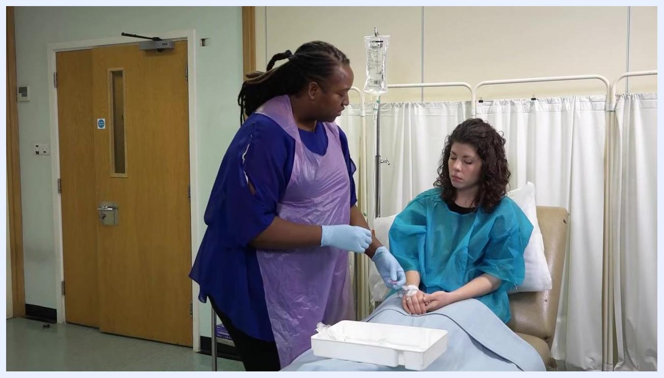
A staff member in a purple apron and gloves uses an alcohol wipe to clean the cap on the patient's cannula. The patient is seated in a clinical chair, wearing a blue gown, with an IV stand and bag visible in the background. A white tray with supplies is on the patient's lap.

Step 24: Check for air bubbles in the syringe
Inspect the syringe carefully before proceeding to ensure there are no air bubbles present, which could cause an air embolism. If air bubbles are detected, expel them safely before continuing.
A healthcare professional in gloves and a plastic apron is preparing to check a syringe for air bubbles, with a patient seated and an IV setup visible.

Step 25: Close the clamp
Locate the clamp on the IV administration set and close it to temporarily stop the flow of fluids. This step is necessary before connecting or disconnecting any components to prevent spillage or air entry.

Close-up of gloved hands manipulating the IV administration set, showing the clamp and connection point.

Step 26: Remove the cap from the administration tube
Identify the administration tube connected to the IV setup and carefully remove the protective cap from its end, exposing the key part for connection. Maintain aseptic technique throughout to avoid contamination.
The healthcare professional is removing the cap from the administration tube, while the patient looks on and smiles.

Step 27: Open the clamp to start the infusion
Once the administration tube is connected and ready, open the clamp again to allow the IV fluids to begin infusing into the patient. Monitor the flow to ensure it is running at the prescribed rate.

Step 28: Document the procedure
Sign the drug chart to confirm administration and record the following details in the patient's notes:
- Name & Strength: SODIUM CHLORIDE 0.9%
- Volume: 500mls
- Duration: 4°
- Rate: 125mls/h
- Prescriber's signature and any other required checks
A close-up of a drug chart with handwritten entries: SODIUM CHLORIDE 0.9%, 500mls, 4°, 125mls/h, and signatures.
Ensure all documentation is clear and complete.

Verification summary
Before considering the IV infusion complete, confirm the following:
- The patient's identity and prescription were verified using the Five Rights.
- All equipment was checked for expiry and sterility throughout preparation.
- The administration line was fully primed and free of air bubbles.
- The cannula cap was disinfected before connection.
- The clamp was closed and reopened correctly during connection to prevent spillage or air entry.
- The procedure was fully documented on the drug chart and in the patient's notes.

What's next
For more information and detailed clinical skills resources, visit the Clinical and Professional Skills Centre at ucl.ac.uk/medicalschool/cpsc.
Black screen with white text: "Clinical and Professional Skills Centre" and "ucl.ac.uk/medicalschool/cpsc".

