How to Set Up a Sterile Field for a Wound Care Dressing Procedure
This protocol explains how to set up a sterile field for a wound care dressing change, from gathering supplies to donning sterile gloves and maintaining sterility throughout the procedure. It applies to healthcare professionals performing dressing changes in a clinical setting, including clinical skills labs and bedside patient care areas. Following these steps in order helps you avoid contaminating your supplies and protects the patient from wound infection.

Purpose & Scope
This procedure covers the preparation, inspection, and sterile setup of a dressing tray used for wound cleaning and dressing changes. It applies to any healthcare professional performing a sterile dressing procedure at a patient's bedside or in a clinical skills lab. The scope includes supply verification, sterile field establishment, sterile gloving, and ongoing maintenance of sterility during the procedure.
Before you begin, gather all necessary supplies and place them on a clean, flat surface at waist height. You will need:
- A sealed dressing tray
- Cleaning solution for the wound
- Medical tape
- Extra supplies as needed, such as scissors or forceps
- Duoderm dressing
- 2x2 and 4x4 gauze pads for cleaning and drying the wound
- Sterile gloves
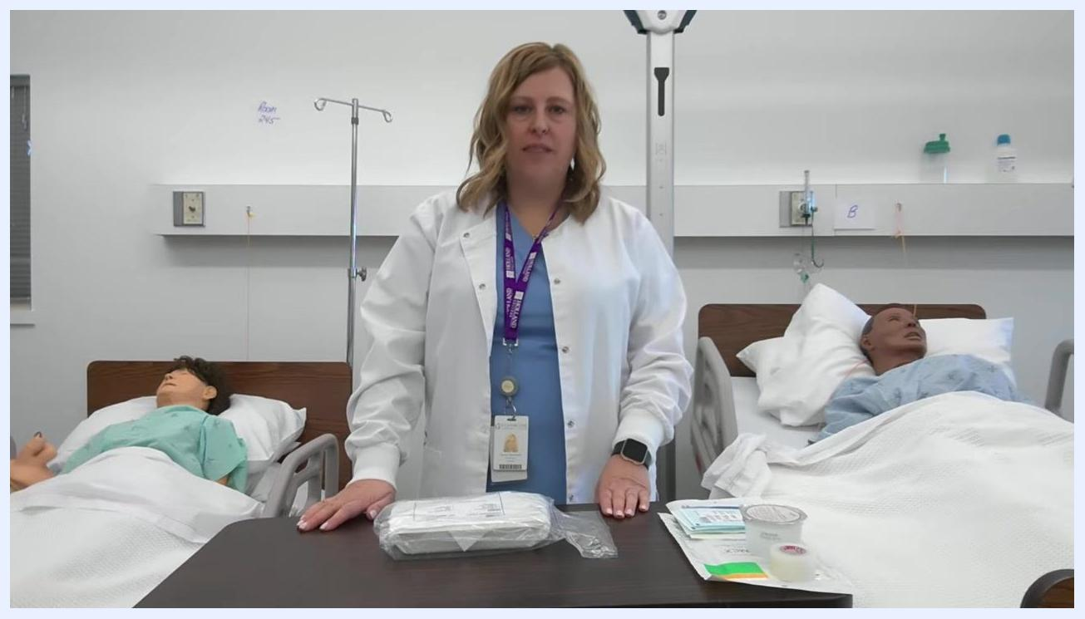
A healthcare professional stands behind a table with a sealed dressing tray, tape, gauze, duoderm dressing, and cleaning solution in a clinical skills lab with two patient mannequins in hospital beds.

Procedure Overview
The core principle behind setting up a sterile field is separating sterile items from non-sterile surfaces to prevent transmission of contaminants to the wound. A 1-inch (2.5 cm) border around the entire tray is always considered non-sterile; only the center area of the tray and drape is sterile. Risk factors for contamination include touching instrument handles and allowing them to cross into the sterile center, letting hands or packaging drop below waist level, and using expired or damaged supplies. Maintaining this boundary throughout the procedure is clinically significant because it directly reduces the risk of introducing pathogens into an open wound during dressing changes.

Supply Verification & Inspection
Before opening any sterile packaging, perform hand hygiene thoroughly. Then visually inspect the dressing tray and all supplies to confirm you have everything required, adding any missing items such as scissors or an extra pair of forceps.
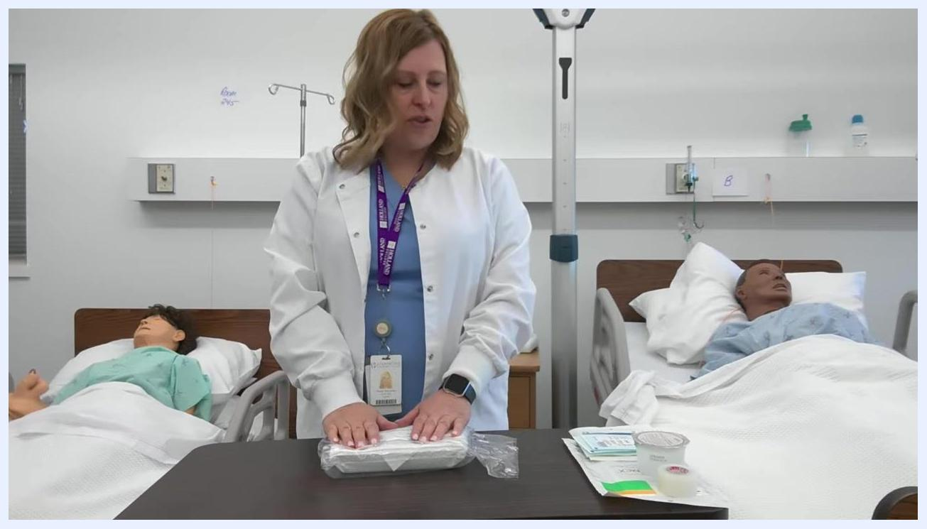
A healthcare professional places both hands on the sealed dressing tray, preparing to inspect and organize the supplies.
Check the expiry date on the dressing tray and all sterile supplies, and confirm that none of the items have expired.
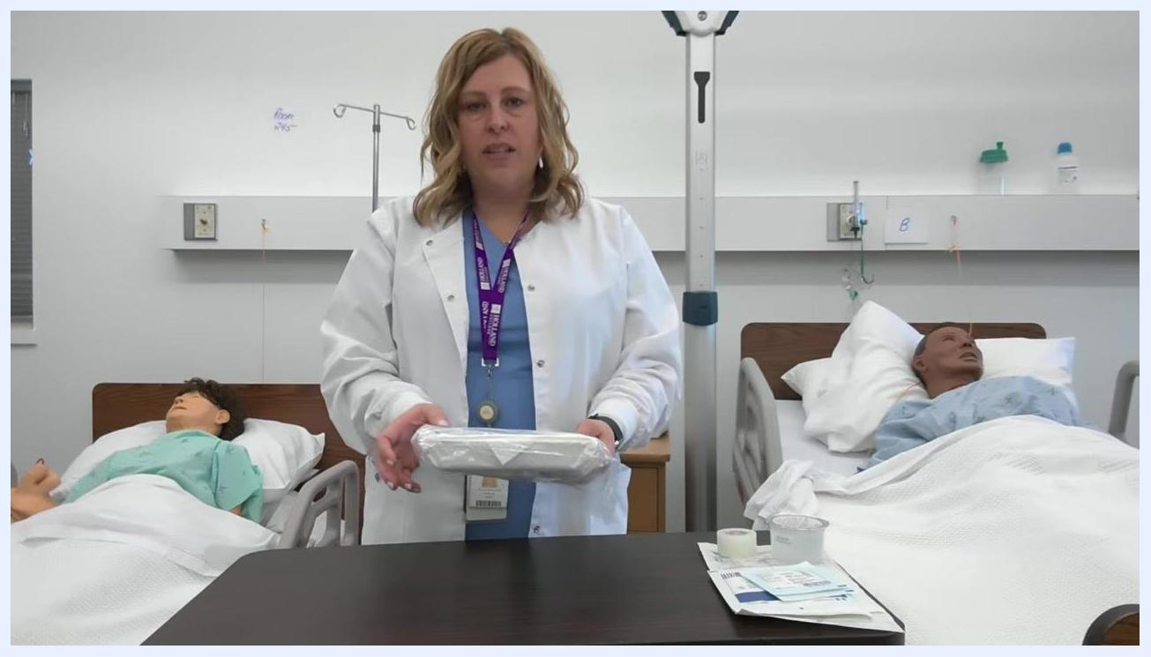
A healthcare professional holds the dressing tray and inspects it, with other supplies visible on the table.
Examine all packaging for tears, breaks, or other signs of compromise. If any packaging is damaged, discard the affected item and replace it with a new, intact package.
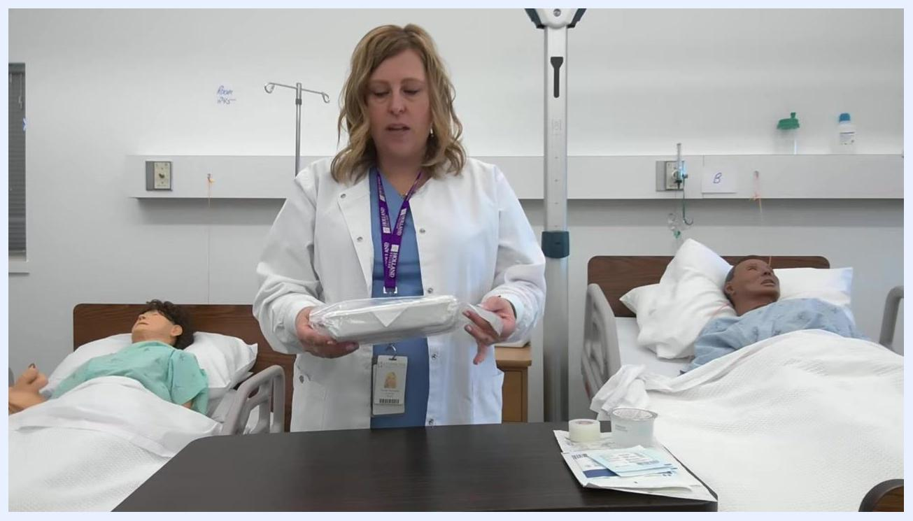
A healthcare professional closely inspects the dressing tray packaging for any breaks or tears.

Isolation Precautions: How to Set Up a Sterile Field

Opening the tray
With the tray positioned at waist height, identify the flap on the tray packaging. Remove the outer plastic and plan to open the tray by moving the packaging flap away from your body to maintain sterility.
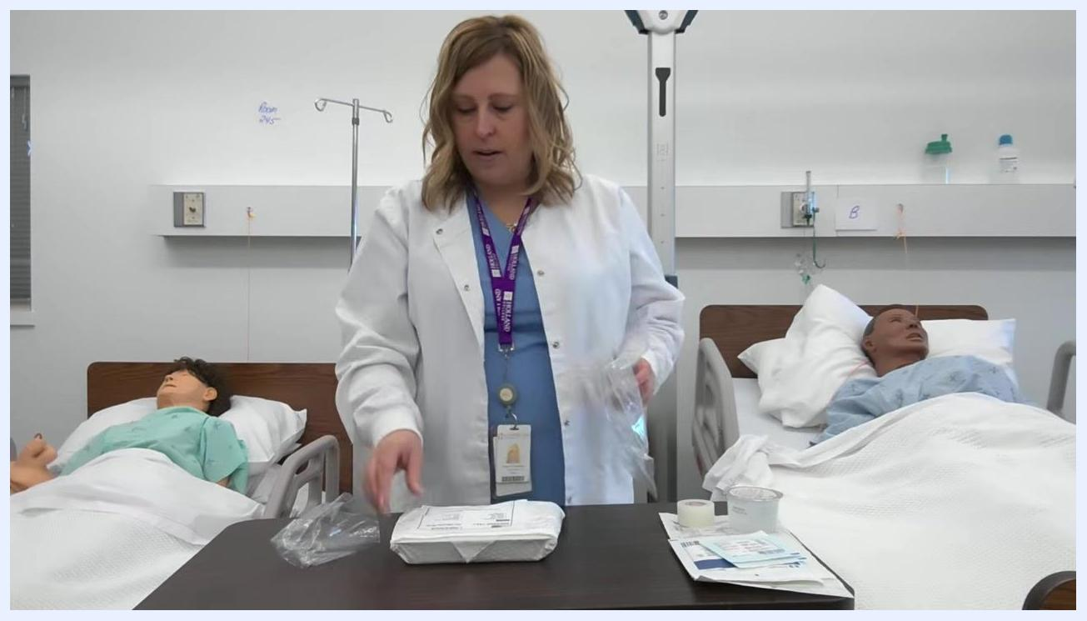
A healthcare professional removes the outer plastic from the dressing tray, preparing to open it.
Reconfirm that the tray is at waist height and that you have already performed hand hygiene before proceeding.
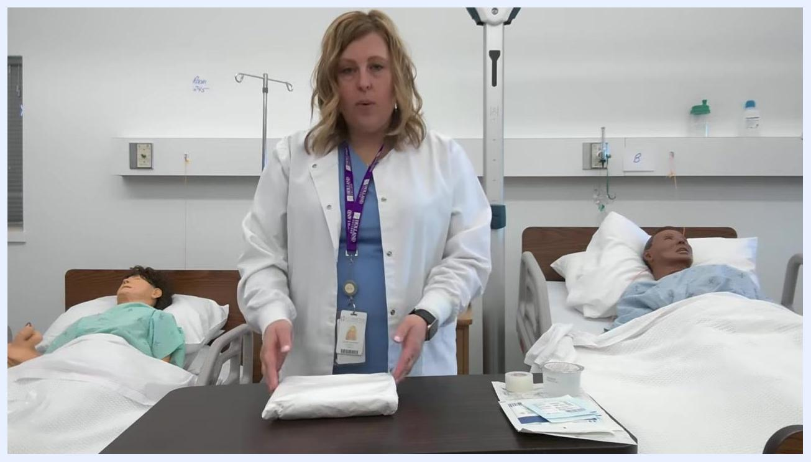
A healthcare professional stands with the unwrapped dressing tray at waist height, ready to proceed.
Open the tray by grasping the flap and moving it away from yourself, ensuring you do not contaminate the sterile field.
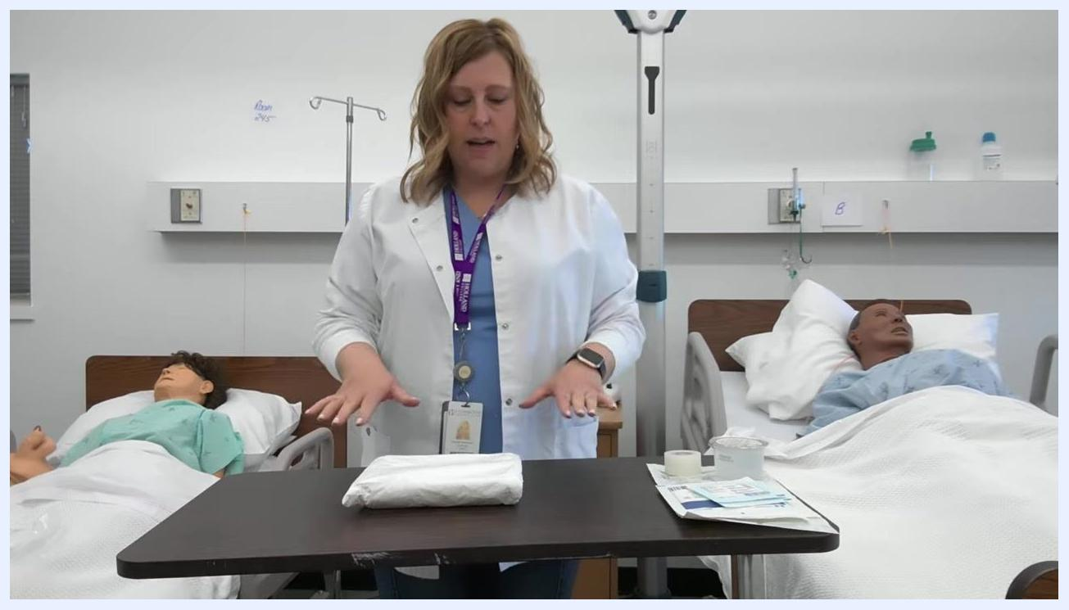
A healthcare professional gestures towards the tray, demonstrating the correct way to open the packaging flap away from the body.

Establishing the sterile field
Locate the forceps inside the opened tray. Grasp them by the handle only, ensuring you do not touch the sterile tips.
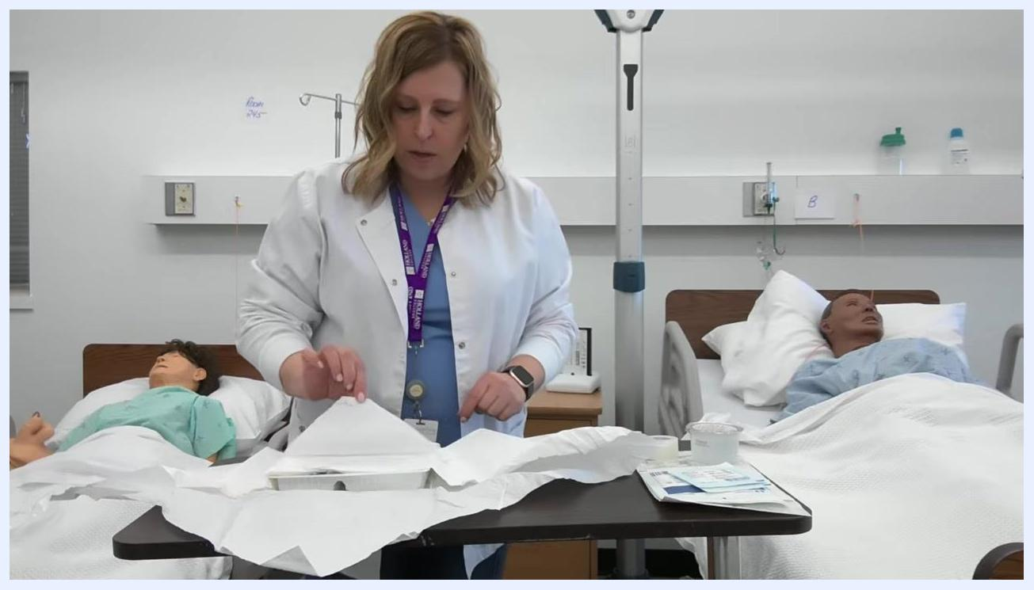
A healthcare professional reaches into the opened dressing tray to retrieve a set of blue forceps, in a clinical skills lab with two patient mannequins in hospital beds.
"Square off" the tray using the drape included at the top of the tray. Remember that a 1-inch border around the entire tray is non-sterile, and only the center area is sterile. Remove any included items, such as a small garbage bag, and set them aside away from the sterile field. Place the forceps inside the tray so the tips stay within the sterile center; if you have scissors, place them to the side of the tray unless needed.
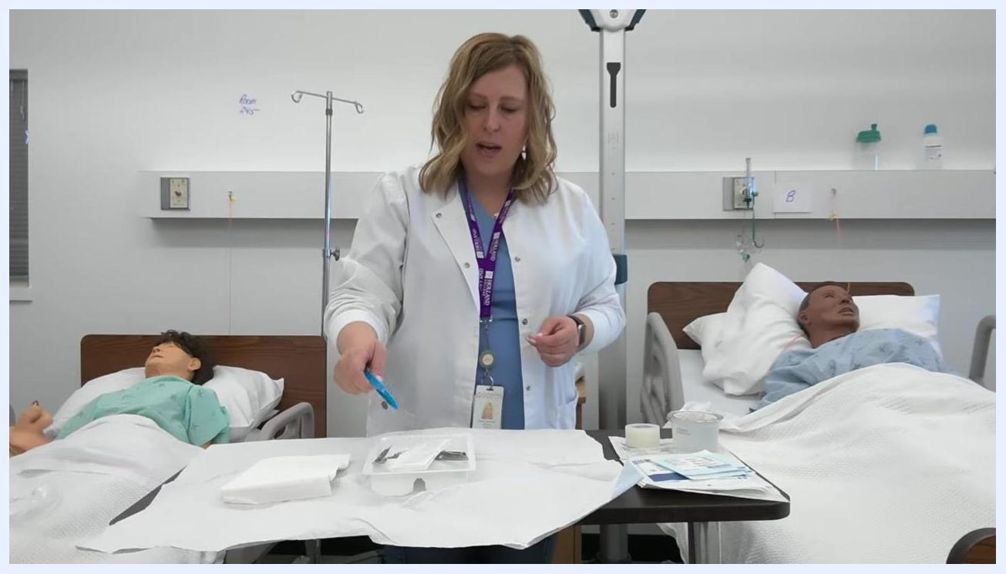
A healthcare professional holds blue forceps, preparing to arrange them inside the sterile tray, which has been squared off with a drape. Other supplies including tape and gauze are visible on the table.
Organize the gauze pads by placing 2x2 and 4x4 gauze to the side of the tray if not immediately needed. If you touch the handle of an instrument, keep that part on the 1-inch non-sterile border and never let it enter the sterile center. Continue arranging supplies while observing this border at all times.
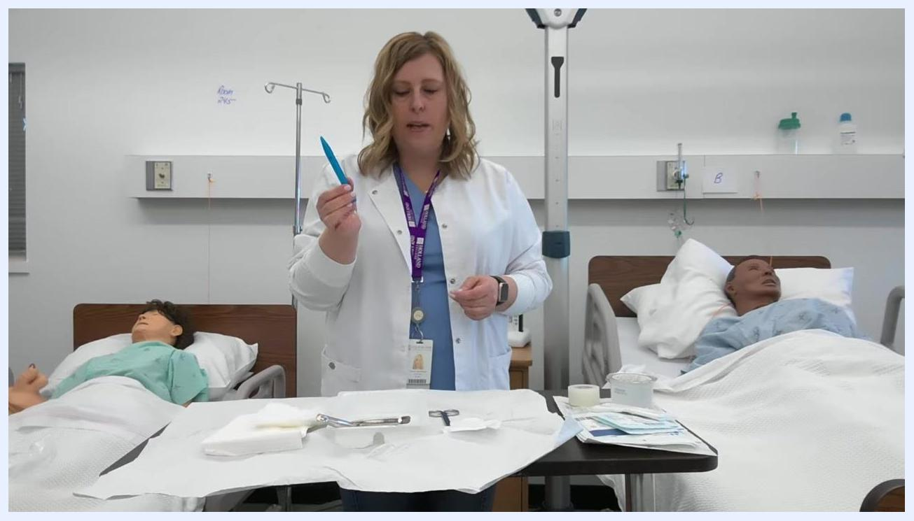
A healthcare professional holds blue forceps above the tray, showing that the handle where it was touched stays on the non-sterile border while the sterile tip remains in the sterile field. The tray contains forceps, scissors, and gauze, with the drape squared off.
Ensure the tips of the forceps remain on the sterile part of the tray, holding the instrument so only the sterile tips touch the sterile field while the handles stay on the non-sterile border.
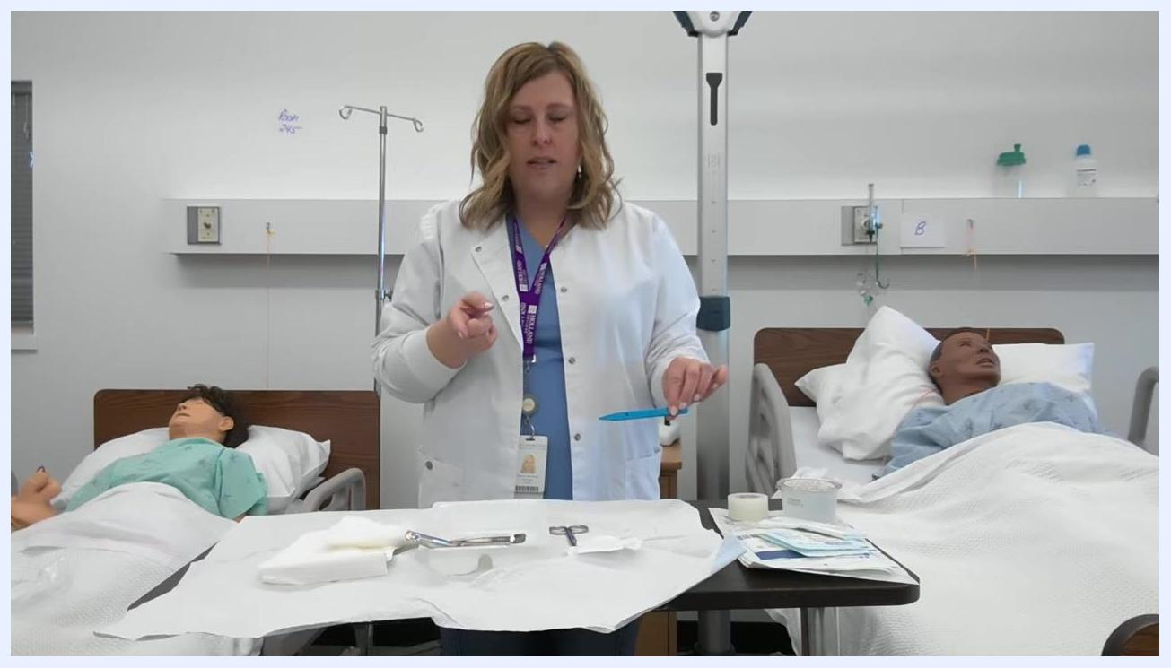
A healthcare professional holds blue forceps above a squared-off sterile tray containing forceps, scissors, gauze, and tape. Two patient mannequins are visible in the background.

Adding supplies to the sterile field
Peel back the packaging of your gauze with both hands, exposing the sterile gauze without touching the inside of the package or the gauze itself.
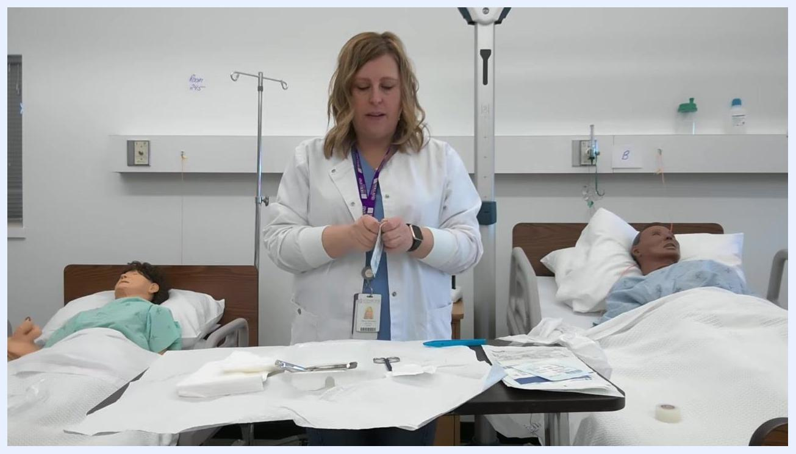
A healthcare professional peels back gauze packaging over a sterile field, with medical mannequins visible in the background and sterile instruments laid out on the tray.
Gently drop the sterile gauze onto the sterile field, ensuring it lands within the sterile area and that your hands or the packaging never touch the field.
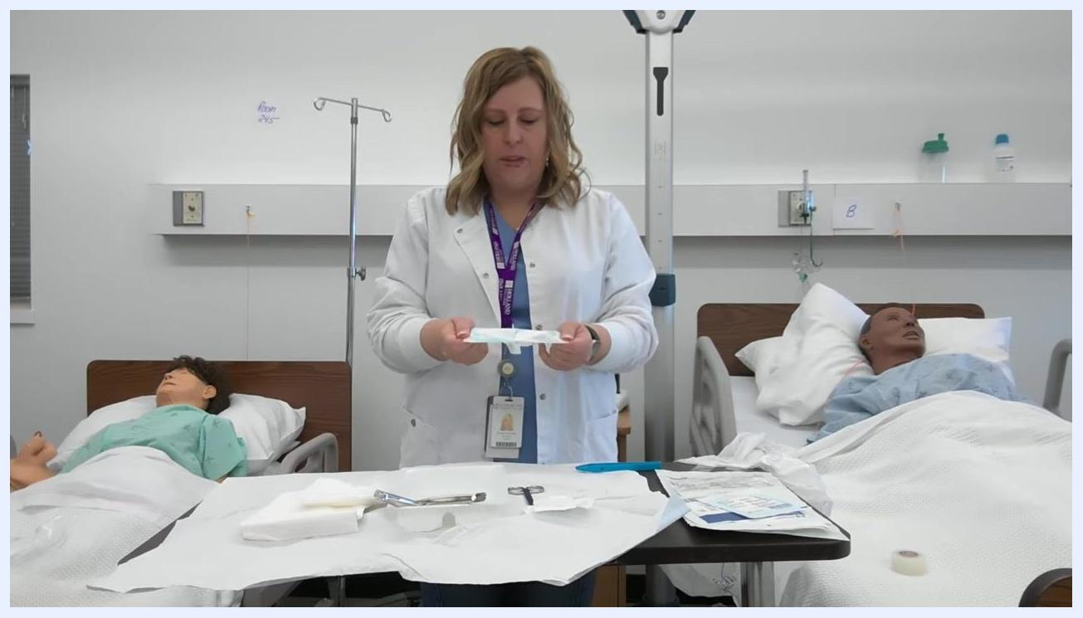
A healthcare professional holds open gauze packaging, preparing to drop the gauze onto the sterile tray, which contains forceps, scissors, and other sterile supplies.
Confirm that every item you add is placed entirely within the sterile drape area, with nothing hanging over the edge or resting within the one-inch non-sterile border.
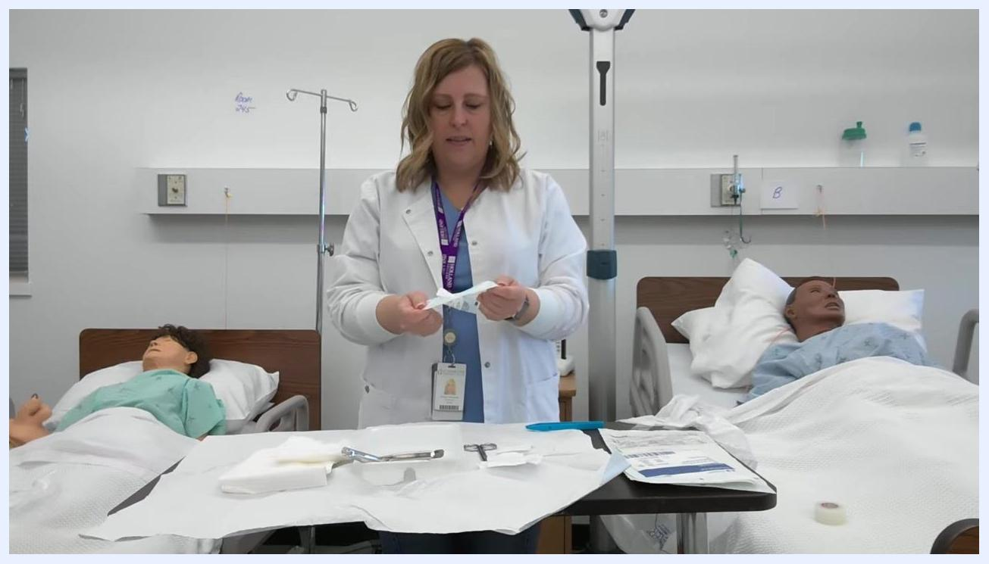
A healthcare professional holds gauze packaging while confirming placement within the sterile field. The tray is organized with all supplies inside the drape.
Keep all items within the central sterile area, away from the one-inch border, and make sure no supplies or wrappers hang over the edge of the field.
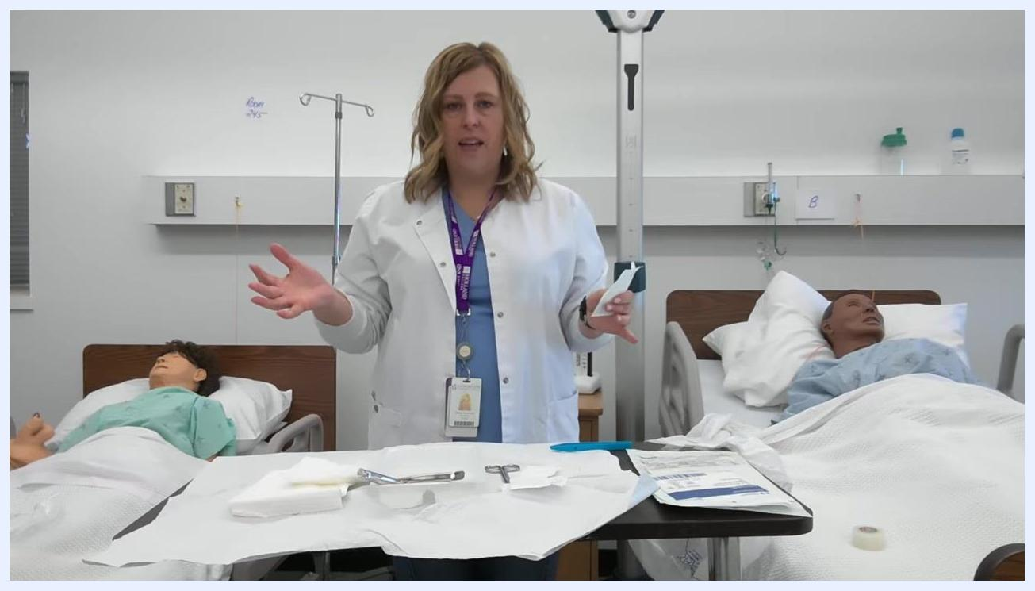
A healthcare professional gestures with both hands, explaining the importance of keeping supplies within the sterile field and away from the border.
Open additional gauze packages in the same manner as needed, preparing to use forceps to handle the gauze while maintaining sterility.
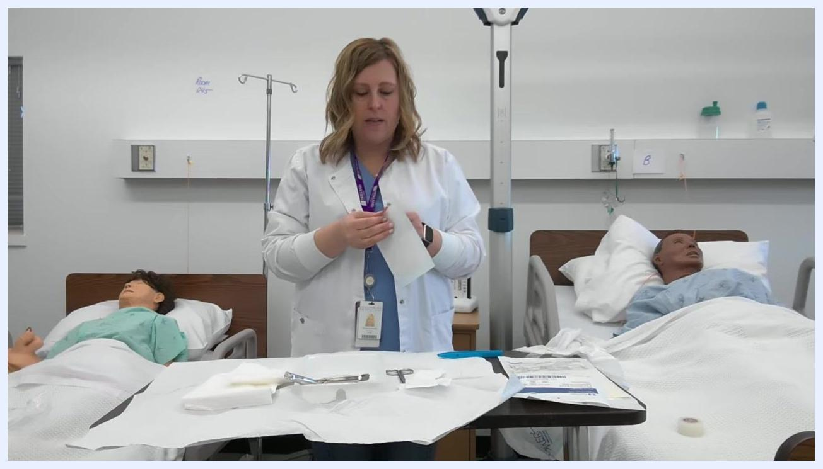
A healthcare professional opens another gauze package, preparing to use forceps while the tray and supplies remain organized within the sterile field.
Use sterile forceps by picking them up at the handles, keeping the tips sterile, and use them to transfer gauze from the packaging to the sterile field if needed.
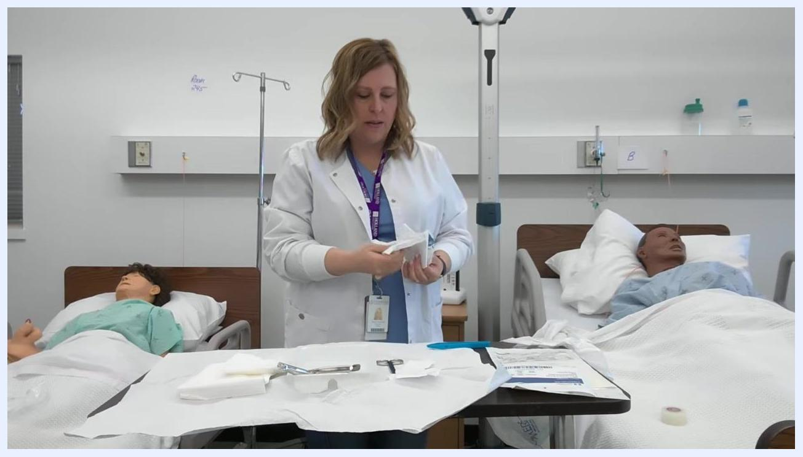
A healthcare professional demonstrates how to use forceps to handle gauze while keeping the tips sterile.
Limit the supplies on your sterile field to only those required for the procedure, keeping the field uncluttered and organized.
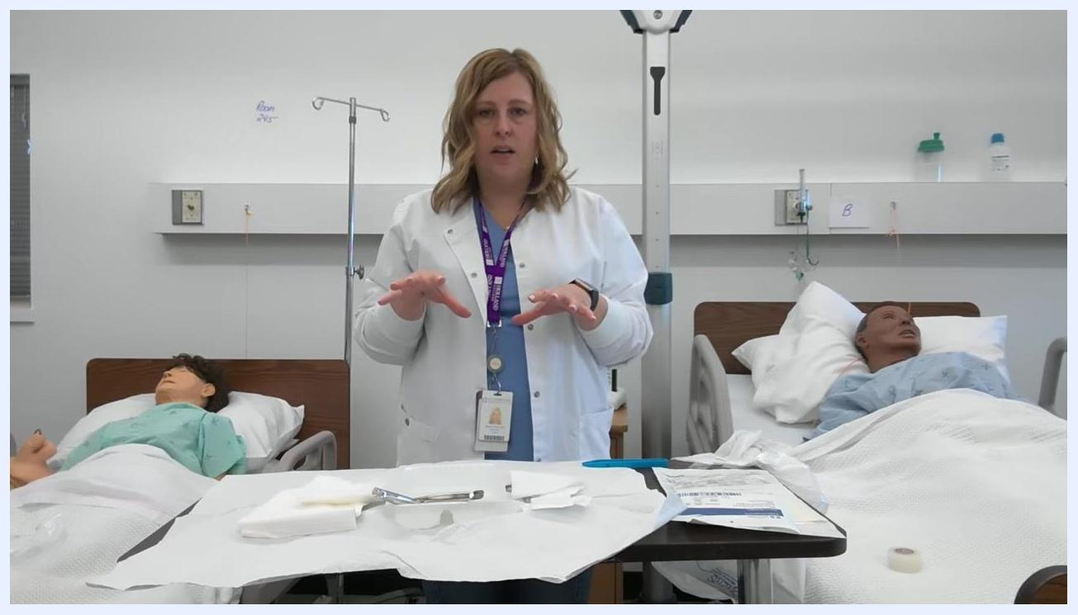
A healthcare professional gestures over the sterile field, emphasizing that only necessary items should be placed on it.

PPE requirements
Item | Role | Requirement
Sterile gloves | Healthcare professional performing dressing change | Select correct size from sealed package; don using sterile technique
Sterile forceps | Healthcare professional | Handle only by handles, keep tips within sterile field
Dressing tray and drape | Healthcare professional | Sealed, unexpired, and inspected for intact packaging before use
Gauze (2x2 and 4x4) | Healthcare professional | Transferred to sterile field without touching packaging interior
Saline solution | Healthcare professional | Single-use, checked for expiration before opening

Donning sterile gloves
Retrieve your sterile gloves from their sealed package and select the correct glove size for your hands.
A healthcare professional holds up a package of sterile gloves labeled "GAMMEX" size "7", explaining glove selection.
Grasp the tray with one hand and gently slide it to a position that allows easy access to your sterile glove package, ensuring the sterile field remains undisturbed.
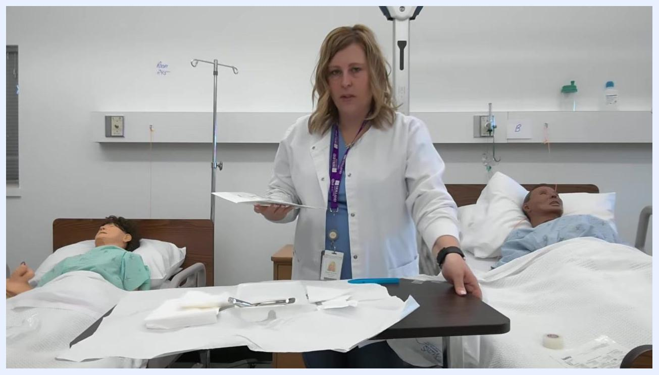
A healthcare professional moves the tray to a more convenient position while holding the glove package in the other hand. The sterile field remains organized, with medical mannequins visible in the background.
Place the glove package on the sterile field and carefully peel open the outer wrapper, exposing the inner sterile glove packaging without touching the gloves themselves.
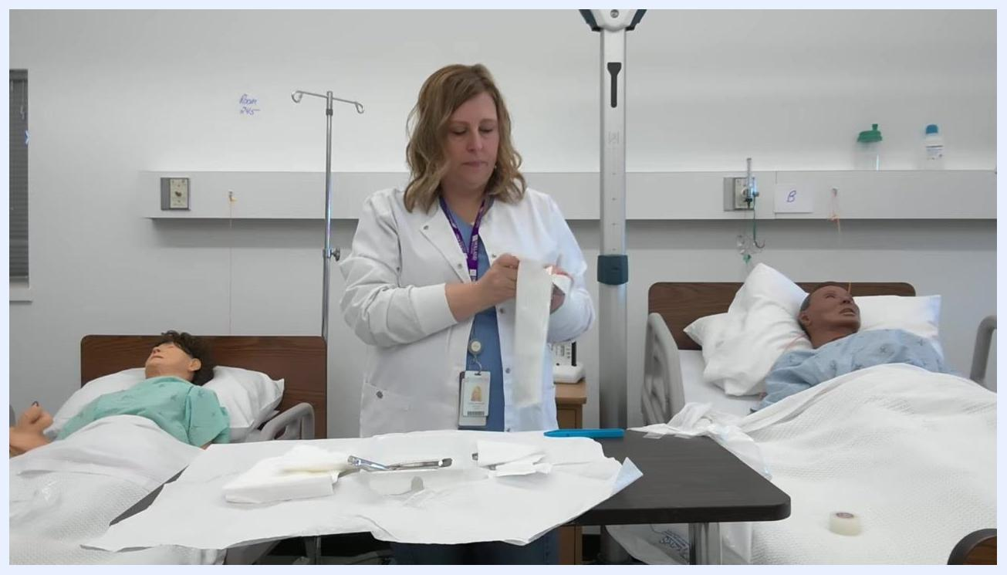
A healthcare professional opens the sterile glove package on the tray, preparing for gloving. The sterile field is visible with forceps, gauze, and other supplies.
Using your non-dominant hand, pick up the first glove by the inside of the cuff only, and hold the glove open with the cuff facing you.
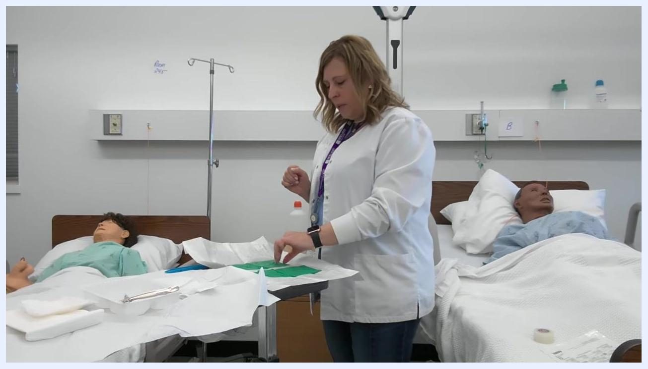
A healthcare professional prepares to pick up the first glove by the cuff, with green gloves visible on the sterile field.
Slip your dominant hand into the glove, touching only the inside of the cuff with your non-dominant hand. The glove does not need to be perfectly straight at this point.
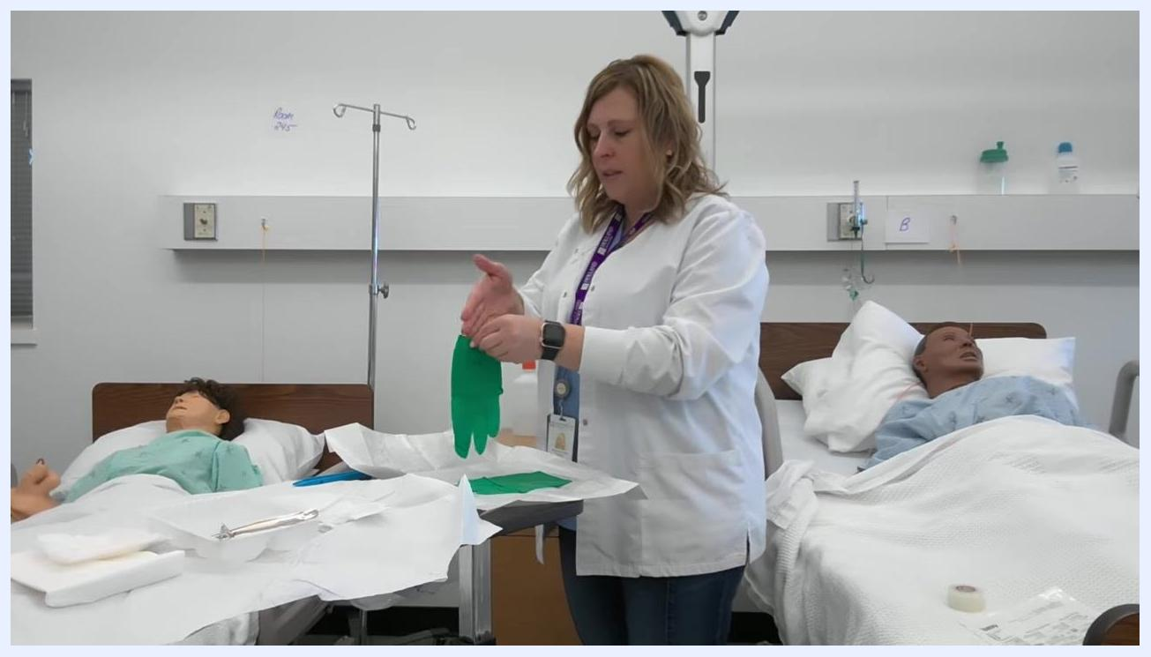
A healthcare professional slides her dominant hand into the green glove while holding the cuff open.
Once your dominant hand is gloved, hold it up and away from non-sterile surfaces, touching only the sterile glove packaging and the second glove.
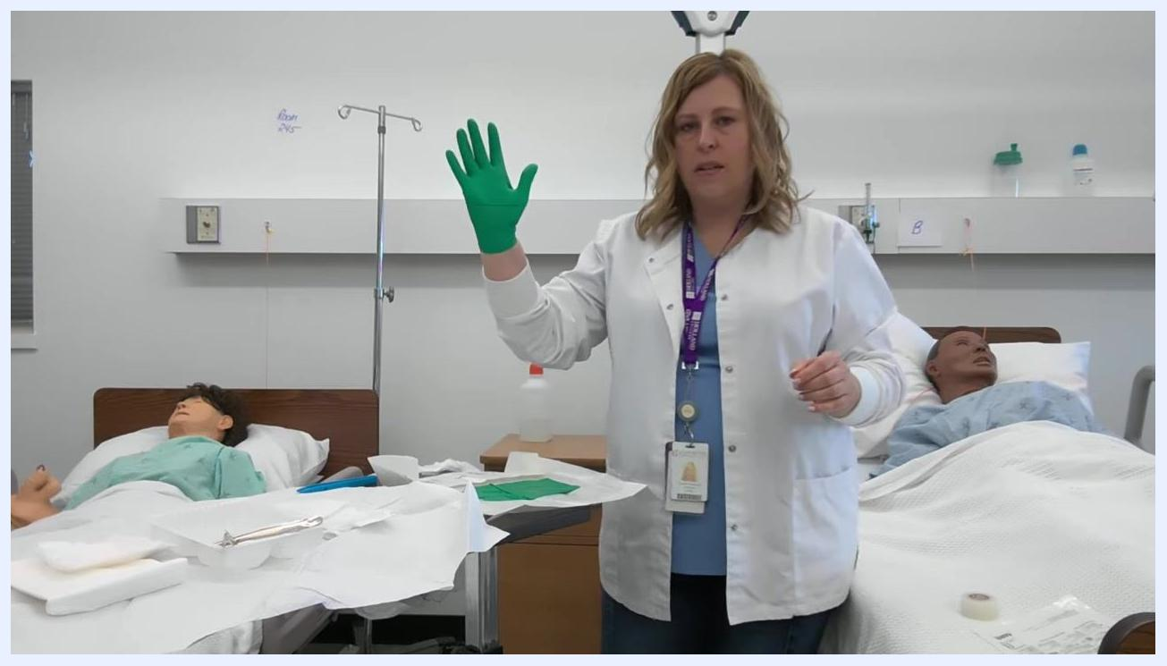
A healthcare professional holds up her now-gloved dominant hand, demonstrating proper technique.
With your gloved dominant hand, slide your fingers under the cuff of the second glove and lift it, holding it open for your non-dominant hand.
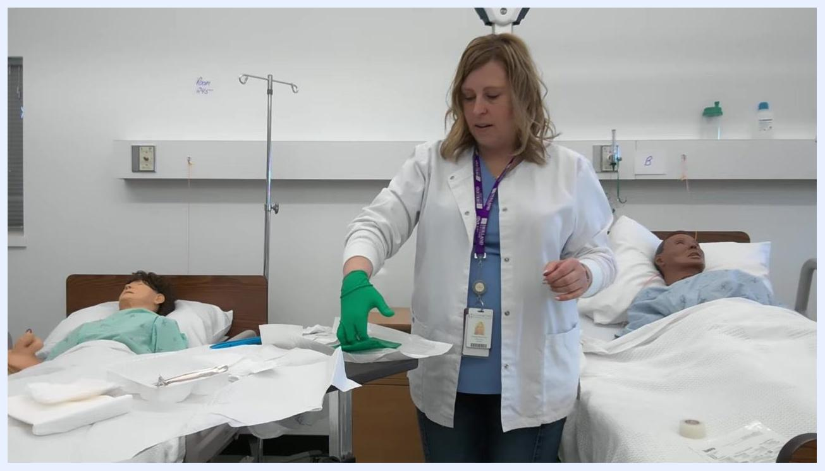
A healthcare professional uses her gloved hand to reach under the cuff of the second glove, preparing to insert her non-dominant hand.
Carefully slip your non-dominant hand into the glove, touching only the inside of the cuff. Again, the glove does not need to be perfectly straight yet.
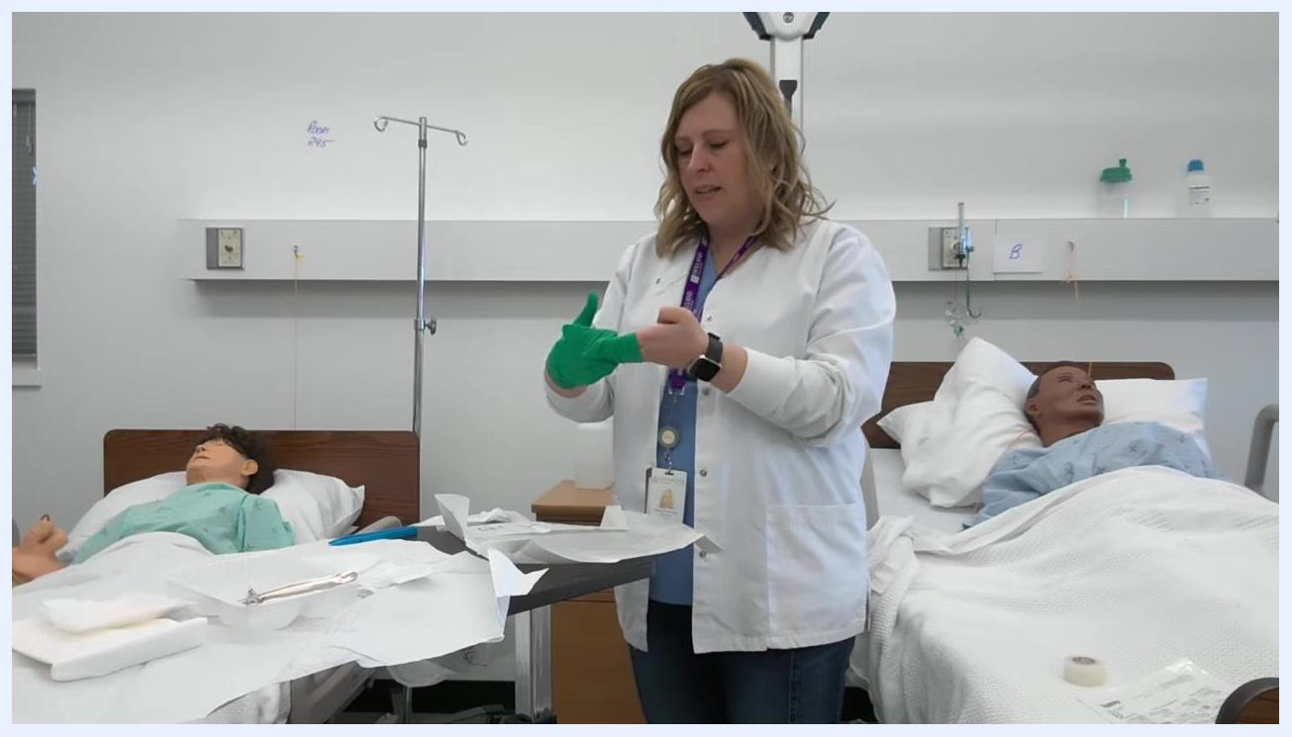
A healthcare professional places her non-dominant hand into the second glove, with both gloves partially donned.
Once both gloves are on, use your gloved fingers to adjust the cuffs and straighten the gloves, ensuring a snug fit without contaminating them.
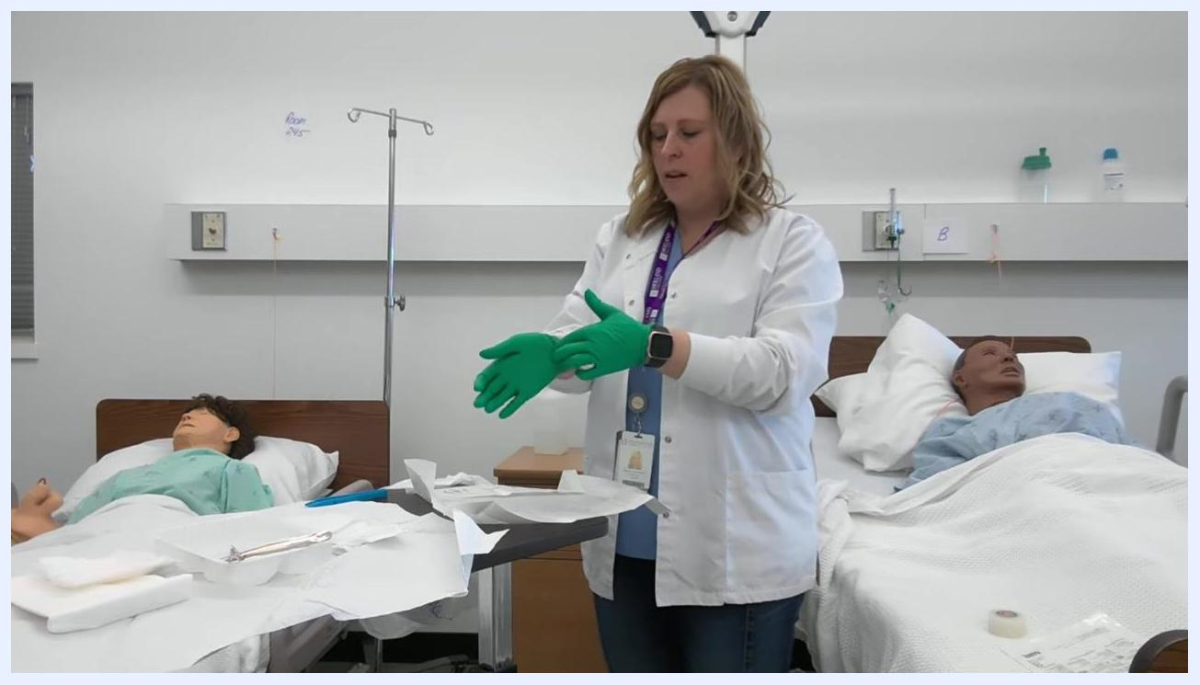
A healthcare professional adjusts the fit of her gloves, ensuring both are properly donned and the cuffs are straightened.

Hand Hygiene Protocol
Perform hand hygiene thoroughly before starting the procedure and reconfirm that you have done so before opening the tray. The source procedure does not specify a particular product (soap versus alcohol-based hand rub) or a compliance monitoring method; document your facility's approved hand hygiene product and monitoring process here.
Throughout the procedure, keep your gloved hands above waist level at all times to preserve sterility. Never allow your hands to drop below the waist, since this increases the risk of contamination.
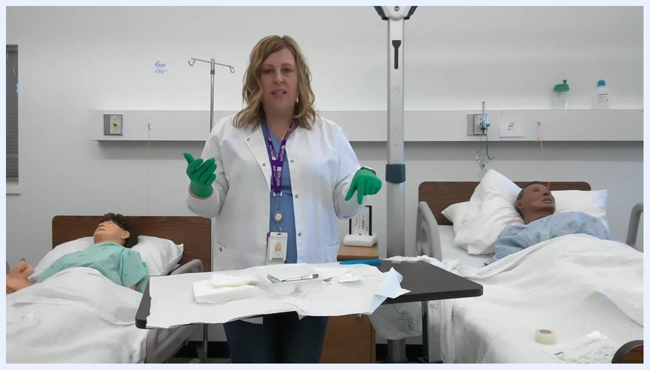
A healthcare professional demonstrates proper hand position, keeping gloved hands above waist level over the sterile tray.

Environmental Cleaning

Waste management during the procedure
Remove the small garbage bag from the dressing tray, open it fully, and tape it to the corner of the table or tray to keep it accessible for disposing of used materials.
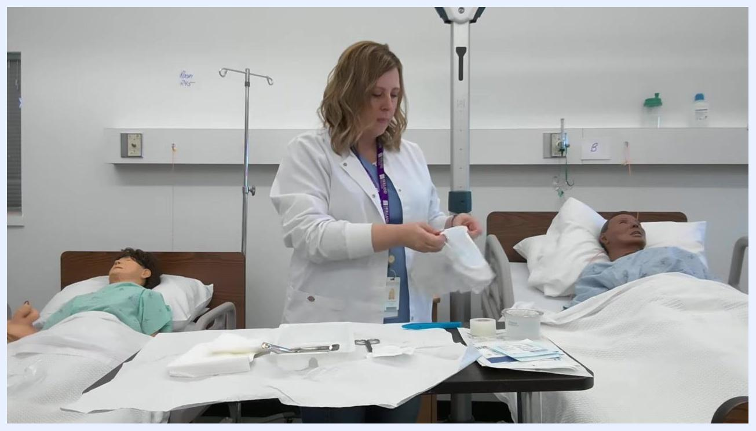
A healthcare professional prepares to tape a small garbage bag to the corner of the table, with the sterile tray and supplies visible.
Use the attached garbage bag to dispose of non-sterile or used items, placing any packaging, used gauze, or other waste directly into the bag to maintain a clean workspace.
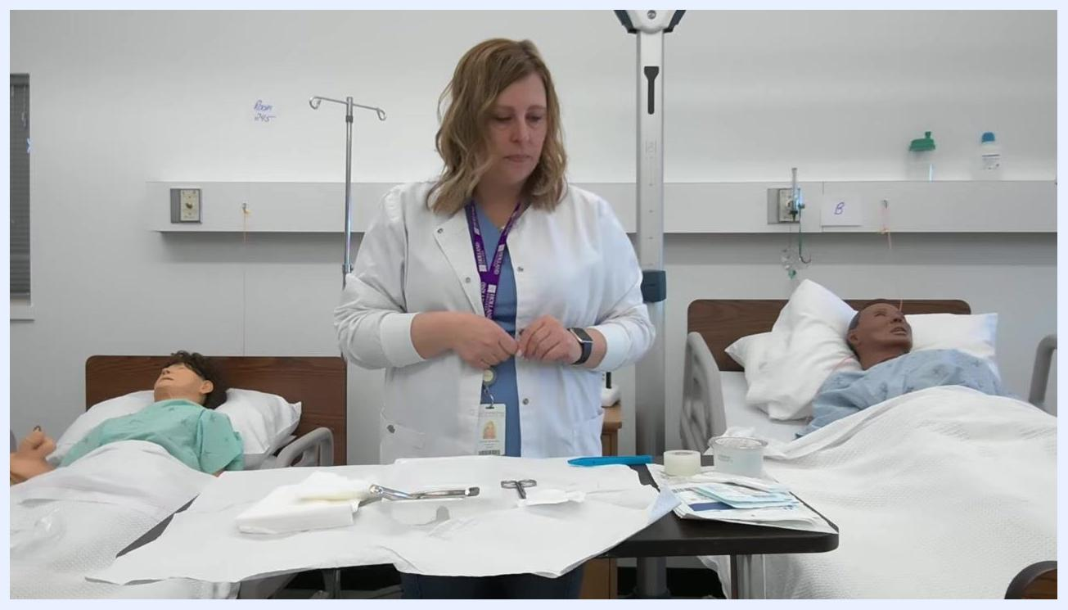
A healthcare professional places an item into the small garbage bag attached to the corner of the table, with the sterile tray and supplies visible.

Handling sterile fluid
Retrieve the saline solution container and check the expiration date to confirm it is still valid. Confirm the saline is a single-use container and plan to discard any unused portion after the procedure.
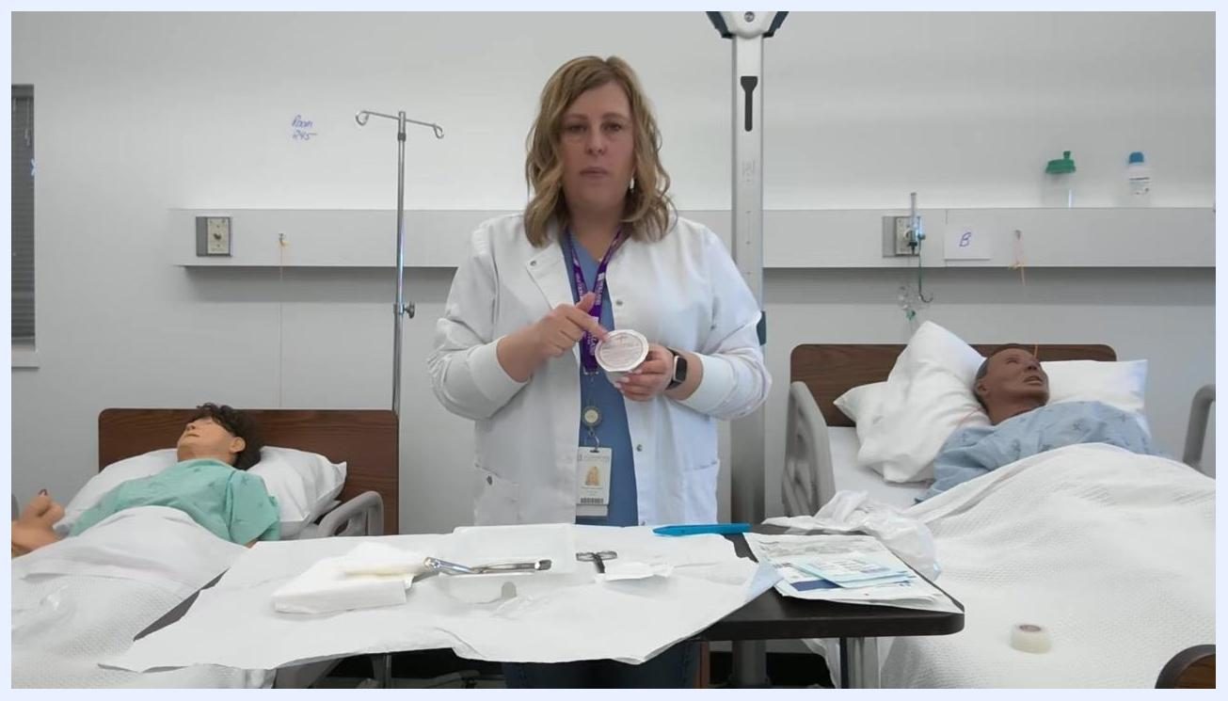
A healthcare professional holds a container of saline solution and points to the label to check the expiration date, with the sterile tray and supplies visible.
Remove the cap or seal from the saline container without contaminating the spout, then "lip" the container by pouring a small amount into the garbage bag to rinse and sterilize the spout before use.
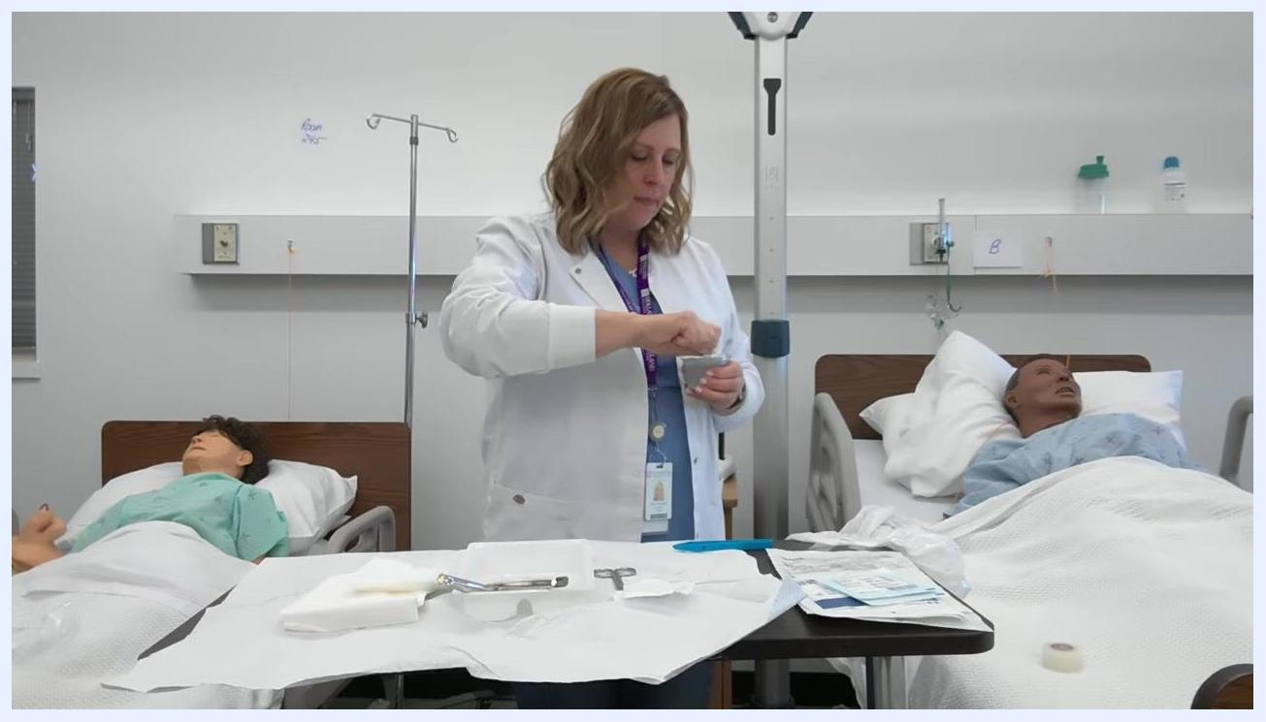
A healthcare professional opens the saline solution container, preparing to "lip" it by pouring a small amount out.
Hold the saline container close to the tray to avoid splashing and pour the required amount into the designated sterile area. Discard the used container into the garbage bag immediately after use.
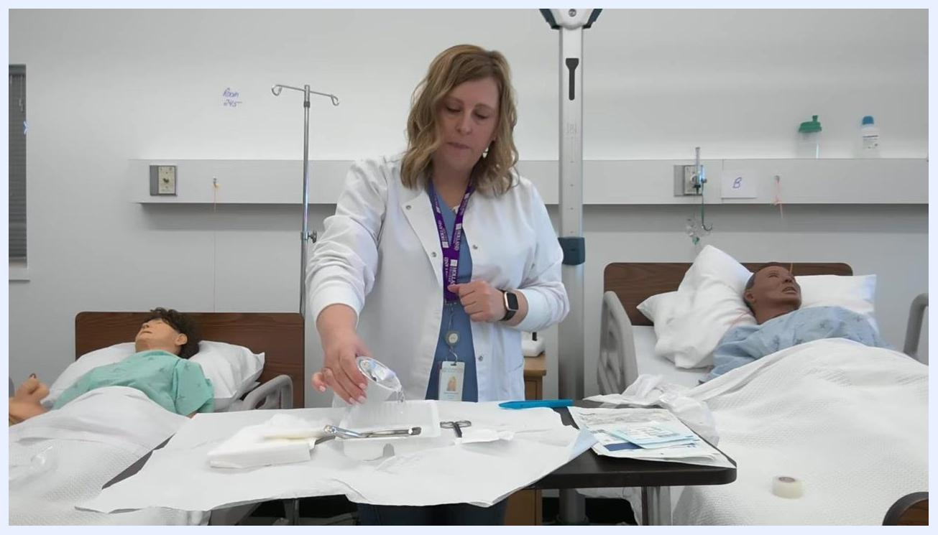
A healthcare professional pours saline solution from the container into the sterile tray, keeping the container close to the tray to avoid splashing.
Hold the empty or used saline container above the garbage bag attached to the corner of the table and drop it directly in. Ensure no part of the used container touches the sterile tray or supplies.
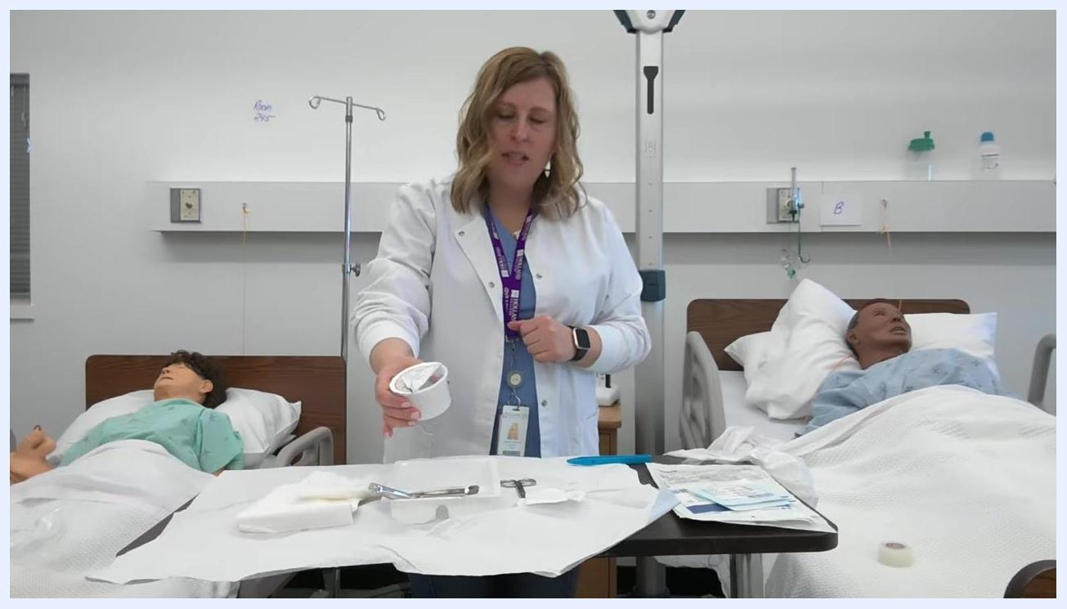
A healthcare professional holds an empty saline container above a sterile tray containing forceps, scissors, gauze, and tape, preparing to discard it into the garbage bag taped to the table.

Managing used and contaminated items
Grasp any used or contaminated items, such as wrappers or packaging, by the center and move them away from the sterile field. Slide the sterile tray forward to keep your working area organized and accessible.
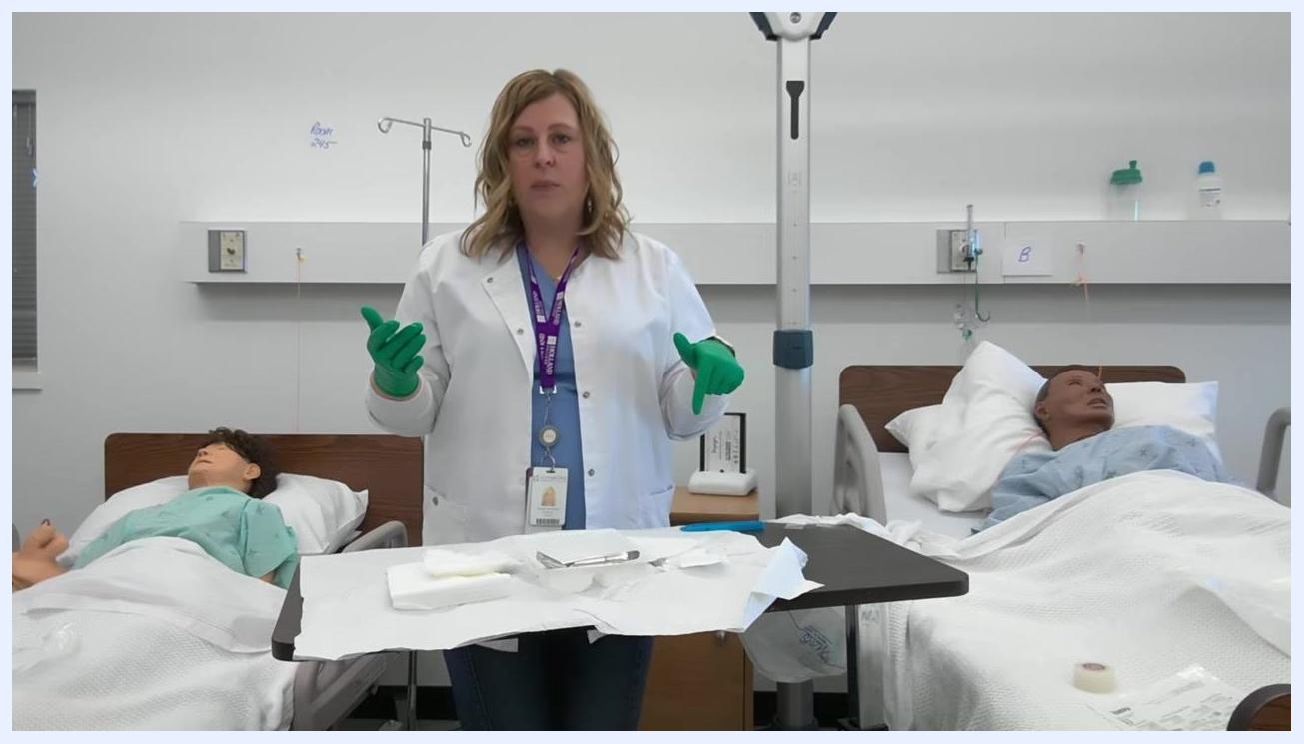
A healthcare professional with gloved hands raised stands between two hospital beds with mannequins. The sterile tray in front of her contains gauze, forceps, and other supplies, with used wrappers visible and being moved away.
If an instrument, such as blue forceps, becomes contaminated by touching a non-sterile surface or being grabbed by the tip end, do not use it further. Remove contaminated instruments from the tray immediately.
A healthcare professional stands behind the sterile tray, explaining the importance of not using contaminated instruments. Blue forceps and other supplies are visible on the tray.
Use your sterile gloves to arrange items such as gauze, forceps, and bowls on the tray, keeping all items within easy reach and not overlapping.
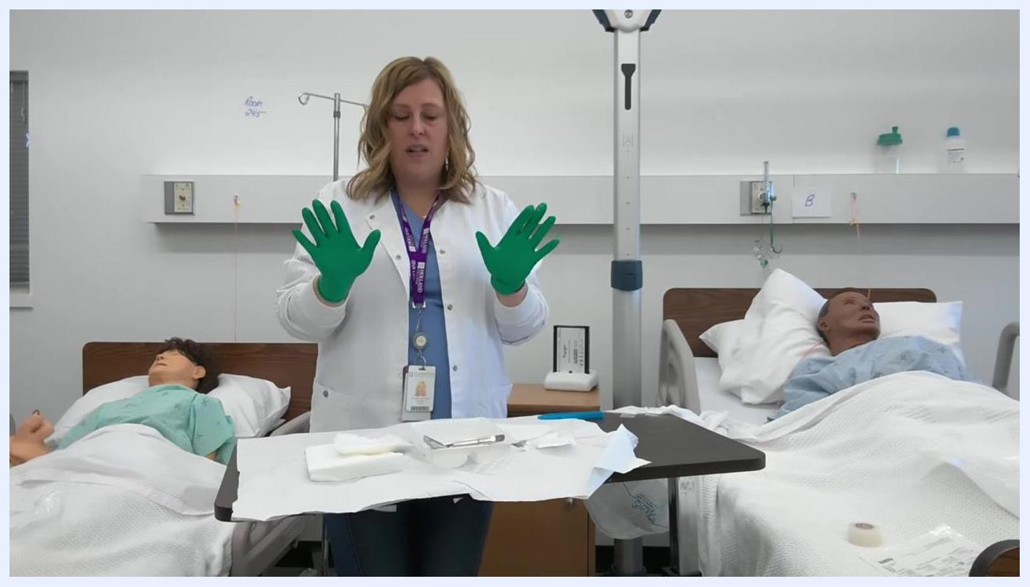
A healthcare professional holds her hands above the tray, preparing to organize supplies. Gauze, forceps, and other sterile items are visible on the tray.
When performing a dressing procedure, always return only clean, unused items to the sterile tray, and never place used or dirty items back onto the sterile field.
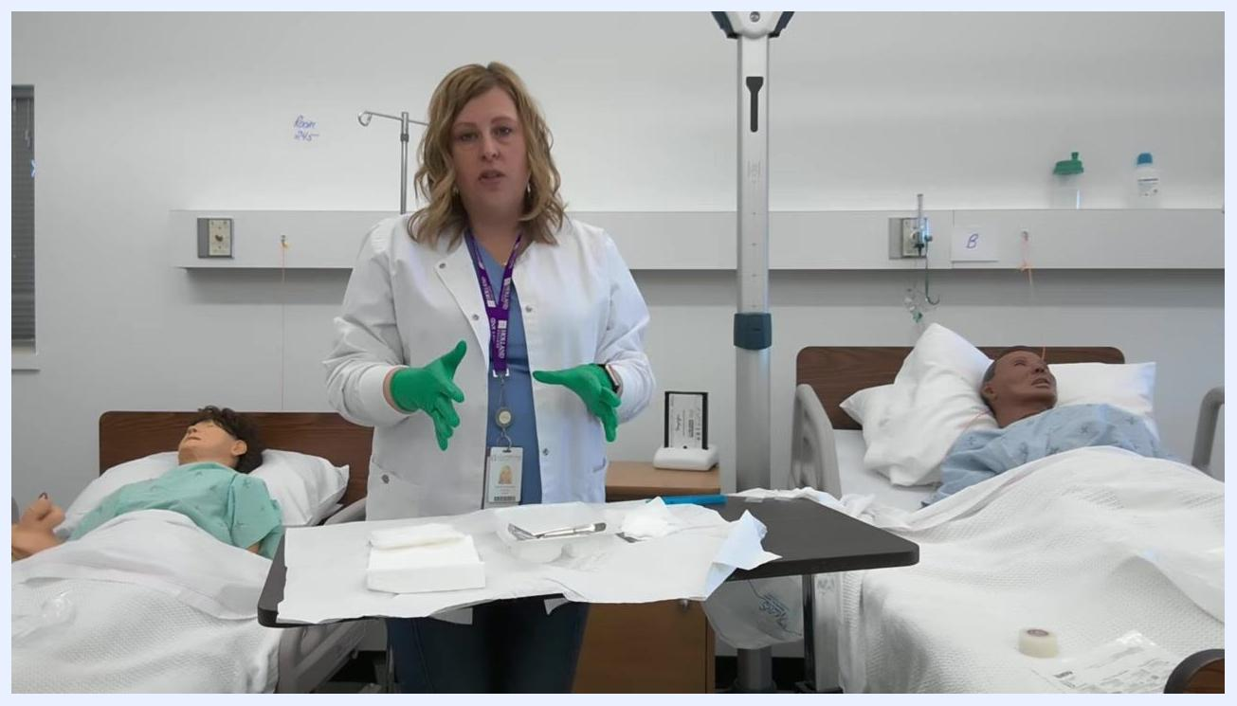
A healthcare professional demonstrates the correct placement of clean items on the sterile tray, with gloved hands and organized supplies.
After using an item, such as a swab for wound cleaning, dispose of it in the garbage immediately rather than returning it to the sterile tray.
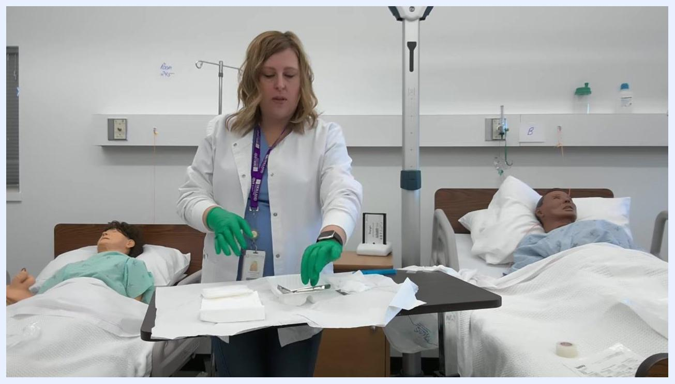
A healthcare professional reaches to discard a used item, demonstrating proper disposal technique.
Item | When to discard | Disposal method
Opened packaging and wrappers | Immediately after removing sterile contents | Place into garbage bag taped to table
Used saline container | Immediately after pouring | Drop into garbage bag without touching sterile tray
Contaminated instruments | As soon as contamination occurs | Remove from tray and discard
Used swabs or gauze | Immediately after use on the wound | Dispose in garbage bag; never return to tray

Surveillance & Reporting
The source procedure does not include outbreak thresholds, mandatory reporting requirements, or a line listing template; this section should document your facility's surveillance criteria and reporting workflow for wound infections related to dressing procedures.

Staff Education
Leave only clean, necessary supplies on the tray in preparation for dressing changes, which are demonstrated as a separate step; this stage focuses on tray setup and maintaining sterility.
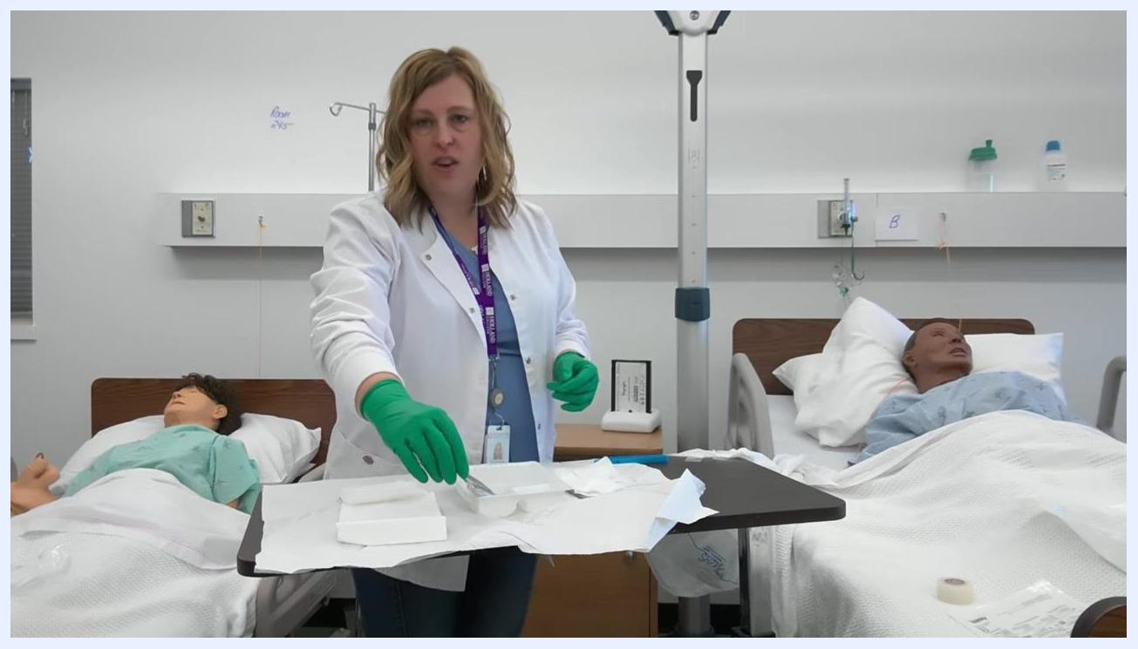
A healthcare professional organizes the tray, ensuring only clean supplies remain, with gauze and forceps neatly arranged.
Review that all steps for maintaining sterility and proper glove technique have been followed, confirming that the tray is organized, hands remain sterile, and contaminated items have been properly discarded.
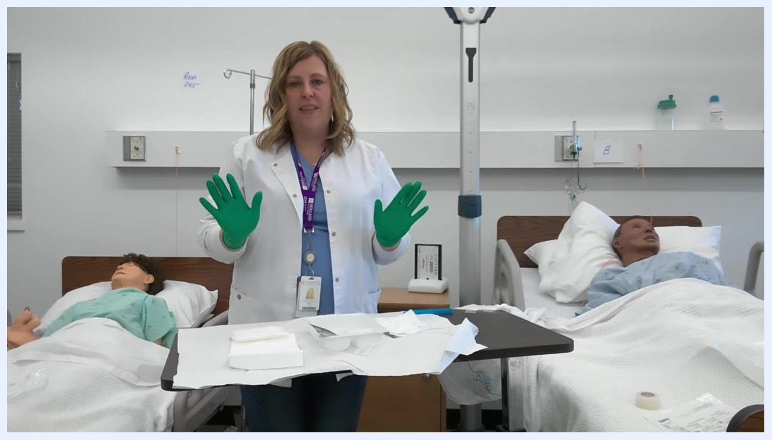
A healthcare professional faces forward with both gloved hands raised, summarizing the procedure. The sterile tray is organized and ready for use.
The source material does not specify formal training requirements, competency assessment criteria, or an annual refresher schedule; these should be defined according to your facility's clinical education policy, using this procedure as the basis for competency verification on sterile field setup and sterile gloving.

