How to Run Quality Control on a Glucometer: Instrument Calibration Log
Running quality control on a glucometer confirms that the device and test strips are calibrated correctly before you rely on them for blood glucose readings. Quality control (QC) uses a special solution provided with your glucometer to verify accuracy, and the results should be recorded in a calibration log such as this one. Use this document to guide each quality control check and to maintain a traceable record of instrument performance.

Prerequisites
Before you run quality control on a glucometer, gather the following items:
- Glucometer device
- Quality control solution (provided with your glucometer)
- Test strips that are not expired
- Your glucometer's user manual, for any additional items or device-specific instructions
Inspect your test strips before use. Check the expiration date printed on the test strip container, and note that once opened, test strips are typically good for four months. Discard any strips older than this or past their printed expiration date.
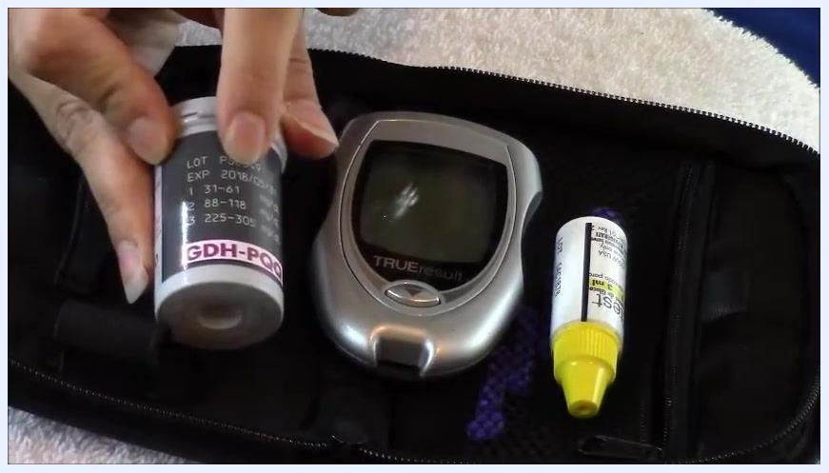
Close-up of a glucometer kit showing a container of test strips, a glucometer, and a control solution bottle, all stored together in a carrying case.
Locate the expiration date and lot number on the test strip container and confirm the strips fall within the valid date range before testing.
A hand holding a test strip container, displaying the label with expiration date, lot number, and reference ranges.

Instrument Details
Instrument ID | Model | Serial Number | Location | Owner | Intended Use
Record per facility policy | TRUEresult glucometer | Record per facility policy | Record per facility policy | Record per facility policy | Blood glucose testing
The source material identifies the device model only. Record the instrument ID, serial number, location, and owner according to your facility's asset-tracking policy at the time of logging.

Calibration Schedule
Frequency | Due Date | Procedure | Responsible Role
Before first use of a new glucometer | Record at time of test | See procedure steps below | Record per facility policy
Each time you open a new batch of test strips | Record at time of test | See procedure steps below | Record per facility policy
Periodically throughout the week | Record at time of test | See procedure steps below | Record per facility policy
When blood sugar readings are unusually high or low | Record at time of test | See procedure steps below | Record per facility policy
Always refer to your glucometer's user manual for device-specific QC recommendations. The source material does not assign a specific responsible role; record this per your facility's protocol.
Procedure for running quality control on a glucometer:

- Record the opening and expiration dates of your test strips and control solution directly on their containers.
- Mix the quality control solution by rolling the bottle gently between your hands. Do not shake it, so the solution stays homogeneous.
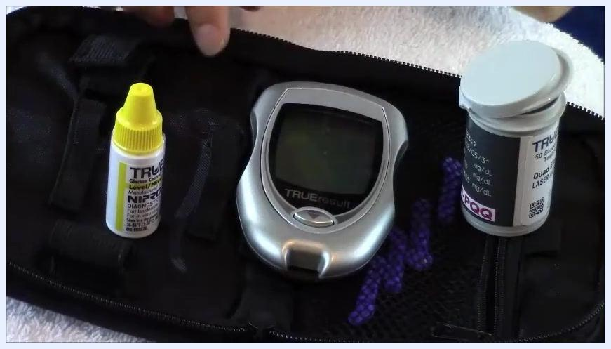
A hand rolling a control solution bottle between the palms to mix it, with the glucometer and test strip container nearby.

- Prepare the glucometer. For a TRUEresult monitor, insert a test strip to power on the device; other models may require you to turn the device on manually, per the user manual.
TRUEresult glucometer positioned next to the test strip container and control solution, ready for testing.

- Insert a new test strip into the glucometer's slot with the marked end facing in. The device should power on automatically.
A hand inserting a test strip into the glucometer, with the control solution and test strip container visible nearby.

- Remove the cap from the control solution bottle and apply a small drop to the area of the test strip where you would normally apply a blood sample. The strip draws up the solution automatically.
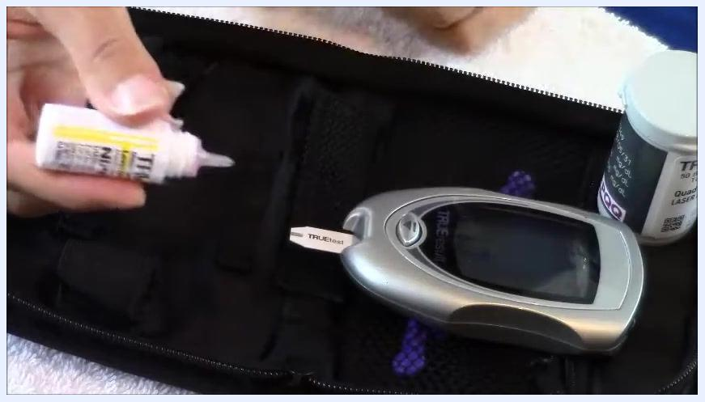
A hand holding the control solution bottle with the cap removed, preparing to apply a drop to the inserted test strip.

Standards Used
Reference Standard | Lot Number | Certificate | Expiration Date | Traceability
Quality control solution | Printed on test strip/solution container | Not specified in source | 3 months after opening (solution); 4 months after opening (test strips) | Not specified in source
Check the lot number and expiration date printed on the test strip container before each test. Certificate and traceability details are not covered in the source material; record these per your facility's reference-standard documentation requirements.

Calibration Results
Measured Value | Acceptance Limits | Pass/Fail | Analyst Initials
46 (example reading, Level 1 control) | Per Level 1 range printed on test strip container or user guide | Pass if within range / Fail if outside range | Record per facility policy
After applying the control solution, wait for the glucometer to process the sample and display a result.
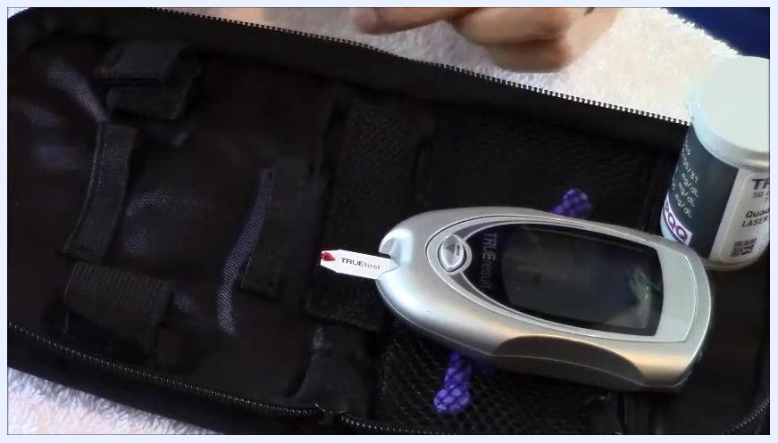
Glucometer with a test strip inserted, showing a red drop of control solution applied to the strip.
Compare the displayed reading to the acceptable control range for the control solution level you used (for example, Level 1, Level 2, or Level 3), as printed on the test strip container or user manual. Some glucometers display a PASS message when the result falls within range.
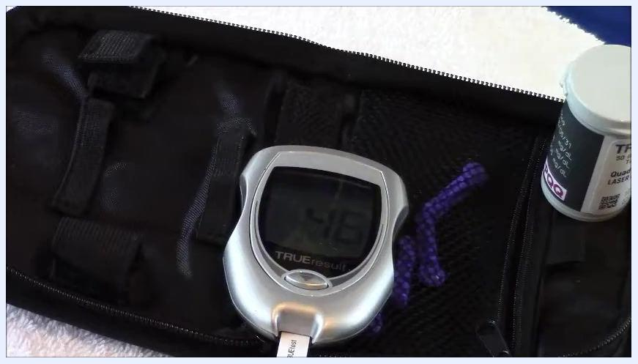
TRUEresult glucometer displaying a reading of 46, with the test strip inserted and the carrying case visible.
Identify which control solution level you used and confirm the result falls within the printed range for that level. The source material does not specify an analyst initials field; record this per your facility's logging requirements.

Maintenance
Preventive Maintenance | Repairs | Parts Replaced | Service Provider
Replace the cap on the control solution bottle tightly; close the test strip container securely; store the glucometer, strips, and solution in their carrying case away from direct sunlight and moisture | Not specified in source | Not specified in source | Not specified in source
The source material covers storage practices only. Record any repairs, parts replaced, or service provider information per your facility's maintenance protocol when applicable.

Out-of-Tolerance Actions
Impact Assessment | Affected Data Review | Quarantine | Corrective Action
Not specified in source | Not specified in source | Not specified in source | Repeat the test with a new test strip and new control solution
If the repeated result remains outside the acceptable range, consult your user manual or contact the manufacturer. The source material does not address impact assessment, affected data review, or quarantine procedures; follow your facility's protocol for these steps when a glucometer fails quality control.

Approval
Reviewer | Date | Release-to-Use Decision
Record per facility policy | Record at time of review | Record per facility policy
Document the result, date, and control solution level used in your logbook or quality control record, as recommended by your facility or personal tracking system. The source material does not specify a reviewer, review date, or formal release-to-use decision; complete these fields according to your facility's approval process before the glucometer is returned to use.

What's Next
For more information on using your glucometer, refer to your device's user manual. You can also review related instructional resources on checking your blood sugar, loading a lancet device, and using a lancet device.
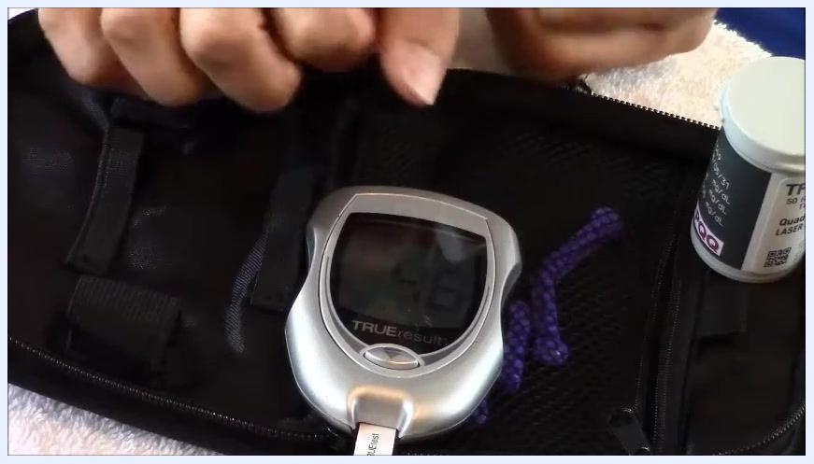
A nurse in blue scrubs stands in front of a whiteboard with red writing, providing closing remarks and encouraging viewers to subscribe for more instructional content.

