How to Reposition a Patient in Bed Using a Draw Sheet (One-Person Technique)
This procedure describes how to reposition a patient in bed using a draw sheet when only one caregiver is available. It covers patient assessment, bed adjustment, the repositioning technique itself, pressure-injury prevention, and restoring the room to a safe setup afterward. The technique is intended for caregivers—including family members—who may not have a second person present to assist.

Purpose & scope
This procedure applies to repositioning a patient who has slid down in bed, using a draw sheet already placed under the patient. It is designed specifically for the one-person technique, acknowledging that family caregivers often provide care alone without a second person available.
The technique applies in a home care setting, as referenced throughout the procedure (for example, being mindful of personal items around the bed). It uses a standard adjustable hospital-style bed with a movable head section, movable foot section, and locking wheels. The procedure assumes the patient may or may not be able to assist with the move; this guide demonstrates the steps assuming the patient is unable to assist.

Patient assessment
Before attempting to move the patient, assess the patient's position and the surrounding environment using the checklist below.
Assessment item | What to check
Patient position | Confirm whether the patient's feet are pressed against the foot of the bed and whether the hips are low, which can cause discomfort and increase the risk of bed sores
Draw sheet placement | Confirm a draw sheet is already positioned under the patient for easier repositioning
Room environment | Remove unnecessary items from around the bed to allow space for movement; in a home setting, be mindful of personal items that may obstruct the process
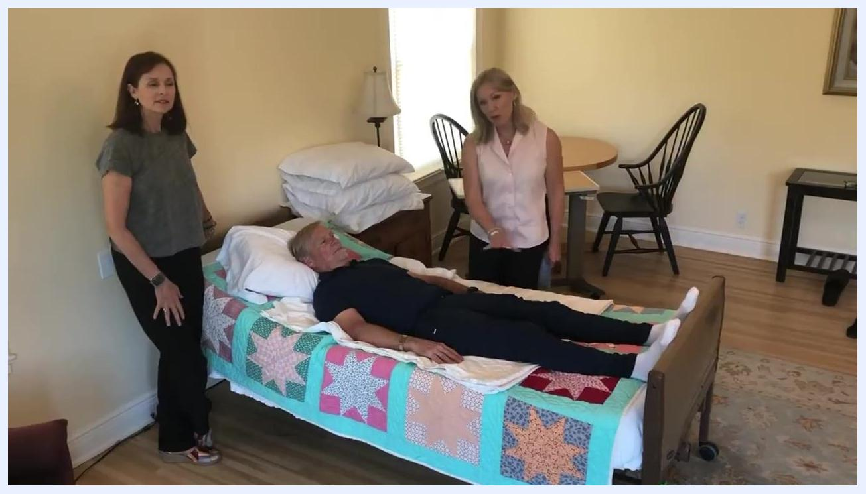
A patient lies in bed with two caregivers standing nearby. The patient's feet are pressed against the footboard, and a draw sheet is visible under the patient. The room is tidy with minimal clutter, and extra pillows are stacked on a bedside table.
This assessment is limited to positioning and environmental safety. Vital sign monitoring frequency, a formal pain assessment tool, and neurovascular checks are not addressed in this source and should be documented separately according to standard patient monitoring policy.

Care protocol
Follow these phases in order to safely reposition the patient up in bed.

Phase 1: Bed adjustment

- Flatten the head of the bed using the bed controls so the patient is lying flat. This makes repositioning easier and safer.
- Unlock the bed wheels. The wheel locks are typically found on opposite corners of the bed (one at the head, one at the foot). Flip the lock lever down to lock and up to unlock. Unlock both wheels to allow the bed to move.
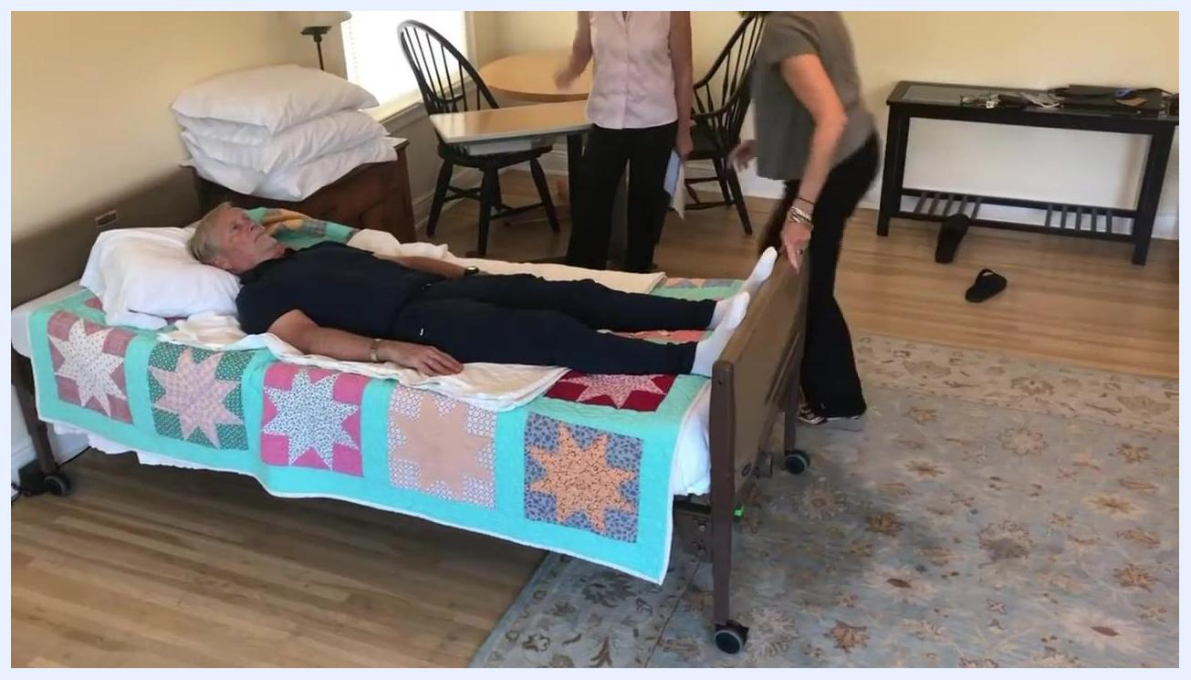
A caregiver stands at the foot of the bed preparing to unlock the bed wheels, while another caregiver stands at the head of the bed. The patient remains lying flat, and the room is organized with chairs and a table in the background.

- Carefully pull the bed away from the wall to create space for repositioning the patient.
- Lock the bed wheels again by flipping the levers down once the bed is in its new position. Double-check that the bed is stable and will not move during the maneuver.

Phase 2: Position the bed for gravity assistance

- Using the bed control, raise only the foot of the bed, leaving the head flat. This uses gravity to help move the patient up the bed, which is especially helpful when working alone.
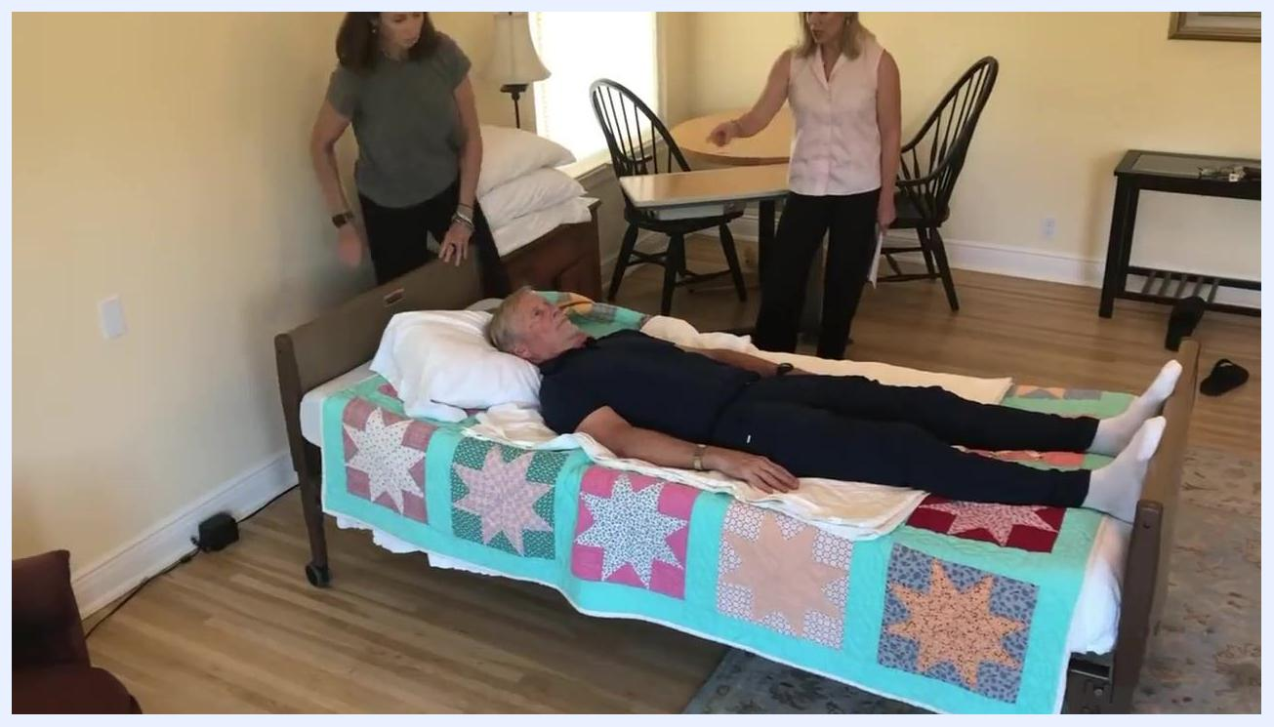
A caregiver uses the bed control to raise the foot of the bed while the patient remains lying flat. The head of the bed is not elevated, and the environment is clear and organized.

Phase 3: Prepare the pillow and draw sheet

- Pull the pillow up toward the head of the bed and straighten it so it will support the patient's head after repositioning.
- Confirm the draw sheet is flat and positioned under the patient's shoulders for a secure grip.
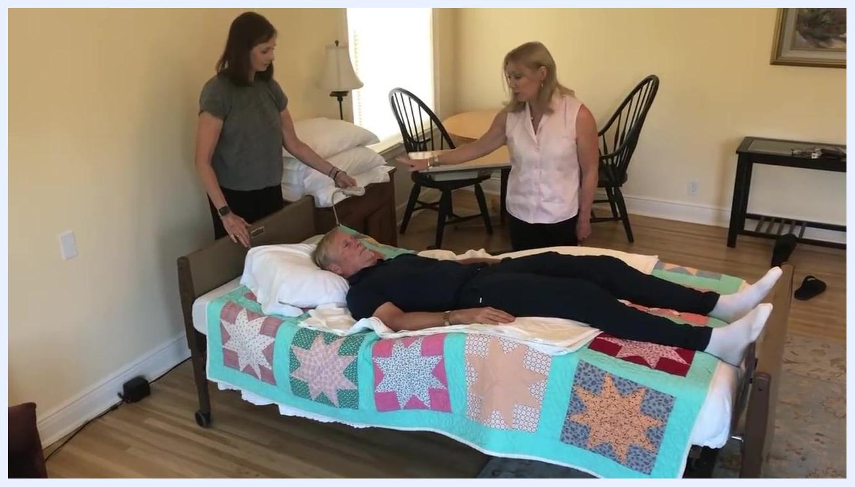
A caregiver at the head of the bed adjusts the pillow under the patient's head while a second caregiver observes nearby. The patient lies flat under a colorful quilt in a tidy room.

Phase 4: Position yourself and communicate

- Stand with your feet shoulder-width apart for good footing and balance.
- Grasp the draw sheet firmly at the patient's shoulders, keeping your hands close to the patient for better control.
- If the patient is able to assist, instruct them to bend their knees and push with their feet to help move up in bed.
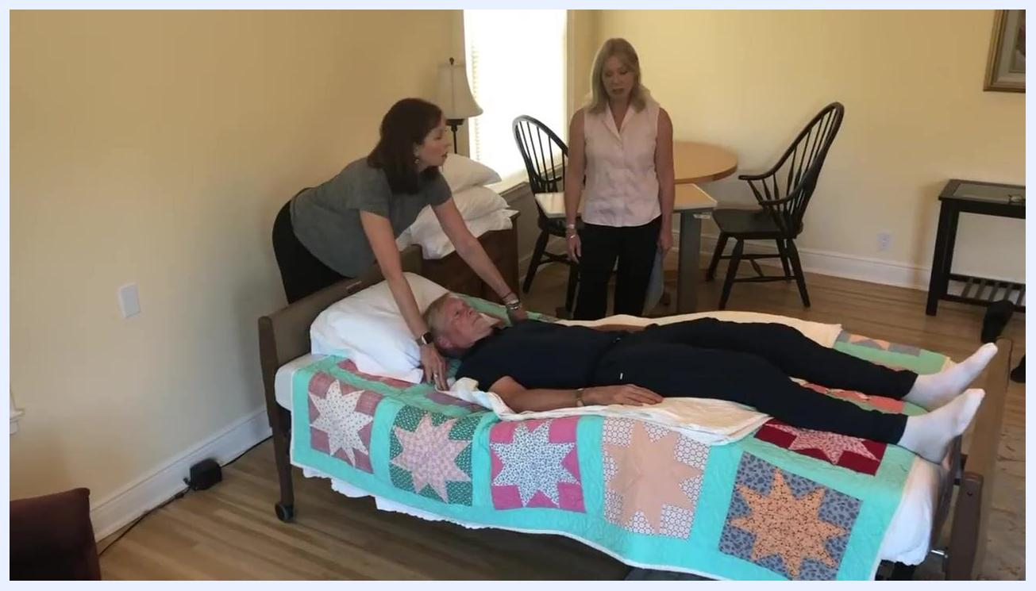
The caregiver at the head of the bed leans forward, grasping the draw sheet at the patient's shoulders in preparation for the move, while a second caregiver watches.

Phase 5: Inform the patient

- Always tell the patient what you are about to do to avoid startling them. For example, say, "I'm going to move you toward the head of the bed."
- Ensure the patient is ready and aware before proceeding.

Phase 6: Move the patient up in bed

- On the count of three, use the draw sheet to gently but firmly pull the patient up toward the head of the bed.
- Use your legs and core muscles to avoid straining your back.
- Ensure the patient's head and neck are supported by the pillow as you complete the move.
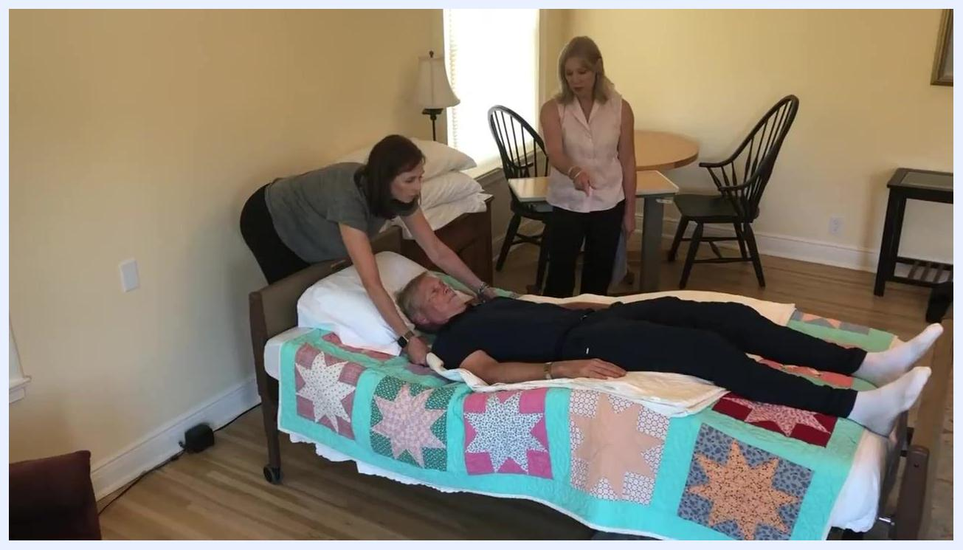
The caregiver pulls the draw sheet to move the patient up in bed while supporting the patient's head; a second caregiver observes.

Phase 7: Adjust the pillow and confirm position

- Once the patient is in the desired position, adjust the pillow to ensure their head and neck are well supported.
- Confirm the patient is lying comfortably and is not too high or too low in the bed.
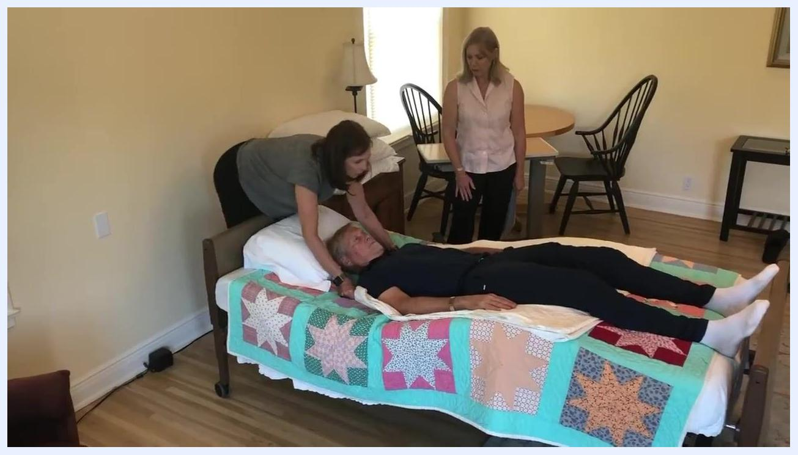
The caregiver adjusts the pillow under the patient's head after moving them up; the patient appears comfortable and is now higher in the bed.

Phase 8: Final comfort check and sliding prevention

- Double-check the patient's alignment and comfort. Smooth out the draw sheet and bedding to prevent wrinkles that could cause discomfort or pressure sores.
- Note that patients may gradually slide down again over time, so regular repositioning may be necessary.
The caregiver performs a final check, ensuring the patient is comfortable and the pillow is properly positioned, while a second caregiver observes.

- Use the bed controls to lower the legs partway, keeping the knees slightly elevated. This helps prevent the patient from sliding down when the head of the bed is raised. This technique is sometimes called "tacoing."
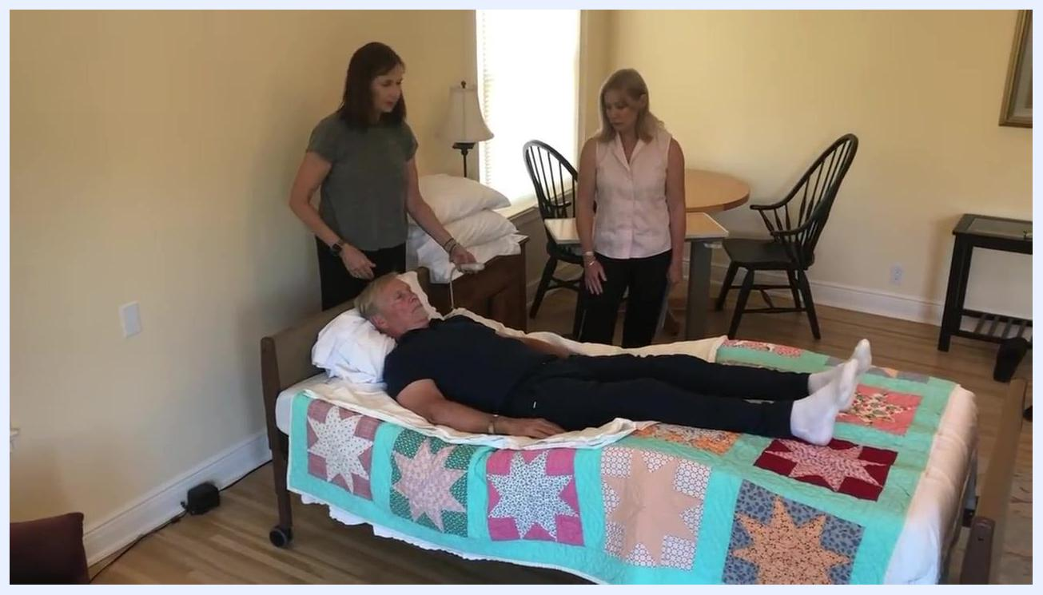
Both caregivers stand by the bed, one holding the bed control, with the patient now in a higher and more comfortable position and the bed slightly elevated at the knees.
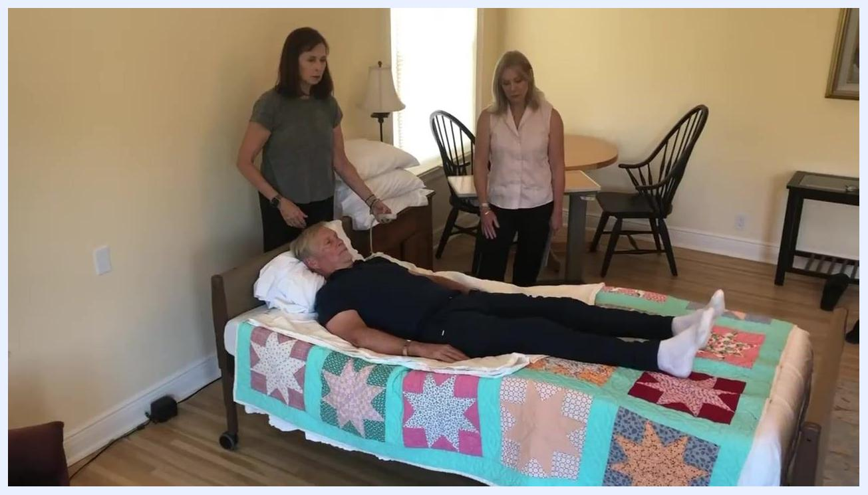
The caregiver confirms the bed is properly adjusted, with the patient's knees slightly elevated and the patient comfortably positioned.

- Keep the knees up just a little bit for optimal support and to minimize sliding.
- If working in a small space, ensure you have enough room to maneuver safely around the bed.

Phase 9: Return the bed to its original position

- Decide bed placement based on room size. In a large room, you may leave the bed pulled out from the wall by about 18 inches, allowing easier access to both sides of the bed for repositioning and care. If space is limited, move the head of the bed back against the wall.
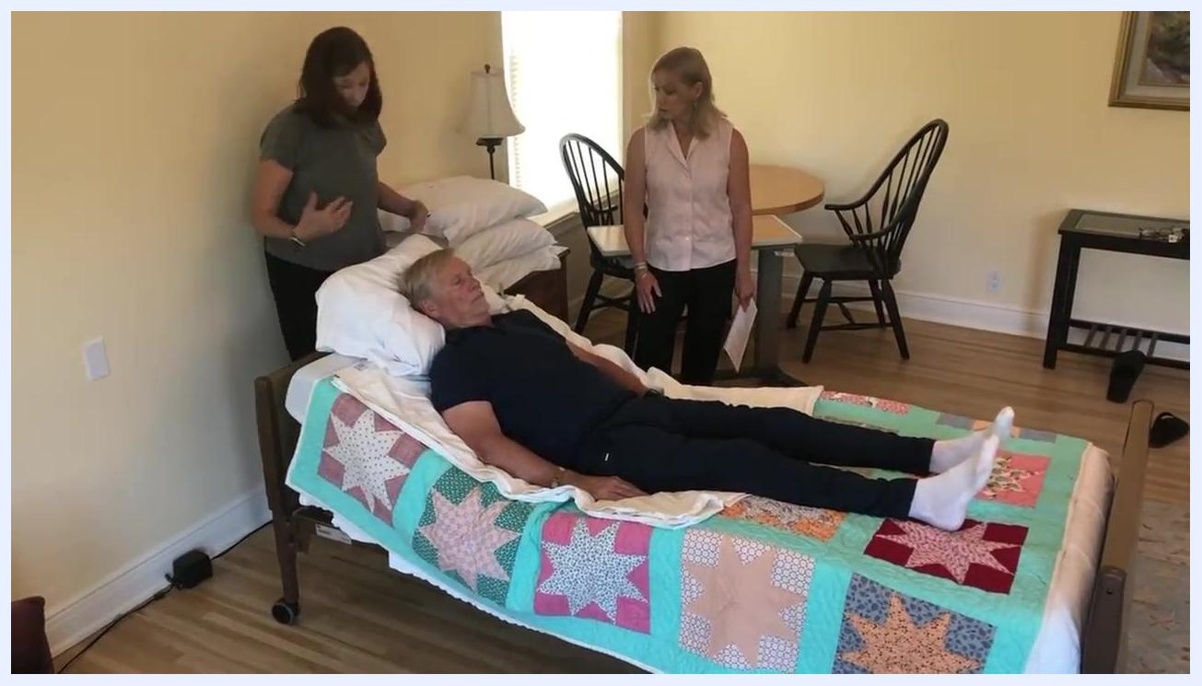
Two caregivers stand near the head and side of the bed with the patient lying comfortably. The room is spacious, with a table, chairs, and a lamp visible, and the bed is pulled out from the wall demonstrating the 18-inch gap.

- If needed, carefully roll or slide the bed back so the head of the bed is flush against the wall. Ensure there is still enough space on each side for safe patient care and movement, and confirm the bed is positioned straight and not at an angle.
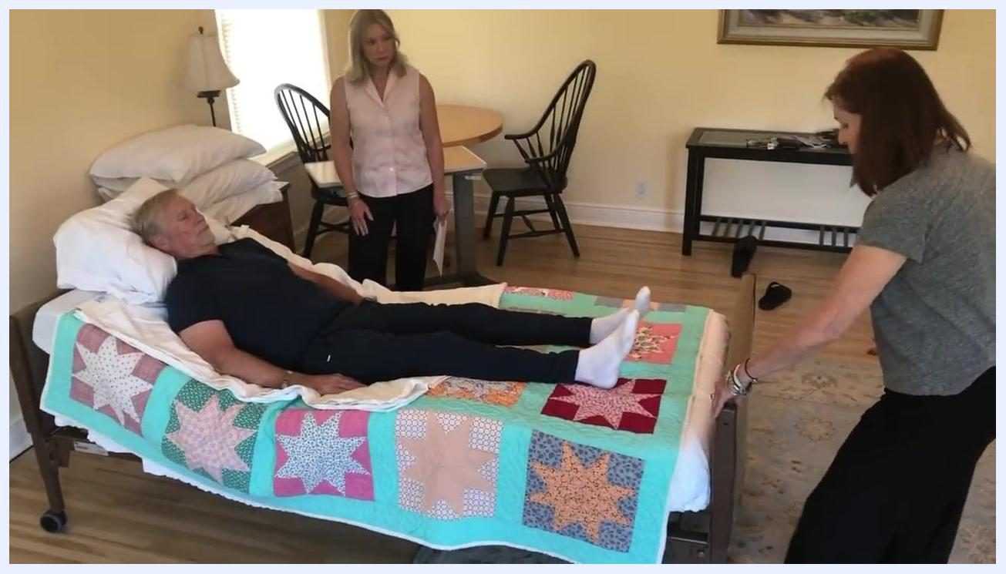
One caregiver moves the bed back toward the wall while the other observes; the patient remains in bed and the gap between the bed and the wall is visible.

- Once the bed is in the desired position, lock the bed wheels to prevent any movement. Double-check that all wheels are securely locked for patient safety.
- Confirm the patient is still comfortable and safely positioned, that pillows and bedding are properly arranged, and that the room is tidy with clear pathways and any necessary equipment within reach.
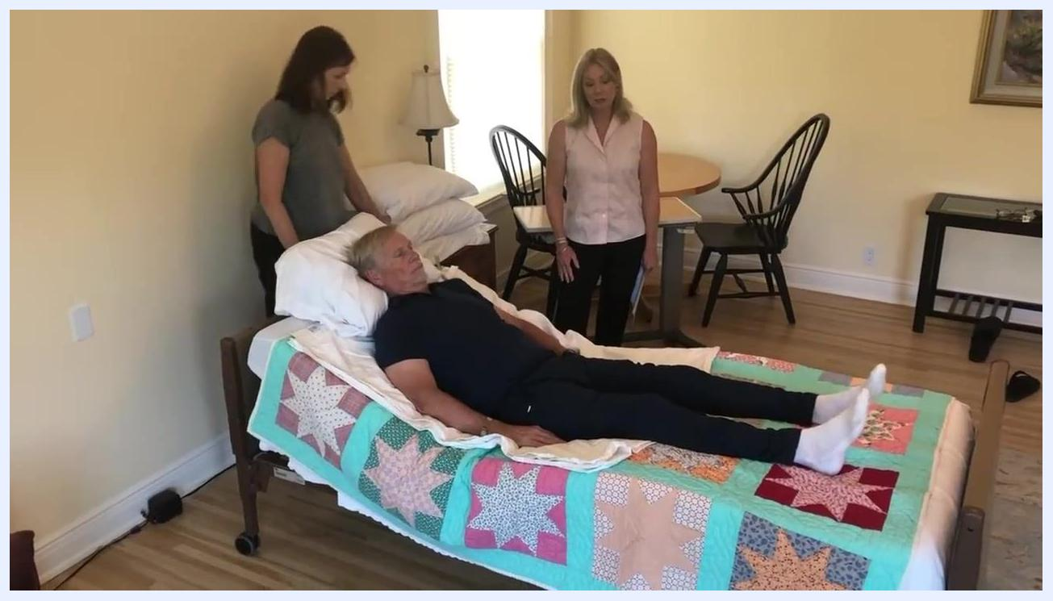
Both caregivers stand by the bed with the patient in a comfortable, elevated position. The room remains tidy and organized, with space around the bed for movement.

Pain management
This procedure does not include a medication protocol, dosing table, or pain score targets. A complete pain management section would normally specify multimodal medications (drug, dose, route, frequency), target pain scores, and an escalation pathway, but none of this information is covered by the source material.

Mobility milestones
Milestone | Detail from procedure
Repositioning frequency | Patients may gradually slide down again over time, so regular repositioning may be necessary
A full progressive mobility timeline (such as bed exercises, chair transfer, and ambulation with a walker across specific days) is not addressed in this source and should be defined separately based on the patient's broader care plan.

Complication monitoring
Monitor for the following signs during and after repositioning:
- Feet pressed against the foot of the bed and low hip position, which can cause discomfort and increase the risk of bed sores
- Wrinkled draw sheet or bedding, which could cause discomfort or pressure sores
- Gradual sliding down in bed over time, indicating the need for repositioning
Specific early warning criteria and escalation contacts for complications are not covered in this source and should follow your facility's or home care program's standard escalation protocol.

Discharge criteria
This procedure addresses in-bed repositioning only and does not include discharge criteria. Discharge readiness should be assessed separately according to the patient's overall care plan.

Patient education
Before and during the repositioning process, provide the following guidance to the patient:
- Always tell the patient what you are about to do before moving them, to avoid startling them (for example, "I'm going to move you toward the head of the bed").
- If the patient is able to assist, instruct them to bend their knees and push with their feet to help move up in bed.
- Maintain eye contact and clear communication throughout the move so the patient knows what to expect.
- Thank the patient and any assisting caregivers for their cooperation once the move is complete.
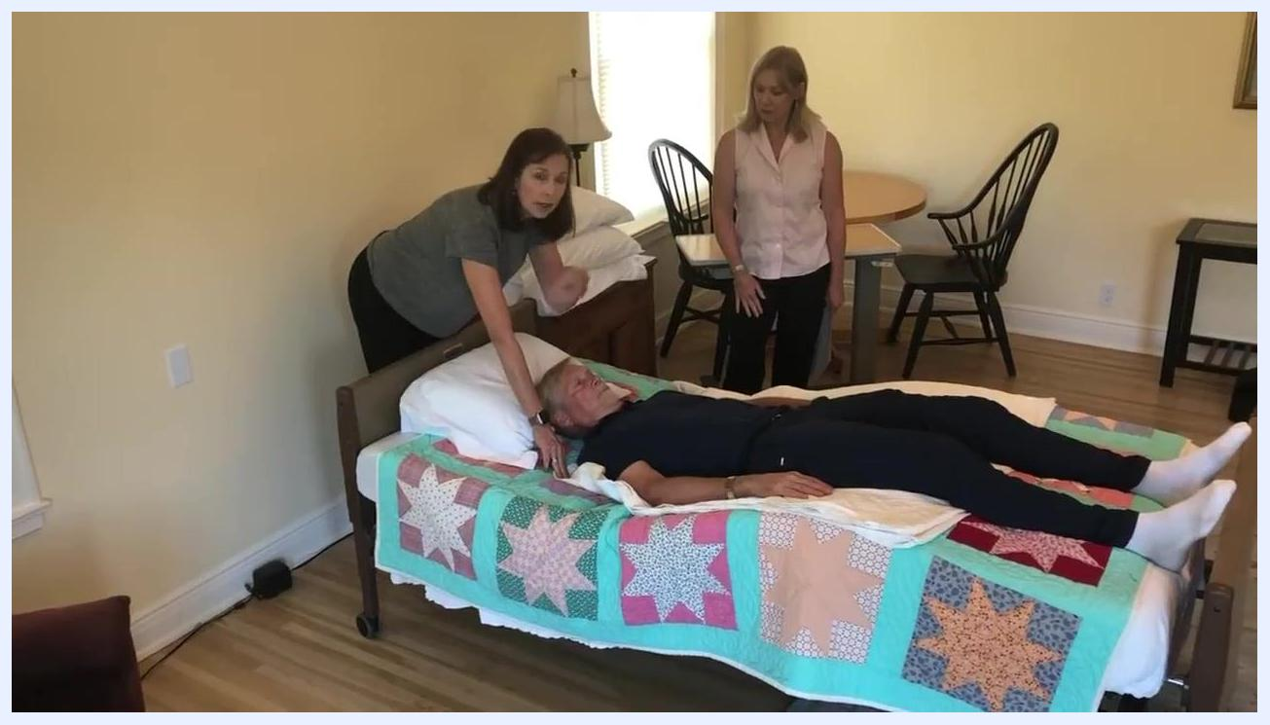
The caregiver speaks to the patient, maintaining eye contact and preparing to move them up in bed, while a second caregiver observes.

What's next
Continue to monitor the patient's position regularly, as patients may gradually slide down in bed over time and require repositioning again. Always confirm the bed wheels are locked after any adjustment, and maintain clear communication with the patient and any other caregivers throughout ongoing care.
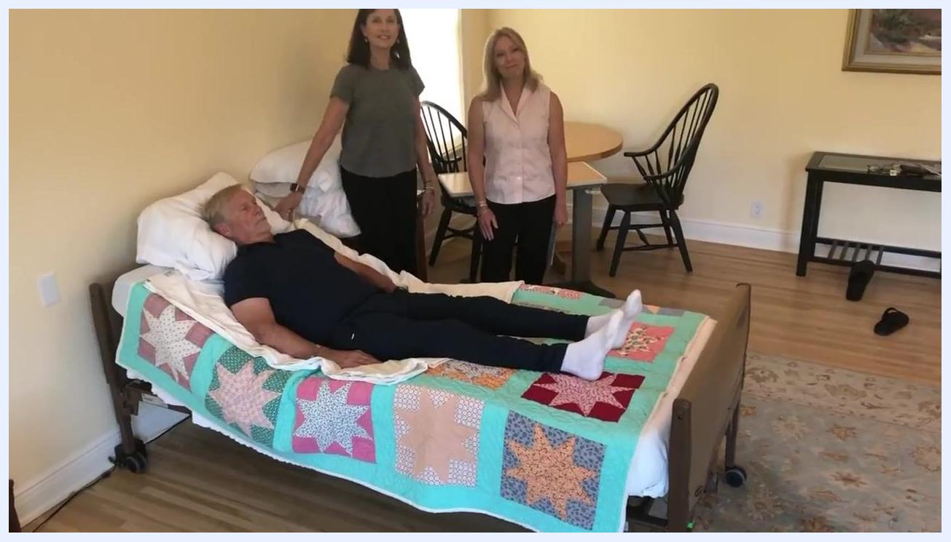
Both caregivers stand at the head and side of the bed, smiling, with the patient comfortably positioned. The bed is back in place and the room is organized and ready for ongoing care.

