How to Put on PPE in Order: A Step-by-Step Donning and Doffing Guide
This guide explains how to put on PPE in order and how to remove it safely afterward. It covers the recommended sequence for donning a gown, face mask or N95 respirator, eye protection, and gloves, followed by the correct sequence for doffing each item without contaminating yourself or your surroundings. Because PPE protocols vary by facility and can change during a pandemic, always confirm the current sequence and PPE type required by your facility before beginning.
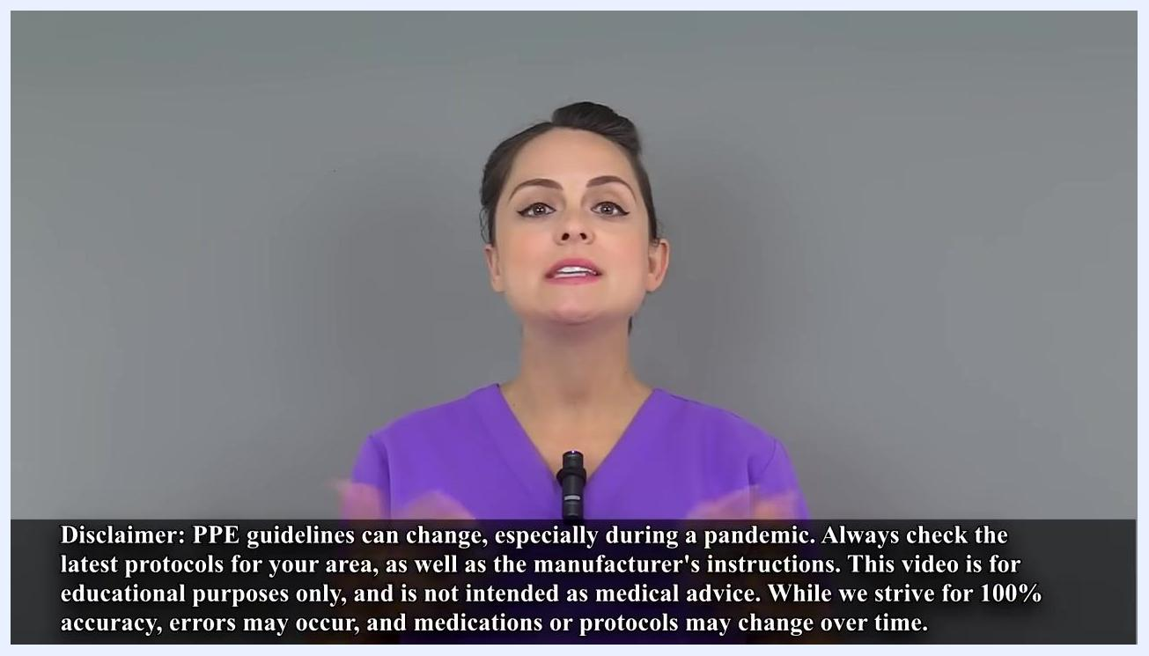
Presenter in purple scrubs, checklist on right: "When Using PPE: - Select the right PPE based on the infectious agent. - Make sure you've been properly fitted and sized for your PPE."

Purpose
The purpose of this procedure is to protect healthcare workers from exposure to infectious agents by ensuring that personal protective equipment is put on and taken off in a safe, consistent order. Following this sequence reduces the risk of self-contamination during patient care.

Scope
This procedure applies to any healthcare worker who needs to don and doff PPE before and after entering a patient care area where an infectious agent may be present. It covers gowns, face masks, N95 respirators, goggles or face shields, and gloves.

Prerequisites
Before donning PPE, confirm the following:
- You have selected the appropriate PPE based on the specific infectious agent your patient has.
- You have been properly fitted and sized for your PPE, including a fit test for any respirator.
- You are familiar with your hospital's current protocols and sequence for donning and doffing, since guidelines can change, especially during a pandemic.
- You have reviewed the manufacturer's instructions for each piece of equipment.
Presenter in purple scrubs, neutral background, text overlay: "Nurse Sarah, BSN, RN RegisteredNurseRN.com"
Note: There are multiple acceptable sequences for donning PPE. This guide demonstrates one recommended sequence, but you should always follow your facility's specific protocol.

Required equipment
- Isolation gown
- Face mask with ear loops, or N95 respirator
- Goggles or face shield
- Gloves
- Soap and water or alcohol-based hand sanitizer
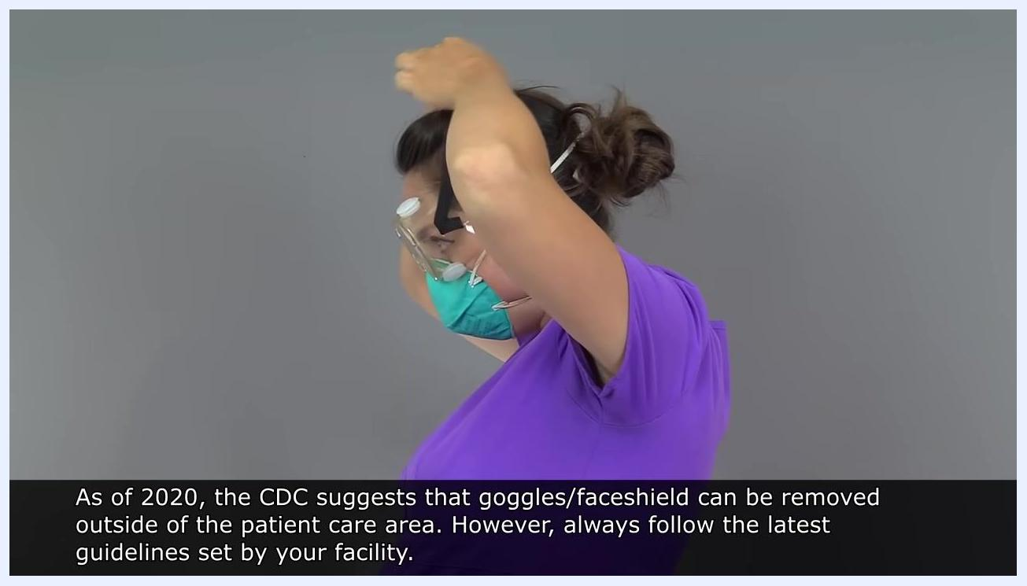
Close-up of hands being washed with soap under running water at a sink

Donning PPE

Step 1: Perform hand hygiene
Before touching any PPE, wash your hands thoroughly or use an alcohol-based hand sanitizer.

Step 2: Put on the gown
Slide the gown up both arms. If the gown has thumb inserts, place your thumbs through them. If it has a loop, place the loop over your head, then secure the gown by tying the ties in the back.
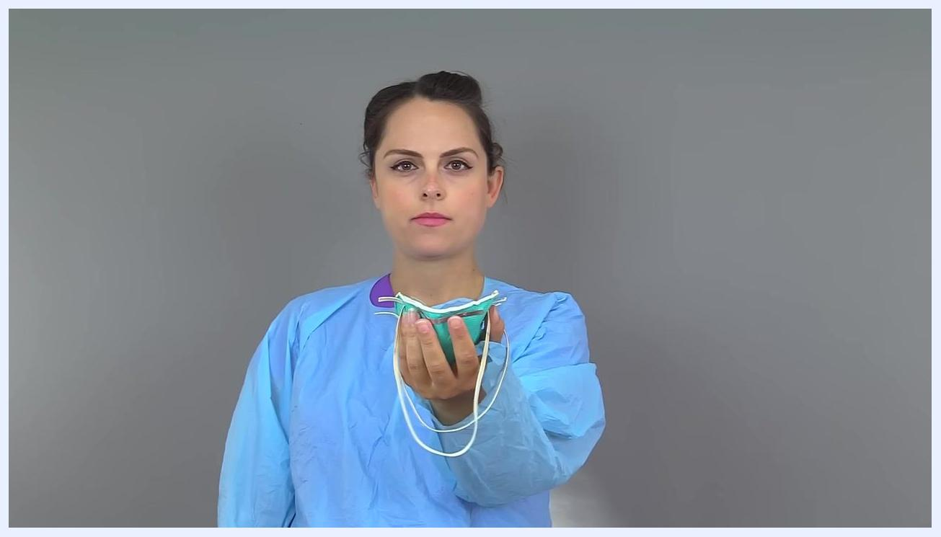
Nurse holding an N95 respirator in one hand, demonstrating correct grip for donning

Step 3: Don a face mask with ear loops
Hold the mask by the ear loops, place each loop over your ears, then grasp the nose piece and bring it to cover the bridge of your nose. Mold the nose piece with the fingertips of both hands, starting at the bridge and working outward toward the cheekbones. Pull the bottom of the mask under your chin.
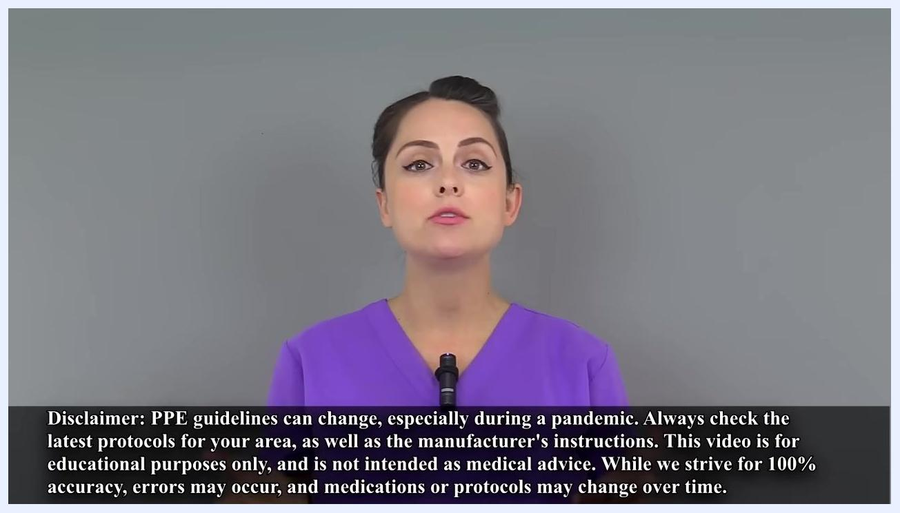
Nurse sliding her arms into a blue isolation gown while preparing to put on PPE
Nurse holding a face mask by its ear loops, ready to put it on
If you are using an N95 respirator instead of a face mask, continue with the detailed steps below.

Donning an N95 respirator step by step

Step 4: Prepare the respirator
Hold the respirator in one hand with the front touching the inside of your hand and the metal nose piece resting near your fingertips. Let the straps hang freely below your hand and check that the top and bottom straps are not tangled or twisted.
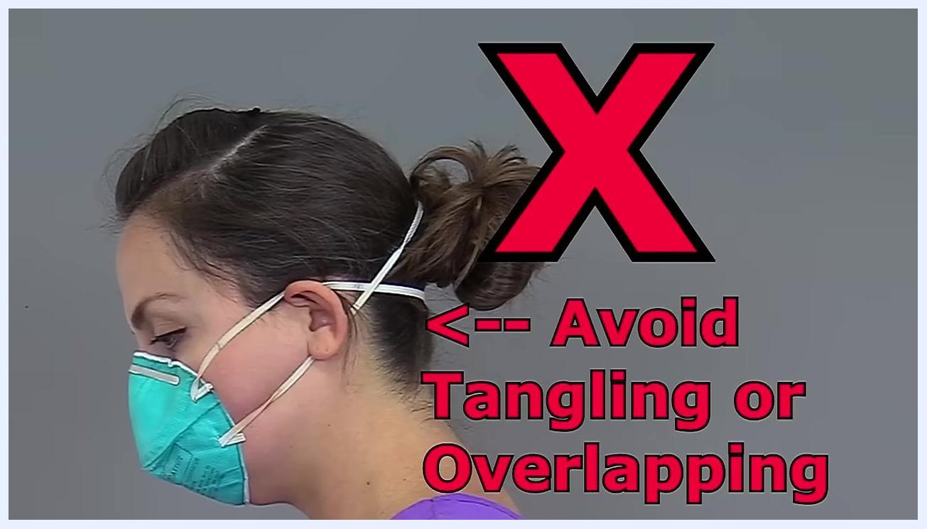
Nurse placing the bottom strap of an N95 respirator around the back of her head, with the straps separated

Step 5: Position the respirator on your face
Place the respirator over your nose and mouth and under your chin. Hold it in place with one hand while you secure the straps with your free hand.
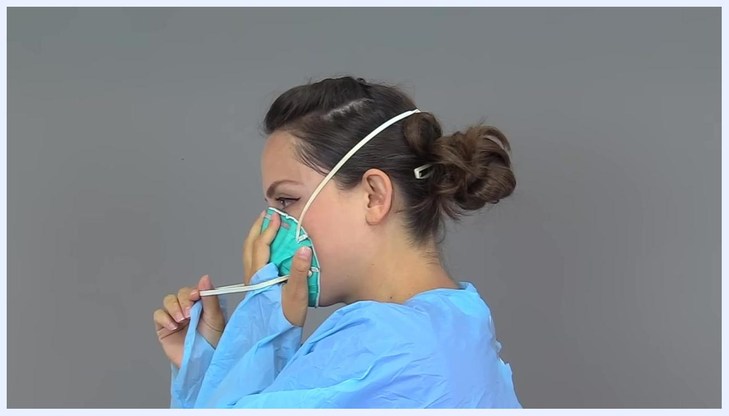
Nurse with both hands over an N95 respirator, performing the inhalation part of a seal check with eyes closed

Step 6: Secure the straps
With your free hand, take the top strap and place it just past the top of your head, above your ears, making sure it lies flat and is not twisted. Then take the bottom strap and position it around the back of your head, just below your ears.
Nurse holding an N95 respirator against her face while preparing to secure it
Safety note: Avoid letting the straps overlap or tangle, as this compromises the fit of the respirator.

Step 7: Mold the nose piece
Using the fingertips of both hands, bend the metal nose piece around your nose. Start at the center of the nose piece and work outward on each side to create a secure fit.
Side view showing straps of an N95 respirator incorrectly overlapped, marked with a red X and the warning "Avoid Tangling or Overlapping"

Step 8: Perform a seal check — inhale
Place both hands over the respirator, take a sharp breath in, and confirm that the respirator seals tightly against your face during inhalation.
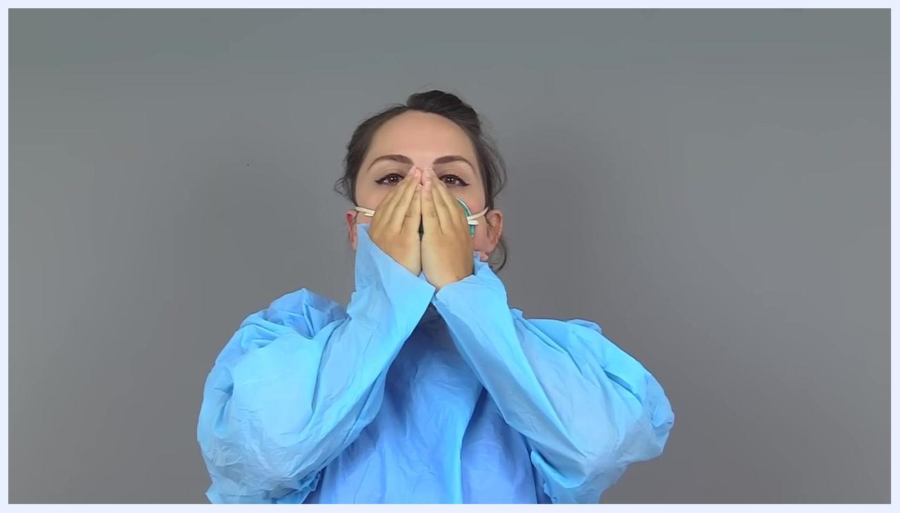
Nurse with both hands over an N95 respirator, performing the exhalation part of a seal check

Step 9: Perform a seal check — exhale
Keep both hands on the respirator and breathe out. Feel for any air leaking around the nose piece or the perimeter of the respirator.
Nurse using both hands to mold the nose piece of an N95 respirator for a secure fit

Step 10: Adjust the fit if needed
If air leaks around the nose piece, re-bend the nose piece with both hands and repeat the seal check. If air leaks around the perimeter, adjust the straps and recheck, ensuring the fit is not affected by piercings, facial hair, or other obstructions.
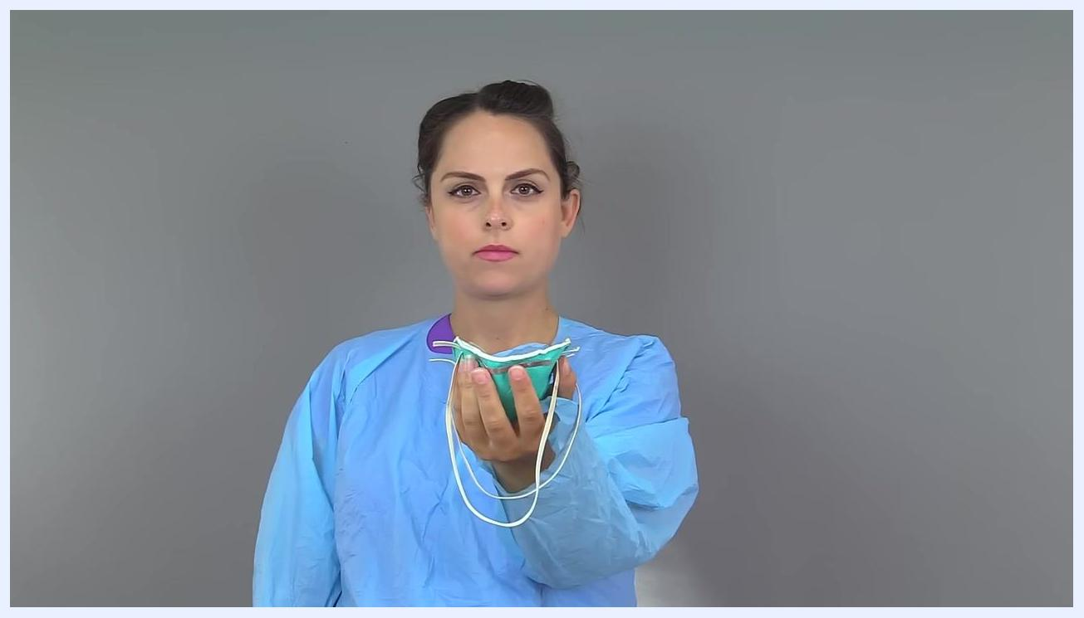
Nurse holding an N95 respirator in one hand, straps hanging freely, before putting it on
Safety note: If the respirator still leaks after adjustments, try a different size or type. Do not use the respirator unless a proper seal is achieved.
Nurse adjusting the fit of an N95 respirator by pressing around the edges with both hands

Completing the donning sequence

Step 11: Don eye protection
Place goggles over your eyes and secure the straps or bands around your head. Confirm that they fit snugly but comfortably over the respirator.
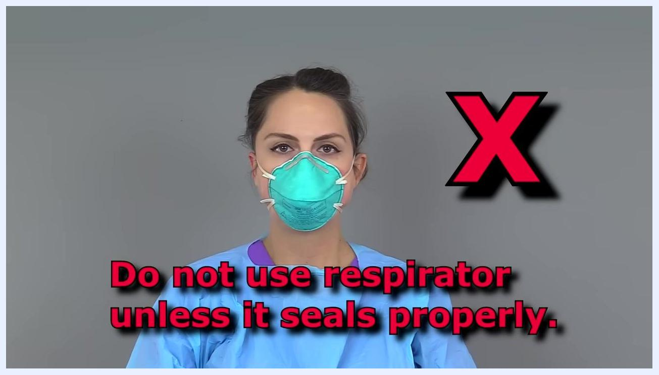
Nurse holding goggles in front of her face, preparing to put them on over her N95 respirator

Step 12: Perform hand hygiene
Wash your hands thoroughly with soap and water or use an alcohol-based hand sanitizer before putting on gloves.

Step 13: Don gloves
Pull each glove over your hand and extend the cuff of the gloves over the sleeves of your gown to ensure full coverage before entering the patient care area.
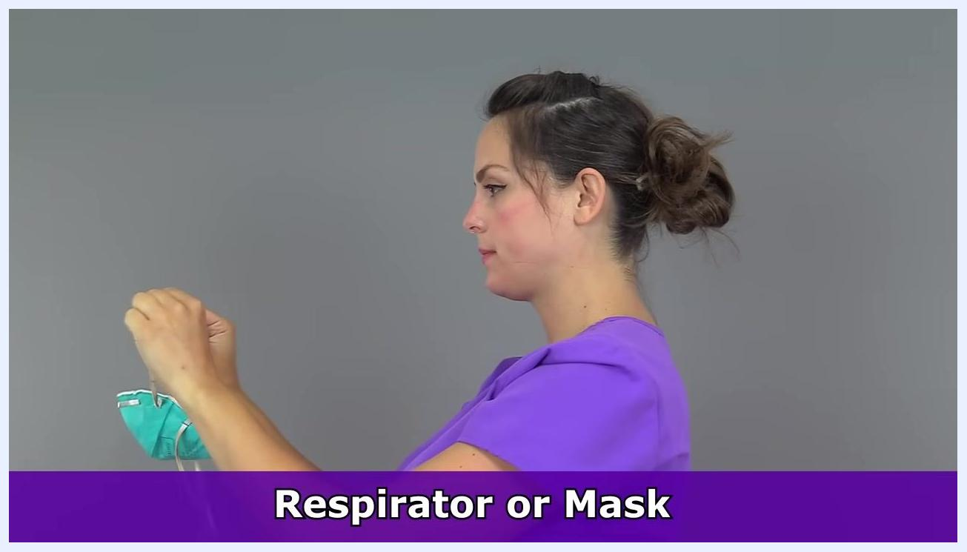
Close-up of hands being washed under running water with soap lather

Doffing (removing) PPE
Recommended removal order: gloves, gown, goggles or face shield, and finally the mask or respirator. The respirator is removed only after you have left the patient care area.
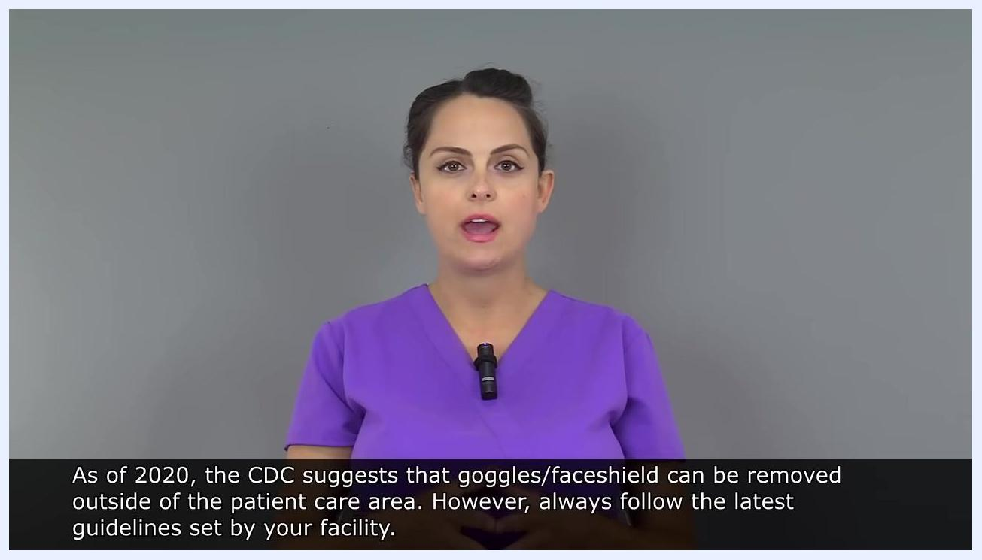
Side view of a person removing an N95 respirator by the straps

Step 14: Remove the first glove
Use your non-dominant gloved hand to pinch the outside of the other glove at the wrist. Peel the glove off, turning it inside out, and hold it in your gloved hand. Do not touch the outside of the gloves with your bare hands, as they are considered contaminated.
Close-up of gloved hands with one hand pinching the cuff of the other glove to begin removal

Step 15: Remove the second glove
Slide the index finger of your ungloved hand carefully under the cuff of the remaining glove and push forward, turning it inside out over the first glove.
Close-up of gloved hands marked with a red X and the warning "Do not touch outside of gloves with ungloved hands while removing"

Step 16: Complete glove removal and dispose
Continue pushing your index finger forward along the inside of the glove, peeling it off as it turns inside out. Avoid touching the outside surface of the glove with your bare skin, then dispose of both gloves in the appropriate waste container.
Close-up of gloved hands, large red X, and text: "Do not touch outside of gloves with ungloved hands while removing."
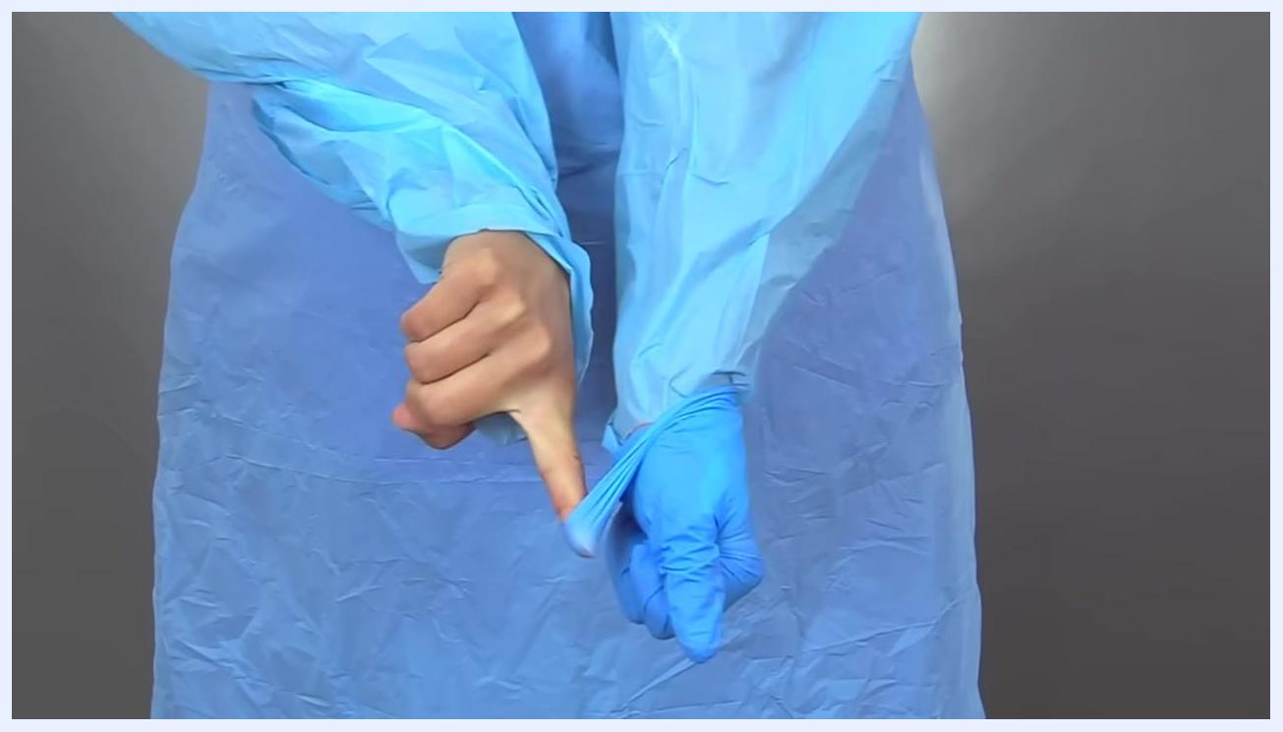
Close-up of bare index finger sliding under the cuff of a blue glove to complete removal
Safety note: Never touch the outside of the gloves with ungloved hands while removing them.

Step 17: Untie the gown
Avoid touching the front of the gown and sleeves, since these areas are considered contaminated. Carefully untie or break the ties at the back of the gown. The ties and the inside of the gown are considered clean.
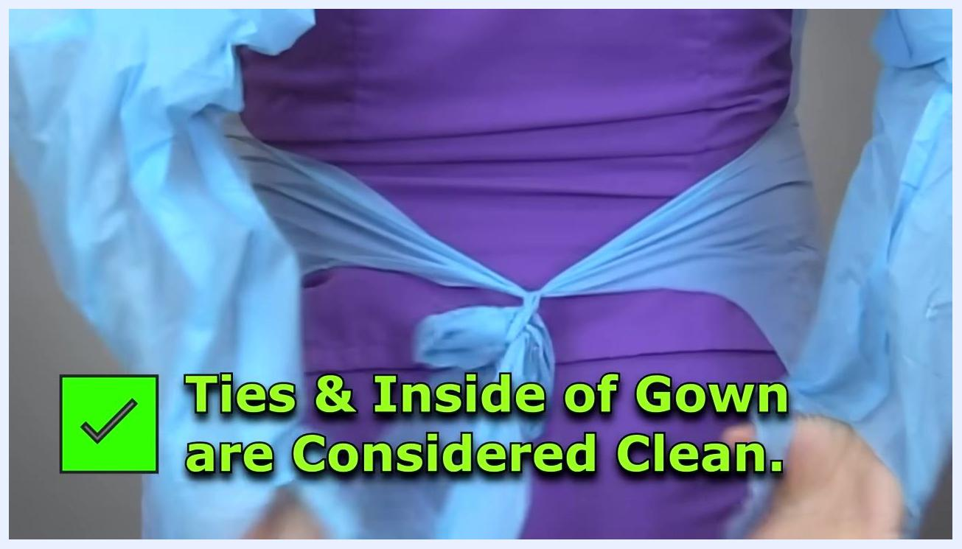
Person in a blue gown untying the back ties, with on-screen text confirming that the ties and inside of the gown are considered clean

Step 18: Remove the gown
Remove your thumbs from the thumb inserts if present, then move your shoulders and arms up and out through the gown to slide it off your body.
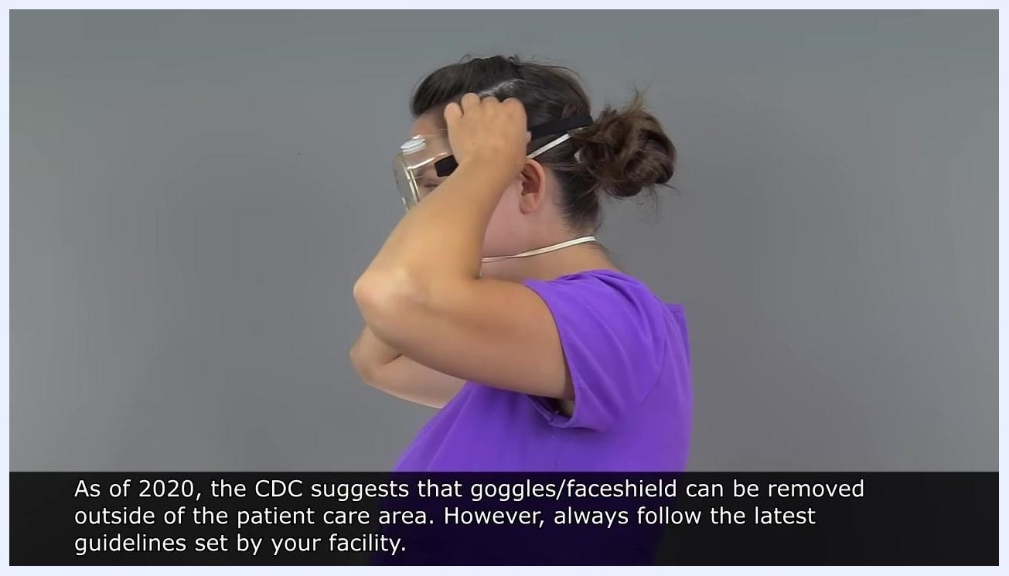
Person in purple scrubs, wearing a surgical mask. Large red X and text: "Avoid touching the front of mask after exposure."

Step 19: Remove goggles or face shield
Do not touch the outside of the goggles or face shield, since this surface is considered contaminated. Grasp and lift the back band carefully, avoiding contact with the front.
Person lifting goggles up and over the head to remove them
Lift the band over your head to remove the goggles, then dispose of or clean them according to your facility's protocol.
Safety note: As of 2020, the CDC suggests that goggles or a face shield can be removed outside of the patient care area. Always follow the latest guidelines set by your facility.
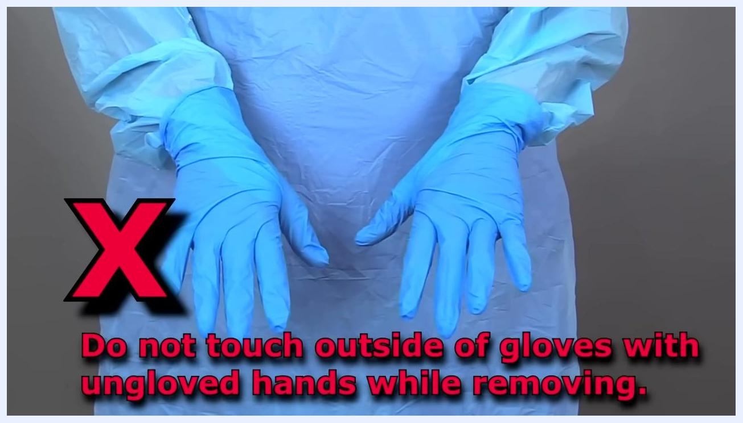
Close-up of one gloved and one ungloved hand, with the ungloved finger sliding under the cuff of the remaining glove

Step 20: Remove the mask
Grasp the ear loops of the mask with your fingertips and remove it, avoiding contact with the front. The front of the mask is considered contaminated after exposure.
Person in a blue gown with hands out and thumbs removed from the inserts, preparing to slide the arms out of the sleeves

Step 21: Perform hand hygiene
Wash your hands thoroughly with soap and water immediately after removing gloves, gown, goggles, and mask, and before touching your face or any clean surface.
Person removing goggles by grasping the back band

Step 22: Remove the respirator after leaving the patient care area
The front of the respirator is considered contaminated. Remove it by grasping the straps only, and avoid touching the front.
Person wearing a surgical mask, marked with a red X and the warning to avoid touching the front of the mask after exposure
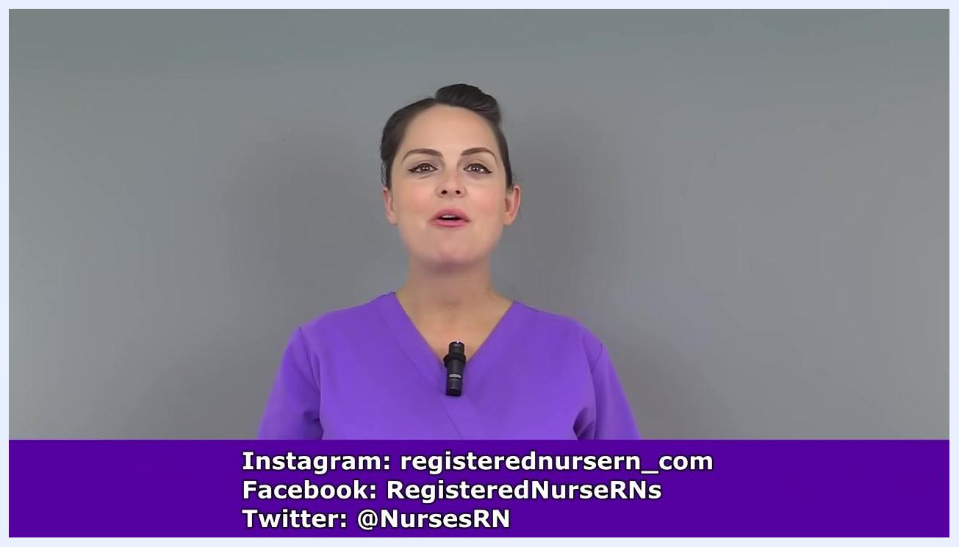
Person wearing a respirator with hands raised near the face, marked with a red X and the warning to avoid touching the front of the respirator after exposure

Verification and safety summary
Confirm the following before and after each PPE session:
- PPE was selected based on the specific infectious agent and you were properly fitted.
- The donning sequence followed hand hygiene, gown, mask or respirator, eye protection, hand hygiene, then gloves.
- A seal check was performed and passed before using an N95 respirator; the respirator was not used if it failed to seal.
- The doffing sequence followed gloves, gown, goggles or face shield, then mask or respirator (removed only after leaving the patient care area).
- Hand hygiene was performed immediately after removing gloves and again after removing all PPE.
- The outside of gloves, the front of the gown, and the front of the mask, respirator, goggles, or face shield were never touched with bare or ungloved hands.
Presenter in purple scrubs, disclaimer text at bottom: "Disclaimer: PPE guidelines can change, especially during a pandemic. Always check the latest protocols for your area, as well as the manufacturer's instructions. This video is for educational purposes only, and is not intended as medical advice. While we strive for 100% accuracy, errors may occur, and medications or protocols may change over time."
Nurse wearing an N95 respirator, marked with a red X and the warning "Do not use respirator unless it seals properly"

What's next
Always refer to your facility's current protocols and the latest CDC guidelines, since PPE requirements can change, especially during a pandemic. Confirm the manufacturer's instructions for any new PPE type before use, and repeat fit testing for respirators as required by your facility.
Person in purple scrubs, smiling, with social media handles displayed at the bottom of the screen.
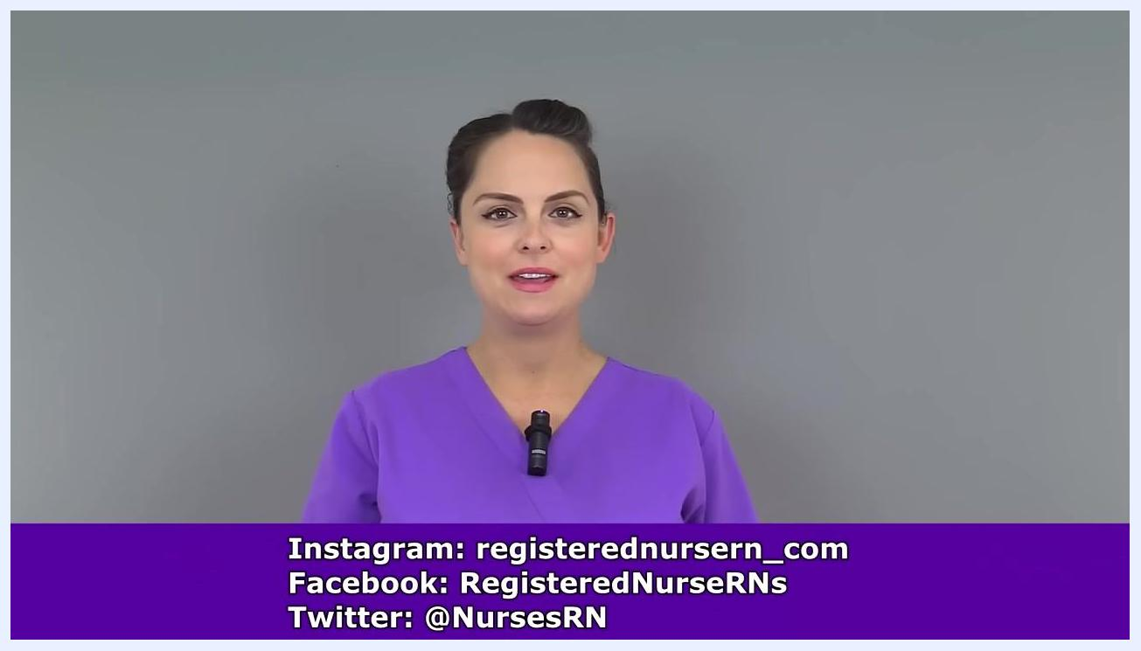
Presenter in purple scrubs, standing against a plain gray background, speaking to the camera. Social media handles for Instagram, Facebook, and Twitter are displayed in a purple banner at the bottom.

