How to Program an IV Pump: Alaris PC Setup and Infusion Guide
This guide walks you through how to program an IV pump using the Alaris PC unit and Alaris Pump modules (CareFusion), from priming the primary tubing through configuring and starting a primary infusion, then setting up and running a secondary (piggyback) medication infusion. Follow each step in order, and always confirm settings against the medication order before starting any infusion.

Disclaimer text: "This video is intended for educational purposes & should NOT be used to guide clinical practice or be taken as medical advice. Refer to your facility’s policies & procedures to ensure accurate & safe nursing technique. Be smart and nurse on."

 | Note: This guide describes a demonstrated setup and programming sequence. Always follow your facility's policies and procedures to ensure accurate and safe nursing technique; this content does not replace facility-specific clinical guidance.

Device Overview
Device: Alaris PC unit with Alaris Pump modules (CareFusion brand).
Intended use: The Alaris PC unit, paired with one or more Alaris Pump modules, is an infusion system used to program and deliver intravenous (IV) fluids and medications. It supports both primary continuous infusions and secondary (piggyback) intermittent medication infusions in a clinical setting.
Principle of operation: The primary IV tubing is primed and loaded into a pump channel. The operator enters infusion parameters — rate (mL/h) and volume to be infused (VTBI) — on the Alaris PC touchscreen and keypad. The pump then delivers fluid at the programmed rate until the set volume has infused. For secondary infusions, the system pauses the primary channel, calculates the rate automatically from the entered volume and duration, and prompts the operator to confirm the secondary clamp is open before starting.
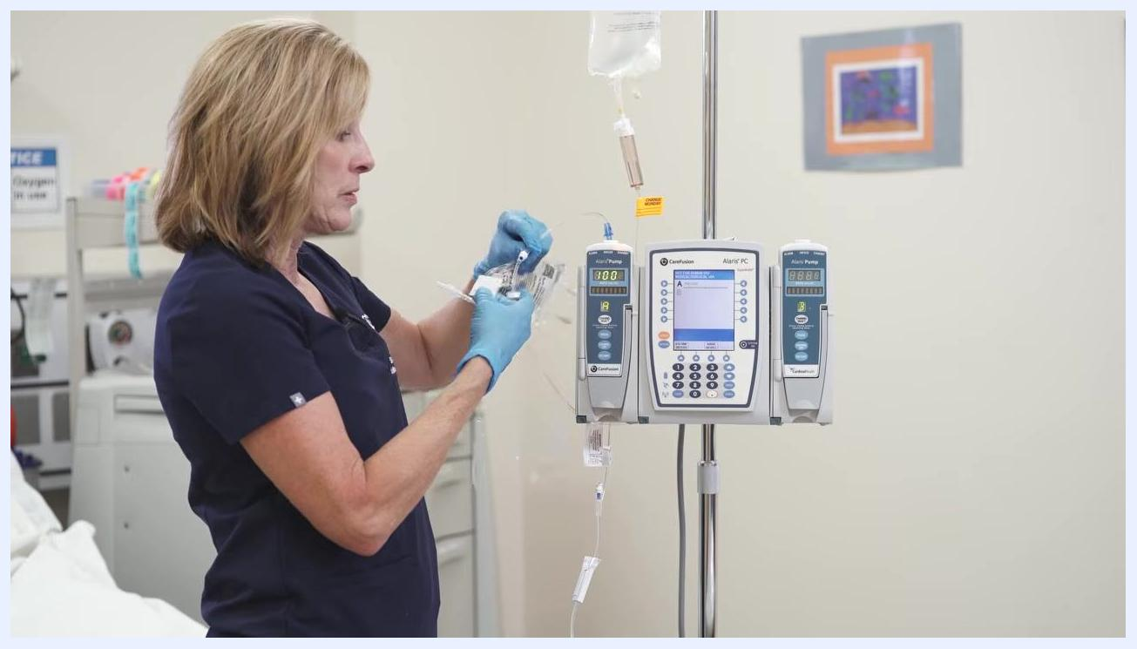
A gloved hand holds an alcohol swab, preparing to cleanse the secondary port above the pump.
Labeled diagram description: The Alaris PC unit and two Alaris Pump modules are mounted together on an IV pole. The Alaris PC unit has a central touchscreen display, a keypad for numeric entry, and a System On button in its lower right corner. Each pump module below it has a hinged door for loading tubing, a Channel Select button, and its own digital display showing the channel's rate and status (for example, "100" and "PAUSE").

Indications & Contraindications
Demonstrated indications: As shown, the Alaris system is used for:
- Primary continuous IV fluid infusion, programmed using the Basic Infusion mode
- Secondary (piggyback) intermittent medication infusion, such as an antibiotic (Cefazolin) infusion for a medical-surgical patient
The Infusion Menu also offers Guardrails Drugs and Guardrails IV Fluids modes as selectable infusion types, though the demonstrated setup uses Basic Infusion.
Contraindications: The source material does not specify absolute or relative contraindications for use of the Alaris system; consult the manufacturer's full labeling and your facility's clinical policies for contraindication and patient-safety information.

Setup & Installation

Gathering supplies
Collect all necessary supplies for priming and piggyback infusion before starting, including the Alaris primary IV tubing set and alcohol prep pads.
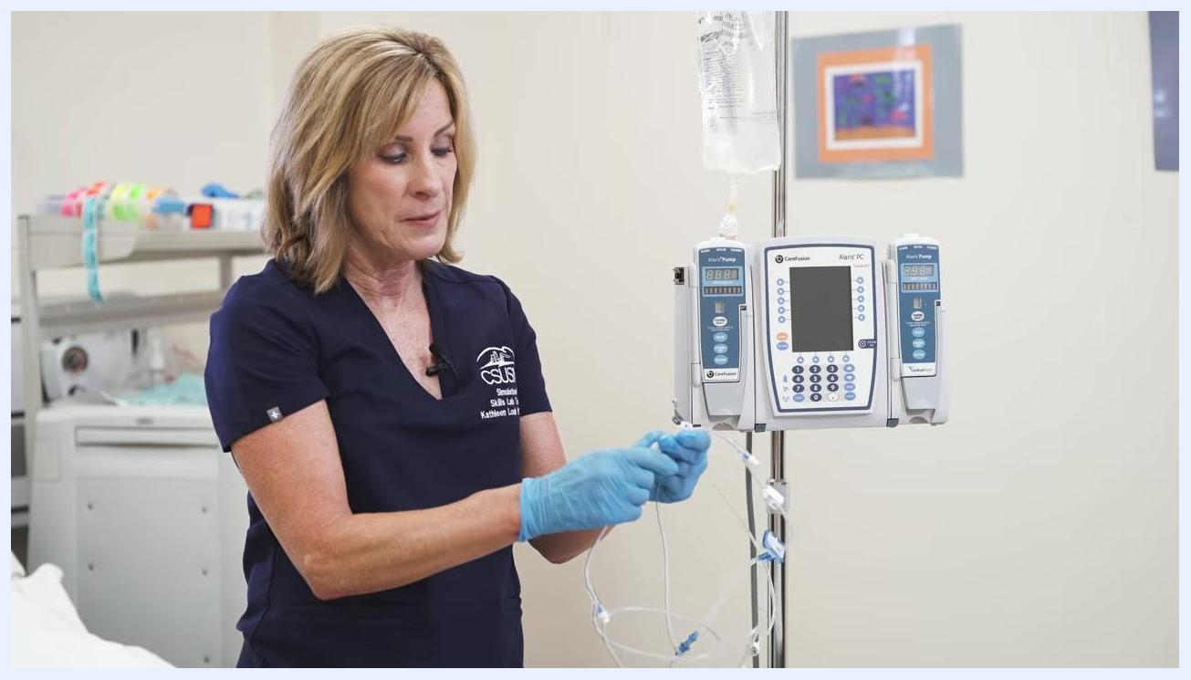
A gloved hand holds the IV bag and the sterile tubing spike, preparing to insert it into the bag.

Opening the primary tubing

- Remove the Alaris primary tubing from its packaging.
- Inspect the tubing — the roller clamp is open by default.
- Immediately close the roller clamp to prevent fluid from flowing prematurely.

A gloved hand holds Alaris primary IV tubing next to the mounted Alaris PC unit and pump modules.

Preparing and spiking the IV bag

- Hold the IV fluid bag securely and remove the protective tab from its entry port, maintaining sterility.
- Take the sterile spike from the IV tubing set and insert it into the bag's entry port using a twisting motion, keeping the spike and port sterile throughout.
A gloved hand squeezes the drip chamber attached to the IV bag, with the pump visible behind it.

Caution: Maintain sterility of all tubing ends and port openings throughout setup; avoid touching sterile surfaces.

Filling the drip chamber and priming the tubing

- Hang the spiked IV bag on the IV pole hook.
- Squeeze the drip chamber until it is approximately halfway full.
- Loosen the cap at the end of the IV tubing slightly to allow air to escape.
- Slowly open the roller clamp to let fluid flow through the tubing until all air bubbles are removed.
Individually wrapped alcohol prep pads laid out on a clean surface.

- Inspect the tubing carefully and continue running fluid through it until it is completely primed and free of air.
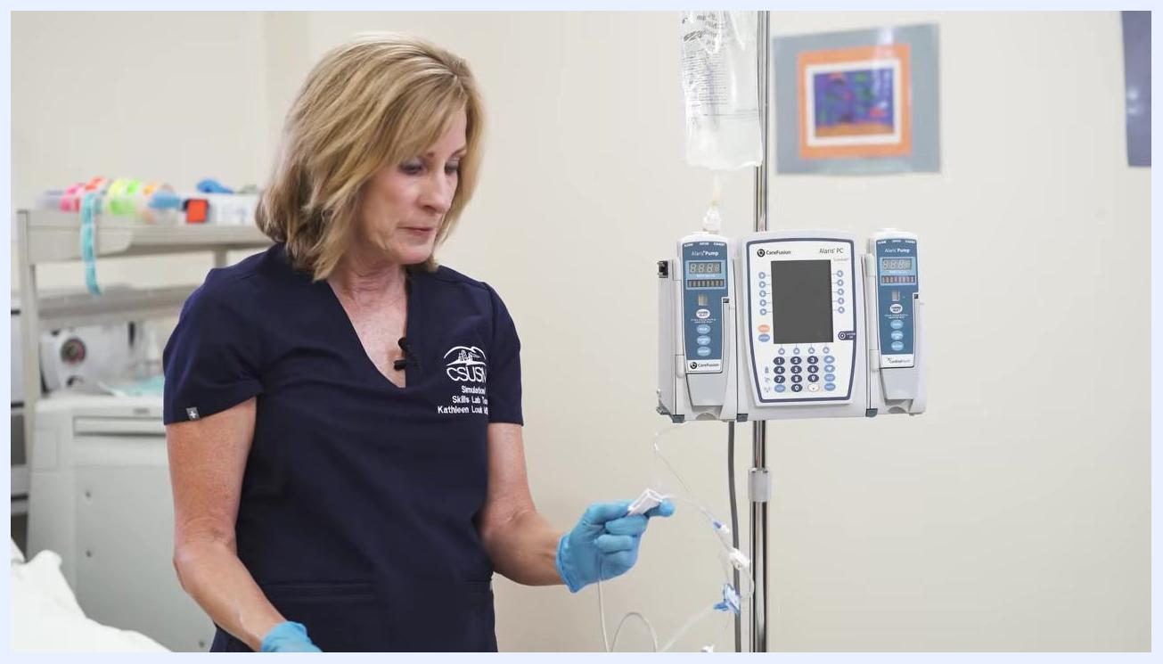
A close inspection of the primed IV tubing checking for remaining air bubbles.

Powering on the Alaris PC unit

- Locate the System On button in the lower right corner of the Alaris PC unit.
- Press System On to turn on the device.
- Wait for the system to boot up and display the initial prompts.

Loading tubing into the pump module

- Open the door of the selected pump module.
- Orient the primed tubing so the segment with the small edge is at the top and the blue filter sits below.
- Insert the tubing into the pump channel until it clicks securely into place.
- Gently close the pump door, ensuring the tubing is properly seated and the door is fully closed.
Pre-use check: Before proceeding to programming, confirm the tubing is fully primed and free of air, the door is securely closed, and clamps are in the correct position for the next step.
Power requirements: The source material does not specify the Alaris system's electrical input, voltage, or battery specifications; refer to the manufacturer's technical documentation for these details.
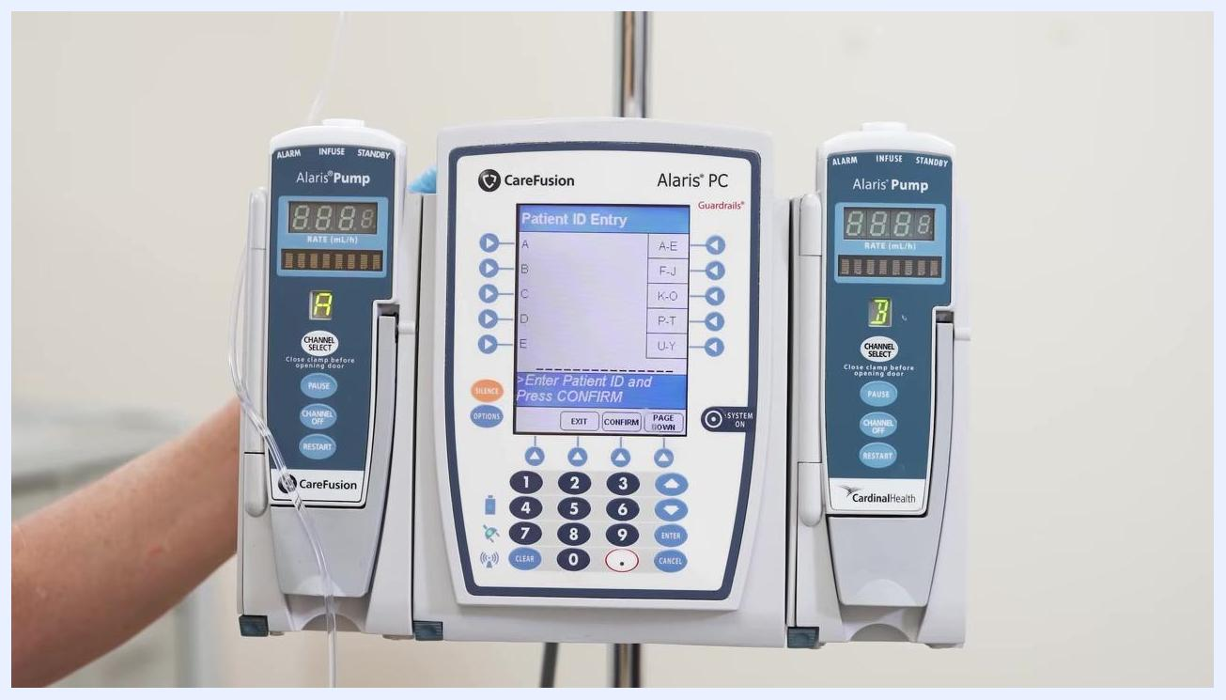
Gloved hands insert primed IV tubing into the open pump module channel.
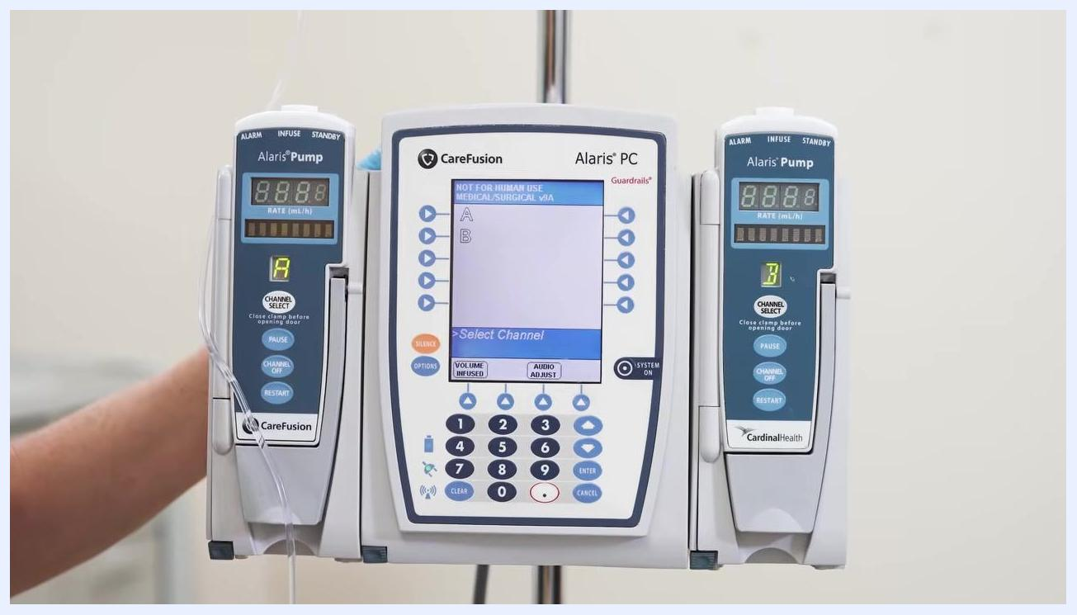
Gloved hands close the pump door after securing the tubing inside.

Programming & Operation

Starting a new patient profile

- When prompted NEW PATIENT?, select Yes to clear previous patient data using the arrow keys and confirm.
- When asked if this is a "med surge patient," select Yes using the arrow keys and confirm.
- When prompted for Patient ID Entry, use the keypad to enter the patient's ID number, then press CONFIRM at the bottom of the screen.
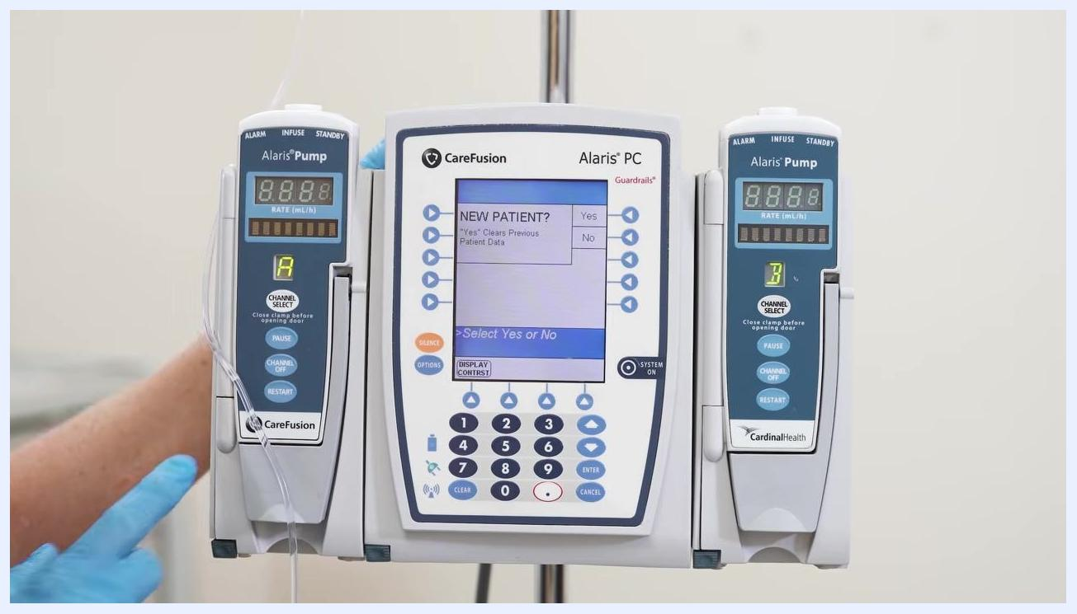
The Alaris PC screen shows the "NEW PATIENT? Yes/No" prompt, with a gloved hand nearby.
The Alaris PC screen displays the "Patient ID Entry" prompt with the keypad and CONFIRM button visible.

Selecting the channel

- The screen displays available channels (for example, A and B). Choose the channel you wish to use.
- Press the Channel Select button on the corresponding pump module.
The Alaris PC screen shows the "Select Channel" prompt, with both pump modules visible.

Selecting the infusion type

- On the Infusion Menu, three options appear: Guardrails Drugs, Guardrails IV Fluids, and Basic Infusion.
- Highlight Basic Infusion and press the corresponding button to select it.
- Confirm that Basic Infusion is selected before proceeding.
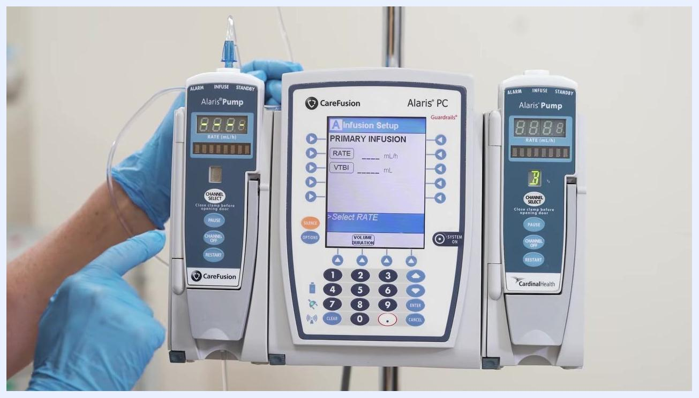
A gloved hand points to the "Basic Infusion" option on the Alaris PC Infusion Menu screen.
A gloved hand confirms the "Basic Infusion" selection on the Alaris PC screen.

Entering infusion parameters

- On the Infusion Setup screen, enter the RATE according to the physician's order (for example, 100 mL/h), then press Next.
- When prompted, enter the VTBI (Volume To Be Infused) to match the volume in the IV bag (for example, 900 mL) and confirm the entry.
- Verify that all IV line clamps are open to ensure proper flow.

Caution: Verify all clamps are open and confirm that the entered RATE and VTBI match the medication order before pressing START.
The Alaris PC "Infusion Setup" screen shows fields for RATE and VTBI, with a gloved hand ready to enter values.
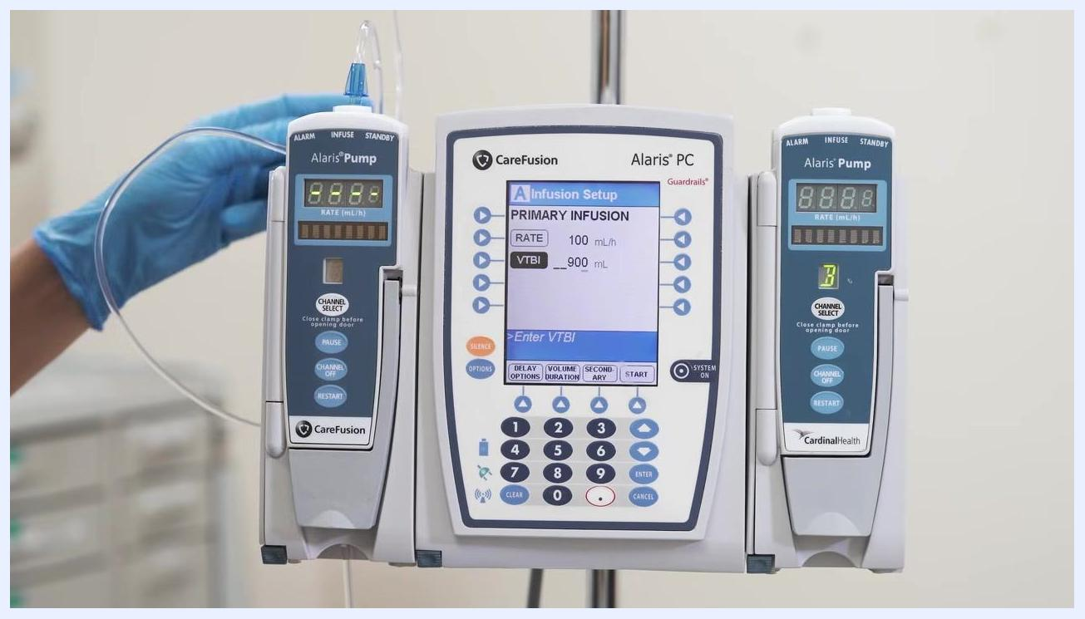
The Alaris PC screen shows RATE = 100 mL/h and VTBI = 900 mL being entered via the keypad.

Starting the primary infusion

- Press START at the bottom right of the main Alaris PC screen to begin the infusion. The IV solution begins infusing at the programmed rate and volume.
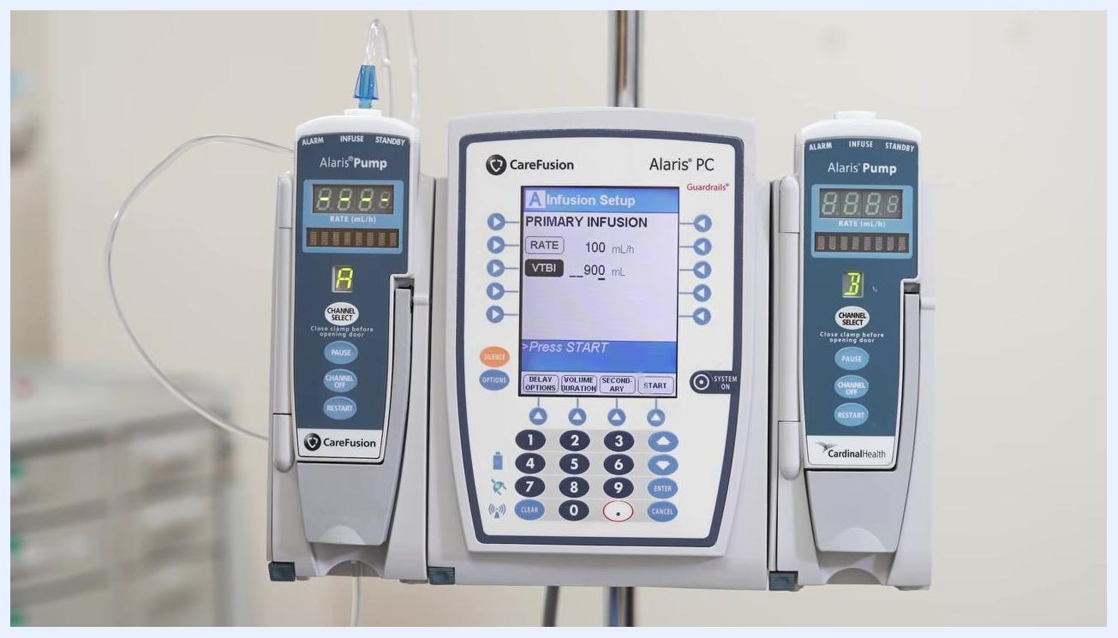
The Alaris PC screen displays the "Press START" prompt with RATE = 100 mL/h and VTBI = 900 mL set, and Channel A active.

Preparing the secondary (piggyback) medication

- Gather the secondary medication (for example, Cefazolin 2 grams) and secondary IV tubing.
- Open the secondary tubing packaging, maintaining sterility, and ensure its clamp is closed before proceeding.
- Hang the secondary medication bag on the IV pole above the primary infusion, and prime the secondary tubing, allowing fluid to flow through it until no air remains. Maintain sterility of both the medication port and the secondary tubing port throughout.
A gloved hand holds an IV fluid bag while removing the protective tab from the entry port.

- While connecting the secondary tubing, avoid touching the tubing ends or the medication port to maintain sterility.
- Select the appropriate port on the primary IV setup and connect the secondary tubing, ensuring all connections are secure and sterile.
- Identify the designated secondary medication port on the primary tubing, typically located above the primary drip chamber. Confirm the secondary bag hangs higher than the primary bag for proper flow, and keep the secondary tubing clamp closed until ready to infuse.
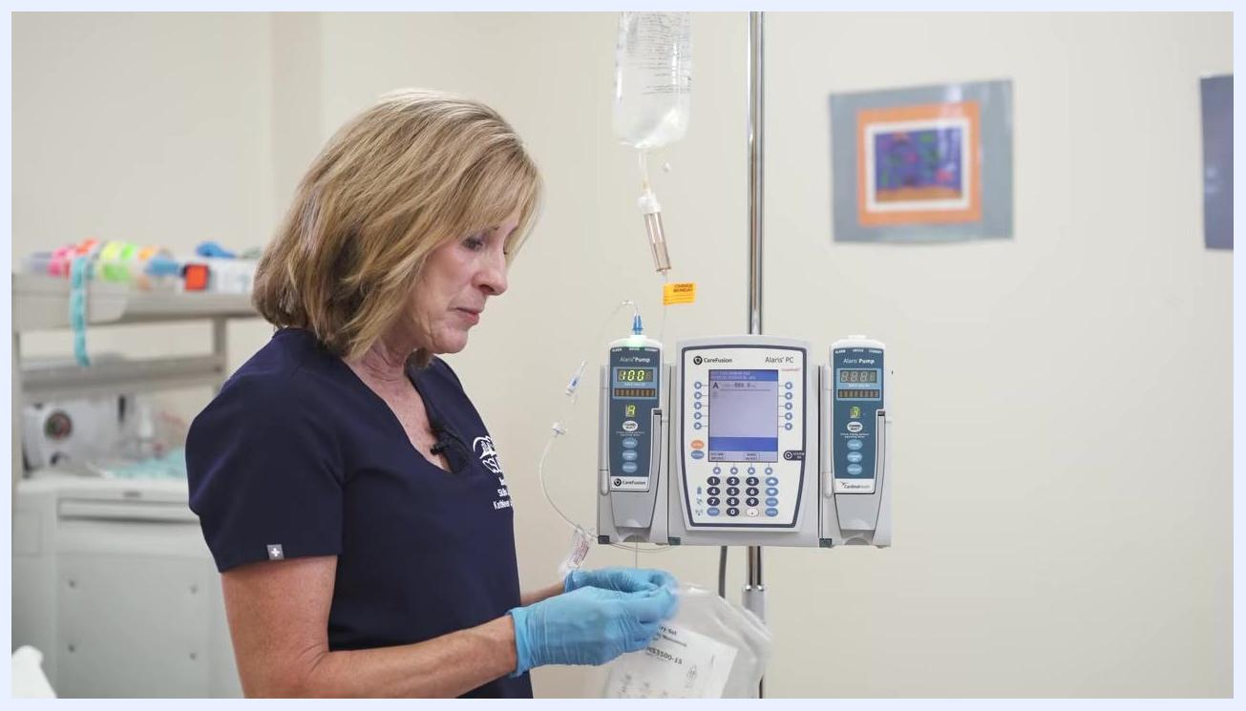
A gloved hand holds the secondary IV tubing package next to the Alaris setup.
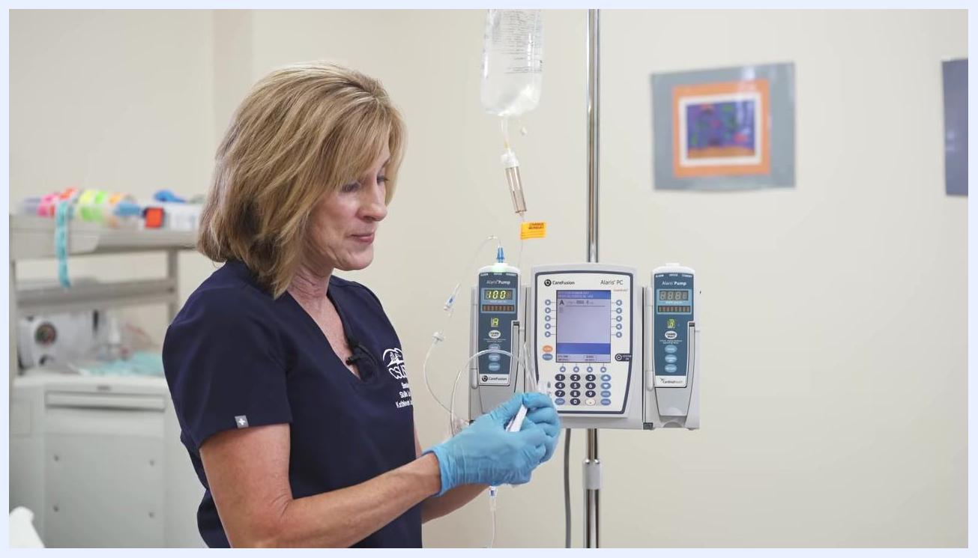
A gloved hand prepares to hang and prime the secondary tubing above the primary infusion setup.
A gloved hand holds the IV port and tubing near the top of the IV pole, demonstrating sterile technique.
A gloved hand connects the secondary tubing to the primary IV setup at the top of the IV pole.
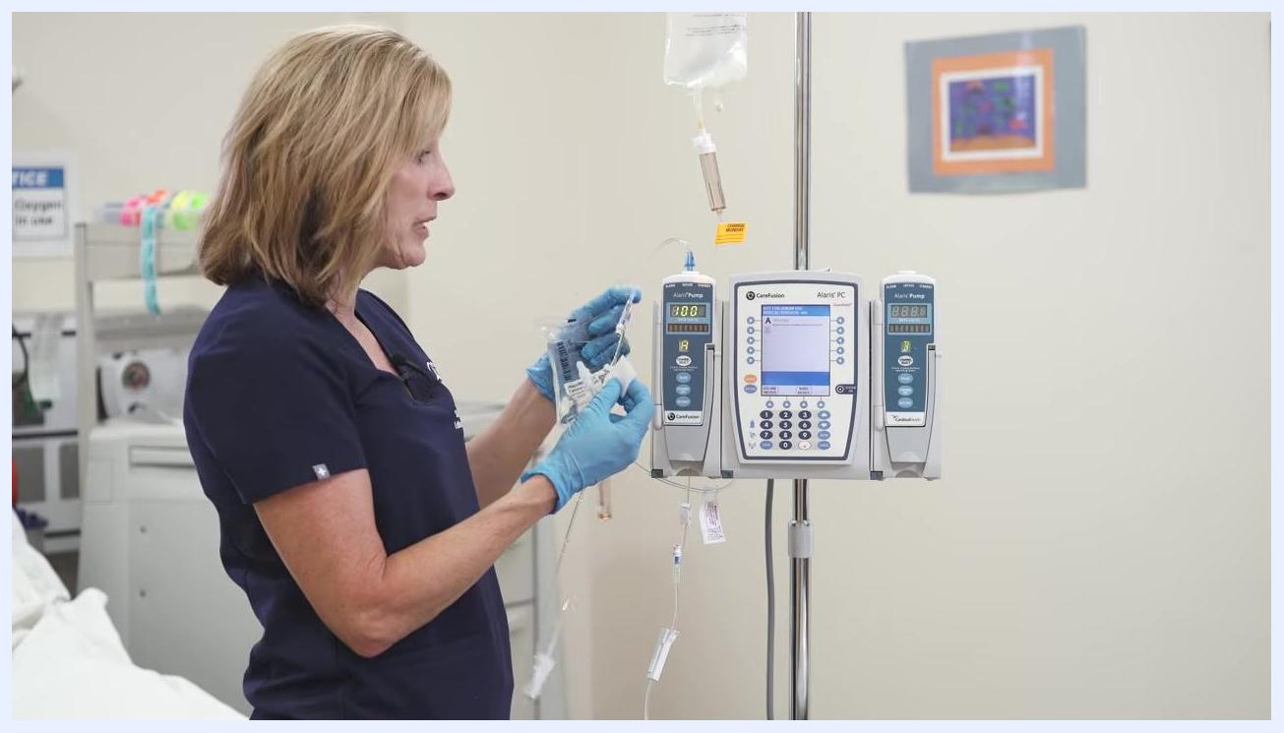
A gloved hand holds the end of the secondary IV tubing near the primary setup, preparing to connect it to the correct port.

Programming the secondary infusion

- Put on clean gloves, obtain a new alcohol swab, and cleanse the secondary port thoroughly.
- Pause the pump using the control panel, slowly open the clamp on the secondary tubing, and allow fluid to flow into the drip chamber until it is halfway full. Lower the primary bag to support proper gravity flow.
A gloved hand adjusts the roller clamp to let fluid flow through the tubing, with the IV bag hanging above the pump.

- Hang the secondary IV bag higher than the primary bag on the IV pole, and confirm both bags are securely attached with tubing free of kinks.
- Confirm the pump is paused (display reads PAUSED) and press Channel Select for the appropriate channel.
- On the pump's main screen menu, press SECONDARY to begin programming the secondary infusion.
- When prompted, select the correct drug concentration for the secondary medication (for example, 1,000 mg/50 mL or 2,000 mg/50 mL) as ordered.
- Review the confirmation screen (drug amount, diluent volume, dose, and concentration) and press NEXT to confirm.
- Enter the desired infusion rate or duration (for example, 30 minutes), and confirm VTBI (50 mL) and dose (2,000 mg).

Note: Always double-check medication orders, pump settings, and tubing connections before starting the infusion, following institutional protocols for medication administration and pump programming.
The secondary tubing drip chamber shown filled to the halfway mark, with the pump display visible.

- Review the automatically calculated RATE (based on VTBI and duration), and confirm all displayed values — RATE, VTBI, DURATION, DOSE, and concentration — match the medication order before proceeding.
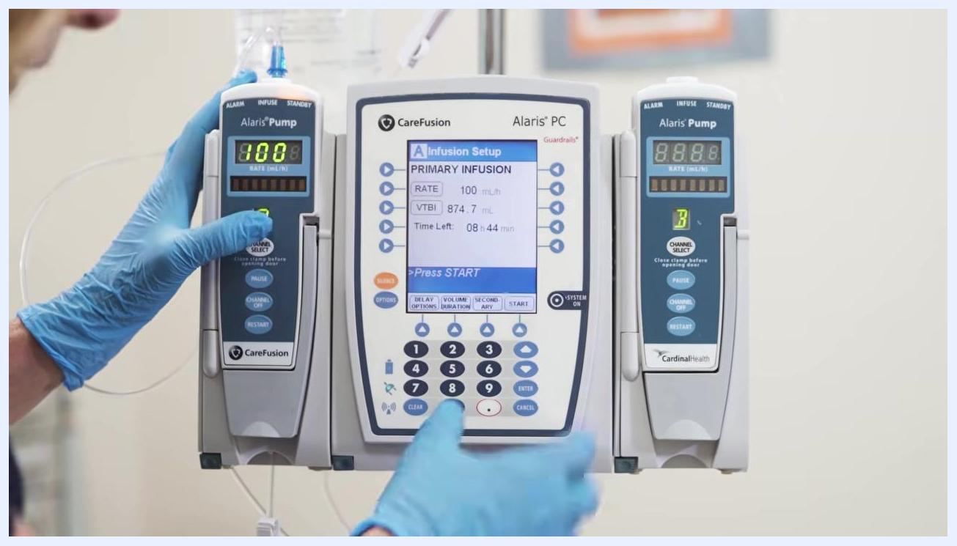
The secondary IV bag is raised above the primary bag on the IV pole for correct gravity infusion.
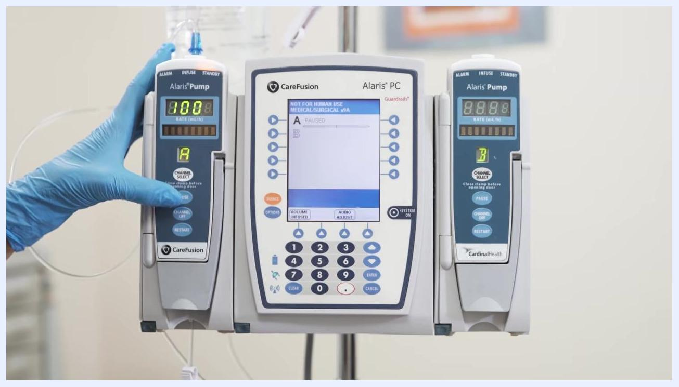
A gloved hand presses the "Channel Select" button while the pump display reads "PAUSED".
The Alaris PC screen shows the Infusion Setup menu with a gloved hand about to press the "SECONDARY" button.
The Alaris PC screen displays drug concentration options for Cefazolin, with a gloved hand navigating the menu.
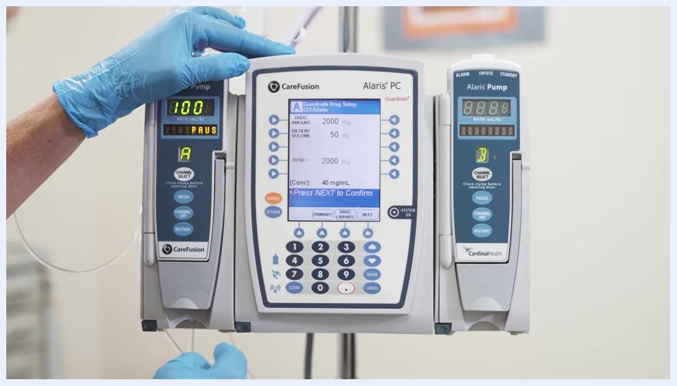
The confirmation screen shows Cefazolin 2,000 mg in 50 mL at a concentration of 40 mg/mL.
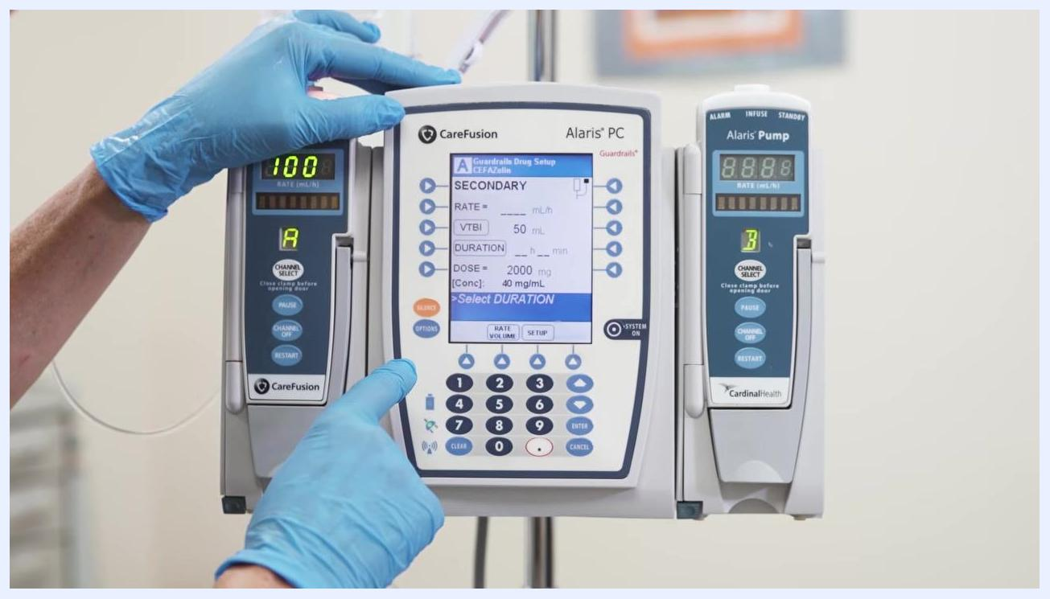
The secondary drug setup screen shows fields for rate, VTBI, duration, dose, and concentration, with a gloved hand entering the duration.

Starting the secondary infusion

- Verify the secondary clamp is open.
- Press START at the bottom right of the Alaris PC main panel. The screen prompts: "Verify Secondary Clamp Open, Then Press START." Confirm the pump transitions from PAUSE to active infusion.
Gloved hands hold the secondary IV bag and tubing near the paused pump, with fluid entering the drip chamber.

- Step back and visually confirm both the primary and secondary IV bags are properly hung and infusion is running; the pump display should show the active rate and no longer show PAUSE.
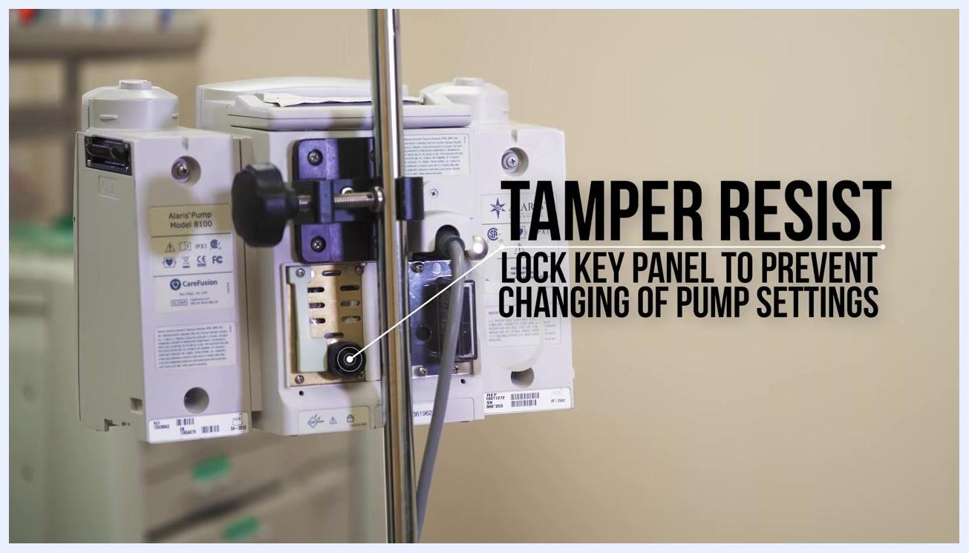
A gloved hand presses the START button while the screen prompts to verify the secondary clamp is open.
Both IV bags hang above the active Alaris pump, confirming the infusion is running.

Alarms & Alerts
The source material documents the following on-screen prompts observed during programming and operation:
Prompt/Status | Priority | Description | Probable cause | Corrective action
NEW PATIENT? Yes/No | Informational | System asks to confirm starting a new patient profile | Beginning a new infusion setup | Select Yes to clear previous patient data, or No as appropriate
PAUSED | Operational status | Pump channel is not actively infusing | Channel selected but infusion not yet started, or paused for secondary programming | Verify settings, then press START to begin or resume infusion
Verify Secondary Clamp Open, Then Press START | Informational | System prompts confirmation before starting the secondary infusion | Secondary infusion has been fully programmed | Confirm the secondary clamp is open, then press START
The Alaris PC unit and pump modules powering on, with the IV bag hanging above.
The source material does not document formal alarm codes, priority classifications (for example, high/medium/low), or fault conditions such as occlusion or air-in-line alarms; refer to the manufacturer's complete alarm reference for this information.

Cleaning & Maintenance
Port disinfection: Cleanse the secondary port thoroughly with a new alcohol swab before each connection, using clean gloves.
Tubing change interval: After hanging the tubing, attach a label indicating the next change date so future caregivers know when to replace it. Typical tubing change intervals are between 72 and 96 hours, but always follow your facility's policy.
Logo for "NURSEIT" with a subscribe prompt, indicating the end of the instructional video.
Securing pump settings: Locate the tamper-resistant lock on the back of the Alaris pump and lock the key panel to prevent unauthorized or accidental changes to pump settings. This is especially important in environments where pump security is a concern. The rear label identifies the device as "Alaris Pump Model 8100."
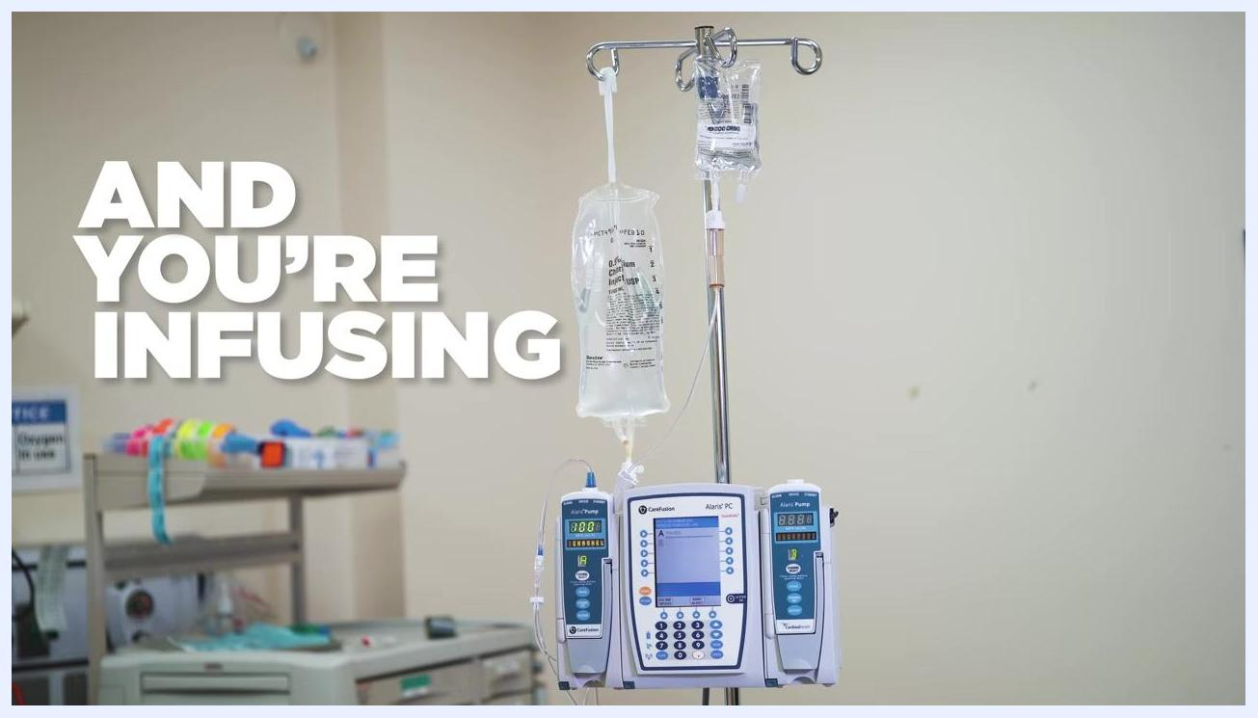
The Alaris PC and pump modules display the calculated secondary infusion parameters: RATE 100 mL/hr, VTBI 50 mL, DURATION 30 min, DOSE 2,000 mg.
Calibration requirements: The source material does not specify a calibration schedule or procedure; consult the manufacturer's service documentation for calibration requirements.
A yellow label reading "CHANGE MONDAY" is attached to the IV tubing.
The rear of the Alaris pump shows the tamper-resistant lock mechanism used to secure pump settings.

Troubleshooting
Symptom | Possible cause | Solution
Air bubbles remain visible in primary or secondary tubing after priming | Priming was stopped before all air cleared the line | Continue allowing fluid to flow through the tubing until it is completely free of air before loading it into the pump
Secondary infusion does not begin after pressing START | Secondary tubing clamp is closed | Verify the secondary clamp is open, then press START again
Fluid does not flow properly through secondary tubing | Secondary bag is not hung higher than the primary bag | Confirm the secondary bag is positioned higher than the primary bag on the IV pole
Front view of the Alaris PC unit and two Alaris Pump modules mounted together on an IV pole.
The source material does not cover error codes, occlusion alarms, or other fault-driven troubleshooting scenarios; consult the manufacturer's service manual for these situations.

Technical Specifications
Attribute | Value
Device model | Alaris Pump Model 8100 (per rear label)
Manufacturer | CareFusion
Configuration | Alaris PC unit with Alaris Pump modules mounted on an IV pole
Physical dimensions, electrical specifications, environmental operating requirements, and regulatory classifications are not covered in the source material; refer to the manufacturer's technical specification sheet for this information.

What's Next
Once the primary and secondary infusions are running, regularly check the infusion site, tubing, and pump for any alarms, occlusions, or issues, and document the start time, medication, dose, and any observations per your institution's policy. When the procedure is complete, dispose of all supplies properly and continue to monitor the patient as directed by your facility's protocol.

