Standard Operating Procedure: Proper Hand Washing Technique

Purpose
This procedure provides step-by-step instructions for performing proper hand hygiene. Correct hand washing technique is essential for preventing the transmission of infection, particularly in healthcare and clinical settings.

Scope
This procedure applies to any individual required to perform hand hygiene at a sink equipped with liquid soap, running water, and hand-drying materials, including personnel in clinical or healthcare environments.

Required equipment/PPE
- Sink with a functioning faucet and running water
- Liquid soap dispenser (pink soap)
- Hand hygiene instructional posters (for reference)
- Tissue paper dispenser
- Clean basin or sink area free of contamination

Procedure

Step 1: Start by washing hands
Approach a sink equipped with a faucet, liquid soap dispenser, and hand hygiene instructional posters. Turn on the water and wet your hands thoroughly under the running tap, ensuring water flows over all surfaces of your hands.
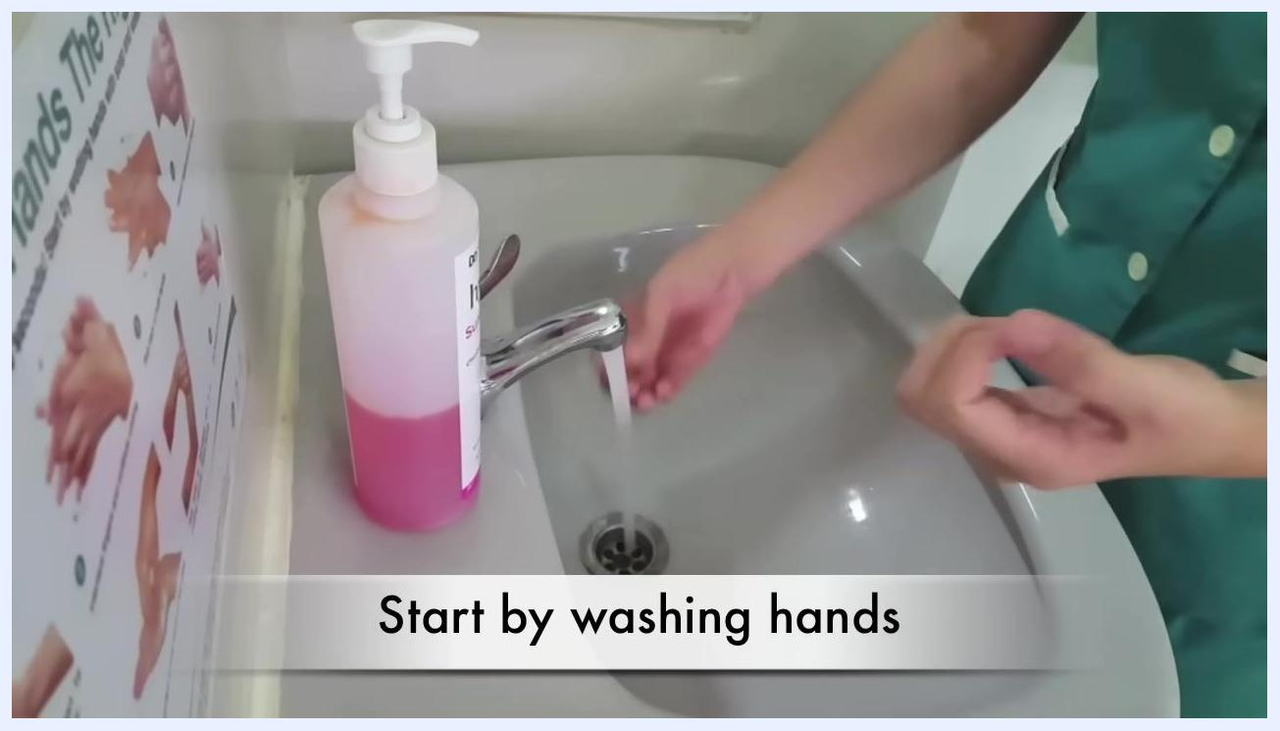
A person in a green uniform wets their hands under running water at a sink. A large bottle of pink liquid soap is on the left, and a handwashing instruction poster is visible on the wall. The caption reads "Start by washing hands."

Step 2: Apply soap
Dispense soap by pressing down on the pump of the liquid soap bottle and collect it in one palm. Use enough soap to cover all surfaces of both hands.
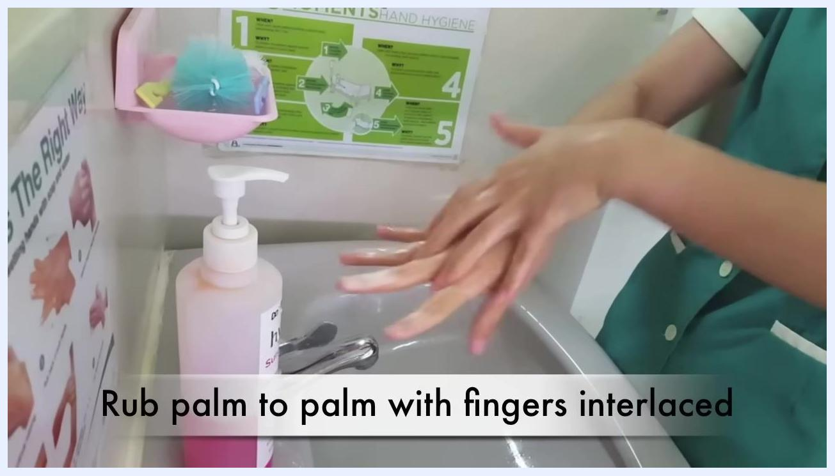
A person dispenses pink liquid soap from a pump bottle into their palm over a sink. The caption reads "with soap and water."

Step 3: Rub hands palm to palm
Rub your hands together palm to palm to create a lather, ensuring both palms are fully covered with soap.
A person rubs their soapy hands palm to palm over a sink. The caption reads "Rub hands palm to palm."

Step 4: Rub palm to palm with fingers interlaced
Interlace your fingers and rub your hands together, ensuring soap reaches between all fingers. Continue this motion until the spaces between all fingers are cleaned.
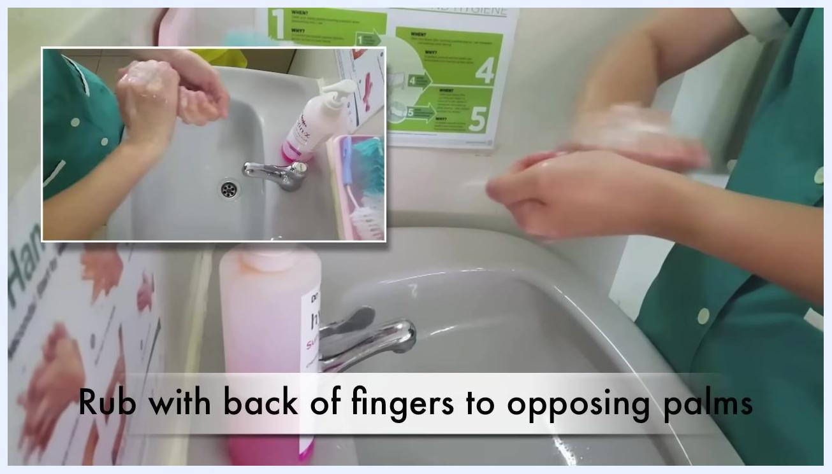
A person rubs their soapy hands palm to palm with fingers interlaced over a sink. The caption reads "Rub palm to palm with fingers interlaced."

Step 5: Rub with back of fingers to opposing palms
Place the backs of your fingers against the opposing palm and rub them together. Alternate hands to ensure both are cleaned thoroughly. An inset image shows a close-up of this action from a different angle for clarity.
A person rubs the back of their fingers against the opposing palm, with an inset showing a close-up of the action. The caption reads "Rub with back of fingers to opposing palms."

Step 6: Sweep hand from fingers to thumb
Use a sweeping motion to clean from the fingers down to the thumb, and repeat this action for both hands. An inset image provides an additional perspective of the sweeping motion.
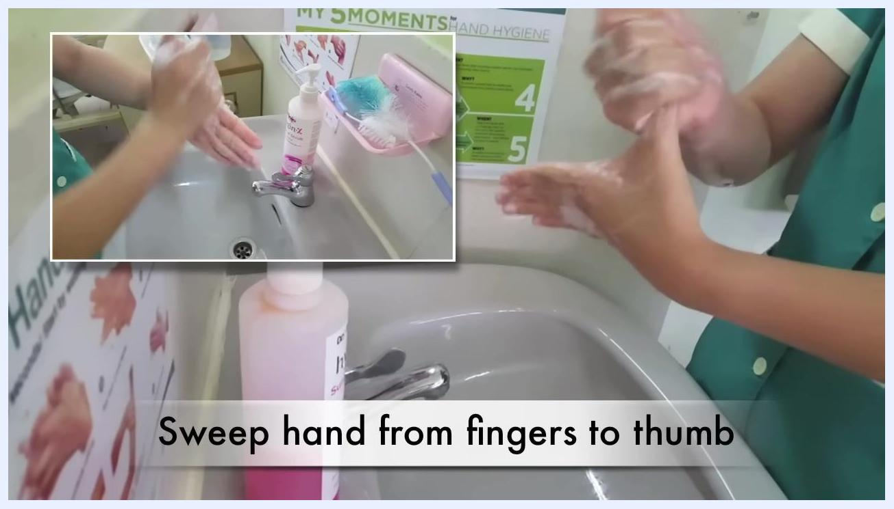
A person sweeps one hand from fingers to thumb while lathering with soap, with an inset showing the same action from above. The caption reads "Sweep hand from fingers to thumb."

Step 7: Rub tips of fingers in opposite palm
Place the tips of your fingers into the opposite palm and rub in a circular motion. Repeat for both hands to ensure fingertips and the areas under the nails are cleaned.
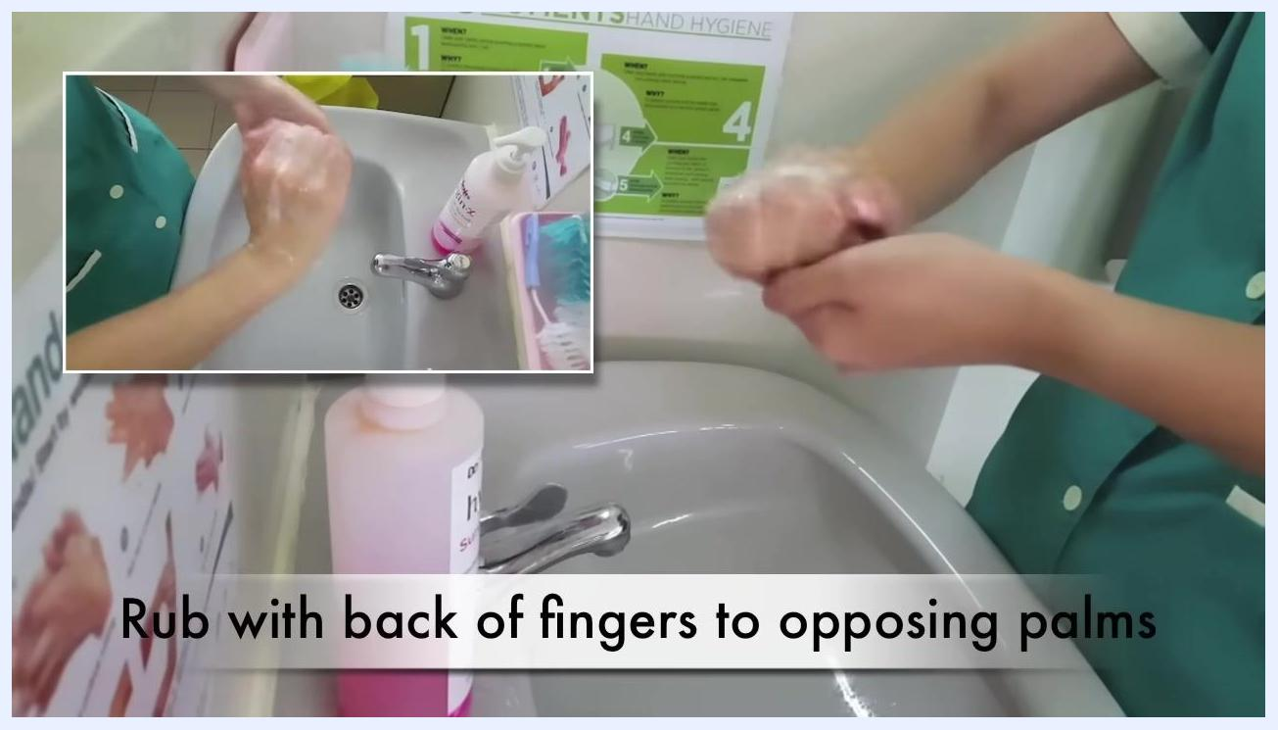
A person rubs the tips of their fingers in the opposite palm over a sink. The caption reads "Rub tips of fingers in opposite palm."
A person continues rubbing the tips of their fingers in the opposite palm, focusing on thorough cleaning. The caption reads "Rub tips of fingers in opposite palm."
Note: Each of the steps above should be visually verified against the demonstrated technique to ensure proper coverage of every hand surface. Follow all steps in sequence for optimal hand hygiene.

Step 8: Rub each wrist with the opposite hand
Grasp your right wrist with your left hand and rub thoroughly, ensuring soap covers the entire wrist area. Repeat by grasping your left wrist with your right hand and rubbing thoroughly. This step ensures that wrists, which are often missed, are also cleaned.
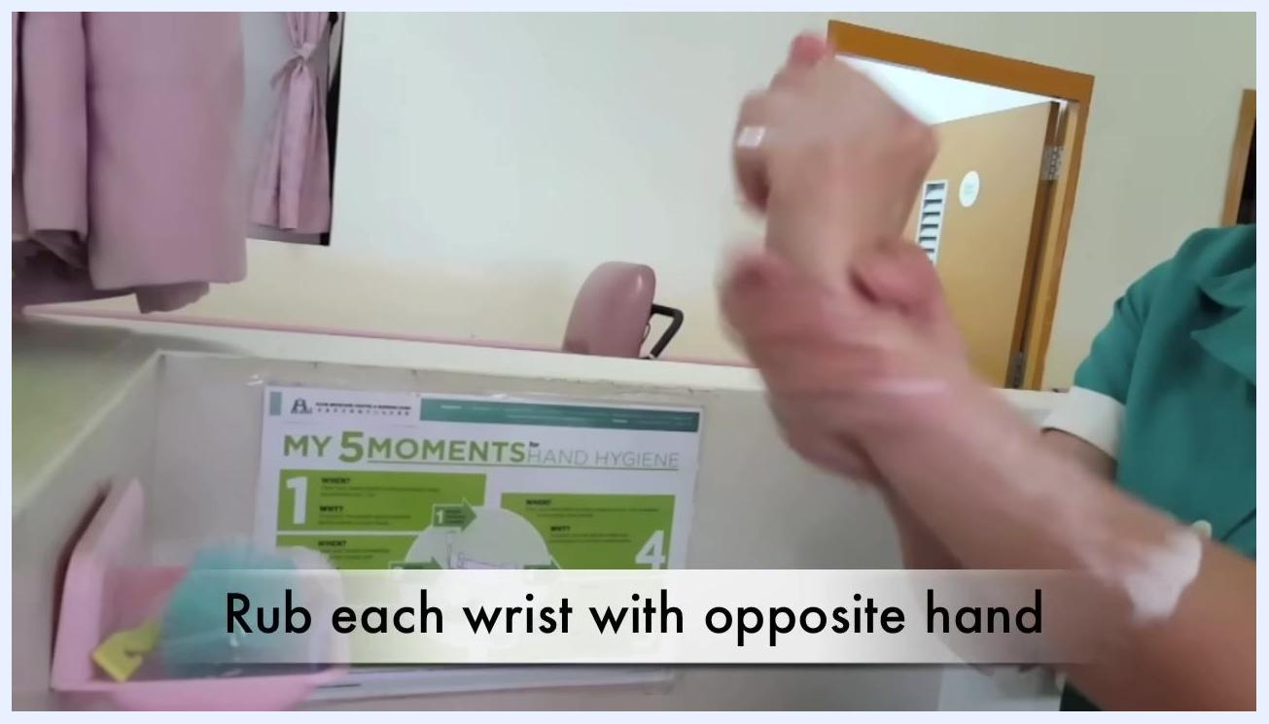
A person rubs each wrist with the opposite hand, as indicated by the caption "Rub each wrist with opposite hand." A hand hygiene poster and cleaning supplies are visible in the background.

Step 9: Rinse hands with water
Place your hands under running water from the faucet and ensure all soap is rinsed off from your hands and wrists.
A person rinses their hands under running water at a sink. A bottle of "Skin-X" hand scrub and cleaning brushes are visible. The caption reads "Rinse hands with water."

Step 10: Use elbow to turn off tap
Safety note: After rinsing, use your elbow — not your hands — to turn off the faucet. This prevents re-contaminating your clean hands.

A person uses their elbow to turn off the tap after rinsing hands, as indicated by the caption "Use elbow to turn off tap." Soap and cleaning brushes are visible.

Step 11: Wipe each hand with a separate tissue paper
Take a tissue paper from the dispenser. Dry your right hand with one tissue and your left hand with a separate tissue to prevent cross-contamination.

A person wipes each hand with a separate tissue paper, as indicated by the caption. A tissue dispenser is visible on the wall.

Key reminders
Clean hands save lives. Proper hand hygiene plays a critical role in preventing the transmission of infection.

A blue background with the message "CLEAN Hands SAVE Lives!" in large yellow text.

Acknowledgments
The instructional video concludes with credits listing the director, demonstrator, supervisors, and contributors, recognizing the team involved in producing this hand hygiene instructional material.
Credits screen listing contributors and supervisors involved in the video production, displayed on a blue background.
Final credits screen with additional contributor names on a blue background.

Verification and summary
By following all steps above in sequence, you ensure thorough and effective hand hygiene, reducing the risk of infection transmission. Always use proper technique at each stage, and avoid re-contaminating your hands after washing.

