How to Operate a Portable Oxygen Tank: Setup, Use, and Safety Guide
This guide explains how to operate a portable oxygen tank for home use, including identifying its components, setting the prescribed flow, attaching the nasal cannula, replacing an empty tank, transporting the tank safely, and following essential oxygen safety precautions. Always follow your healthcare provider's prescription and your oxygen company's guidance alongside these instructions.

Device Overview
A home oxygen tank system delivers a prescribed flow of oxygen to the user through a nasal cannula. The system consists of the following components:
- On-off valve: located at the top of the tank, used to open or close the oxygen supply.
- Regulator: attaches to the tank and controls oxygen flow.
- Gauge: mounted on the regulator; shows how much oxygen remains in the tank. Green indicates the tank is full, and red indicates it is empty.
- Flow control knob: adjusts the oxygen flow to the prescribed liters per minute.
- Oxygen outlet: the connection point where the nasal cannula attaches.
- Cylinder wrench: used to open or close the valve and to tighten the regulator.

A person in scrubs sits at a table with an oxygen tank in a black carrier, holding a green regulator and a green cylinder wrench to show the system components.
The tank must always be kept in its provided carrier to hold it in a stable, secure position.

 | Caution: Do not leave the tank standing upright on its own. An unsecured tank can tip over and cause injury or damage to the regulator.
A person in scrubs holds an oxygen tank upright on a table, with a large blue "X" over the image showing this is not the correct way to position the tank.

Indications & Contraindications
The source material does not specify formal clinical indications or contraindications; oxygen flow rate and duration of use must be set exactly as prescribed by your healthcare provider, and any deviation should be discussed with them before use.

Setup & Installation
Follow these steps to prepare a new oxygen tank for use.

- Attach the regulator to the oxygen tank.
- Place the regulator onto the top of the tank, lying horizontally, and ensure it is securely fastened.
- Use the cylinder wrench to tighten the regulator if necessary.
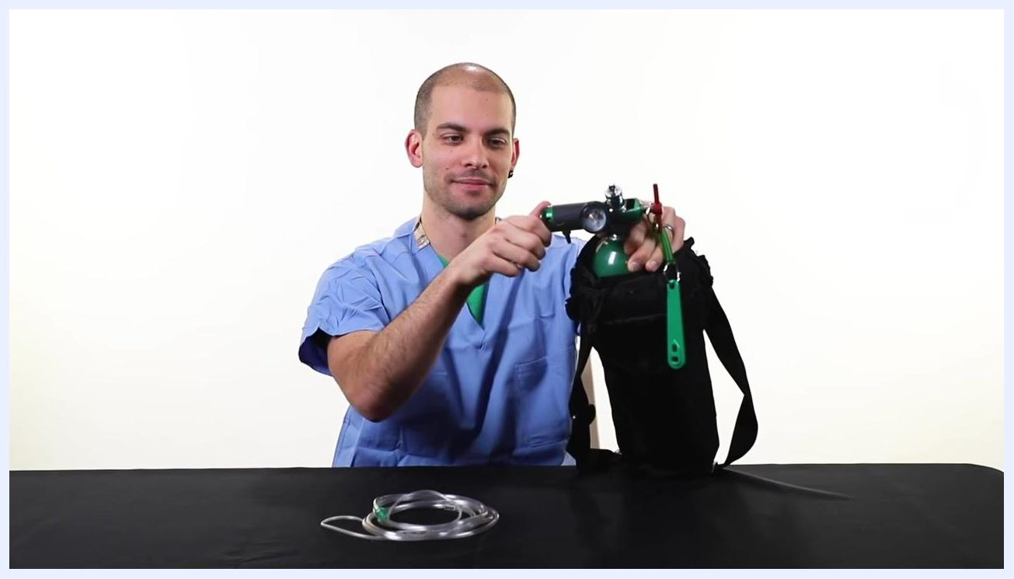
A person in scrubs attaches the green regulator to the oxygen tank, which lies horizontally on the table, with the cylinder wrench visible.

- Turn on the oxygen tank.
- Use the cylinder wrench to turn the valve on top of the tank to the left (counterclockwise) to open it.
- Watch the gauge to confirm the dial moves up, indicating the tank is open and pressurized.
A person in scrubs uses the cylinder wrench to turn the valve on top of the oxygen tank, opening it, with the regulator and gauge attached.

Pre-use check: Before connecting the nasal cannula, confirm the gauge shows adequate pressure and that oxygen flow is audible and can be felt at the outlet.

Programming & Operation
Use these steps to set the prescribed flow and deliver oxygen to the user.

- Set the prescribed oxygen flow.
- Turn the flow control knob to the prescribed liters per minute as directed by your healthcare provider.
- Listen and feel for oxygen flow at the outlet before attaching the nasal cannula.
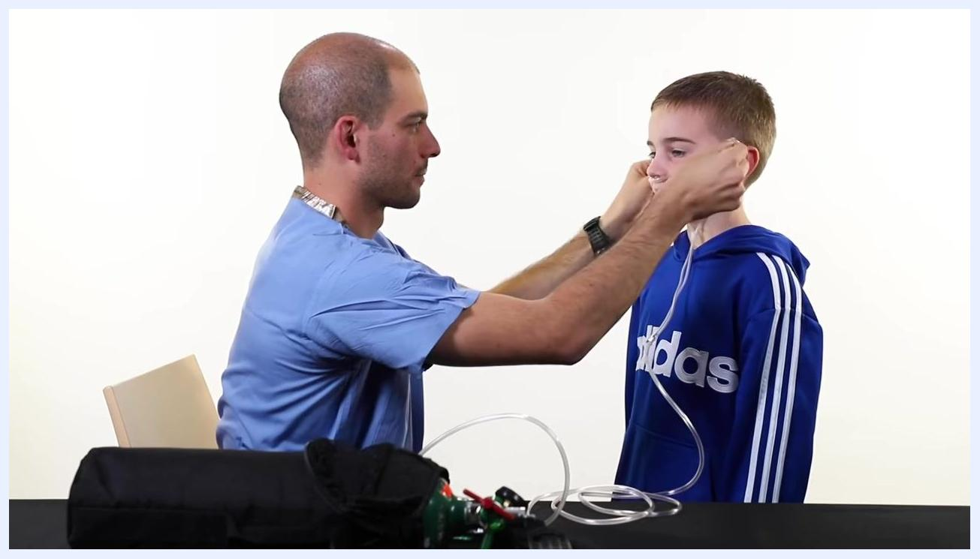
A person in scrubs adjusts the flow control knob on the regulator attached to the oxygen tank, with nasal cannula tubing on the table.

- Attach and position the nasal cannula.
- Ensure the two prongs of the nasal cannula point downwards, not upwards.
- Never cut the prongs of the nasal cannula.
- Place the cannula behind the ears and tighten it under the chin or behind the head, whichever is more comfortable.
A person in scrubs places the nasal cannula on a child, positioning it behind the ears, with the oxygen tank and tubing visible on the table.
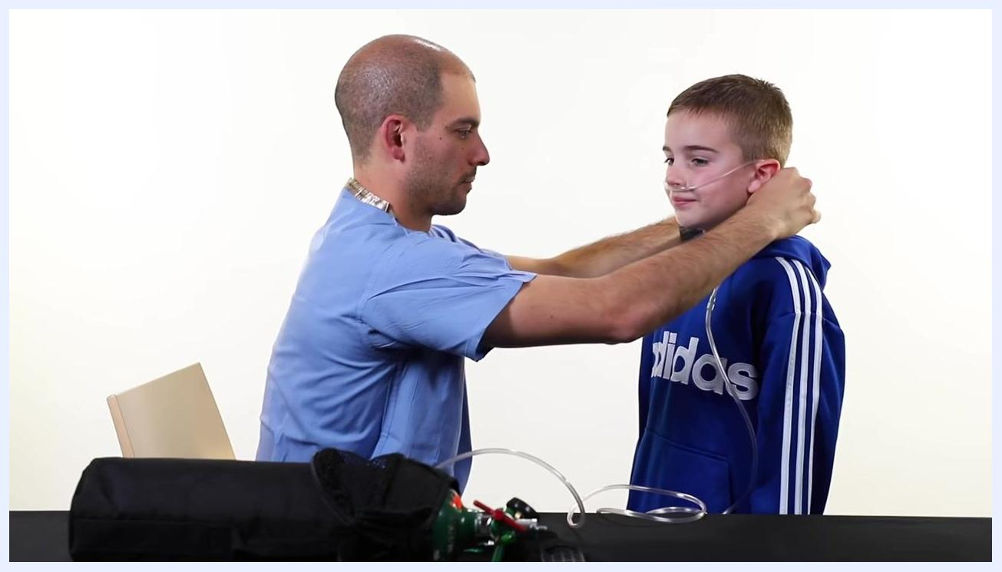
A person in scrubs adjusts the nasal cannula behind the head of a child to ensure a secure and comfortable fit.

- Secure the nasal cannula if needed.
- Use pieces of tape, if provided, to help secure the cannula to the child's face for additional comfort and stability.

- Turn off the oxygen tank when not in use.
- Turn off the oxygen flow using the flow control knob.
- Use the cylinder wrench to turn the valve on top of the tank to the right (clockwise) to close it completely.
A person in scrubs uses the cylinder wrench to turn off the valve on top of the oxygen tank, with nasal cannula tubing on the table.

Note: Always follow your healthcare provider's instructions for prescribed oxygen flow and usage.

Alarms & Alerts
The oxygen tank system does not have electronic alarms, but the following hazard alerts apply whenever the device is in use.
Alert | Description | Probable cause | Corrective action
Fire hazard from leaking oxygen | Oxygen itself is not flammable, but it causes any burning material to burn hotter and faster. | Oxygen leaking from the tank or regulator. | Keep the tank away from open flame and heat sources; check regulator fit regularly.
No smoking near equipment | Smoking near oxygen equipment creates a serious fire risk. | Cigarettes or open flame near the tank or tubing. | Never smoke in the same room or car as the oxygen equipment; display the "No Smoking" sign provided by your home care company on your door.
Oil-based products on skin | Oil-based creams and lotions, such as petroleum jelly, are flammable near oxygen. | Applying oil-based creams, lotions, or lip moisturizer containing oil-based ingredients. | Use only water-based creams and lotions; check ingredient lists on lip moisturizers.
Proximity to heat sources | Heat sources near oxygen equipment increase fire risk. | Tank or tubing placed near a stove, oven, or heater. | Keep oxygen tanks and tubing at least 10 feet away from any heat source.
Proximity to flammable materials | Grease, oil, aerosols, paints, gasoline, and solvents increase fire risk near oxygen. | Storing or using oxygen equipment near these materials. | Keep oxygen equipment away from grease, oil, aerosols, paints, gasoline, or solvents.

On the left, a blue candle with a yellow flame; on the right, text reads: "Oxygen makes things burn hotter and faster."

A "No smoking" sign with a crossed-out cigarette and the text "No smoking."
Text on a dark blue background reads: "No oil-based creams and lotions like petroleum jelly on your skin."
A kitchen scene shows an oxygen tank and tubing placed near a stove, overlaid with a large blue "X" indicating this is unsafe.
Text on a dark blue background reads: "No grease, oil, aerosols, paints, gasoline or solvents."

Cleaning & Maintenance
Maintenance of the oxygen tank system centers on replacing an empty tank correctly.

- Empty the oxygen tank completely before replacing it.
- Turn on the flow control knob and allow the oxygen to run until the gauge dial returns to zero.
- This ensures the tank is fully empty before removal.
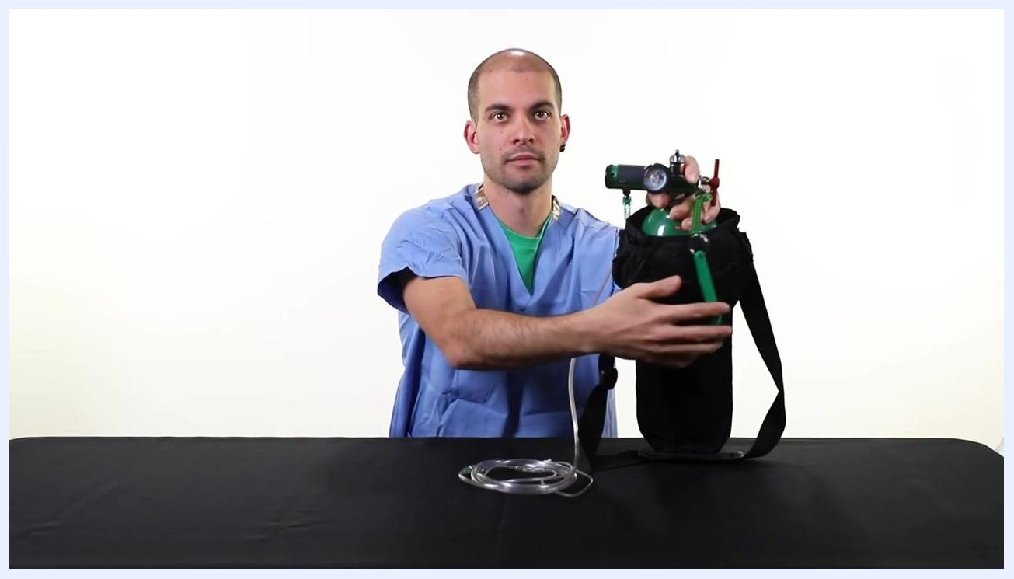
A person in scrubs holds an oxygen tank in a black carrier, adjusting the regulator and preparing to empty the tank, with nasal cannula tubing on the table.

- Remove the regulator from the empty tank.
- Turn the T-handle on the regulator counterclockwise to loosen and remove it from the tank.
- Set the regulator aside for use with the new tank.
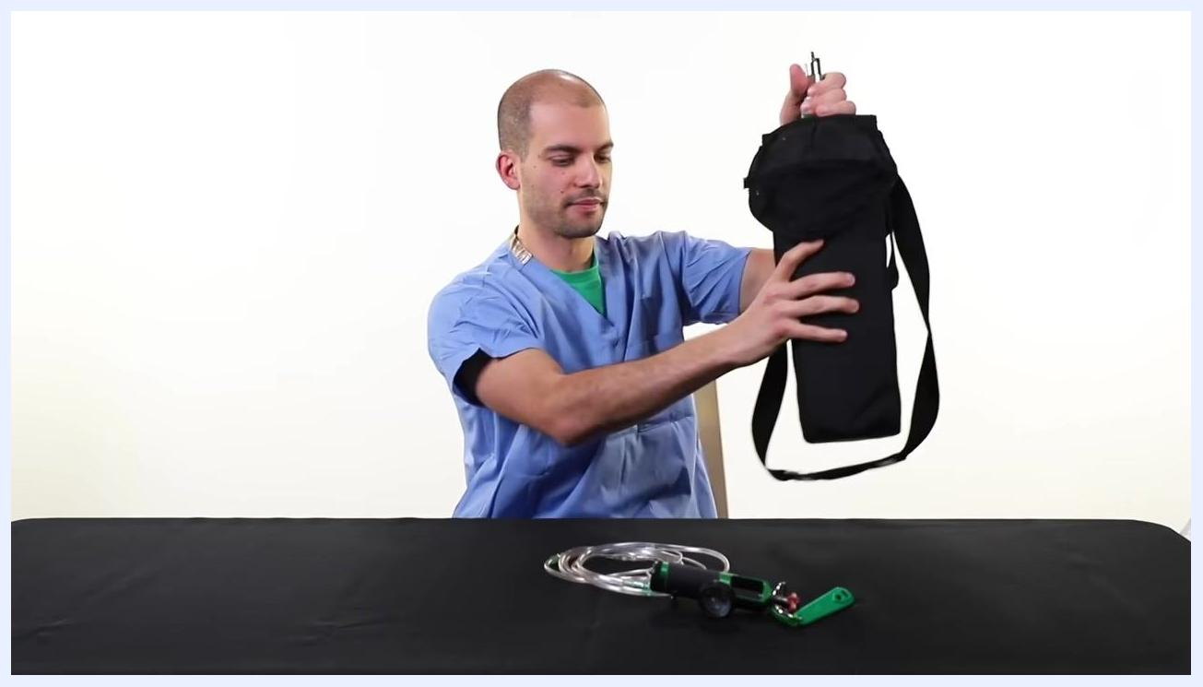
A person in scrubs lifts the empty oxygen tank in its black carrier off the table, with the regulator and tubing placed in front.

- Prepare the new oxygen tank.
- Inspect the top of the new tank for two holes where the regulator pins will fit.
- Ensure a washer is placed in the middle of the regulator pins; use a new washer if needed, as your oxygen company will provide extras.
Close-up of the top of a green oxygen tank in a black carrier, showing the two holes for the regulator pins as a hand prepares to attach the regulator.

- Attach the regulator to the new tank.
- Align the two pins on the regulator with the holes on the top of the oxygen tank.
- Place the regulator onto the tank so the pins fit securely into the holes.
- Tighten the regulator using the T-handle until it is firmly attached.
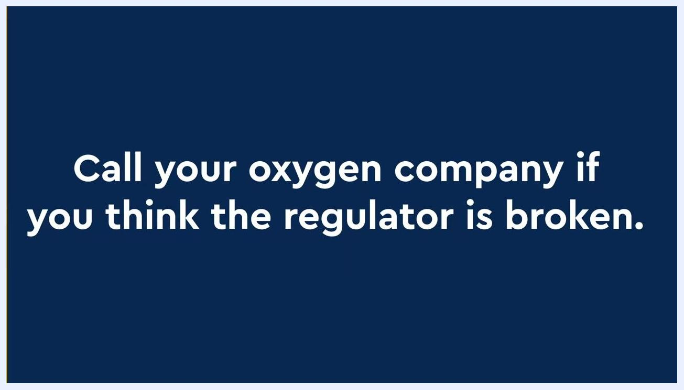
A person in scrubs attaches and tightens the regulator onto a new oxygen tank in a black carrier, ensuring proper alignment.

- Turn on the new tank and check for leaks.
- Use the cylinder wrench to turn the valve on top of the tank to the left (counterclockwise) to open it.
- Listen and feel for any leaks around the regulator.
- If you hear or feel a leak, turn off the tank, retighten the regulator, or replace the washer as needed.
A person in scrubs tightens the regulator on the oxygen tank to ensure a secure fit.
Transporting your oxygen tank in a vehicle:
- Do not smoke in the car while transporting oxygen.
- Keep at least one window partially open for ventilation.
- Lay the oxygen tank on its side on the floor behind the seats to prevent it from rolling.
- Use a restraining device, such as a seat belt, soft clothing, blankets, or towels, to secure the tank and prevent movement.
A woman sits in the front seat of a car with the window partially open, demonstrating safe transport of an oxygen tank.
Storage reminders:
- Always keep oxygen tanks secure in their provided carriers.
- Do not leave tanks in areas where they can be easily knocked over.
- Never store oxygen tanks in small, enclosed spaces such as closets or the trunk of a car.

An oxygen tank in a black carrier is left unsecured on the back seat of a car, with a large blue "X" over the image indicating this is not safe storage.

Note: Proper handling during replacement and transport prevents accidents and ensures a continuous supply of oxygen.

Troubleshooting
Issue | Possible cause | Solution
Regulator leaks after attachment | Regulator not tightened fully, or washer is worn or missing. | Turn off the tank, retighten the regulator with the T-handle, or replace the washer with one provided by your oxygen company.
Regulator will not secure properly or appears broken | Damaged regulator or misaligned pins. | Call your oxygen company immediately for a replacement.
Tank running low or empty | Normal consumption during use. | Call your oxygen company right away so they can deliver more oxygen tanks.
Tank knocked over or stored unsafely | Tank left outside its carrier or in an enclosed space. | Always keep the tank secured in its carrier and away from areas where it can be knocked over; never store it in closets or a car trunk.
Uncertainty about safety or equipment condition | Any doubt about safe handling of the oxygen equipment. | Contact your oxygen supply company for guidance.
Text on a blue background reads: "Call your oxygen company if you think the regulator is broken."
Text on a blue background reads: "Call your oxygen company right away so they can bring you more oxygen tanks."

Text on a dark blue background reads: "If you have any questions, please contact your oxygen supply company."

Technical Specifications
The source material does not provide physical dimensions, electrical specifications, environmental requirements, or regulatory classifications for the oxygen tank system; refer to the documentation provided by your oxygen supply company for these details.

What's Next
After completing setup, always confirm the flow rate matches your healthcare provider's prescription before each use. Keep your oxygen company's contact information accessible for tank replacement, leak concerns, or any equipment questions.

