How to Give an Intramuscular Injection
This guide shows you how to give yourself an intramuscular (IM) injection at home. An intramuscular injection delivers a small amount of medicine through a needle placed into the muscle beneath the skin. IM injections are commonly used to manage or prevent health problems such as immune disorders, infections, and low vitamin B12 levels.
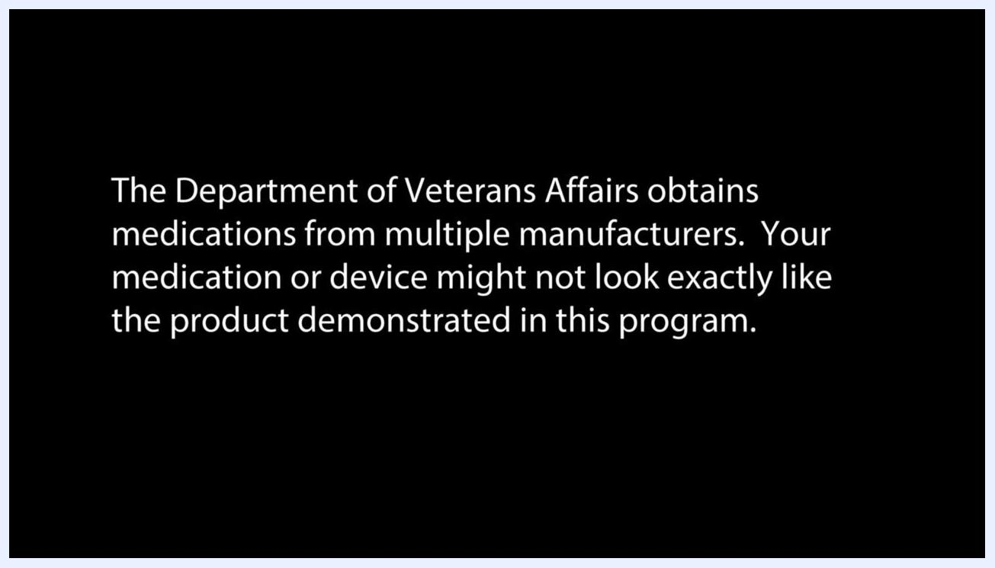
Text disclaimer explaining that medications come from multiple manufacturers and may look different from those shown.

Purpose
This document walks you through preparing your medication, drawing it into a syringe, administering the injection, and safely disposing of used supplies.

Scope
This procedure applies to self-administered IM injections using auto-injectors/pens, pre-filled syringes, or vials that require drawing up medicine before use. Always follow your healthcare provider's specific instructions, since dosing and technique can vary by medication.
Important: Medications are sourced from multiple manufacturers, so your medication or device may not look exactly like the ones shown in the reference images below. Mention of a manufacturer-specific medicine or device does not imply an endorsement of that product.
Text disclaimer clarifying that showing a specific medicine or device is not an endorsement of that product.

Understanding your medication
IM injection medicines come in one of three forms:
- Auto-injectors or pens
- Pre-filled syringes, ready for immediate use
- Vials, from which you draw the medicine using a syringe each time you inject
The injection itself is delivered into the muscle, which sits beneath the skin and the subcutaneous tissue layer.
Auto-injector pens are often labeled with illustrated instructions for use.
Pre-filled syringes come ready to use straight out of their packaging.
If your doctor prescribes a powdered medication, you must mix it with a liquid, such as saline or distilled water, before use.
Some powdered medications come as a two-vial set: one vial holds the powder, and the other holds the liquid used for mixing.
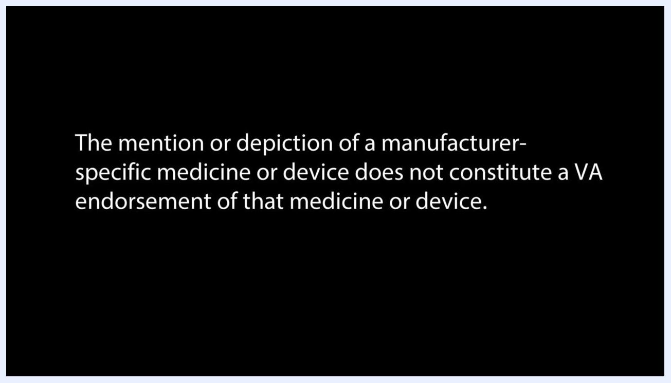
Cross-section diagram of skin, subcutaneous tissue, and muscle, showing a syringe needle reaching into the muscle layer.
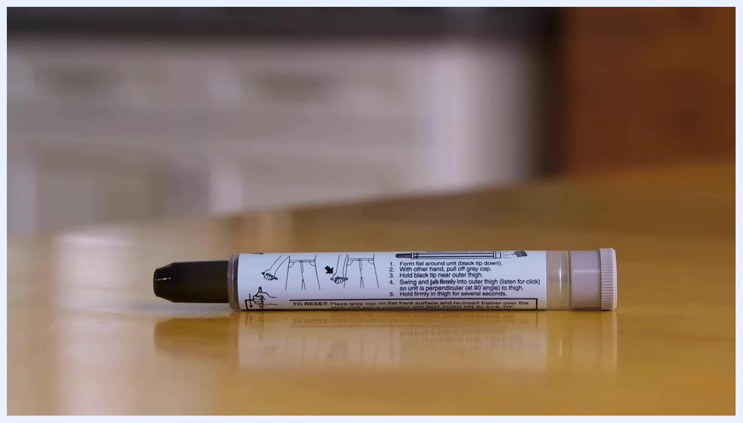
Auto-injector pen with printed instructions on its label, resting on a wooden surface.
Pre-filled syringe and auto-injector pen shown in plastic packaging on a wooden surface.
Vial labeled "Sodium Chloride Injection, USP" with a green cap, used for mixing powdered medication.
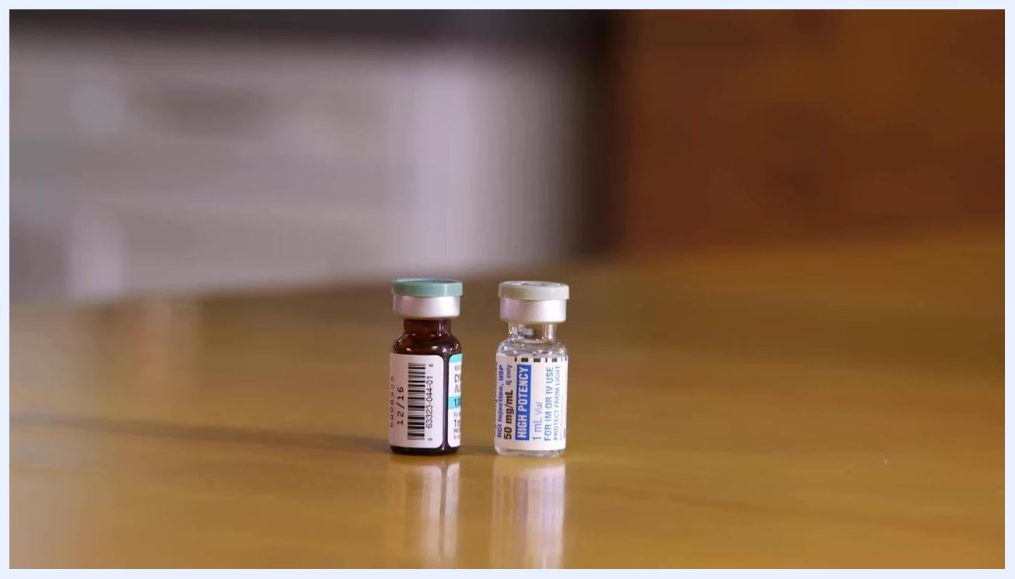
Two vials side by side: one brown vial with a green cap and barcode, and one clear vial labeled "HIGH POTENCY."

Required equipment
Before you begin, gather the following supplies and place them on a clean, flat surface:
- Alcohol pads or cotton swabs dipped in rubbing alcohol
- A disposable syringe
- The medicine you will be using
- Cotton balls
- Adhesive bandages
- A sharps container or another safe disposal option for the used syringe
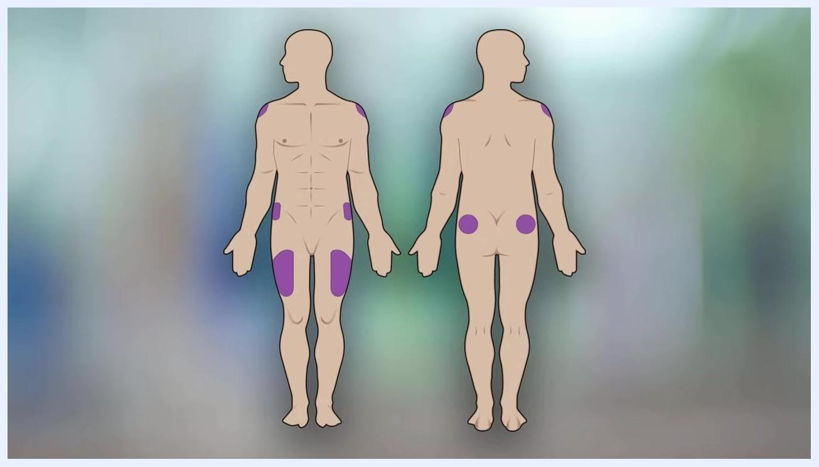
A person seated at a kitchen table reaching into a plastic supply container, with a red sharps disposal container nearby.

Step 1: Prepare your medication and workspace
1.1 Bring medication to room temperature. If your medication has been stored in the refrigerator, remove it and let it warm to room temperature before use. Cold medicine can make the injection more painful.
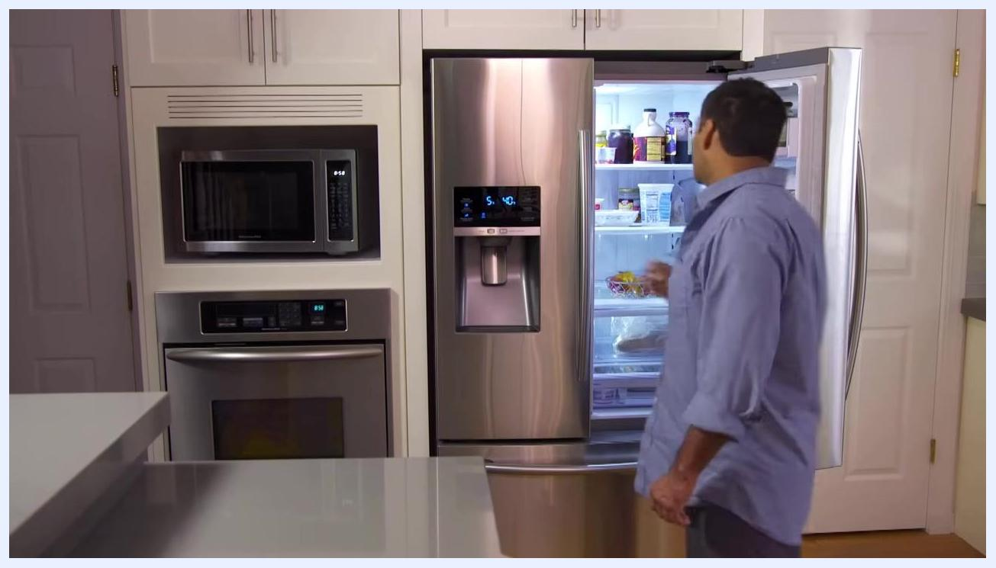
A person reaching into an open refrigerator in a kitchen, with various bottles and containers visible inside.
1.2 Wash your hands. Go to a sink and wash your hands thoroughly with soap and warm water. This step is essential to prevent infection.
1.3 Gather your supplies. Collect all the items listed in the Required Equipment section and set them on a clean, flat surface, including your sharps container.

Step 2: Choose and prepare the injection site
2.1 Select an injection site. IM injections can be given in the following locations:
- Deltoid muscle of the shoulder
- Upper thigh (vastus lateralis)
- Outer hip (gluteal muscle)
Safety note: Rotate your injection site each time you give an injection to avoid tissue damage from repeated use of the same spot. Do not inject into areas that are bruised, tender, or scarred.
2.2 Check the medication. Verify the expiration date on your medicine. If the vial has a plastic cap, pop it off. Wipe the top of the vial with an alcohol pad or swab and let it air dry.
A person washing their hands at a kitchen sink with soap and running water; a blender is visible on the counter.
2.3 Clean the injection area. Use a new alcohol pad or swab to clean the skin at your chosen injection site.
Safety note: Allow the skin to air dry completely before proceeding, and avoid touching the cleaned area while it dries.
2.4 Review the syringe parts. Familiarize yourself with the three main components before drawing up your medication:
- Plunger – draws in and pushes out the medication
- Barrel – the tube holding the medication, marked with measurement lines
- Needle – the sharp tip that delivers medication into the muscle
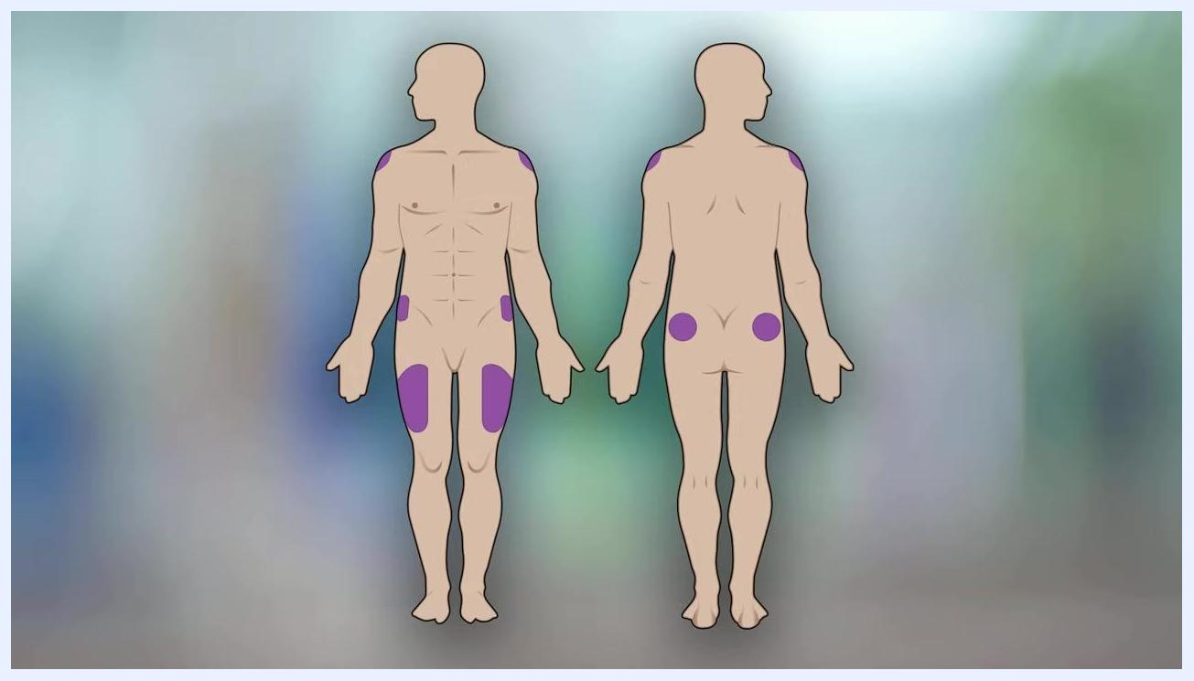
Front and back diagram of a human body with shaded areas marking recommended IM injection sites for rotation.
A person opening an alcohol pad at a kitchen table, with a vial, syringes, and a sharps container laid out nearby.
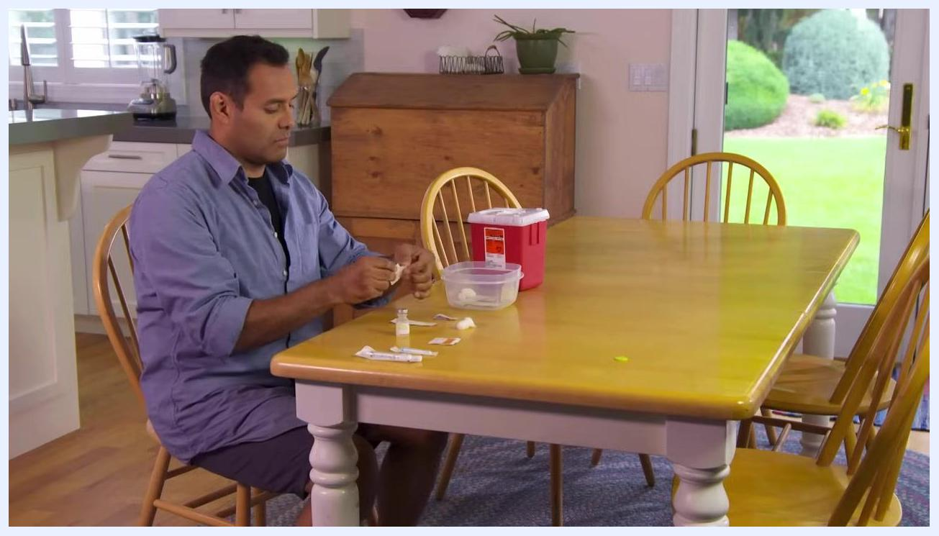
A person exposing their upper thigh at a kitchen table, with injection supplies laid out and ready.
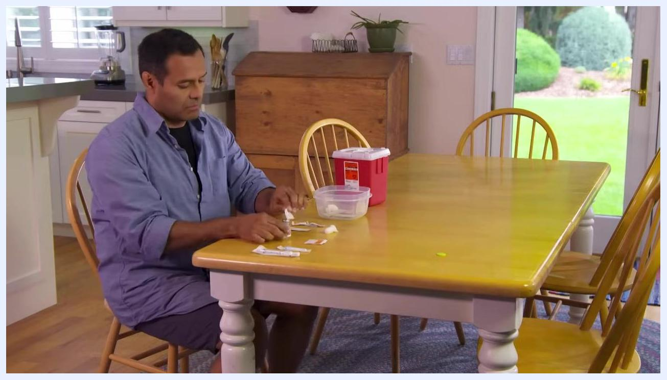
Close-up of a syringe labeled with arrows pointing to the Plunger, Barrel, and Needle, with measurement lines on the barrel.

Step 3: Draw up your medication
3.1 Confirm the dosage markings. Consult your doctor or pharmacist beforehand to make sure you understand how to read the measurement markings on your specific syringe.
3.2 Open the syringe and needle packaging. Remove the sterile syringe from its package without touching the needle or tip, then remove the sterile needle from its own packaging.
3.3 Attach the needle. If the needle is not pre-attached, screw it securely onto the syringe.
3.4 Draw air into the syringe. Pull the plunger back to draw air into the syringe up to the mark matching your prescribed dosage.
3.5 Uncap the needle. Carefully remove the needle cap and set it aside on a clean surface.
3.6 Insert the needle into the vial. Stick the needle straight through the rubber top of the medication vial.
3.7 Inject air and draw medication. Flip the vial and syringe so the vial is on top, then push the plunger to inject air into the vial. This equalizes pressure and makes it easier to draw out the medicine. With the vial still upside down and the needle tip below the liquid surface, slowly pull back the plunger until you reach your prescribed dose.
Front and back diagram of a human body with shaded areas marking the shoulder, thigh, and outer hip injection sites.
Safety note: Keep the needle tip under the liquid surface to avoid drawing in air bubbles. If large bubbles appear, push the medication and air back into the vial, then slowly redraw the correct amount.
3.8 Verify the dose. Inspect the syringe to confirm you have the correct amount of medication with no large air bubbles.
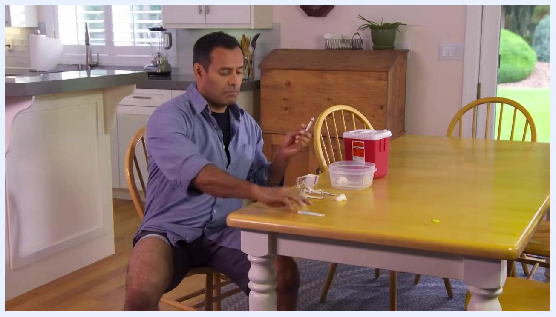
Close-up of a syringe with the needle exposed and the cap set aside; the barrel is marked up to 3 mL.
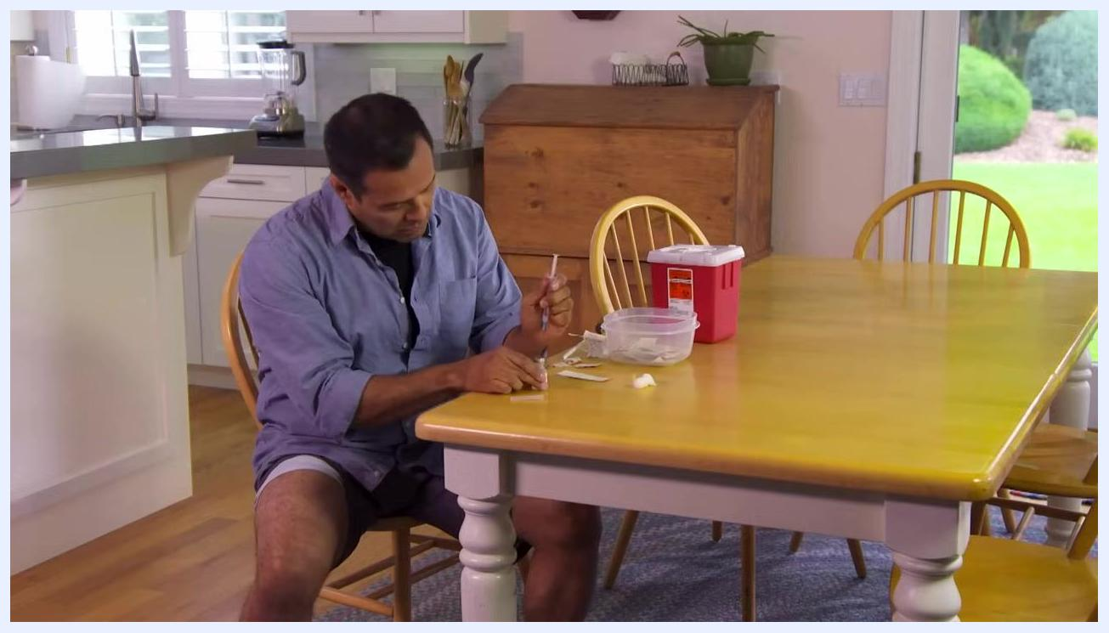
A person inserting a syringe needle into a vial at a kitchen table, with supplies and a sharps container nearby.
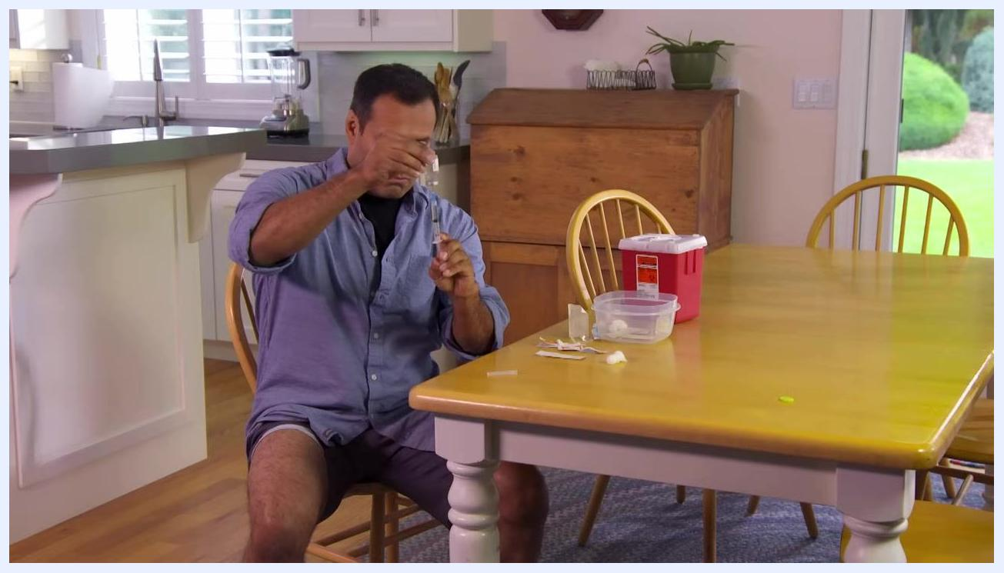
Close-up of medication being drawn from an upside-down vial into a syringe, with the needle submerged in the liquid.
A person holding a vial upside down while drawing medication into a syringe, keeping the needle submerged to prevent air bubbles.
Close-up of a syringe showing measurement markings and medication free of air bubbles after being drawn from a vial.

Step 4: Give the injection
4.1 Insert the needle. Hold the barrel so the needle points straight at the cleaned injection site. With a firm, smooth motion, insert the needle through the skin and into the muscle at a 90-degree angle. Once fully inserted, shift your thumb to the plunger.
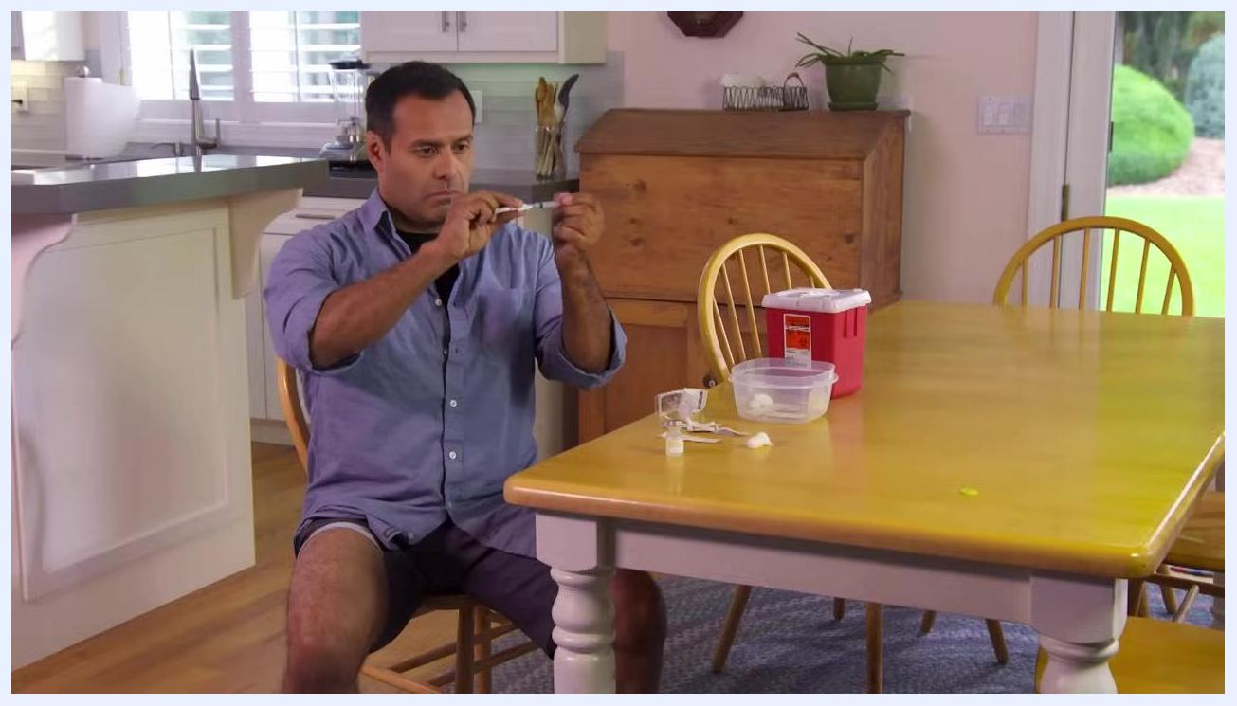
A person screwing a needle onto a syringe at a kitchen table, with supplies and a sharps container nearby.
4.2 Push the plunger and count to three. Sit comfortably and keep the syringe steady. Slowly push the plunger all the way down, then count to three (aloud or silently) before removing the syringe. This ensures the syringe is completely empty.
4.3 Remove the needle. Withdraw the needle from your thigh and apply gentle pressure to the injection site with a cotton ball or gauze.
Safety note: Do not attempt to re-cap the needle. Re-capping increases the risk of accidental needle sticks.
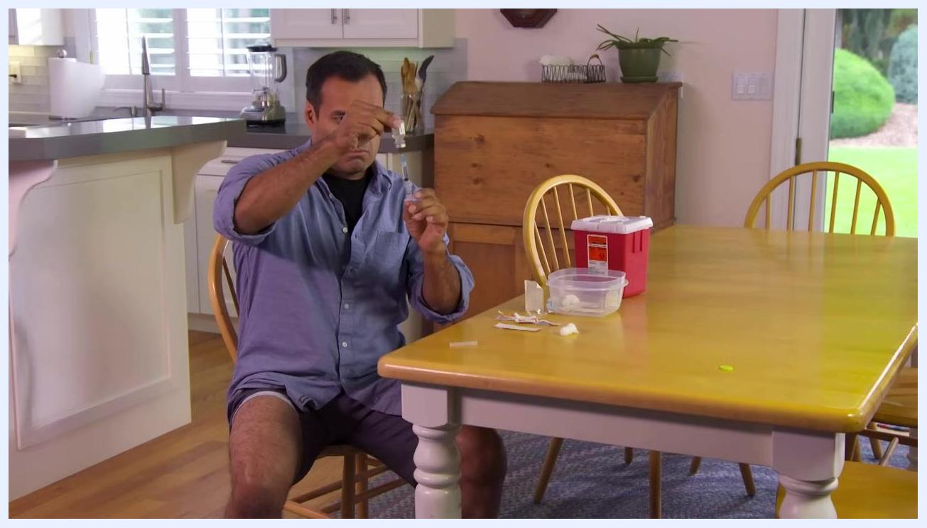
A person holding a syringe and vial at a kitchen table, preparing to insert the needle into the injection site.

Step 5: Dispose of supplies safely
5.1 Dispose of the needle immediately. Place the uncapped needle directly into a red sharps container. Do not leave needles or syringes on the table, and do not attempt to re-cap them.
5.2 Use an alternative container if needed. If you don't have a ready-made sharps container, use a sturdy, heavy-duty plastic container, such as an empty laundry detergent bottle. Label it clearly with "Danger: Used needles" using a permanent marker.
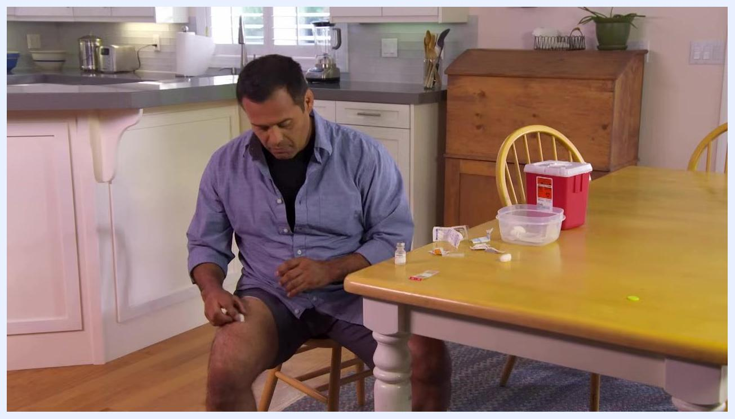
A person placing a used needle into a sharps container on a kitchen table, with other medical supplies nearby.
5.3 Dispose of remaining supplies. Throw away alcohol swabs, wrappers, and other non-sharp waste in the regular trash. Discard single-dose vials after use. For multi-dose vials, it's acceptable to leave them uncapped and store as directed.
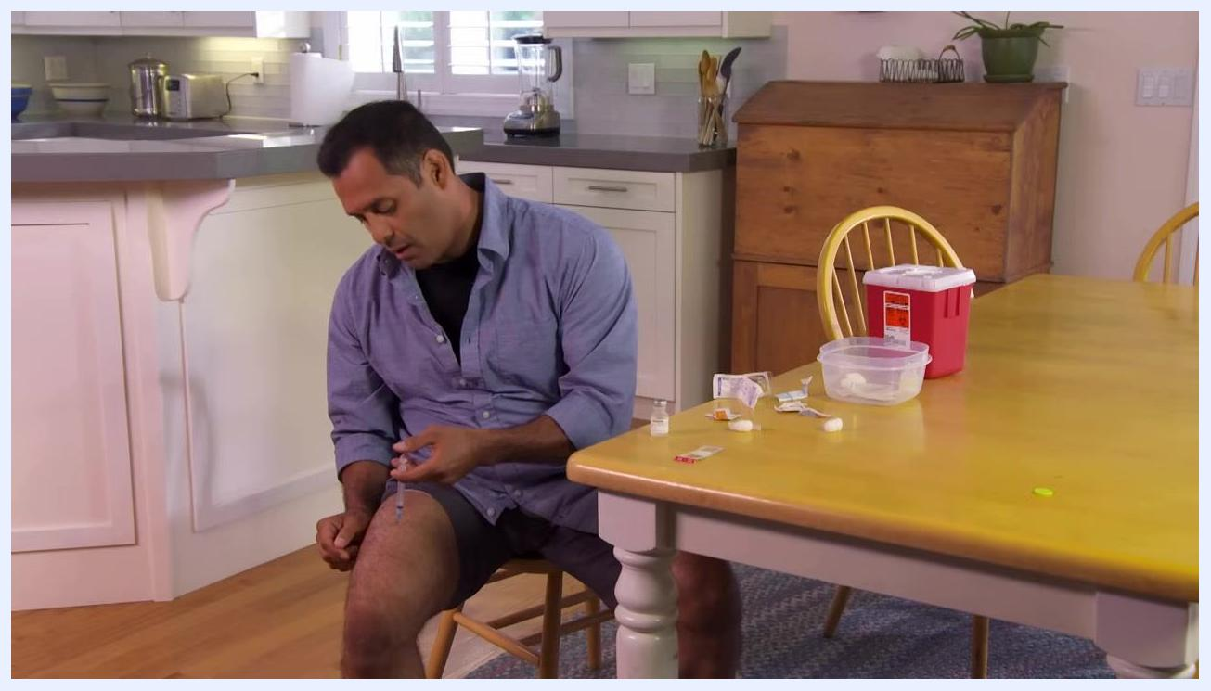
A person holding a syringe steady in their thigh at a kitchen table, with medical supplies and a sharps container nearby.
5.4 Refrigerate medication if required. If your medication needs refrigeration, return it to the refrigerator immediately, storing it at the temperature indicated on the label or by your healthcare provider.
5.5 Finish cleaning your workspace. Place wrappers, cotton balls, and packaging in the regular trash to maintain a safe and sanitary environment.
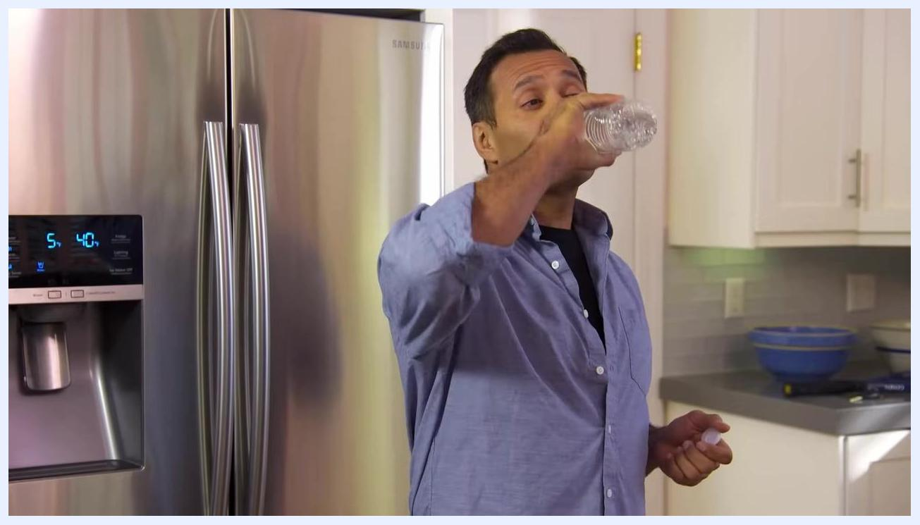
Close-up of a white plastic container labeled "Danger Used needles" in black marker.
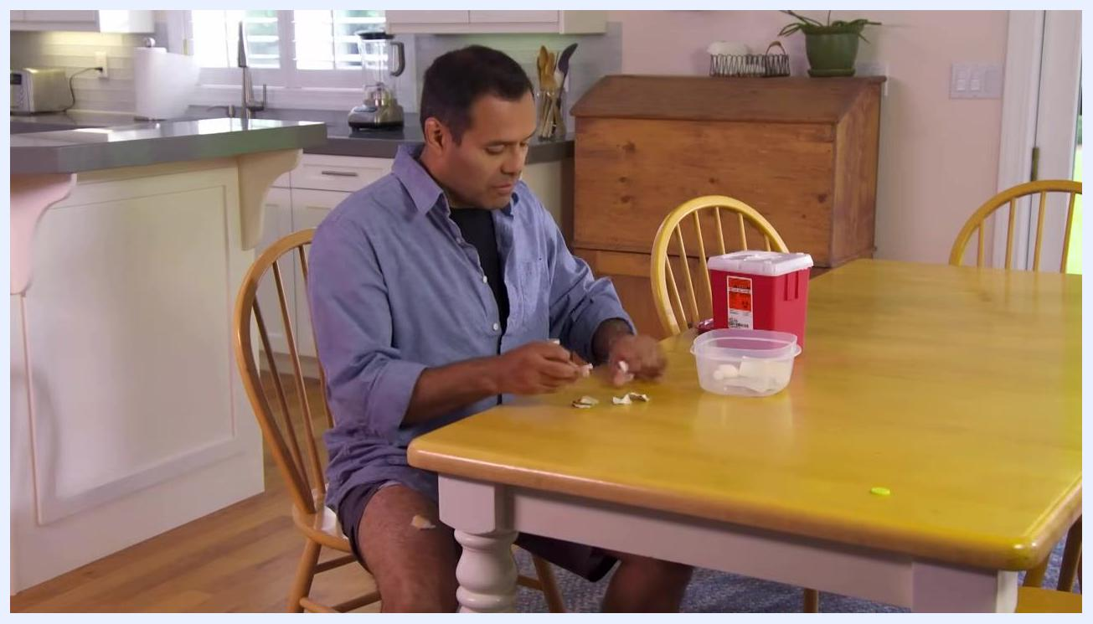
A person cleaning up used medical supplies at a kitchen table, with a sharps container and other items nearby.

A person standing in a kitchen near an open refrigerator after returning medication to storage.
A person cleaning up their kitchen workspace after completing the injection procedure.

Verification
Once you've completed the procedure, confirm the following:
- The full prescribed dose was injected and the syringe was empty before removal.
- The used needle was placed in a sharps container or a properly labeled alternative, without re-capping.
- All non-sharp waste was discarded in the regular trash.
- Any medication requiring refrigeration was returned to proper storage.
- Your workspace is clean and free of used supplies.
A person applying a cotton ball to their thigh after the injection, with used supplies and a sharps container on the table.

What's next
Always follow your healthcare provider's instructions for medication administration and disposal. Use only approved sharps containers or clearly labeled, puncture-resistant alternatives for needle disposal. If you have questions about your injection, medication, or disposal process, contact your healthcare provider or local VA facility.
Veterans Health Administration Employee Education System logo on a white background.

VA and U.S. Department of Veterans Affairs logos on a white background.

