Patient Care Procedure: How to Give an Insulin Injection with a Pen
This procedure explains how to give an insulin injection with a pen safely and correctly, from hand hygiene through disposal of used needles. It is intended for patients with type 1 diabetes and for patients with type 2 diabetes who require insulin injections, as well as for caregivers assisting with self-administration.

Purpose & Scope
Insulin helps move glucose from the blood into the cells to provide energy. All patients with type 1 diabetes and many patients with type 2 diabetes require insulin injections to lower blood sugar. Many patients need two types of insulin: basal (long-acting) insulin and bolus (mealtime) insulin.
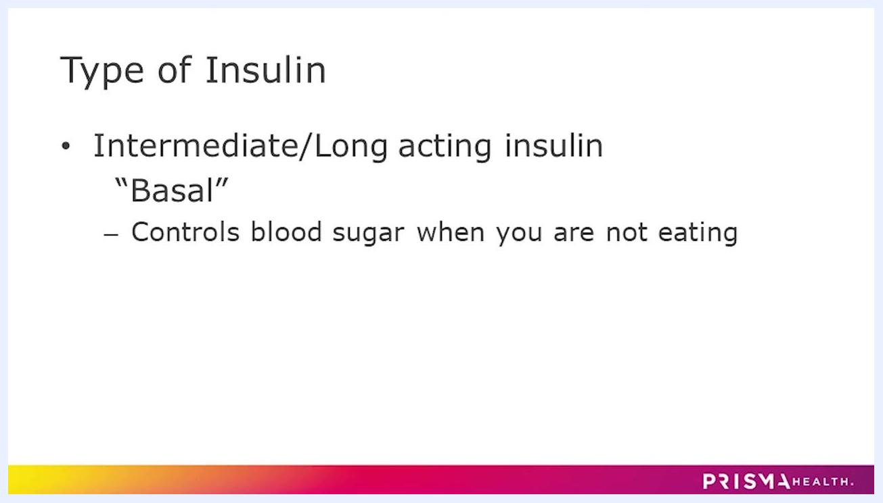
Diagram explaining what insulin is, showing a cell, a key labeled "Insulin," blood with glucose, and the phrase "Glucose = Energy"
Insulin type | Function | Timing
Basal (Intermediate/Long-acting) | Controls blood sugar overnight and between meals | Taken every day, regardless of eating
Bolus (Short/Rapid-acting or Mealtime) | Prevents a spike in blood sugar after eating | Taken with the first bite of a meal; skip if the meal is skipped
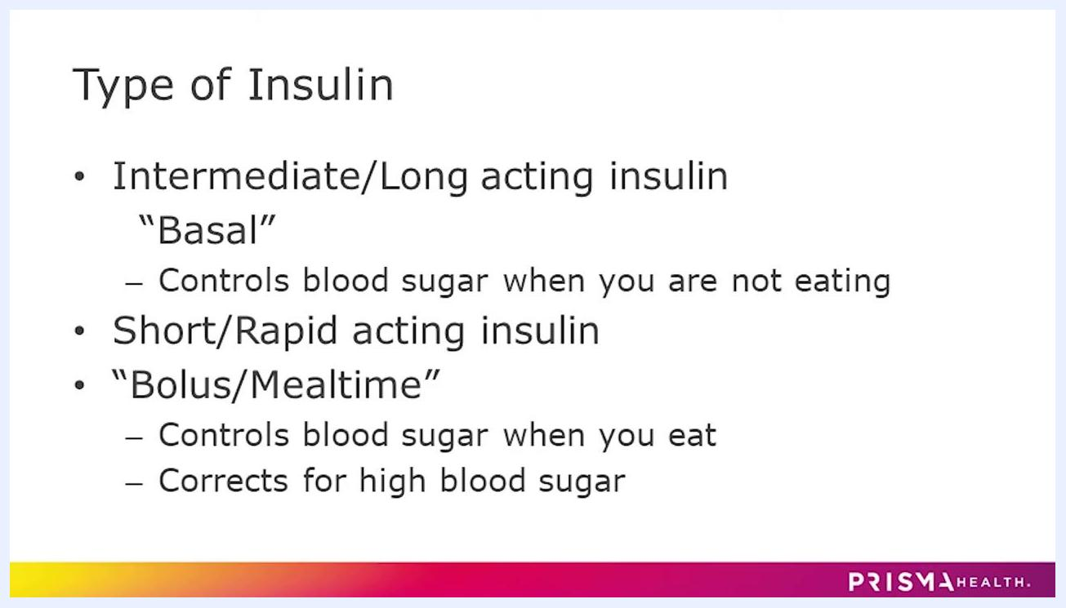
Slide listing types of insulin: Intermediate/Long acting ("Basal") and Short/Rapid acting ("Bolus/Mealtime"), with their functions
This procedure applies to self-administered or caregiver-administered insulin injections given with an insulin pen, typically in the outpatient or home setting.

Patient Assessment
Complete the following checks before every insulin pen injection:
Assessment step | Detail
Hand hygiene | Wash hands thoroughly with warm soapy water for at least 20 seconds to prevent infection
Injection site selection | Choose from the abdomen, back of the arm, upper thigh, or top of the buttocks
Site rotation | Rotate injection sites every time to reduce the risk of scar tissue or infection
Distance from belly button | Stay at least two inches away from the belly button if injecting in the abdomen
Supplies check | Confirm all supplies are on hand before starting the injection
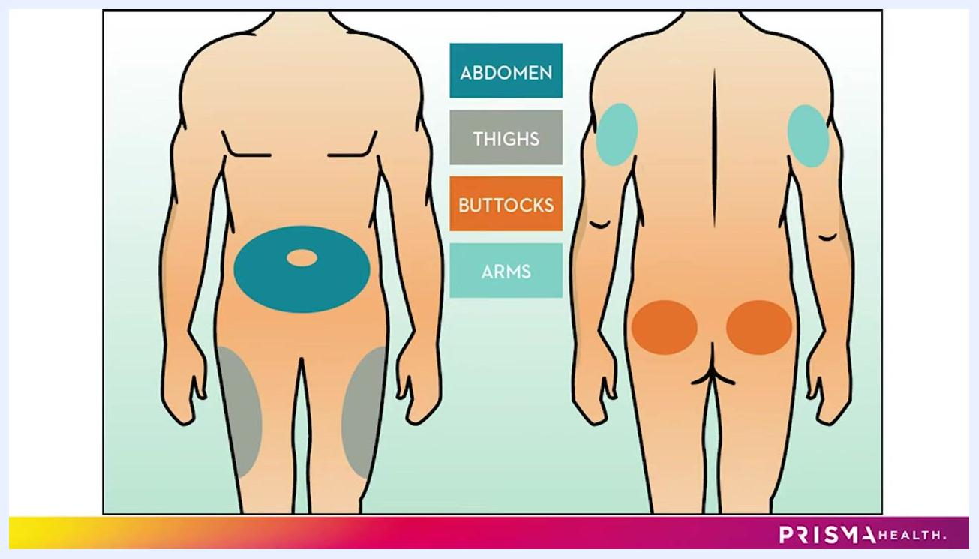
Diagram of a human body (front and back) highlighting injection areas: abdomen, thighs, buttocks, and arms
Even when using the same general area, such as the abdomen, move the injection point a few inches from the last injection each time.
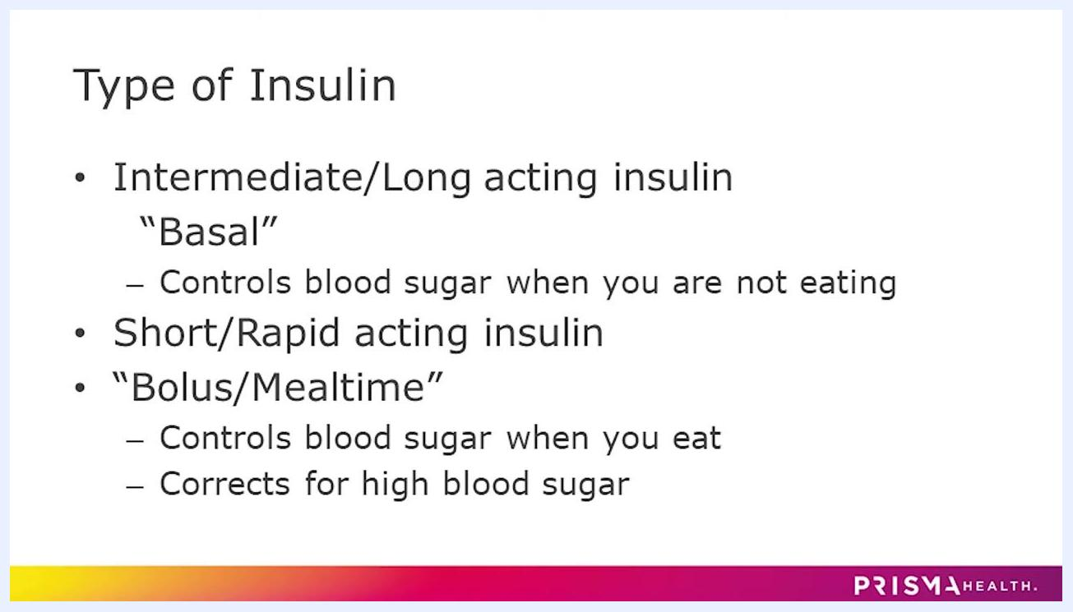
Diagram showing numbered and sectioned areas on the abdomen and thighs for rotating injection sites
Rotating the injection site helps reduce the risk of scar tissue development or infection.
Text slide: "Rotating the site of injection will help reduce the risk of scar tissue development or infection"
This procedure does not include vital sign monitoring, a formal pain assessment tool, or neurovascular checks, as an insulin pen injection is a brief self-administered task rather than a monitored clinical intervention.

Care Protocol

Phase 1: Preparation
Gather your supplies before beginning:
Method | Supplies needed
Insulin pen | Insulin pen, new pen needle, two alcohol wipes
Insulin vial | Insulin vial, new syringe, two alcohol wipes
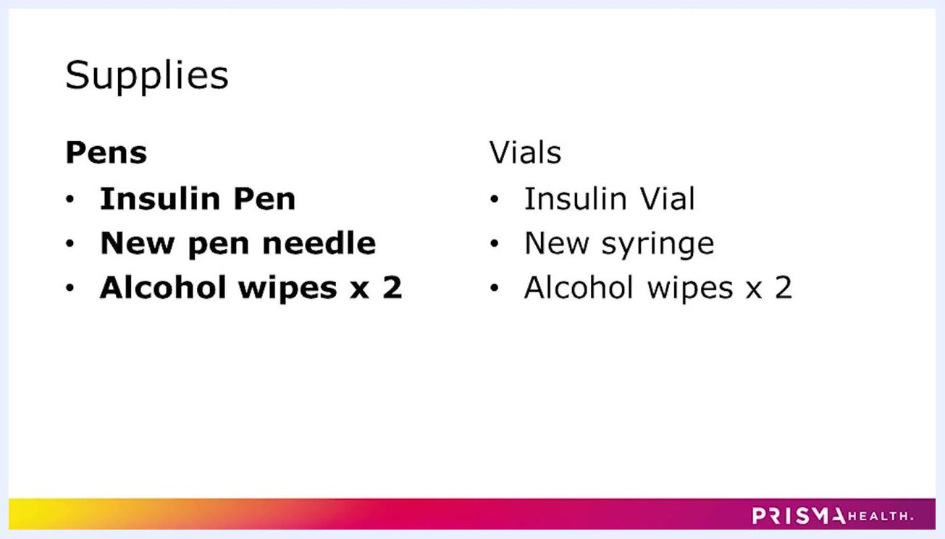
Slide listing supplies for pens (insulin pen, new pen needle, alcohol wipes x2) and vials (insulin vial, new syringe, alcohol wipes x2)
Always use a new pen needle or syringe for every injection. Do not reuse needles or syringes, to prevent infection and ensure an accurate dose.
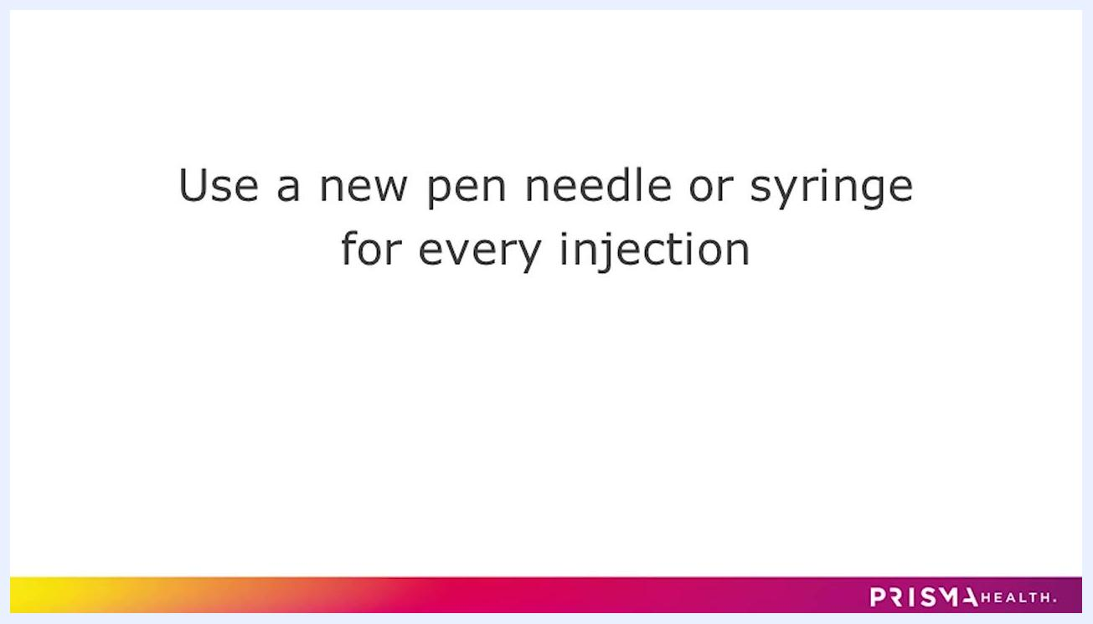
Slide with the text "Use a new pen needle or syringe for every injection" and Prisma Health branding

Phase 2: Site cleaning and pen preparation
Clean the injection site with an alcohol wipe. Wipe the chosen area (abdomen, thigh, arm, or buttocks) thoroughly and allow the alcohol to dry completely before proceeding, to avoid stinging and to keep the site sterile.
Person seated, lifting shirt and cleaning abdomen with an alcohol wipe, preparing for injection
Remove the cap from the insulin pen and wipe the rubber seal of the pen with a second alcohol wipe to ensure cleanliness.
Take a new pen needle, peel off the paper backing, and twist the needle onto the insulin pen immediately before the injection. Do not store the insulin pen with a pen needle attached, as this can lead to contamination or leakage.
Person holding an insulin pen and peeling the paper backing off a new pen needle, preparing to attach it
The pen needle has two caps: an outer cap and an inner cap. Remove the outer cap and save it for later needle disposal, then carefully remove the inner cap to expose the needle.
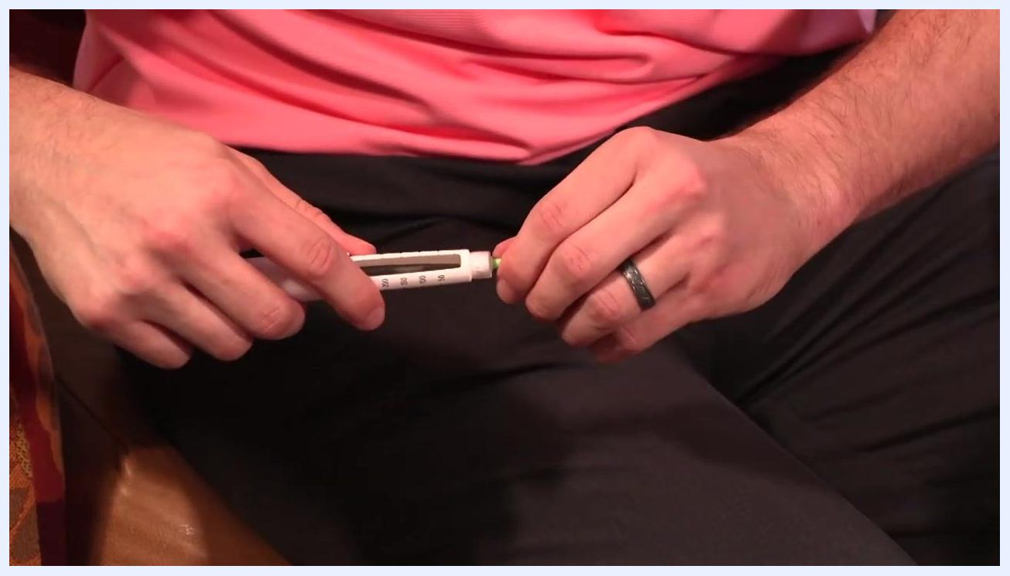
Person removing the outer cap from the pen needle after attaching it to the insulin pen

Phase 3: Priming and dosing
Prime the pen needle before every injection to remove air and confirm the pen is working. Turn the dose dial to 2 units, hold the pen with the needle pointing straight up, and press the injection button. Look for a spray or drops of insulin at the needle tip; repeat the priming step if none appears.
Person holding insulin pen upright, preparing to prime the needle by pressing the button
Confirm that insulin is visible at the tip of the needle before continuing.
Close-up of insulin pen needle with a visible drop of insulin at the tip, confirming successful priming
Turn the dose dial to the number of units prescribed by the doctor and double-check the dose window to confirm accuracy.
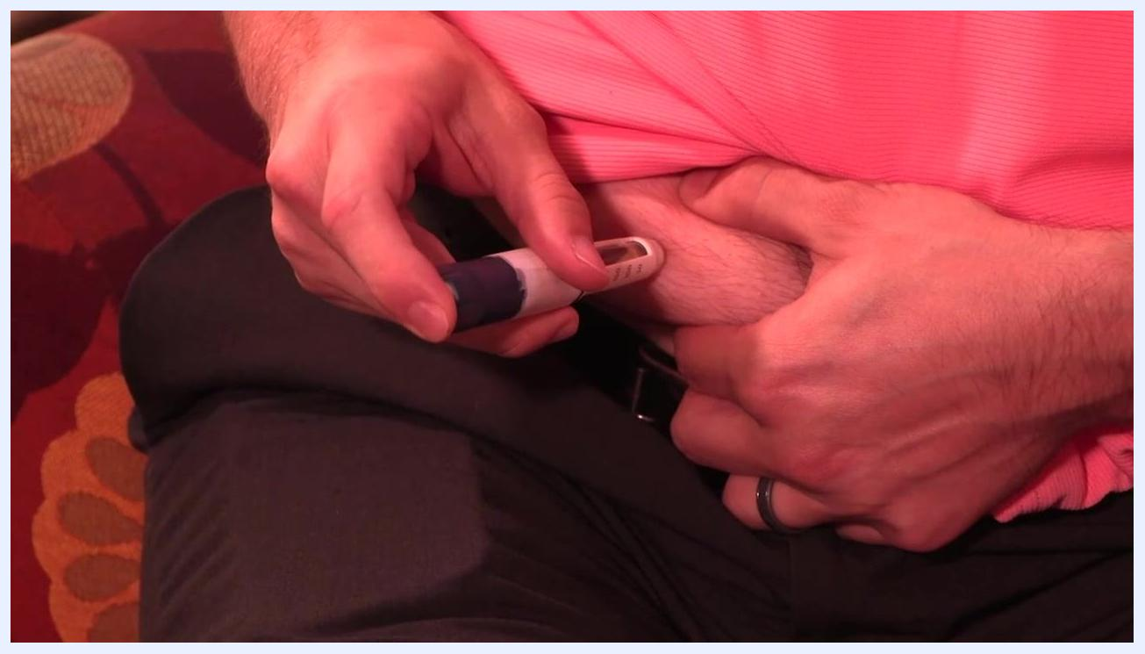
Close-up of insulin pen showing the dose dial set to a specific number of units

Phase 4: Giving the injection
If using a nano pen needle, pinching the skin is not necessary. For all other needle lengths, gently pinch the skin at the injection site. Insert the needle at a 90-degree angle into the skin, press the pen button to deliver the insulin, and watch the dose dial turn down to zero to confirm the full dose has been administered.
Person pinching skin on abdomen and injecting insulin pen at a 90-degree angle
Count to 10 slowly before withdrawing the needle from the skin. This ensures the entire dose is delivered and helps prevent insulin leakage.

Phase 5: Needle removal and disposal
Place the outer cap back onto the pen needle carefully, twist the capped needle off the insulin pen, and remove it. Never store the insulin pen with a used needle attached, as this can cause contamination or leakage.
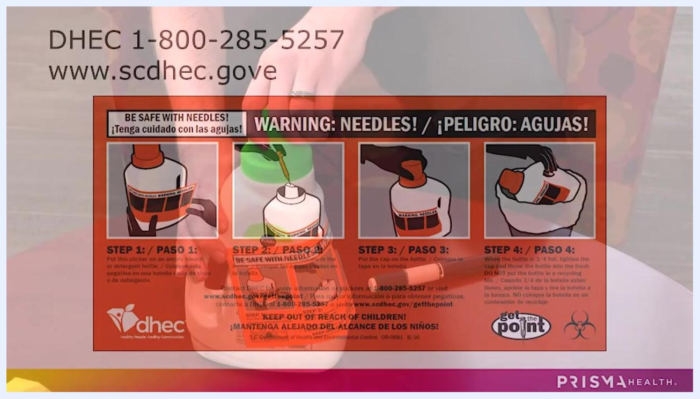
Person placing the clear outer cap back on the pen needle and twisting it off the insulin pen, with the pen and cap on a table
Put the main cap back on the insulin pen to keep it clean and protected, then place the capped, used needle immediately into a sharps container.

Pain Management
This procedure does not include a medication table, pain score target, or escalation pathway, as an insulin pen injection does not require pain medication. Discomfort can be minimized by gently pinching the skin (except when using a nano pen needle) and by inserting the needle at a 90-degree angle as described in the Care Protocol.

Mobility Milestones
Mobility milestones are not applicable to this procedure, since giving an insulin pen injection is a brief self-administered task rather than a recovery process requiring progressive mobility goals.

Complication Monitoring
Watch for the following risks and follow the corresponding preventive actions:
Risk | Preventive action
Infection at injection site | Wash hands before injecting; clean the site with an alcohol wipe and let it dry fully
Scar tissue development | Rotate injection sites every time, staying a few inches from the previous site
Contamination or leakage | Never store the pen with a needle attached; attach the needle only immediately before injecting
Incomplete dose | Prime the pen before every use; watch the dial return fully to zero; count to 10 before removing the needle
Needlestick injury | Recap the used needle immediately and place it in a sharps container right away
Use a homemade sharps container, such as a hard plastic detergent or milk jug, and place the used needle (with its cap on) into the container immediately after removal.
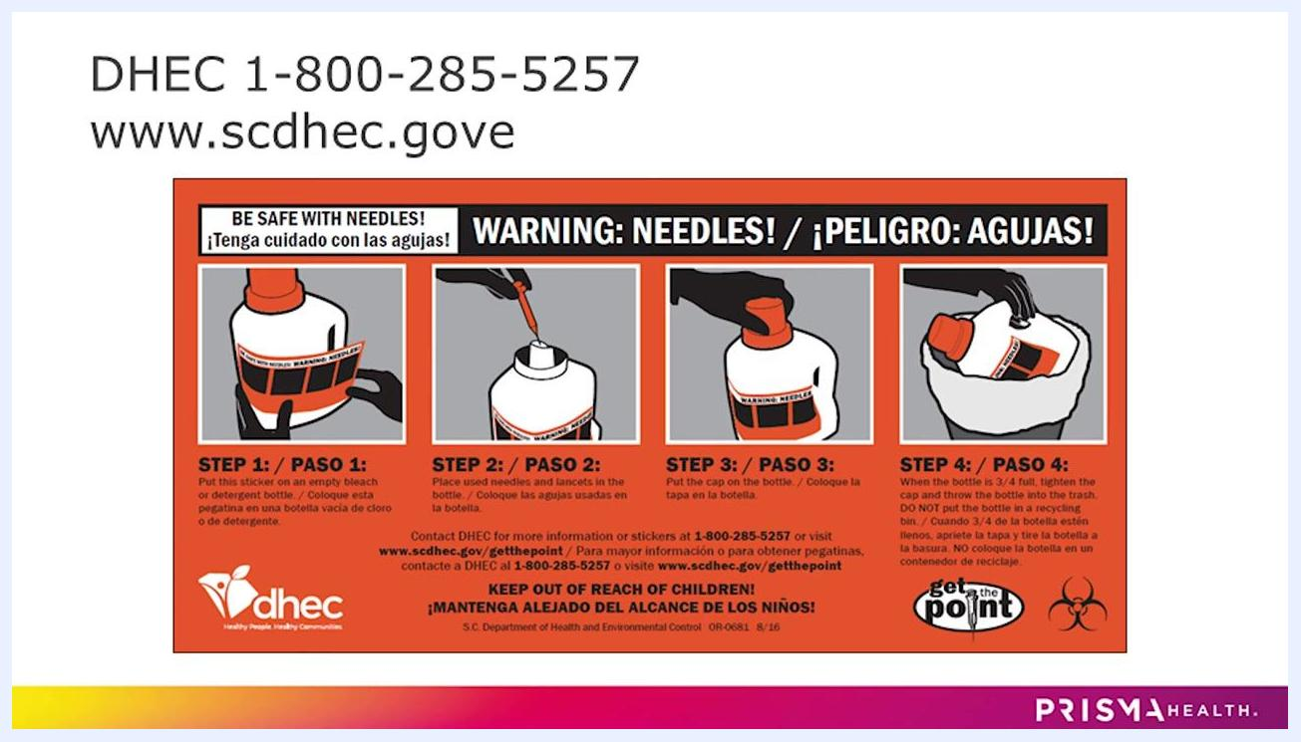
Homemade sharps container made from a detergent bottle with a warning sticker, insulin pen, needle cap, and green cap on a table
When the container is three-quarters full, secure the cap tightly, throw it in the regular trash (never in a recycling bin), and keep it out of reach of children at all times.
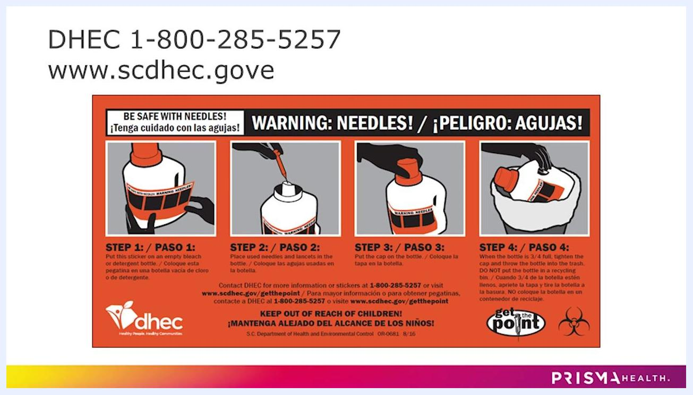
DHEC contact information and warning sticker instructions for sharps disposal, including phone number and website
For further assistance with any complication, contact your healthcare provider.

Discharge Criteria
An insulin pen injection is complete and can be considered finished when all of the following are met:
Criterion | Confirmation
Full dose delivered | Dose dial has returned fully to zero
Needle held in place | Needle was left in the skin for a count of 10 after pressing the button
Needle safely removed | Outer cap replaced and needle twisted off the pen
Pen stored properly | Main cap replaced on the pen with no needle attached
Needle disposed of | Used, capped needle placed immediately into a sharps container

Patient Education
Before ending the injection routine, review the following points with the patient or caregiver:
- Wash hands with warm soapy water for at least 20 seconds before every injection.
- Understand the difference between basal (daily, regardless of eating) and bolus (with meals) insulin.
- Rotate injection sites among the abdomen, back of the arm, upper thigh, and buttocks, staying at least two inches from the belly button.
- Use a new pen needle or syringe for every injection; never reuse them.
- Prime the pen before each injection and confirm a drop of insulin appears at the needle tip.
- Never store the insulin pen with a needle attached.
- Dispose of used needles in a proper sharps container, such as a homemade one made from a hard plastic bottle.
The South Carolina Department of Health and Environmental Control (DHEC) provides free warning stickers to label a homemade sharps container. Place the sticker on the container to clearly indicate it contains hazardous sharps.
Close-up of DHEC warning sticker for sharps containers, with instructions and illustrations in English and Spanish
DHEC will mail these stickers free of charge, or they can be printed from the DHEC website. Contact DHEC at 1-800-285-5257 or visit www.scdhec.gov/getthepoint for more information or to request stickers.
DHEC contact information and warning sticker instructions for sharps disposal, including phone number and website
For more information, visit PrismaHealth.org or follow Prisma Health on social media for additional resources and support.
PrismaHealth.org website and social media icons for Facebook, Twitter, Instagram, and YouTube
By following these steps, the patient or caregiver can safely complete the insulin injection and properly dispose of all sharps, protecting themselves and others from accidental injury or contamination. For further assistance, contact a healthcare provider or use the resources listed above.

