How to Give a Subcutaneous Injection
This guide explains how to give a subcutaneous (sub-Q) injection at home. Subcutaneous means "below the skin," and this type of injection delivers medicine into the fatty tissue just beneath the skin surface. Follow the steps below in order to prepare your supplies, draw up your medication, administer the injection safely, and dispose of used materials correctly.
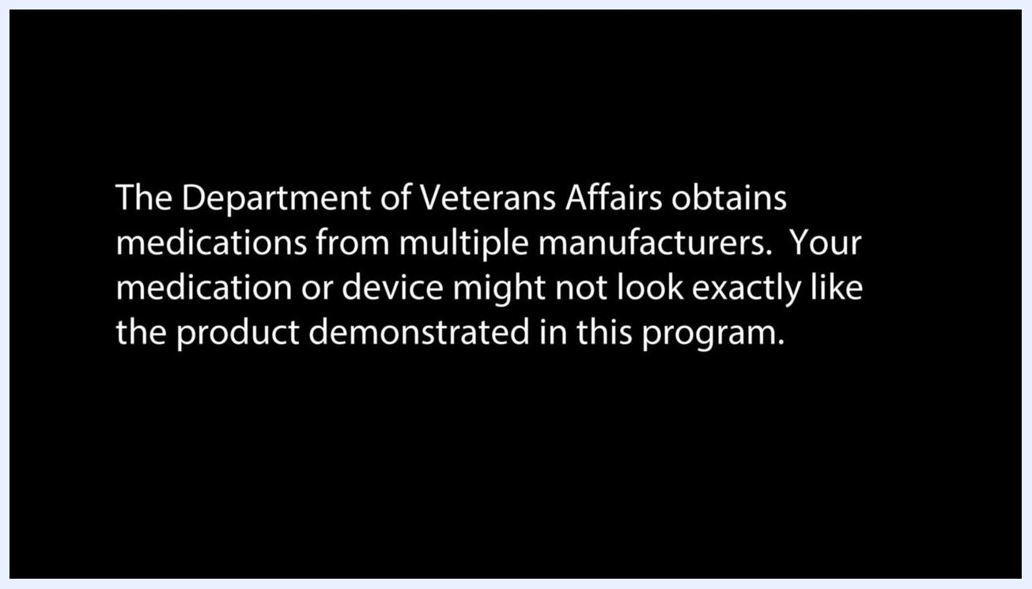
Text notice: "The mention or depiction of a manufacturer-specific medicine or device does not constitute a VA endorsement of that medicine or device."

Purpose
This procedure describes how to safely give yourself a subcutaneous injection, from gathering supplies through disposal of the used syringe. Always follow the specific instructions given by your healthcare provider for your medication and dosage, as they take priority over general guidance.

Scope
Subcutaneous injections are commonly used to manage several health conditions, including:
- Diabetes
- Anemia
- Blood clotting disorders
Important notice: Medications are obtained from multiple manufacturers, so your medication or device may not look exactly like the ones shown in this guide. Reference to any manufacturer-specific medicine or device in this document does not represent an endorsement of that product.
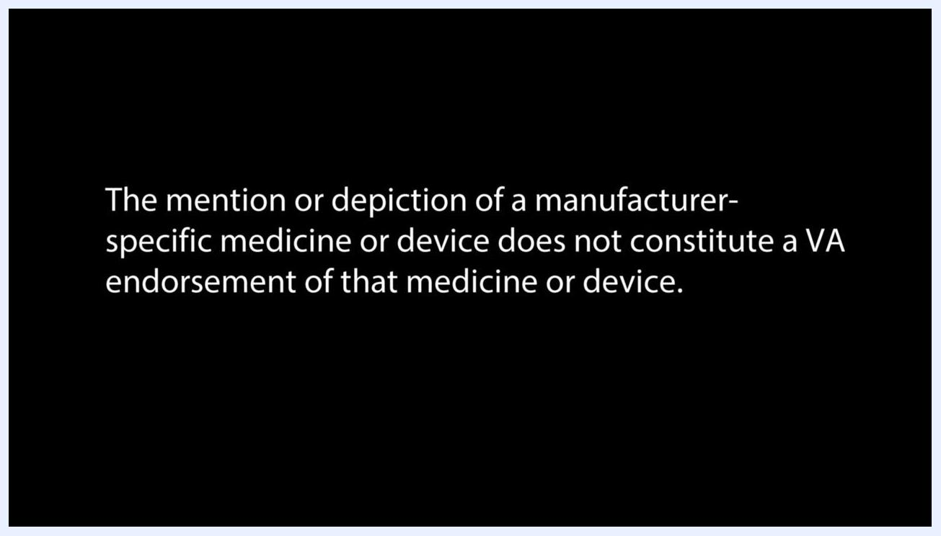
Illustration showing a needle inserted at the correct depth and location into the fatty tissue below the skin for a subcutaneous injection.

Overview: Injection devices and medication forms
Medications for subcutaneous injection are packaged in a few different ways, and it helps to recognize which type you have before you begin.
- Auto-injectors or pens: Pre-loaded devices with instructions printed directly on the label.
- Traditional syringes: May come pre-filled with medicine.
- Vials: Medicine must be withdrawn from the vial each time you give yourself an injection.
Text notice: "The Department of Veterans Affairs obtains medications from multiple manufacturers. Your medication or device might not look exactly like the product demonstrated in this program."
Medicine may come in liquid or powder form. Powdered medicine must be mixed with a liquid, such as saline or distilled water, before use.
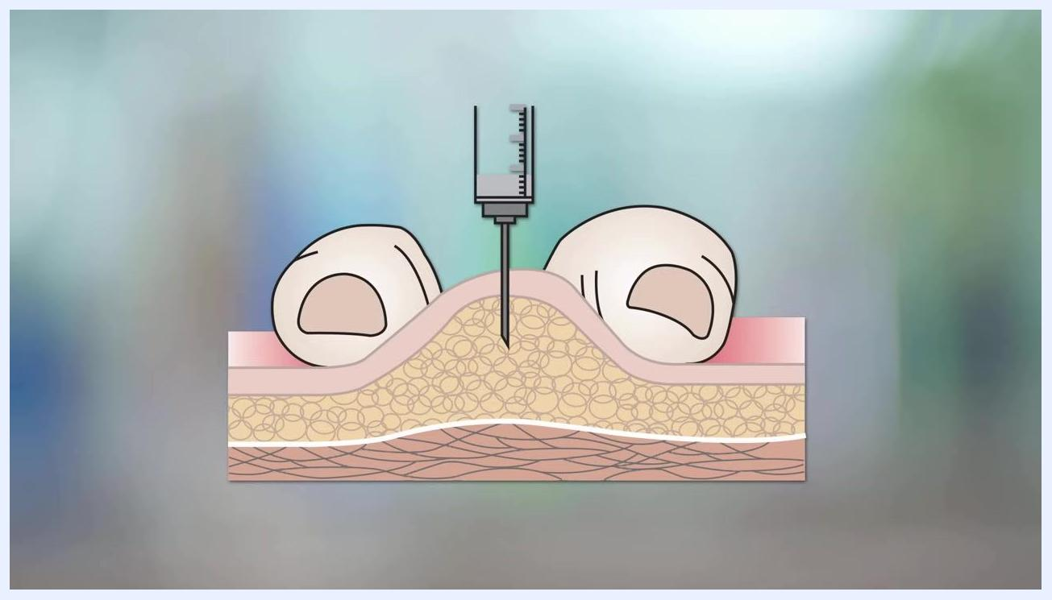
A cylindrical auto-injector device with instructions printed on its label, resting on a table.
To give a subcutaneous injection, you insert a small needle into the fatty tissue just below the skin and inject the medicine into that tissue.
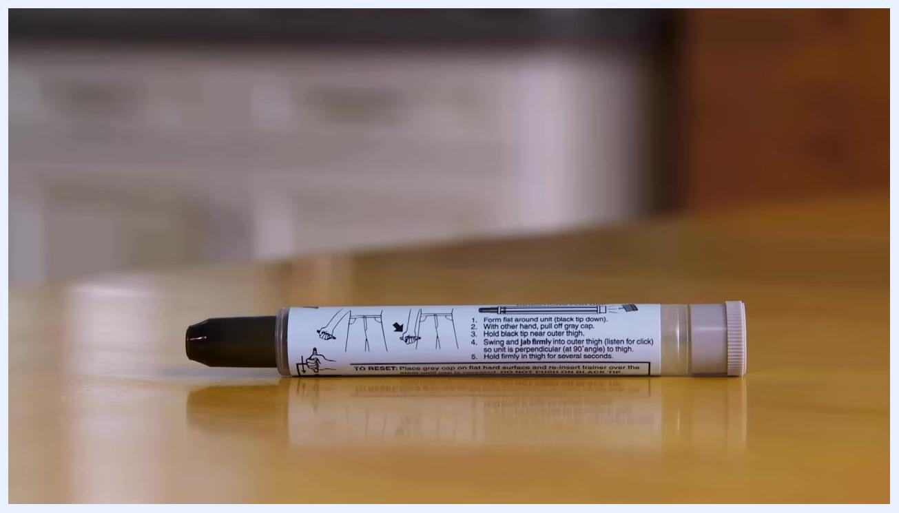
A single vial of sodium chloride injection with a yellow cap, standing on a table.
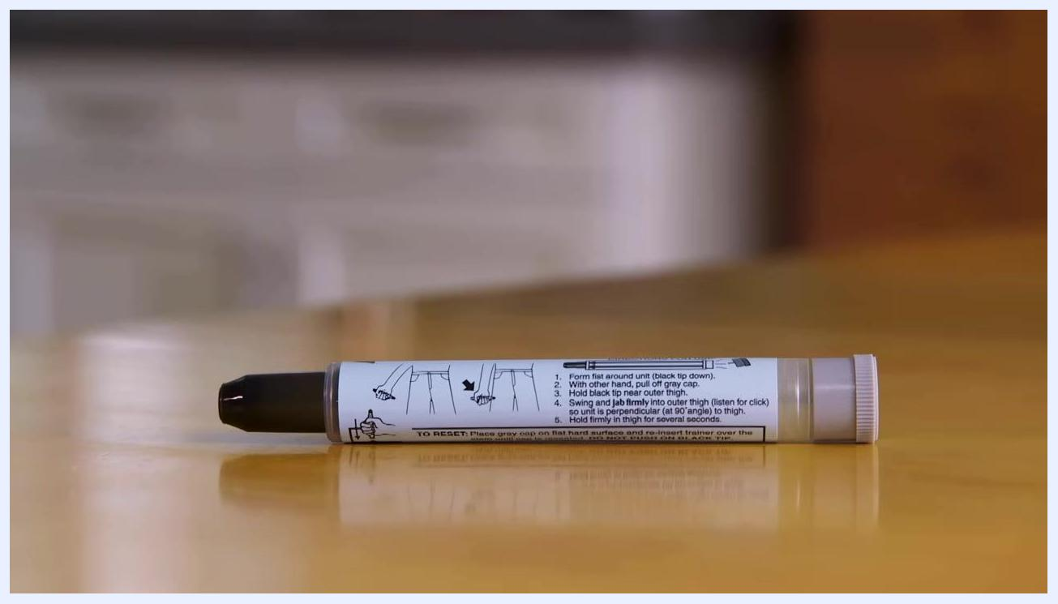
Two medication vials, one brown and one clear, each with a label and colored cap, placed on a table.

Required supplies
Before you begin, gather the following items:
- Alcohol pads or cotton swabs dipped in rubbing alcohol
- A disposable syringe
- The vial of medicine you will be using
- Adhesive bandages
- A sharps container or another safe disposal container for the used syringe
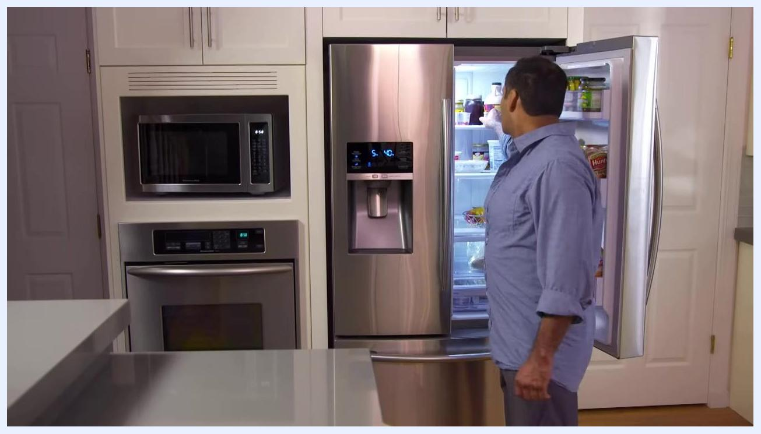
A person washing their hands at a kitchen sink with running water.

Procedure

Step 1: Let refrigerated medication reach room temperature
If your medication is stored in the refrigerator, remove it and let it sit at room temperature before use. Injecting cold medicine can be more painful, so this step helps reduce discomfort.
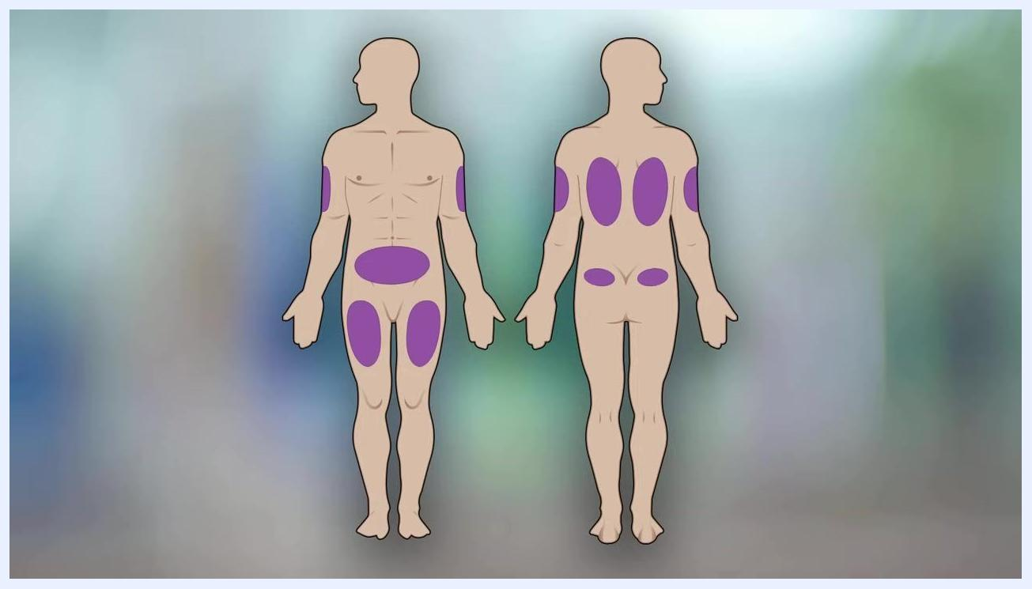
A person at a kitchen table with alcohol pads, a medicine vial, a disposable syringe, adhesive bandages, and a sharps container laid out.

Step 2: Wash your hands
Wash your hands thoroughly with soap and warm water before handling any supplies or medication. Proper handwashing helps prevent infection.
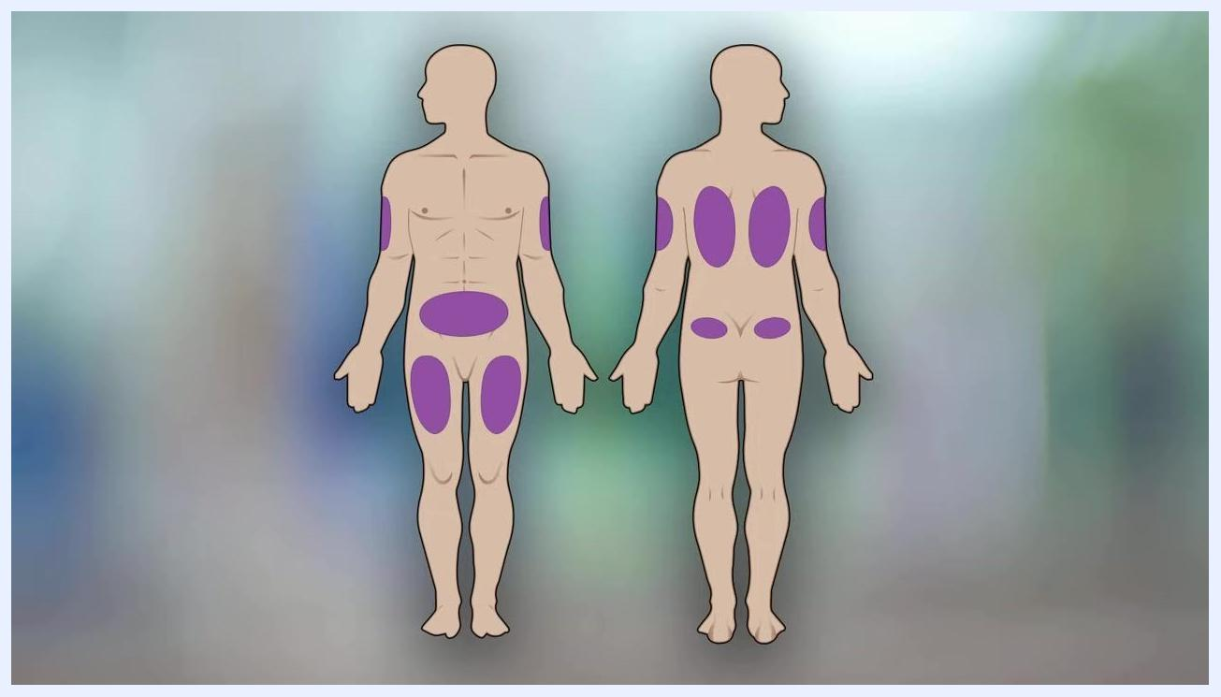
Close-up of an upright syringe on a table with its parts labeled: needle, barrel, and plunger, with measurement markings visible on the barrel.

Step 3: Gather your supplies
Check that you have all required items on hand: alcohol pads or cotton swabs, a disposable syringe, your medicine vial, adhesive bandages, and a sharps container.
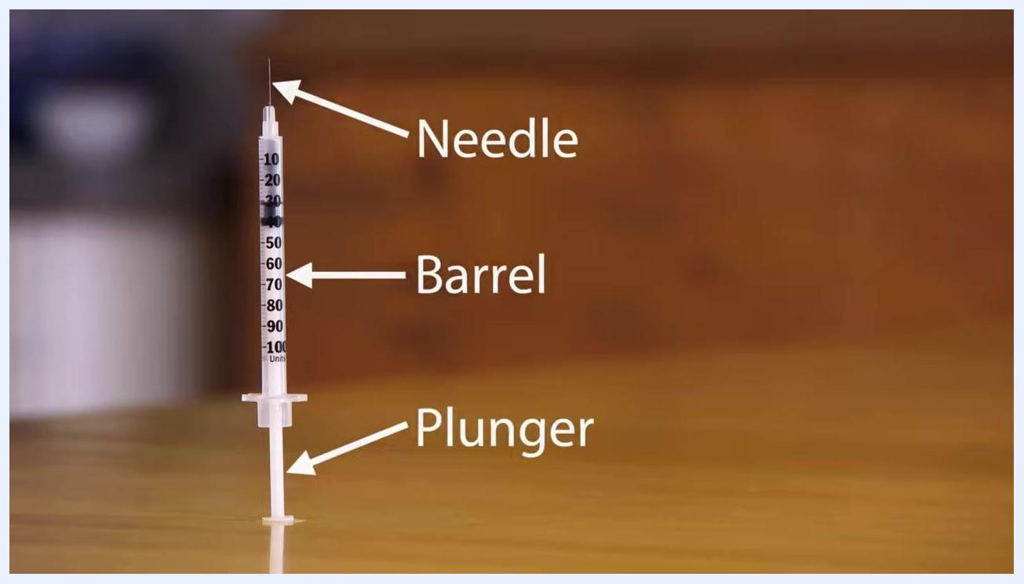
Close-up of a syringe standing upright with its measurement markings clearly visible.

Step 4: Lay out your supplies
Open your supply container and lay out the alcohol pads, medicine vial, disposable syringe, adhesive bandages, and sharps container on a clean surface so everything is within easy reach.
A person seated at a kitchen table with a red-lidded container and a red sharps disposal container, preparing to gather supplies.

Step 5: Choose an injection site
Subcutaneous injections can be given in the upper arm, upper thigh, outer hip, or abdomen. Do not inject into areas that are bruised, tender, or scarred.
Diagram of a human body, front and back, with purple shading marking recommended subcutaneous injection sites at the upper arms, abdomen, upper thighs, and outer hips.
Safety note: Rotate your injection site each time rather than using the exact same spot repeatedly, which helps prevent tissue damage.

Step 6: Identify the parts of your syringe
Every syringe has three main parts: the needle, which enters the skin; the barrel, which has measurement markings in units or milliliters to help you draw the correct dose; and the plunger, which you push to inject the medicine. Insulin syringes are usually marked in units, while other syringes may be marked in milliliters.
A person reaching into an open refrigerator in a kitchen to retrieve medication.

Step 7: Check the syringe markings
Review the measurement markings on your syringe carefully. Your healthcare provider will instruct you on how to use these markings to measure your dose accurately.
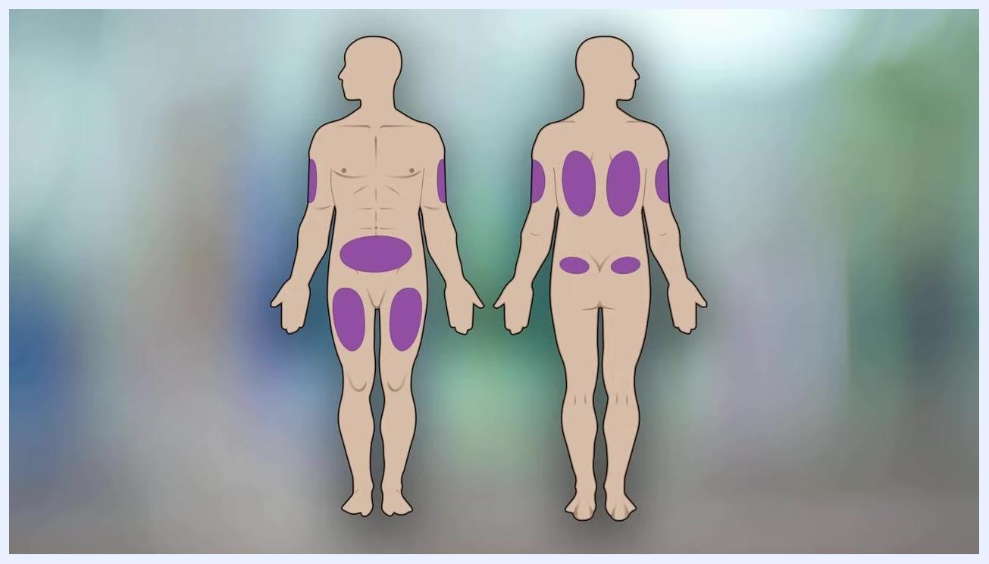
A second diagram of the human body with shaded injection zones, emphasizing site rotation and the need to avoid damaged skin areas.

Step 8: Let the alcohol dry on the vial
After cleaning the vial's rubber stopper with an alcohol swab, allow it to dry for a few seconds before proceeding. This prevents stinging and reduces the risk of contamination.

Step 9: Remove the cap from the plunger
If your syringe has a cap on the plunger end, take it off before drawing up medication.

Step 10: Draw air into the syringe
Pull the plunger back to the prescribed unit mark to draw air into the syringe. This amount should match your medication dose.

Step 11: Insert the needle into the vial
Carefully remove the cap from the needle and set it aside on a clean surface, then push the needle through the rubber stopper at the top of the medication vial.

Step 12: Inject air into the vial
Flip the vial and syringe upside down, keeping the needle tip below the surface of the liquid, then slowly push the plunger all the way in to inject the air into the vial.
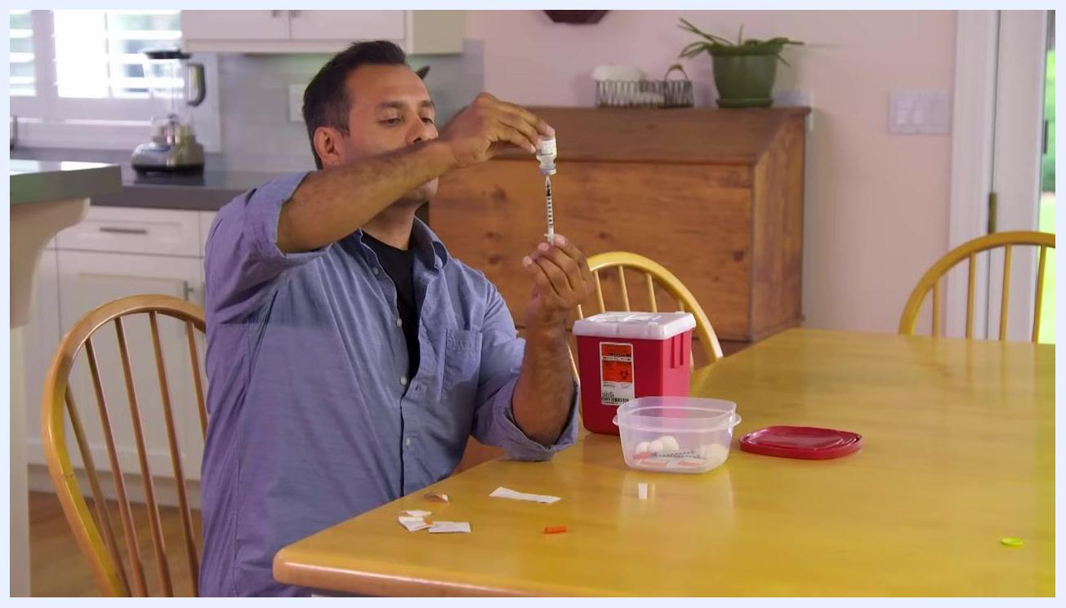
A person drawing medication into a syringe from an inverted vial, keeping the needle below the liquid surface.

Step 13: Draw up the medication
With the vial still upside down, slowly pull the plunger back to the prescribed unit mark to draw the correct dose into the syringe. Keep the needle tip under the liquid surface to avoid drawing in air.
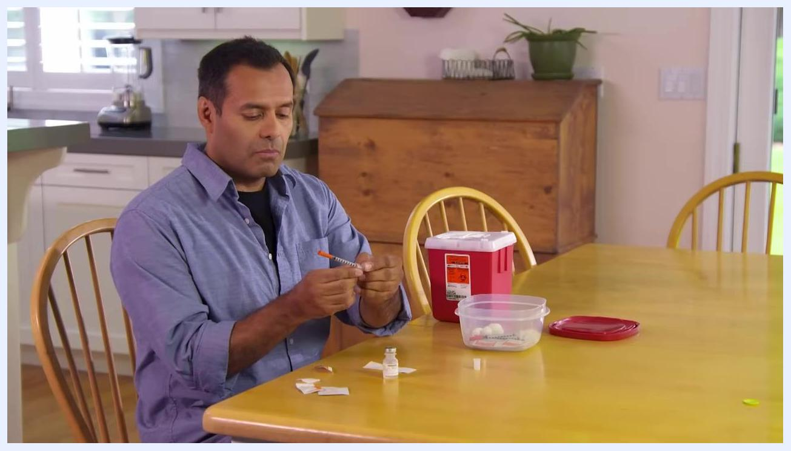
A person inserting the needle of a syringe into the top of a medication vial on a kitchen table.
Safety note: If you notice large air bubbles in the syringe barrel, push the plunger to send the medication back into the vial, then slowly draw the correct amount again, minimizing air bubbles.

Step 14: Prepare the injection site
Clean your chosen injection site with a fresh alcohol swab and allow the area to dry completely before injecting.

Step 15: Pinch the skin and position the needle
Using your non-dominant hand, pinch a section of skin at the injection site between your thumb and forefinger. Hold the syringe like a pencil and position the needle so it points straight at the skin at a 90-degree angle, or as instructed by your healthcare provider.
A person pulling back the plunger of a syringe to draw air to the prescribed unit mark.
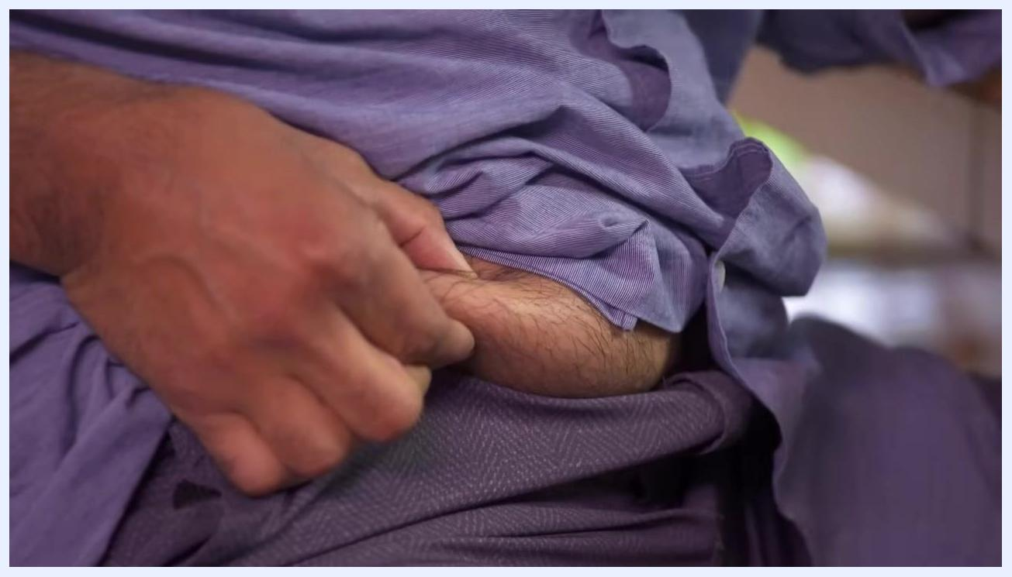
A close-up of a person pinching the skin on their abdomen in preparation for a subcutaneous injection.

Step 16: Insert the needle and inject the medication
With a firm, smooth motion, push the needle through the skin into the fatty tissue just beneath the surface. Shift your thumb to the plunger and slowly push it all the way in. Count to three to ensure the syringe is completely empty.
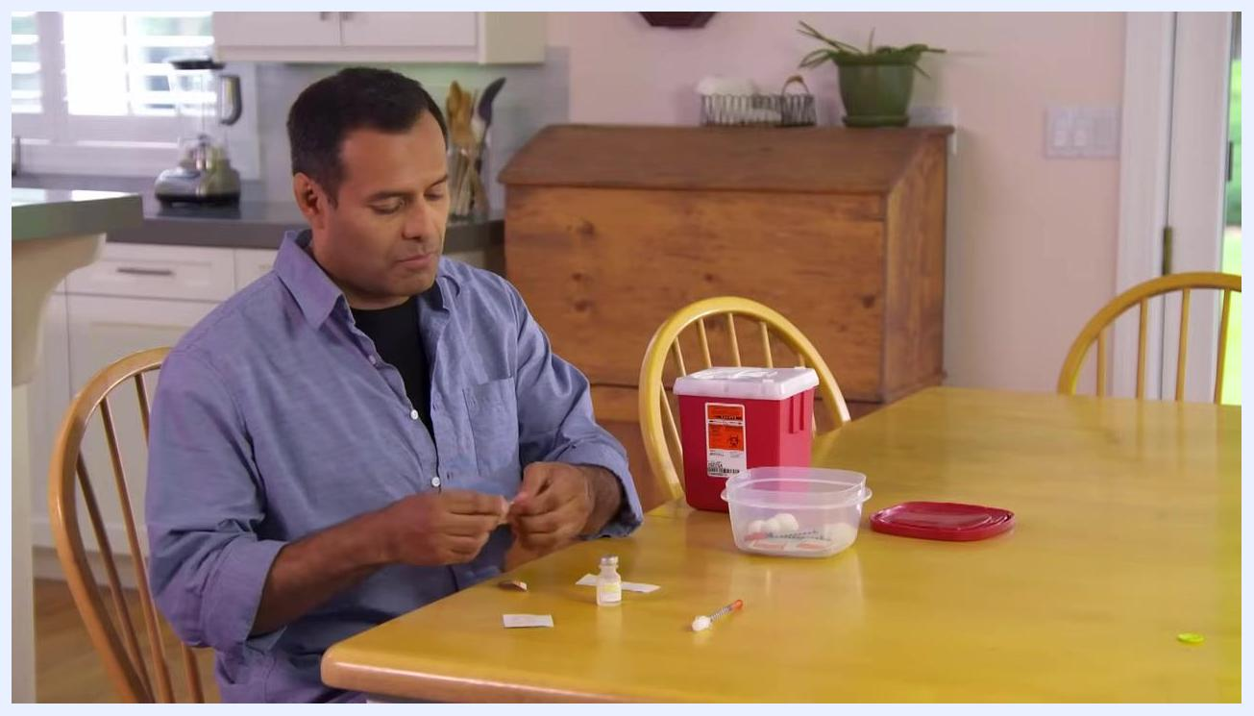
A person removing the cap from a syringe plunger at a kitchen table, with a vial, alcohol pads, and a sharps container visible.
A close-up of a person administering a subcutaneous injection into their abdomen, holding the syringe steady while pinching the skin.

Step 17: Withdraw the needle
Pull the needle straight out from the skin in one smooth motion.

Step 18: Dispose of the used syringe
Immediately place the used syringe into a sharps container. If you do not have a commercial sharps container, use a jar or bottle made of stiff plastic with a screw-on cap.
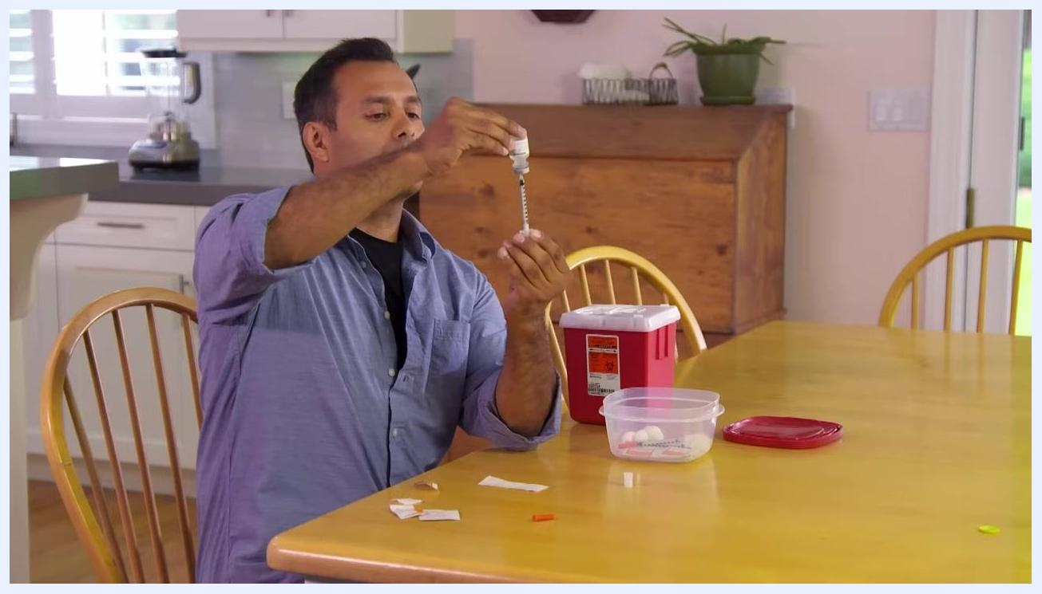
A person holding a vial upside down with a syringe inserted, pushing the plunger to inject air into the vial.
A person at a kitchen table disposing of used supplies after an injection, with a red sharps container and other supplies visible.

Step 19: Secure your sharps container
If using a household substitute container, clearly label it as "Dangerous" or "Sharps" so anyone who sees it knows not to touch it, and place it in a safe location out of reach of children and pets.

A person in a kitchen placing a red sharps container and a labeled plastic container on a table, next to a medication vial.

Step 20: Store your medication
If your medication requires refrigeration, return it to the refrigerator immediately after use. Confirm the refrigerator is set to the appropriate temperature recommended for your medication.

Step 21: Dispose of remaining supplies
Discard all other used supplies, such as alcohol swabs, wrappers, and packaging, in your regular household trash unless otherwise instructed.

A person opening a refrigerator door while holding a medication vial, preparing to store it.

Verification and summary
Confirm the following before finishing:
- The needle has been fully withdrawn and the syringe is empty.
- The used syringe is sealed inside a sharps container, clearly labeled and stored out of reach of children and pets.
- Refrigerated medication has been returned to proper storage.
- All remaining supplies have been discarded appropriately.
Subcutaneous injections may seem intimidating at first, but following these steps consistently allows you to safely and effectively administer your medication. Always keep sharps containers and medications in a secure place, and check your sharps container regularly, disposing of it according to local regulations once it is full.

What's next
If you have questions or concerns about your medication, injection technique, or disposal methods, contact your healthcare provider or pharmacist for assistance. For additional information and support, refer to resources provided by your healthcare provider or the relevant health authority overseeing your care.
The VA logo and the U.S. Department of Veterans Affairs seal and text on a white background.

