How to Give a Bed Bath: Standard Operating Procedure
This procedure explains how to give a bed bath to a resident who requires full assistance with hygiene. It demonstrates a skill described in the Nursing Assistant OER textbook and covers pre-procedure preparation, washing and rinsing the face, arms, chest, legs, back, and backside, and completing post-procedure room reset and documentation. Always review and follow your agency's policies when performing patient care, since local protocols may differ slightly from the steps described here.

Purpose
The purpose of this SOP is to guide you through giving a complete bed bath to a resident who cannot bathe independently. Following these steps ensures the resident is thoroughly cleaned, kept warm and comfortable, and treated with dignity and privacy throughout the process.

Scope
This procedure applies to caregivers performing a full bed bath for a resident confined to bed. It covers preparation, washing the upper body, washing under the leg and foot, transitioning to backside and perineal care, and the final steps of dressing the resident and resetting the room.

Requirements
Before you begin, gather the following supplies from the clean utility area:
- Four washcloths
- Two towels
- A clean gown (unless the resident prefers to wear their own clothing)
- A basin for water
- Disposable gloves
- Linen bag for soiled items
- Hand sanitizer or access to soap and water
You will need clean gloves throughout the procedure and must change them whenever you move between different body areas or handle soiled linens.
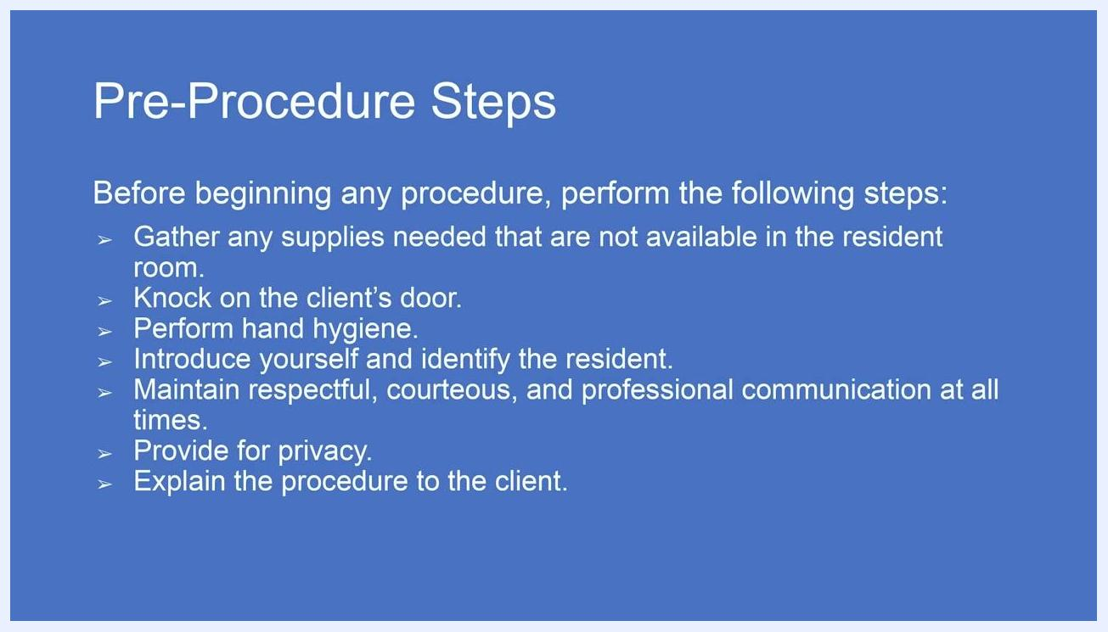
Screen with text: "Introduction. This video is an instructor demonstration of a skill described in the Nursing Assistant OER textbook. As always, review and follow agency policies when performing patient care."

Pre-procedure preparation
Complete the following steps before you begin the bed bath itself.

- Review pre-procedure steps. Before beginning any procedure, gather any supplies not available in the resident's room, knock on the client's door, perform hand hygiene, introduce yourself and identify the resident, maintain respectful and professional communication, provide for privacy, and explain the procedure to the client.
Screen with text: "Pre-Procedure Steps. Before beginning any procedure, perform the following steps: Gather any supplies needed that are not available in the resident room. Knock on the client's door. Perform hand hygiene. Introduce yourself and identify the resident. Maintain respectful, courteous, and professional communication at all times. Provide for privacy. Explain the procedure to the client."

- Gather supplies from the clean utility area. Sanitize your hands before leaving the room, then go to the clean utility area and collect four washcloths, two towels, and a clean gown (unless the resident will be putting on their own clothes).
A clinical setting with a nurse in blue scrubs standing near a hospital bed with a mannequin patient. A bedside table holds linens, towels, washcloths, a pink basin, and hygiene supplies.

- Enter the room and greet the resident. Knock on the resident's door, wash your hands upon entering, and greet the resident by name, identifying yourself as their caregiver and confirming they are ready to get up.
Nurse in blue scrubs standing at the foot of a hospital bed, hands together, addressing a mannequin patient. Supplies are organized on a bedside table.

- Provide for privacy. Close the privacy curtain around the resident's bed before continuing.
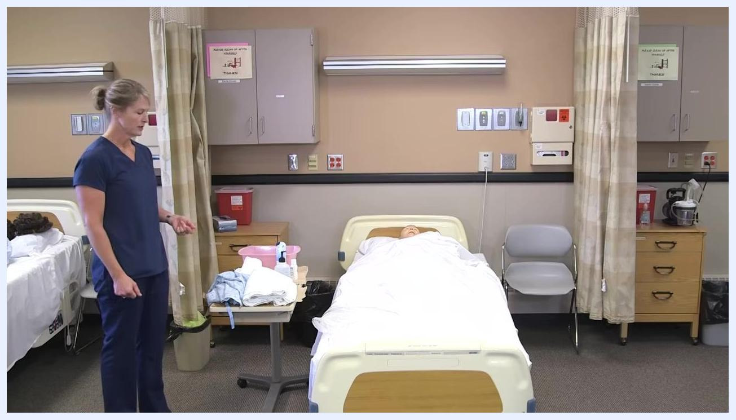
Nurse in blue scrubs pulling the privacy curtain around the bed, preparing for the procedure.

- Prepare the bed and resident. Raise the side rail on the side of the bed you are not working on for safety, tell the resident you will raise the bed to make it easier to work, and adjust the bed height as needed.
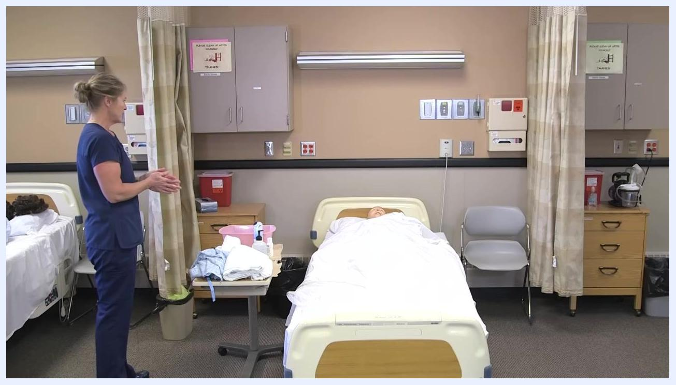
Nurse in blue scrubs adjusting the bed controls, raising the bed with the mannequin patient lying under a white sheet.

- Put on gloves. Put on a clean pair of gloves before beginning the bed bath.
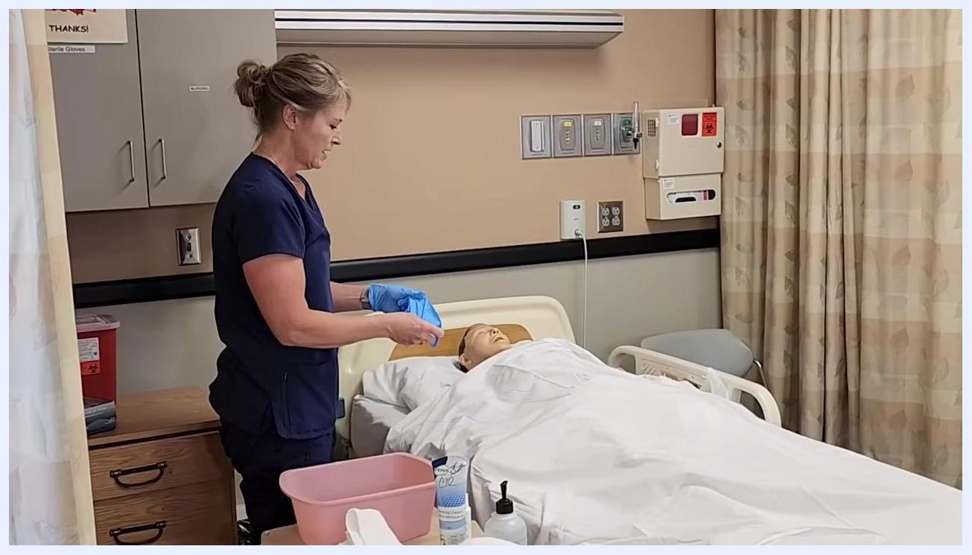
Nurse in blue scrubs putting on blue gloves, standing next to the bed and supplies.

- Explain the procedure and involve the resident. Tell the resident you will begin the full bed bath, starting the same way you would for a partial bed bath, and ask them to test the water temperature to make sure it is comfortable.
Nurse in blue scrubs holding a washcloth, speaking to the mannequin patient, with supplies including a pink basin and hygiene products on the bedside table.

Washing the face and arms
Follow these steps to wash, rinse, and dry the resident's face and arms as part of how to give a bed bath.

- Let the resident check the water temperature. Offer the resident the option to check the water by placing their hand in the basin or feeling a wet washcloth, and confirm the water is comfortable before proceeding.
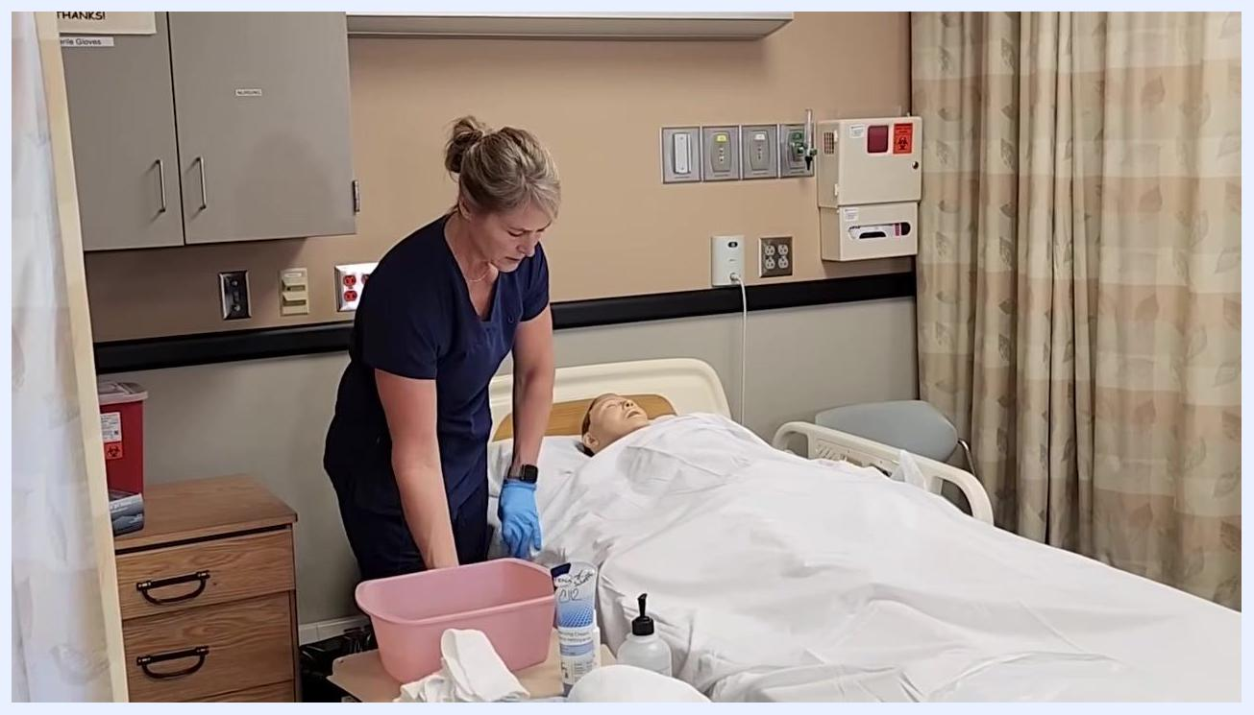
Nurse in blue scrubs, wearing gloves, standing beside a hospital bed with a mannequin patient. She is preparing to wet a washcloth in a pink basin on the bedside table, which also holds hygiene supplies and linens.

- Soak the washcloths. Place all four washcloths into the basin of water to soak.
- Protect the resident's chest. Place a dry towel over the resident's chest and under the chin to protect the bedding and provide modesty.
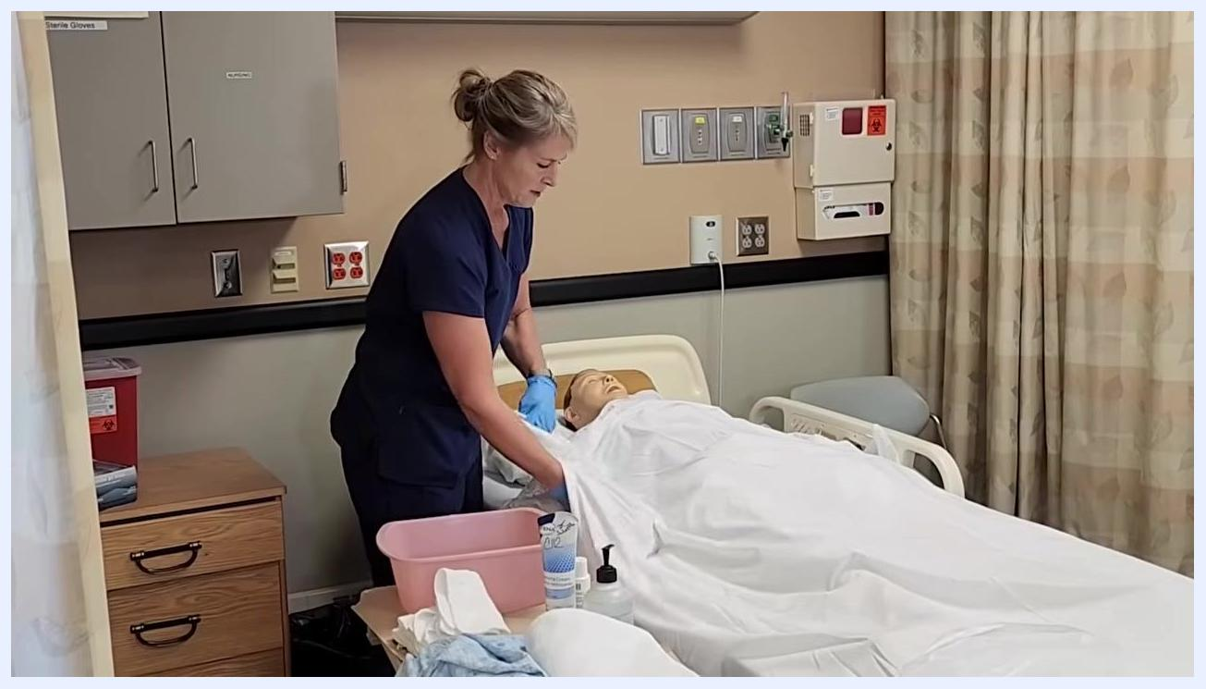
Nurse in blue scrubs placing a towel over the mannequin patient's chest, preparing for face washing. Supplies and a pink basin are on the bedside table.

- Wash the face. Use a clean, wet washcloth with no soap to avoid irritating the eyes. Start at the inner corner of one eye and wipe outward, using a different part of the washcloth for each eye, then continue washing the rest of the face with gentle strokes.
Nurse in blue scrubs reaching across the bed, gently washing the mannequin patient's face with a washcloth.

- Pat the face dry. Use a clean, dry towel to gently pat the resident's face dry and ask if everything feels comfortable.
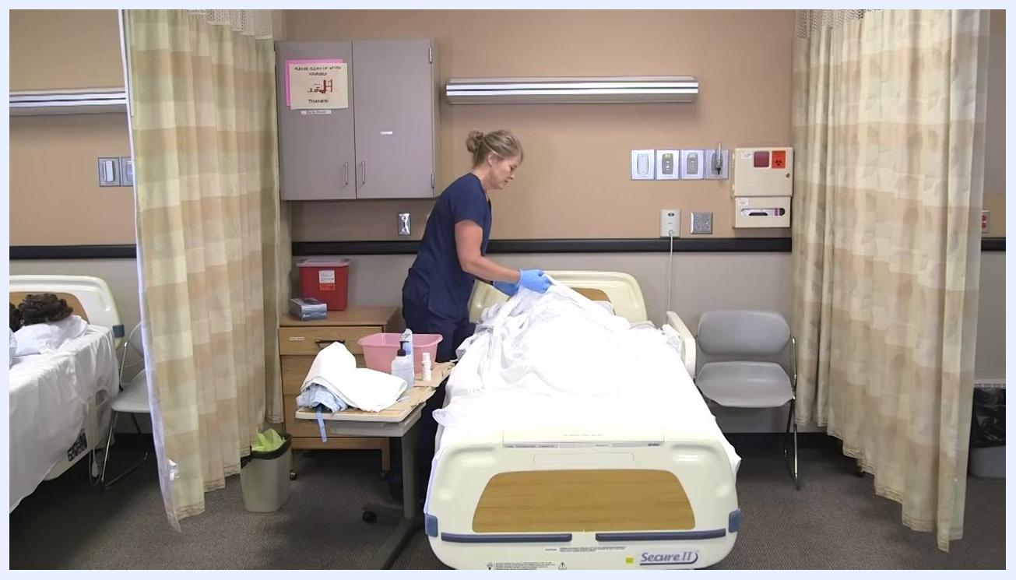
Nurse in blue scrubs gently patting the mannequin patient's face dry with a towel.

- Prepare to wash the arm. Place a towel underneath the resident's arm to keep the bed dry during washing.
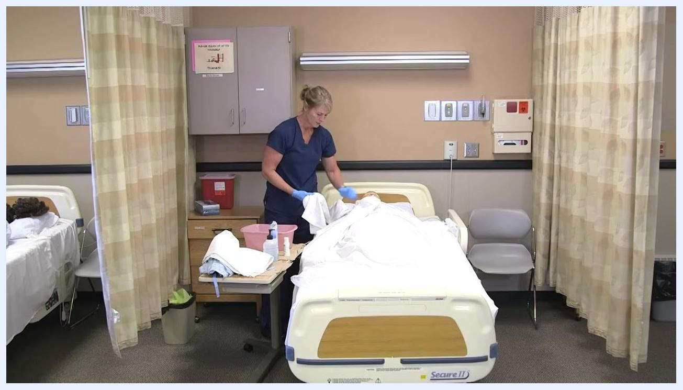
Nurse in blue scrubs placing a towel under the mannequin patient's arm, preparing for arm washing.

- Remove the gown from the arm. Carefully remove the gown from the arm you are about to wash while keeping the resident covered with the sheet or towel for privacy and warmth. Remind the resident to tell you if they feel cold.
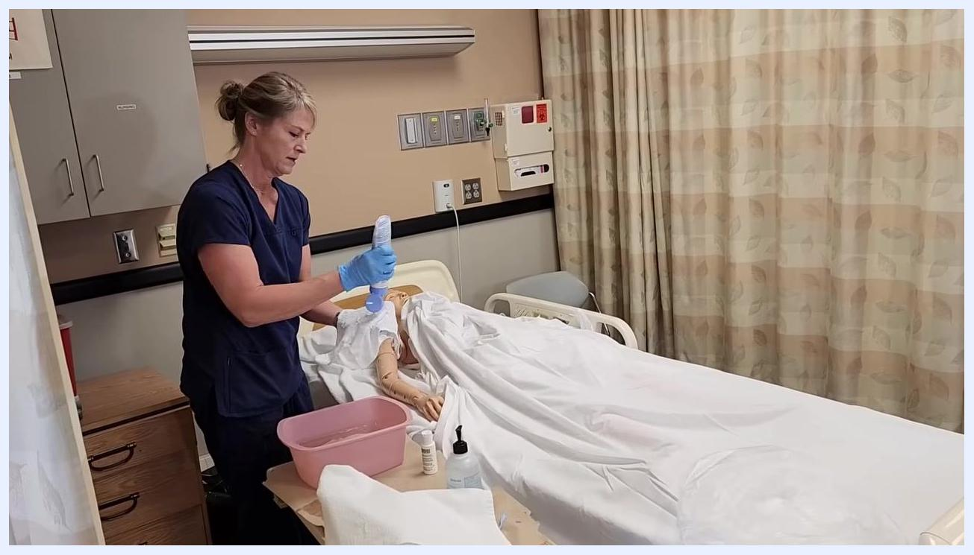
Nurse in blue scrubs removing the gown from the mannequin patient's arm while keeping them covered with a sheet.

- Apply soap to a washcloth. Take a clean washcloth and apply soap generously to it.
Nurse in blue scrubs applying soap to a washcloth over the pink basin, mannequin patient's arm exposed and ready for washing.

- Wash the arm. Wash the upper arm, forearm, and hand thoroughly, paying special attention to cleaning between the fingers, using gentle circular motions to ensure all areas are cleaned.
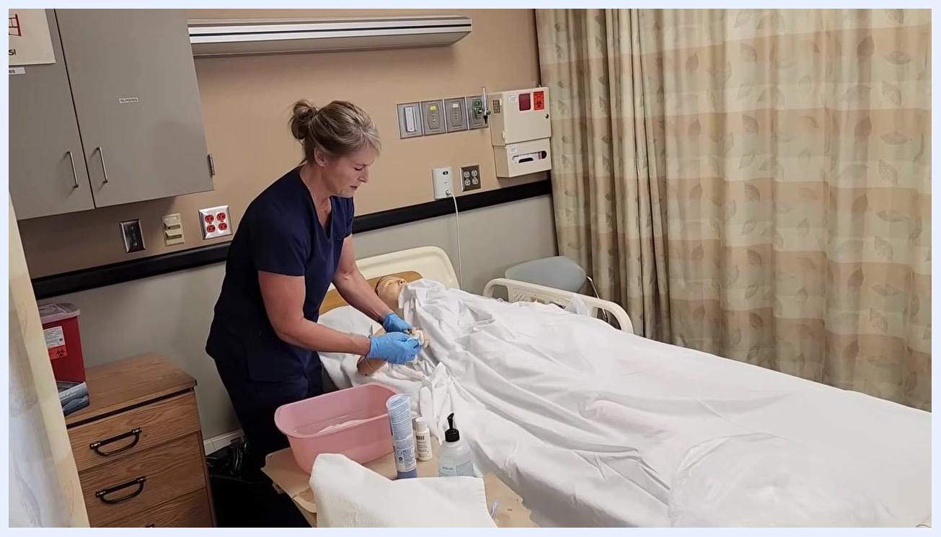
Nurse in blue scrubs washing the mannequin patient's arm with a soapy washcloth, towel underneath to protect the bed.

Rinsing and drying the chest and arm

- Wash the chest. Use the clean, soapy washcloth to wash the entire chest area. Keep the resident warm by working under the linens and only exposing the area being washed, holding the linens up to prevent them from getting wet.
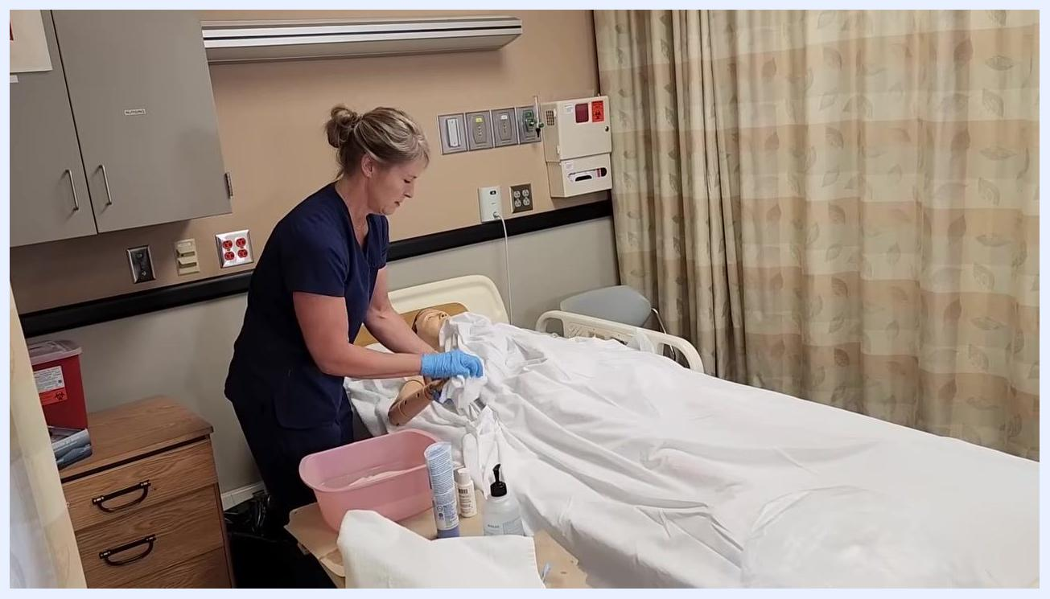
Nurse in blue scrubs, wearing gloves, washing the mannequin patient's chest under the linens, holding the sheet up to maintain warmth and privacy. Pink basin and hygiene supplies are on the bedside table.

- Set the soapy washcloth aside. Place the soapy washcloth on the side of the basin to avoid contaminating the rinse water with soap.
- Rinse the chest. Use a clean, wet washcloth with no soap to rinse the chest thoroughly, continuing to hold the linens up to keep them dry.
Nurse in blue scrubs holding up the linens with one hand while reaching for a clean washcloth from the pink basin with the other hand, preparing to rinse the mannequin patient's chest.

- Dry the chest. Use the towel that was placed under the resident's arm to gently pat the chest dry. Ask the resident if everything feels dry and comfortable, and pay special attention to drying under any abdominal folds, breast folds, or skin creases to prevent moisture buildup and irritation.
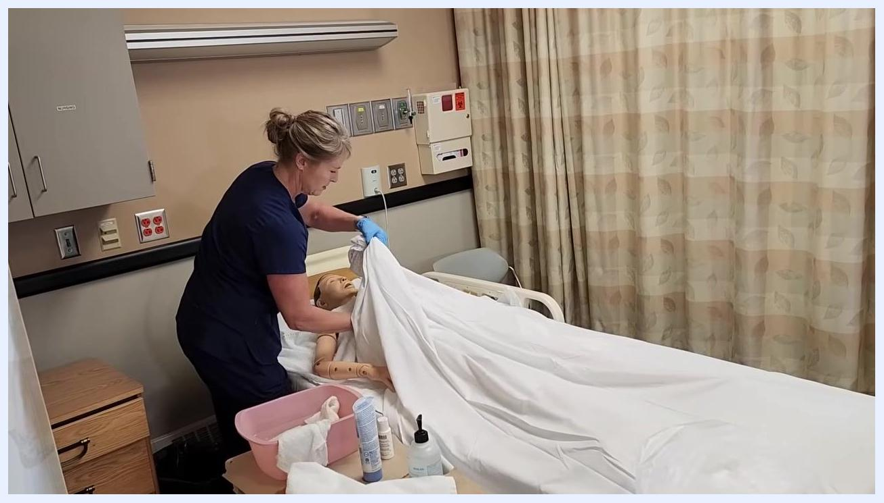
Nurse in blue scrubs patting the mannequin patient's chest dry with a towel, holding up the linens for privacy and warmth.

- Rinse the arm. Use a clean, wet washcloth with no soap to rinse the upper arm, forearm, and hand. Since this washcloth has no soap on it, you can place it back into the basin after use.
- Dry the arm. Gently pat the resident's arm dry with a clean towel, making sure all skin folds and creases are thoroughly dried to prevent irritation, and ask the resident if everything feels okay.
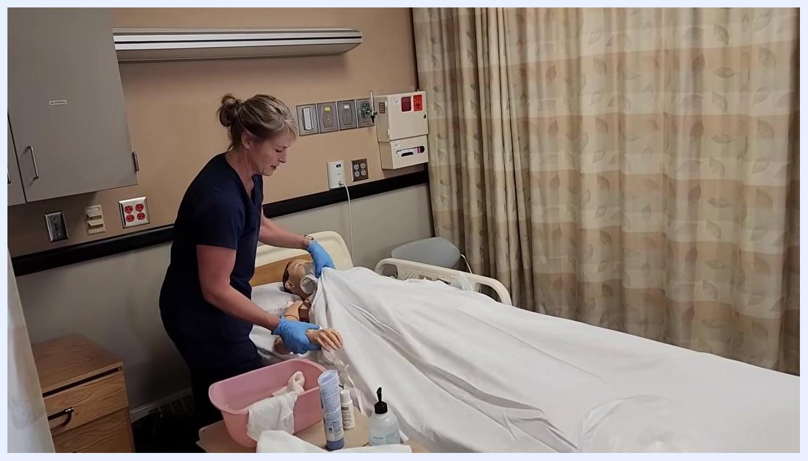
Nurse in blue scrubs patting the mannequin patient's arm dry with a towel, ensuring all areas are dry. Supplies and pink basin visible on the bedside table.

- Cover the resident. Cover the resident back up with the linens to maintain warmth and privacy.
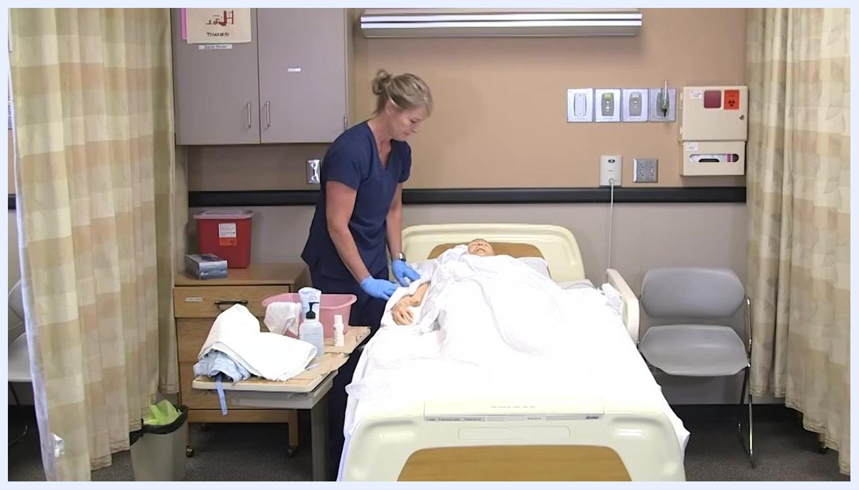
Nurse in blue scrubs covering the mannequin patient with linens after completing care for the upper body.

- Prepare to wash the lower body. Move to the lower part of the body, exposing only the leg you will wash next while keeping the resident covered elsewhere for privacy and warmth.
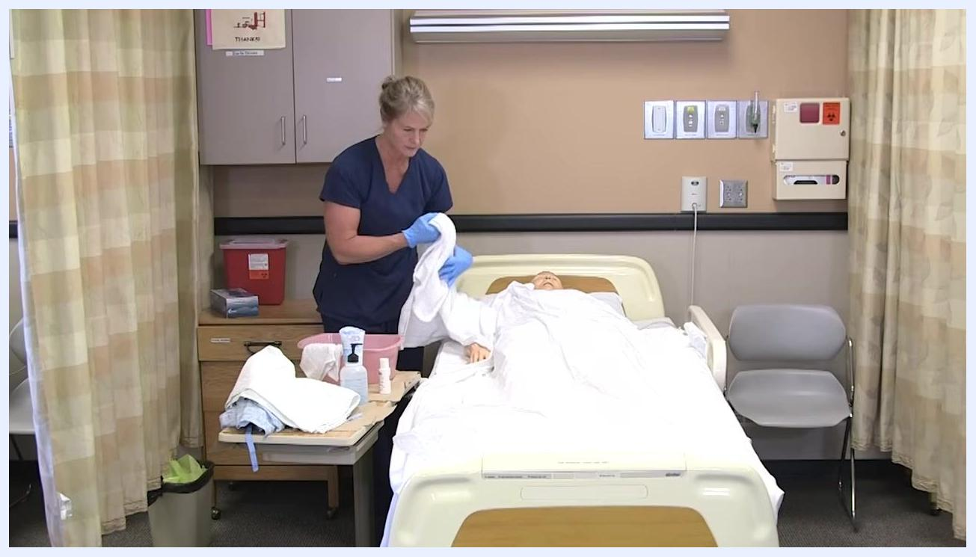
Nurse in blue scrubs preparing to wash the lower body, holding a towel and standing beside the mannequin patient, who is covered except for the arm.

Washing and rinsing under the leg
Follow these steps to wash, rinse, and dry under the leg and foot.

- Position the leg and place a protective towel. Put on disposable gloves, take a soapy washcloth, and gently lift the resident's leg to access the area underneath. Keep the resident covered with a sheet or towel for privacy and warmth, and place a towel or absorbent pad under the leg to protect the bedding.
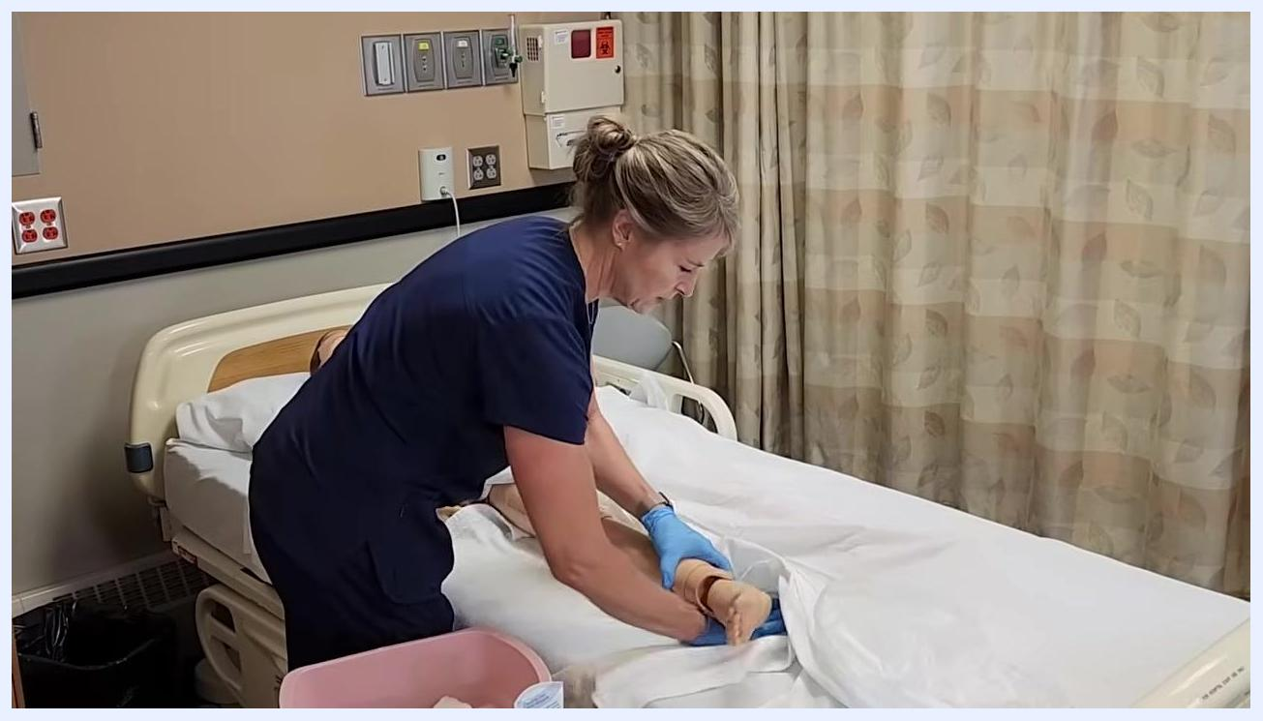
A healthcare worker in navy scrubs and blue gloves is lifting a mannequin's leg on a hospital bed, preparing to wash underneath. A pink basin with supplies is on the bedside table. The environment is a clinical room with privacy curtains and medical wall panels.
Safety note: If the soapy washcloth becomes cold, take it to the sink to warm it up again. Do not re-dip a used washcloth into the basin, as this will contaminate the clean water.

- Wash the leg and foot. Use the soapy washcloth to gently clean under the leg, moving from the thigh down to the foot and paying special attention to the area between the toes and around the foot. After washing, place the used soapy washcloth on the side of the basin, not inside it.
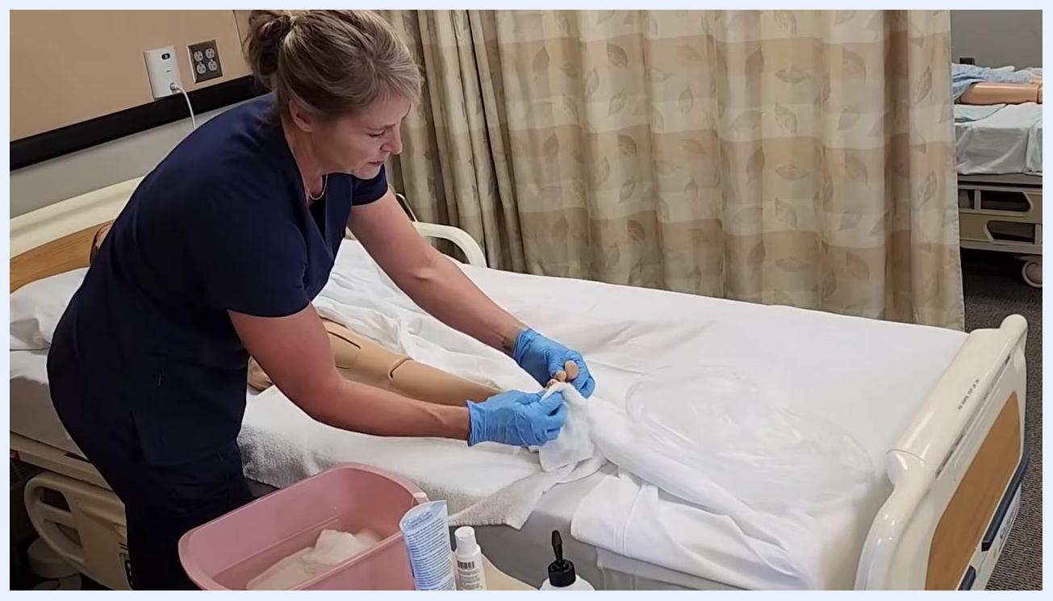
The healthcare worker is holding a soapy washcloth and demonstrating cleaning the mannequin's leg, with the leg resting on a towel. The pink basin and hygiene supplies are visible.

- Rinse the leg and foot. Take a clean, damp washcloth with no soap to rinse the leg and foot, making sure all soap is removed, especially between the toes, and confirm the resident is staying warm enough throughout the process.
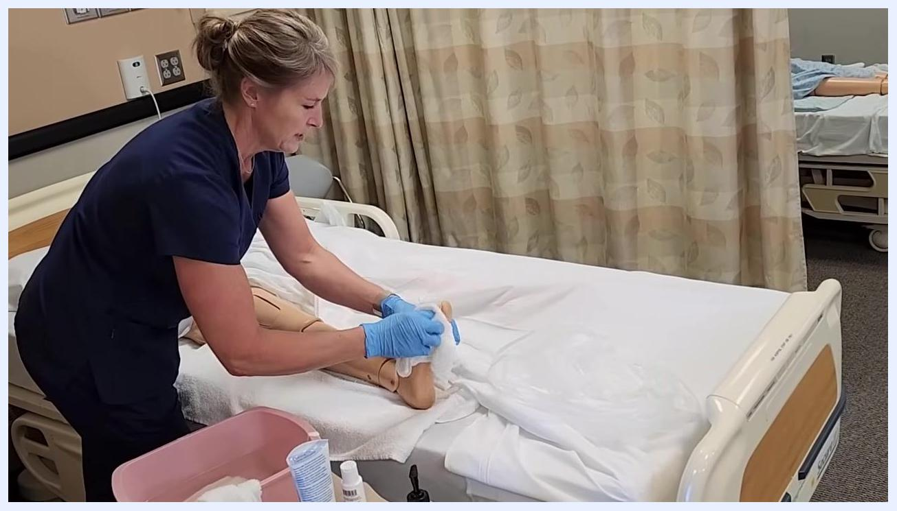
The healthcare worker is rinsing the mannequin's foot and toes with a clean washcloth, focusing on between the toes. The leg is supported on a towel, and supplies are nearby.

- Dry the leg and foot thoroughly. Use a dry towel to gently pat the leg and foot dry, paying close attention to drying between the toes and in all skin creases to prevent moisture buildup.
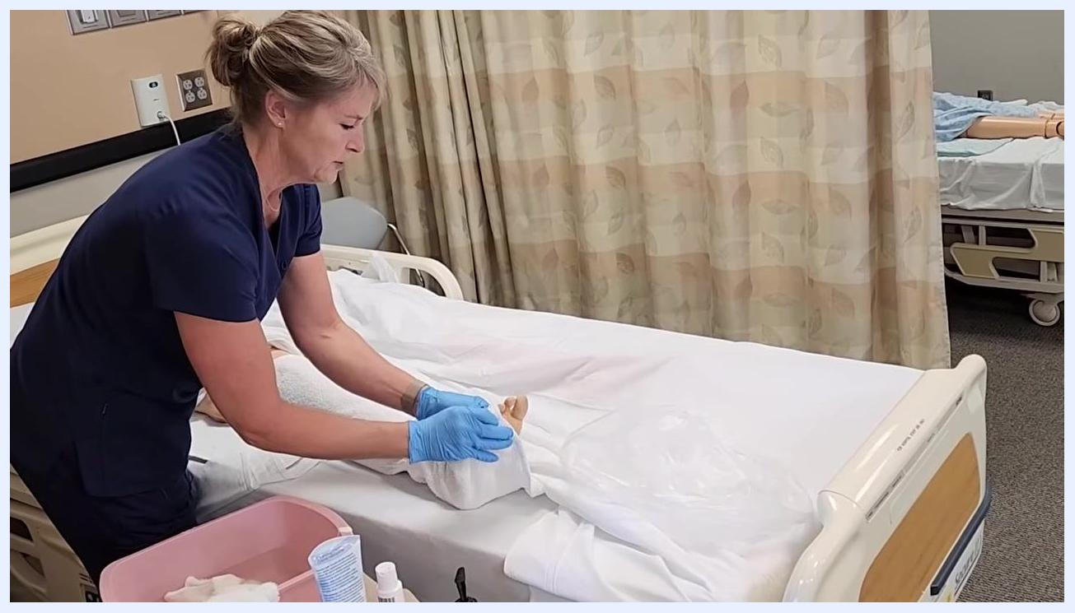
The healthcare worker is drying the mannequin's foot and toes with a towel, ensuring all moisture is removed from skin creases.

- Take extra care with diabetic residents. If the resident is diabetic, ensure the feet and toes are completely dry, since diabetic patients are more susceptible to infection, especially in moist areas between the toes.
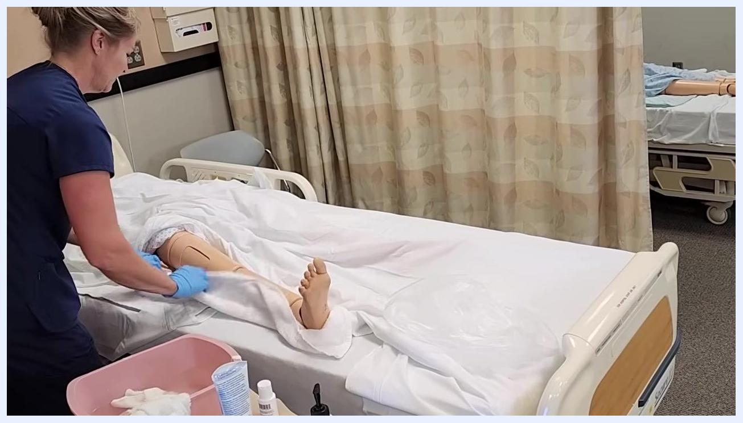
The healthcare worker is carefully drying the mannequin's foot, emphasizing the importance of dryness for diabetic residents.
Key points for this section:
- Always use a clean washcloth for rinsing; never re-dip a used cloth into the basin.
- Maintain resident privacy and comfort throughout the procedure.
- Ensure all soap and moisture are removed, especially for diabetic residents, to reduce infection risk.

Transitioning to perineal care and preparing for backside cleaning
After completing the under-the-leg washing and drying, follow these steps to move on to perineal care and prepare the resident for backside cleaning.

- Follow the dedicated perineal care procedure if needed. If you need guidance on perineal care specifically, refer to the dedicated perineal care procedure for detailed instructions. This procedure now moves on to cleaning the resident's backside.
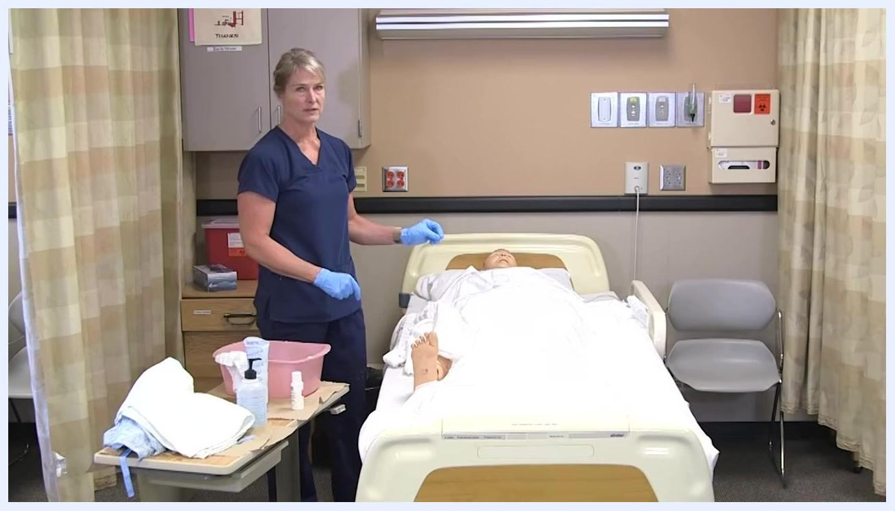
A healthcare worker in navy scrubs and blue gloves stands beside a hospital bed with a mannequin patient. A pink basin, towels, and hygiene supplies rest on a bedside table. The clinical room has privacy curtains, medical wall panels, and a sharps container.

- Prepare to clean the front side and dispose of used linens. Proceed to clean the front side of the resident, then place all used washcloths and towels into the linen bag to prevent cross-contamination. Do not reuse any soiled linens or washcloths.
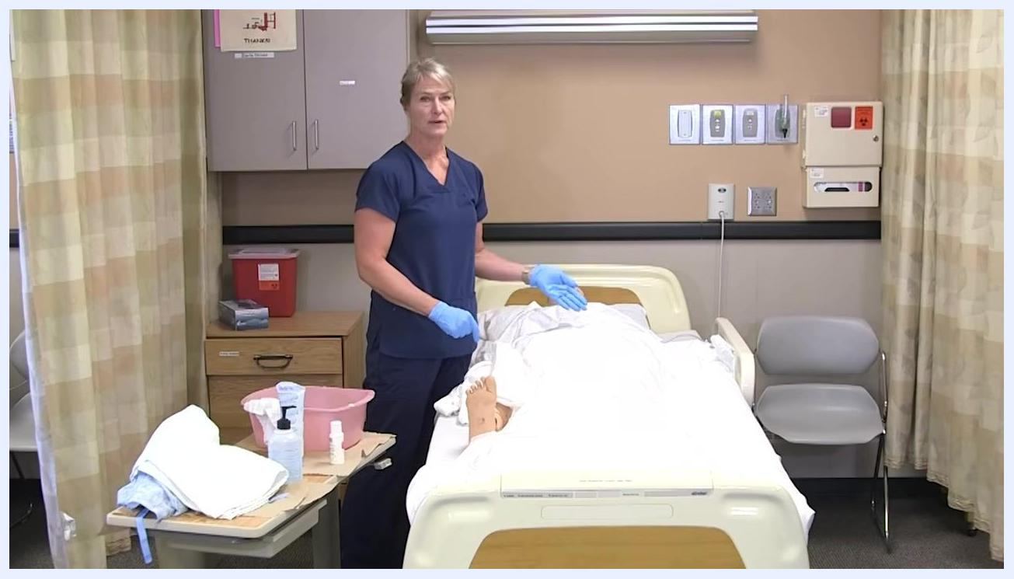
The healthcare worker gestures toward the mannequin patient, indicating the next step. The supplies remain organized on the bedside table.

- Change gloves before proceeding. Remove your gloves after handling soiled linens or after completing the front side cleaning, dispose of them in the appropriate waste container, and put on a new pair of gloves before starting the next cleaning procedure.
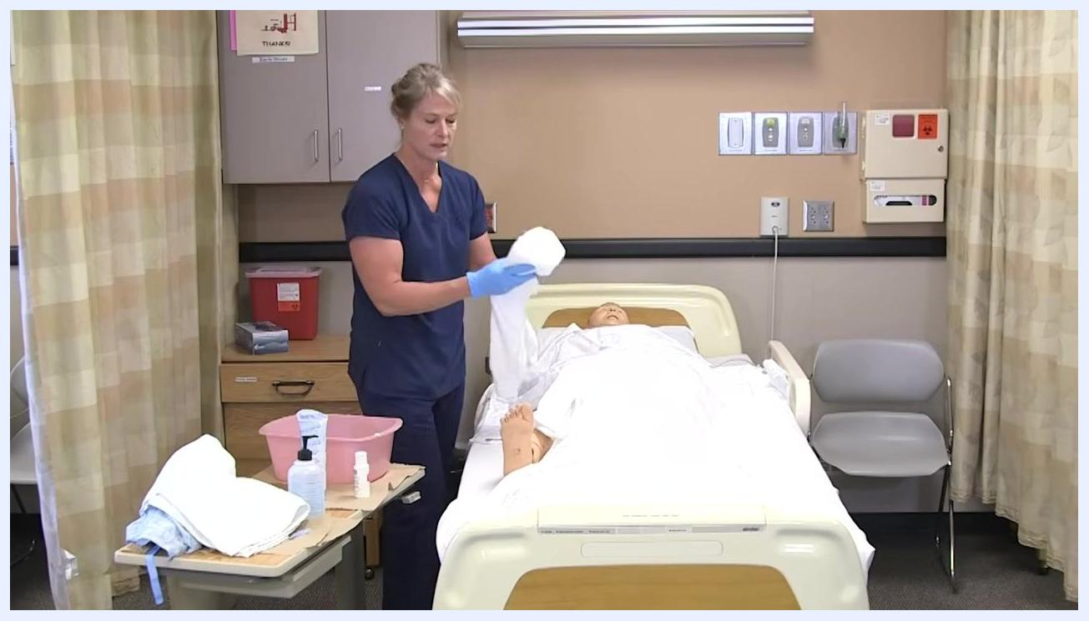
The healthcare worker is holding a clean towel and preparing to change gloves, standing beside the bed and supplies.

- Dispose of soiled linens and prepare for repositioning. Place soiled towels and washcloths in the linen bag or designated disposal area, ensure the resident is covered and comfortable, and move to the bedside table or linen disposal area as needed.
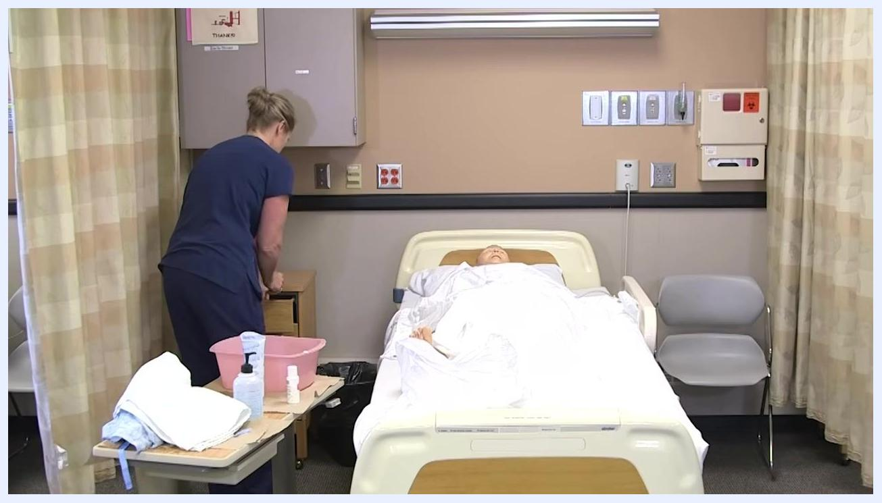
The healthcare worker is turned toward the bedside cabinet, disposing of linens. The mannequin remains covered on the bed.

- Put on fresh gloves and prepare to turn the resident. Put on a new pair of gloves, explain to the resident that you will assist them in turning onto their side, and raise the side rail on the opposite side of the bed for safety and to provide a handhold.
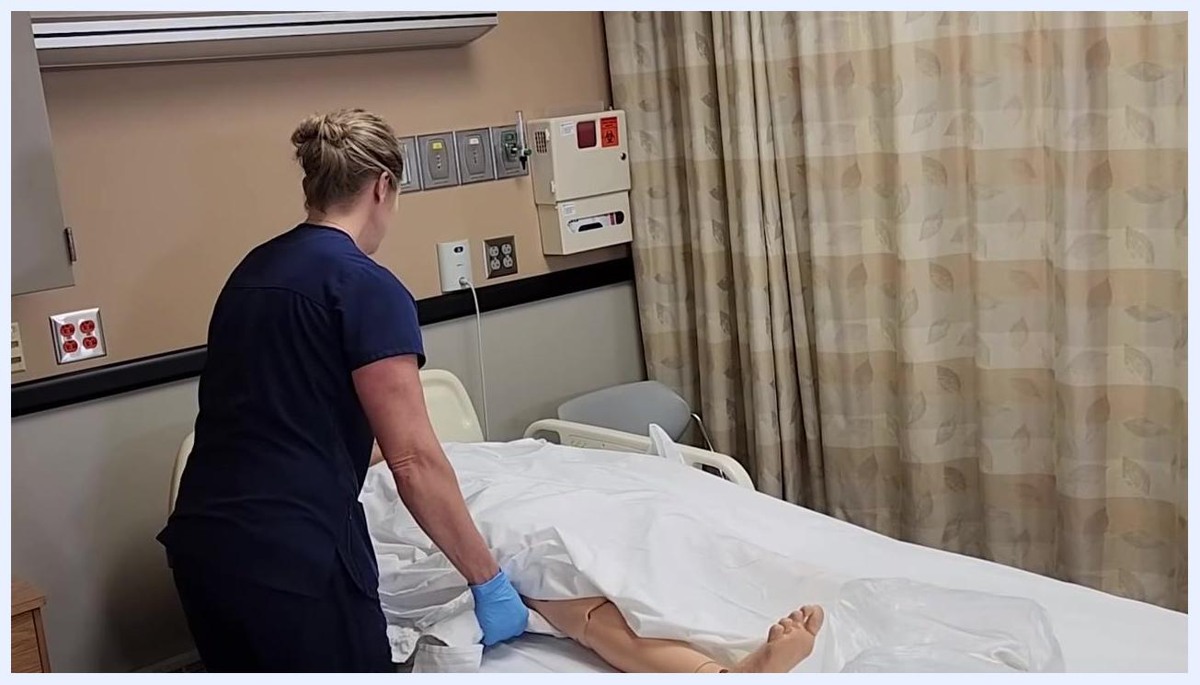
The healthcare worker is putting on fresh gloves, standing beside the bed and preparing for the next step.

- Reposition the resident. Instruct the resident to move their arm out of the way so they do not lie on it, then on the count of three, gently assist them in turning onto their left side, making sure their arm is positioned safely and comfortably.
The healthcare worker is leaning over the bed, preparing to turn the mannequin patient onto their side, ensuring proper arm placement.

- Turn the resident and adjust their position. On the count of three, turn the resident onto their left side, check that they are comfortable and that their face is not pressed against the pillow, and keep them covered with a sheet or towel for privacy.
The healthcare worker is turning the mannequin patient onto their left side, ensuring the patient is covered and positioned safely.

- Adjust the pillow and maintain privacy. Adjust the pillow so the resident's face is not obstructed, keep their body covered as much as possible to maintain dignity and warmth, and confirm their comfort before proceeding.
The healthcare worker is adjusting the patient's pillow and sheet, ensuring the patient is comfortable and covered.

- Complete final positioning. Ensure the resident is securely on their side with their back exposed for cleaning, keep the lower body and legs covered except for the area being cleaned, and prepare clean towels and washcloths for the next steps.
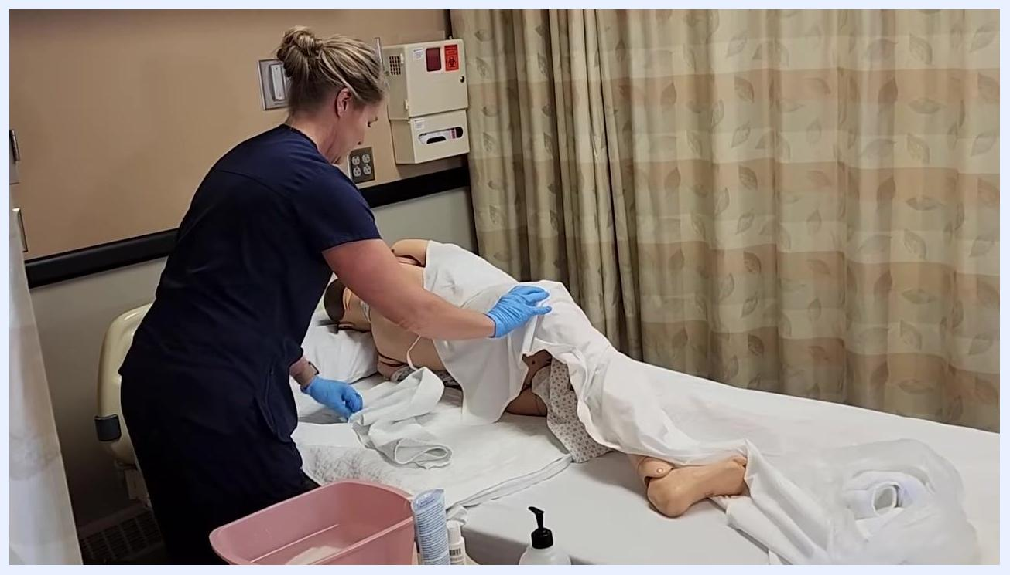
The healthcare worker is ensuring the mannequin patient is properly positioned on their side, with the back exposed and the rest of the body covered. Supplies are ready on the bedside table.
Key points for this section:
- Always change gloves between different cleaning areas to prevent cross-contamination.
- Dispose of all soiled linens and washcloths immediately after use.
- Maintain resident privacy and comfort by keeping them covered and explaining each step.
- Use the side rail and proper body mechanics to safely reposition the resident.
- Prepare all necessary supplies before beginning the next cleaning procedure.

Cleaning and rinsing the back and backside
Follow these steps to properly clean, rinse, and dry the resident's back and backside, ensuring comfort, privacy, and infection control throughout.

- Prepare a clean washcloth for back cleaning. Take a new, clean washcloth, moisten it with soapy water from the basin, and make sure you are wearing fresh gloves. Approach the resident, who should be positioned on their side with their back exposed and the rest of their body covered for privacy.
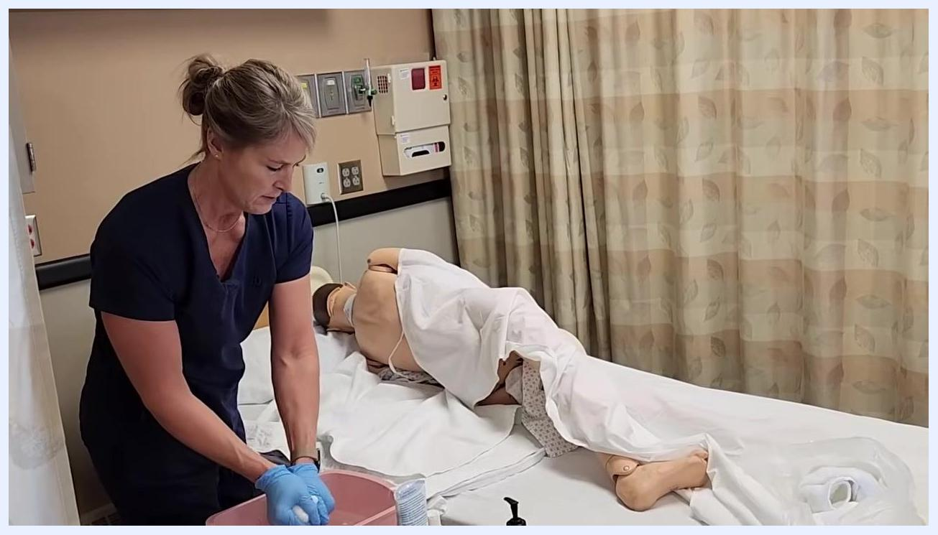
A healthcare worker in navy scrubs and blue gloves prepares a clean washcloth at the bedside. The mannequin patient is lying on their side, covered with a sheet except for the back. Supplies including a pink basin, hygiene products, and towels are organized on the bedside table. The clinical room has privacy curtains and medical wall panels.

- Wash the entire back. Gently wash the entire back with the soapy washcloth, keeping the lower body and backside covered as long as possible to maintain privacy, and lift the sheet only as needed to access the back and upper buttocks.
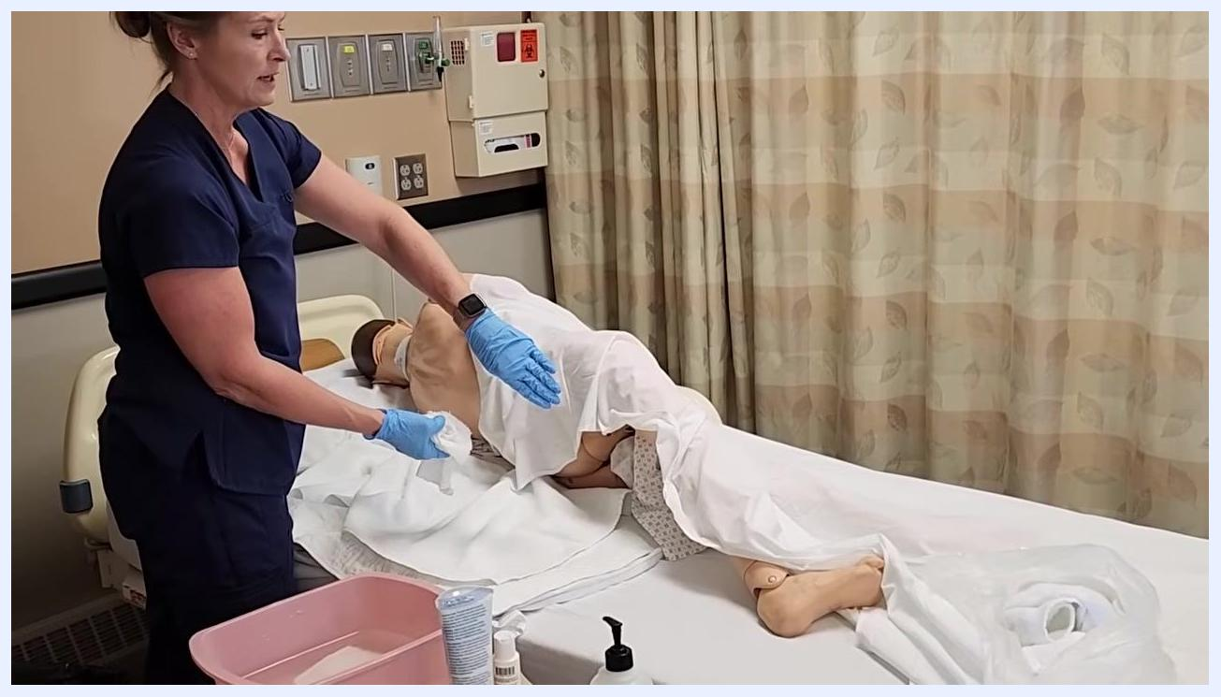
The healthcare worker is gently washing the patient's back with a washcloth, lifting the sheet just enough to access the area while maintaining privacy.

- Clean the back of the legs if needed. If the resident is mobile enough, wash the back of their legs at this time. If you already washed the back of the legs while the resident was lying face-up, you may skip this step. Prepare to perform backside perineal care if required, following the dedicated perineal care procedure for detailed instructions.
The healthcare worker is washing the patient's back and possibly the back of the legs, maintaining coverage and privacy.

- Dispose of the used washcloth. Place the soiled washcloth into the linen bag or designated disposal area. Do not reuse it for rinsing or drying, and prepare a new, clean washcloth for rinsing.
The healthcare worker gestures toward the linen bag, holding a used washcloth, ready to dispose of it.

- Rinse the back. Take a clean rinse washcloth, moisten it with clean water, and gently rinse the resident's back, removing all soap residue. While rinsing, visually inspect the skin for any reddened areas or signs of irritation and report any concerns to the nurse.
The healthcare worker is rinsing the patient's back with a clean washcloth, carefully inspecting the skin.

- Rinse the back of the legs and perineal area if needed. If necessary, rinse the back of the legs and the perineal area using the rinse washcloth, ensuring all soap is removed to prevent skin irritation.
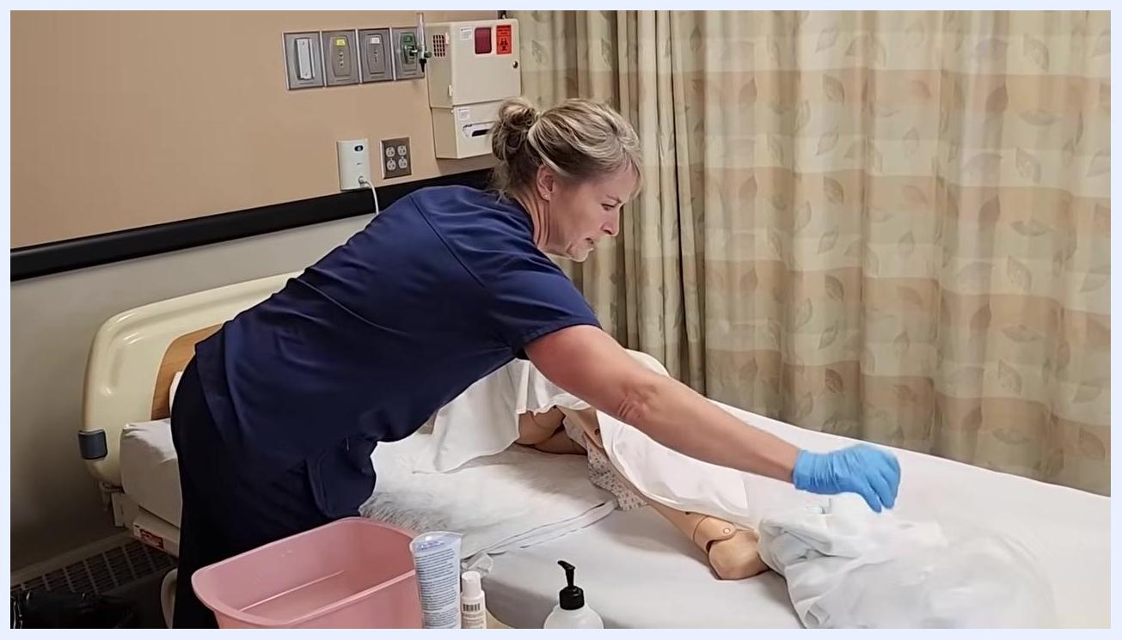
The healthcare worker is rinsing the patient's back and possibly the back of the legs, maintaining proper technique and coverage.

- Dry the back and backside. Use a clean, dry towel to gently pat the back and backside dry, ensuring all areas are thoroughly dried to prevent moisture-related skin issues.
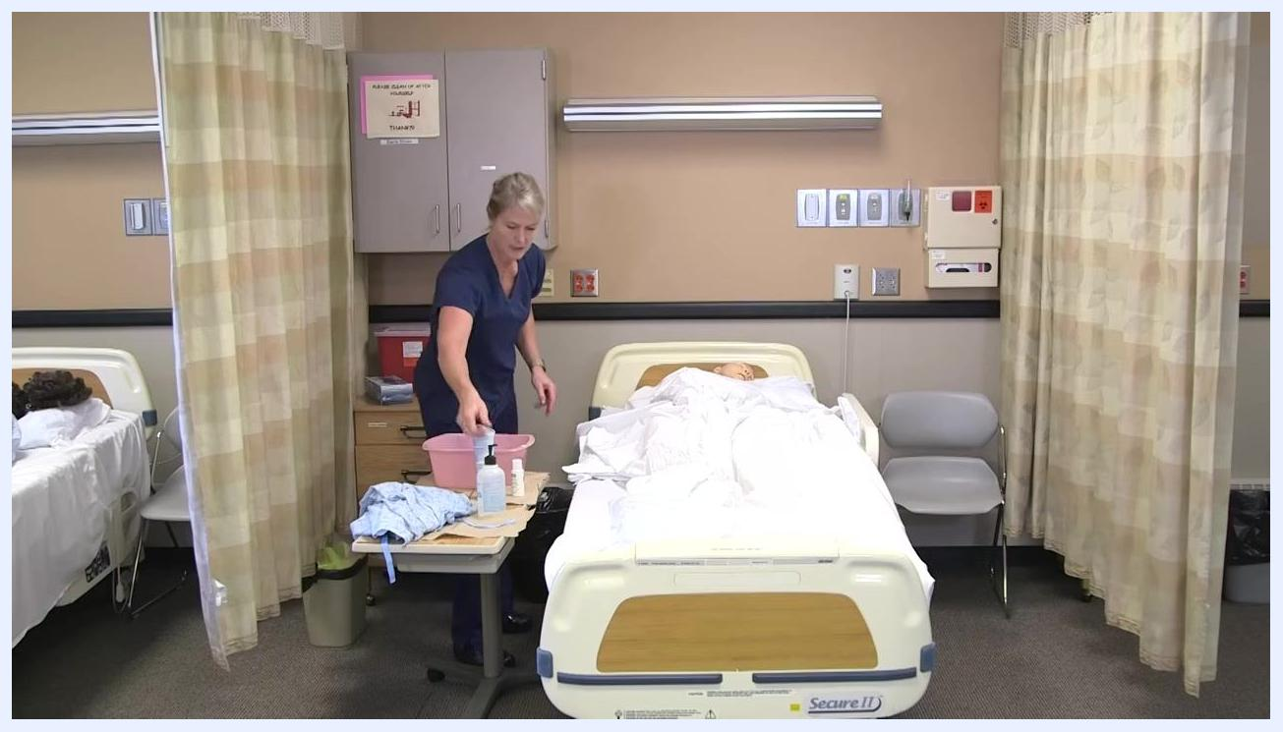
The healthcare worker is drying the patient's back with a clean towel, ensuring the area is completely dry.

- Dispose of used towels and washcloths. Place all used towels and washcloths into the linen bag or designated disposal area. Do not leave any soiled linens in the resident's bed or on nearby surfaces.
The healthcare worker is disposing of used linens into the linen bag, maintaining a clean environment.

- Remove gloves and sanitize your hands. Remove your dirty gloves and dispose of them in the appropriate waste container, then immediately sanitize your hands using hand sanitizer or wash with soap and water. Ensure all supplies are removed from the bedside and the resident is left clean, dry, and comfortable.
The healthcare worker stands at the bedside table, removing gloves and reaching for hand sanitizer. The patient is covered and the area is tidy.
Key points for this section:
- Always use a clean washcloth for each step: washing, rinsing, and drying.
- Maintain resident privacy by keeping them covered as much as possible.
- Inspect the skin for redness or irritation and report findings to the nurse.
- Dispose of all soiled linens and gloves immediately after use.
- Sanitize your hands after glove removal to prevent infection.

Completing patient care and room reset
Once the bed bath itself is complete, follow these steps to dress the resident and restore the room.

- Change the gown or assist with clothing. Ensure the resident is covered for privacy, offer them a choice between a hospital gown or their own clothes, prepare the clean clothing or gown, and assist them in changing while maintaining their comfort and dignity throughout.
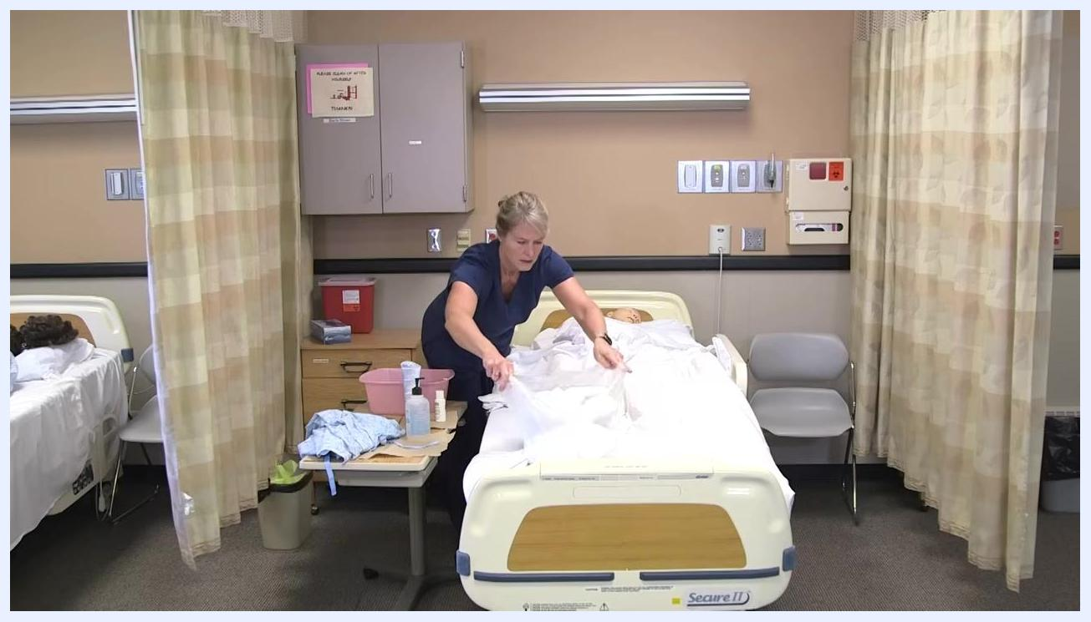
A healthcare worker in navy scrubs is at the bedside of a patient mannequin, preparing linens and a gown. The environment is a clinical room with privacy curtains, medical supplies on a rolling table, and cabinets on the wall.

- Remove dirty linens from the bed. Carefully gather all soiled linens from the bed without shaking them, and place them in a designated area or linen bag for disposal.
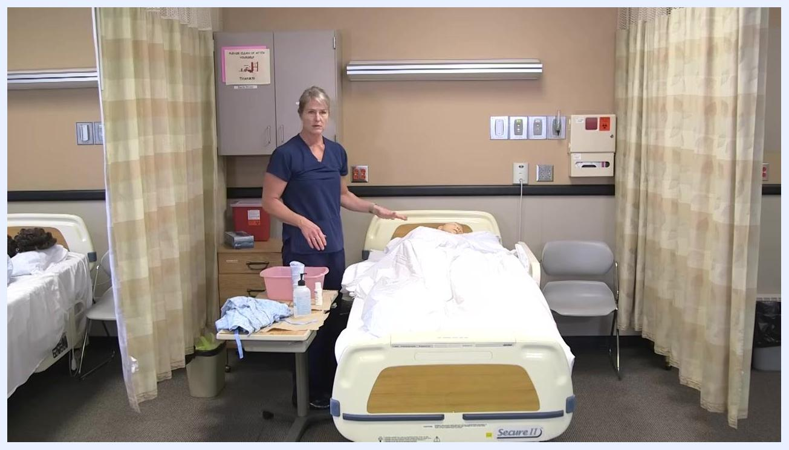
The healthcare worker is standing at the bedside, gesturing toward the patient mannequin, with dirty linens visible on the bed and a pile of supplies on the rolling table.

- Dispose of dirty linens properly. Take the gathered dirty linens and place them in the appropriate hamper or linen disposal bin.
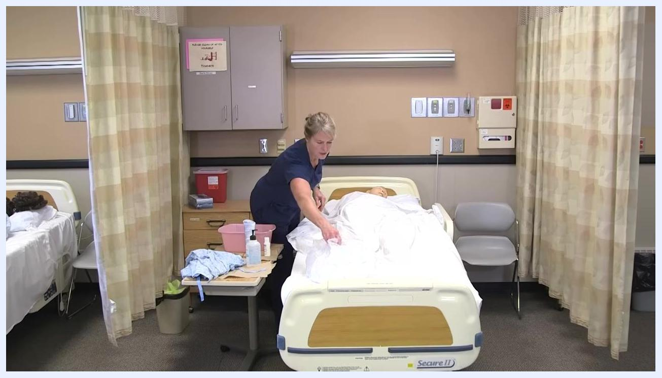
The healthcare worker is removing dirty linens from the bed, preparing to dispose of them. The clinical setting and supplies remain visible.

- Check on the resident's comfort. Ask the resident by name whether they feel comfortable, observe their response, and make any necessary adjustments to their position or bedding.
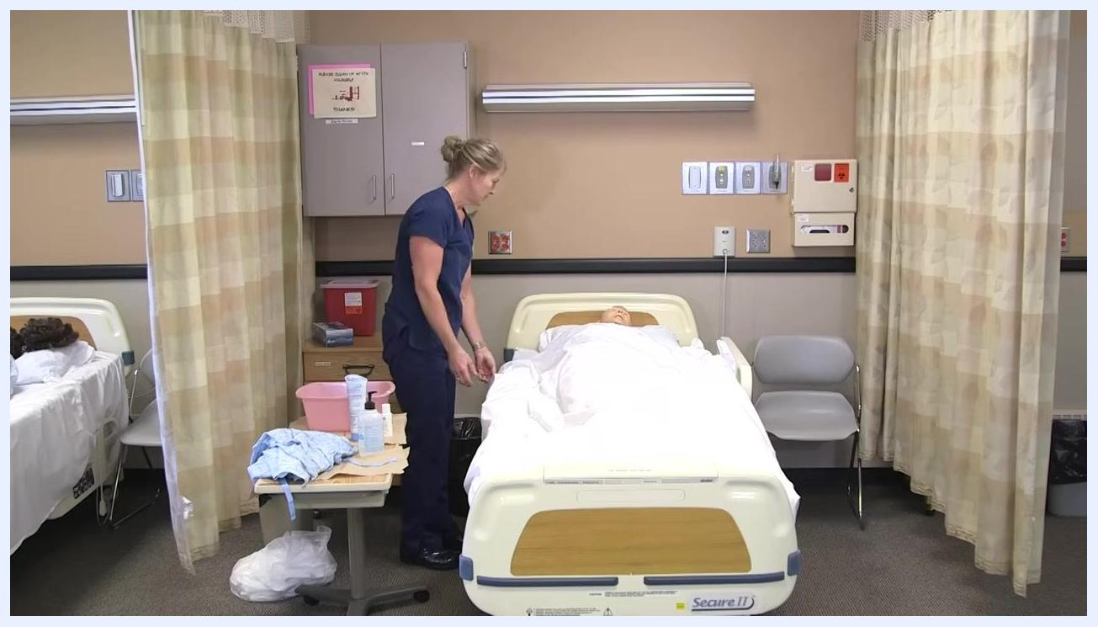
The healthcare worker stands at the bedside, checking on the patient mannequin's comfort. The bed is made, and supplies are organized on the table.

- Confirm comfort and begin tidying up. Acknowledge the resident's response, then continue tidying the area, ensuring all used items are disposed of or removed.
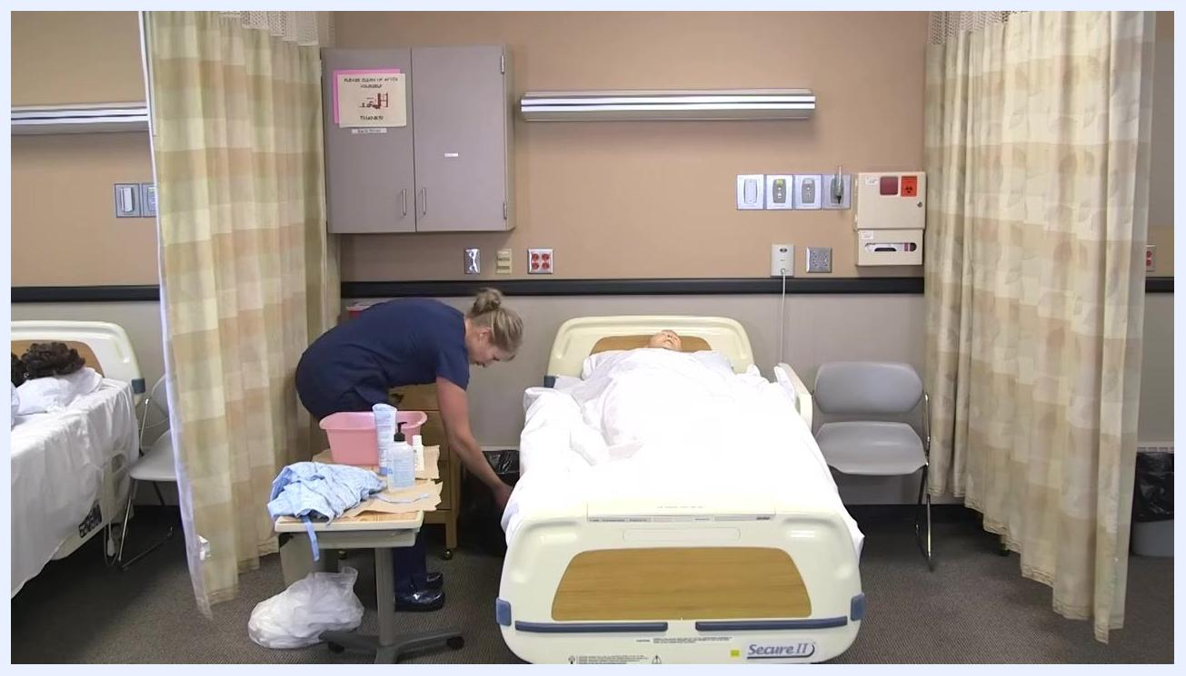
The healthcare worker bends down to dispose of items, maintaining a clean environment. The patient mannequin remains in bed, covered.

- Provide the call light and lower the side rail. Place the call light within easy reach of the resident and lower the side rail to allow them to move safely if needed.
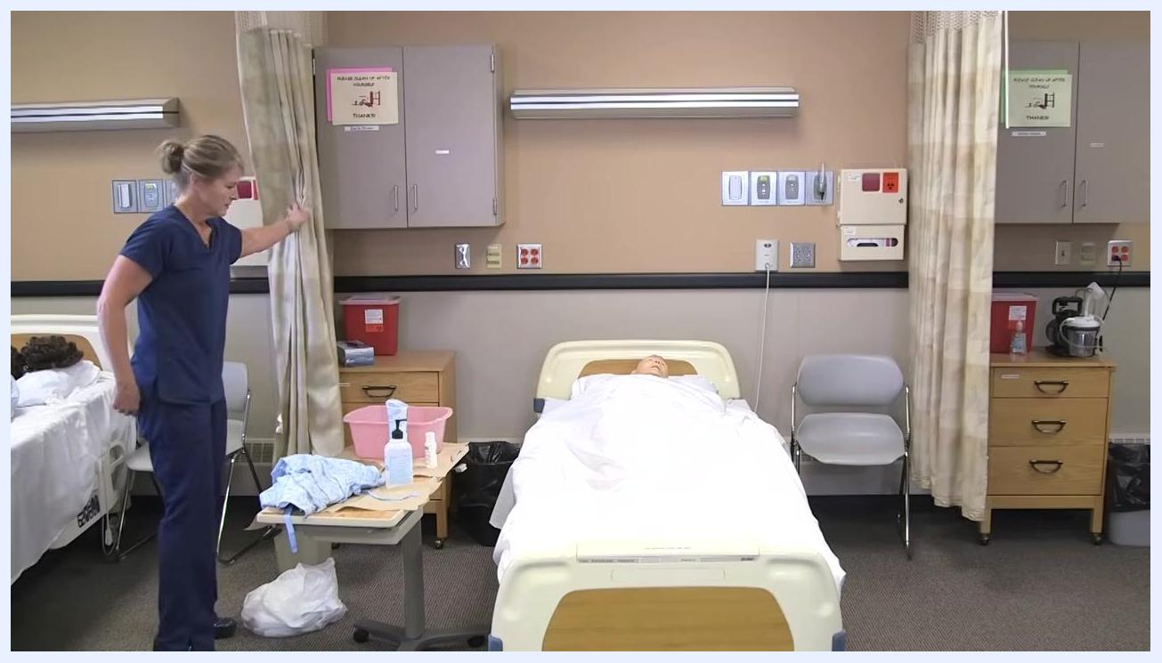
The healthcare worker is at the side of the bed, lowering the side rail and ensuring the call light is accessible.

- Open the privacy curtains. Slide the privacy curtain open to restore visibility and access to the room.
The healthcare worker is opening the privacy curtain, signaling the end of the procedure. The room is well-lit and organized.

- Ask if the resident needs anything else. Address the resident by name and ask if there is anything else you can get for them, then wait for their response and fulfill any reasonable requests.
The healthcare worker stands near the foot of the bed, addressing the patient and ensuring all needs are met.

- Say goodbye and exit the room. Let the resident know you will see them later, and confirm they are safe and comfortable before leaving.
The healthcare worker is moving toward the exit, drawing the curtain aside, and preparing to leave the patient resting comfortably in bed.

- Dispose of any remaining dirty linens. Take any remaining dirty linens and place them in the designated linen hamper, ensuring the resident's area is clean and free of used supplies.
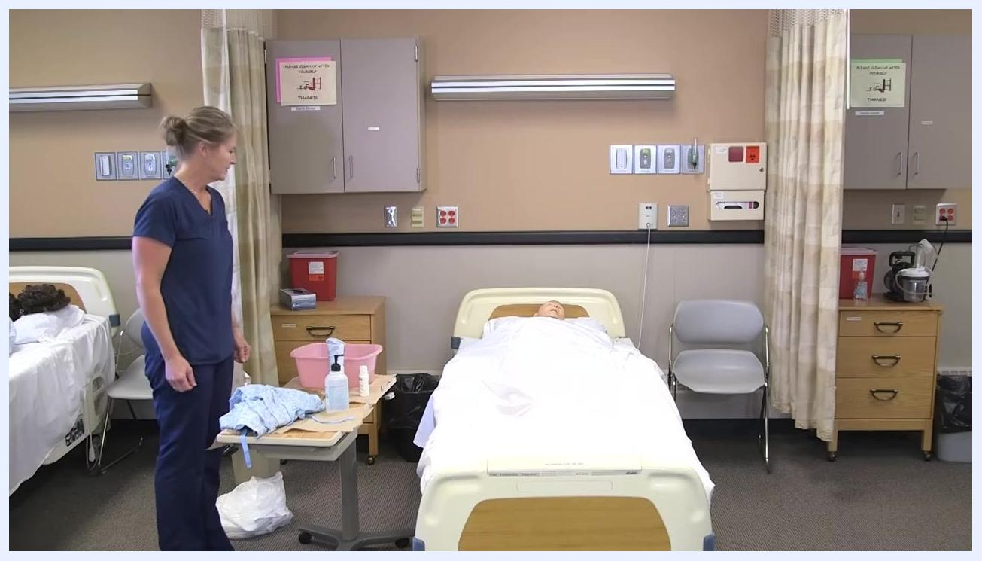
The healthcare worker stands near the bed, with the patient mannequin resting comfortably and the area tidy. The linen hamper is visible.

Post-procedure steps and final documentation
After completing direct patient care and resetting the room, complete the following post-procedure steps to ensure safety, compliance, and thorough documentation.

- Perform hand hygiene. Wash your hands thoroughly with soap and water, or use an alcohol-based hand sanitizer, immediately after completing patient care and before touching any other surfaces.
- Check on resident comfort and needs. Approach the resident and ask if they are comfortable and whether there is anything else you can get for them, then address any additional requests.
- Ensure the bed is low and locked; check the brakes. Lower the bed to its lowest position to reduce fall risk, and confirm the bed brakes are engaged and the bed is stable.
- Place the call light within reach. Ensure the call light or signaling device is easily accessible to the resident so they can request assistance if needed.
- Open the door and privacy curtain. Slide open the privacy curtain to restore visibility and access to the room, and open the door to allow for observation and easy entry and exit.
- Perform hand hygiene again. Repeat hand hygiene after leaving the resident's immediate environment to prevent the spread of infection.
- Report and document. Communicate any unusual observations, such as changes in skin condition, vital signs, or behavior, to the nurse promptly, and accurately document all care provided and any abnormal findings in the resident's medical record.
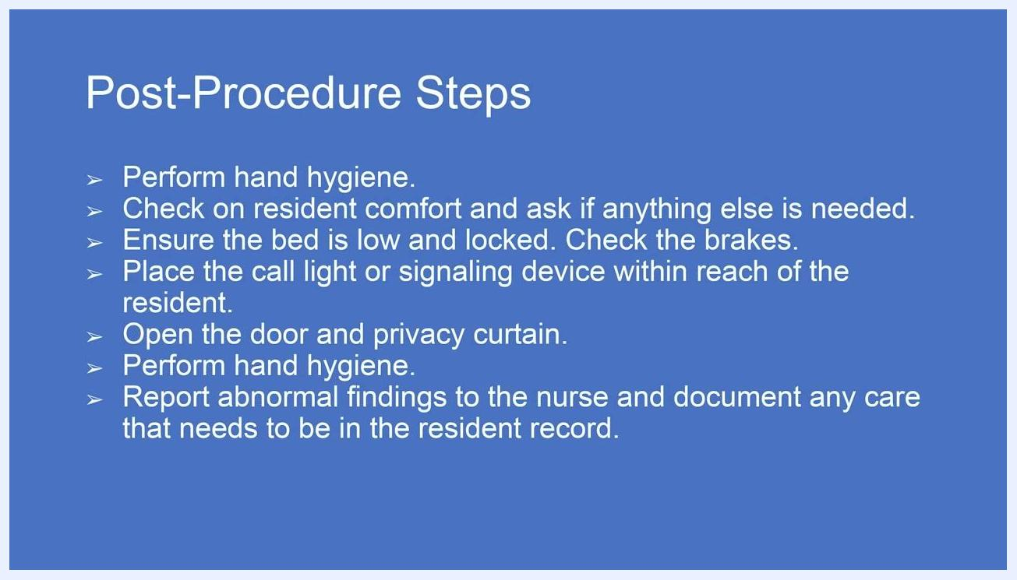
A blue slide titled "Post-Procedure Steps" lists the following instructions: Perform hand hygiene; Check on resident comfort and ask if anything else is needed; Ensure the bed is low and locked, check the brakes; Place the call light or signaling device within reach of the resident; Open the door and privacy curtain; Perform hand hygiene; Report abnormal findings to the nurse and document any care that needs to be in the resident record. No people or objects are visible—this is a text-based instructional slide.

Summary
This procedure covers how to give a bed bath from start to finish: preparing supplies and the resident, washing and rinsing the face, arms, chest, legs, feet, back, and backside, dressing the resident, and resetting the room afterward. Throughout the process, always use a clean washcloth for each new task, never re-dip a used cloth into clean water, keep the resident covered and warm except for the area being cleaned, pay close attention to drying skin folds and between the toes (especially for diabetic residents), and change gloves between different body areas. Complete the care cycle by performing hand hygiene before and after contact, confirming the environment is safe, ensuring the resident can call for help, restoring room access, and documenting any abnormal findings for the nurse.

