How to Flush a PICC Line: A Step-by-Step Patient Care Procedure
This procedure explains how to flush a PICC line to confirm patency, administer medications, and lock the line safely afterward. It follows the SAS/SASH protocol and reflects the sequence, supplies, and technique demonstrated on a simulated central line model. Use this guide alongside your facility's protocols whenever you need to know how to flush a PICC line before an infusion, after a blood draw, or during a routine patency check.
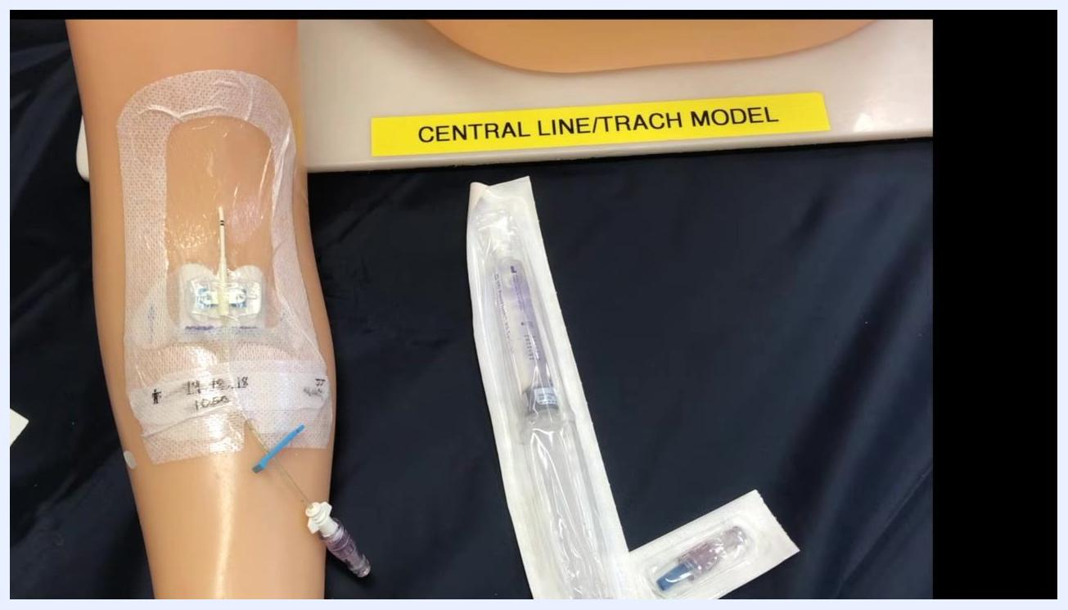
Gloved hands scrubbing the PICC line hub on a training arm, with a saline flush syringe positioned nearby for use

Purpose & Scope
You access a PICC line to perform a patency check or to administer medications. A patency check is required before infusing medications or fluids, and at minimum every 24 hours if the line has not been accessed.
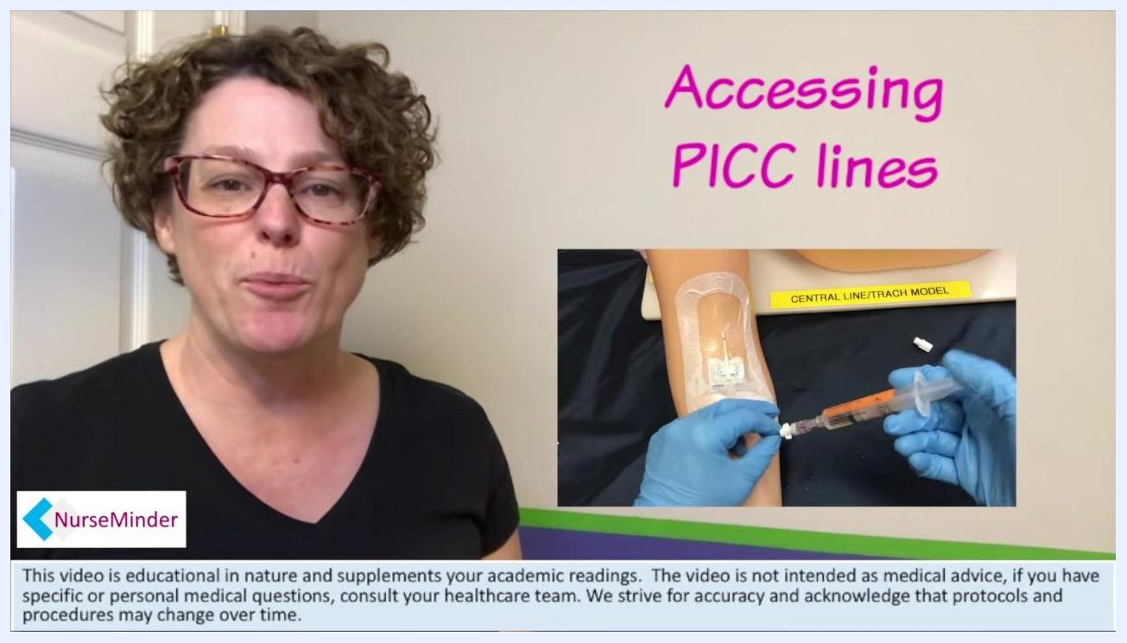
A training arm labeled "Central Line/Trach Model" with a PICC line in place and a packaged saline flush syringe positioned nearby
The procedure follows the SAS acronym: Saline flush, Administer medication/fluids, Saline flush, and a final Sodium citrate lock. If your facility uses heparin instead of sodium citrate, follow the same sequence under the acronym SASH, ending with Heparin.
This guidance is based on a simulated training environment. Always follow your facility's protocols and the manufacturer's instructions for the specific PICC line, cap, and locking solution in use.

Patient assessment
Before and during PICC line access, confirm the following:
Assessment item | When to perform it
Line patency | Before any infusion, or at least every 24 hours if the line is unaccessed
Blood return | Immediately after the initial 2 mL saline flush
Resistance during flushing | Throughout the flush; stop immediately if felt
Cap condition | Before every cap change and whenever contamination is suspected
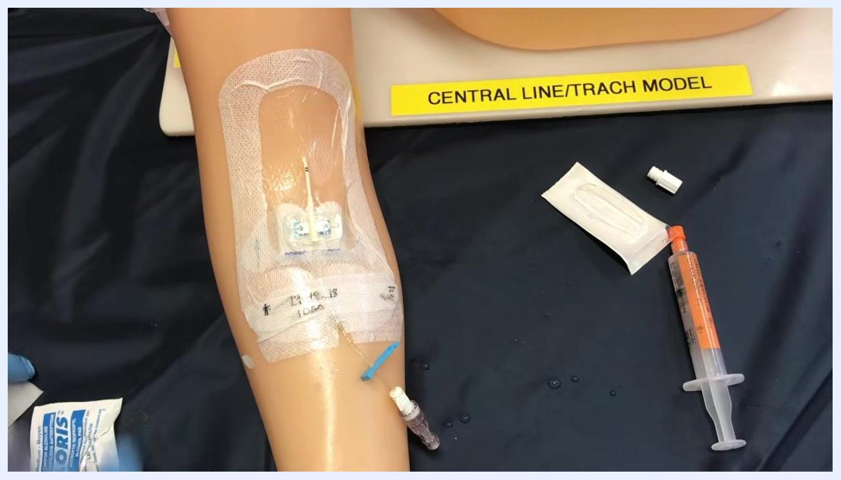
A gloved clinician disinfecting the PICC line access cap with an alcohol swab
If you cannot confirm patency, or if you meet resistance during flushing, stop the procedure and troubleshoot for a positional or partially clotted line according to your facility's guidelines.
Vital sign monitoring frequency, formal pain assessment tools, and neurovascular checks are not addressed in this procedure and should follow your facility's separate assessment protocols.

Care protocol

Phase 1: Preparing to access the PICC line

- Gather your supplies. Collect an alcohol or chlorhexidine swab, a pre-filled saline flush syringe, a medication syringe (if administering medication), and sodium citrate or heparin (if locking is required). Confirm all sterile packaging is intact before use.
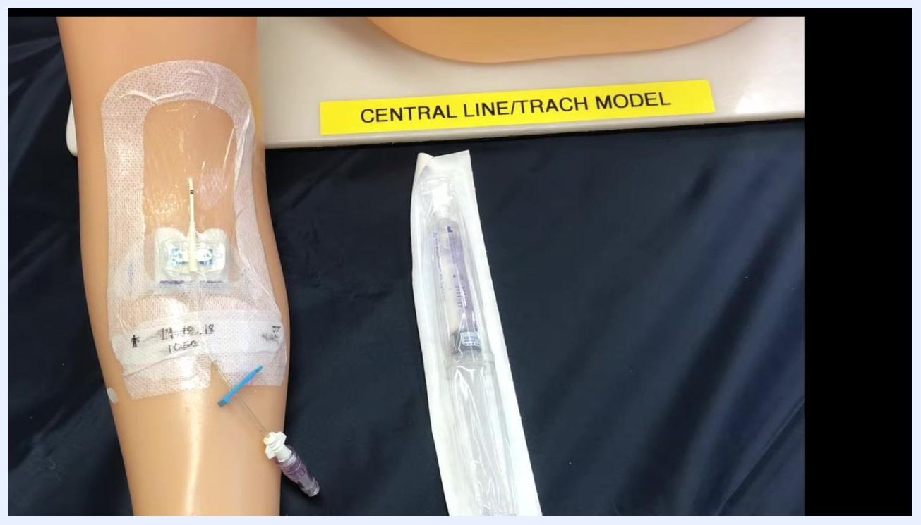
Split screen showing a gloved clinician preparing a syringe at a simulated PICC line site on a training arm, with the SAS protocol listed alongside: Saline flush, Administer medication/fluids, Saline flush, Sodium citrate

- Cleanse the PICC line hub. Scrub the hub thoroughly with an alcohol or chlorhexidine swab for at least 15 seconds, using friction and covering all surfaces to prevent contamination. Allow the hub to air dry completely.
- Prepare and attach the saline syringe. Remove the saline syringe from its packaging and expel any air. Attach it to the cleansed hub using a push-and-twist motion to create a secure connection.
- Unlock the line. If the PICC line has a clamp or locking mechanism, release it to allow infusion.

Phase 2: How to flush a PICC line for patency confirmation

- Inject 2 mL of saline. Use gentle pressure so the saline flows smoothly without force. This initial flush confirms the line is open and ready for use.
- Check for blood return. Gently pull back on the syringe plunger and watch for a flash of blood in the saline. Blood return confirms the line is patent. If you do not see blood return, stop and troubleshoot per your facility's guidelines.
- Infuse the remaining saline. Once patency is confirmed, deliver the rest of the saline using a pulsing (push-pause) technique. As you reach the last 1 mL, begin clamping the line to maintain positive pressure and prevent blood reflux. Stop and troubleshoot if you meet resistance.
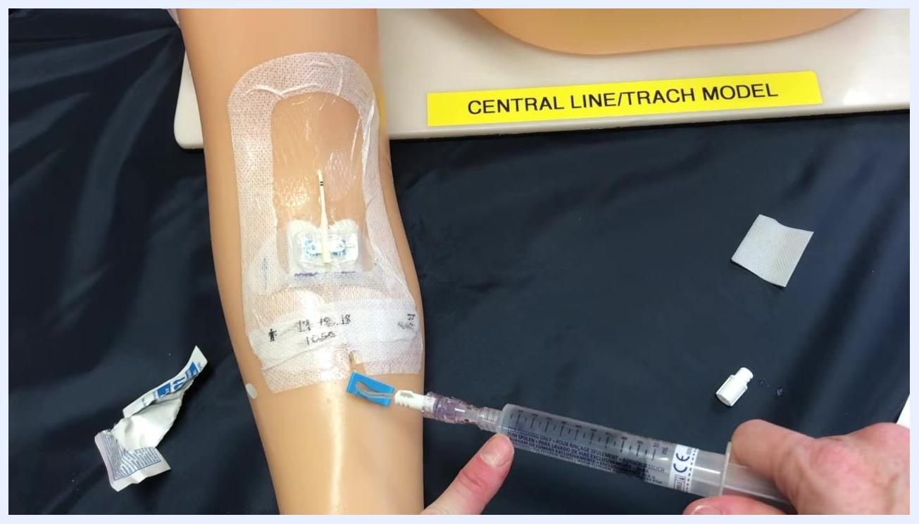
A gloved hand injecting saline into a PICC line on a training arm secured with a transparent dressing, with supplies arranged nearby

- Disconnect the saline syringe. Remove the syringe from the hub and keep the line clamped to prevent air entry or blood reflux.
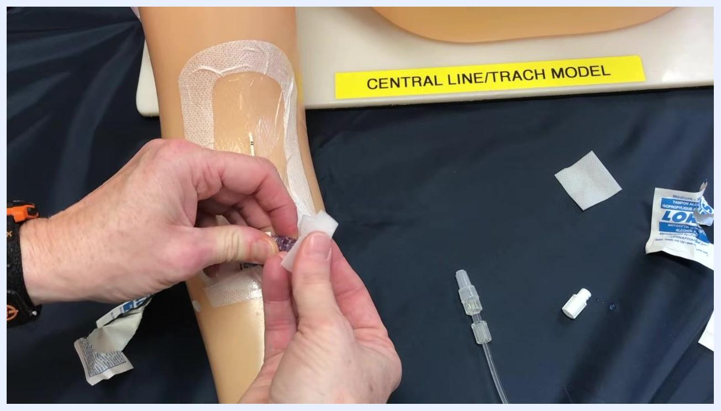
The saline syringe disconnected from the PICC line hub, which remains clamped, with supplies arranged around the training arm

Phase 3: Administering medication through the PICC line

- Re-cleanse the hub. Using a new alcohol or chlorhexidine swab, scrub all hub surfaces for at least 15 seconds with friction, then allow the hub to air dry completely.
Hands performing the pulsing push-pause flush technique on the PICC line, with the clamp and supplies visible nearby

- Attach the medication or infusion line. Connect the prepared medication syringe or infusion line to the neutral cap using a push-and-twist motion for a secure connection.
- Start and monitor the infusion. Unclamp the line to allow medication or fluids to infuse, and monitor to confirm it is running smoothly.
- Secure the line. Tape the PICC line and tubing to the patient's arm to prevent the line from dangling or being pulled accidentally.
A gloved hand scrubbing the PICC line hub with an alcohol swab before medication administration, with packaging and supplies visible
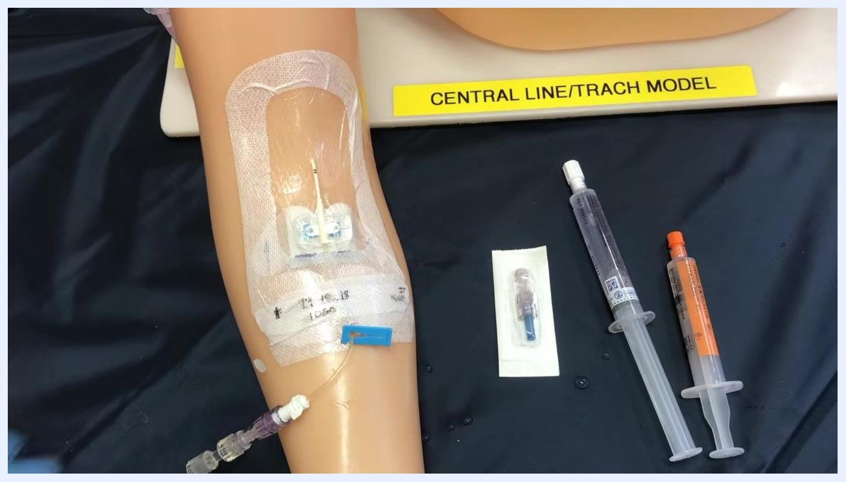
Hands connecting the medication or infusion line to the neutral cap of the PICC line using a push-and-twist motion
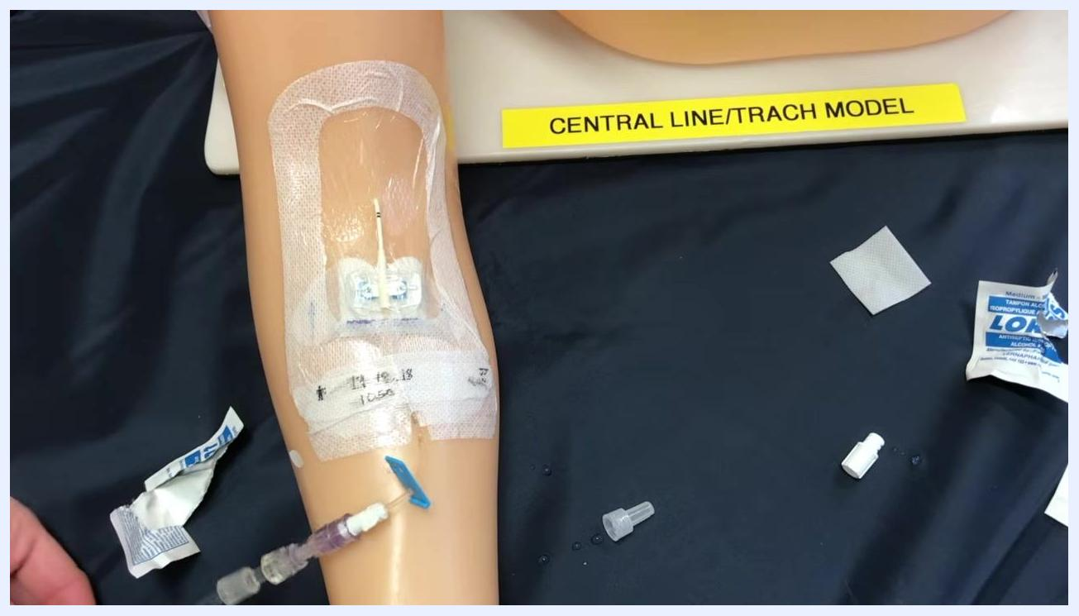
The medication or infusion line attached and unclamped, running smoothly with supplies organized nearby
The PICC line taped securely to the training arm, with medication syringes, saline syringe, and a neutral cap staged nearby

Phase 4: Second saline flush and cap change

- Gather supplies for the second flush and lock. Collect a new sterile cap, a saline flush syringe (typically 10 mL), and a sodium citrate or heparin syringe per your facility's locking protocol. Cap changes are performed every 96 hours, after blood draws, or whenever the cap appears contaminated; if a change is not needed, proceed without changing the cap.
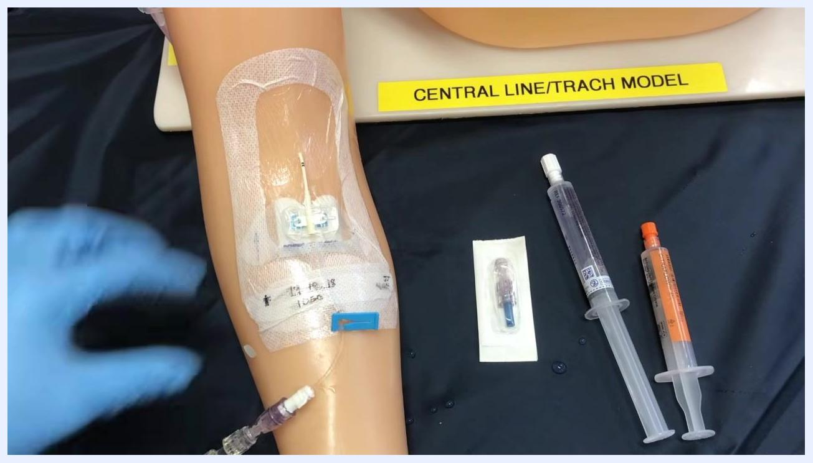
A training arm with a PICC line and staged supplies including a packaged sterile cap, a saline flush syringe, and a sodium citrate or heparin syringe, with a gloved hand ready to begin

- Follow the SASS sequence. After the first saline flush and medication administration, perform a second saline flush followed by the sodium citrate or heparin lock.
- Stage supplies for the cap change. Place the new sterile cap and the saline and sodium citrate (or heparin) syringes within reach, keeping all items sterile until use.
- Prime the new cap. Remove the cap from its sterile packaging and attach the saline syringe, maintaining sterile tip-to-tip contact. Gently push saline through the cap until it is fully primed and free of air.
- Complete the priming. Continue gently pushing the plunger until saline flows through the cap with no remaining air.
- Cleanse the catheter connection site. Using a new swab, scrub the area where the old cap connects to the catheter for at least 15 seconds, focusing on the lower area where the cap will detach.
- Continue cleansing and allow the site to air dry. Keep scrubbing until the area is thoroughly clean, then wait for it to dry before proceeding.
- Allow the site to fully air dry. Do not touch the cleansed area while it dries; this step is critical for antiseptic effect and infection prevention. Use this time to gather the next set of supplies.
Split screen of the training arm with the PICC line alongside the SASS protocol steps: Saline flush, Administer medication/fluids, Saline flush, Sodium citrate
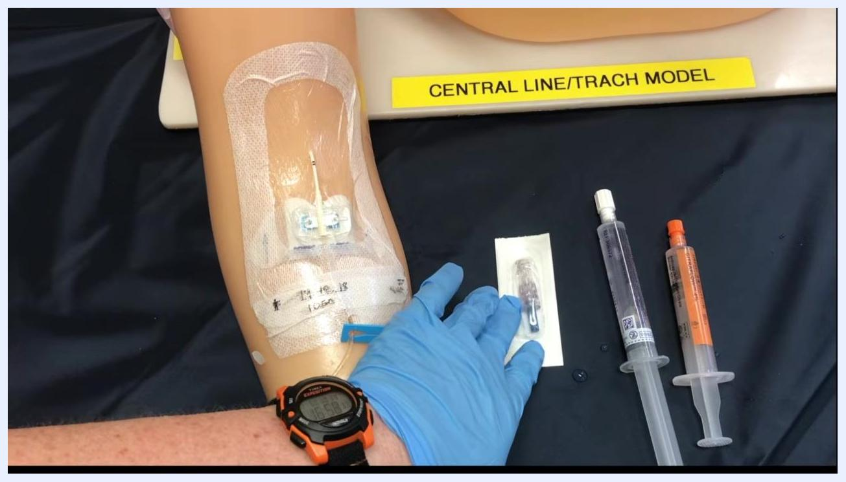
A gloved hand reaching for a new sterile cap in its packaging, with saline and sodium citrate syringes staged nearby on the training arm
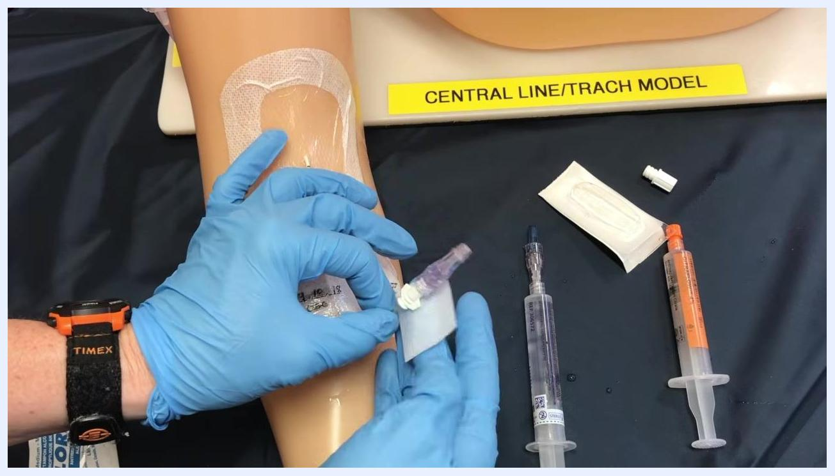
The new cap attached to a saline syringe while saline is gently pushed through to complete priming
A gloved hand scrubbing the catheter connection site with an alcohol swab, focusing on the area where the cap will be detached
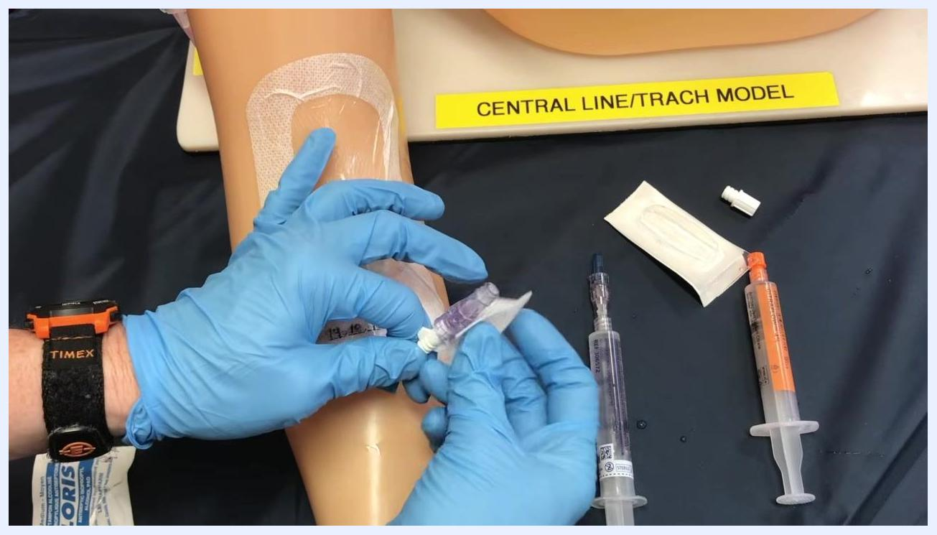
A gloved hand continuing to scrub the PICC line connection site with an alcohol swab before the cap change
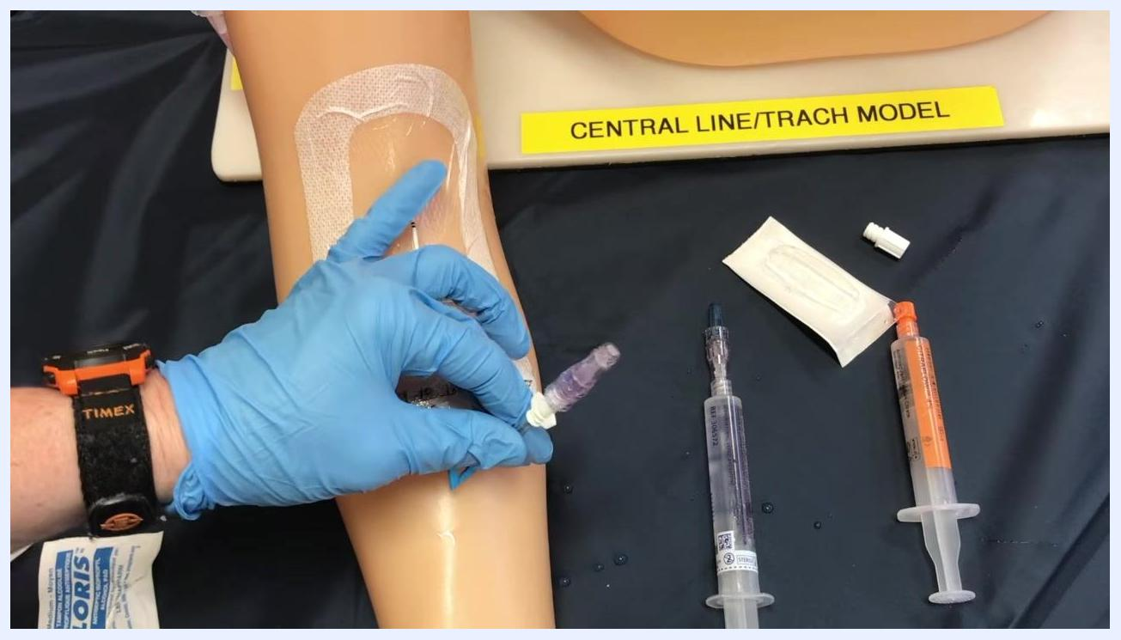
A gloved hand holding the cleansed PICC line connection site on the training arm while it air dries, with staged supplies including a saline syringe, a sodium citrate or heparin syringe, a packaged sterile cap, and the removed cap

Phase 5: Locking and securing the PICC line

- Prepare to lock the line. Confirm patency was checked prior to medication administration, and gather sterile gloves, a saline syringe, a locking solution syringe (e.g., sodium citrate), alcohol swabs, and a sterile cap. Confirm the field is clean and all equipment is within reach.
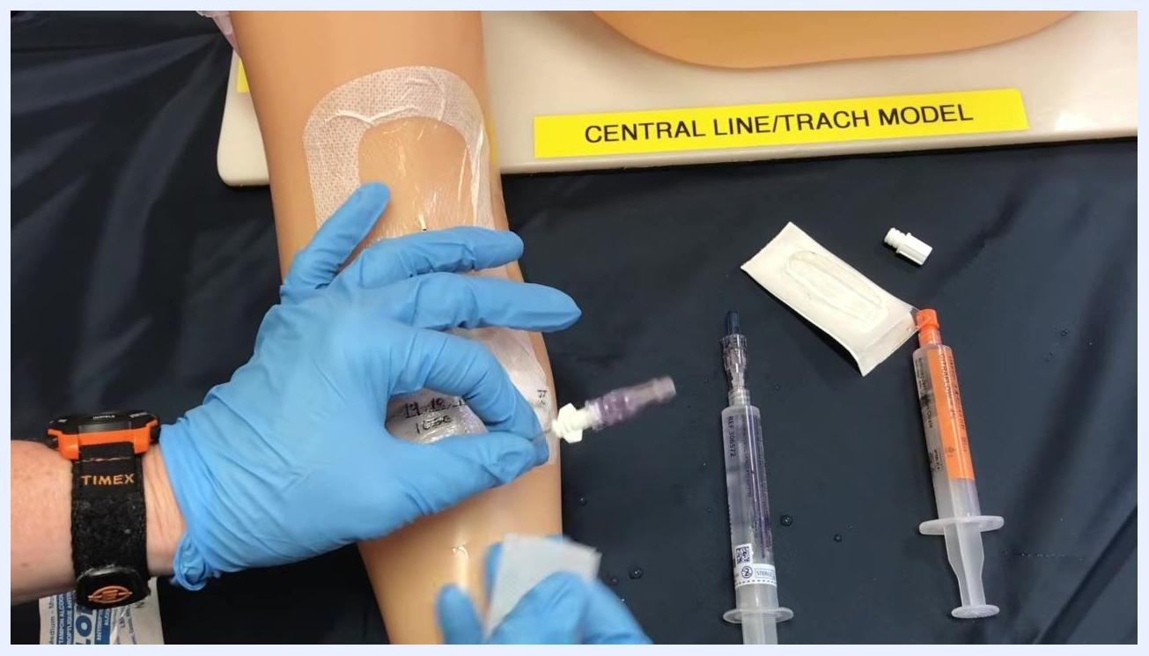
A gloved hand holding the new sterile cap and preparing to attach the saline flush syringe for priming

- Administer medication using pulsating pressure. Attach the medication syringe to the extension set and deliver the medication with a push-pause technique to promote patency. Watch for resistance or complications.
- Clamp the line during the final milliliter. As you reach the last 1 mL of medication or flush, clamp the extension set while still administering the final portion of fluid to maintain positive pressure and prevent blood reflux.
- Remove the syringe and prepare for locking. Detach the syringe, keeping the line clamped to prevent air entry or blood reflux, and set aside the used syringe.
- Disinfect the cap. Scrub the access cap with an alcohol swab for at least 15 seconds and allow it to dry completely before proceeding.
- Attach the locking solution syringe. Maintain sterile technique by touching only sterile surfaces, then attach the locking solution syringe (labeled CITRAFLOW™ 4% in this example) to the disinfected cap, inserting and turning it to secure the connection.
- Infuse the locking solution and finalize the lock. Slowly infuse the solution, using a pulsating technique if recommended. As you reach the last 1 mL, clamp the line to lock it under positive pressure, then remove the syringe while keeping the line clamped.
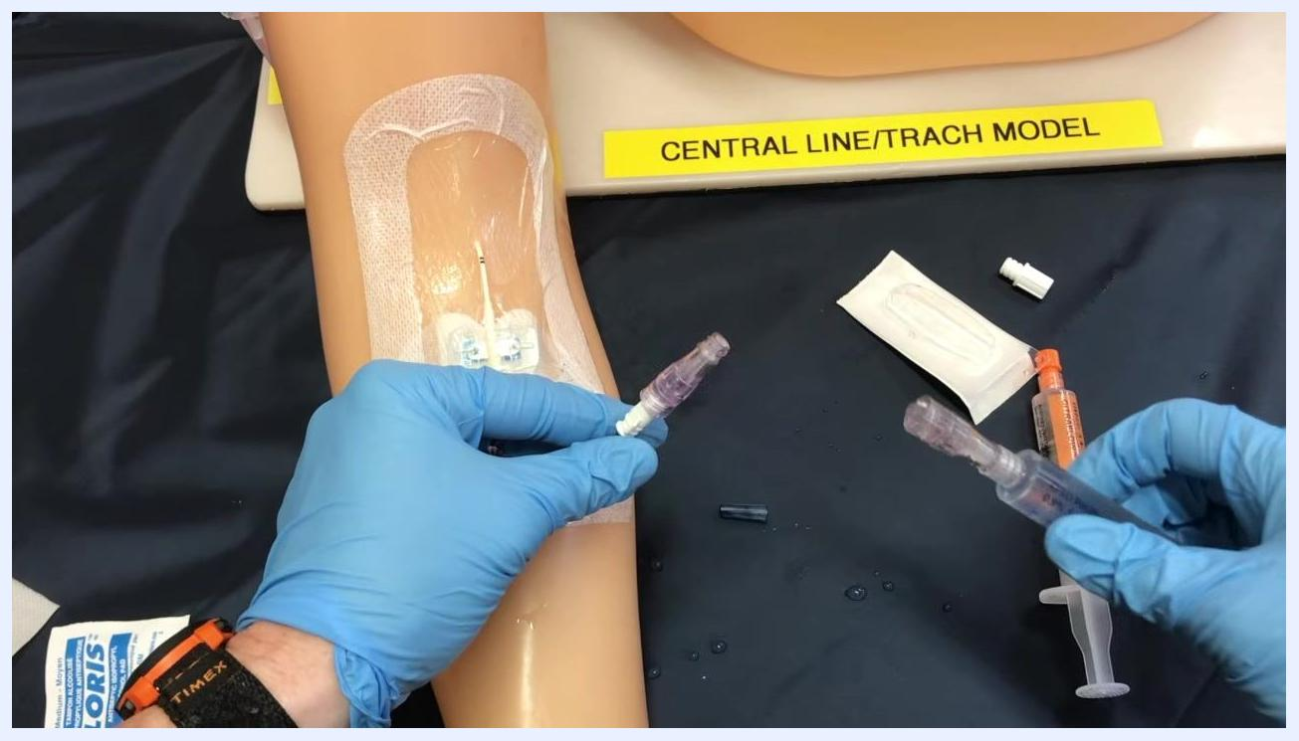
A gloved clinician holding a PICC line extension set and a syringe on a training arm, with supplies arranged on a sterile field
If sterility is compromised at any point during this procedure, replace the affected supplies and repeat the cleansing step before continuing.
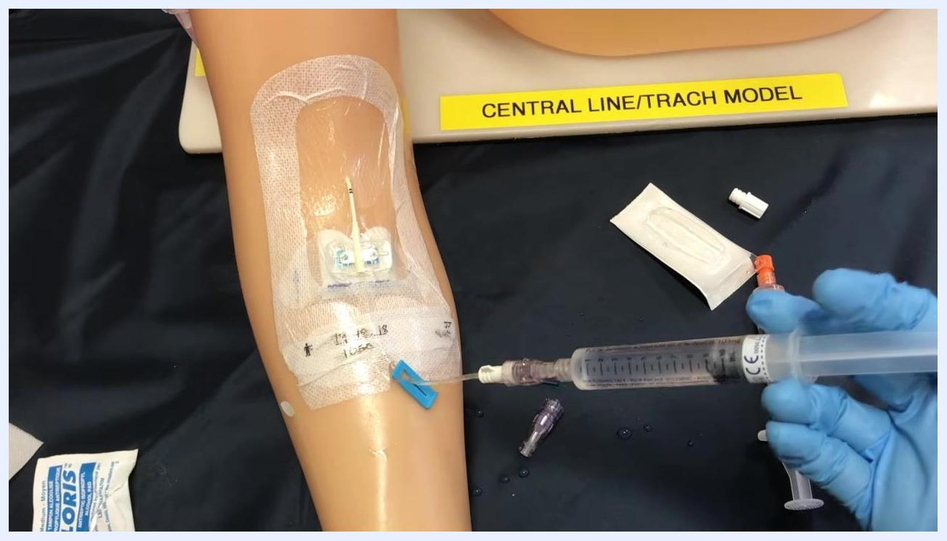
A gloved clinician administering medication through a syringe attached to the PICC line on the training arm
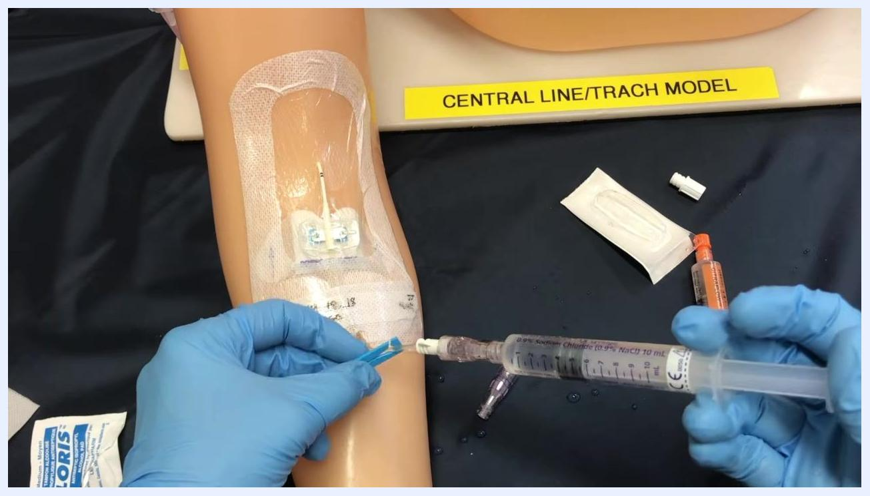
A gloved clinician clamping the PICC line while administering the last portion of fluid with a syringe
A gloved clinician holding the PICC line extension set after removing the syringe, with supplies visible on the sterile field
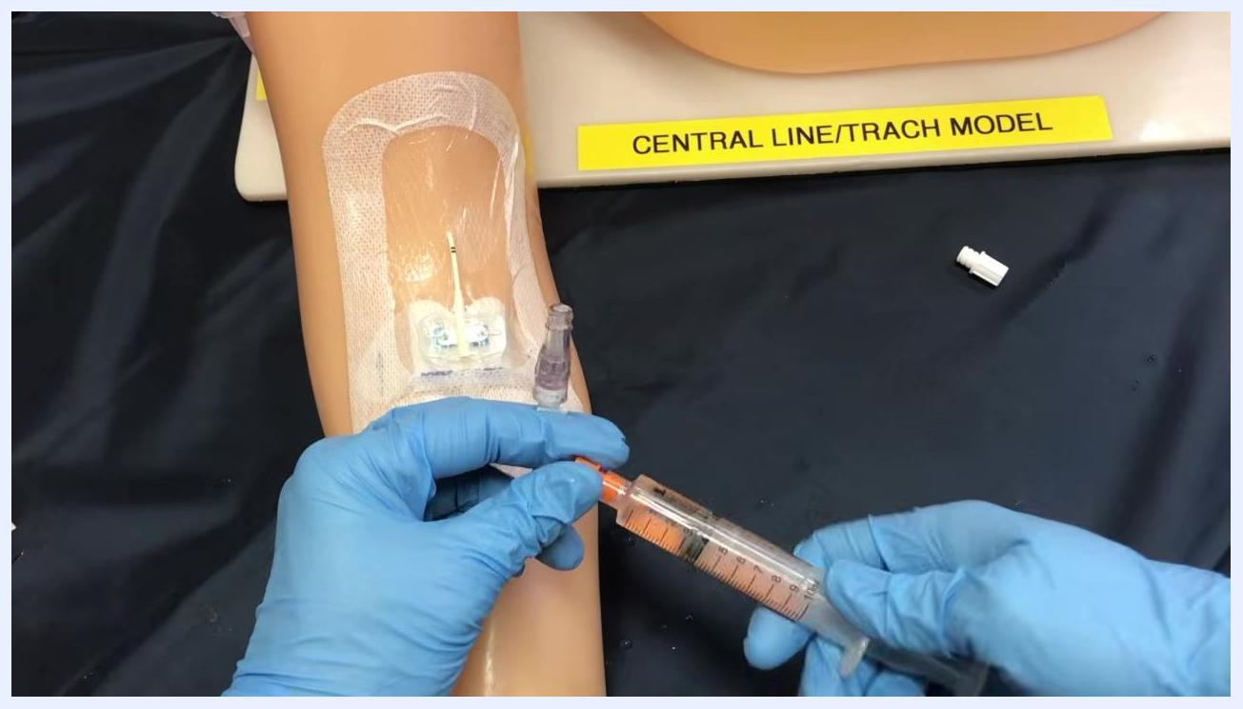
A gloved clinician attaching a syringe labeled CitraFlow 4% to the PICC line extension set while maintaining sterile technique
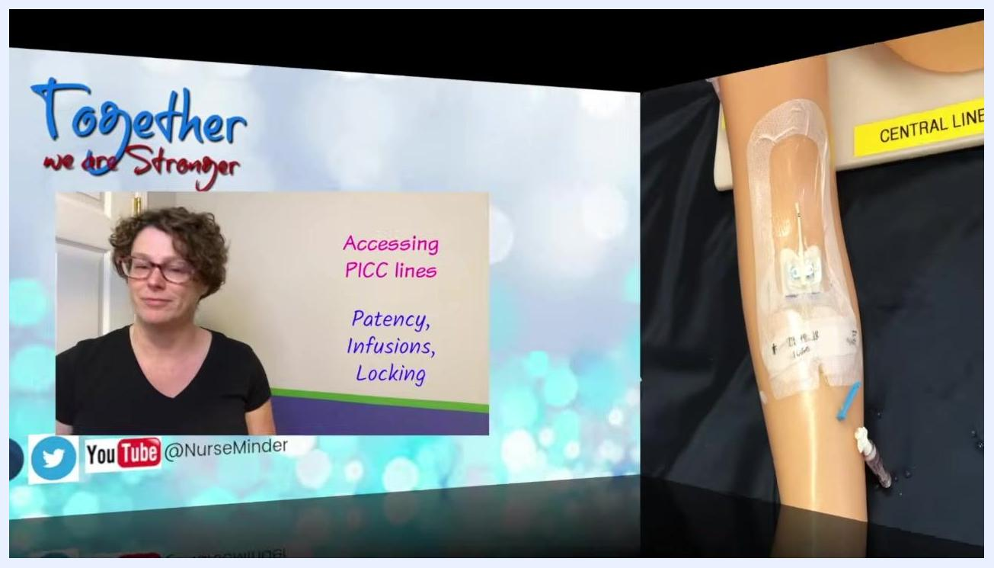
A gloved clinician infusing the locking solution into the PICC line while preparing to clamp it

Pain management
This source does not describe an analgesic or pain management plan; it addresses only the saline flush and sodium citrate/heparin locking solutions used to maintain line patency, as detailed in the Care Protocol above. For pain assessment and analgesic dosing, refer to your facility's separate pain management protocol.
Split screen: On the left, a person in a black shirt with text "Accessing PICC lines: Patency, Infusions, Locking." On the right, the simulated arm with the PICC line in place.

Mobility milestones
Progressive mobility goals and timelines are not addressed in this procedure, as it focuses solely on PICC line access, flushing, and locking technique.

Complication monitoring
Watch for the following signs and respond as indicated:
- Resistance or the need to force fluid during a flush — stop and troubleshoot for a positional or partially clotted line
- Absence of blood return after the initial 2 mL saline flush — stop and troubleshoot before proceeding
- Compromised sterility during hub or cap cleansing — replace supplies and repeat the cleansing step
- Cap appears contaminated, or 96 hours have passed since the last change, or a blood draw has occurred — perform a cap change
A syringe attached to the PICC line while the clinician checks for a flash of blood return after the initial saline injection
If you cannot confirm patency or resolve resistance, stop the procedure and follow your facility's guidelines and manufacturer instructions. This source does not specify named escalation contacts; direct escalation to your institution's designated line per its own protocol.

Discharge criteria
This procedure does not include discharge criteria, as it covers PICC line access and locking technique rather than a full episode of care.

Patient education
This source does not include patient or family teaching content; it is written for clinical staff performing the access, flush, and locking technique. Patient-facing education materials should be developed separately according to your facility's standards.

What's next
Once the line is locked, document the procedure, including patency confirmation, medication administered, and the locking solution used, per your institution's charting requirements. Continue routine patency checks at least every 24 hours if the line remains unaccessed, and follow your facility's schedule for cap changes and dressing care. Always confirm any product-specific steps against the manufacturer's instructions for the PICC line, cap, and locking solution in use.
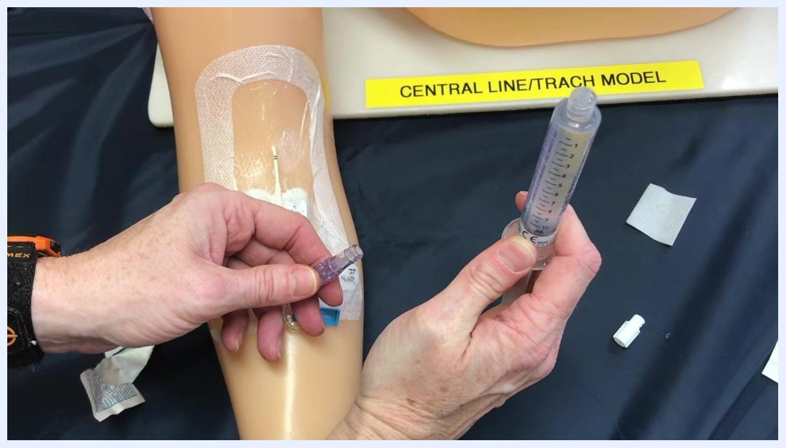
Gloved hands holding the PICC line hub and a saline flush syringe, preparing to connect them, with the clamp and supplies visible on the field
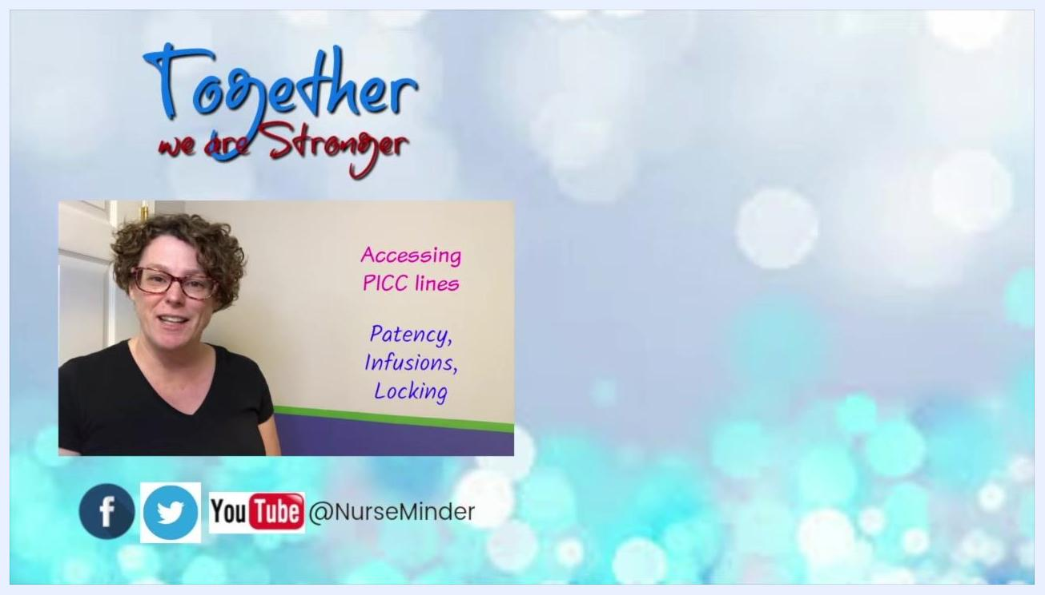
A person in a black shirt stands in front of a wall, smiling. On the left, text reads "Accessing PICC lines: Patency, Infusions, Locking." The background features the phrase "Together we are Stronger." Social media icons for Facebook, Twitter, and YouTube with the handle @NurseMinder are displayed at the bottom.

