How to Draw Up Medication from a Vial for Subcutaneous Injection
This procedure describes how to draw up medication from a vial and administer it as a subcutaneous injection, using heparin as the reference medication. It covers hand hygiene, vial preparation, aseptic drawing technique, injection administration, and safe disposal, so that the medication is prepared and given without contamination or needle-stick risk.

Formulation summary
- Drug name: Heparin (or other medication as prescribed).
- Medication class: Anticoagulant, used to prevent new blood clots from forming and to prevent existing clots from getting bigger.
- Dosage form: Injectable solution supplied in a vial.
- Route of administration: Subcutaneous (SUBQ) or intravenous (IV) injection. Heparin is not given orally (PO), because it is inactivated by gastric acids in the stomach.
- Volume/quantity to prepare: The volume drawn from the vial equals the ordered dose, measured in units, and should match the volume of air injected into the vial beforehand.
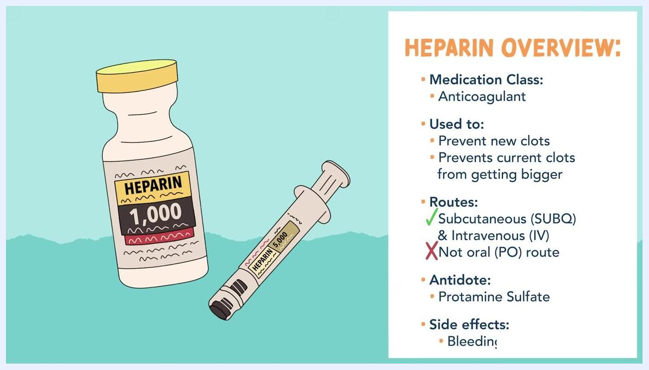
Illustration of a heparin vial and syringe summarizing the medication class and uses: anticoagulant, used to prevent new clots and to stop existing clots from getting bigger
Illustration of a heparin vial and syringe listing the approved routes of administration: subcutaneous (SUBQ) and intravenous (IV), with oral (PO) route excluded

Ingredients & equipment
Gather the following items and place them on a clean, flat surface before beginning:
Item | Quantity | Grade/specification | NDC/lot number | Supplier
Alcohol prep pads | As needed (individually packaged) | Sterile, single-use | Not specified in procedure — record per facility policy | Not specified in procedure — record per facility policy
Sterile syringe with needle | 1 per dose | 25-gauge, 5/8 inch, 3 mL (e.g., BD Eclipse) | Not specified in procedure — record per facility policy | Not specified in procedure — record per facility policy
Heparin vial (or prescribed medication) | 1 vial | Per prescriber order; verify label, strength, and expiration date | Not specified in procedure — record per facility policy | Not specified in procedure — record per facility policy
Clean gloves | 2 pairs (one set for preparation, one fresh set for injection) | Non-sterile exam gloves | Not applicable | Not specified in procedure — record per facility policy
Sharps container | 1 | Facility-approved sharps disposal container | Not applicable | Not specified in procedure — record per facility policy

 | Note: The source procedure does not specify NDC numbers, lot numbers, or suppliers. Record these details on the vial label and dispensing documentation according to your facility's labeling and traceability requirements.
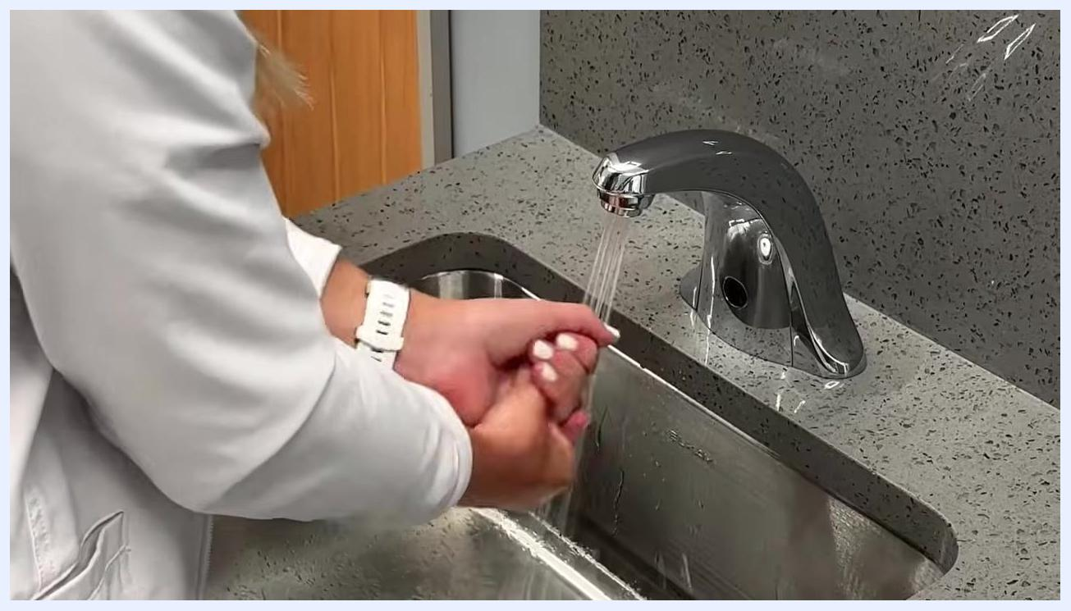
Gloved hands holding a BD Eclipse 3 mL, 25-gauge, 5/8 inch syringe package, with alcohol prep pads and vials visible on a white surface

Compounding procedure

Step 1: Perform hand hygiene
Wash your hands thoroughly with soap and water at a sink before starting the procedure. Ensure all surfaces of your hands are cleaned to reduce the risk of contamination.
Person washing hands at a sink, wearing a white coat and a watch, with water running over the hands

Step 2: Verify the medication
Check the medication label, strength, and expiration date on the vial before proceeding.

Step 3: Prepare the vial
Remove the protective cap from the medication vial. Open an alcohol prep pad and use it to thoroughly clean the rubber stopper on top of the vial. This step is essential to prevent contamination.
Gloved hands using an alcohol prep pad to clean the top of a vial, with other supplies visible on a white surface

⚠️ Critical step: Always disinfect the rubber stopper before inserting the needle to maintain aseptic technique.

Step 4: Prepare the syringe and needle
Uncap the sterile needle from the syringe. Do not touch the needle at any point, to maintain sterility.
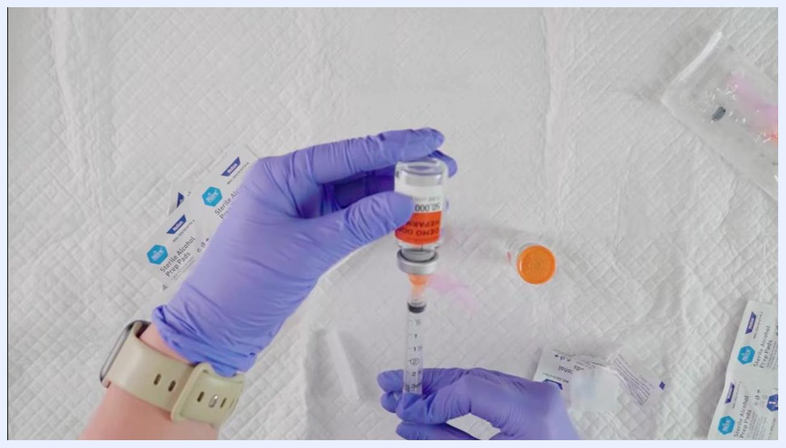
Gloved hands preparing supplies, including uncapping the needle and cleaning the vial

Step 5: Draw air into the syringe
Pull back the plunger to draw air into the syringe equal to the volume of medication you will withdraw from the vial, as ordered.

Step 6: Insert the needle and inject air
Insert the needle through the rubber stopper of the vial. Inject the air from the syringe into the vial by pushing the plunger in. This equalizes pressure and makes it easier to withdraw the medication.

Step 7: Draw up medication from the vial
With the needle still in the vial, turn the vial upside down and ensure the needle tip is submerged in the liquid medication. Slowly pull back on the plunger to draw up the ordered volume, in units, of medication.
Gloved hands holding an inverted vial and syringe while drawing up medication, with clear labeling visible on the vial and syringe

Step 8: Check for air bubbles
Inspect the syringe for air bubbles. If bubbles are present, gently tap the syringe to move them to the top, then push the plunger slightly to expel the air without losing medication.
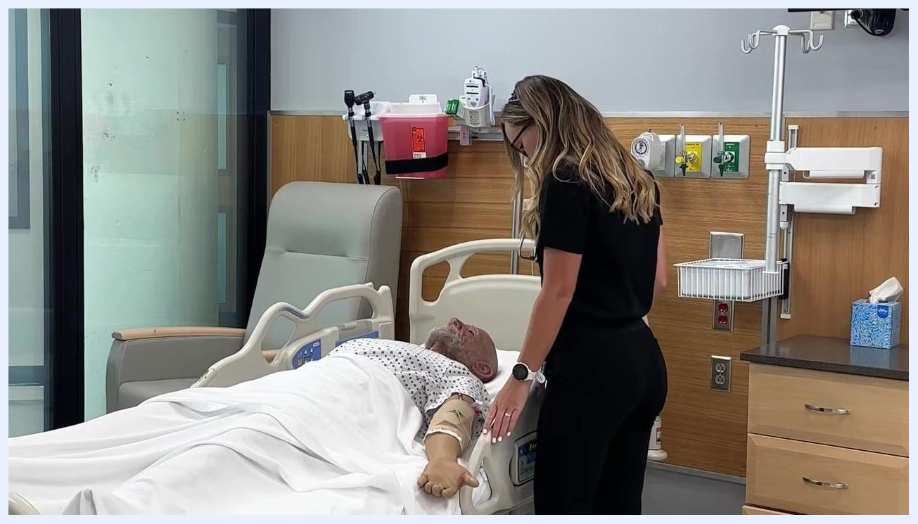
Gloved hands holding the inverted vial and syringe, checking the drawn medication for air bubbles before withdrawal

Step 9: Remove and recap the needle
Remove the needle from the vial. Inspect the needle for bends or damage; replace it with a new sterile needle if it appears bent. Carefully recap the needle using the "swoop" method to avoid accidental needle sticks.
Gloved hands recapping a syringe needle using the swoop method, with supplies and vials visible on a white surface

⚠️ Safety note: Use the swoop method rather than a two-handed recap to reduce the risk of an accidental needle-stick injury.

Step 10: Prepare for injection
Review the patient's chart or records to determine where the last injection was given, and rotate injection sites as appropriate to prevent tissue damage.
Healthcare provider standing next to a patient in a hospital bed, reviewing injection sites

Step 11: Perform hand hygiene again and don gloves
Wash your hands again before proceeding to the injection, then put on a new pair of clean gloves.

Step 12: Clean the injection site
Use a new alcohol prep pad to clean the selected injection site on the patient. Allow the area to air dry completely before administering the injection.
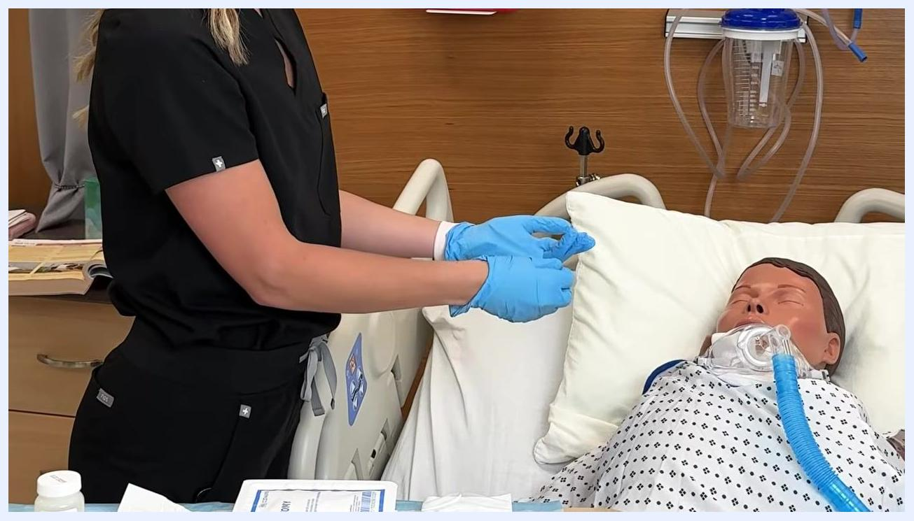
Healthcare provider wearing blue gloves, preparing to clean the injection site on a patient in a hospital bed

Step 13: Administer the injection
Hold the syringe at the appropriate angle for a subcutaneous injection, typically 45 or 90 degrees as per protocol. Push the needle all the way into the skin at the selected site, then inject the medication slowly and steadily until the entire dose is delivered.
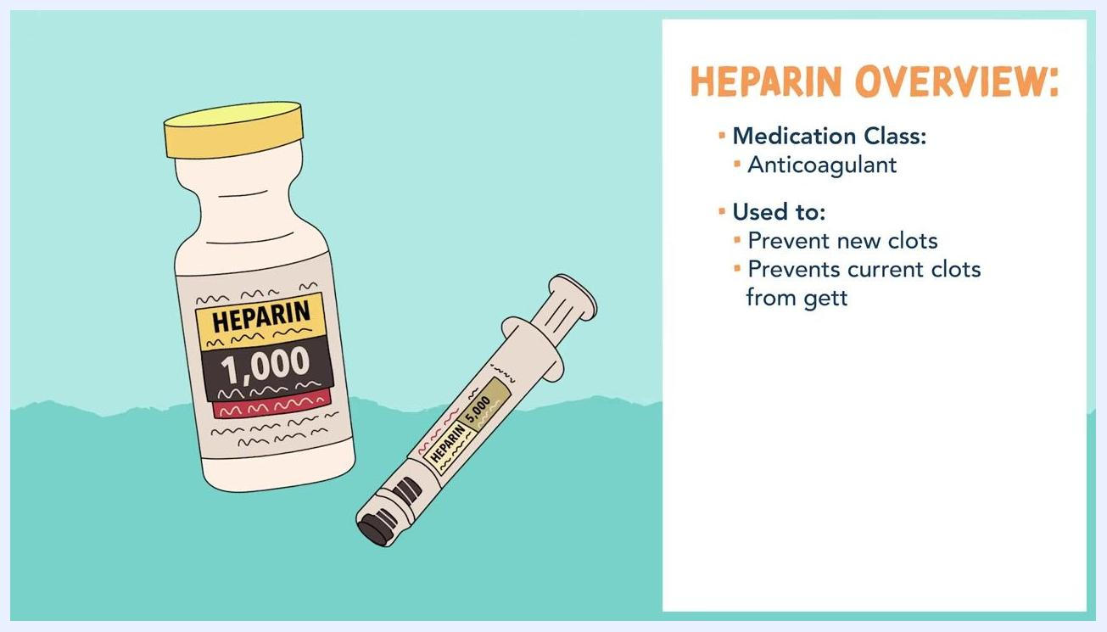
Gloved hands holding a syringe at an angle, needle inserted into simulated skin and injecting medication, with the safety shield visible and a hospital bed and patient gown in the background

Step 14: Withdraw the needle and activate the safety shield
Remove the needle from the skin at the same angle it was inserted. Immediately activate the safety feature on the needle, such as pushing the safety shield over it, to prevent accidental needle sticks.
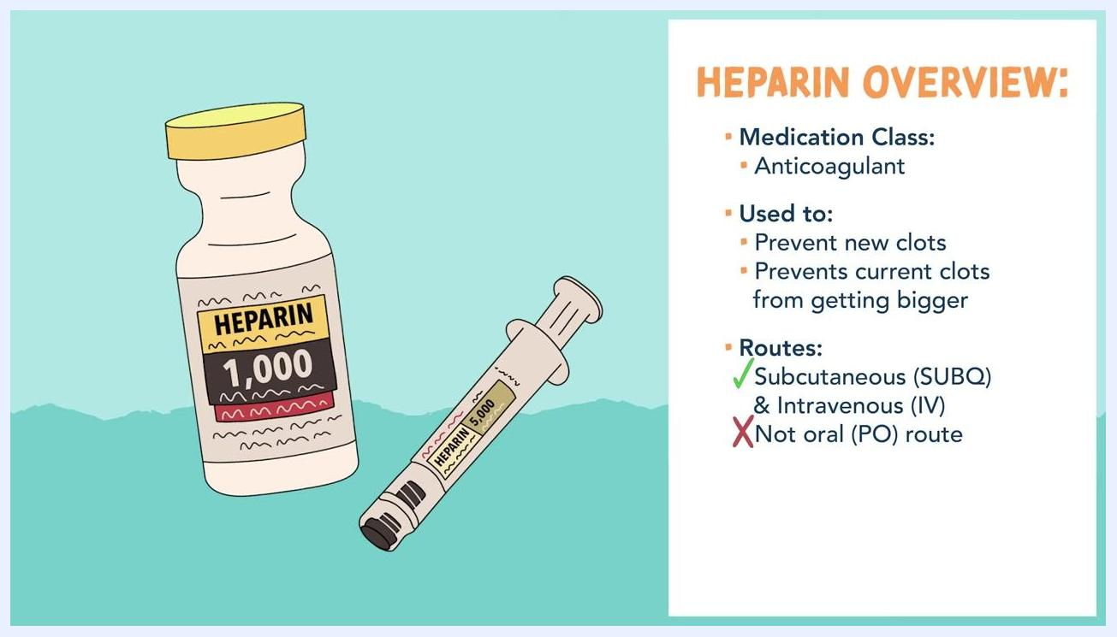
Gloved hands withdrawing the syringe from the skin and preparing to activate the needle's safety shield, with the syringe and safety mechanism clearly visible

Step 15: Dispose of the syringe properly
Place the used syringe and needle directly into a designated sharps container without recapping, if possible, to ensure safe disposal.

⚠️ Critical step: Never attempt to recap a used needle by hand after injection; dispose of it directly into a sharps container.

Quality control checks
- Verify the medication label, strength, and expiration date on the vial before drawing up the dose.
- Confirm the drawn volume matches the ordered dose in units.
- Inspect the syringe for air bubbles and expel any before administration, without losing medication.
- Inspect the needle for bends or damage after withdrawal from the vial; replace if damaged.
- Confirm the injection site has been rotated appropriately based on the patient's chart, to prevent tissue damage.
- Be aware of heparin's antidote and primary side effect as part of ongoing patient monitoring: the reversal agent is protamine sulfate, and the primary side effect is bleeding.
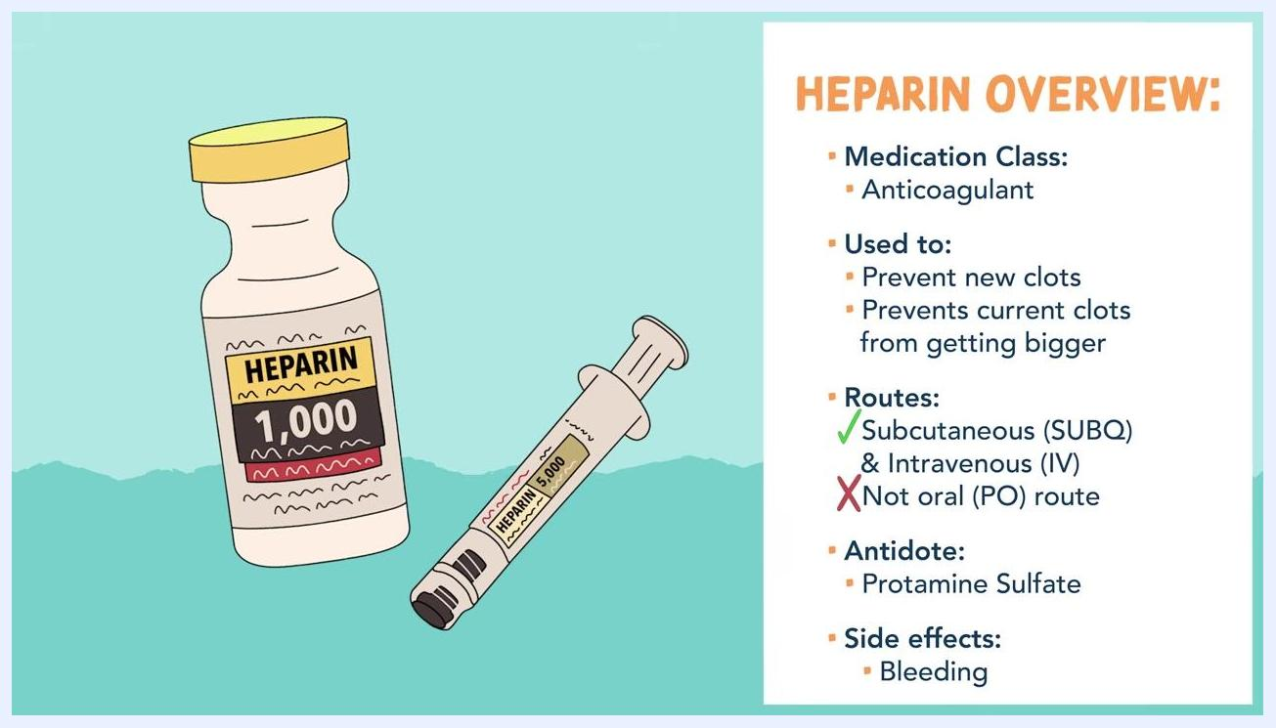
Illustration of a heparin vial and syringe with a complete summary: medication class, uses, routes of administration, antidote (protamine sulfate), and side effects (bleeding)

⚠️ Safety note: Monitor patients receiving heparin for signs of bleeding, and be prepared to reference protamine sulfate as the reversal agent if needed.

Labeling requirements
The procedure describes verifying the existing manufacturer label on the medication vial, confirming the drug name, strength, and expiration date before use. It does not describe preparing a new compounded-product label; if your facility requires a syringe label prior to administration, apply it according to your facility's labeling policy and state board requirements.

Beyond-use dating
The procedure does not specify a beyond-use date (BUD) for the drawn-up dose. Assign a BUD according to your facility's policy and USP guidance for the specific drug and preparation conditions, and administer the dose promptly after drawing it up.

Storage & handling
The procedure does not describe storage temperature or light-sensitivity requirements for the vial. After use, dispose of the syringe and needle immediately into a designated sharps container without recapping, if possible, to ensure safe handling.

References
The procedure does not cite specific USP chapters or formulary references. The following heparin medication overview is provided as clinical reference based on the content covered:
- Medication class: Anticoagulant.
- Uses: Prevent new blood clots from forming; prevent existing clots from getting bigger.
- Approved routes: Subcutaneous (SUBQ) and intravenous (IV); not administered orally (PO), as it is inactivated by gastric acids.
- Antidote: Protamine sulfate.
- Primary side effect: Bleeding.
Consult your facility's protocols and applicable USP standards for aseptic technique and injection safety requirements beyond what is captured here.

What's next
Continue with the injection procedure according to your facility's protocol, ensuring all safety and aseptic techniques are followed for each patient encounter. Document the administered dose, injection site, and any observations per your facility's charting requirements.

