How to Draw Blood: A Step-by-Step Venepuncture Guide
Learning how to draw blood safely requires a consistent, patient-centered approach that covers preparation, execution, and post-procedure care. This guide walks you through the complete venepuncture process, from introducing yourself to the patient through to sealing samples for laboratory transport, so you can perform the procedure confidently and in line with best clinical practice.

Purpose
This document provides a standardized procedure for performing venepuncture (blood draw) safely and effectively, covering patient communication, equipment preparation, the blood draw itself, and proper disposal of clinical waste.

Scope
This procedure applies to any healthcare professional or student performing venepuncture on a patient in a clinical setting. It covers patient identification, consent, equipment gathering, the draw itself, and post-procedure steps including sample handling and waste disposal.

Required equipment and PPE
Before starting, gather the following items and place them in a clean tray:
- Tourniquet (e.g., pink with a green release button)
- Gauze
- Blood collection device (e.g., butterfly needle)
- Sample tubes (e.g., yellow-top and purple-top)
- Alcohol swab
- Plaster
- Apron (PPE)
- Gloves
Ensure all equipment is within easy reach before you begin the procedure.

Step-by-step procedure

1. Introduce yourself and confirm patient identity
Greet the patient and introduce yourself clearly, for example: "Hi there, I'm one of the final year medical students." Ask the patient to confirm their name and date of birth: "Could I just confirm your name and date of birth please?" Wait for their response, then acknowledge and confirm the details they provide.
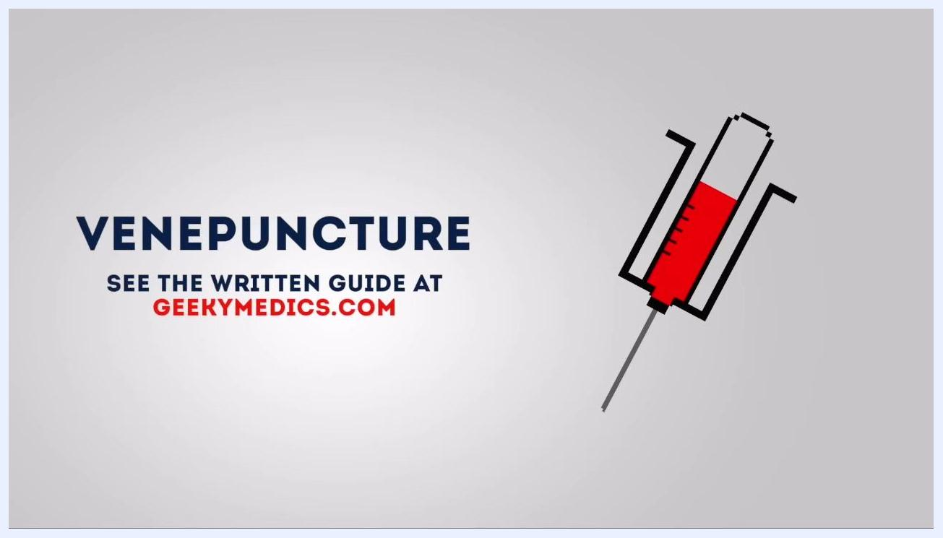
Two people seated facing each other, one in blue scrubs and one in casual clothing, with the heading "Confirm patient details"

2. Explain the procedure
Clearly explain what you are about to do: "Today I've been asked to take some blood from you. Would that be okay?" Describe what the patient can expect: "This will just involve using a small needle and inserting it into one of the veins in your arm. It might be a touch uncomfortable but won't be painful. Is that alright?" Wait for verbal consent before continuing.
Two people seated facing each other, one in blue scrubs explaining the procedure, with the heading "Explain procedure"

3. Check for allergies and gain consent
Ask the patient directly: "Are you allergic to anything at all?" Wait for their response and acknowledge it, for example: "Fantastic." Do not proceed until you have obtained explicit consent from the patient.
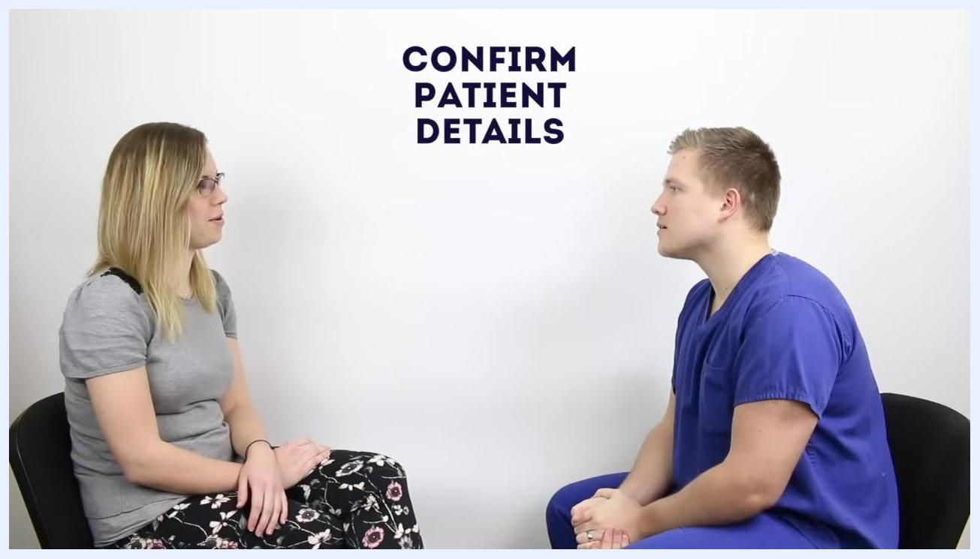
Two people seated facing each other, one in blue scrubs, with the heading "Gain consent"

4. Gather all necessary equipment
Collect the tourniquet, gauze, blood collection device, sample tubes, alcohol swab, and plaster, and arrange them in a clean tray. Having everything within easy reach before you start helps the procedure run smoothly and safely.
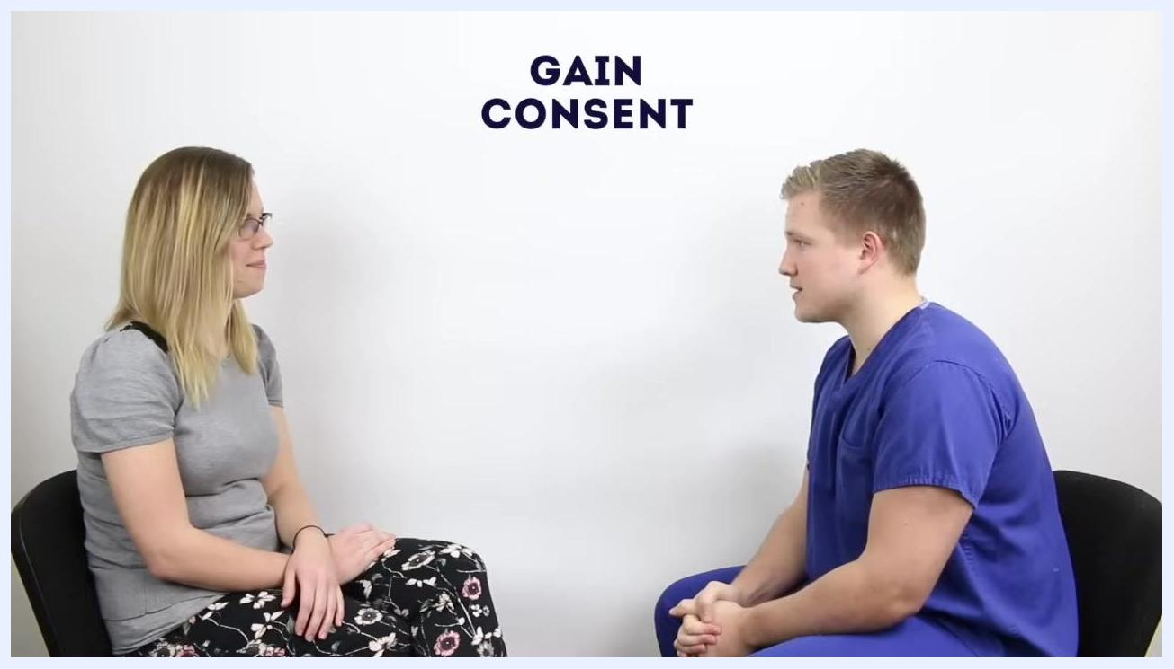
Blue tray containing a pink tourniquet, gauze, blood collection device, sample tubes, alcohol swab, and plaster, each labeled, with the heading "Gather equipment"

5. Apply the tourniquet
Position the patient's arm comfortably on a pillow or support surface. Apply the tourniquet around the upper arm to make the veins more prominent and easier to access.
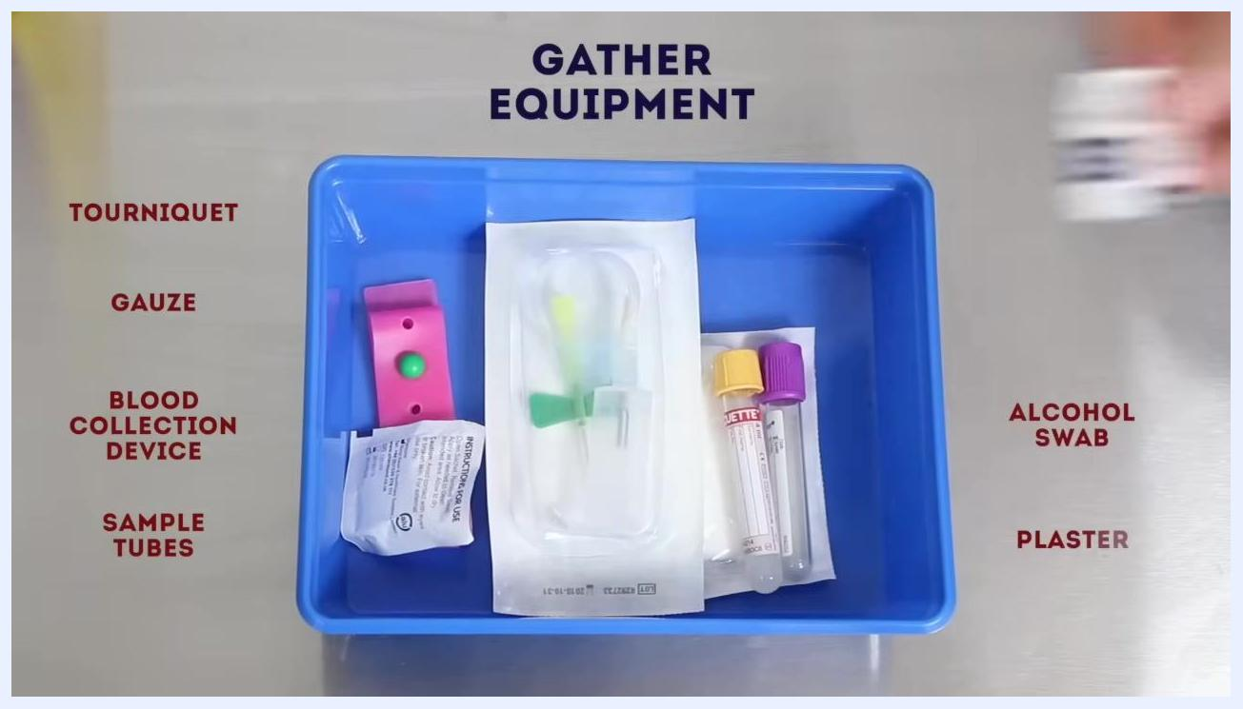
Close-up of a patient's arm with a pink tourniquet applied, heading "Apply tourniquet"

6. Don personal protective equipment (PPE)
Put on an apron to maintain infection control standards. Make sure it is securely tied and fully covers your clothing before you proceed.
Person in blue scrubs putting on a white apron, heading "Don apron"

7. Anchor the vein and prepare for venepuncture
With gloved hands, anchor the vein from below using your thumb to stabilize it. Hold the blood collection device steady in your other hand, ready to insert the needle, and confirm that all sample tubes are within reach before proceeding.
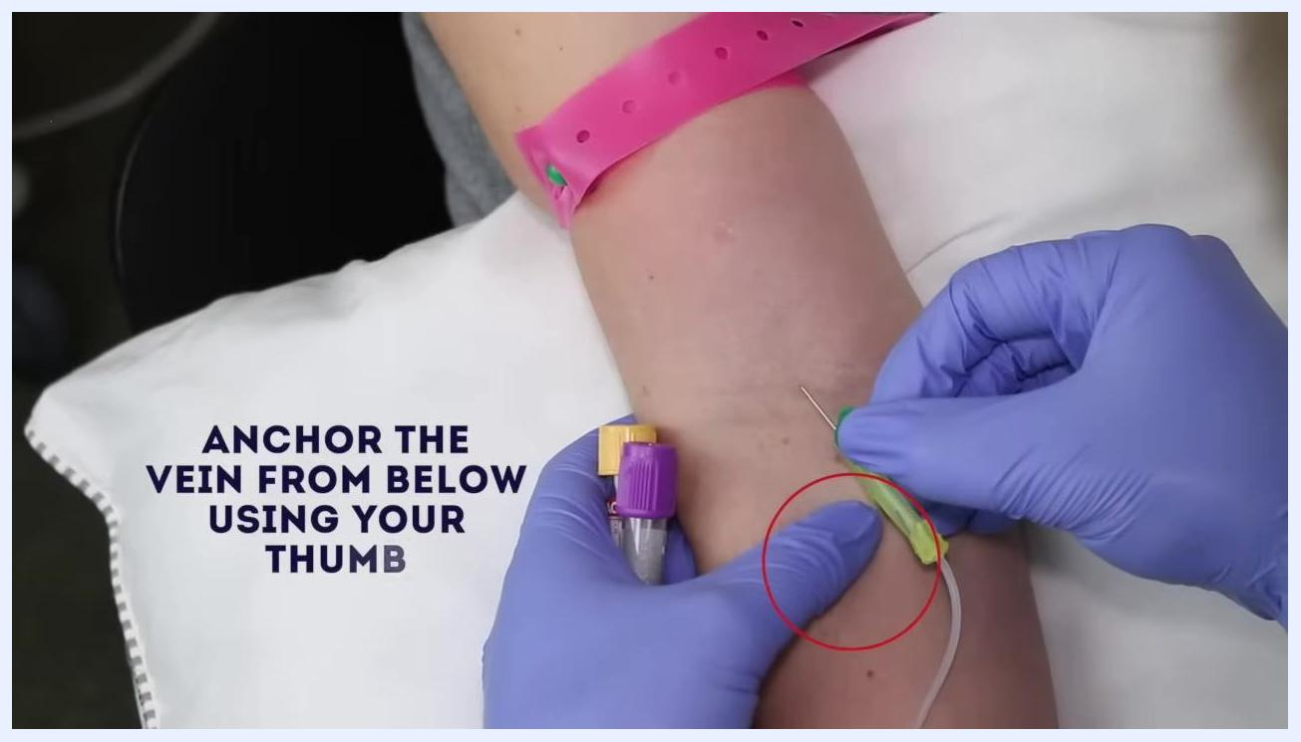
Gloved hands anchoring a vein on a patient's arm with a pink tourniquet in place, holding a butterfly needle and sample tubes, heading "Anchor the vein from below using your thumb"

8. Fill the sample bottles
Once the venepuncture is successful, allow blood to flow into the sample bottles. Hold the blood collection device steady and ensure each required tube fills to the correct volume, observing the blood entering the tube to confirm proper collection.
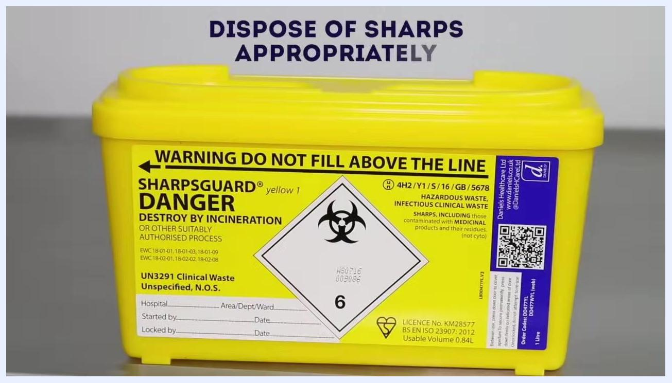
A gloved hand holding a butterfly needle in a patient's arm, blood flowing through the tubing into a sample bottle, heading "Fill the sample bottles"

9. Release the tourniquet
Once all blood samples are collected, release the tourniquet from the patient's arm by pressing the release mechanism (e.g., the green button). Always ensure the tourniquet is removed before withdrawing the needle.
Gloved hands releasing a pink tourniquet with a green button from a patient's arm, heading "Release the tourniquet"

10. Dispose of sharps appropriately
Immediately dispose of the used needle and any other sharps in a designated sharps container. Do not recap the needle or leave it unattended, and make sure the container is never filled above its marked line.
Yellow sharps container labeled "SharpsGuard Danger" with a biohazard symbol and warning text, instruction "Dispose of sharps appropriately"

11. Remove apron and dispose of all clinical waste appropriately
Remove your apron carefully to avoid contamination. Dispose of the apron along with any other clinical waste, such as gloves and gauze, in the appropriate clinical waste bin, following your local infection control protocols.
Person in blue scrubs removing a white apron, heading "Remove apron and dispose of all clinical waste appropriately"

12. Thank the patient and confirm wellbeing
Thank the patient for their cooperation, for example: "Thank you, that completes the procedure. Are you feeling okay?" Wait for their response and ensure they are comfortable before they leave.
Two people seated facing each other, one in blue scrubs and one in casual clothing, with the heading "Thank patient"

13. Seal the samples in a bag for transport to the lab
Place all filled and labeled blood sample tubes into a pathology sample bag. Confirm that the request form is attached and that all patient details are correct, then seal the bag securely for safe transport to the laboratory.
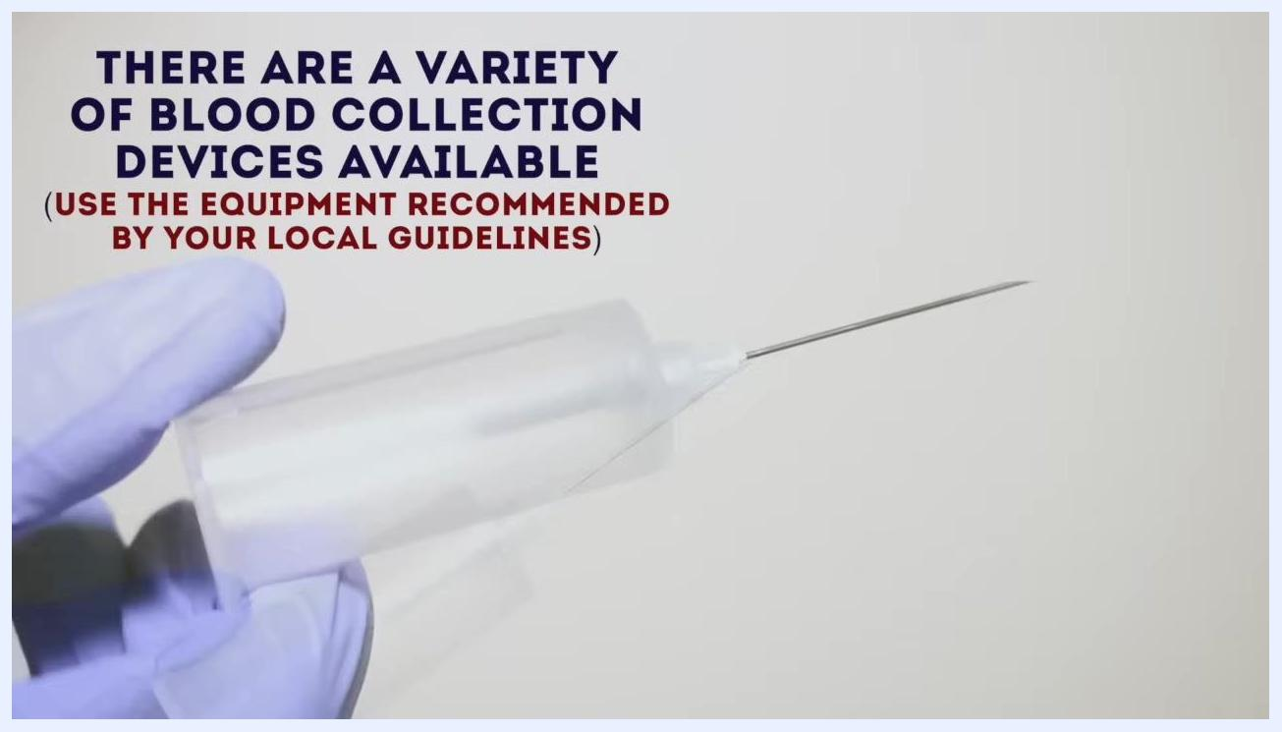
Hand holding a sealed pathology sample bag containing labeled blood tubes, heading "Seal the samples in a bag for transport to the lab"

Safety notes
- A variety of blood collection devices are available; always use the equipment recommended by your local guidelines.
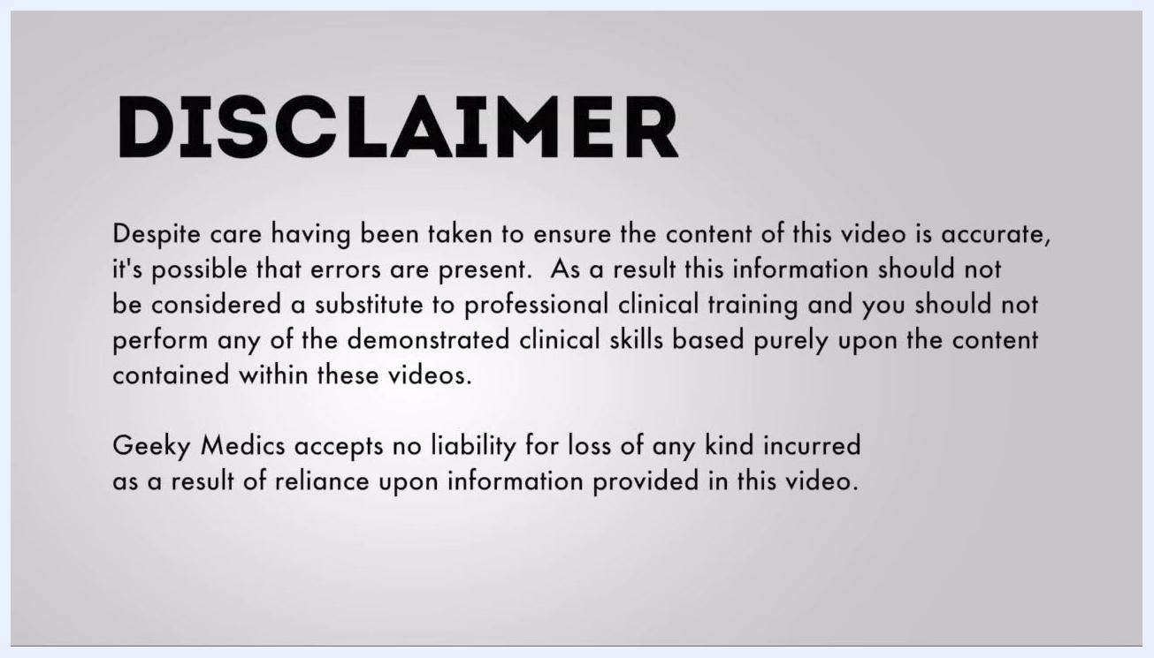
Gloved hand holding a blood collection needle, with the note "There are a variety of blood collection devices available (use the equipment recommended by your local guidelines)"
- This guide is intended for educational purposes only. Always follow your professional clinical training and local protocols, as no liability is accepted for loss incurred as a result of reliance on this information.
Screen displaying the heading "Disclaimer" with a paragraph explaining the educational purpose and liability disclaimer for this content

Verification and summary
By following these steps, you ensure patient safety, comfort, and proper preparation throughout the venepuncture procedure. Confirming patient identity, explaining the process, checking for allergies, and obtaining consent at the start sets up a safe draw. Anchoring the vein correctly, filling sample bottles to the right volume, releasing the tourniquet before withdrawing the needle, disposing of sharps and waste properly, and sealing samples correctly for transport ensures the procedure is completed safely, efficiently, and in accordance with best clinical practice.

What's next
After completing the procedure, confirm that all samples are correctly labeled and that the request form matches the patient's details before sending them to the laboratory. Continue to follow your local clinical protocols for any follow-up documentation or patient monitoring required after venepuncture.

