How to Do a Head-to-Toe Assessment: Eyes, Ears, Nose, Throat, Mouth, Tongue, and Neck
This procedure explains how to do a head-to-toe assessment of the eyes, ears, nose, throat, mouth, tongue, and neck, including the key clinical findings you may observe and what they can indicate. Use this guide to build a consistent, thorough physical assessment routine while remaining aware that exact steps and expected findings can vary by facility.

Purpose & scope
This procedure supports nursing and allied health staff performing a head-to-toe assessment of the eyes, ears, nose, throat (ENT), mouth, tongue, and neck. It applies broadly to adult patients, with particular relevance to elderly patients, patients with liver disease (such as cirrhosis or hepatitis), patients on long-term oxygen therapy, patients taking steroids, patients with a history of stroke, and patients at risk of fluid volume overload from heart failure.
Assessment findings and specific procedures may vary depending on your hospital or clinical facility. This guidance is intended for educational purposes only and is not a substitute for your facility's procedures, policies, or skills checklists. Always refer to your institution's protocols for graded demonstrations and clinical practice.

Patient assessment
Work through each body area systematically, comparing your findings against expected normal presentation. The table below summarizes what to inspect and what abnormal findings may indicate.
Body area | What to observe | Clinical significance
Eyes | Cloudy appearance of the eye | Often associated with glaucoma, especially in elderly patients
Eyes | Blue halo on the perimeter of the eye | Indicates cataracts
Eyes | Metal prongs visible inside the eye | Sign of prior cataract surgery
Eyes | Jaundice in the sclera (white of the eye) and under the bottom eyelid | Associated with liver disease such as cirrhosis or hepatitis
Ears | Redness inside the ear canal | May indicate ear infection
Ears | Inflamed tympanic membrane (eardrum) with redness | Confirms ear infection
Ears | Reported loss of balance with earache | May indicate Ménière's disease (extra fluid in the inner ear)
Nose | Crusting around the nostrils | Requires nasal cleaning
Nose | Dry mucous membranes | Common in patients on long-term oxygen therapy
Throat | White splotches in the back of the throat | May indicate strep throat
Throat | Inflamed uvula | Supports a strep throat finding
Mouth (smile) | Facial symmetry when smiling | Asymmetry or one-sided weakness may indicate stroke or stroke history
Gums | Inflammation, redness, or bleeding | Typically indicates gingivitis
Tongue | White coating on the tongue | Oral thrush (fungal infection), common with steroid use, including inhaled steroids
Tongue | Red, beefy appearance of the tongue | Pernicious anemia (vitamin B12 deficiency)
Neck | Visible bulging of the jugular vein | Jugular vein distention (JVD), a sign of fluid volume overload, commonly from heart failure exacerbation
Reference visual guides during assessment to distinguish between normal findings and abnormal presentations.
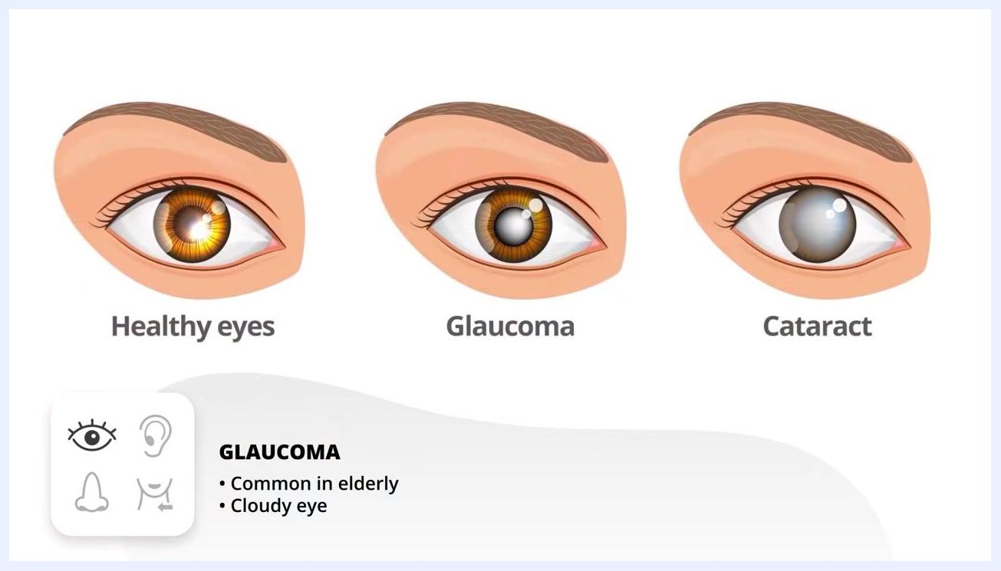
Illustration comparing a healthy eye, a glaucoma-affected eye (cloudy), and a cataract-affected eye (cloudy lens), labeled "Glaucoma: common in elderly patients, cloudy eye appearance"
Close-up of an eye showing a cataract with a blue halo around the perimeter and metal prongs visible after surgery, labeled "Cataract: blue halo on the perimeter and, after surgery, metal prongs in the eye"
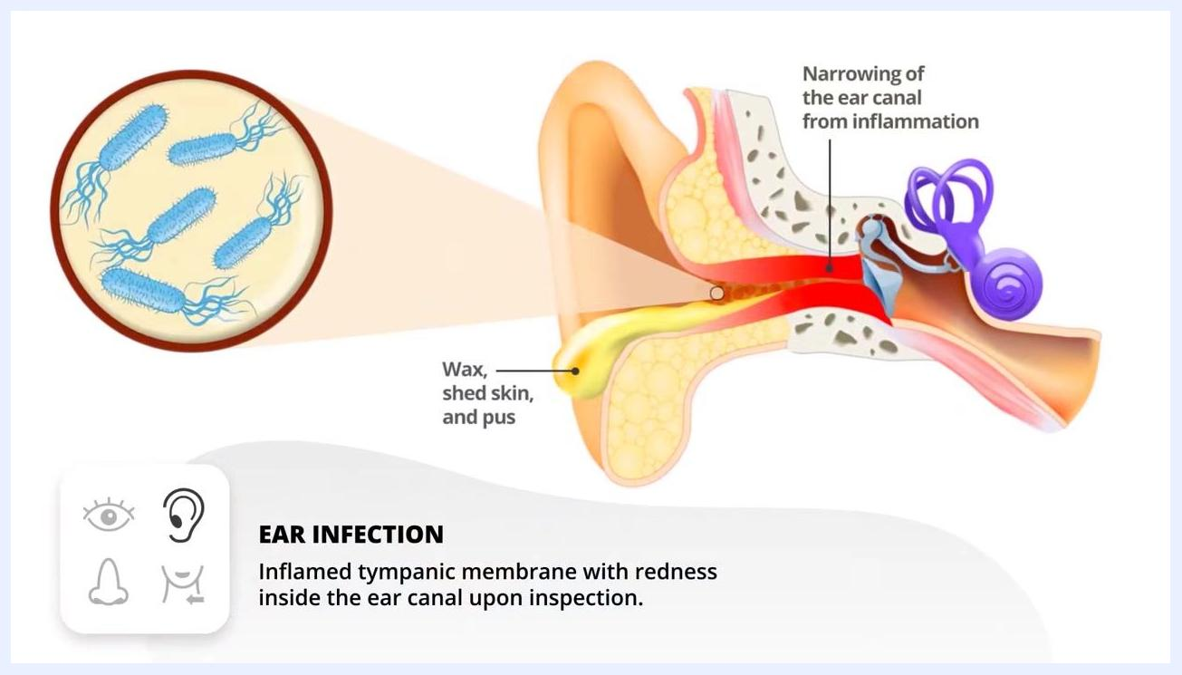
Close-up of an eye with yellow sclera, labeled "Jaundice in sclera: associated with liver diseases such as hepatitis or cirrhosis"
Diagram of an ear infection showing an inflamed tympanic membrane, redness, and narrowing of the ear canal, labeled "Ear infection: inflamed tympanic membrane with redness inside the ear canal upon inspection"
Diagram of Ménière's disease showing excess fluid in the inner ear, labeled "Ménière's disease: extra fluid in the inner ear causing loss of balance"
Image of the throat showing an inflamed uvula and white spots, labeled "Strep throat: an inflamed uvula and spots in the back of the throat could indicate strep"
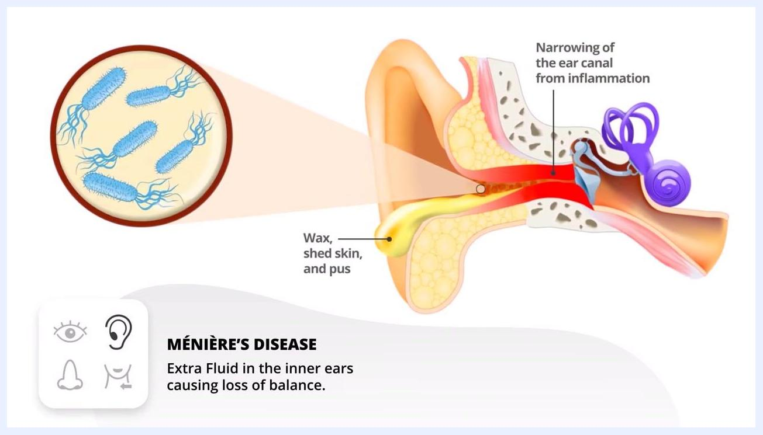
Nurse instructing a patient to smile while observing for facial symmetry, medical equipment visible in the background

Care protocol
A facility-specific care plan (day-by-day interventions, wound care, nutrition, and medication administration) should be documented here based on the patient's diagnosis and unit protocols; the source material for this assessment covers physical examination technique only and does not include a phase-based care plan.

Pain management
A multimodal pain management plan, including a medication table (drug, dose, route, frequency), pain score targets, and an escalation pathway, should be documented here per your facility's pain management protocol; this information was not part of the head-to-toe ENT, mouth, and neck assessment covered in this procedure.

Mobility milestones
Progressive mobility goals with a timeline (for example, bed exercises, chair transfer, ambulation with a walker) should be recorded here as part of the patient's overall care plan; mobility progression was not addressed in this assessment procedure.

Complication monitoring
Monitor for the following signs during and after the head-to-toe assessment, and escalate according to your facility's protocol.
Sign/symptom observed | Possible cause | Action
Cloudy eye appearance | Glaucoma | Document finding; refer per facility protocol
Blue halo on eye perimeter | Cataract | Document finding; refer per facility protocol
Yellow sclera | Liver disease (cirrhosis, hepatitis) | Document finding; refer per facility protocol
Redness or inflammation in ear canal/eardrum | Ear infection | Document finding; refer per facility protocol
Reported loss of balance | Ménière's disease | Document finding; refer per facility protocol
White splotches and inflamed uvula | Strep throat | Document finding; refer per facility protocol
One-sided facial weakness or drooping when smiling | New or previous stroke | Escalate immediately per facility stroke protocol
Inflamed, red, or bleeding gums | Gingivitis | Document finding; refer per facility protocol
White coating on tongue | Oral thrush, often linked to steroid use | Document finding; refer per facility protocol
Red, beefy tongue | Pernicious anemia (B12 deficiency) | Document finding; refer per facility protocol
Jugular vein distention (JVD) | Fluid volume overload / heart failure exacerbation | Escalate per facility heart failure protocol
Note that if the patient is reclined, jugular vein distention may appear more pronounced due to increased pressure. Adjust the patient's position as needed to accurately assess for JVD.
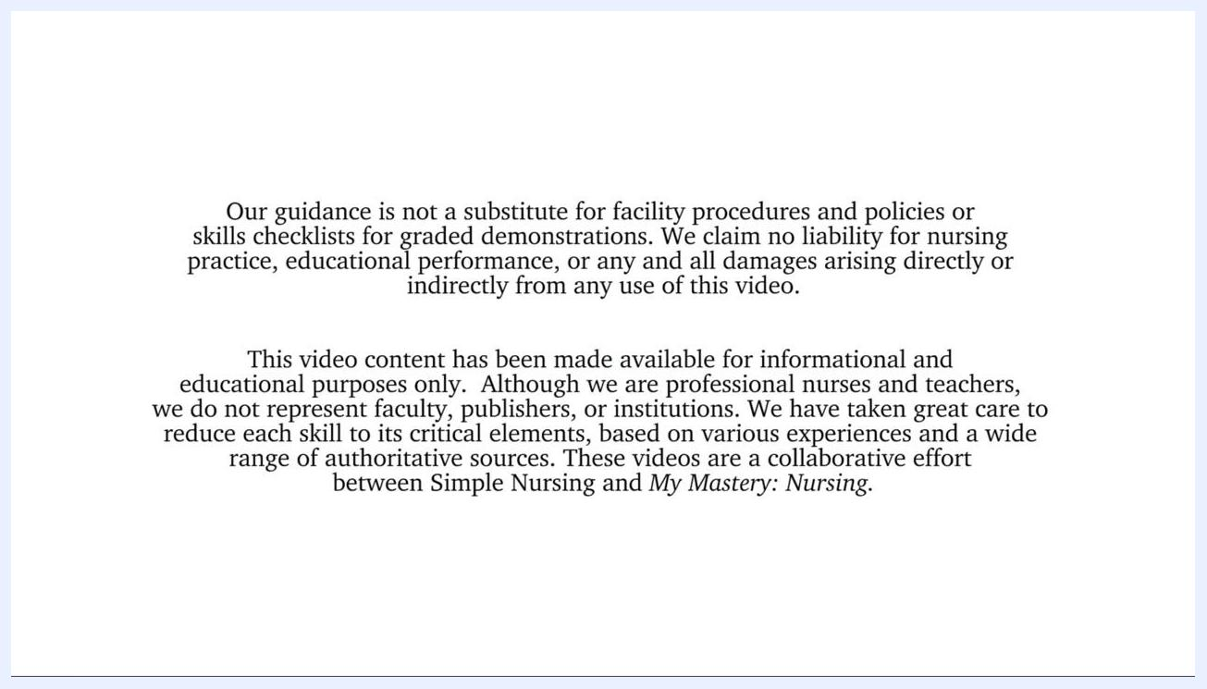
Close-up of a patient's neck showing jugular vein distention, labeled "Jugular vein distention (JVD): fluid volume overload due to heart failure exacerbation. HF = heart failure = heavy fluid"
Nurse demonstrating a JVD assessment on a patient while pointing to the neck, labeled "Jugular vein distention (JVD): fluid volume overload due to heart failure exacerbation. HF = heart failure = heavy fluid"

Discharge criteria
Specific measurable criteria that must be met before discharge should be documented here based on the patient's diagnosis and clinical status; discharge criteria were not part of this head-to-toe assessment procedure.

Patient education
Before concluding the assessment, keep the following points in mind:
- Assessment findings and procedures may vary by hospital or clinical facility.
- This guidance is for educational purposes only and does not replace your facility's procedures, policies, or skills checklists.
- Always refer to your institution's protocols for graded demonstrations and clinical practice.
Text disclaimer explaining that the content is for educational use only, addressing liability and noting collaborative production

What's next
For additional learning resources, access the full assessment video and accompanying quiz bank through the provided link, and consider subscribing for further educational content.
Promotional screen showing links to the full video, quiz bank, and team credits, with "Subscribe here!" and "Click here" buttons
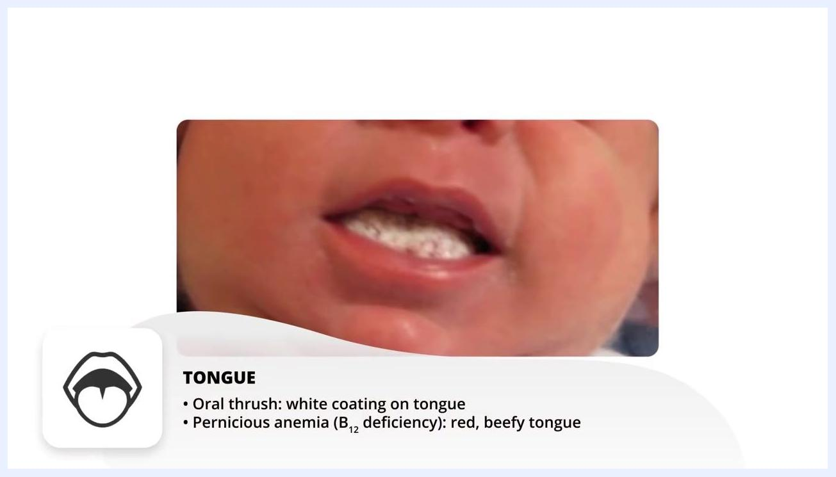
Nurse instructing patient to smile, observing for facial symmetry. Medical equipment visible in the background. On-screen text: "SMILE: With stroke or stroke history, weakness on one side."
Close-up of mouth showing white coating on tongue. On-screen text: "TONGUE: Oral thrush: white coating on tongue. Pernicious anemia (B12 deficiency): red, beefy tongue."
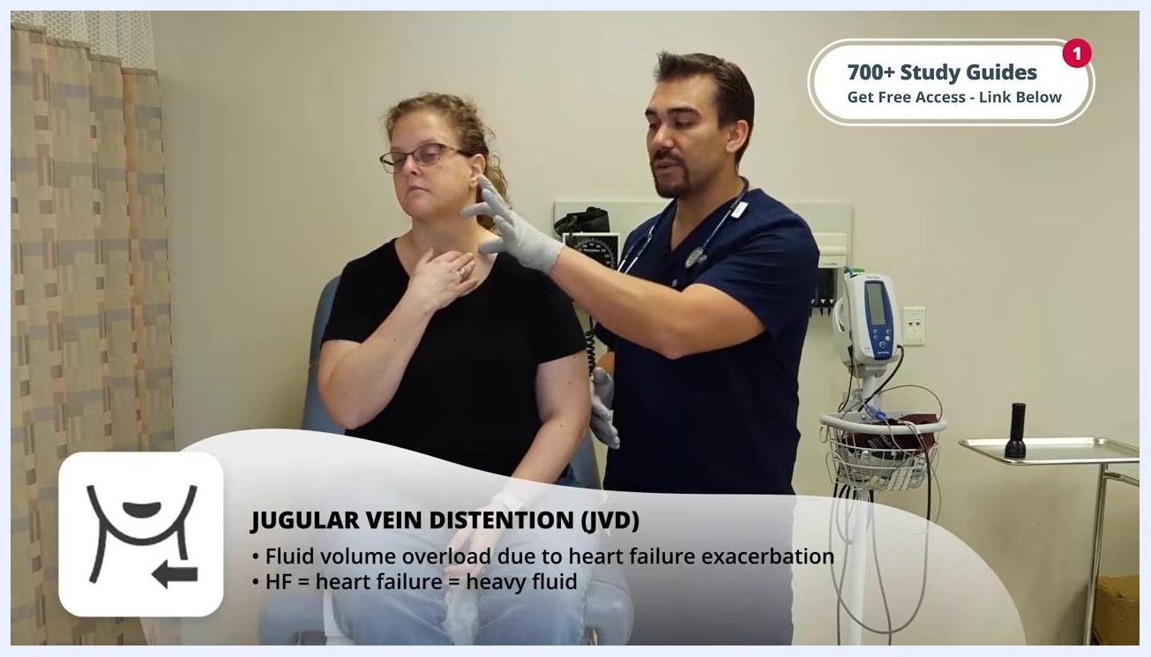
Close-up of mouth showing red, beefy tongue. On-screen text: "TONGUE: Oral thrush: white coating on tongue. Pernicious anemia (B12 deficiency): red, beefy tongue."

