Standard Operating Procedure: Safe Disposal of Needles and Other Sharps

Purpose
This procedure provides guidance for the safe collection, storage, and disposal of needles and other sharps. Following these steps helps prevent injury to yourself, others, and animals, and ensures compliance with local disposal regulations.
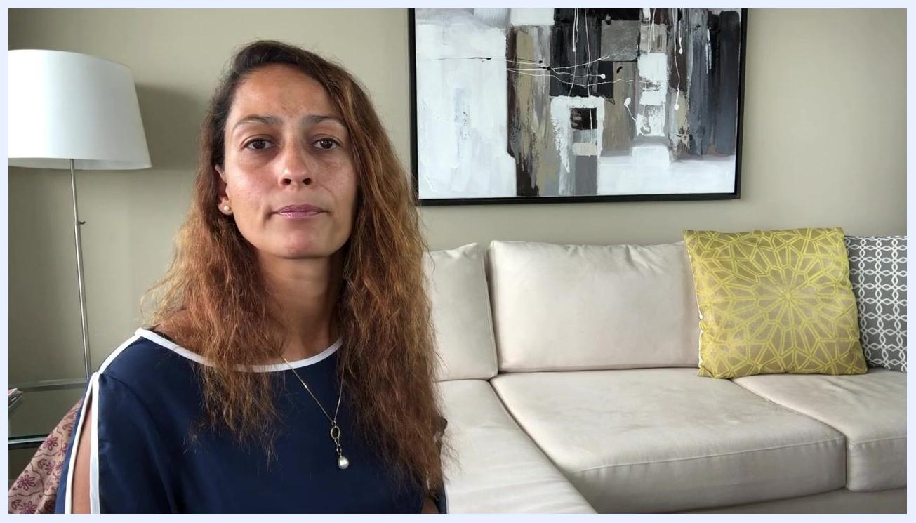
Presenter concluding the guide and summarizing the safe disposal process for needles and sharps, seated in a living room with a beige couch, yellow and gray pillows, a modern painting, and a white floor lamp.

Scope
This procedure applies to anyone who uses needles, syringes, infusion sets, lancets, autoinjectors, or any device with a puncturing component — including individuals managing diabetes or other conditions requiring regular injections or blood sampling. "Sharps" is the medical term covering all such objects capable of cutting or puncturing skin.

Required equipment / materials
Depending on the disposal method you choose, you will need one of the following:
- A commercial sharps container (available at pharmacies or online, approximately $7)
- A BD Needle Clipper (a portable device for clipping and storing used needles, compatible with 28–31 gauge needles, approximately $7 on Amazon)
- A homemade sharps container made from a clean, hard plastic bottle (such as an empty bleach or detergent bottle) with a secure lid, plus a permanent marker for labeling
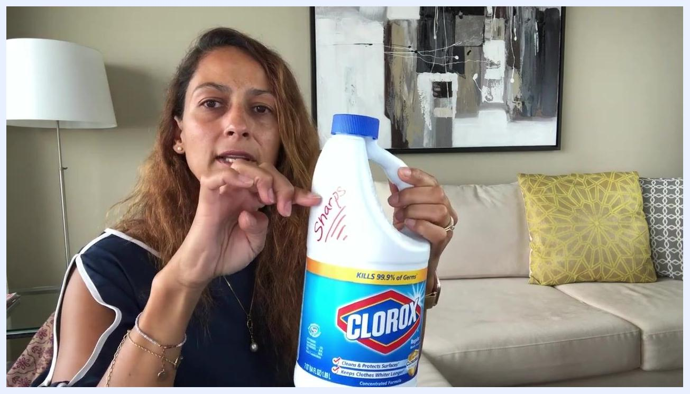
Person screwing the blue lid onto the labeled bleach bottle, demonstrating how to securely seal the homemade sharps container.

Safety notes
- Never place sharps directly in regular household trash. Many regions, including several US states, prohibit this practice.
- Improper disposal creates safety hazards for people and animals who may come into contact with the trash.
- Never place sharps containers — homemade or commercial — in the recycling bin. Sharps cannot be recycled.
- Always check your local regulations before disposing of a full sharps container, as rules vary by location (for example, sharps containers cannot be thrown in the trash in California, Massachusetts, or parts of Washington).
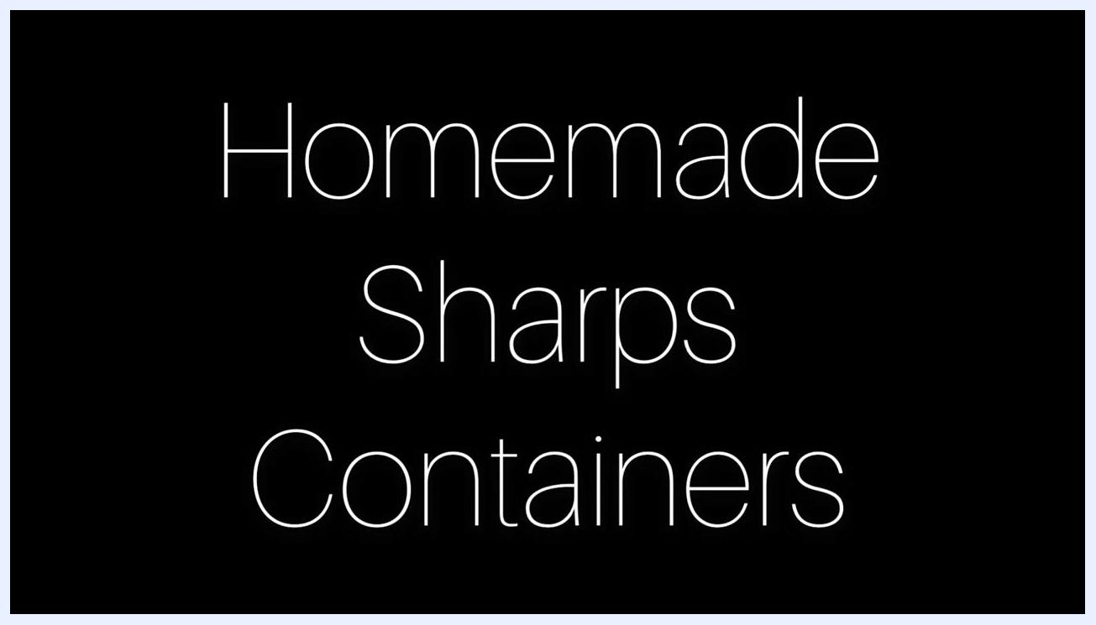
Text on a black background reading "Homemade Sharps Containers."

Step-by-step procedures

Method 1: Using a BD Needle Clipper (portable disposal)

- Purchase a BD Needle Clipper.
- The device is available for approximately $7 on Amazon and is compatible with needles ranging from 28 to 31 gauge.
- A purchase link is typically provided in the accompanying video description.
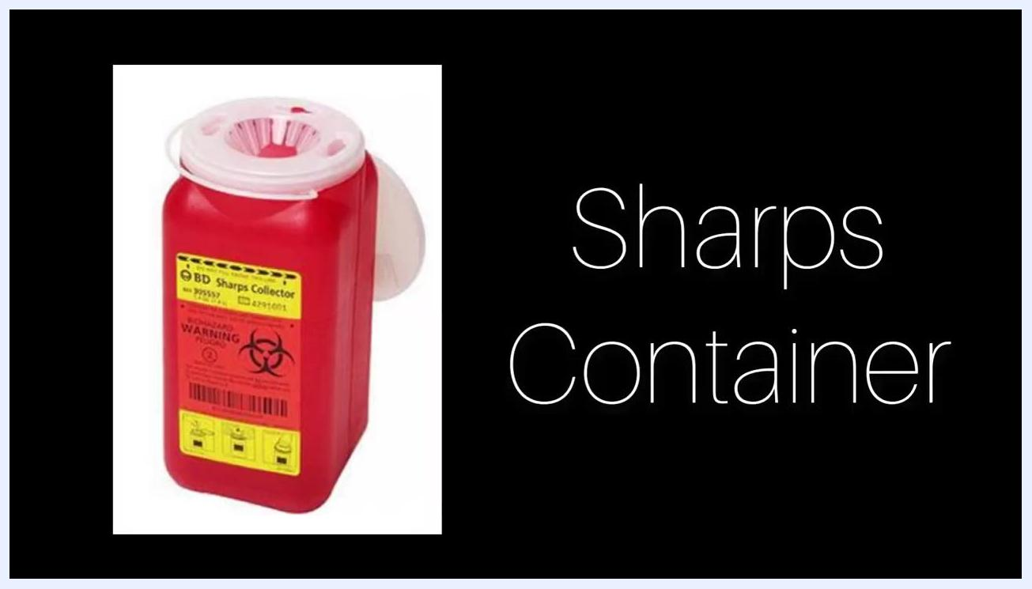
Person holding a syringe with a visible needle, preparing to insert it into the BD Needle Clipper.

- Prepare the needle clipper.
- Hold the device in your hand and click on the sides to open it. The top will pop up with a spring action.
- Locate the small hole where the needle will be inserted.

- Dispose of a used needle.
- Take the used syringe with the needle attached and insert the needle into the hole on the device.
- Press firmly to clip the needle off. The sharp portion is safely stored inside the device, which can hold up to 1,500 clipped needles.
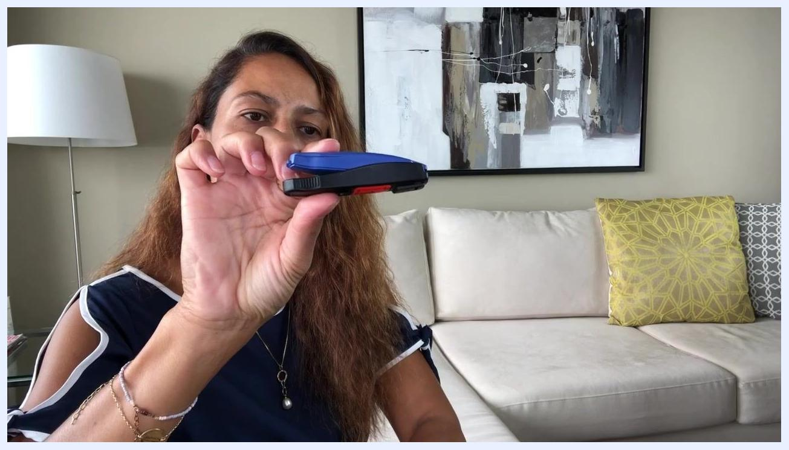
Person holding a blue BD Needle Clipper and demonstrating how to open it by pressing the sides. The device is shown in a living room setting with a couch and pillows in the background.
Person demonstrating the process of inserting the needle into the BD Needle Clipper, showing both the device and the syringe.
Safety note: This device is especially useful for safe disposal while traveling.

Method 2: Using a commercial sharps container

- Purchase a sharps container.
- Obtain a hard plastic sharps container from a local pharmacy or online retailer such as Amazon, typically costing around $7.
- A purchase link is usually included in the video description.
Red BD Sharps Collector container with a yellow label displaying the words "Sharps Container" against a black background.

- Dispose of used sharps.
- Immediately after using a needle, syringe, or other sharp object, place it into the sharps container.
- Do not overfill the container; replace it with a new one once it is full.
Person holding a red BD Home Sharps Container with a yellow biohazard label, demonstrating proper sharps disposal.

- Secure the container.
- Once full, tighten the lid securely.
- Set the container aside until you can dispose of it according to local regulations.
Person securing the lid on a full BD Home Sharps Container.

Method 3: Creating and using a homemade sharps container
Use this method only when a commercial sharps container is unavailable.

- Select a suitable container.
- Choose a hard plastic container, such as an empty bleach or detergent bottle, that has been thoroughly washed and dried.
- Do not use water bottles or other thin, flimsy plastic containers, as sharps can easily puncture them.
- Label the container clearly with the word "Sharps" using a permanent marker.
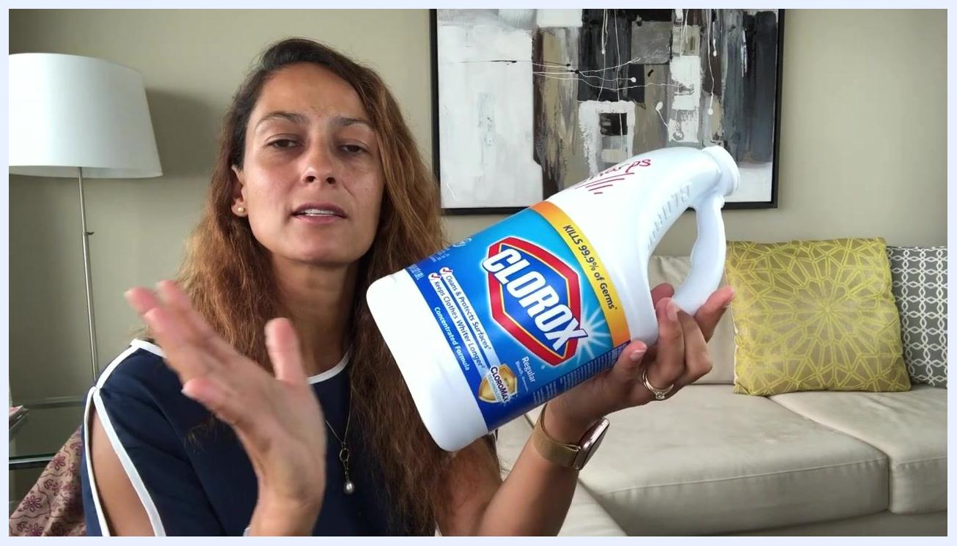
Person holding a clean, empty Clorox bleach bottle labeled "Sharps" in red marker, shown as an example of a homemade sharps container, in a living room setting with a couch, pillows, and a lamp in the background.

- Prepare the container for use.
- Confirm the container is completely dry before use.
- Verify that the lid fits securely to prevent accidental spills.

- Dispose of used sharps.
- Immediately after use, drop the needle or sharp object into the homemade container.
- Do not overfill the container; leave enough space so the lid can close securely.

- Seal and store the container.
- When the container is nearly full, screw the lid back on securely.
- Store the sealed container in a safe place, out of reach of children and pets, until ready for final disposal.
Person pointing to the sharps container, emphasizing its role in safe disposal.

- Do not recycle.
- Never place sharps containers, homemade or commercial, in the recycling bin.
- Only dispose of the container in regular trash if local regulations permit, and only if it is firmly sealed.

- Check local disposal regulations.
- Disposal rules vary by location. In some areas, including California, Massachusetts, and parts of Washington, it is illegal to place sharps containers in the trash.
- Always verify your local regulations before disposing of a full container.

- Use SafeNeedleDisposal.org for guidance (U.S. only).
- Visit .
- Enter your zip code to find approved sharps disposal locations near you.
- This free service provides up-to-date information on safe disposal options in your area.
Person gesturing while explaining that sharps containers must be firmly sealed and never recycled. The labeled bleach bottle is not visible in this frame.

Additional disposal options

- Explore drop-off and pickup services.
- Consider dropping off your sealed sharps container at an approved collection site. Many pharmacies, hospitals, and clinics offer sharps disposal services.
- In some areas, pickup services are available that will collect your sealed sharps container from your home.
- Check with your local health department or visit to determine what options are available in your area.
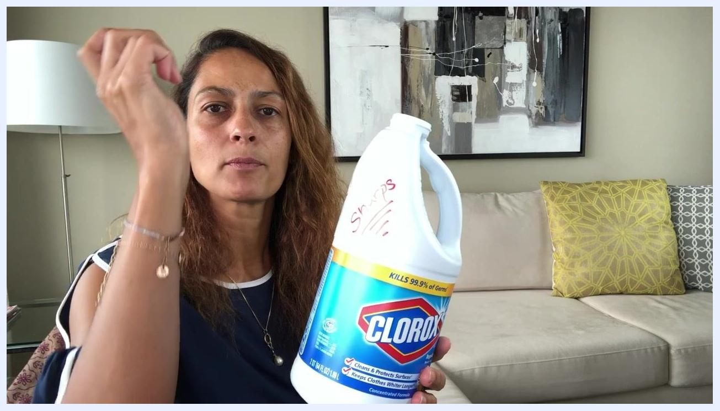
Person dropping a used sharp into the labeled bleach bottle, holding the container upright with the lid removed.
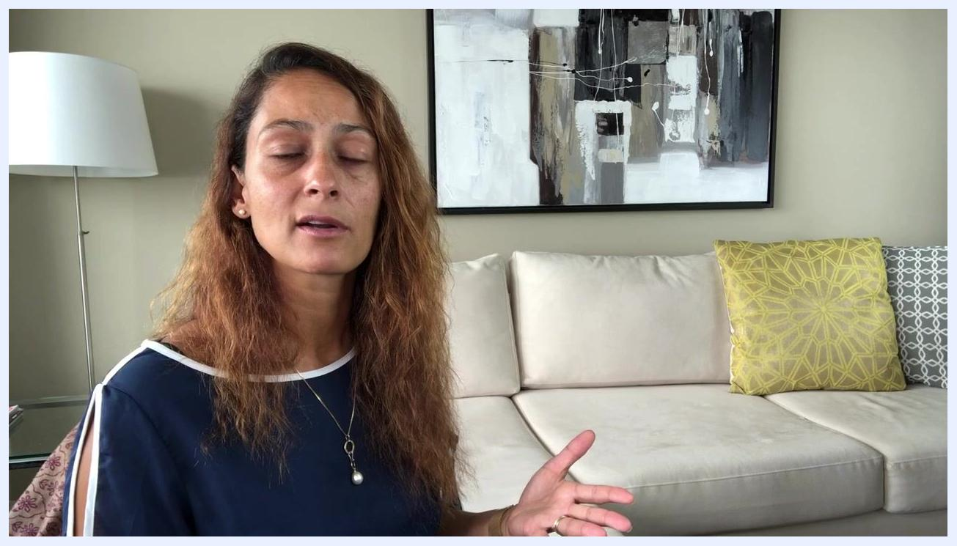
Presenter explaining that drop-off locations and home pickup services exist for sharps disposal, seated in a living room with a beige couch, yellow and gray pillows, a modern painting, and a white floor lamp.

Verification / summary
Before considering the disposal process complete, confirm the following:
- Sharps were never placed in regular household trash or recycling bins.
- Used sharps were stored in an approved sharps container (commercial, BD Needle Clipper, or homemade) immediately after use.
- Homemade containers were made of hard plastic, clearly labeled "Sharps," and never made from thin plastic.
- Full containers were sealed securely before storage or disposal.
- Local regulations were checked prior to final disposal.
- Drop-off or pickup services were used where available, or the container was disposed of according to local rules.
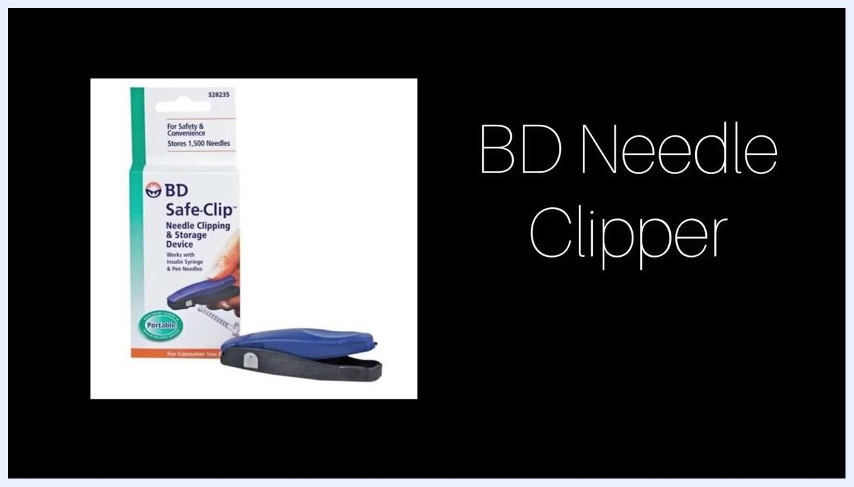
Packaging and device of the BD Safe-Clip Needle Clipping & Storage Device shown against a black background with the text "BD Needle Clipper." The packaging indicates it stores 1,500 needles and is portable.

What's next
- Always check your local regulations before disposing of a full sharps container.
- Use for up-to-date disposal site information within the United States.
- Consider professional pickup services where available for added convenience and safety.
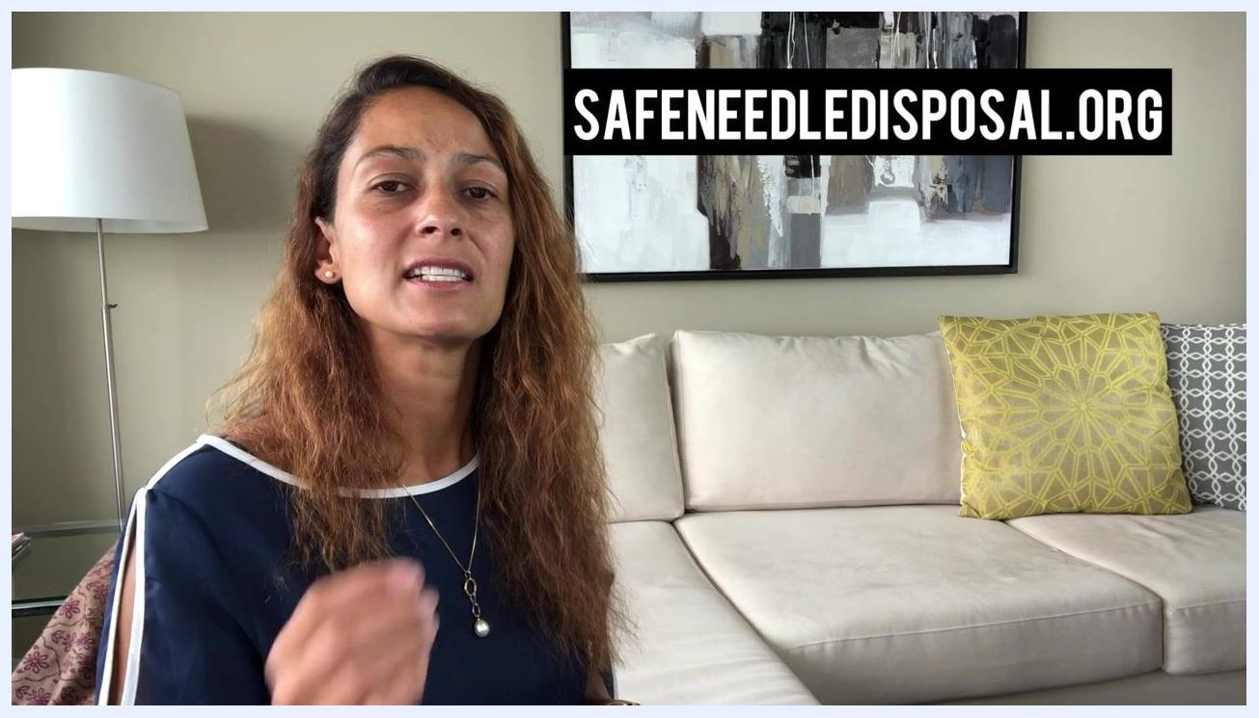
Website address "SAFENEEDLEDISPOSAL.ORG" displayed prominently on screen while the presenter explains its use.
Following this procedure protects yourself, your household, and your community from the hazards of improper sharps disposal.

