How to Calculate an IV Drip Rate: Clinical Protocol Document
This protocol document describes the procedure for how to calculate an IV drip rate, covering the tubing calibration systems, roller clamp mechanics, and the standard formats used to write IV fluid orders. It is intended to serve as a reference for interpreting drop factors, adjusting infusion rates manually, and determining total infusion volumes from a prescriber's order.
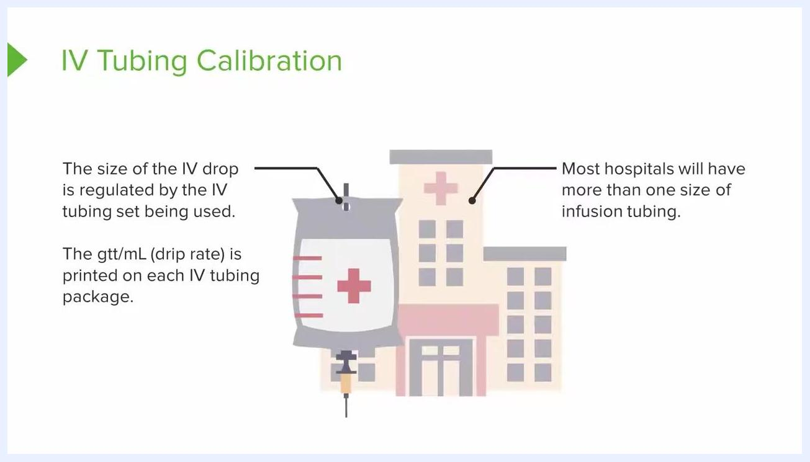
A presenter stands beside a slide titled "Macrodrip and Microdrip," showing two drip chambers: one labeled 10 gtt/mL for adults and one labeled 60 gtt/mL for pediatric patients.
Protocol ID: IV-DRIP-CALC-001
Version: 1.0
Document Date: 2026-09-20
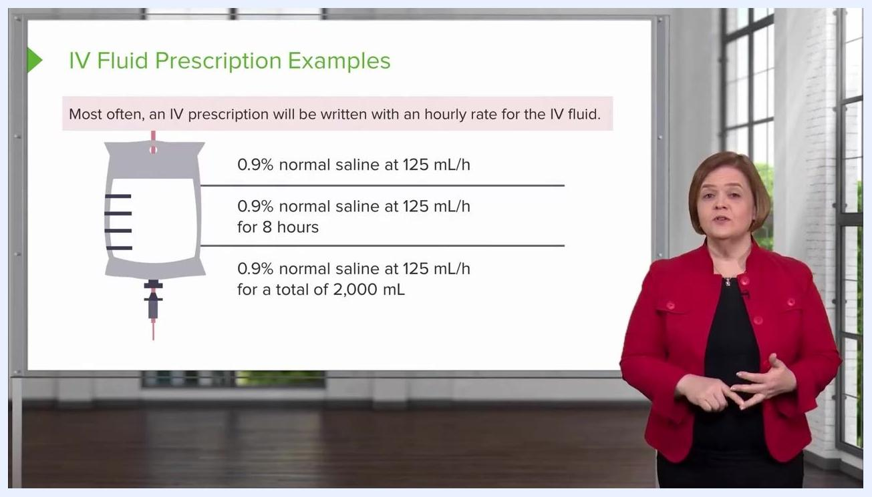
End-of-lesson screen with instructor smiling, text encouraging the viewer to continue the course or check out a YouTube playlist.

Study Synopsis
Field | Details
Protocol Title | How to Calculate an IV Drip Rate
Protocol ID / Version | IV-DRIP-CALC-001 / Version 1.0
Sponsor | Not applicable — this is a procedural training document rather than a sponsored clinical trial.
Phase | Not applicable — the content describes a bedside nursing procedure, not a trial phase.
Indication | Administration and rate calculation of intravenous (IV) fluid therapy
Study Population | Adult patients receiving macrodrip IV tubing (10, 15, or 20 gtt/mL) and pediatric or critical-medication patients receiving microdrip IV tubing (60 gtt/mL)
Design Summary | Manual calculation and adjustment of the IV drip rate using the drop factor printed on the tubing package and the roller clamp, cross-checked against the healthcare provider's written fluid order
Primary Endpoint | Delivery of the prescribed IV fluid at the correct rate (mL/h), as specified in the order
Estimated Duration | Variable, depending on the order type: continuous infusion, a fixed 8-hour duration, or infusion until a specified total volume (e.g., 2,000 mL) is reached
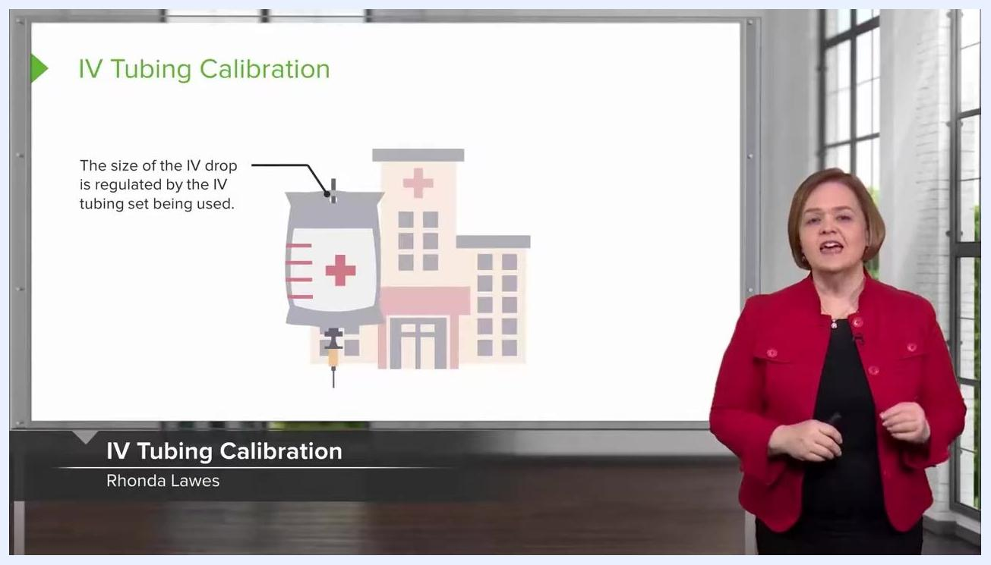
A presenter stands beside a slide titled "IV Tubing Calibration," showing an IV bag illustration with a hospital building in the background and the text explaining that drop size is regulated by the tubing set in use.

Background & Rationale
The size of each IV drop is regulated by the IV tubing set in use, not by the practitioner. The drop chamber built into the tubing set determines how large each drop is, and this is fixed by the manufacturer.
You do not need to memorize the drop size for every tubing set. This information is printed directly on the tubing packaging, so it should always be confirmed at the bedside rather than assumed.
Most hospitals stock more than one size of infusion tubing. When working in a clinical setting, check which tubing set is available and in use before calculating a rate, since the drop factor varies by set.
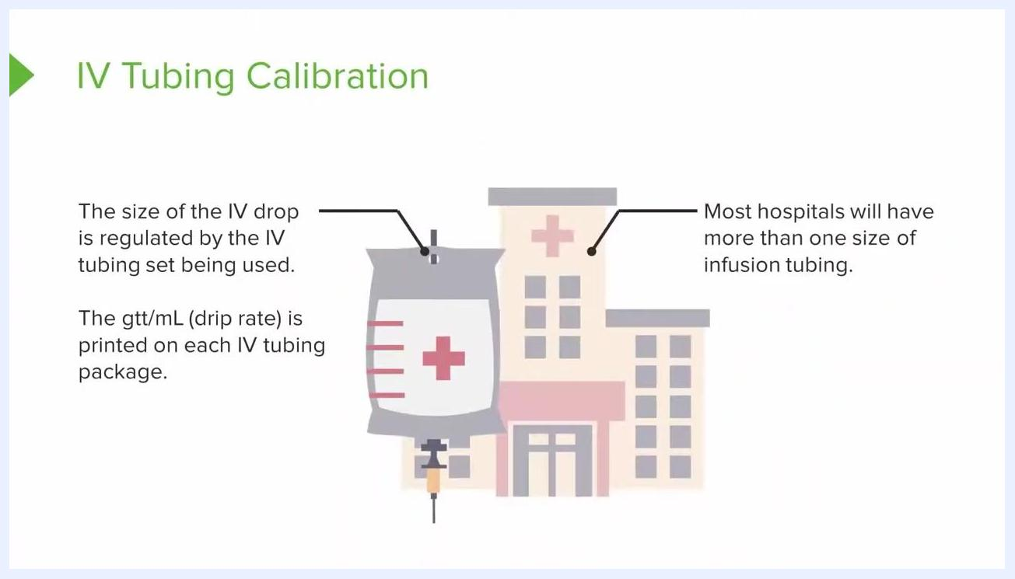
A close-up of a slide summarizing that drop size is set by the tubing, that the gtt/mL drip rate is printed on the package, and that most hospitals stock more than one tubing size.
The abbreviation "GTT" refers to a drop, and the drip rate is expressed as gtt/mL (drops per milliliter). This value is always printed on the tubing package and must be checked before setting any rate.

Study Design
IV tubing sets fall into two categories: macrodrip and microdrip. Macrodrip sets, typically used for adults, come in drop factors of 10, 15, or 20 gtt/mL. Microdrip sets, used for pediatric patients, have a drop factor of 60 gtt/mL.
A presenter stands beside a slide noting that most hospitals will have more than one size of infusion tubing available.
A macrodrip package marked "10" means 10 drops are required to deliver 1 mL of fluid. This printed drop factor is the basis for every manual rate calculation.
To set a rate manually, count the number of drops according to the tubing's drop factor. For a macrodrip set of 10 gtt/mL, count 10 drops to confirm that 1 mL has been delivered, then adjust as needed to meet the prescribed rate.
The roller clamp on the IV tubing controls flow by applying pressure to the tubing. Tightening the clamp increases pressure and slows the drip rate; loosening the clamp decreases pressure and speeds up the drip rate.
Adjust the clamp gradually while watching the drip chamber, counting drops per minute against the tubing's drop factor until the count matches the prescribed rate. If drops move too fast to count, tighten the clamp slightly until individual drops become visible.
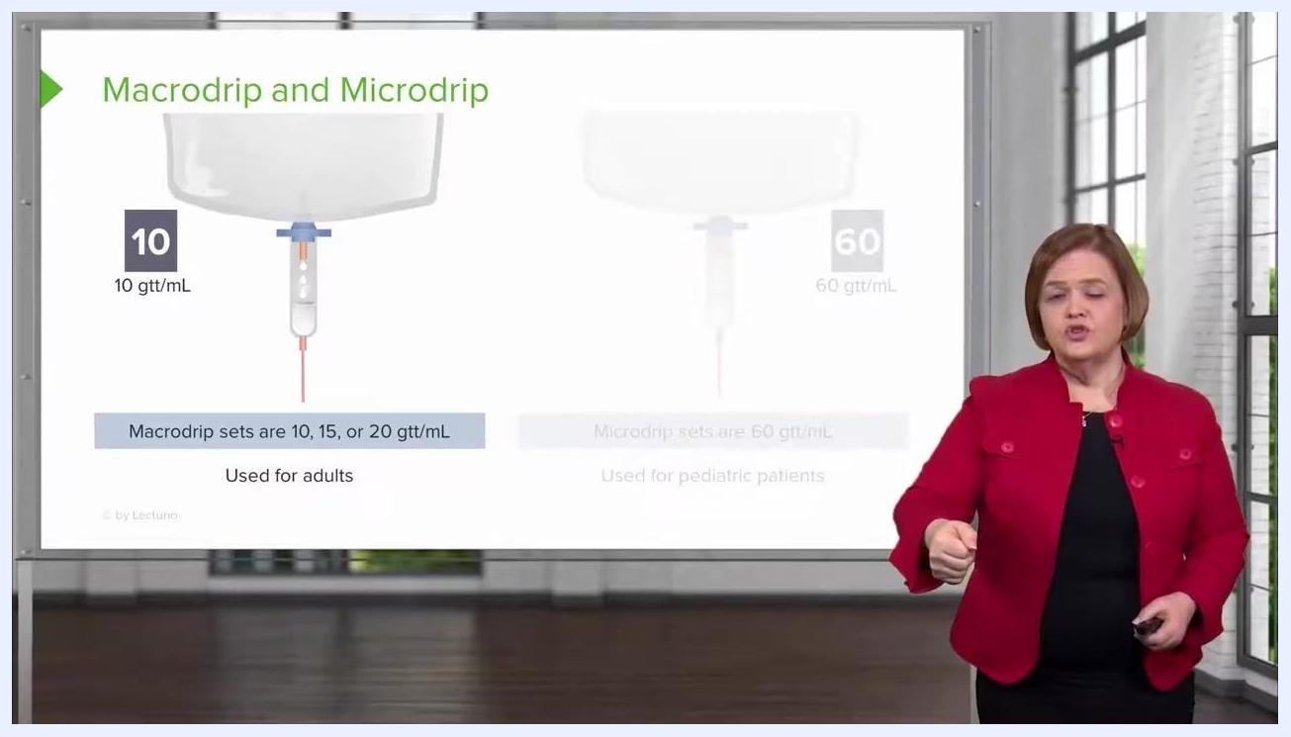
A presenter demonstrates adjusting the roller clamp with a hand gesture, with the macrodrip and microdrip slide visible behind her.
Confirm the relationship between clamp position and rate before finalizing any adjustment: tighter produces slower drops, looser produces faster drops. Always adjust until the drip rate is steady and countable.
If the roller clamp is backed all the way off, fluid will flow too quickly and may form a continuous stream rather than countable drops, making an accurate rate impossible to verify. Always keep the clamp adjusted so individual drops can be counted.
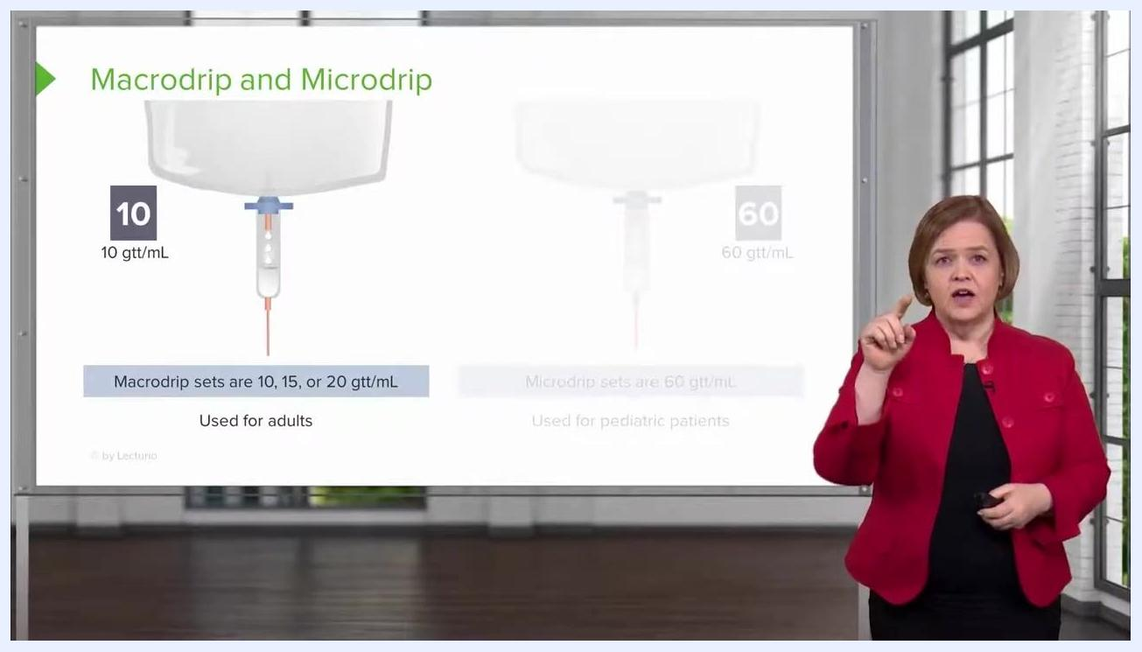
A presenter counts on her fingers while standing next to the Macrodrip and Microdrip slide, demonstrating how to count drops against the drip rate.
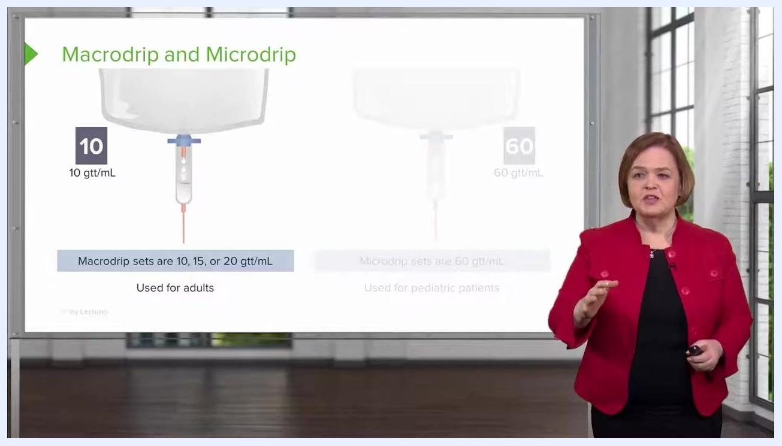
A presenter gestures with both hands to explain how clamp tightness or looseness controls the IV drip rate.
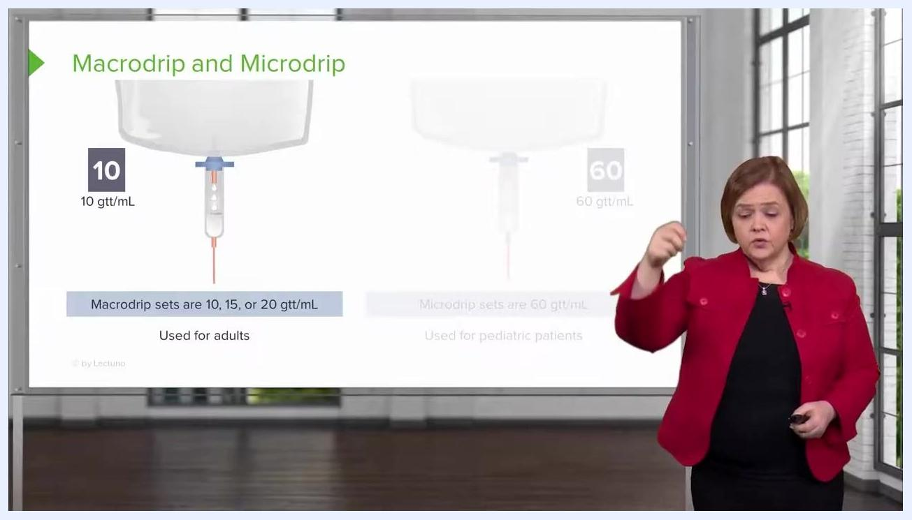
A presenter makes a downward hand motion to illustrate the effect of fully loosening the roller clamp.

Eligibility Criteria
Selection of the appropriate tubing set depends on the patient population and the clinical need for precise volume control.
Inclusion criteria — macrodrip tubing:

- Adult patients receiving standard IV fluid therapy.
- Tubing sets available in drop factors of 10, 15, or 20 gtt/mL.
- Clinical scenarios where a wide range of infusion rates is acceptable.
Exclusion / special population criteria — microdrip tubing:

- Pediatric patients, who are especially sensitive to fluid volume.
- Patients receiving crucial medications where precise volume control is required.
- Any scenario requiring a drop factor of 60 gtt/mL rather than a macrodrip set.
Microdrip tubing (60 gtt/mL) is reserved for pediatric patients and for administering medications where precise volume is critical, since this population is more sensitive to fluid load than adults.
Practice and training scenarios generally focus on macrodrip sets (10, 15, or 20 gtt/mL) rather than microdrip (60 gtt/mL). Microdrip tubing remains relevant in clinical practice for the specific populations above, even though it appears less often in general training exercises.
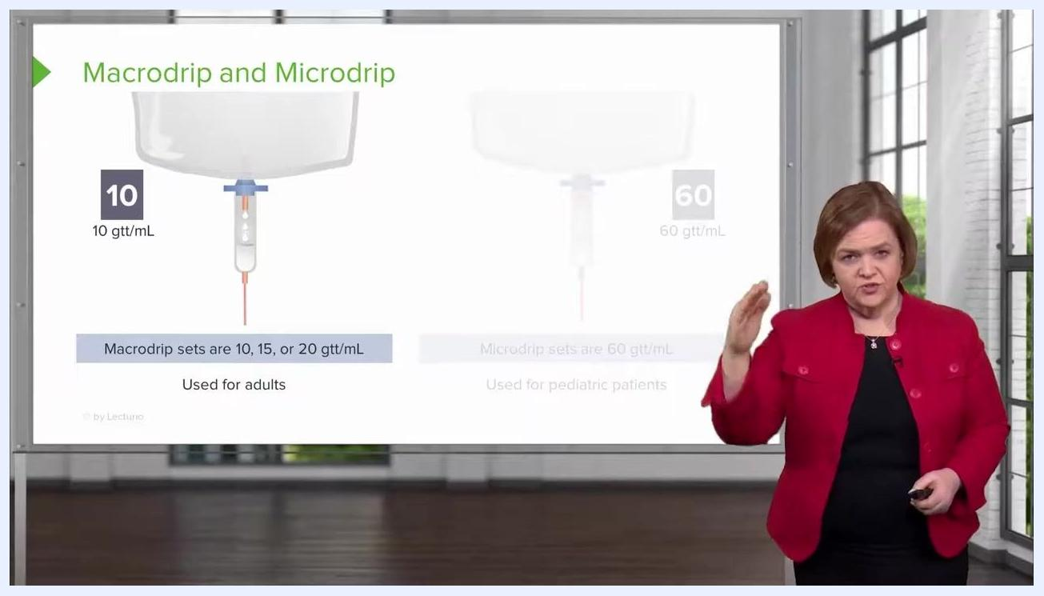
A presenter gestures to emphasize the distinction between macrodrip and microdrip tubing on a slide showing both drip chambers and their drop factors.
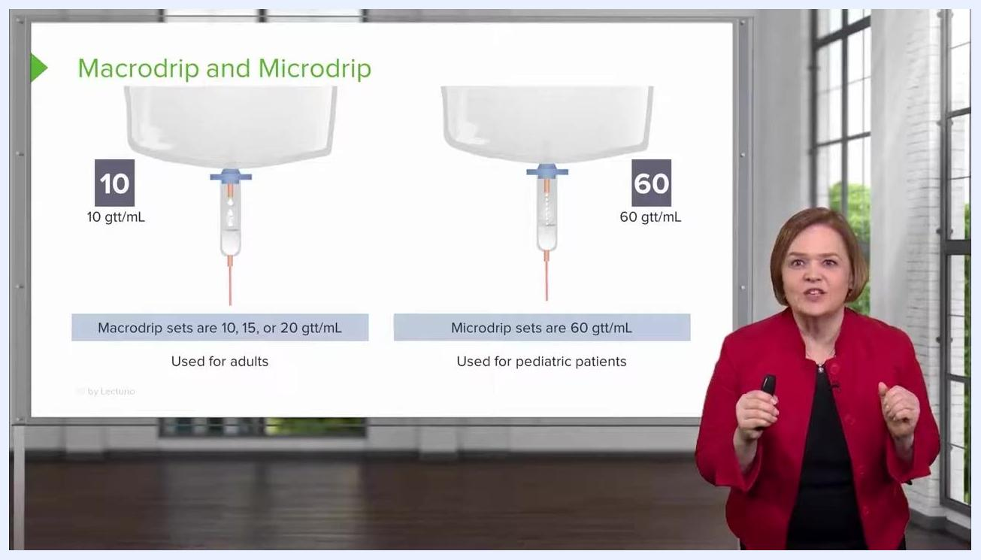
A close-up of a slide showing the macrodrip chamber labeled 10 gtt/mL and the microdrip chamber labeled 60 gtt/mL, with explanatory text on their drop factors and uses.
A presenter stands in front of a slide showing both macrodrip and microdrip chambers with usage notes for each.
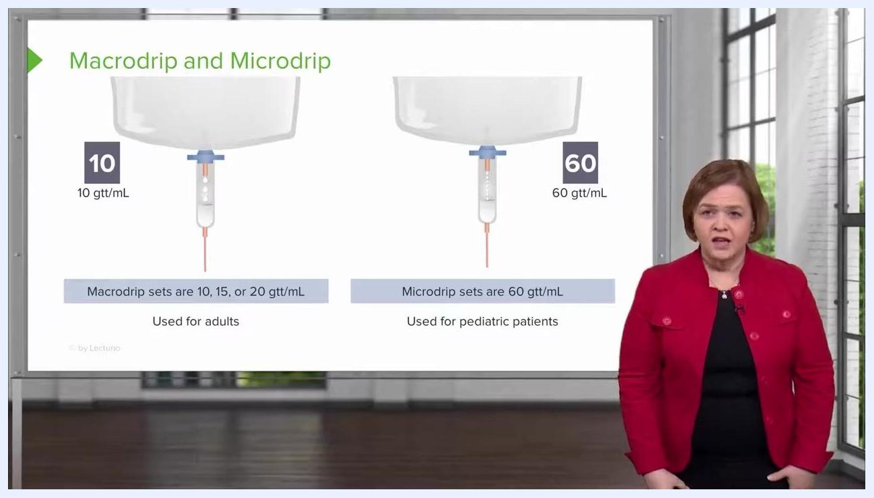
A presenter stands in front of the slide, noting that training scenarios typically do not use the 60 gtt/mL microdrip set, with both chambers visible on the slide.

Study Endpoints
The primary endpoint of the drip rate calculation procedure is delivering the exact drop factor printed on the tubing package, so that the correct number of drops equals 1 mL of fluid delivered.
A secondary endpoint is correct interpretation of the written IV fluid order. Most orders are written with an hourly rate, such as "0.9% normal saline at 125 mL/h," meaning the patient should receive 125 milliliters of fluid every hour.
An exploratory endpoint is recognizing when an order specifies only a rate with no stated duration or total volume. In this case, the infusion should continue at the stated rate until further instructions are received from the healthcare provider.
A close-up of the macrodrip chamber labeled 10 gtt/mL, with text explaining that 10 drops on this tubing correspond to 1 mL of fluid.

Schedule of Assessments
The table below summarizes the assessment and action required for each type of IV fluid order, based on how the order is written.
Order Format | Required Action | Timing Window
Rate only (e.g., "0.9% normal saline at 125 mL/h") | Hang the bag, set the rate, and continue infusing at that rate. | No specified end time or volume; continue until further orders are given.
Rate with fixed duration (e.g., "125 mL/h for 8 hours") | Calculate total volume (rate × hours) and infuse for the stated period. | Discontinue after the specified duration unless additional fluids are ordered.
Rate with total volume (e.g., "for a total of 2,000 mL") | Infuse at the stated rate until the total volume has been delivered. | Discontinue once the specified total volume has been reached.
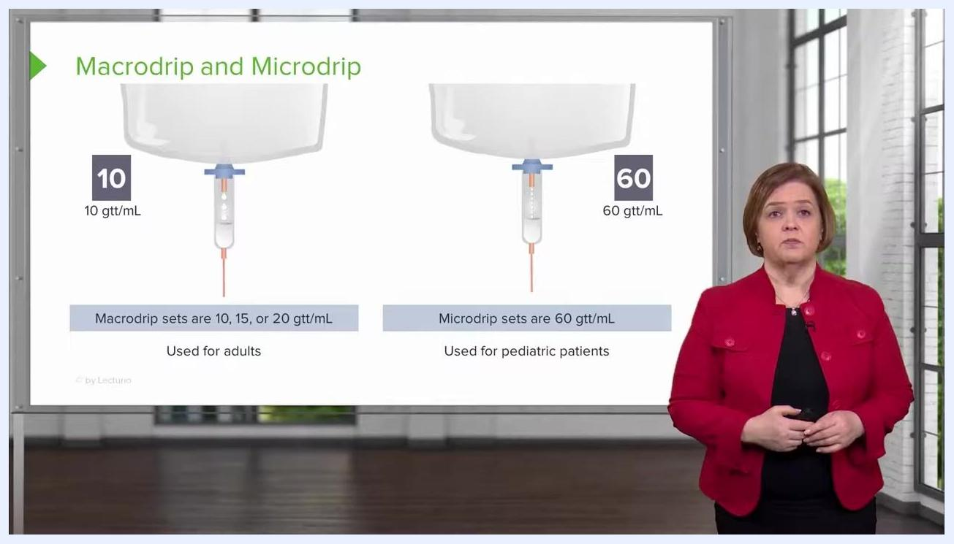
A presenter stands in front of a slide titled "IV Fluid Prescription Examples," listing three example orders with different rate, duration, and total-volume specifications.
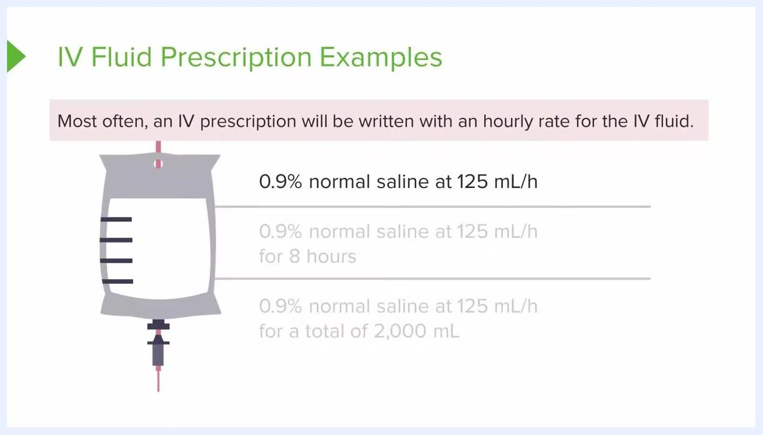
A close-up of a slide showing the first example order, "0.9% normal saline at 125 mL/h," with background text noting that most IV prescriptions are written as an hourly rate.
Orders with only a rate specified do not indicate how much fluid to give in total or for how long. Continue communicating with the healthcare provider to determine how long the patient should remain on therapy.
For a time-limited order such as "0.9% normal saline at 125 mL/h for 8 hours," calculate the total volume as 125 mL/h × 8 hours = 1,000 mL, and discontinue the IV after 8 hours unless additional fluids are ordered.
Multiply the hourly rate by the number of hours to determine total volume for any time-limited order, and ensure the IV is discontinued after that duration unless new orders are received.
Some orders specify a total volume instead of a duration (e.g., "for a total of 2,000 mL"). Always read the order carefully to determine whether rate, duration, or total volume is specified, and clarify with the healthcare provider if any detail is unclear.
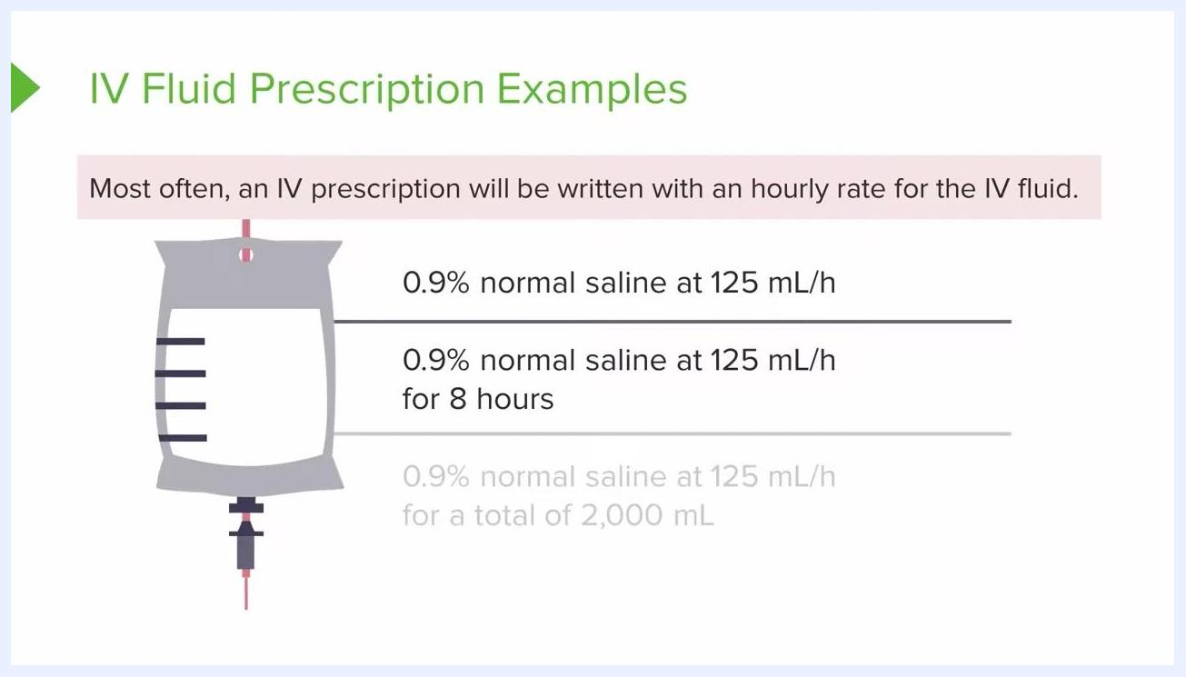
A presenter stands in front of a slide emphasizing that the first example order does not specify a time limit or total volume.
A slide highlighting the second example order, with the presenter explaining the calculation and the importance of stopping the infusion after the specified time.
A slide continuing to display the second example order, reinforcing the total-volume calculation for a time-limited infusion.
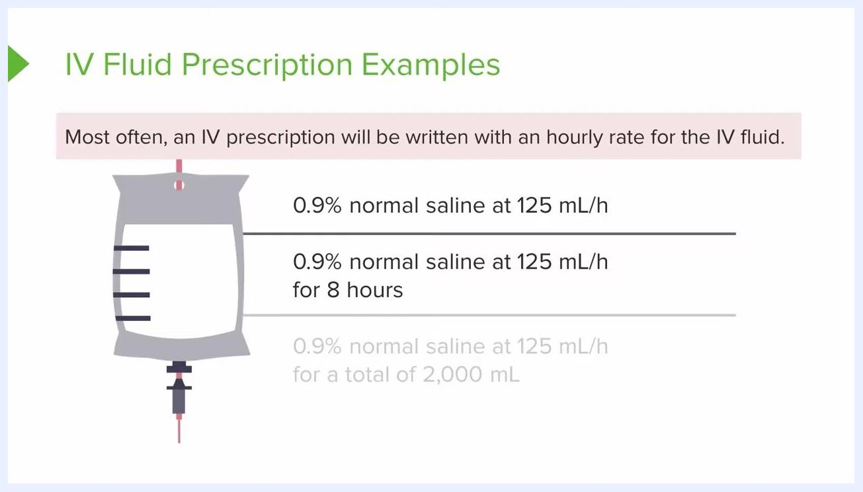
A slide displaying all three example orders, with the third order — for a total of 2,000 mL — visible but not yet discussed in detail.

Statistical Considerations
Sample size calculation and formal analysis populations do not apply to this procedural document; where such content would normally appear, this section instead documents the calculation method used to determine infusion rate and total volume.
There are three standard formats for writing an IV fluid prescription: rate only, rate with a fixed duration, and rate with a total volume. Each format specifies the concentration, rate, and either duration or total volume for administration.
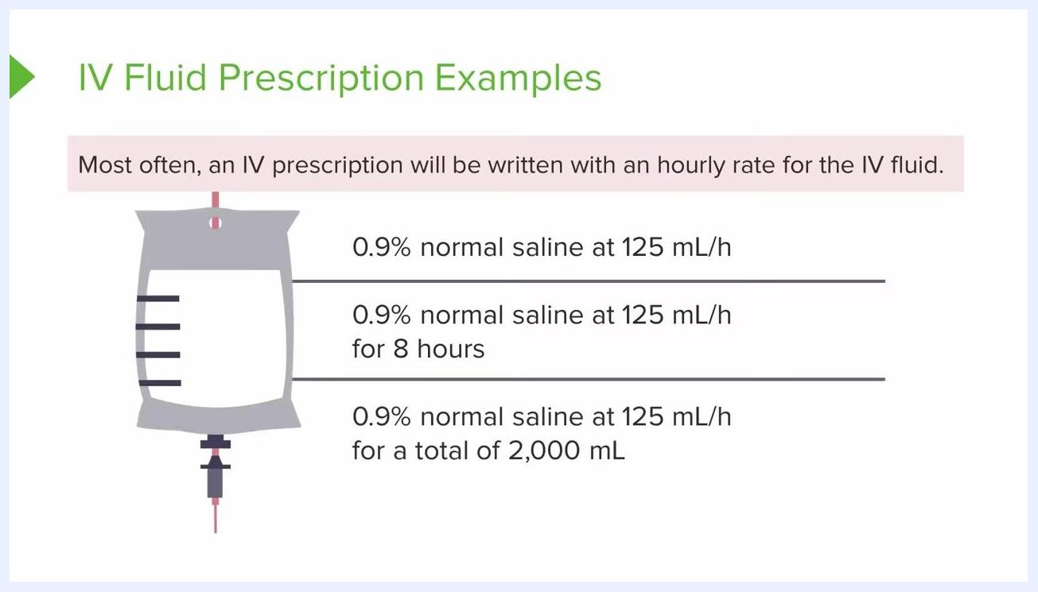
A slide showing three IV fluid prescription examples: rate only, rate with 8-hour duration, and rate with a total volume of 2,000 mL, alongside an IV bag graphic and a note about hourly rates.
All three formats are valid and commonly used in clinical settings; no calculation is required beyond recognizing which format is in use. Familiarize yourself with all three before applying the corresponding calculation.
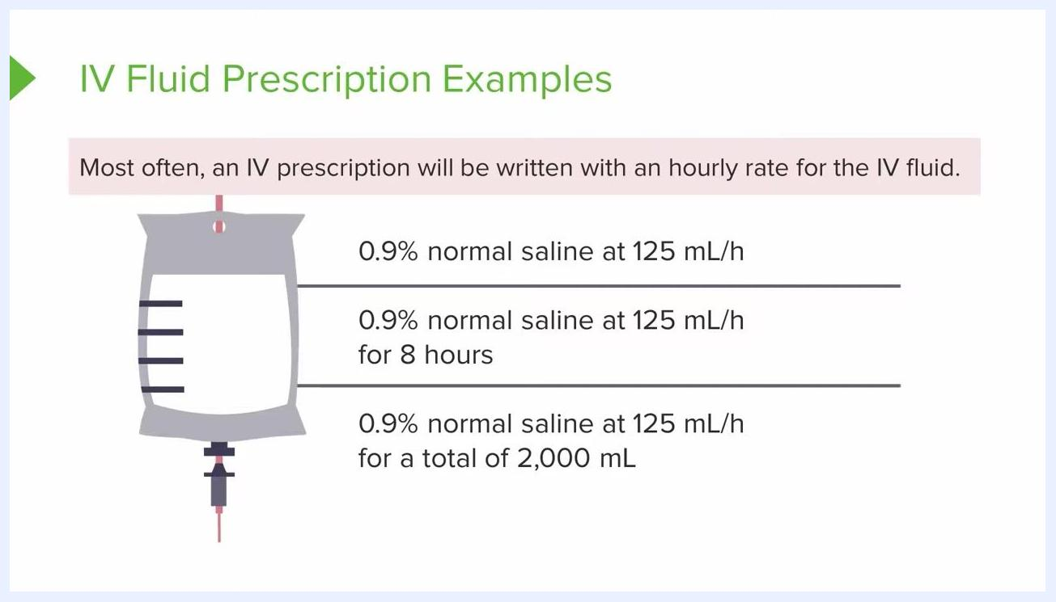
An instructor stands next to the slide with the three IV fluid prescription examples, emphasizing the different formats an order may take.

Safety Reporting
Adverse event grading scales and DSMB oversight, as understood in a formal clinical trial, do not apply to this bedside procedure; where such content would normally appear, this section instead documents the flow-rate risks and escalation points identified during the procedure.
For a rate-only order such as "0.9% normal saline at 125 mL/h," hang the IV and allow it to infuse continuously at that rate. Because there is no specified end time or volume, the infusion continues until further orders are given.
For a time-limited order such as "125 mL/h for 8 hours," administer the fluid at the stated rate for exactly 8 hours and then stop the infusion, since the order specifies both rate and duration.
For a total-volume order such as "125 mL/h for a total of 2,000 mL," administer the fluid at the stated rate until 2,000 mL (2 liters) has been infused, then stop, since the order specifies both rate and total volume. Monitor the total volume infused throughout to identify the correct stopping point.
A key safety consideration across all formats is fully loosening the roller clamp, which allows fluid to flow so quickly that drops cannot be counted, risking an unmonitored and inaccurate infusion rate. Always keep the clamp adjusted so that drops remain visible and countable, and clarify any ambiguous order with the healthcare provider before proceeding.
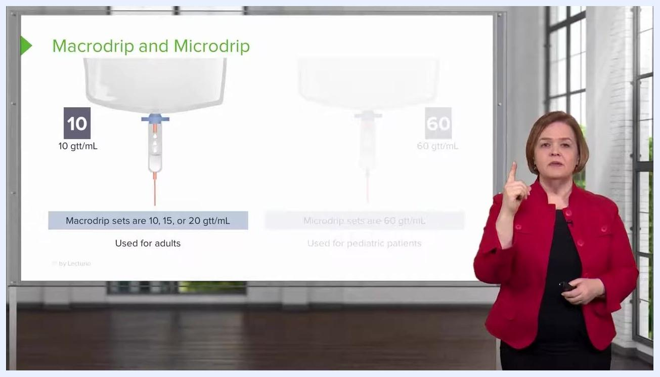
A presenter stands in front of the Macrodrip and Microdrip slide, gesturing to emphasize how the roller clamp controls drip rate.
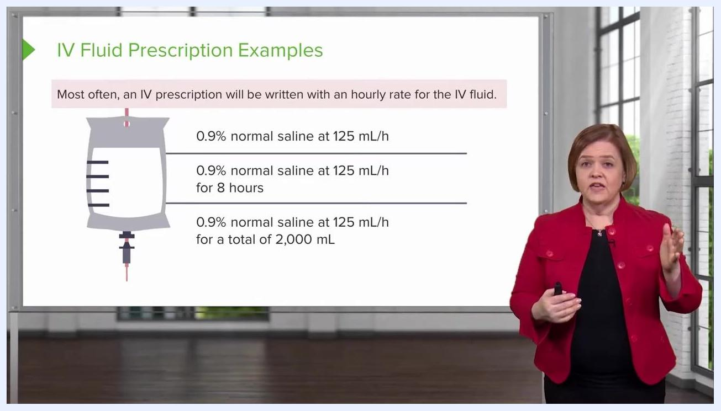
An instructor explains the first IV prescription format, with the slide visible in the background.
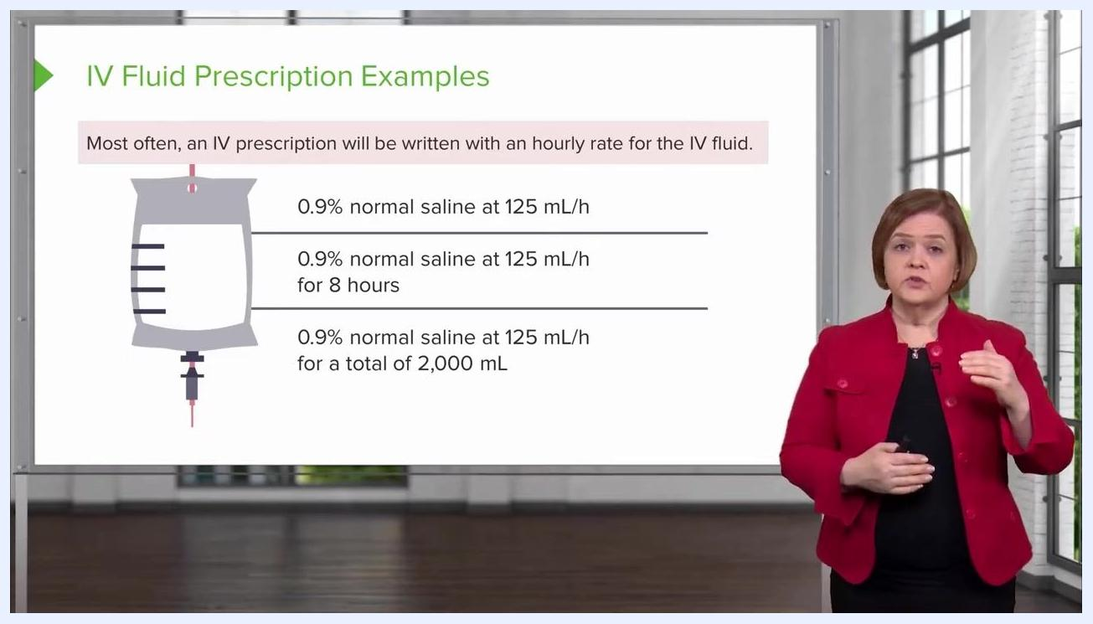
An instructor explains the second IV prescription format, with the slide visible in the background.
An instructor explains the third IV prescription format, with the slide visible in the background.
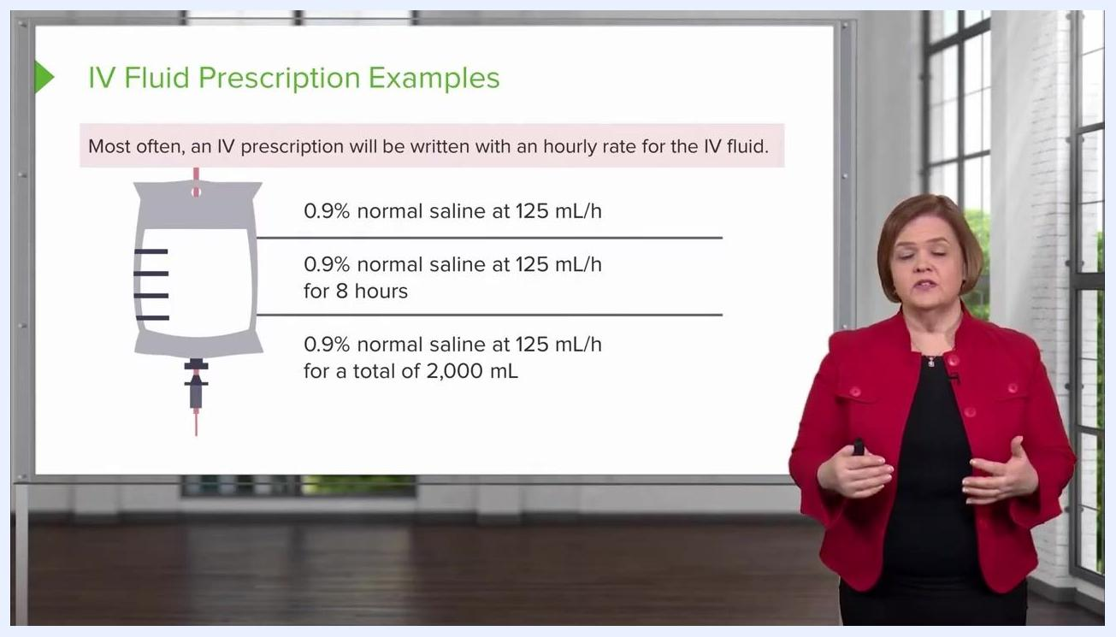
Instructor standing and smiling, with the end-of-lesson message still visible.

