How to Apply a Splint to a Lower Leg
This document explains how to apply a splint to a lower leg fracture using a rigid splint with a soft side and cravats. Follow these steps in sequence to immobilize the injury properly and prepare the patient for safe transport.

Purpose
This procedure provides step-by-step guidance for splinting a lower leg fracture, from initial assessment through securing the splint and preparing the patient for transport.

Scope
This procedure applies to responders splinting a closed lower leg fracture in the field. Always consult your local medical or EMS protocols before beginning, as specific requirements may vary.

Required equipment
- A soft splint with a rigid structure and a soft side, in a length appropriate to the injury
- Cravats or tape for securing the splint
- A longboard and stretcher for transport
- Gauze or 4x4 dressings (only required if the fracture is open)

Procedure

1. Refer to local protocols
Before beginning, consult your local medical or EMS protocols for specific instructions and requirements applicable to your jurisdiction.

2. Assess the injury
Examine the lower leg to determine the location and type of fracture. If the fracture is closed with no open wound, you do not need to apply gauze or 4x4 dressings. Prepare a soft splint, preferably one with a rigid structure and a soft side.
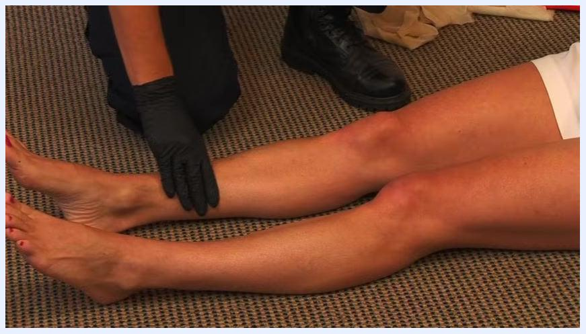
A responder in uniform kneels beside a patient seated on the floor with legs extended. Splinting materials and equipment are visible nearby.

3. Select the appropriate splint
Choose a splint of suitable length to immobilize the area. The splint should extend beyond the joint above and below the fracture site.
A responder holds a bright orange rigid splint with a soft side, preparing to apply it to the patient's leg.

4. Position the splint
Place one splint on the inner side and one on the outer side of the injured leg. Ensure both splints are properly aligned to immobilize the leg fully.
A responder positions a rigid orange splint along the outer side of the patient's leg, covering the area from below the foot to above the knee.

5. Check pulse, motor, and sensory function
Before securing the splint, check for a pulse in the foot. Ask the patient if they can feel you touching their foot, and ask them to move their toes to confirm motor function. Complete this check before applying tension to the splint.
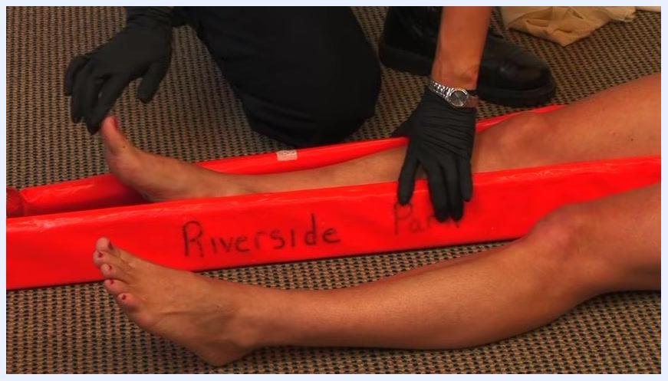
A responder checks the patient's foot for pulse and sensation, with the splint in place along the leg.

6. Apply the splint
Place the soft side of the splint against the leg. Ensure the splint is snug but not too tight, and that it covers the area from below the foot to above the knee. Secure the splint using tape or cravats. When using cravats, wrap one above the joint and tie the knot on the rigid side of the splint, never against the skin.
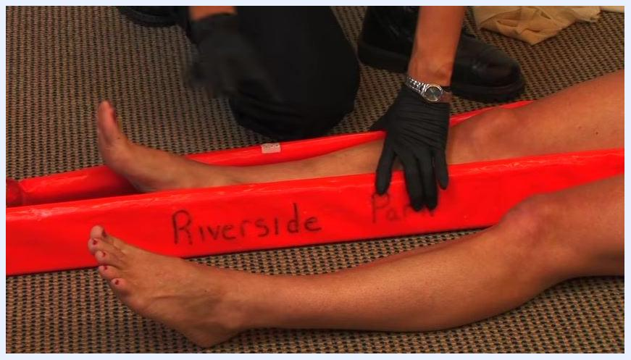
A responder begins wrapping a cravat above the knee to secure the splint, ensuring the knot rests on the rigid side.

7. Secure above the fracture
Place an additional cravat above the area of the break to further stabilize the splint. Tie it securely, again ensuring the knot sits on the rigid side of the splint.
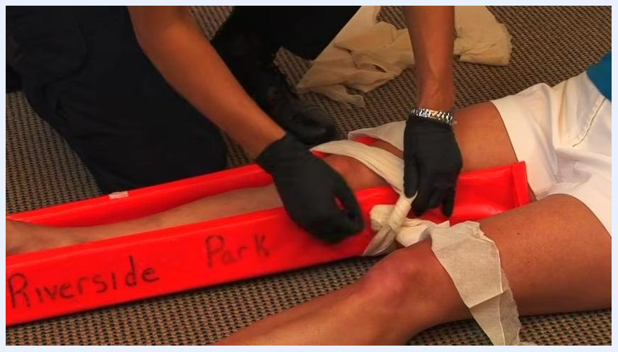
A responder ties a cravat above the fracture site, securing the splint in place. Multiple cravats and the rigid splint are visible.

8. Secure the splint with additional cravats
Place a cravat above the area of the break for added stability. Wrap the cravat around the leg and splint twice to ensure it holds securely. Tie an overhand knot, then complete a square knot to prevent slipping. Confirm the knot is positioned on the rigid side of the splint, not against the skin.
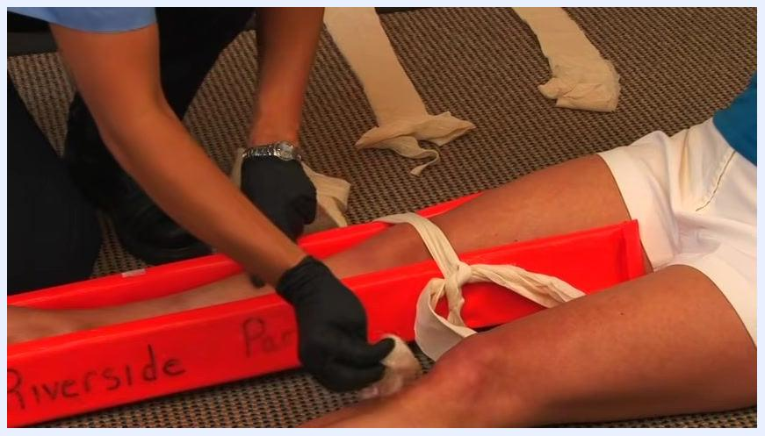
A responder wraps and ties a cravat above the fracture site, securing it with a square knot on the rigid orange splint labeled "Riverside Park." Multiple cravats and the patient's leg are visible.

9. Place a cravat below the break
Position another cravat below the fracture site. Wrap it twice around the leg and splint for extra security. Tie an overhand knot, then reverse direction and tie again to form a square knot. Confirm all knots are on the rigid side of the splint.
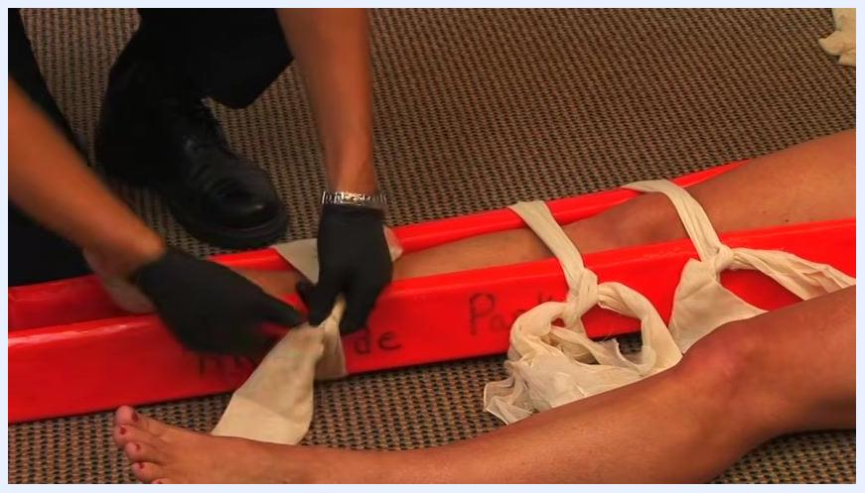
A responder ties a cravat below the fracture site, using a square knot to secure the splint. The orange rigid splint and multiple cravats are visible.

10. Perform a final pulse, motor, and sensory check
After all cravats are secured, reassess the patient's distal pulse by feeling for a pulse at the foot. Ask the patient, "Can you feel me touching you?" to check sensory function, and instruct them to move their toes to confirm motor function. Do not proceed to transport until all three checks are confirmed.
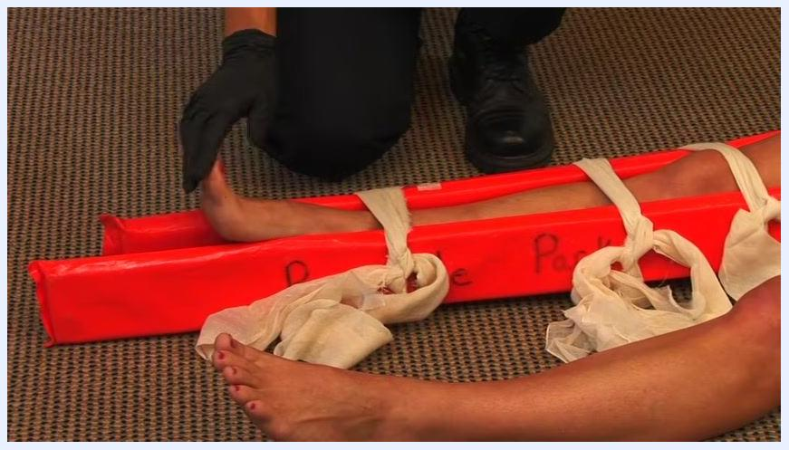
A responder checks the patient's foot for pulse and sensation after splinting. The leg is immobilized with an orange rigid splint and multiple cravats.

11. Prepare for transport
Once the splint is secure and neurovascular checks are complete, prepare the patient for transport. Place the patient onto a longboard for additional support, then transfer them to a stretcher for safe movement to advanced care.
A responder in uniform kneels beside the patient with the completed splint, preparing for transport. The patient is seated with the leg immobilized by an orange splint and cravats.

Verification checklist
Before completing the procedure, confirm the following:
- All cravats are tied securely with square knots positioned on the rigid side of the splint.
- Pulse, motor, and sensory functions have been checked both before and after splinting.
- The splint extends beyond the joints above and below the fracture and covers the area from below the foot to above the knee.
- The patient is ready for safe transport using a longboard and stretcher.

Summary
Splinting a lower leg fracture requires checking local protocols, assessing the injury, and selecting a soft splint with a rigid structure of appropriate length. Immobilize the joints above and below the fracture, and check pulse, motor, and sensory function both before and after applying the splint. Secure the splint with cravats or tape, tying all knots on the rigid side. Following these steps helps immobilize the fracture effectively and reduces the risk of further injury during transport to advanced care.

