How to Administer Medication Through a Feeding Tube
This procedure explains how to administer medication through a feeding tube for a patient who cannot swallow safely. It covers preparing the medication, verifying tube placement, assessing gastric content, administering the dose by gravity, and documenting the process. Follow these steps whenever a physician has ordered medication to be given via a nasogastric (NG) feeding tube instead of by mouth.
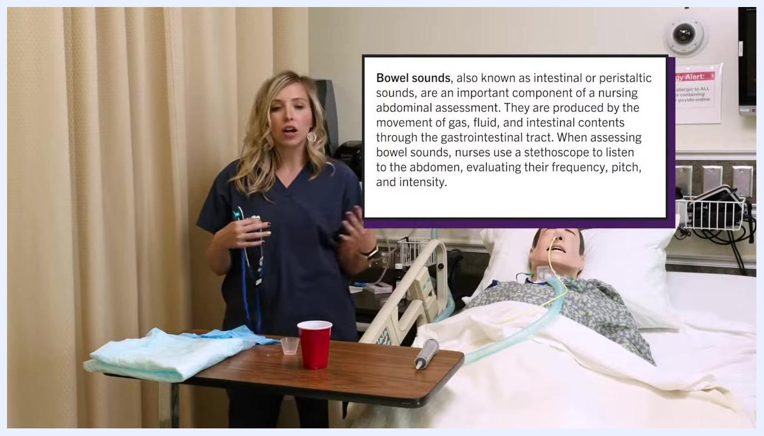
Nurse holding a medication bottle and cup at eye level beside a patient's bed with a feeding tube. Supplies, including a water cup and absorbent pad, are visible on the table.

Purpose & Scope
Clinical context: This procedure applies whenever a patient cannot swallow and a physician has ordered medication to be administered via a feeding tube instead of orally. Medication may be given in liquid form or, if a liquid form is not available, prepared by crushing and dissolving pills.
Patient population: Patients with an existing NG feeding tube who require ongoing medication administration because they are unable to swallow.
Care setting: This procedure is performed at the bedside in an inpatient hospital room, using standard precautions (gloves) and the patient's medication administration record (MAR).
Supplies needed:
- Prescribed medication (liquid, or crushed and dissolved as needed)
- Medication cup and a separate cup of lukewarm tap water
- 60 mL (60 cc) syringe and tube adapter
- Gloves
- Absorbent pad (chux)
- Stethoscope
- Patient documentation/MAR
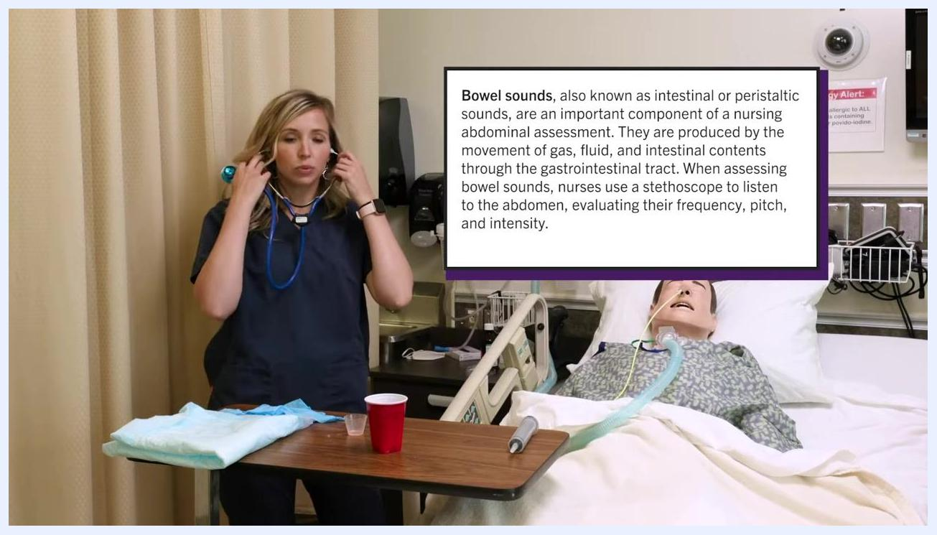
Nurse placing stethoscope earpieces in her ears before listening to the patient's abdomen, with on-screen text describing bowel sound assessment. Patient mannequin with NG tube is in the bed.

Patient Assessment
Before administering any medication through the feeding tube, complete the following checks in order.
Assessment step | What to check
Hand hygiene | Wash hands thoroughly before any patient contact
Patient identity | Ask patient to state name and date of birth; confirm against wristband and MAR
Allergy check | Ask the patient about any known medication allergies
Five Rights | Right patient, right drug, right dose, right time, right route (feeding tube, per physician's order)
Bowel sounds | Auscultate all four abdominal quadrants for 5 minutes each if none are heard initially
NG tube placement | Confirm caps are in place, then remove caps and attach adapter for syringe connection
Gastric aspirate | Aspirate with a 60 mL syringe and assess volume, color, and presence of undigested material
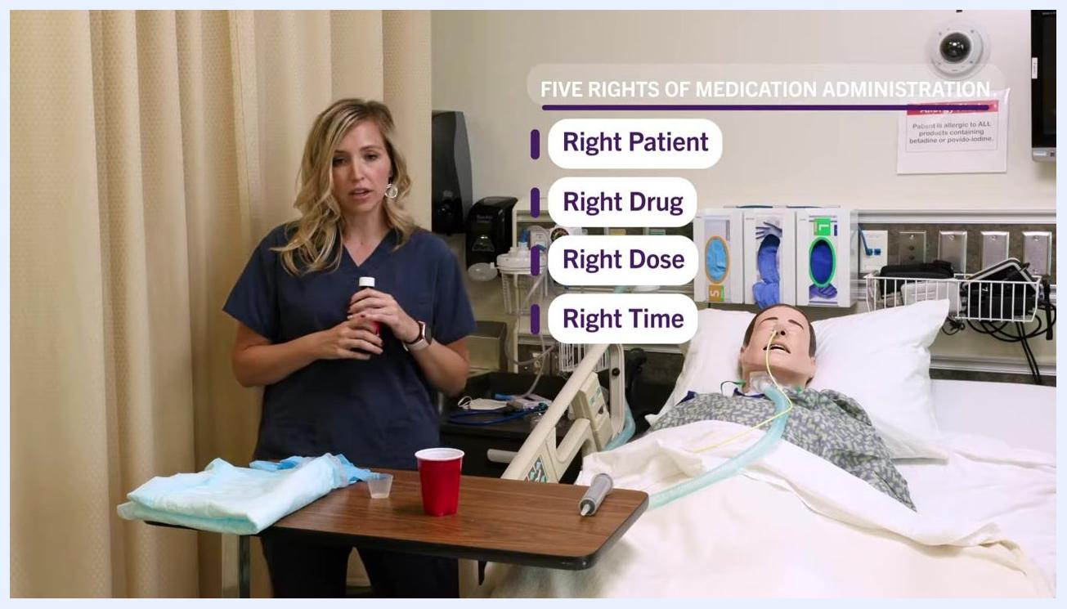
Nurse standing beside a patient's hospital bed, holding a medication bottle, with on-screen text listing the Five Rights of Medication Administration: right patient, right drug, right dose, right time. Supplies including a medication cup, water cup, and absorbent pad are on the table, with an allergy alert sign visible in the background.
Introduce yourself to the patient and confirm identity by name and date of birth before beginning any assessment.
Explain to the patient which medication you are giving and why (for example, a cough medication may cause drowsiness while also reducing cough and improving sleep).
Verify the Five Rights of Medication Administration against the MAR and the physician's order: right patient, right drug, right dose, right time, and right route.
Assess bowel sounds before giving any medication. Explain to the patient that you will be listening to their abdomen, then lift the gown as needed to access all four quadrants.
Place the stethoscope earpieces in your ears and position the diaphragm on the abdomen. Systematically listen to all four quadrants, noting frequency, pitch, and intensity of sounds.
Normal bowel sounds occur at a rate of 5–10 sounds per minute in each quadrant. If no sounds are heard after listening for 5 minutes in a quadrant, consider bowel sounds absent in that quadrant and do not proceed with administration; notify the physician.
Nurse holding stethoscope, explaining bowel sound findings. Patient mannequin with NG tube is in bed. Supplies and medical equipment are visible.
Vital sign monitoring: The source material does not specify a vital sign monitoring frequency for this procedure; follow your facility's standing orders for vital sign checks during medication administration.
Pain assessment tool: No specific pain assessment tool is described in this procedure; use your facility's standard pain scale if the patient reports discomfort.
Neurovascular checks: Neurovascular checks are not part of this feeding tube medication procedure and are not addressed in the source material.

Care Protocol
The procedure is organized into six phases, from preparation through documentation.
Phase 1 – Preparation
- Gather all supplies (medication, medication cup, water, gloves, documentation) and enter the patient's room.
- Perform hand hygiene.
- Introduce yourself, verify patient identity, and confirm the Five Rights against the MAR.
Phase 2 – Pre-administration setup
- Pour the prescribed liquid dose into a medication cup at eye level to measure accurately.
- Put on clean gloves before handling the tube or medication.
- Position the patient in High Fowler's position, elevating the head of the bed to 60–90 degrees, to reduce aspiration risk.
- Adjust the bed so the patient is sitting upright and confirm they are comfortable and properly aligned.
- Place an absorbent pad over the patient's chest and upper abdomen, and set out the medication cup and a cup of lukewarm water.
Phase 3 – Check tube placement and gastric content
- Remove both protective caps from the NG tube and attach the adapter to allow syringe connection.
- Attach a 60 mL syringe and gently pull back on the plunger to aspirate gastric contents. Observe the volume, color, and any undigested medication or food.
- Return the aspirate to the stomach unless otherwise directed, to protect the patient's acid-base balance, and document the volume and color.
- Confirm the tube is correctly positioned and residual content is within acceptable limits before proceeding.
Phase 4 – Administer the medication
- Clamp the feeding tube with your fingers or a tube clamp before disconnecting the syringe, to prevent air entry or leakage.
- Remove the plunger and attach the empty syringe to the tube to prepare for gravity-flow administration.
- Fill the syringe with 30 cc of water and pour it into the barrel, letting it flow by gravity into the tube. Keep the syringe no more than 18 inches above the patient to control flow rate.
- Pour the prescribed medication (for example, 5 cc) directly into the syringe barrel and let it flow into the tube by gravity; do not force it.
- Maintain the syringe height at no more than 18 inches above the patient's stomach level throughout administration.
- After medication, flush again with 30 cc of water to clear the tube, pouring it into the syringe and letting it flow by gravity; place a pad under the connection to catch spills.
- As an alternative, insert the plunger, draw up 30 cc of water, pinch the tube, attach the syringe, and gently push the water through if gravity flow alone is not sufficient.
Phase 5 – Complete instillation and rinse
- Attach the syringe with the plunger, draw up 30 cc of water, and gently push it into the tube slowly, avoiding forceful administration.
- Continue pushing the plunger gently until all 30 cc of water has been administered, monitoring for resistance or discomfort.
- After the flush, draw up the prescribed medication, instill it into the tube, and follow with a final flush of 30–60 cc of water.
- Once all medication and flushes are given, clamp the feeding tube to prevent air entry or leakage.
- Rinse the syringe and other equipment used to remove any remaining medication residue.
- Carefully remove gloves and perform hand hygiene immediately afterward.
Phase 6 – Document the procedure
- Record the medication name, dose, route (feeding tube), time of administration, and any observations.
- Note the amount and type of flush used before and after medication.
- Document the patient's tolerance, the color and amount of gastric residual, and the total input of flush and medication.
- Confirm all documentation categories are complete, including flush and medication volumes.
- Review all documentation once more to confirm nothing has been missed before closing out the procedure.
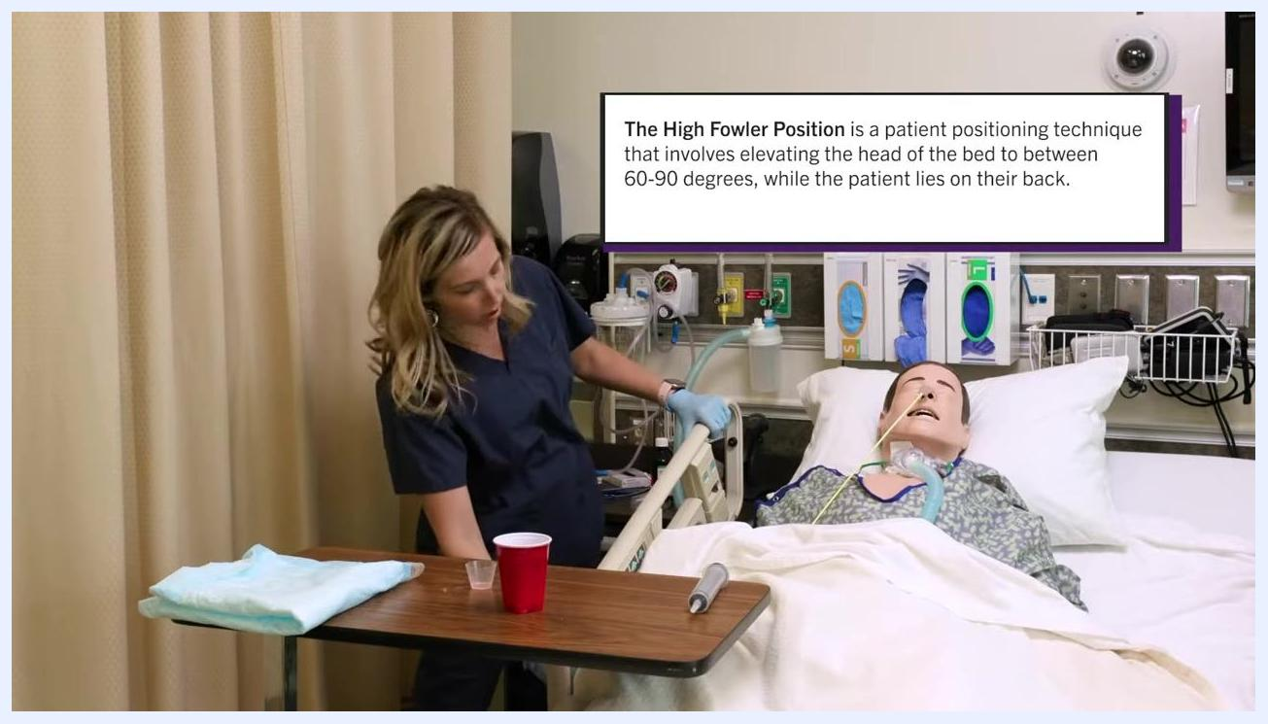
Nurse adjusting the bed to place the patient in High Fowler's position, with the definition displayed on screen. Patient mannequin with NG tube is in the bed.
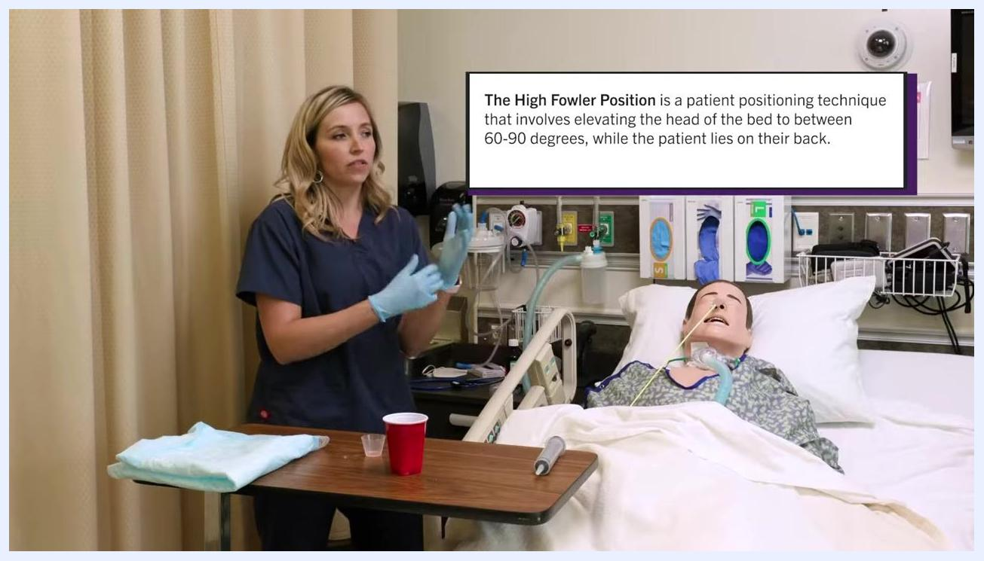
Nurse with gloves and an absorbent pad placed on the patient's chest, medication cup and water cup on the table. Patient mannequin with NG tube is in the bed.
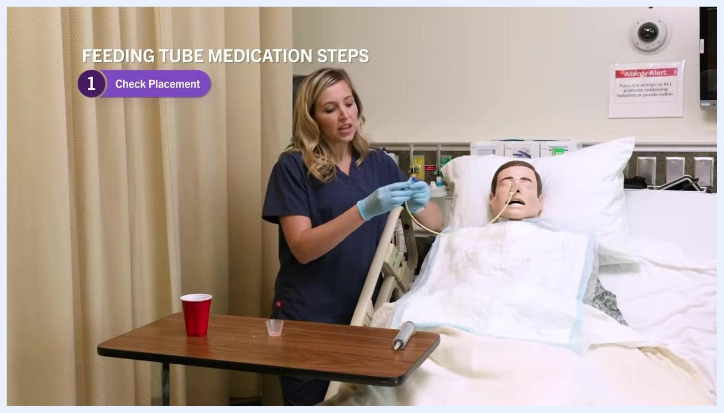
Nurse in navy scrubs holding the NG tube and demonstrating removal of the cap, with on-screen text "Feeding Tube Medication Steps: 1. Check Placement." Patient mannequin is in the bed with supplies nearby.
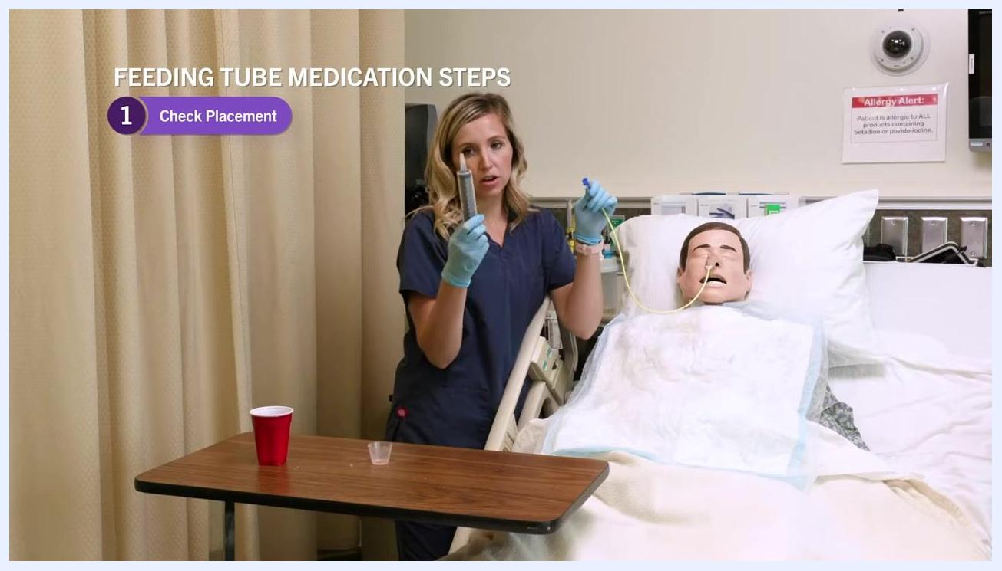
Nurse holding up the NG tube and 60 mL syringe, demonstrating the aspiration process, with on-screen text "Feeding Tube Medication Steps: 1. Check Placement."
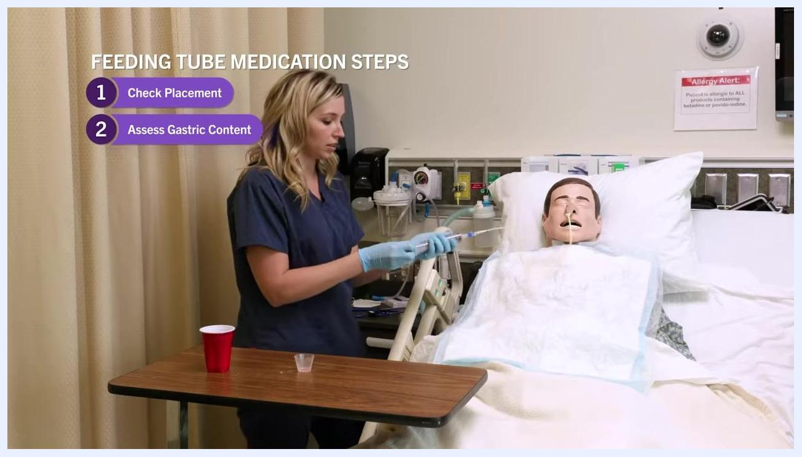
Nurse returning the aspirate to the stomach using the syringe and NG tube, with on-screen text "Feeding Tube Medication Steps: 1. Check Placement, 2. Assess Gastric Content."
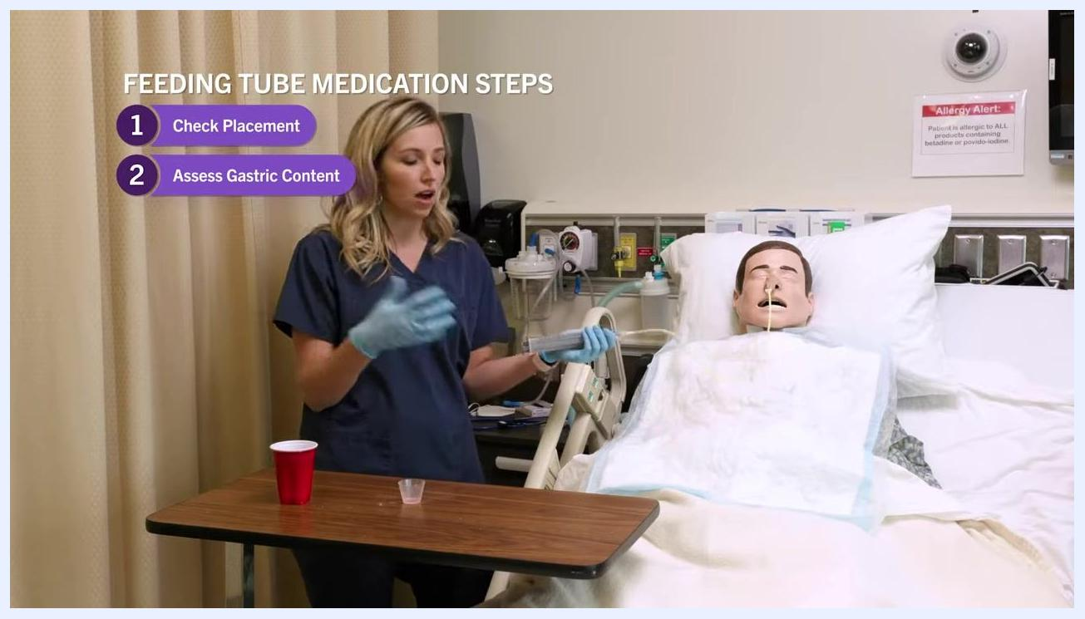
Nurse holding the syringe while explaining documentation and readiness, with on-screen text "Feeding Tube Medication Steps: 1. Check Placement, 2. Assess Gastric Content."
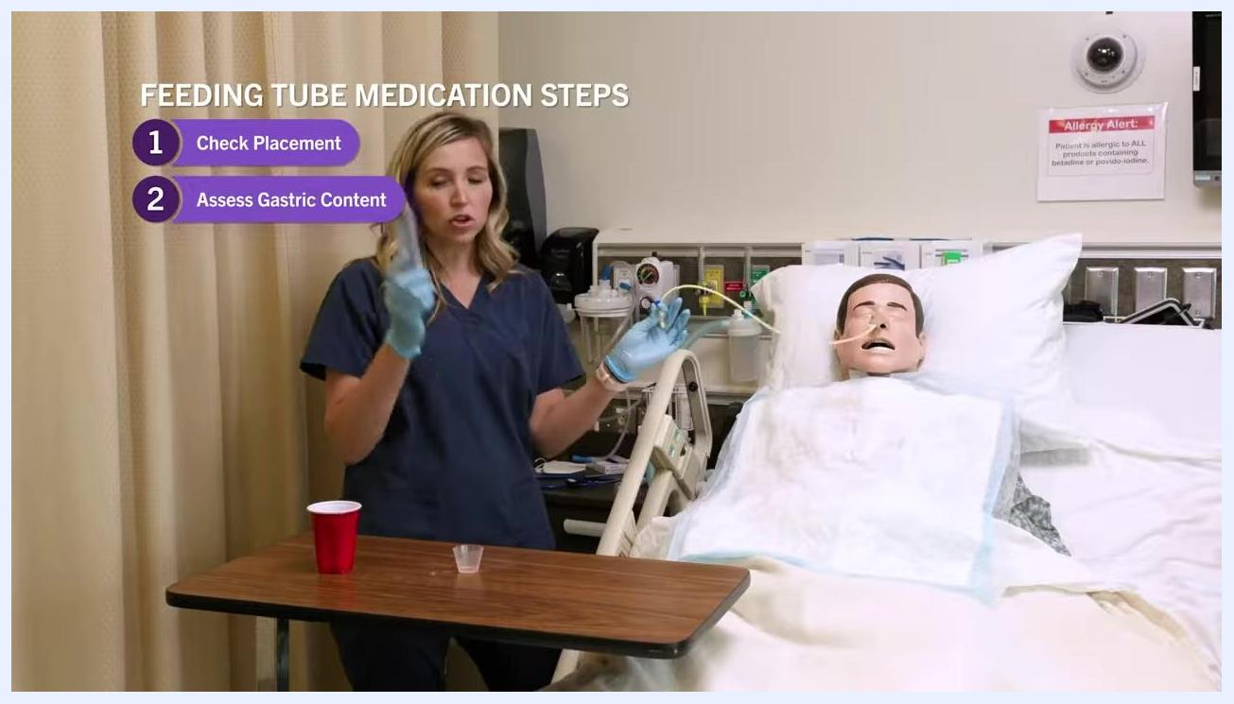
Nurse demonstrating clamping the tube with gloved hands beside a patient mannequin in a hospital bed, with on-screen steps 1 and 2 displayed.
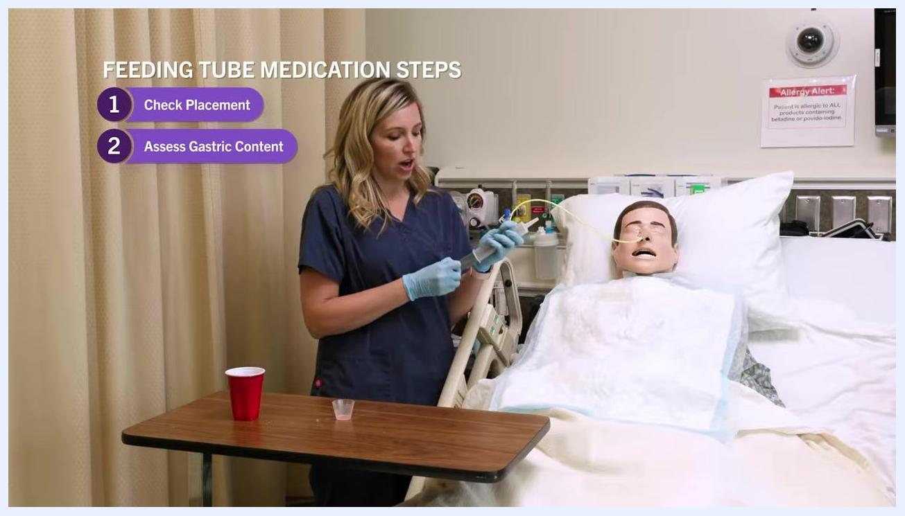
Nurse holding a syringe without a plunger, preparing to attach it to the feeding tube, with on-screen steps 1 and 2 displayed.
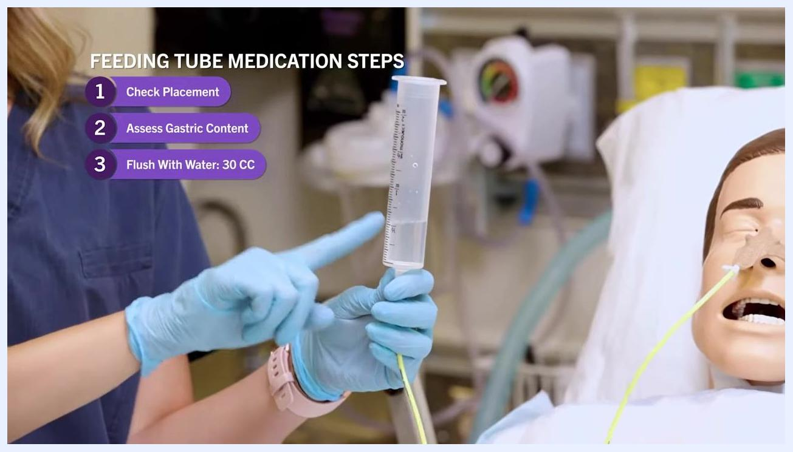
Nurse holding a syringe filled with water, demonstrating the flush, with on-screen steps 1 and 2 displayed.
Nurse holding the syringe upright, ready to pour medication into it, with on-screen steps 1 and 2 displayed.
Close-up of gloved hands holding a syringe filled with water, finger pointing to the measurement, with on-screen text now showing step 3: "Flush With Water: 30 CC."
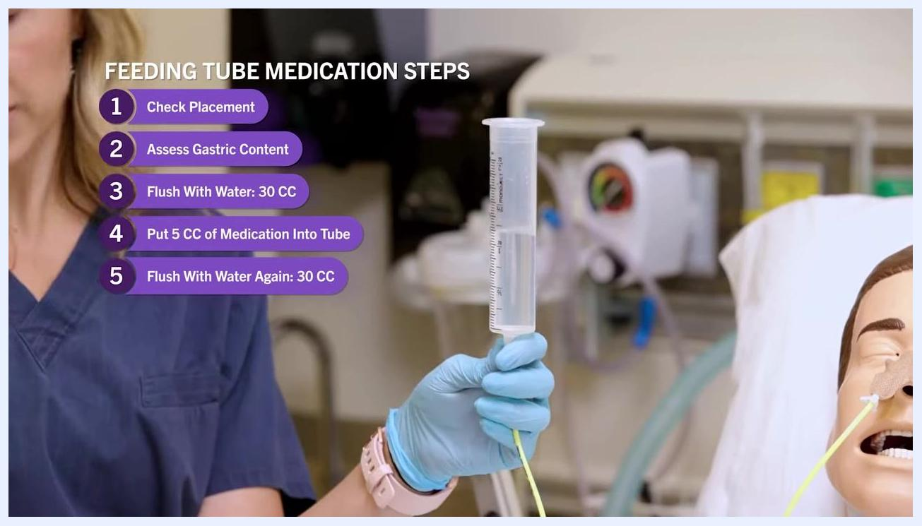
Close-up of nurse holding a syringe with water, with on-screen text now showing steps for "Put 5 CC of Medication Into Tube" and "Flush With Water Again: 30 CC."
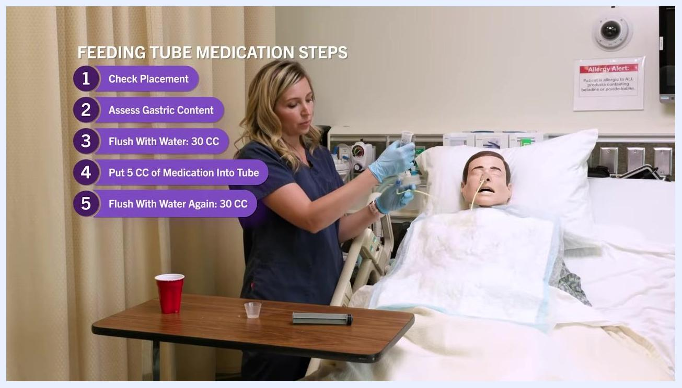
Nurse demonstrating drawing up fluid with the plunger in the syringe, with on-screen steps 1 through 5 displayed.
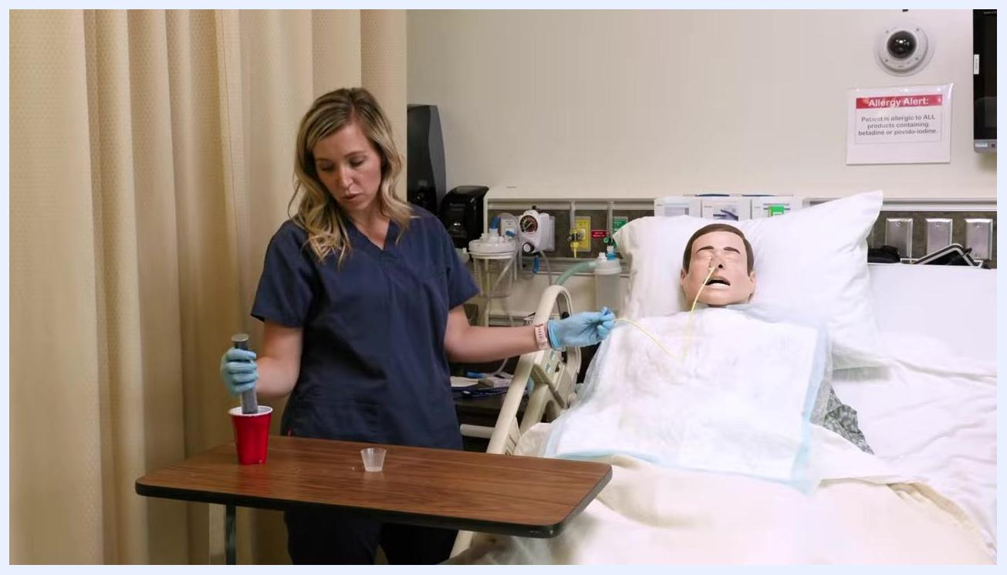
Nurse in blue scrubs holding a syringe with plunger over a red cup, preparing to push water into a feeding tube connected to a mannequin. A medicine cup and supplies are on the table.
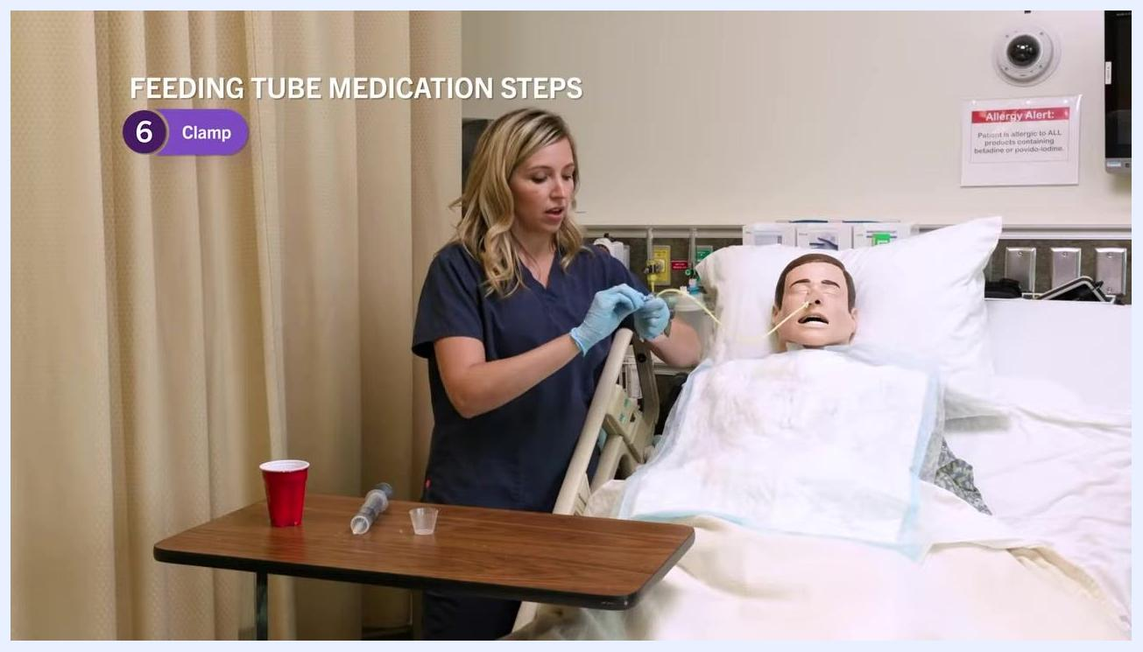
Close-up of gloved hands holding a large syringe connected to a yellow feeding tube, slowly instilling water. Hospital bed rail and patient mannequin visible.
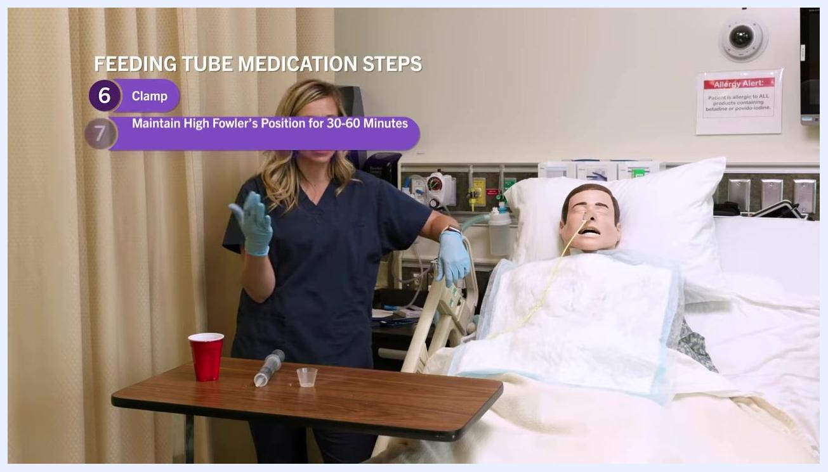
Nurse at the bedside holding the feeding tube and syringe, explaining the next steps. Red cup, medicine cup, and syringe are on the table.
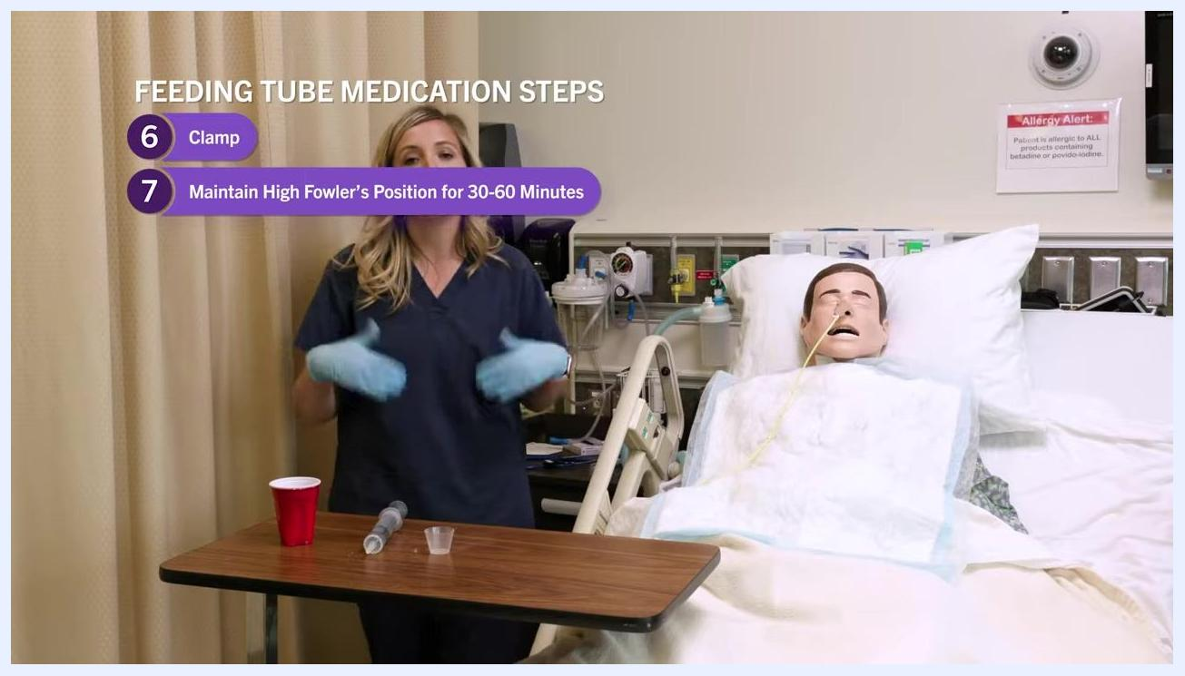
Nurse clamping the feeding tube, with on-screen text highlighting step 6: "Clamp." Supplies on the table, mannequin in bed.
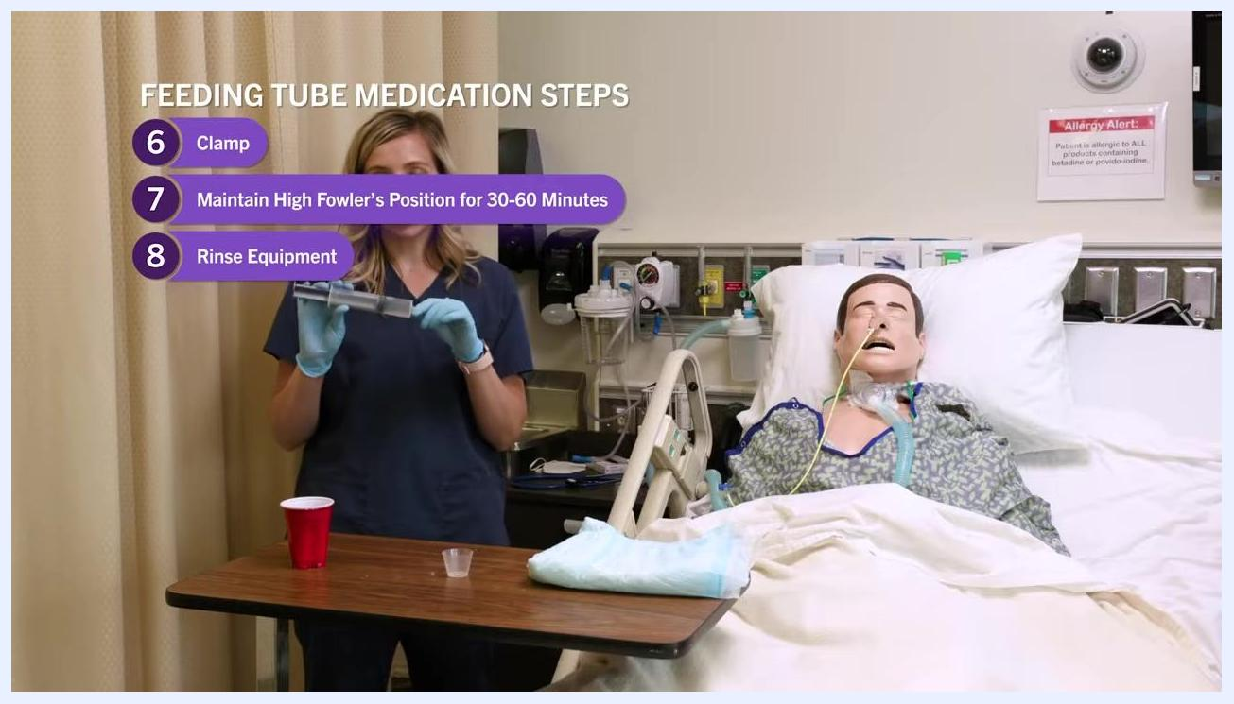
Nurse holding the syringe while demonstrating rinsing, with on-screen text highlighting step 8: "Rinse Equipment." Supplies on the table, mannequin in bed.
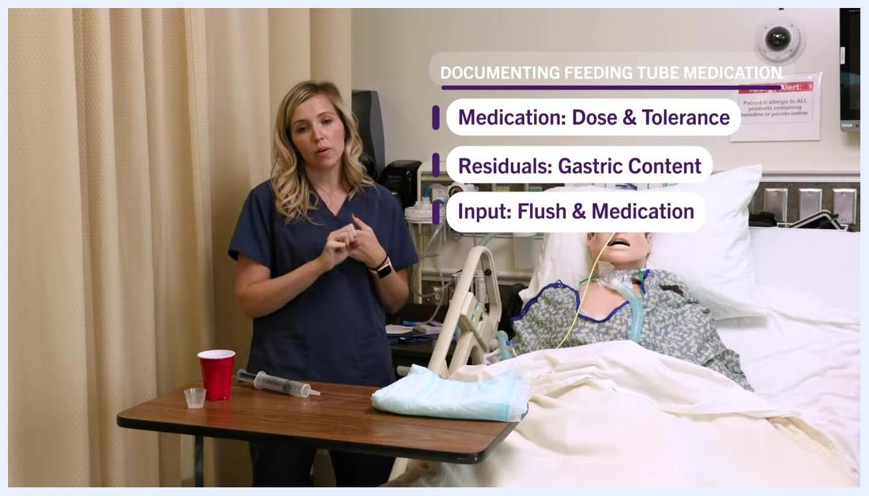
Nurse removing gloves at the bedside, syringe and supplies on the table, mannequin in bed.
Nurse at the bedside with documentation prompts displayed: "Medication: Dose & Tolerance" and "Residuals: Gastric Content." Supplies on the table, mannequin in bed.
Nurse at the bedside with documentation prompts displayed: "Medication: Dose & Tolerance," "Residuals: Gastric Content," and "Input: Flush & Medication." Supplies on the table, mannequin in bed.

Pain Management
The source material does not include a multimodal pain management plan, pain score targets, or an escalation pathway for pain specific to this procedure. The only medication example provided is a cough preparation, illustrated below.
Medication (example) | Dose | Route | Time
Guaifenesin | 5 mL | Feeding tube | As ordered (e.g., 3:30 PM)
Before administering any medication, confirm the prescribed dose, route, and time against the MAR and physician's order, and explain to the patient any expected effects, such as drowsiness alongside symptom relief.

Mobility Milestones
The source material does not describe progressive mobility milestones such as bed exercises, chair transfers, or ambulation for this procedure. The only positioning guidance relates to the patient's posture before, during, and after medication administration.
Phase | Positioning goal
Before administration | High Fowler's position, head of bed at 60–90 degrees
During administration | Maintain High Fowler's position throughout
After administration | Maintain High Fowler's position for 30–60 minutes
Nurse wearing gloves and explaining High Fowler's position, with on-screen text defining it as the head of the bed elevated to 60–90 degrees. Patient mannequin with NG tube is in the bed.
Keeping the patient upright for 30–60 minutes after administration helps prevent aspiration of the medication and flush fluid, which typically totals around 90 cc.
Nurse gesturing while on-screen text highlights step 7: "Maintain High Fowler's Position for 30–60 Minutes." Patient mannequin is upright in bed.

Complication Monitoring
Watch for the following signs during and after the procedure, and escalate to the physician when indicated.
Sign/Finding | Action | Escalation
Absent bowel sounds (none heard after 5 minutes per quadrant) | Do not administer medication via the tube | Notify the physician immediately
Undigested medication or food in aspirate | Do not administer medication; return aspirate to the stomach | Notify the physician
Syringe held too high during flush | Solution drains too quickly; lower syringe to no more than 18 inches above the patient | Adjust technique immediately, no physician notification required unless complications occur
Signs of aspiration risk | Maintain High Fowler's position for 30–60 minutes after administration | Monitor patient closely; notify physician if symptoms of aspiration develop
Nurse holding a stethoscope, preparing to assess bowel sounds, with on-screen text explaining the importance of bowel sound assessment. Patient mannequin with an NG tube is in the bed with supplies nearby.
If the aspirate shows a significant amount of undigested medication or food (for example, pieces of a prior dose still present hours later), this indicates delayed gastric emptying and administration should not proceed.
Never discard gastric aspirate unless specifically instructed by a physician, since doing so can disrupt the patient's acid-base balance.
Monitor the patient for any adverse reactions after administration and ensure the feeding tube remains patent and properly positioned.
If the syringe is held too high above the patient, the solution will drain rapidly, which should be avoided.
Reinforce to the patient and to yourself that remaining upright helps prevent aspiration of the fluid administered.
Nurse holding the syringe with aspirated gastric content, explaining the findings, with on-screen text "Feeding Tube Medication Steps: 1. Check Placement." Patient mannequin is in the bed.
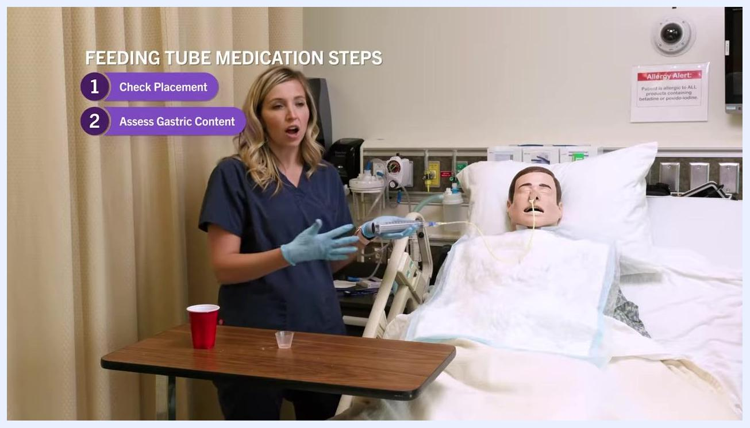
Nurse holding the syringe while emphasizing the importance of returning gastric content, with on-screen text "Feeding Tube Medication Steps: 1. Check Placement, 2. Assess Gastric Content."
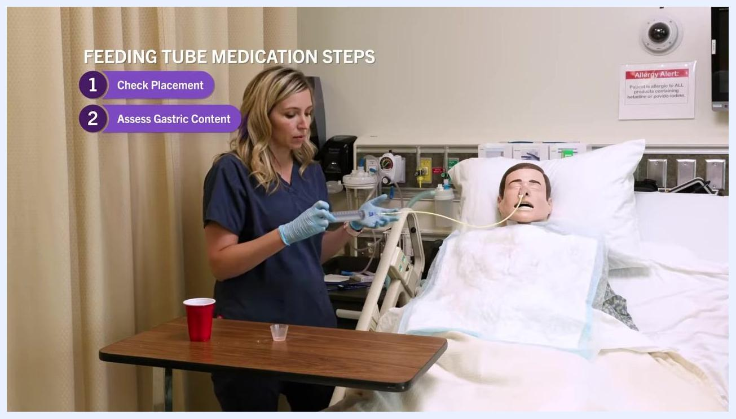
Nurse in navy scrubs holding the NG tube and 60 mL syringe beside a patient mannequin, with on-screen text "Feeding Tube Medication Steps: 1. Check Placement, 2. Assess Gastric Content." Supplies visible on the overbed table.
Nurse holding the tube high above the mannequin, demonstrating rapid drainage when held too high, with step 3 highlighted on screen.
Nurse emphasizing aspiration prevention with gloved hands, with on-screen steps 6 and 7 visible. Mannequin upright in bed.

Discharge Criteria
The source material does not describe discharge criteria, since this procedure covers a single medication administration event rather than a full inpatient stay. Any discharge decision for a patient with a feeding tube should follow your facility's standard discharge protocol.
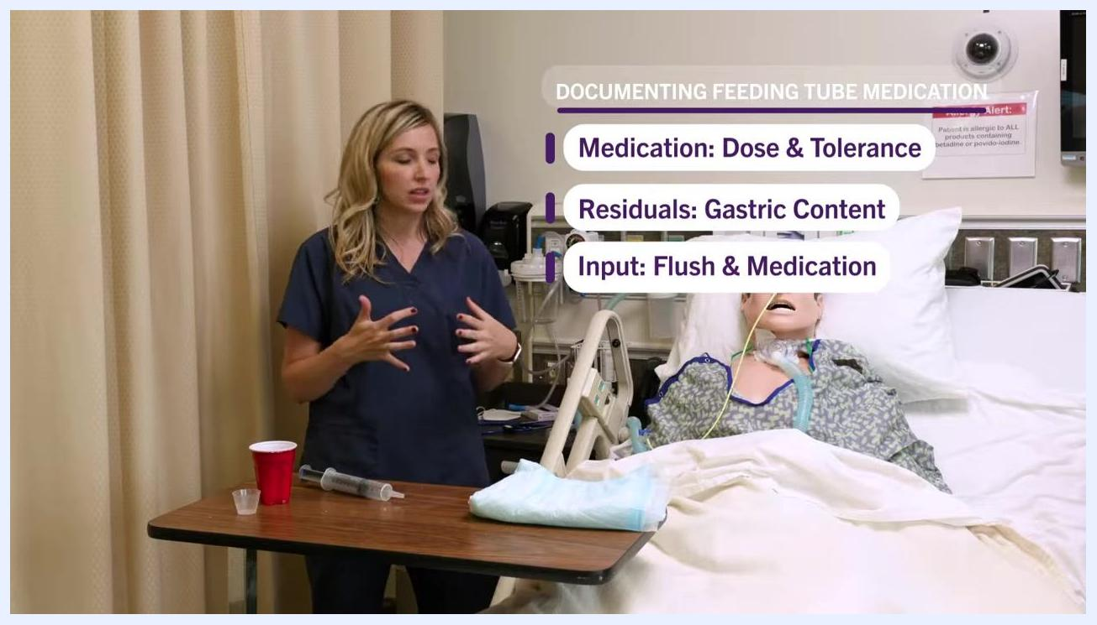
End screen with "FOLLOW US @WeberStateU", "Thanks for watching!", "CLICK HERE TO SUBSCRIBE", and "NEXT VIDEO" prompts.

Patient Education
Before beginning, explain to the patient which medication is being given and why, including the intended purpose and any possible side effects (for example, that a cough medication may cause drowsiness while helping reduce cough and improve sleep).
Nurse at the bedside gesturing toward documentation prompts for Medication: Dose & Tolerance, Residuals: Gastric Content, and Input: Flush & Medication. Supplies on the table, mannequin in bed.
Ask the patient about any known medication allergies before proceeding.
Explain why the patient is being positioned upright: this position helps prevent medication from coming back up the esophagus and reduces the risk of aspiration.
After the procedure, ask the patient if they need anything for comfort, such as adjusting the television or repositioning.
Inform the patient that the procedure is complete, ensure the call light is within reach, and remind them to call if they need anything before you leave the room.
Nurse standing beside the patient mannequin in the hospital bed, near a bedside table with a red cup, syringe, and absorbent pad, engaging with the patient to ensure comfort.

