How to Use a Food Thermometer in Food Service
Knowing how to use a food thermometer correctly is one of the most important food safety skills in any commercial kitchen. All foods must be cooked and held at correct temperatures to prevent foodborne illness, and a metal stem (dial) or digital thermometer is the most reliable tool for confirming that meat, poultry, seafood, and other cooked foods reach safe internal temperatures. This procedure explains how to select, calibrate, and use both thermometer types correctly, and how to keep them clean between uses.
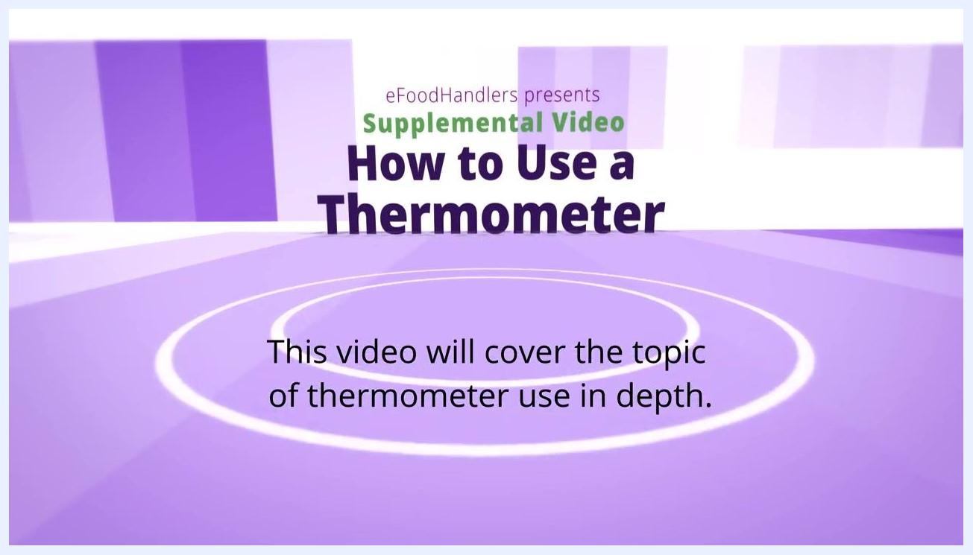
Title screen showing "How to Use a Thermometer" and the statement "This video will cover the topic of thermometer use in depth."
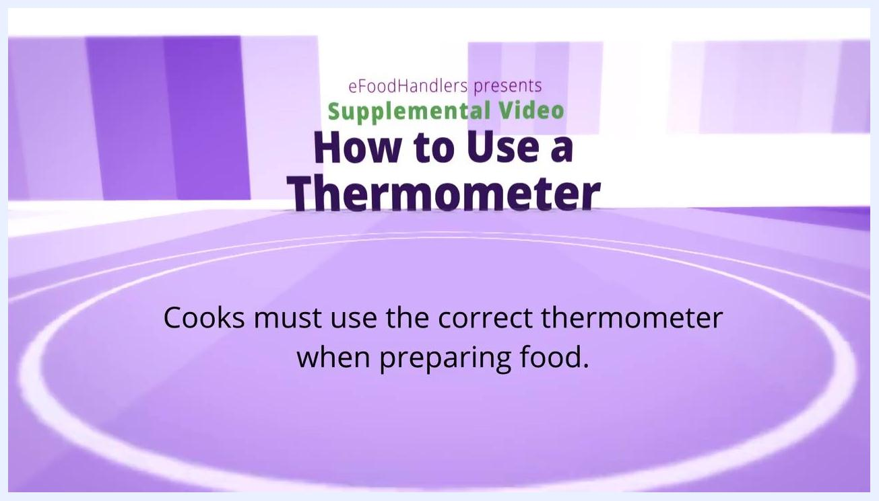
Screen stating that cooks must use the correct thermometer when preparing food.
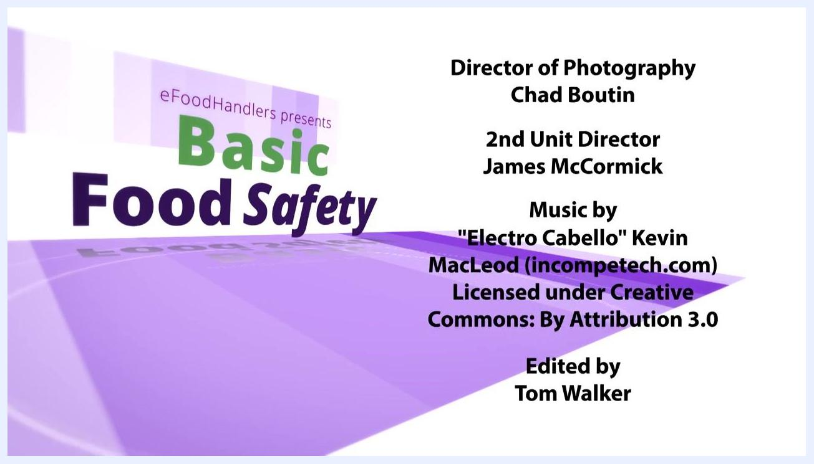
Screen with the text: "Digital thermometers measure one half inch deep for 5 seconds."

Purpose
This procedure ensures that all foods are cooked and held at safe temperatures, minimizing the risk of foodborne illness and maintaining high food safety standards in the kitchen.

Scope
This procedure applies to any food service staff member responsible for preparing or checking the temperature of:
- Hamburgers
- Poultry
- Roasts
- Chops
- Egg casseroles
- Meatloaves
- Other combination dishes

Required equipment
- A metal stem (dial) thermometer, best suited for thick foods
- A digital thermometer, best suited for thin foods
- A cup of crushed ice and water, for calibration checks
- Sanitizing supplies for cleaning the thermometer probe between uses
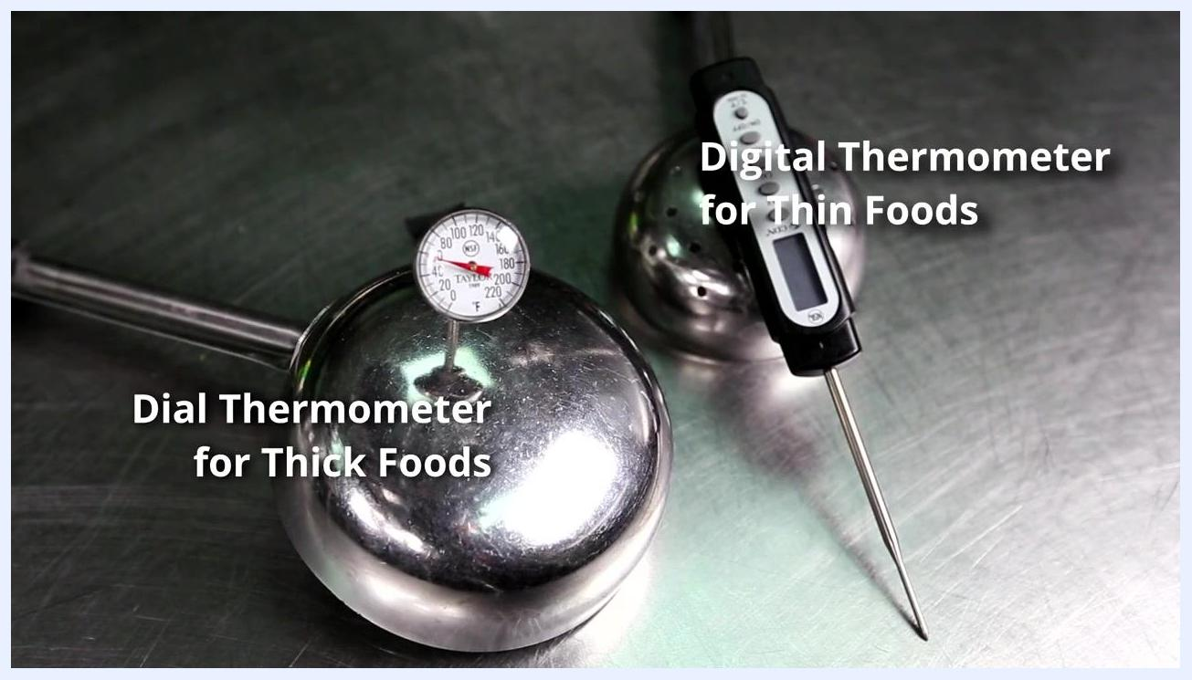
Trays of raw meats, including hamburger patties, steaks, chicken breasts, chicken thighs, and bacon, ready for temperature checking.
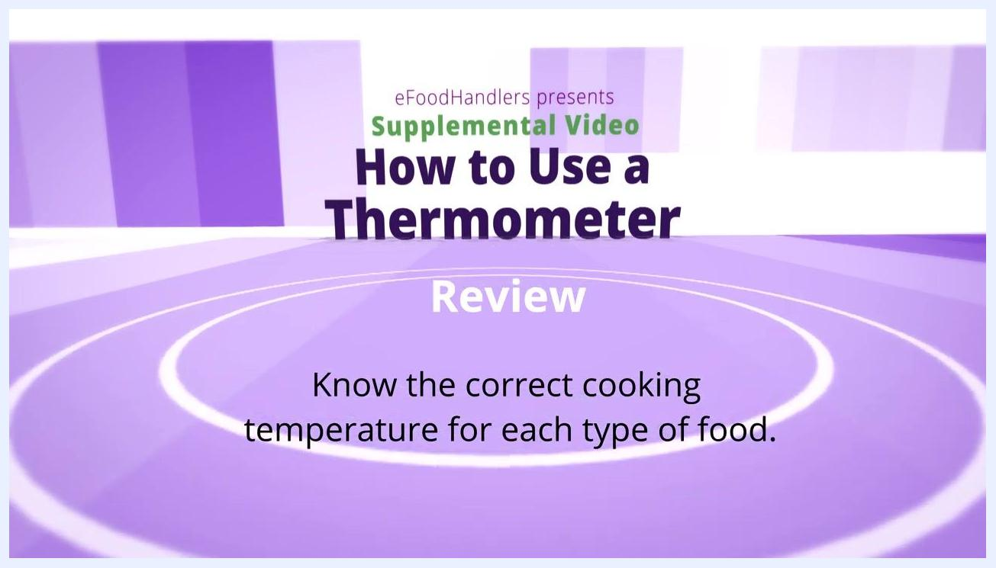
Screen with the text: "Dial thermometers are best for thick foods."
Cooks must always use the correct thermometer for the food being prepared.
Review screen reminding cooks to always wash thermometers between uses.

Procedure

Step 1: Understand the temperature danger zone
Food must not remain in the "Danger Zone"—between 41°F and 135°F—for longer than 2 hours. This range is where bacteria multiply rapidly, increasing the risk of foodborne illness. Keep this limit in mind whenever you are cooking, holding, or cooling food.
Kitchen scene showing a thermometer graphic that marks 41°F to 135°F as the danger zone, with text warning that food must not remain there longer than 2 hours.

Step 2: Choose the right thermometer for the food
Match the thermometer to the thickness of the food you are checking:
- Use a dial (metal stem) thermometer for thick foods. Insert the stem several inches into the thickest part and leave it in place for at least 20 seconds for an accurate reading.
- Use a digital thermometer for thin foods, such as hamburger patties. Digital displays are easy to read and give a quick result.
Dial thermometer and digital thermometer laid out on metal surfaces, showing which tool to use for thick foods and which for thin foods.
Dial thermometer and digital thermometer on metal surfaces, labeled "Dial Thermometer for Thick Foods".
Do not use a dial thermometer on thin foods, since it needs more depth than thin items provide for an accurate reading.

Step 3: Confirm which foods require a thermometer check
Always use a food thermometer when preparing hamburgers, poultry, roasts, chops, egg casseroles, meatloaves, or other combination dishes.
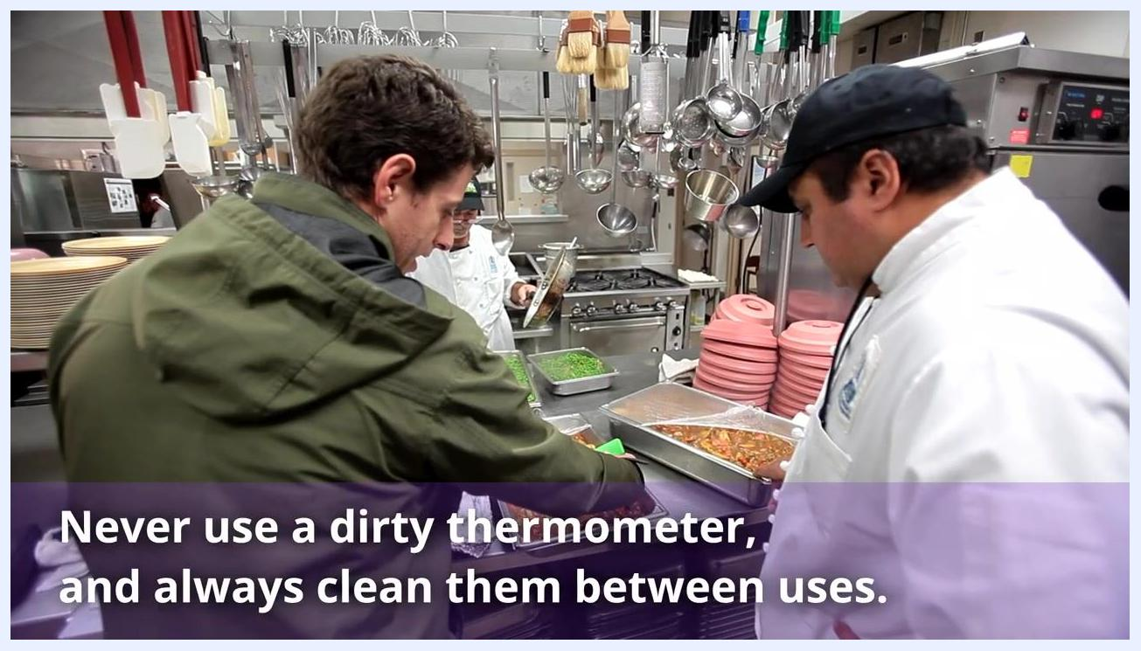
Two whole chickens roasting in an oven, showing the correct side placement for thermometer insertion.

Step 4: Confirm your thermometer's measurement range
Before use, make sure your thermometer can measure temperatures from 0°F to 220°F. Only thermometers covering this full range guarantee accurate readings across all food types.
Metal stem (dial) thermometer inserted into a piece of cooked chicken, with text noting that food thermometers must measure from 0°F to 220°F.

Step 5: Calibrate the thermometer
Check accuracy regularly before relying on a reading:
- Place the thermometer sensor in a cup filled with crushed ice and water.
- The thermometer should read exactly 32°F.
- If it does not read 32°F, adjust it according to the manufacturer's instructions or replace it.
- Calibrate all thermometers periodically as directed by the manufacturer.
Dial thermometer held in a cup of ice water, with text stating that thermometers in ice should read 32°F.

Step 6: Clean and sanitize the thermometer
Always clean and sanitize the thermometer probe after each use, after it has touched an unsanitized surface, or if it becomes contaminated in any way. Never use a dirty thermometer, as it can transfer harmful bacteria to food.
Food service workers in a commercial kitchen, with text warning never to use a dirty thermometer and to always clean it between uses.

Step 7: Insert the thermometer correctly
When checking the temperature of a poultry breast, insert the thermometer from the side rather than from the top. This method is easier to read and gives a more accurate measurement.
Review screen reminding cooks to know the correct cooking temperature for each type of food.

Step 8: Take a reading with a dial thermometer
For thick foods, insert the stem straight in or at an angle, about two inches into the thickest part of the food. Avoid touching bone or fat with the stem, and leave the thermometer in place for at least 20 seconds to get an accurate reading.
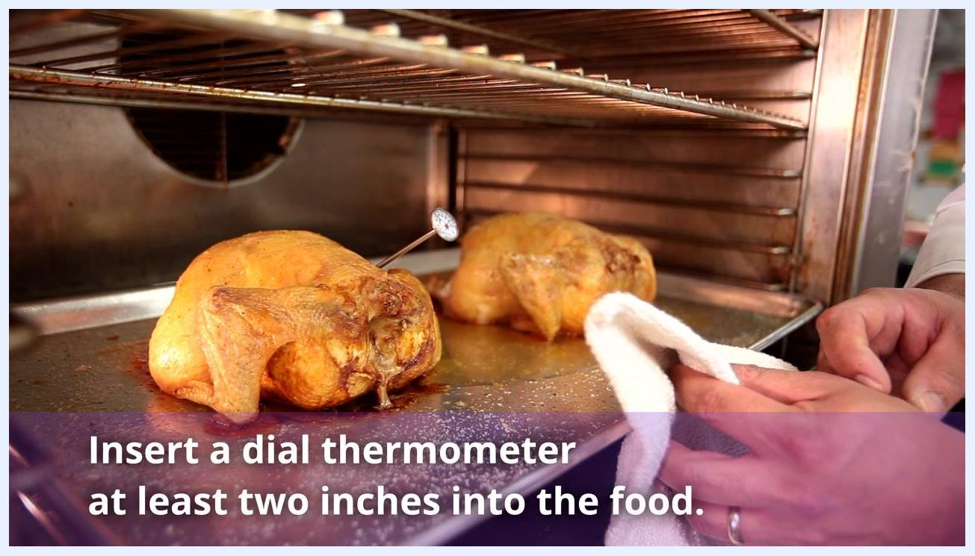
Cooked chickens in an oven with a dial thermometer inserted at an angle, with text noting that a dial thermometer should go at least two inches into the food.

Step 9: Take a reading with a digital thermometer
For thin foods, insert the digital stem about a half inch or less into the center of the thickest part, straight in or at an angle. Avoid touching bone or fat with the probe, and wait approximately five seconds for the temperature to display.
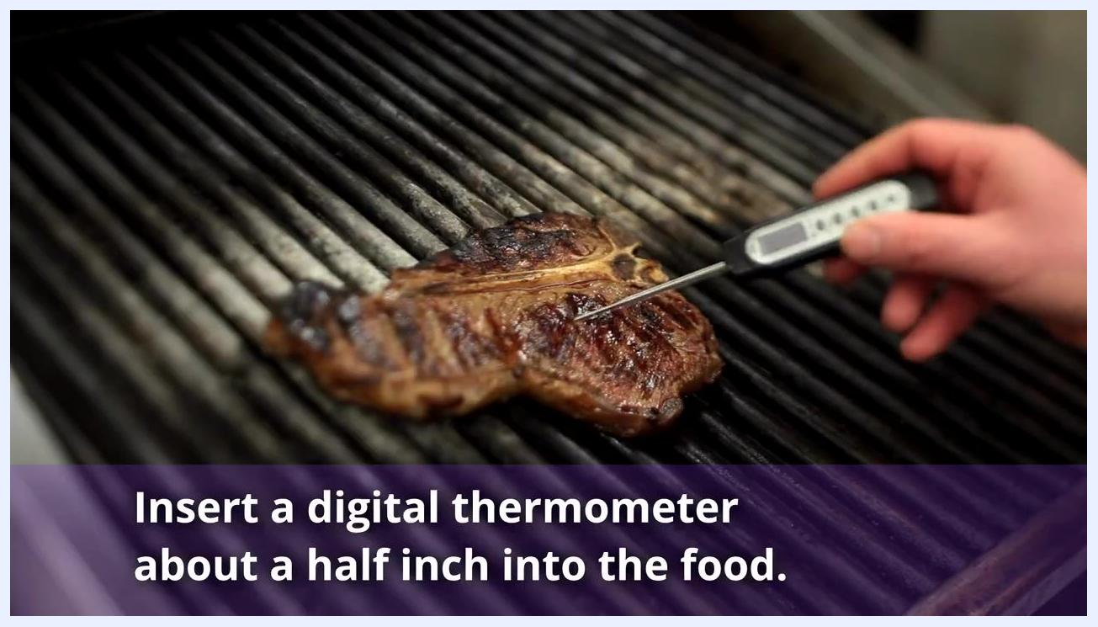
Digital thermometer inserted about a half inch into a steak on a grill, with text noting that a digital thermometer should go about a half inch into the food.

Verification and summary
Before serving any food, confirm it has reached the proper internal temperature using your thermometer—this remains the best way to tell if food is safe to eat.
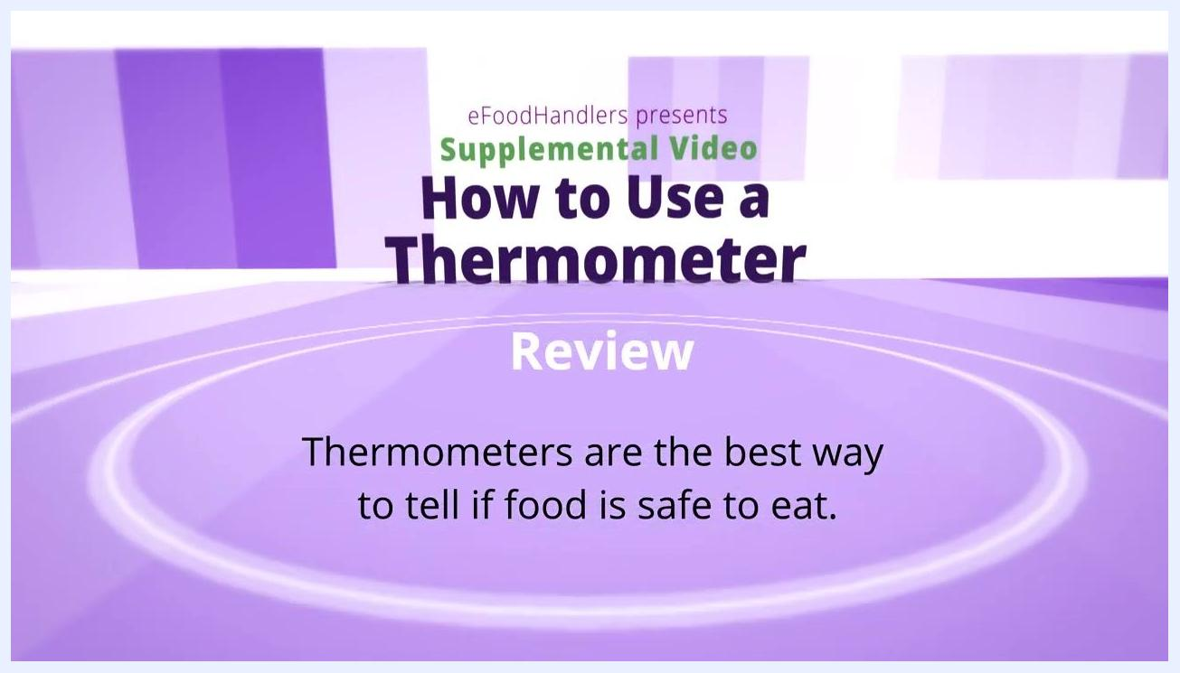
Review slide stating that thermometers are the best way to tell if food is safe to eat.
Use this checklist to confirm the procedure was followed correctly:
- Verify the recommended internal cooking temperature for the food type against official food safety guidelines.
- Confirm you selected the correct thermometer type: dial (metal stem) for thick foods, digital for thin foods, each with its own insertion depth and wait time.
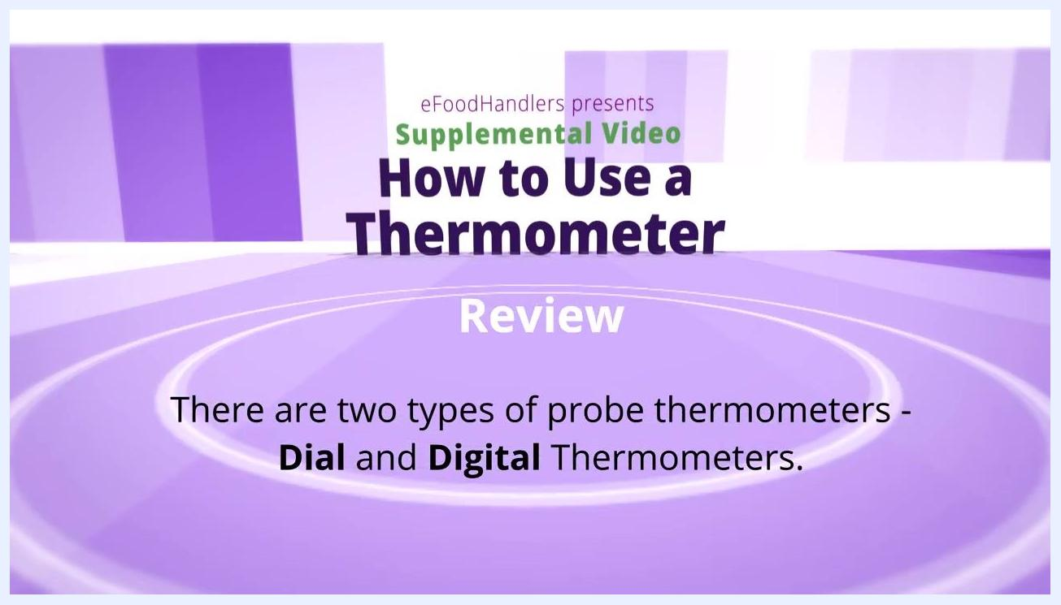
Review screen stating that there are two types of probe thermometers: dial and digital.
- Confirm the thermometer has been calibrated according to the manufacturer's directions.
- Confirm the thermometer was washed and sanitized between uses, and never used while dirty.
Practicing safe thermometer use protects the safety of everyone who eats the food you prepare, so treat every one of these checks as a required part of your routine.
Screen with the text: "Know the proper techniques for each type of thermometer."

What's next
For more information on food safety, refer to the six-part series on basic food safety and other supplemental videos for comprehensive guidance on maintaining safe practices throughout your kitchen.
Screen with credits for the "Basic Food Safety" video series, listing production staff and licensing information.
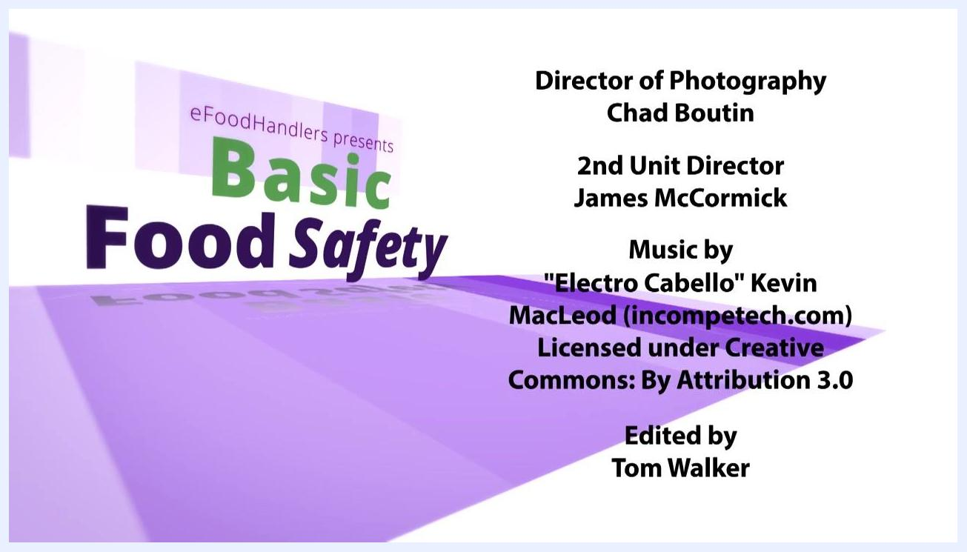
Screen with credits for the "Basic Food Safety" video series, listing production staff and licensing information.

