Turkey Fryer How-To: A Complete Guide to Deep Frying a Whole Turkey
This turkey fryer how-to walks you through the full process of deep frying a whole turkey safely and successfully, based on guidance demonstrated by the Culinary Institute of America. Follow each step in order and observe every safety note, since improper technique with hot oil and open flame can cause fires and severe burns.

Logo for "Today's TURKEY Serve up something unexpected" with ServeTurkey.org and production credit to The Culinary Institute of America and the National Turkey Federation.

Purpose
This procedure explains how to prepare, fry, and serve a whole deep-fried turkey using a propane burner and outdoor fryer setup. It covers equipment preparation, oil measurement, frying temperatures, and safe handling of hot oil.

Scope
This procedure applies to anyone deep frying a whole turkey outdoors using a propane burner and a large fryer pot. It does not cover indoor frying, which you should never attempt due to fire risk.

Safety precautions
- Deep frying a turkey can be very dangerous. Improper techniques can cause fires and severe burns.
- Always deep fry outdoors. Never fry inside your house, garage, or on your deck.
- Proceed with caution and follow every safety instruction throughout this procedure.

Required equipment and PPE
- Propane burner
- Large fryer (pot)
- Fryer basket or perforated poultry rack
- Thermometer
- Burn-proof oven mitts
- Canola, peanut, or vegetable oil (high smoke point oils)
- Whole turkey (fresh or fully thawed)
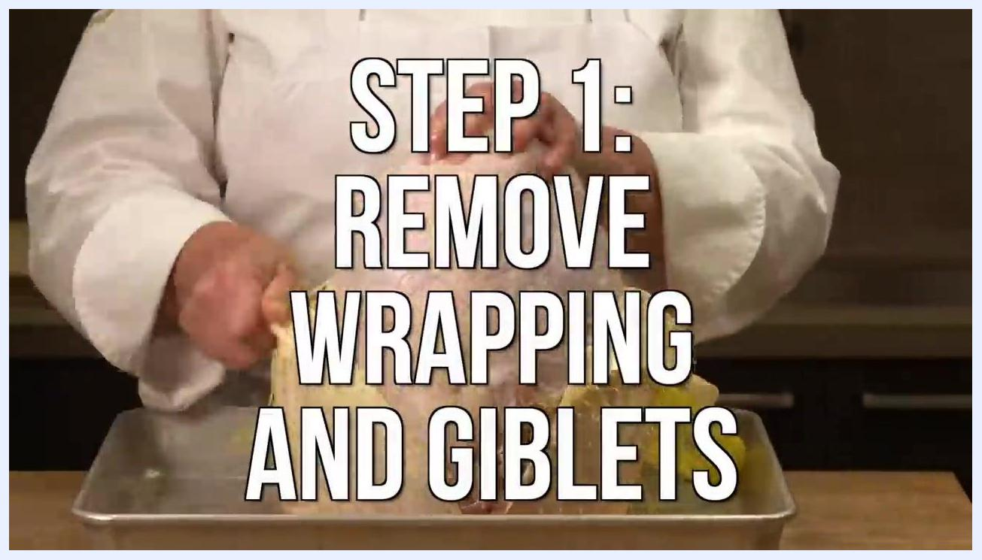
A person connects a propane hose to a tank next to a fryer stand.

Step-by-step instructions

Step 1: Gather your equipment and ingredients
Confirm you have a propane burner, large fryer, fryer basket or poultry rack, thermometer, burn-proof oven mitts, and a high smoke point oil such as canola, peanut, or vegetable oil. Obtain a whole turkey that is either fresh or fully thawed before you begin.
A box labeled "Heavenly Chef Premium Strength Peanut Oil" (35 lbs/15.88 kg) sits next to a clear container of water on the ground outdoors.

Step 2: Set up your frying station outdoors
Always deep fry your turkey outdoors — never inside your house, garage, or on your deck. Place your propane burner on a perfectly balanced, stable surface, and confirm the fryer pot is 100% stable before proceeding. Wear burn-proof oven mitts whenever you handle hot equipment.
A person in chef attire and apron, wearing long black oven mitts, handles a large metal fryer pot on a propane burner outdoors with visible flames beneath it.

Step 3: Select your frying oil
Use canola, peanut, or vegetable oil, since these oils have a high smoking point suited to deep frying.

Step 4: Remove wrapping and giblets
Remove any wrappers from the turkey, then take out the giblets and neck from inside the turkey's body cavity.

Step 5: Prepare your workstation
Set up your propane burner and fryer outdoors, well away from structures and flammable materials, then connect the propane tank securely to the burner.

Step 6: Measure your oil
Make sure you have enough oil to fully submerge the turkey, but not so much that it overflows once the turkey is added.

Step 7: Determine your oil level
Place the turkey on the perforated poultry rack or in the fryer basket, then put the turkey (in the rack or basket) into the empty fryer pot. Fill the fryer with water until the turkey is just covered, keeping the water level at least 3 to 5 inches below the top of the pot to prevent overflow. Remove the turkey and mark the water line on the pot — this mark becomes your oil fill line.
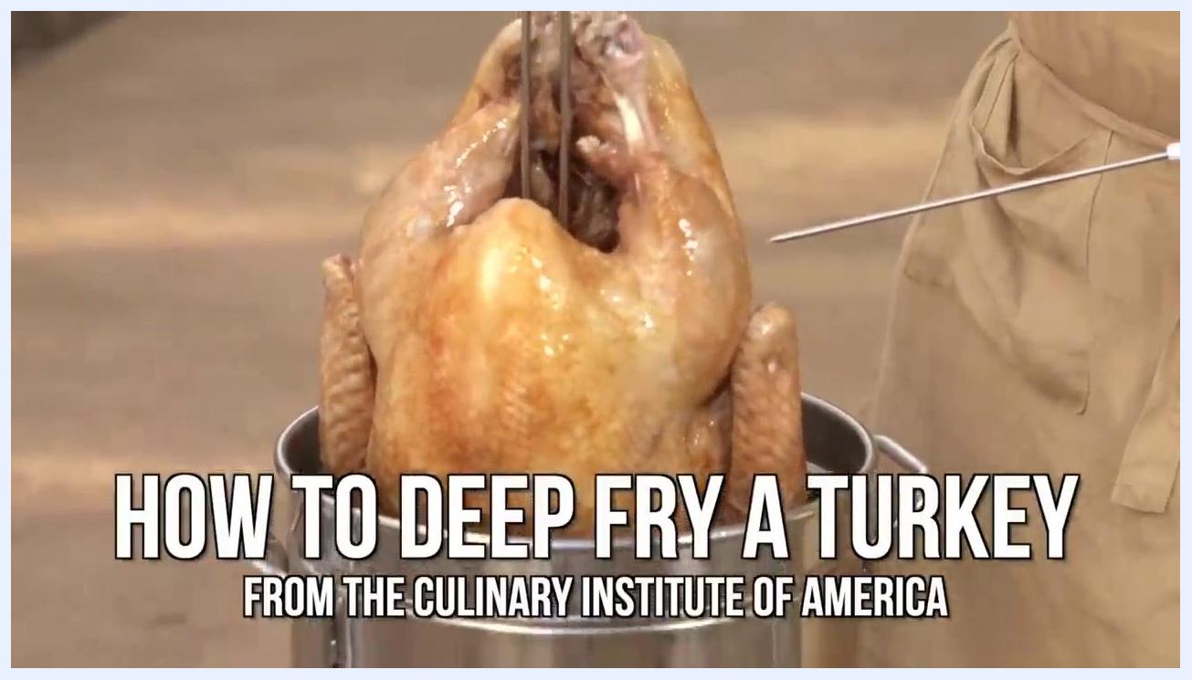
A whole cooked turkey being lifted from a fryer basket, with the text "HOW TO DEEP FRY A TURKEY FROM THE CULINARY INSTITUTE OF AMERICA" overlaid.

Step 8: Remove water and add oil
Remove the turkey from the pot, dump out the water, and thoroughly dry the fryer pot. Fill the fryer with oil up to the marked water line.
A box of peanut oil sits ready for measuring before frying.

Step 9: Heat the oil
Remove any tape or markings from the pot. Light the propane burner and heat the oil to 375°F (190°C), using a thermometer to monitor the temperature. Never leave the deep fryer unattended while heating.
A person in a white chef coat removes wrapping from a raw turkey.

Step 10: Prepare your turkey
While the oil heats, pat the turkey dry with paper towels and add any desired seasonings.
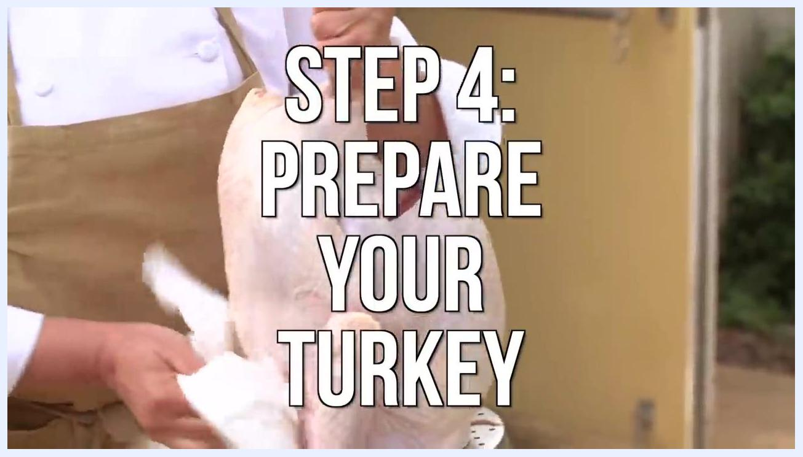
A person pats a raw turkey dry with paper towels.

Step 11: Lower the turkey into the oil
Turn the propane burner OFF before lowering the turkey, and put on burn-proof oven mitts for safety. Using the poultry rack or basket handle, slowly and carefully lower the turkey into the hot oil to avoid splashing or overflow, ensuring it is fully submerged.
A person dumps water from a large fryer pot outdoors, near trees.

Step 12: Cook the turkey
Once the turkey is safely submerged, turn the propane burner back ON. Cook for approximately 3 to 4 minutes per pound, monitoring the oil temperature and adjusting the burner to maintain a steady 350°F (175°C). The turkey is done when the internal meat temperature reaches 165°F (74°C) — verify with a meat thermometer.
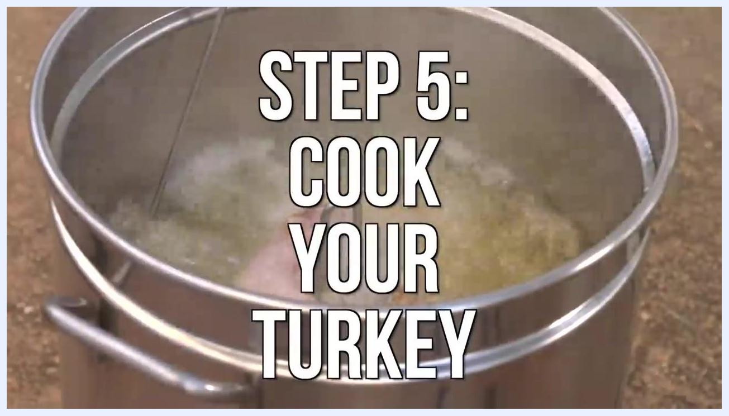
A person in a chef coat and long black oven mitts slowly lowers a raw turkey into a large outdoor fryer pot filled with hot oil, with a propane tank visible nearby.
A large metal fryer pot shows bubbling oil with a turkey submerged inside.

Step 13: Remove and drain the turkey
When the turkey is fully cooked, turn OFF the propane burner. Wearing oven mitts, slowly lift the turkey out of the hot oil using the rack or basket handle, then place it in a large pan or tray to drain excess oil. Let the turkey rest breast side down and legs up for 20 minutes before removing it from the rack or basket.
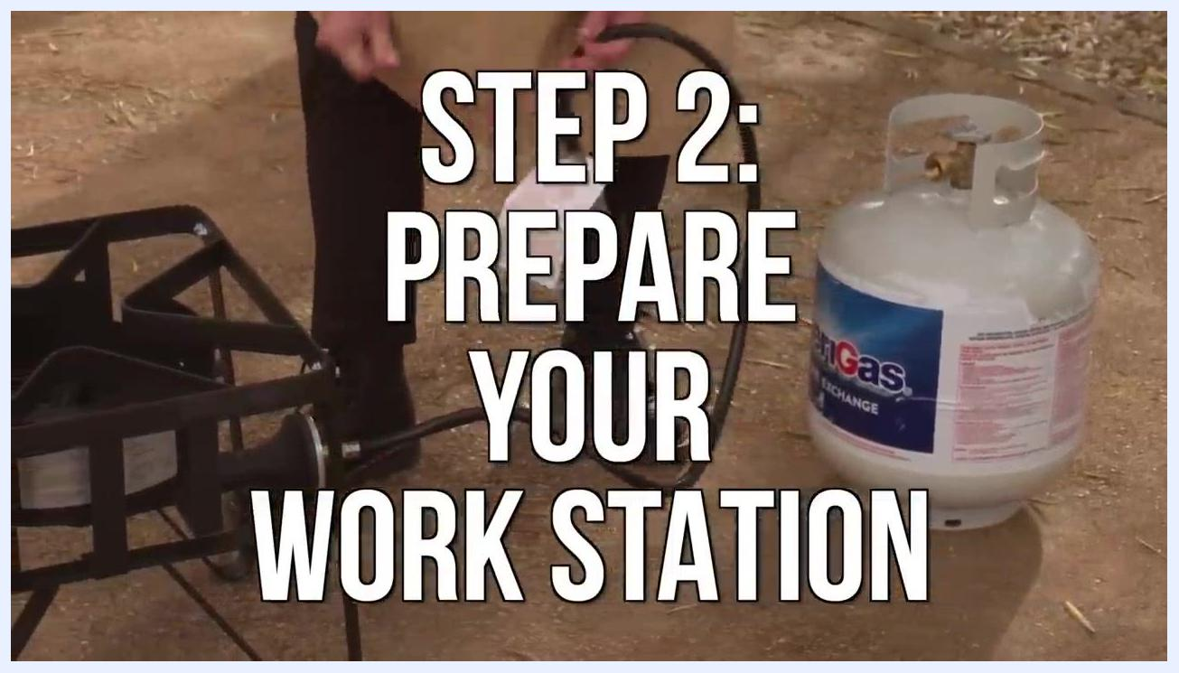
A person lowers a turkey into a large fryer pot filled with water outdoors.
A whole deep-fried turkey rests breast side down and legs up on a perforated rack in a large black roasting pan, ready to drain and rest.

Step 14: Carve and serve
After the 20-minute rest, carefully remove the turkey from the rack or basket and carve as desired.

Verification and summary
Your turkey is properly cooked when the internal temperature reads 165°F (74°C) and the exterior is crispy while the inside stays juicy. By following this turkey fryer how-to in order — with careful attention to outdoor setup, oil temperature, and safe handling of hot equipment — you can safely deep fry a whole turkey with delicious results. Always prioritize safety at every step and enjoy your meal.
A person lights a propane burner connected to a large fryer pot outdoors.

