Restaurant Kitchen Inspection Checklist: Handwashing and Refrigeration Safety Procedures
This restaurant kitchen inspection checklist guides you through verifying handwashing stations, checking refrigeration and hot holding temperatures, confirming safe food storage, and reviewing dishwashing and cross-contamination controls in a food premise. Completing each step helps you confirm that your kitchen meets food safety requirements and reduces the risk of illness outbreaks caused by improper handling or contamination.
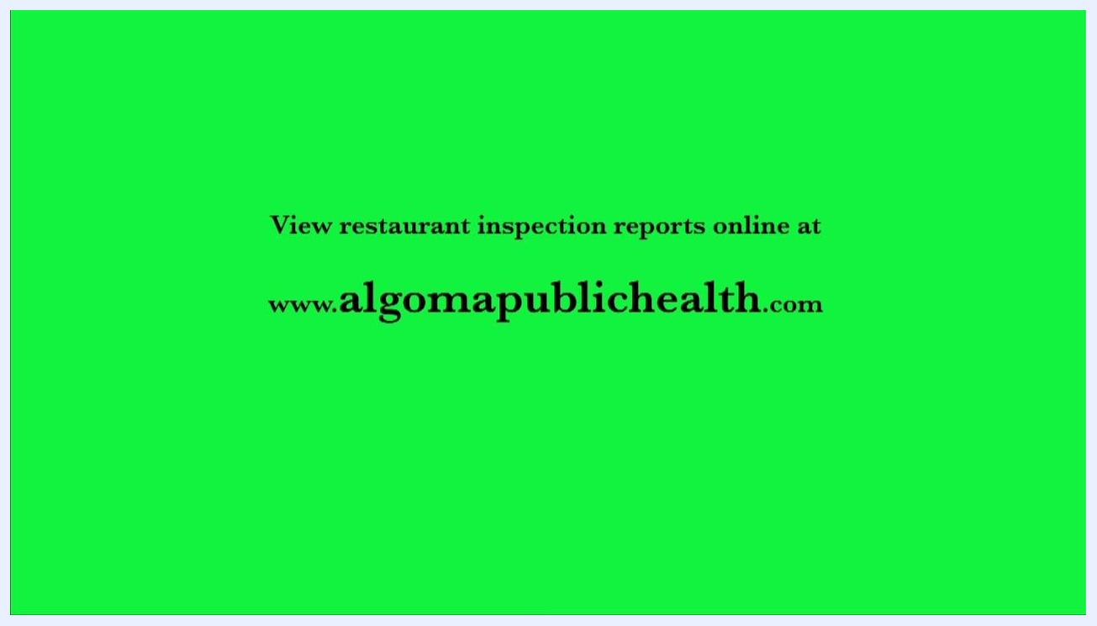
Green screen with black text: "View restaurant inspection reports online at www.algomapublichealth.com"

Purpose
This checklist helps you confirm that a food premise has the required handwashing facilities, maintains safe food temperatures during storage and hot holding, follows proper dishwashing practices, and prevents cross-contamination between raw and ready-to-eat foods.

Scope
This procedure applies to any food premise with a designated handwashing station, walk-in refrigeration unit, hot holding unit, and three-compartment sink used for dishwashing.

Required equipment and materials
- Liquid hand soap
- Paper towel
- Hot and cold running water
- Probe (food) thermometer
- 70% isopropyl alcohol swabs, for sanitizing the probe thermometer
- Quaternary ammonium sanitizer, for the third sink compartment
- Three-compartment sink
- Separate cutting boards and knives for raw and ready-to-eat foods
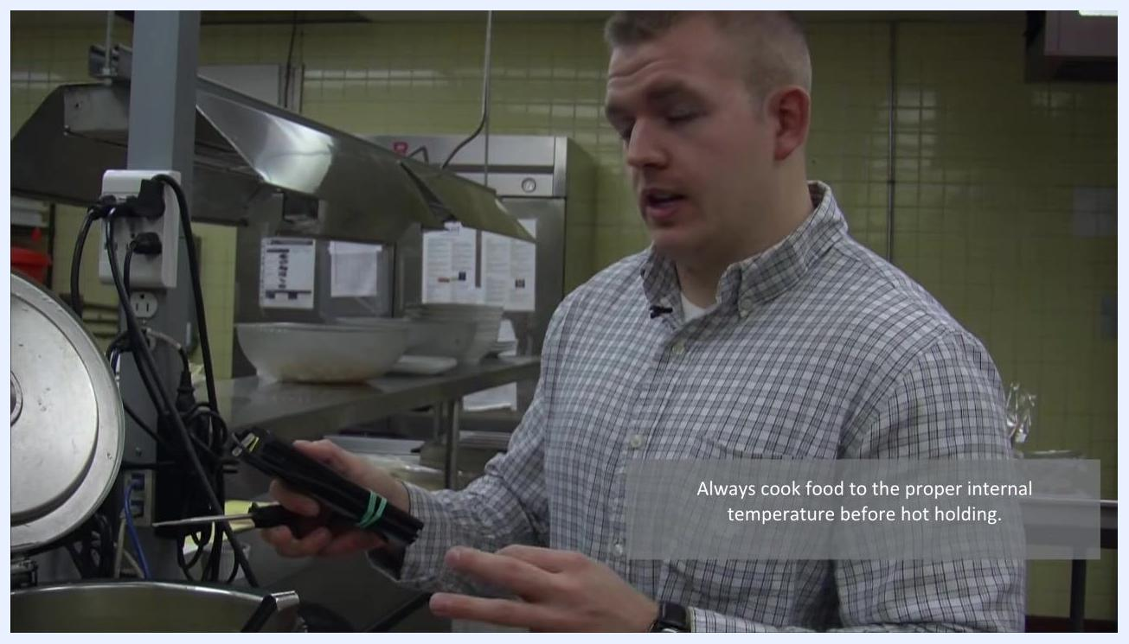
A person stirring and measuring the temperature of soup in a hot holding unit with a probe thermometer, with the unit lid open and kitchen equipment visible in the background

Inspecting the handwashing station

Step 1: Verify the handwashing station is properly equipped
Locate the designated hand wash station in the food preparation area. Confirm it is used only for handwashing and check for signage reading Hand Wash Station Only. Verify that a paper towel dispenser and a liquid soap dispenser are present, and that the sink is accessible and operational with both hot and cold running water.
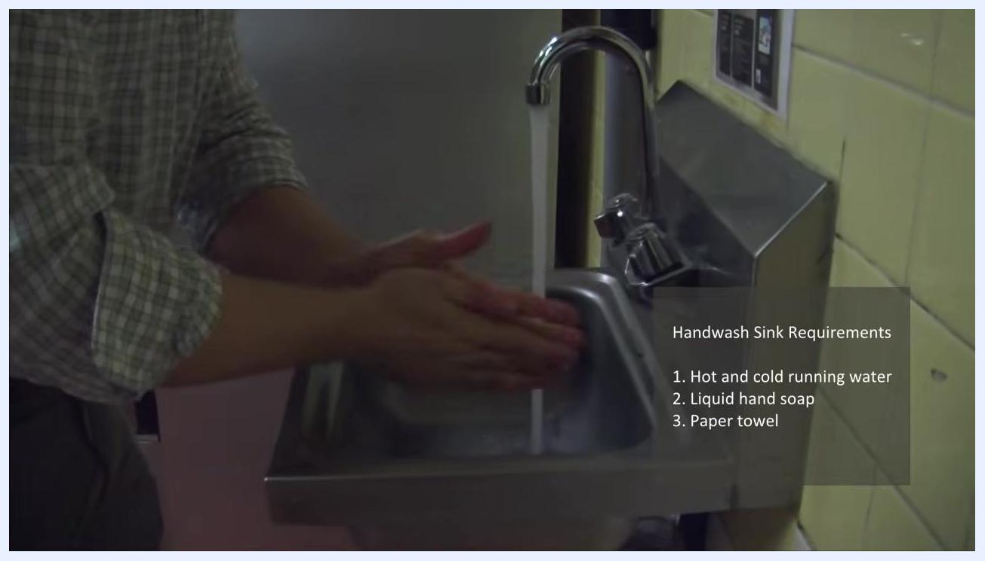
Close-up of hands being washed under running water at a stainless steel sink, with the handwash sink requirements listed: hot and cold running water, liquid hand soap, paper towel

Step 2: Wash your hands thoroughly
Turn on the tap and confirm both hot and cold water flow. Dispense liquid hand soap and wash your hands thoroughly under running water, then rinse completely. A compliant handwash sink must have hot and cold running water, liquid hand soap, and paper towel.
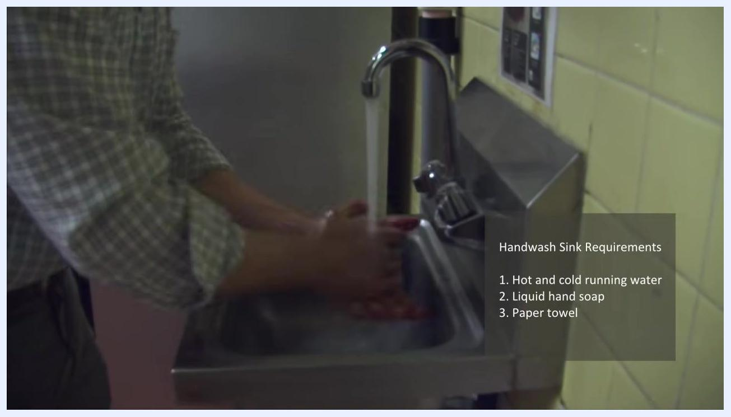
A person standing in front of a walk-in refrigerator door, with a sign showing "Temperature Danger Zone: 4°C to 60°C"

Step 3: Dry your hands and dispose of the paper towel
Dry your hands using paper towel from the dispenser, then dispose of the used towel in the appropriate waste bin.

Reviewing refrigeration temperature safety

Step 4: Know the temperature danger zone
The temperature danger zone falls between 4°C and 60°C. Minimize the time food spends in this range to prevent bacterial growth.

Step 5: Keep cold foods cold and hot foods hot
Maintain cold foods at 4°C or below, and hot foods at 60°C or above, to keep food out of the temperature danger zone.

Step 6: Check the walk-in refrigerator's external thermometer
Before entering the walk-in refrigeration unit, check the external thermometer. It should read between 3°C and 4°C, indicating a safe storage temperature, before you enter to continue the inspection.
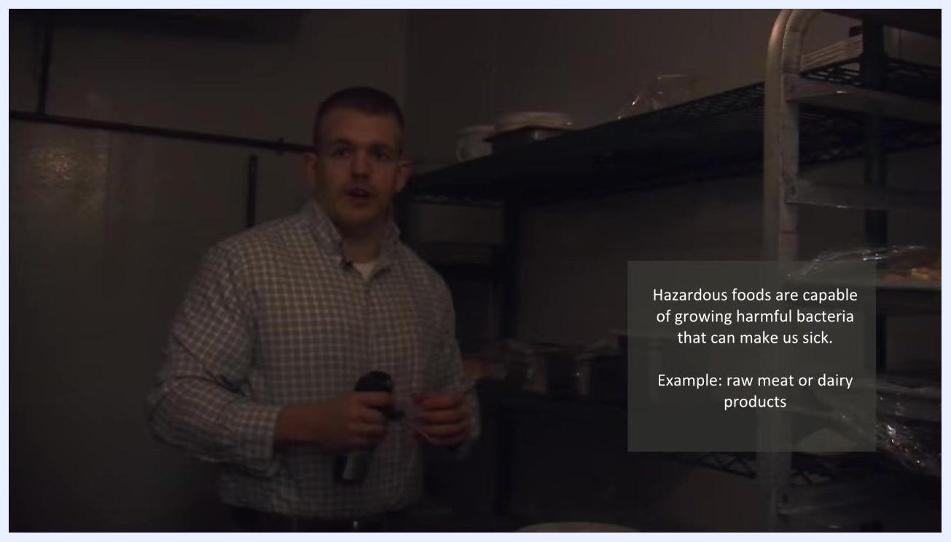
A person entering a walk-in refrigerator, with a thermometer visible on the wall and an emergency eye wash sign nearby

Step 7: Probe hazardous foods for internal temperature
Select a hazardous food item, such as raw meat or dairy, for temperature probing. Hazardous foods are capable of growing harmful bacteria and toxins, so use a probe thermometer to check that their internal temperature stays below 4°C.
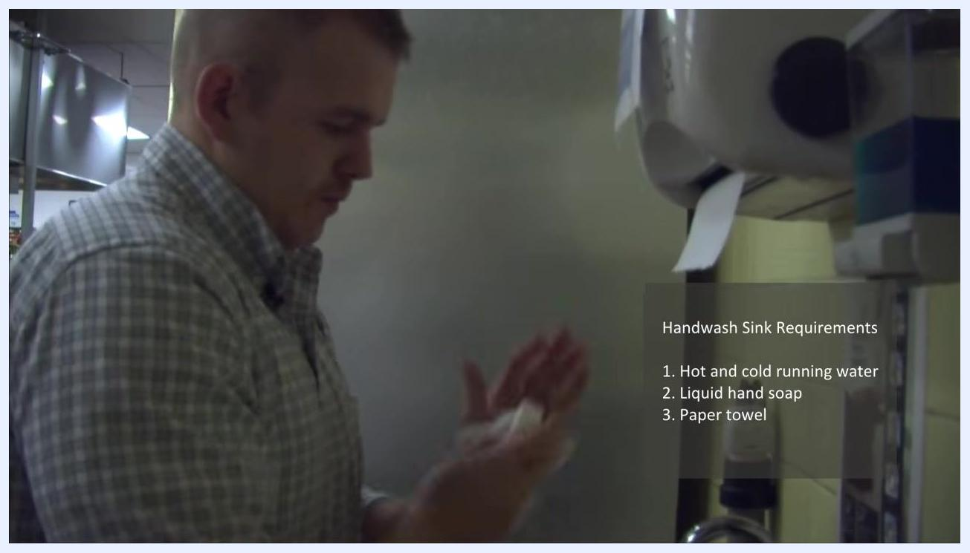
A person drying their hands with paper towel at the handwashing station, with the requirements listed on screen

Verifying refrigerator performance and storage conditions

Step 8: Sanitize the probe thermometer before use
Clean the probe thoroughly with a 70% isopropyl alcohol swab before each use, then allow it to air dry for about one minute before proceeding.

Step 9: Measure food temperature at its thickest point
Insert the sanitized probe into the thickest part of the food item and wait for the reading to stabilize. A reading of approximately 3°C confirms the food is stored safely below 4°C.
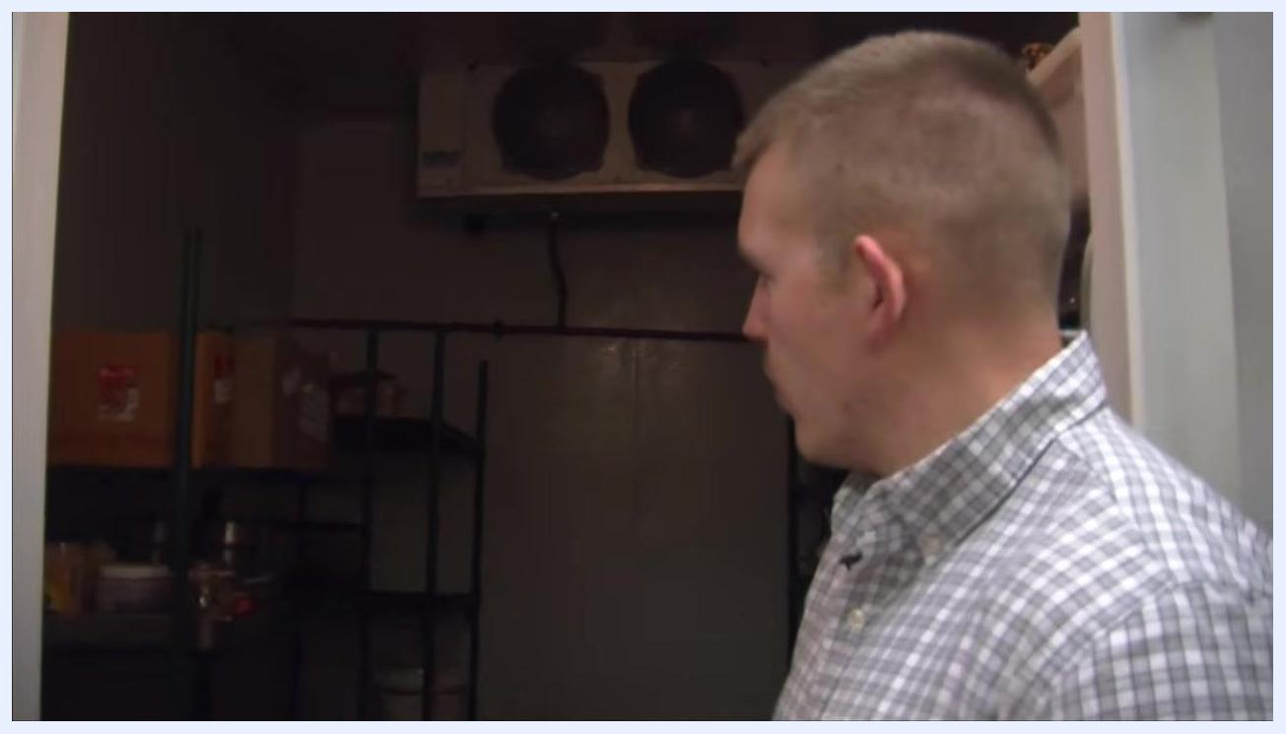
Close-up of metal shelving inside a walk-in refrigerator, holding various food containers and jars

Step 10: Confirm the refrigeration unit is functioning correctly
If the food temperature reads at or below 4°C, the refrigeration unit is cooling food to a safe temperature.

Step 11: Inspect refrigerator shelving units
Check that all shelving units are smooth, non-absorbent, and easy to clean. Damaged or corroded shelving can lead to physical contamination of food.
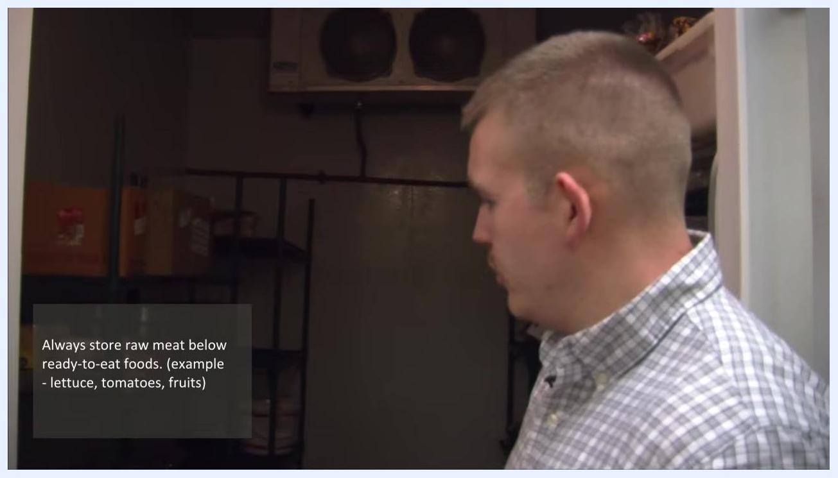
Person holding a thermometer in a commercial kitchen, explaining the temperature danger zone, with kitchen equipment and posted instructions in the background

Step 12: Assess overall shelf condition
Visually inspect every shelf for wear, rust, or peeling paint. Replace or repair any shelving that is not in good condition to prevent contamination.
A person inspecting shelving and food storage inside a walk-in refrigerator, with containers and boxes visible

Step 13: Store foods correctly to prevent cross-contamination
Always store raw foods, such as raw meat, below ready-to-eat foods. Ready-to-eat foods include items that will not undergo further cooking, such as cooked meats, fresh produce, lettuce, tomatoes, and fruit. Follow the rule: Always store raw meat below ready-to-eat foods.
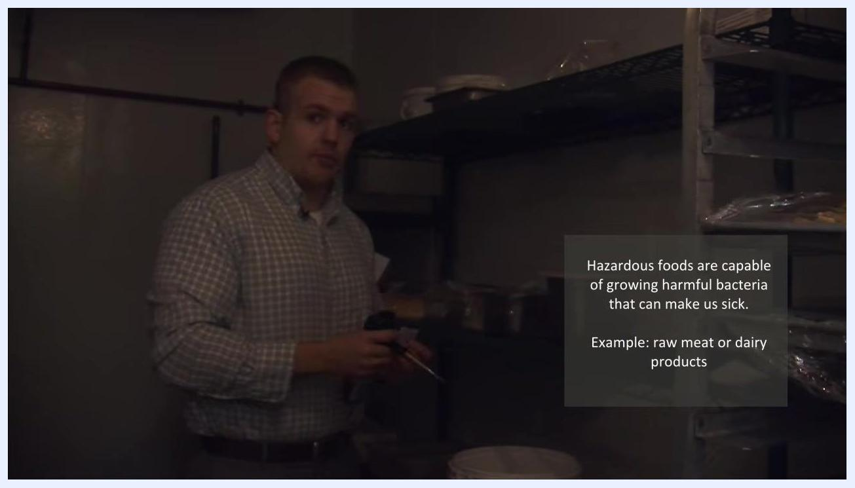
A person holding a thermometer and an alcohol swab inside a walk-in refrigerator, with a reminder about hazardous foods visible on screen
A person standing at the entrance of a walk-in refrigerator, with on-screen text reading "Always store raw meat below ready-to-eat foods. (example - lettuce, tomatoes, fruits)"

Confirming hot holding temperatures

Step 14: Prepare to measure hot holding food temperature
Move to the hot holding area and identify a hot holding food item, such as creamy broccoli soup. Prepare to take its temperature using the sanitized probe thermometer. Hot foods must be held at 60°C or greater to minimize time in the temperature danger zone.
A person standing in front of a walk-in refrigerator, with on-screen text reading "Keep cold foods cold at 4°C or below. Keep hot foods hot at 60°C or above."
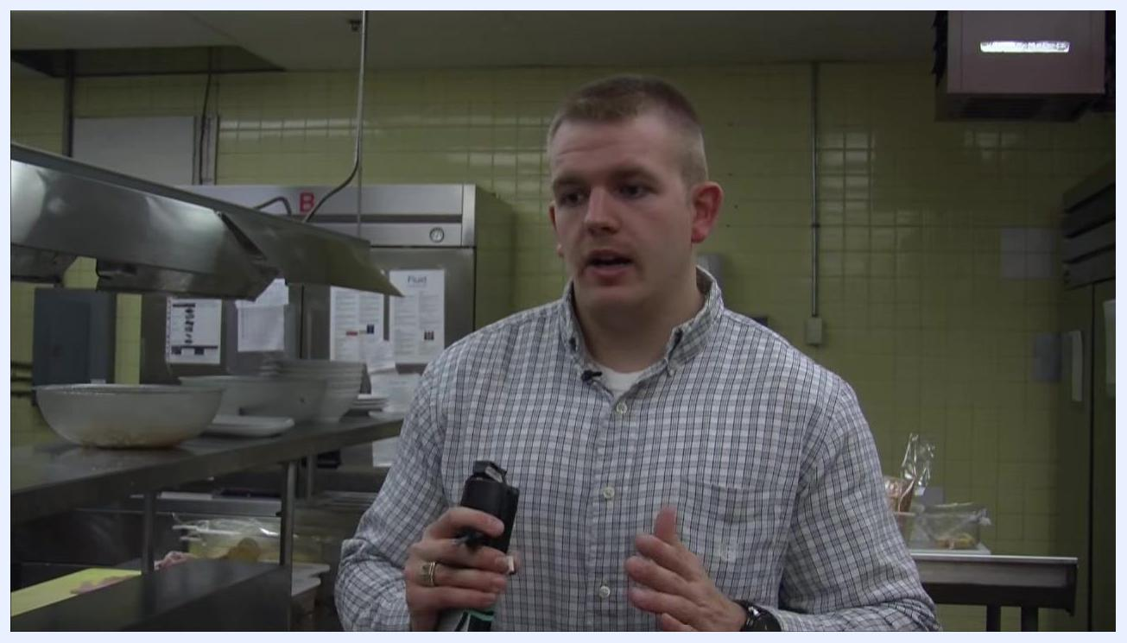
A person holding a thermometer in a commercial kitchen, preparing to measure hot food temperature

Step 15: Stir and measure hot holding food temperature
Stir the hot food in the holding unit to ensure even temperature distribution, then insert the sanitized probe. A reading of approximately 65°C is above the temperature danger zone and confirms safe hot holding.
Close-up of hands holding a thermometer and alcohol swab near a white bucket and metal shelving in a walk-in refrigerator

Step 16: Verify food is held above the temperature danger zone
Confirm the hot food stays at or above 60°C. Food held below 60°C enters the temperature danger zone of 4°C to 60°C, increasing the risk of bacterial growth.
A person checking a thermometer inside a walk-in refrigerator, preparing to measure food temperature

Step 17: Cook food to the proper internal temperature before hot holding
Always cook food to the correct internal temperature before placing it in a hot holding unit. For example, reheat leftover soup from the refrigerator to at least 74°C before holding it at 60°C. Most hot holding units are designed to maintain temperature, not to cook or reheat food.
A person holding a thermometer inside a walk-in refrigerator, with on-screen text reading "Hazardous foods are capable of growing harmful bacteria that can make us sick. Example: raw meat or dairy products"

Step 18: Reinforce proper cooking and holding temperatures
Cook food to the proper internal temperature before transferring it to hot holding, and maintain hot foods at 60°C or higher at all times.
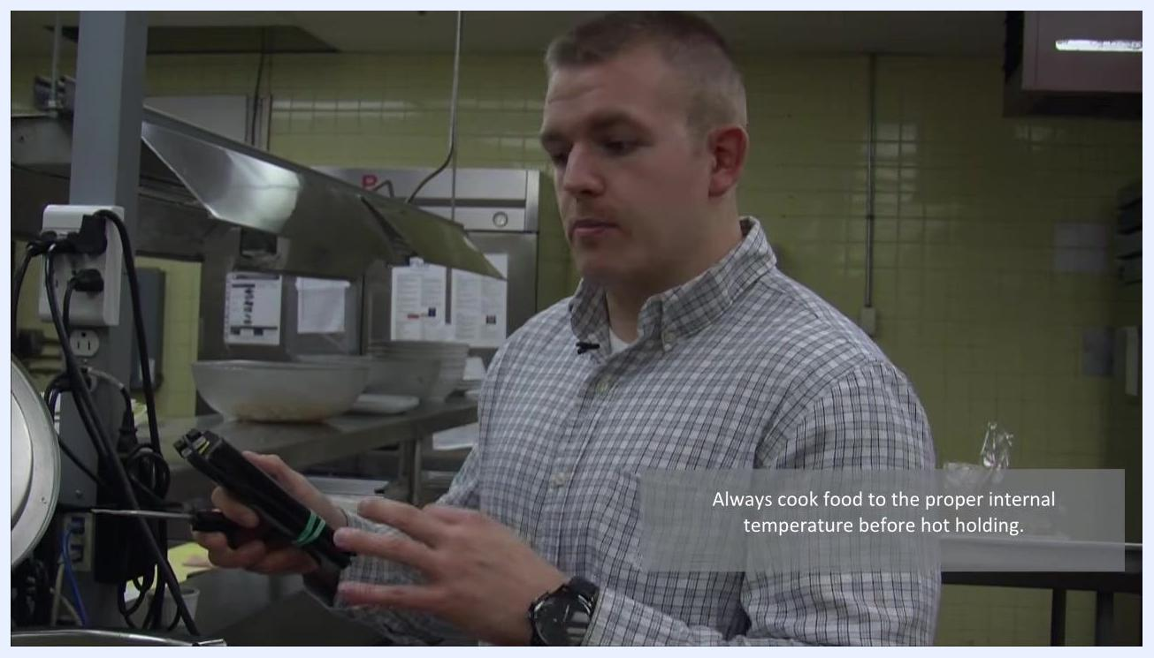
A person holding a thermometer and emphasizing proper cooking and holding temperatures, with on-screen text reading "Always cook food to the proper internal temperature before hot holding."

Following the three-compartment sink dishwashing method

Step 19: Wash, rinse, and sanitize dishware
Use a three-compartment sink for effective dishwashing:
- First sink: Wash dishes in warm, soapy water.
- Second sink: Rinse dishes in clean, warm water.
- Third sink: Sanitize dishes using a quaternary ammonium sanitizer at the correct concentration.
A person holding a thermometer over a hot holding unit, confirming the food is above the temperature danger zone
Allow sanitized items to soak for at least 45 seconds, then air dry.
A person washing dishes in the first compartment of a three-compartment stainless steel sink filled with soapy water, with a faucet and hoses visible
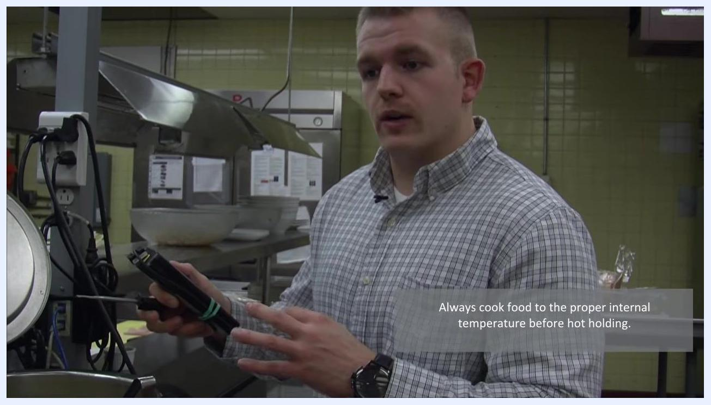
Close-up of the second compartment of a three-compartment sink, showing a hand rinsing dishes in clean water

Preventing cross-contamination

Step 20: Use separate cutting tools for raw and ready-to-eat foods
Cross-contamination is the transfer of harmful microorganisms, such as bacteria, from one food to another, or from hands and equipment to food. Use separate knives and cutting boards for raw and ready-to-eat foods, and wash your hands frequently to reduce this risk.
A person explaining the importance of cooking food to the proper internal temperature before hot holding, with on-screen text reading "Always cook food to the proper internal temperature before hot holding."
Chef's hands using a yellow-handled knife on a red cutting board, with a green cutting board visible in the background, labeled "Cross Contamination"
A chef cutting raw meat or fish on a red cutting board on a stainless steel countertop, labeled "Cross Contamination"

Additional resources
For further food safety information, you can view restaurant inspection reports online at www.algomapublichealth.com.
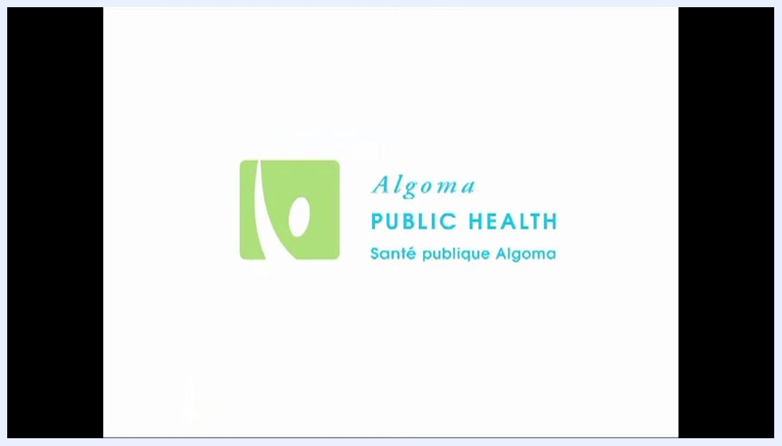
Algoma Public Health logo and text: "Algoma PUBLIC HEALTH Santé publique Algoma" on a white background. No other objects or people are visible.

Summary and verification checklist
Before completing your restaurant kitchen inspection checklist, confirm the following:
- The handwashing station has hot and cold running water, liquid soap, and paper towel, and is used only for handwashing.
- Cold foods are held at 4°C or below and hot foods at 60°C or above.
- The walk-in refrigerator's external thermometer reads between 3°C and 4°C, and hazardous foods inside measure below 4°C.
- Refrigerator shelving is smooth, non-absorbent, and free of rust or peeling paint.
- Raw foods are stored below ready-to-eat foods.
- Hot holding units maintain food at or above 60°C, and food is cooked to the proper internal temperature before hot holding.
- Dishwashing follows the wash, rinse, and sanitize sequence in the three-compartment sink, with sanitized items soaking for at least 45 seconds.
- Separate cutting boards and knives are used for raw and ready-to-eat foods to prevent cross-contamination.
A person standing at a designated hand wash station, with visible paper towel and soap dispensers and signage reading "Hand Wash Station Only"
Person standing in a commercial kitchen, preparing to discuss hot holding procedures, with stainless steel counters and kitchen equipment visible
Completing these checks confirms that your food premise meets handwashing, refrigeration, hot holding, dishwashing, and cross-contamination prevention requirements.
Completely black screen, indicating the end of the video. No objects, people, or text are visible.

