How to Reset Ice Machine: Scotsman Prodigy Plus (Code 3 Lockout)

Purpose
This standard operating procedure explains how to reset an ice machine that has locked out with a Code 3 error, specifically a Scotsman Prodigy Plus (D model) unit. Code 3 indicates the machine could not fill its reservoir quickly enough, a condition most often caused by inadequate water flow due to a clogged or expired water filter. Following this procedure will help you identify the cause, clear the fault, and restore the machine to normal ice-making operation.

Scope
This procedure applies to Scotsman Prodigy Plus (D model) ice machines displaying a Code 3 lockout on the control panel. It covers diagnosis of the lockout condition, water filter replacement, controller reset, and interpretation of the control panel's indicator lights and error codes.

Required equipment
- Replacement water filter compatible with your Scotsman Prodigy Plus model
- Access to the machine's water supply line and drain
- The model number and revision label on the unit (for verification)

Step-by-step instructions

Step 1: Identify the lockout condition
Observe the control panel on the ice machine. Confirm that the code display shows "3," the status light is blinking red, and the water light is also blinking red. These indicators together confirm the machine is locked out due to Code 3, a water flow issue.
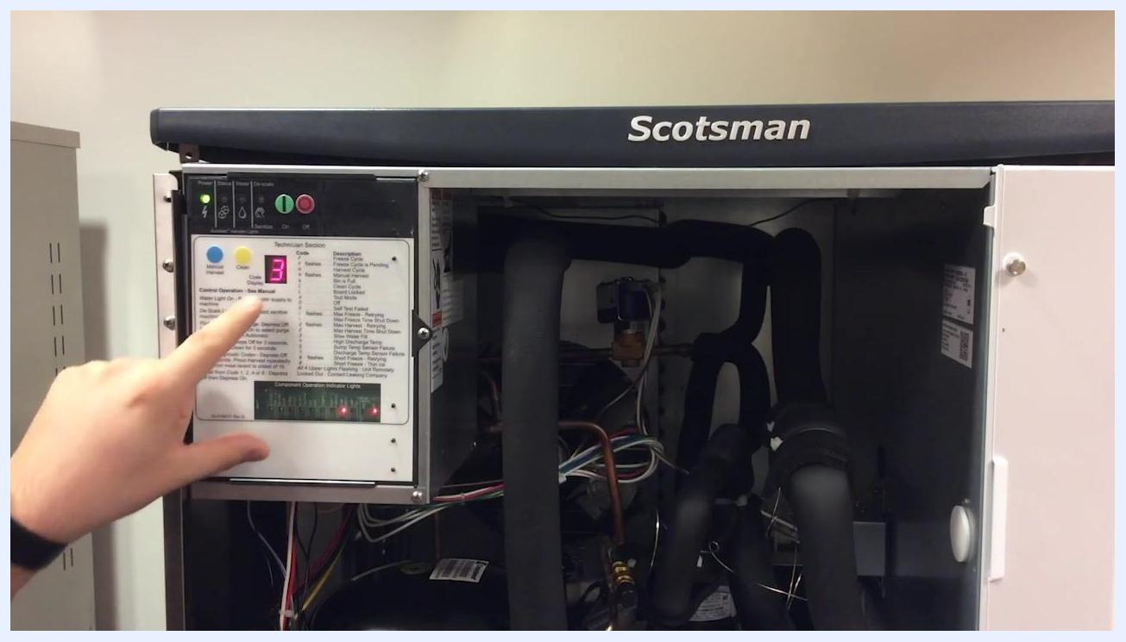
Control panel of the Scotsman ice machine showing code 3, blinking red status and water lights, and the technician section with codes and descriptions

Step 2: Understand the cause of Code 3
Code 3 means the machine did not receive adequate water flow to fill the reservoir within the required time. The most common cause of this condition is a clogged or expired water filter.

Step 3: Replace the water filter
Locate and replace the water filter according to the manufacturer's instructions. After installing the new filter, purge it to flush out any loose debris into the drain before continuing.

Step 4: Verify the machine model
Confirm you are working on a Scotsman Prodigy Plus (D model) by checking the model number and revision on the unit. The model number breaks down as follows:
- C = cuber
- 05 = nominal ice capacity in 100s of pounds
- 30 = nominal width of cabinet
- S = cube size (small/half dice); M = medium/full dice
- A = air cooled; W = water cooled; R = remote
- -1 = 115 volts; -32 = 208–230 single phase
- -3 = 208–230 three phase; -6 = 230 volts, 50 Hz
- D = Prodigy Plus (series revision)
Example: C0530SA-1D
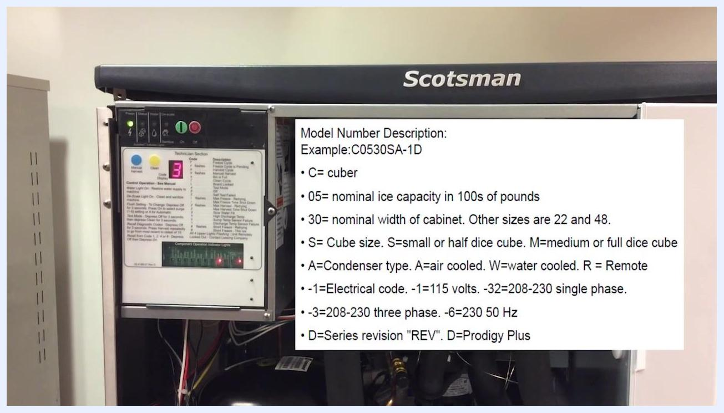
Model number description overlaid on the Scotsman ice machine, showing a breakdown of the model code

Step 5: Check the lower remote panel (if equipped)
If your unit has a lower remote panel, inspect it for additional status indicators. Confirm that both the status and water lights are blinking red, matching what you observed on the main control panel.
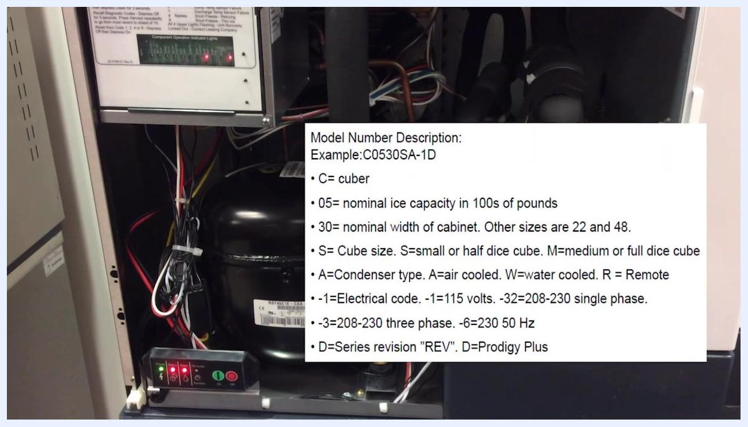
Lower remote panel of the Scotsman ice machine showing blinking red status and water lights, with the model number description overlay

Step 6: Reset the controller
Locate the red "Off" button on the control panel. Press and release it to reset the controller. The code display should change from "3" to "0," confirming the reset was successful.
Instruction overlay showing how to press and release the red Off button on the Scotsman control panel

Understanding the control panel indicators

Step 7: Review the indicator lights and their meanings
Observe the row of indicator lights at the top of the control panel:
- Power light: Illuminates when the machine has proper power.
- Status light: Should be green during normal operation.
- Water light: Normally off; illuminates red if there is a water issue, such as during a Code 3 error.
- De-scale light: Illuminates when the machine is due or overdue for cleaning.
In the "off" position, only the power light is on and the status light is off, as shown by the solid zero on the display.
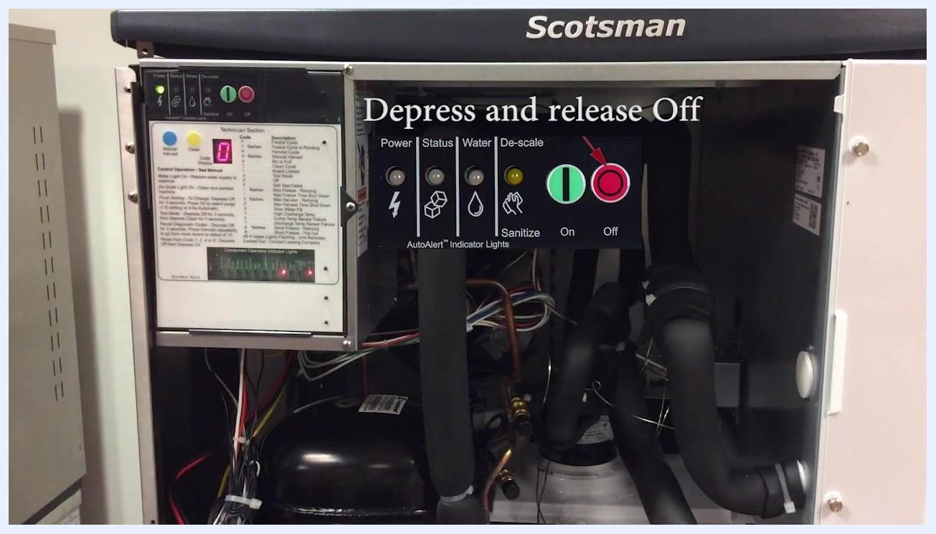
Control panel showing only the power light illuminated, the status light off, and the display reading zero, indicating the machine is off

Step 8: Understand the status light function
The status light is the second indicator from the left. When green, it confirms normal operation. If it is off, the machine is not running. If it is red or blinking, refer to the error code chart to troubleshoot the issue.
Hand pointing to the status light on the control panel, with only the power light illuminated

Step 9: Understand the water and de-scale lights
The water light, third from the left, is typically off. If it turns red, there is a water supply issue. The de-scale light, on the far right, indicates when the machine needs cleaning or is overdue for cleaning.
Hand pointing to the water and de-scale lights, with only the power light illuminated and the de-scale light off

Restarting the machine

Step 10: Turn the machine back on to reset the unit
Ensure the machine is in the "off" position, with the display showing zero. Press and release the green "On" button to restart the machine. The display will change and the machine will begin its startup sequence.
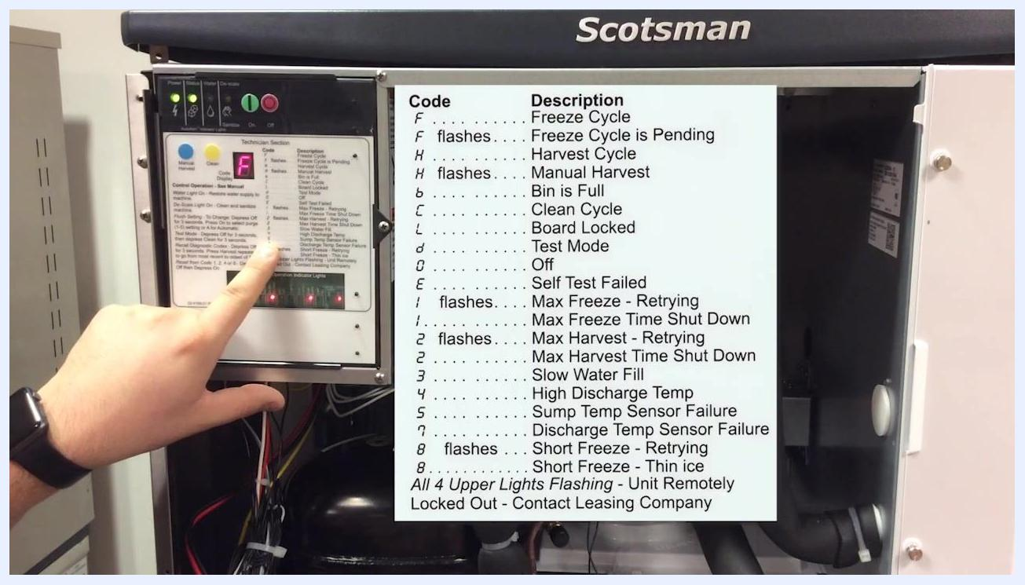
Control panel with the display showing zero, ready to be turned on

Step 11: Observe the startup sequence
After pressing the "On" button, the display will show a blinking "F," which stands for Freeze Cycle. A blinking "F" means the machine is pending the start of a freeze cycle and is performing a self-check. If the self-check passes, the "F" will become solid and the machine will begin making ice.
Display showing a blinking "F" after pressing the On button, indicating a pending freeze cycle

Step 12: Reference the error code chart
Use the chart on the face of the controller to interpret any display codes:
- F = Freeze Cycle
- F (flashing) = Freeze Cycle is Pending
- H = Harvest Cycle
- b = Bin is Full
- C = Clean Cycle
- L = Board Locked
- d = Test Mode
- 0 = Off
- E = Self Test Failed
- 1 = Max Freeze Time Shut Down
- 2 = Max Harvest Time Shut Down
- 3 = Slow Water Fill (Code 3)
- 4 = High Discharge Temp
- 5 = Sump Temp Sensor Failure
- 6 = Discharge Temp Sensor Failure
- 7 = Short Freeze – Retrying
- 8 = Short Freeze – Thin Ice
- All 4 upper lights flashing = Unit Remotely Locked Out
Refer to this chart whenever a code appears on the display.
Close-up of the error code chart on the controller, with a hand pointing to the chart

Step 13: Wait for the machine to complete its self-check
The machine will remain in a pending freeze cycle, with "F" flashing, while it checks all systems. If all checks pass, the display will show a solid "F" and the machine will start making ice.
Display showing a solid "F," indicating the machine is now making ice

Verification and summary
- Code 3 lockout is typically caused by insufficient water flow, often due to a clogged water filter.
- Replace and purge the water filter as instructed.
- Reset the controller by pressing and releasing the red "Off" button, and confirm the display returns to "0."
- Turn the machine back on using the green "On" button and confirm the display progresses from a blinking "F" to a solid "F," indicating normal ice production has resumed.
By following these steps, you can successfully diagnose the Code 3 lockout, reset your Scotsman Prodigy Plus ice machine, and confirm it has returned to normal operation.

Service and support
If you need further assistance, contact Scotsman Technical Service at 1-800-533-6006. You can also visit the Scotsman service website for manuals, parts breakdowns, cleaning and maintenance guides, and technical tools at . Scan the QR code on the service support card for quick access to the mobile-ready website.
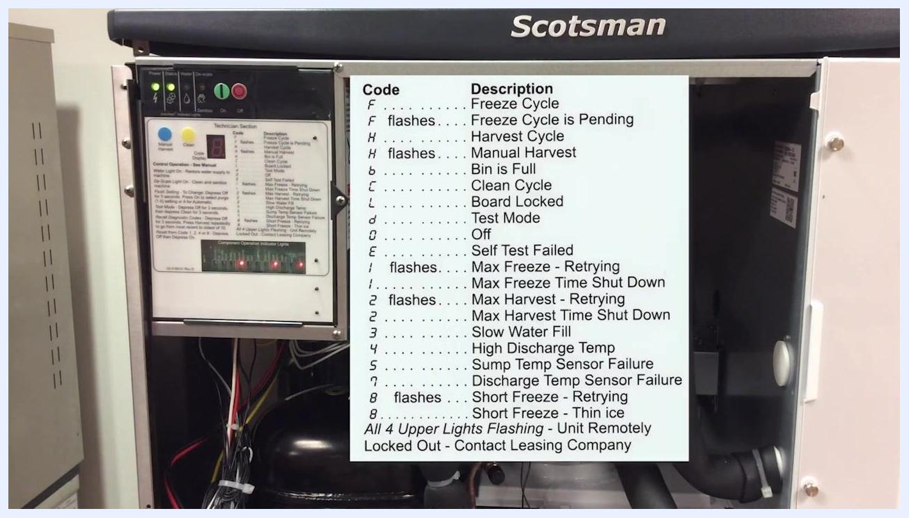
Scotsman service support card showing the technical service phone number, QR code, and website link

What's next
For persistent lockouts or codes not resolved by this procedure, consult the error code chart on the controller or contact Scotsman Technical Service using the contact details above.

