How to Create a HACCP Plan
Learning how to create a HACCP plan starts with understanding that a strong plan is built from a realistic, process-specific example rather than generic definitions. This documentation walks through building a Hazard Analysis and Critical Control Point (HACCP) plan for those responsible for food safety, quality, or compliance, and explains what auditors and inspectors actually look for. Most HACCP plans fail because they are copied from another facility, written only to satisfy a requirement, or created without fully understanding the actual process. During audits, common problems include hazards listed without justification, Critical Control Points (CCPs) that do not need to be CCPs, and a documented process that does not match what happens on the production floor. A HACCP plan only works when it is process-specific, realistic, and maintained over time.
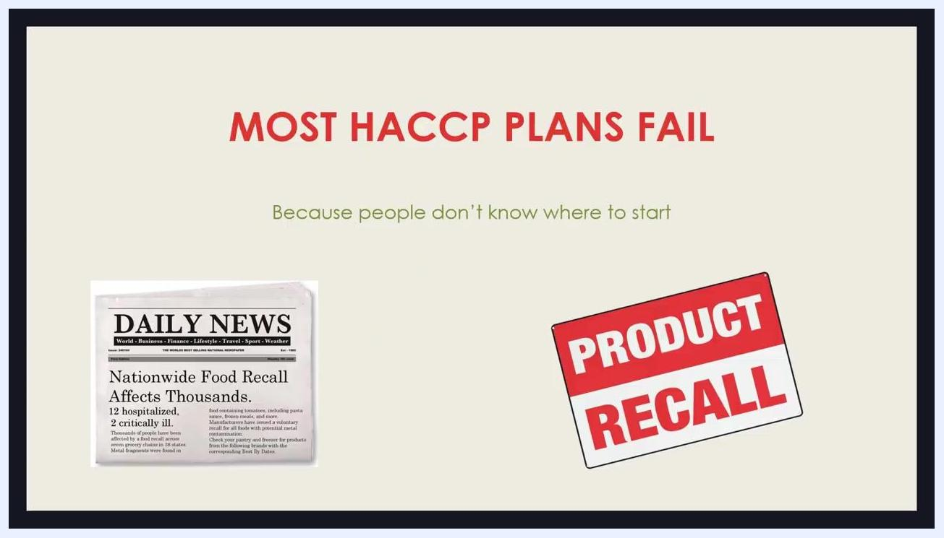
Slide reading "Most HACCP plans fail," showing a newspaper headline about a nationwide food recall next to a large "Product Recall" sign.
HACCP is a preventive food safety system. Instead of relying on finished-product testing, it identifies where hazards could reasonably occur and controls them before they become a problem. Testing alone cannot guarantee safety, since products may already be produced or distributed by the time results are available — HACCP shifts the focus from reaction to prevention. HACCP is required or expected under FDA regulations, GFSI-recognized schemes, and many customer or retailer requirements, and it is often one of the first documents reviewed during an inspection or audit.
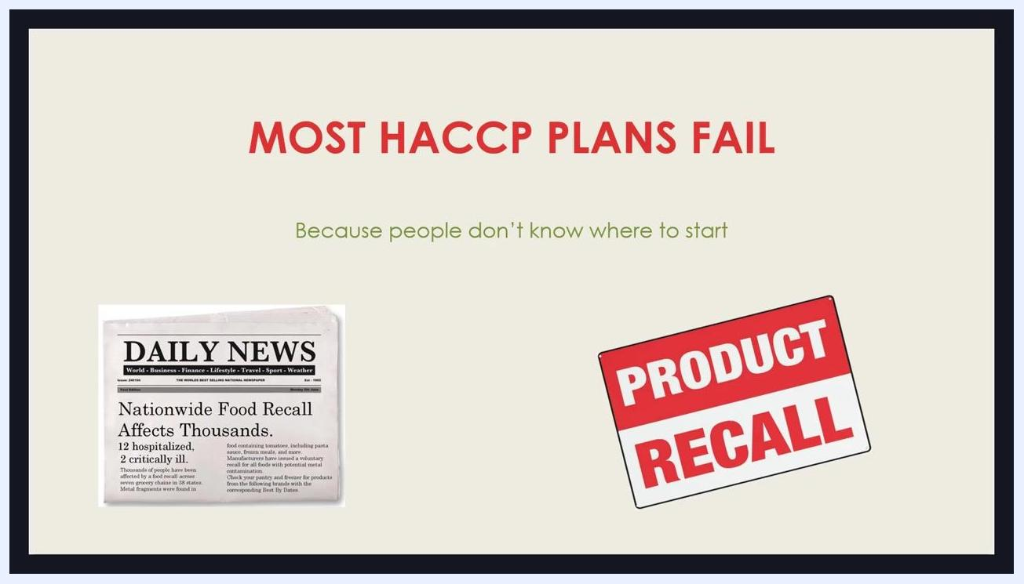
Slide reading "HACCP = Prevention," with the message "Identify, control, prevent food safety hazards" beside a matching sign.
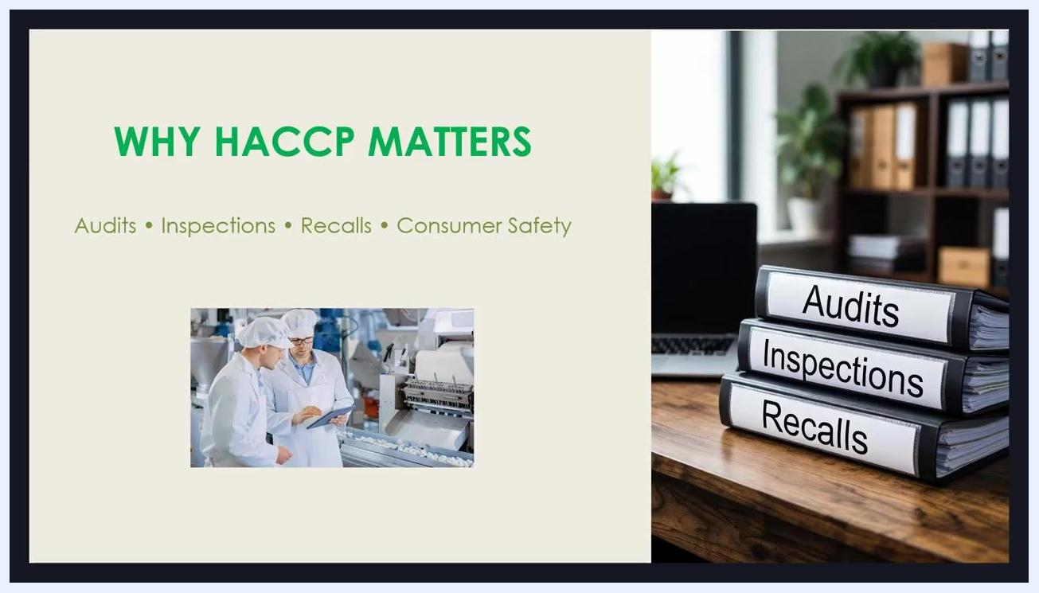
Slide titled "Why HACCP matters," listing audits, inspections, recalls, and consumer safety, alongside an image of food manufacturing staff and a stack of binders labeled Audits, Inspections, and Recalls.

Prerequisites
A weak HACCP plan often signals weaknesses in the overall food safety system. Before building your plan, confirm that the following prerequisite programs are in place and effective:
- Good Manufacturing Practices (GMPs)
- Sanitation programs
- Employee training
- Supplier approval
- Pest control
- Preventive maintenance
HACCP is not designed to control basic hygiene or housekeeping issues. If your prerequisite programs are weak, your HACCP plan becomes overloaded with unnecessary controls. Avoid the common mistake of trying to fix GMP problems by adding Critical Control Points — this is not the intended function of HACCP.
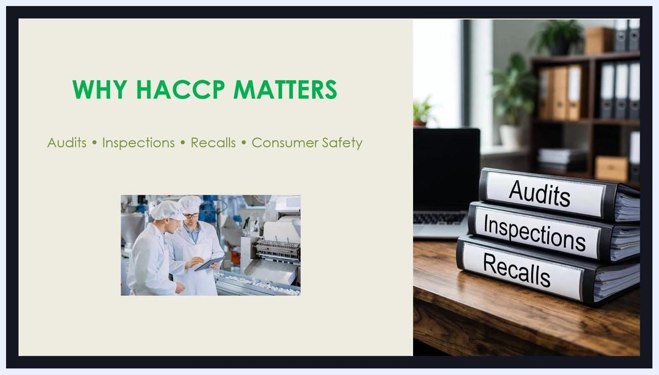
Slide reading "HACCP does not work alone," with icons representing sanitation, a factory, training, and pest control.
Throughout this documentation, a realistic example is used: a refrigerated, ready-to-eat fruit juice packaged in bottles, stored under refrigeration, and consumed without further processing. Ready-to-eat products carry a higher food safety risk, particularly for biological hazards, because the consumer applies no kill step before consumption — a factor that directly shapes hazard analysis and control decisions.
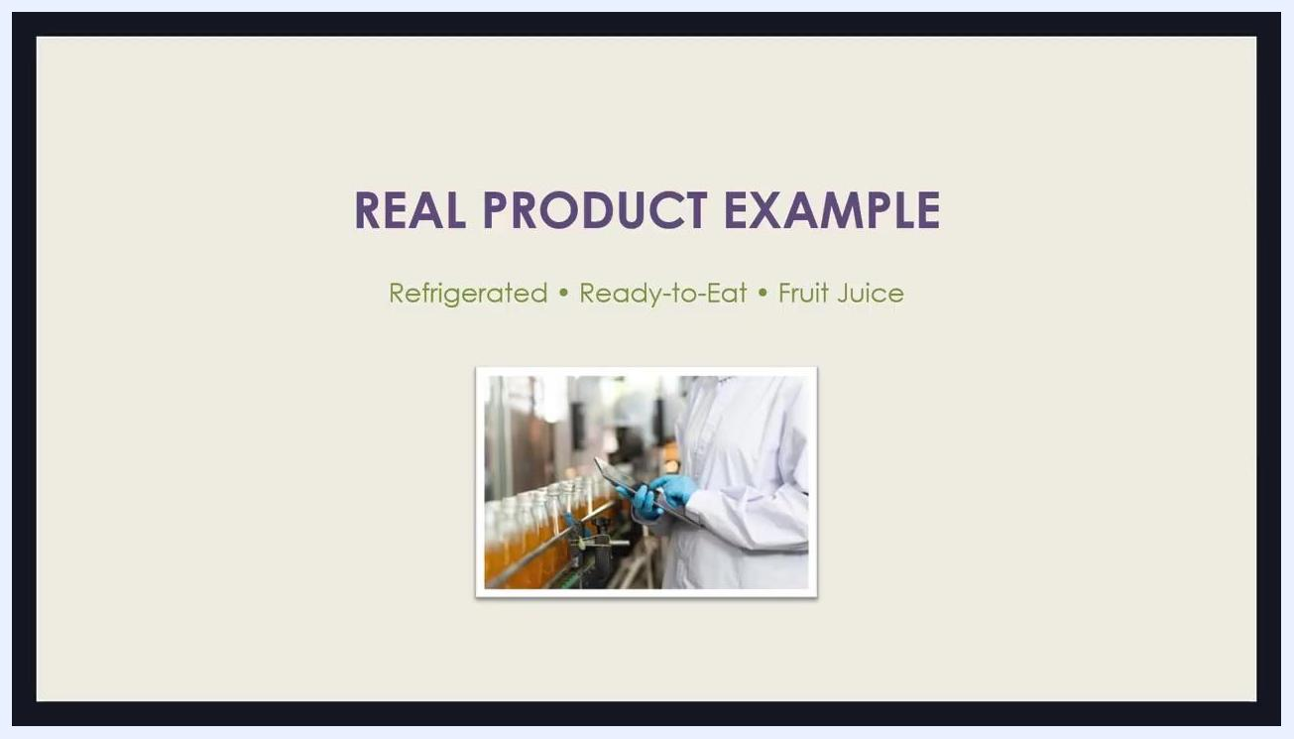
Slide titled "Real product example," reading "Refrigerated, ready-to-eat, fruit juice," with an image of a worker in a lab coat and gloves inspecting bottles on a production line.

Process scope
Document a clear product description as the foundation for identifying realistic hazards. Include:
- Ingredients
- Formulation
- Packaging type
- Storage conditions
- Shelf life
- Distribution method
For the juice example, refrigeration is a critical factor because temperature abuse could allow microbial growth. This SOP does not specify a facility location; record your site's name and address in this field when documenting your own plan.
Step 1 — Product description: Answer clearly: What is the product? How is it stored and distributed?
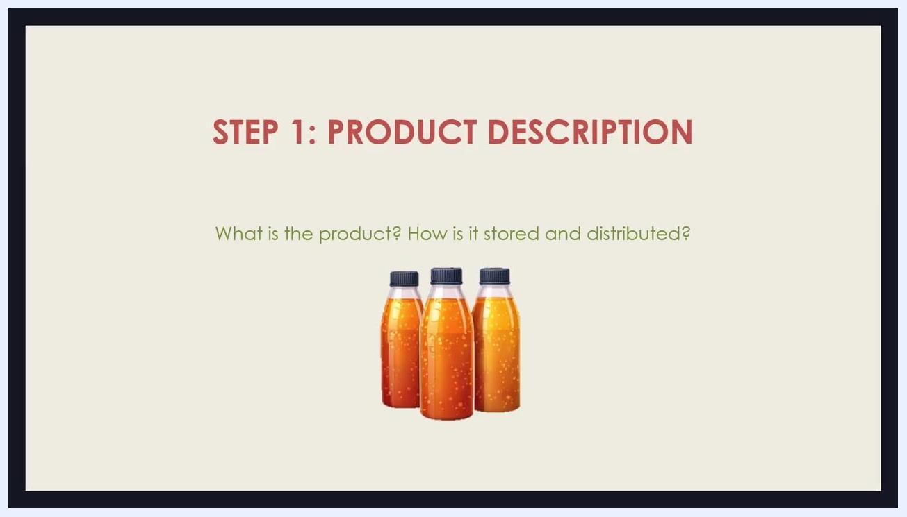
Slide titled "Step 1: Product description," asking "What is the product? How is it stored and distributed?" beside three bottles of juice.
Step 2 — Intended use: Define how the product is expected to be consumed and by whom. For the juice example, the product is consumed directly by the general population, including potentially vulnerable individuals such as children, the elderly, or immunocompromised persons. There is no further cooking or processing by the consumer, so every hazard must be controlled during production. This increases the importance of hazard control, since consumers cannot eliminate risks themselves.
Example documentation: "Intended use: Ready-to-drink juice, consumed directly by all population groups, including vulnerable individuals. No further cooking or processing expected."
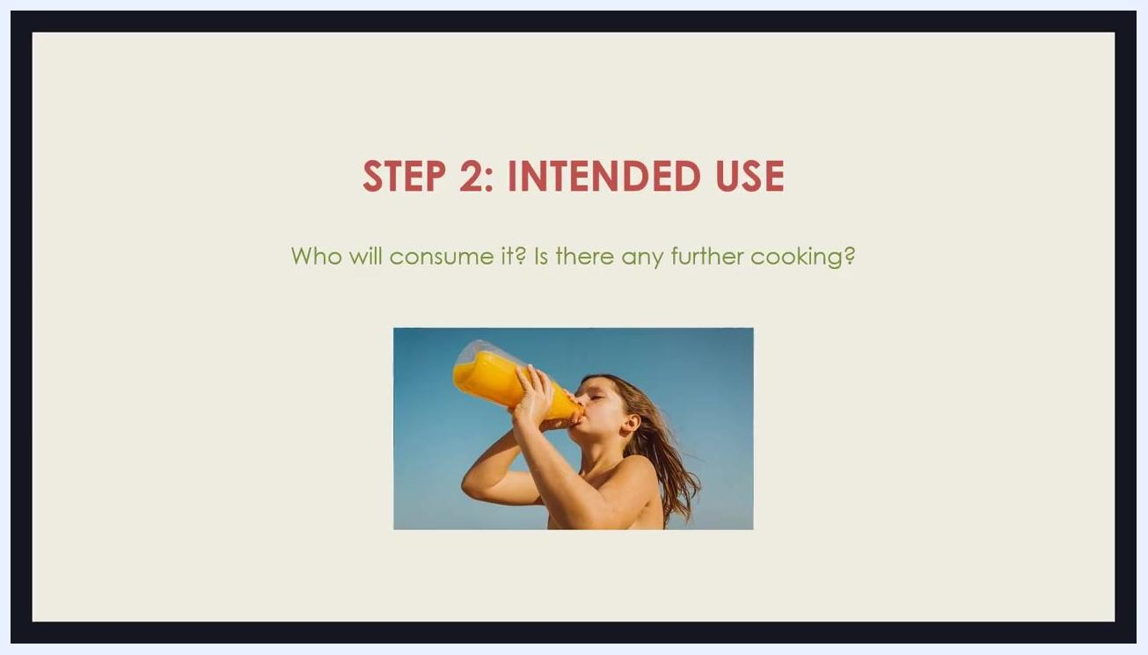
Slide titled "Step 2: Intended use," asking "Who will consume it? Is there any further cooking?" beside a person drinking juice directly from a bottle.
Field | Detail (juice example)
Product | Refrigerated, ready-to-eat fruit juice
Packaging | Bottled
Storage | Under refrigeration
Distribution | Cold chain distribution
Intended consumers | General population, including vulnerable individuals
Preparation by consumer | None — no further cooking or processing

Hazard analysis
Build a process flow diagram that reflects actual practices, not just written procedures. Include every step that occurs in practice, even if undocumented — for example, staging fruit at room temperature before processing. Auditors may verify accuracy by physically walking the process floor and comparing it to your documentation; an inaccurate flow diagram undermines the entire plan.
Example process flow for juice: Receiving → Washing → Juicing → Bottling → Cold Storage → Distribution
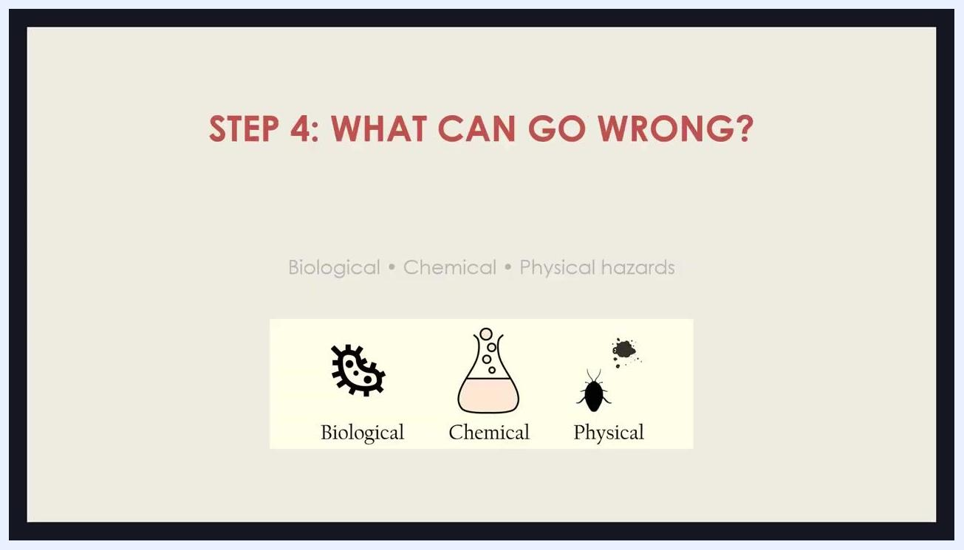
Slide titled "Step 3: Process flow," showing the steps Receiving, Washing, Juicing, Bottling, Cold Storage, and Distribution.
At every step, identify hazards that could reasonably occur, evaluate their severity and likelihood, and determine how each is controlled. Some hazards are already controlled by prerequisite programs (sanitation, supplier approval); not every hazard requires a CCP if it is already adequately controlled.
Slide titled "Step 4: What can go wrong?" with icons and labels for biological, chemical, and physical hazards.
Process step | Biological hazard | Chemical hazard | Physical hazard
Receiving | Controlled via supplier approval program | — | —
Washing | — | Residue from cleaning agents | —
Juicing | Pathogens (no kill step present) | — | —
Bottling | — | — | Foreign objects from equipment
Cold Storage | Microbial growth from temperature abuse | — | —
Distribution | Microbial growth from temperature abuse | — | —

Critical control points
A Critical Control Point (CCP) is a step where control is essential to prevent, eliminate, or reduce a hazard to an acceptable level. Only designate a step as a CCP if it is the last or only point where a specific hazard can be controlled. If a process includes pasteurization, that step may be identified as a CCP for biological hazards.
When your process has no kill step, control the hazard through alternative methods:
- Supplier controls to ensure incoming materials are safe
- Strict sanitation procedures throughout the facility
- Refrigeration to keep products at safe temperatures
- Shelf-life validation to confirm safety over time
Justify and document the rationale for every CCP decision so it is traceable during review.
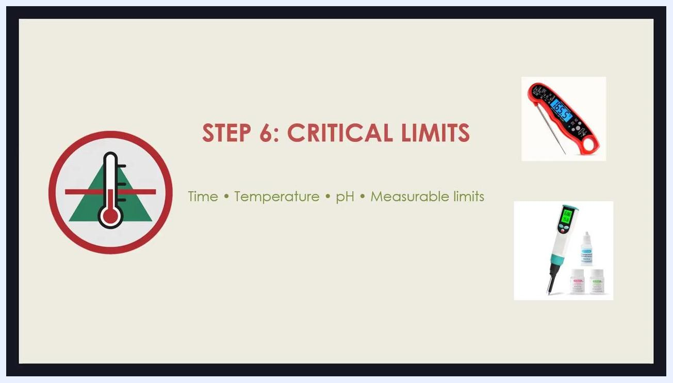
Slide titled "Step 5: Where must we control risk?" showing a CCP warning icon beside the phrase "Critical Control Points (CCPs)."
Establish critical limits for each CCP — measurable values such as time, temperature, or pH — supported by scientific or regulatory evidence.
Slide titled "Step 6: Critical limits," with icons of a thermometer and pH meter beside the text "Time, temperature, pH, measurable limits."
CCP | Critical limit | Responsible role | Required equipment
Pasteurization (if present in the process) | Minimum pasteurization temperature | Line operator / quality technician | Thermometer
Cold storage | Maximum storage temperature | Storage / warehouse personnel | Thermometer, refrigeration monitoring system
Shelf-life control | Validated shelf-life limit | Quality personnel | Shelf-life validation records

Monitoring
Monitoring confirms each CCP stays within its critical limits. Define how, when, who, and how often monitoring occurs, and ensure the method is practical and consistently performed.
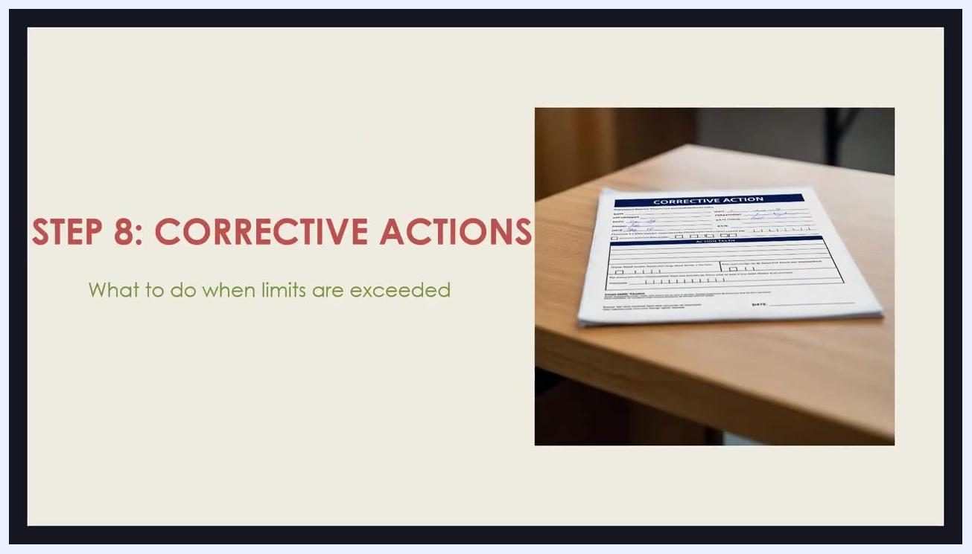
Slide titled "Step 7: Monitoring," reading "How, when, who, how often," beside two workers in a food processing facility reviewing data.
What is checked | Frequency | Method | Record location
Critical limit parameter (e.g., temperature, pH) | Defined per facility risk assessment | Direct observation or instrument reading (thermometer, pH meter) | Monitoring log

Corrective actions
Define what to do when monitoring shows a limit has been exceeded. Corrective actions must be specific and realistic, not vague, so staff can act immediately and consistently.
Slide titled "Step 8: Corrective actions," reading "What to do when limits are exceeded," beside a corrective action form on a desk.
Trigger | Required action | Product disposition
Critical limit exceeded | Correct the process and document the deviation per facility procedure | To be assessed against risk before release, rework, or disposal, per facility procedure

Verification
Verify that the HACCP plan actually works through record reviews, calibration of monitoring equipment, internal audits, and validation studies. Verification is typically carried out by supervisory or quality personnel, with the goal of catching gaps before they become serious issues.
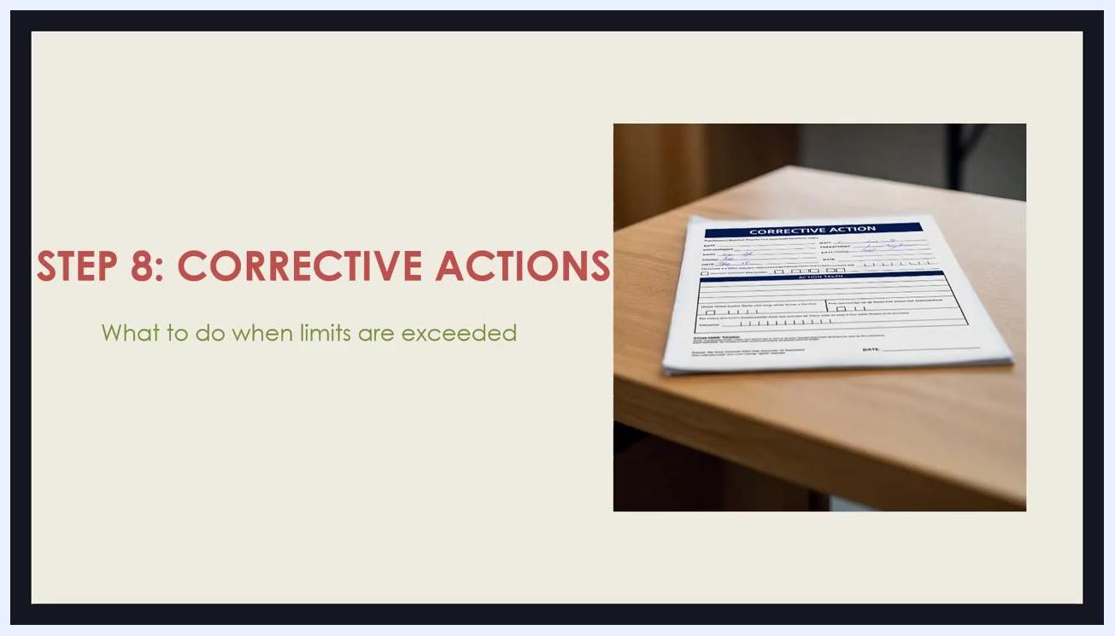
Slide titled "Step 9: Verification," asking "Does the HACCP plan actually work?" beside a quality control worker in a food processing facility.
Activity | Performed by | Frequency
Record review | Supervisory or quality personnel | Per facility schedule
Equipment calibration | Quality personnel | Per facility schedule
Internal audit | Supervisory or quality personnel | Per facility schedule
Validation study | Quality personnel | Per facility schedule

Records
Records provide evidence that controls were implemented as planned. Ensure all monitoring, corrective action, and verification activities are documented — if it isn't documented, it didn't happen.
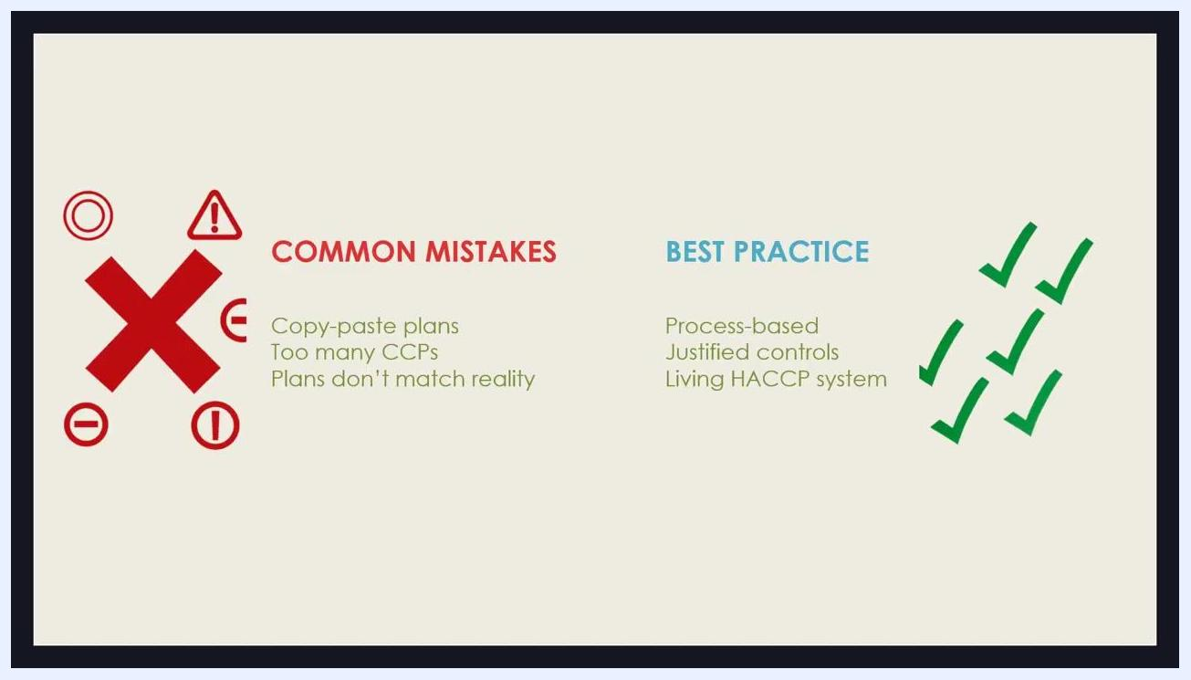
Slide titled "Step 10: Record keeping," reading "If it's not documented, it didn't happen," beside a worker in a lab coat filling out a form on a clipboard.
Log | Retention period | Accountable owner
Monitoring log | Defined per facility procedure | Assigned monitoring personnel
Corrective action record | Defined per facility procedure | Quality personnel
Verification record | Defined per facility procedure | Supervisory or quality personnel
During audits, records are often reviewed in more detail than the HACCP plan itself, so keep all documentation organized and readily accessible.

What's next
Compare your plan against common pitfalls and adopt best practice habits going forward:
Common mistakes | Best practice
Copy-paste plans | Process-based plan
Too many CCPs | Justified controls only
Plans don't match reality | Living HACCP system
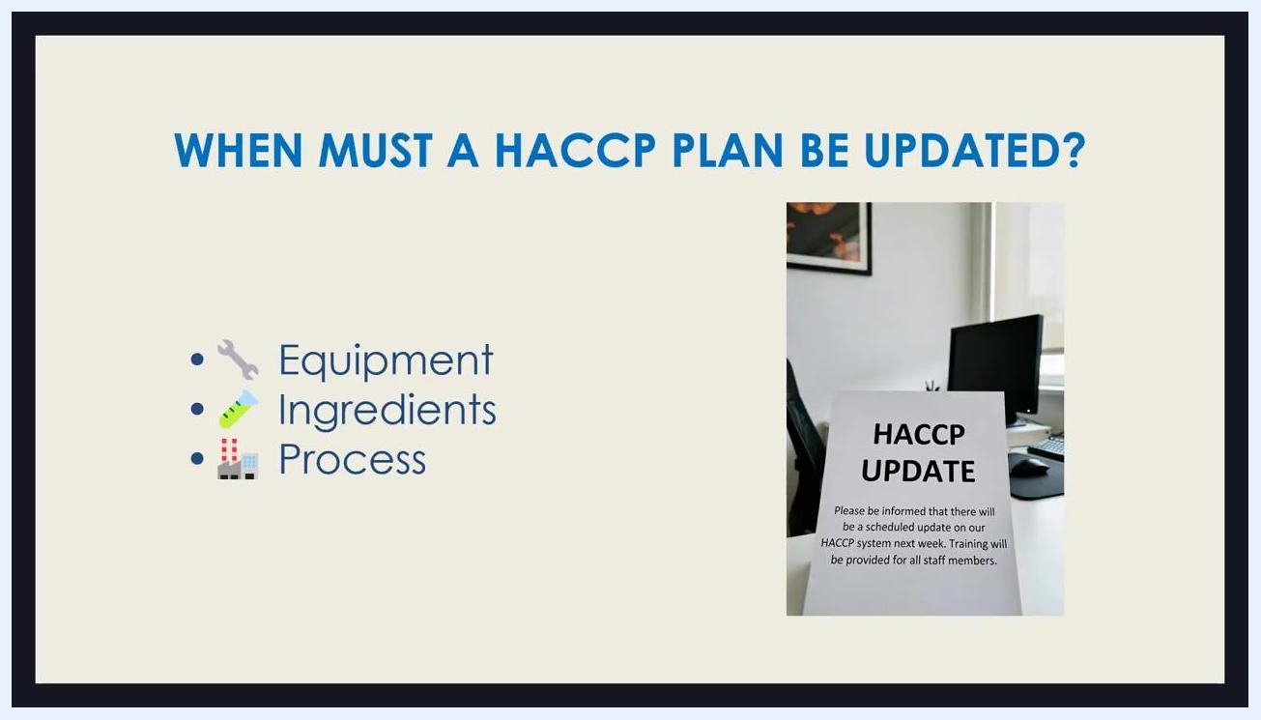
Slide comparing "Common mistakes" (copy-paste plans, too many CCPs, plans that don't match reality) with "Best practice" (process-based, justified controls, living HACCP system), marked with red X and green checkmark icons.
Treat your HACCP plan as a living document. Update it whenever there is a change to equipment, ingredients, or process — including switching suppliers, adding a new product line, changing cleaning chemicals, modifying processing times, or adjusting packaging or production volumes. If the process changes but the plan is not updated, this is commonly cited as a nonconformance during audits.
Slide titled "When must a HACCP plan be updated?" listing equipment, ingredients, and process, beside a sign reading "HACCP Update" on an office desk.
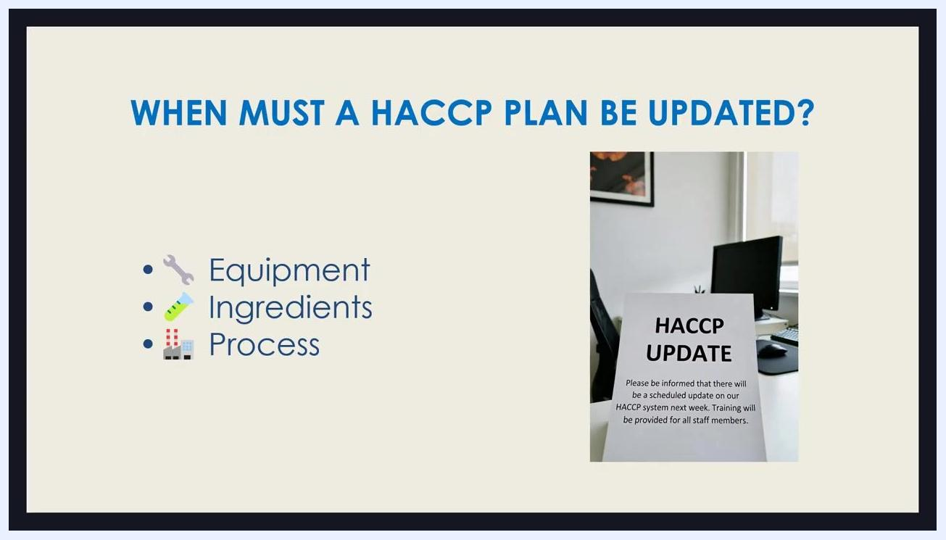
Slide reiterating equipment, ingredient, and process triggers for updates, with a sign reading "HACCP Update" on an office desk with a computer and office supplies.
Remember that a HACCP plan is not just a regulatory requirement — its primary purpose is to protect consumers and ensure food safety. Confirm every control, monitoring step, and corrective action in your plan is relevant to your specific operation rather than relying solely on a generic template.
Sign in a food processing facility reading "HACCP must match your process," emphasizing customization over generic templates.
Templates can serve as a helpful starting point, but always tailor them to reflect your facility's actual procedures and hazards before finalizing your plan.
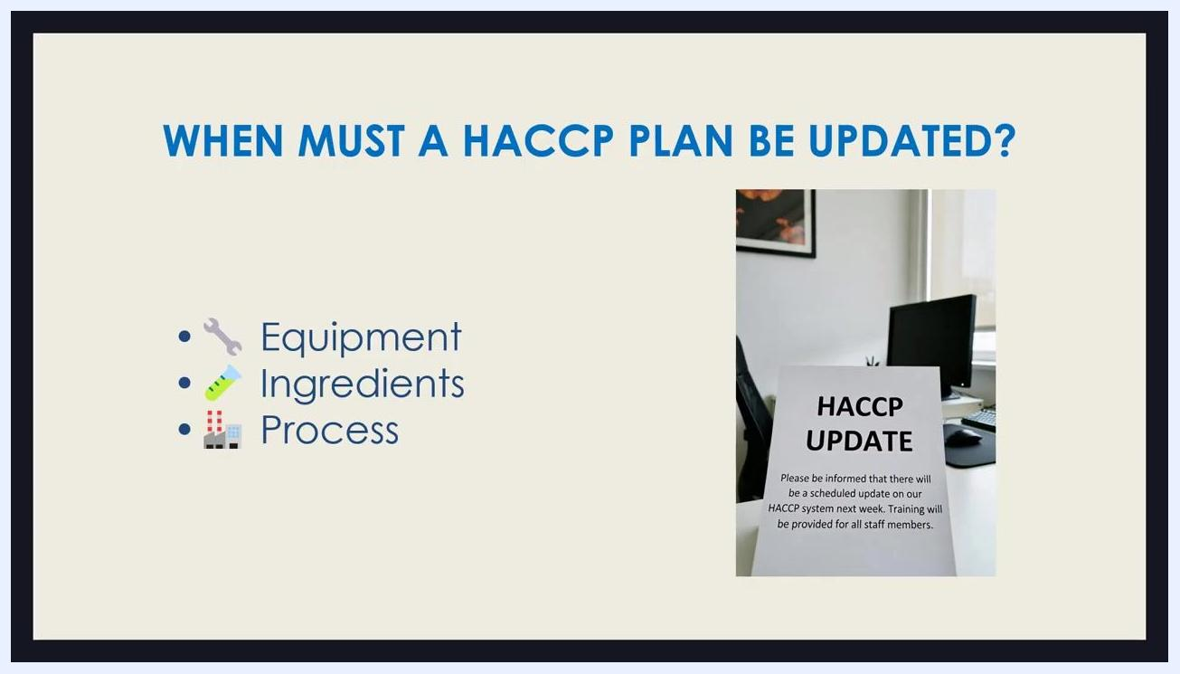
Sign in a food processing facility reading "HACCP must match your process," paired with a note that reference templates can help as a starting point.
Title slide: "HOW TO BUILD A HACCP PLAN" with subtitle "Step by Step • Real Example • Food Safety" and an illustration of a team reviewing charts and food safety icons.

