How to Clean a Soft Serve Machine
This standard operating procedure explains how to clean a soft serve machine safely and effectively, covering full disassembly, washing, sanitizing, lubrication, and reassembly. Follow every step in sequence to keep the machine sanitary, protect product quality, and meet local and state health requirements.
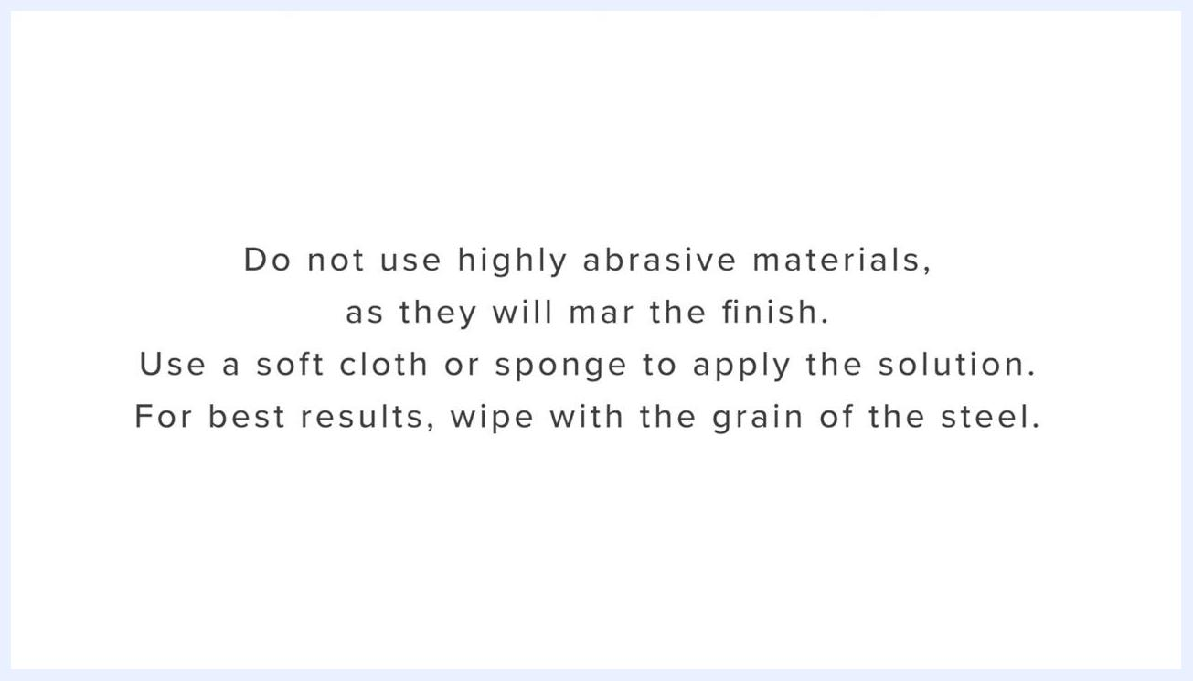
Front view of a stainless steel soft serve machine with three dispensing levers, a digital control panel, and visible orange seals around the freezing cylinders. The machine is clean and assembled.

Purpose
The objective of this procedure is to ensure the soft serve machine is completely disassembled, cleaned, and sanitized before its first use, and cleaned on a routine basis afterward. This controls the risk of product contamination, protects operators and customers from injury caused by worn or broken parts, and preserves consistent product quality. Complete machine disassembly, cleaning, and sanitizing procedures must be performed before using the machine for the first time, and all routine cleaning intervals and procedures must comply with local and state health regulations.
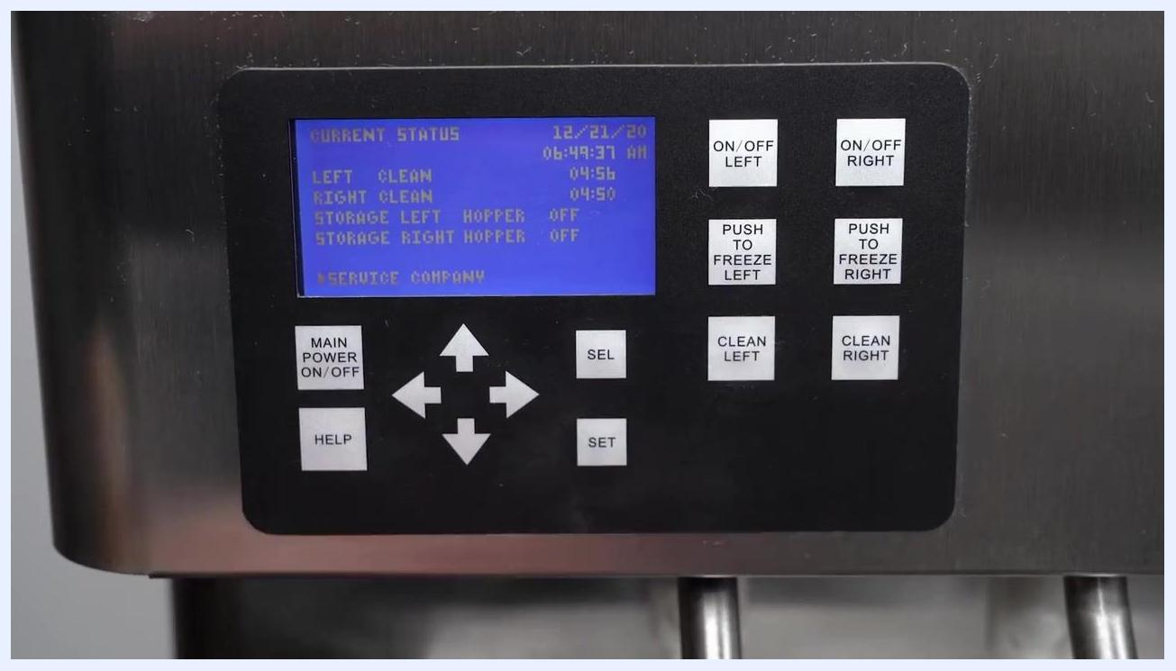
Close-up of the control panel with the display showing "LEFT CLEAN" and "RIGHT CLEAN", and the CLEAN buttons visible

Scope
This procedure applies to the following machine components and surfaces:
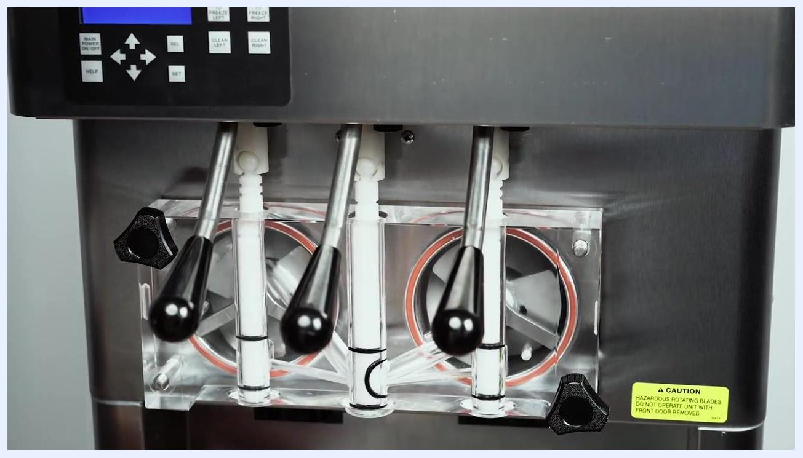
A black screen with the white Stoelting logo and the text "A Vollrath Division" centered.
- Freezing cylinders and augers
- Hoppers and mix inlet regulators
- Front door assembly, spigots, rosette caps, and spigot extensions
- Auger flights, springs, rear seal assemblies, and O-rings
- Auger support bushings
- Drip trays and drain trays
- Exterior stainless steel surfaces
- Control panel operation related to cleaning cycles
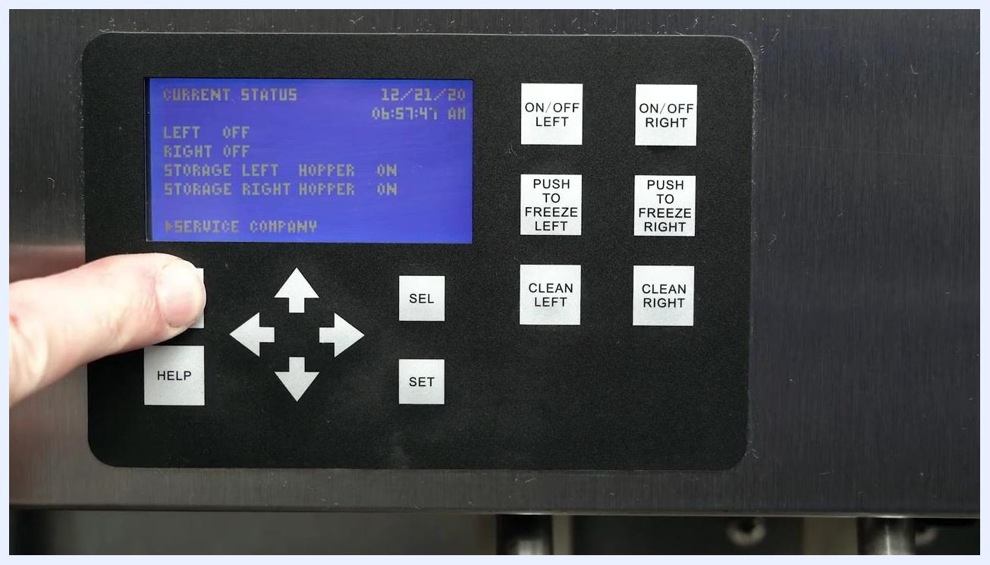
Text screen: "Please note that the hopper covers have compartments for all freezing cylinder parts. This helps with part identification and prevents loss."
The source procedure does not specify particular rooms, shifts, or exclusions; facilities should define these details separately in line with their own health code requirements.

Supplies
Gather the following items before starting:
- [ ] Buckets
- [ ] Detergent solution
- [ ] Hopper cleaning brush
- [ ] Clean towel or paper towel
- [ ] Provided cleaning brushes
- [ ] Sanitizing solution
- [ ] Clean dry cloth
- [ ] Total Blend lubricant or equivalent
Close-up of the inside of the freezing cylinder, showing the auger rotating and liquid inside, with visible cleaning action
Approved lubricants only:
- [ ] Total Blend Lubricant
- [ ] Petro-Gel sanitary lubricant
- [ ] An equivalent product specified for food equipment
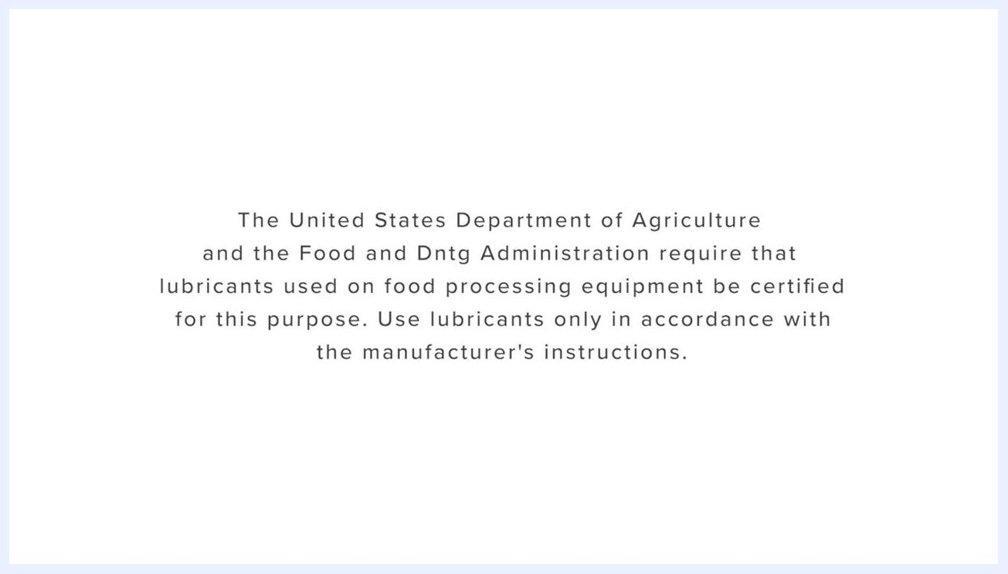
A packet of Stera-Sheen Total Blend Lubricant with text: "Total Blend Lubricant, Petro-Gel sanitary lubricant, or an equivalent, must be used when lubrication of parts is specified."
Total Blend Lubricant can be used in place of two separate products, simplifying the lubrication process.
Dilution and temperature requirements:
- Wash water and rinse water: mild detergent water heated to 90–110°F (32–43°C)
- Sanitizing solution: submerge parts for at least one minute
- Hopper fill for cleaning cycle: 2 gallons of cool tap water per hopper, or a detergent solution instead of tap water
The source procedure does not specify chemical storage requirements; facilities should store all cleaning chemicals according to manufacturer labeling and local health code requirements.

Safety Precautions
- Complete machine disassembly, cleaning, and sanitizing procedures must be followed before using the machine for the first time.
- Routine cleaning intervals and procedures must comply with local and state health regulations.
- Turn off both freezing cylinders at the control panel before beginning disassembly.
- Turn off main power at the control panel (press and hold MAIN POWER ON/OFF for 3 seconds) before removing the front door.
- Inspect all parts for wear or damage during disassembly and replace worn or broken parts immediately to protect operator and customer safety and maintain product quality. Pay special attention to the wear line on the auger flights; replace augers if the wear line is reached.
- Use only lubricants certified for food processing equipment as required by the United States Department of Agriculture (USDA) and the Food and Drug Administration (FDA).
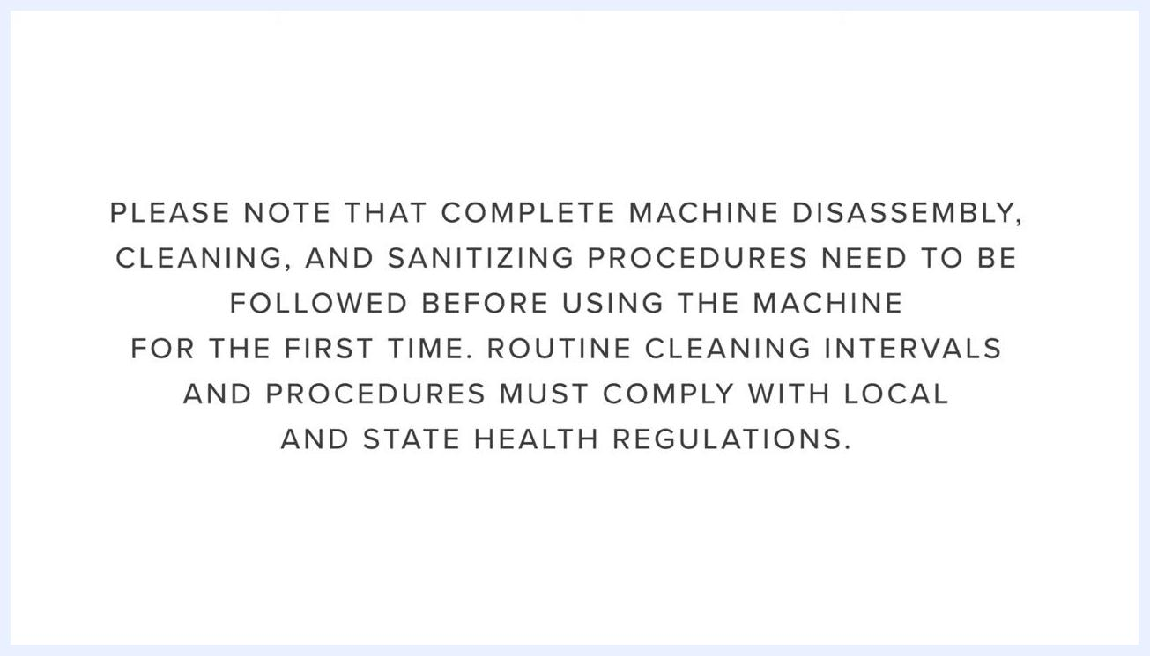
Text screen stating: "PLEASE NOTE THAT COMPLETE MACHINE DISASSEMBLY, CLEANING, AND SANITIZING PROCEDURES NEED TO BE FOLLOWED BEFORE USING THE MACHINE FOR THE FIRST TIME. ROUTINE CLEANING INTERVALS AND PROCEDURES MUST COMPLY WITH LOCAL AND STATE HEALTH REGULATIONS."
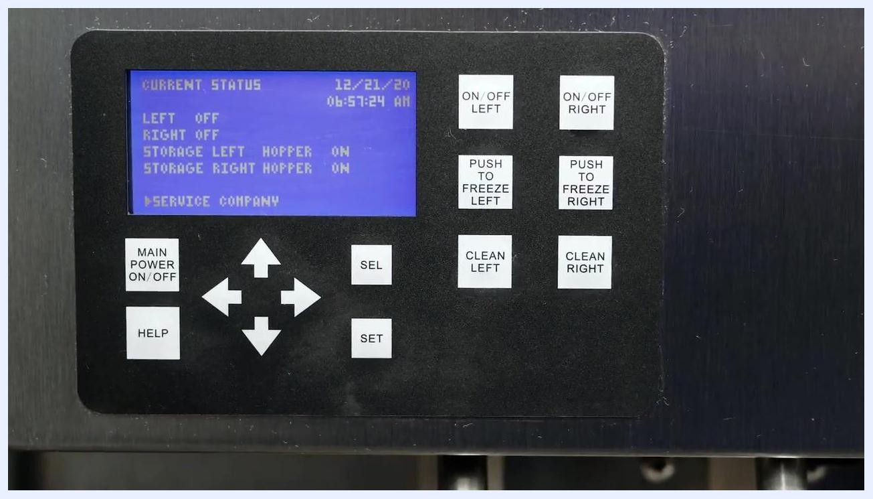
Close-up of the control panel display showing "LEFT OFF" and "RIGHT OFF" with all relevant buttons visible
- Use lubricants strictly in accordance with the manufacturer's instructions.
- Do not use highly abrasive materials on stainless steel exterior surfaces, as they will mar the finish.
- Do not over-tighten front door knobs; excessive force can damage plastic components.
The source procedure does not address lockout/tagout, wet-floor signage, ventilation requirements, or allergen controls; facilities should apply their own site-specific controls for these hazards in addition to the steps above.
Text instructions: "The United States Department of Agriculture and the Food and Drug Administration require that lubricants used on food processing equipment be certified for this purpose. Use lubricants only in accordance with the manufacturer's instructions."

Cleaning Steps

Step 1: Prepare for cleaning the soft serve machine

- Gather all required cleaning supplies listed above before starting.
- Verify that the main freezer power is switched on and that the Intellitech 2 display shows the current status screen.
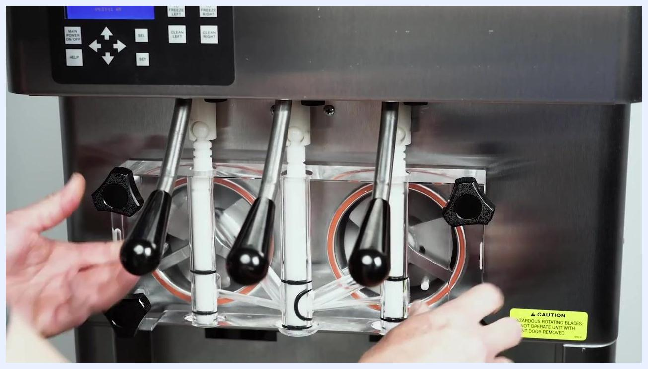
A black screen with the white Stoelting logo and the text "A Vollrath Division" centered.

- At the control panel, press ON/OFF LEFT and ON/OFF RIGHT to turn off both freezing cylinders. The display should show both cylinders as "OFF".
A hand pressing and holding the "MAIN POWER ON/OFF" button on the control panel, with the display still lit

Step 2: Run the initial cleaning cycle

- Press CLEAN LEFT and CLEAN RIGHT to start the cleaning cycle for both sides. The display will show "LEFT CLEAN" and "RIGHT CLEAN" with a timer.
- Remove the hopper covers from the top of the machine and remove the mix inlet regulators from the hoppers.
- Wait approximately 5 minutes after starting the cleaning cycle, then open the spigots to drain the mix from the machine.
- Press CLEAN LEFT and CLEAN RIGHT again to stop the augers after draining.
- Pour 2 gallons of cool tap water into each hopper, or use a detergent solution instead of tap water to facilitate cleaning after disassembly.
- Press CLEAN LEFT and CLEAN RIGHT to start the augers again and allow them to rotate for at least 30 seconds. While the augers rotate, scrub the hoppers thoroughly with a clean brush.
A set of cleaning supplies including a green bucket labeled "Stera Sheen Sanitizer & Cleaner (Milkstone Remover)", a large white cleaning brush, a small tube, a packet of sanitizer, and a clean white cloth arranged on a white surface
Front view of the soft serve machine with the control panel display lit up, showing the machine is powered on

- Drain the water or cleaning solution. If the drained water is not clear, refill the hoppers with fresh tap water or detergent solution and repeat this cycle.

Step 3: Disassemble the machine

- Press CLEAN LEFT and CLEAN RIGHT to stop the augers and confirm the display shows both as "OFF".
- As you disassemble the machine, inspect all parts for wear or damage. Replace worn or broken parts immediately.
- Use the compartments in the hopper covers to store all freezing cylinder parts after disassembly; this aids identification and prevents loss during transport to the washing station.
All disassembled parts neatly arranged in the hopper cover compartments, showing clear organization for identification and transport

- Press and hold MAIN POWER ON/OFF for 3 seconds to turn off the machine. Confirm the display powers down.
- Remove the rosette caps and spigot extensions if installed, unscrew the front door knobs, and carefully pull the front door off the studs to remove it.
- Place the front door assembly on a clean towel and remove the large red O-rings from the front door by gently pulling them out of their grooves.
- Wipe off any lubricant from O-rings with a clean towel. Squeeze each O-ring upward to form a loop, then roll it out of its groove to remove it.
- Remove the front auger supports and bushings, then carefully pull the auger assemblies out of the freezing cylinders, supporting their weight as you remove them.
- As you pull each auger out, remove the plastic flights and springs. Keep the rear of the auger tipped up once clear of the cylinder to prevent the rear seal assembly from dropping. Wipe lubricant off the hex ends with a clean cloth, remove the rear seal assemblies, and unscrew the springs from the flights.
- Confirm all machine parts are fully disassembled and separated, with all O-rings, seals, flights, springs, and other components removed and ready for cleaning.
A hand continuing to hold the "MAIN POWER ON/OFF" button, as the display prepares to power down
Hands removing the clear front door assembly from the machine, with visible spigots and caution label
Front door assembly on a towel, with O-rings being removed from their grooves
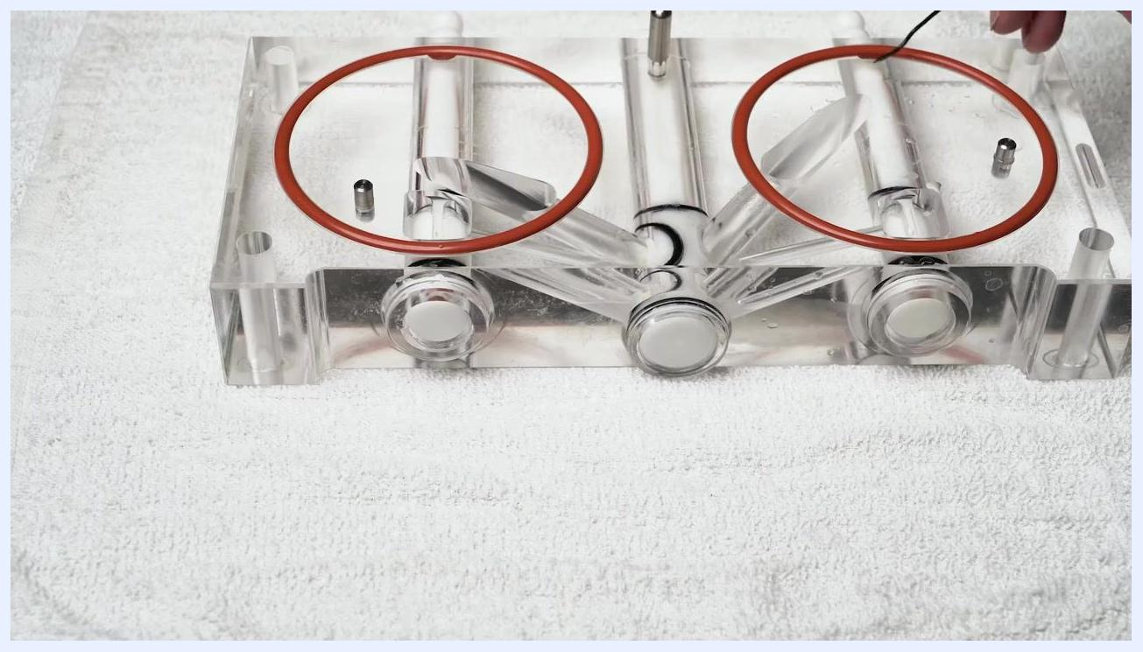
Hands demonstrating the removal of a black O-ring from a white plastic part by squeezing and rolling it out of the groove
View of the machine with the front door removed, showing the auger assemblies inside the freezing cylinders, ready for removal

Step 4: Wash, rinse, and sanitize parts

- Each part must be completely cleaned, sanitized, and air dried before reassembly. Local and state health codes dictate the required procedure; some require a four-sink process (pre-wash, wash, rinse, sanitize, air dry), while others require a three-sink process without the pre-wash step. Consult your local and state health codes for the procedure required in your area.
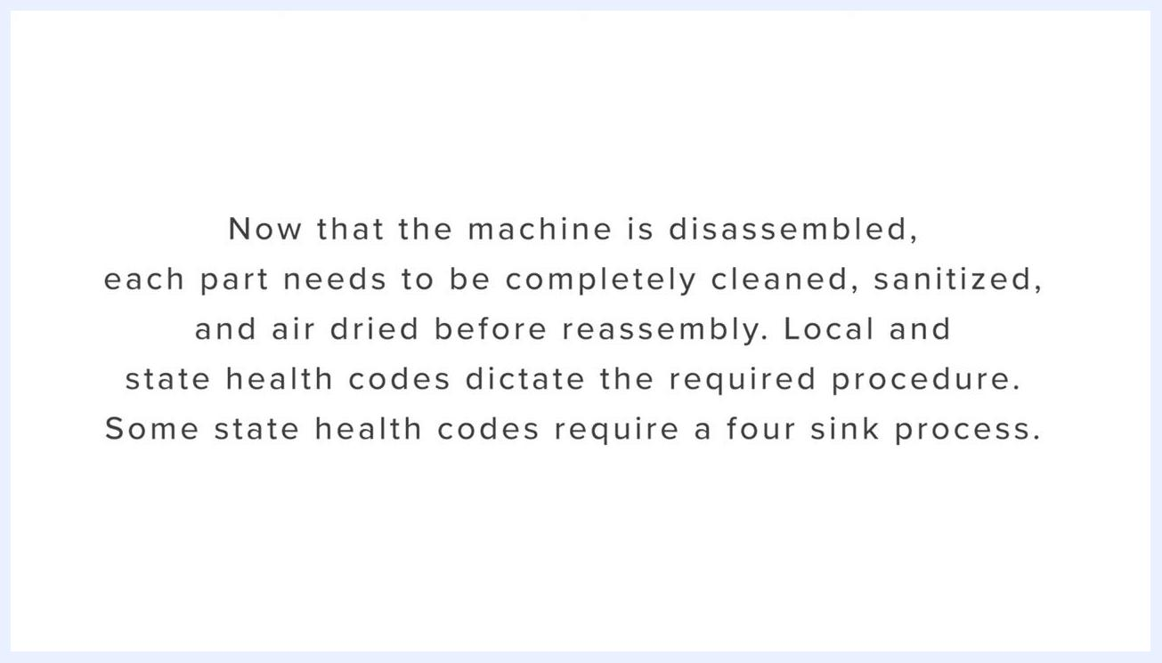
Empty freezing cylinder openings on the machine, with all auger assemblies removed and black handles visible

- Place all disassembled parts in mild detergent water heated to 90–110°F (32–43°C). Use the brushes provided with the machine to clean all holes in the front door, flights, mix pickup assembly, and other components.
- Rinse all parts with clean water heated to 90–110°F (32–43°C) to remove detergent residue.
- Place all parts in a sanitizing solution for at least one minute.
Text screen: "Now that the machine is disassembled, each part needs to be completely cleaned, sanitized, and air dried before reassembly. Local and state health codes dictate the required procedure. Some state health codes require a four sink process."
Text screen: "While other only require a three sink process. Without the pre-wash step. The following is a general guideline only."
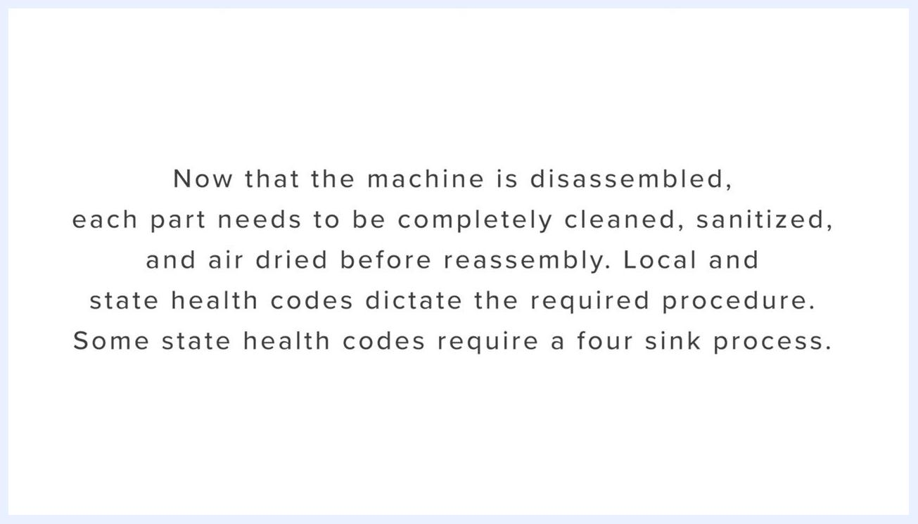
Text screen: "Consult your local and state health codes for the procedures required in your area."
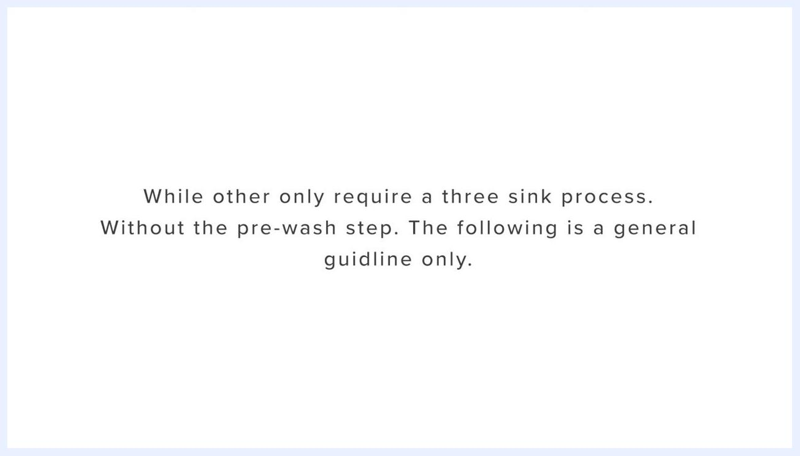
Hands washing machine parts in a stainless steel sink filled with soapy water, using a brush to clean the parts
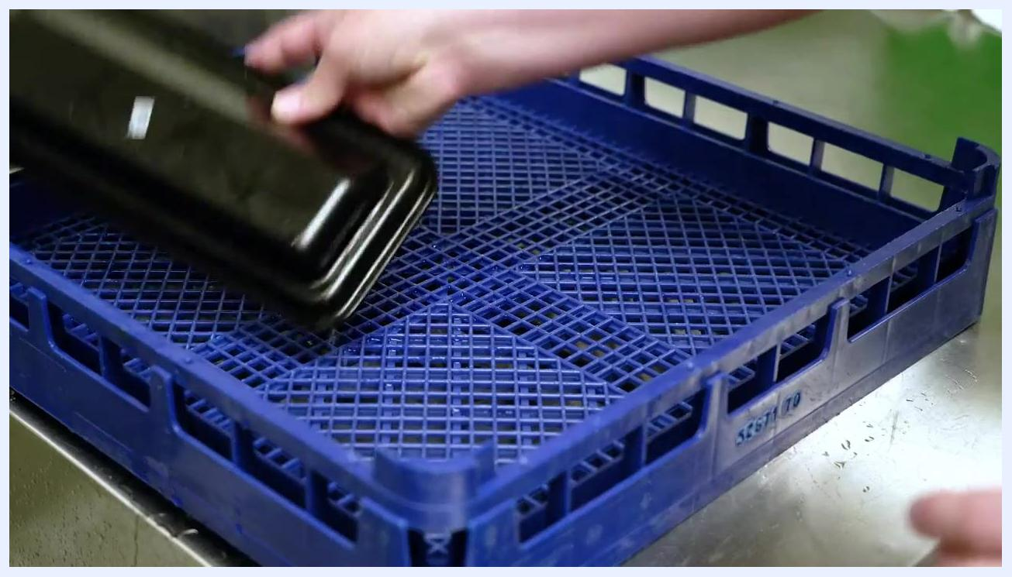
Parts submerged in a stainless steel sink filled with soapy water, hand visible above the water surface
Hand placing a cleaned machine part onto a blue drying rack for air drying after sanitizing

Step 5: Air dry all parts

- Remove parts from the sanitizing solution and place each one onto a clean, food-safe drying rack or tray.
- Arrange the parts so air can circulate freely around each item, ensuring thorough drying.
- Do not towel dry; allow all parts to air dry completely before reassembly to prevent contamination.
- Inspect the drying rack and surrounding area to confirm cleanliness and the absence of debris or contaminants.
- Only proceed to reassembly once all parts are fully dry.
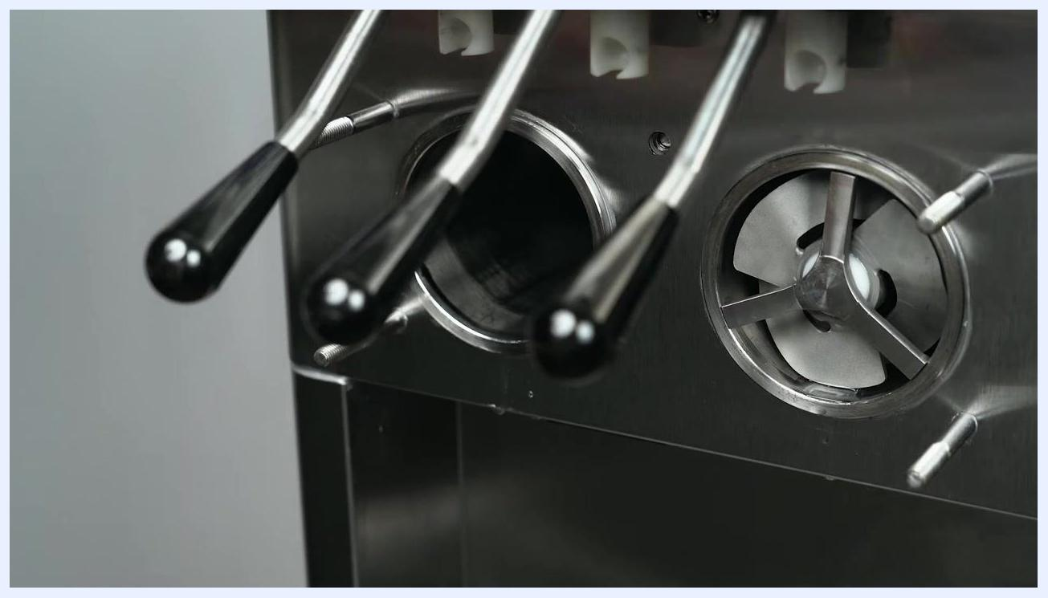
Hands pulling the auger assembly out of the freezing cylinder of the machine, with visible black handles and stainless steel front panel
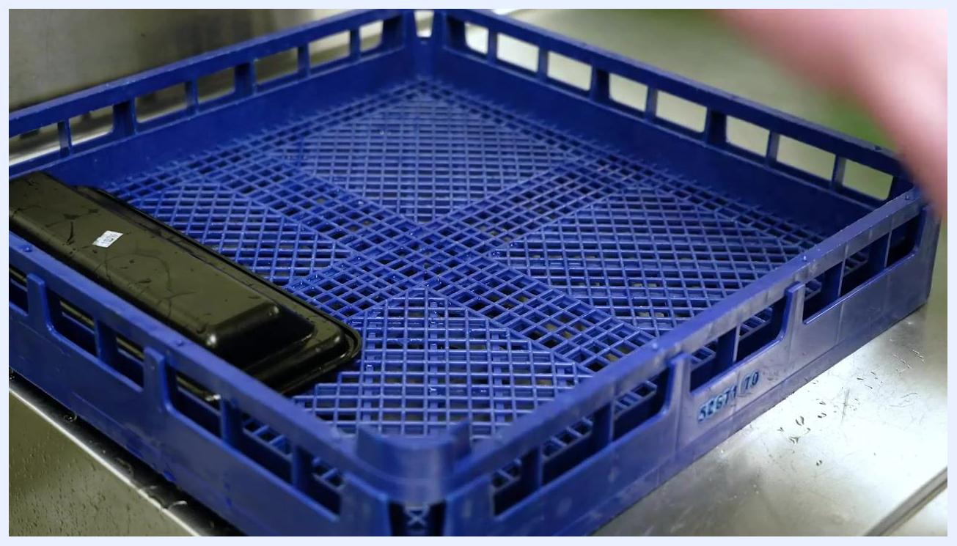
A blue plastic drying rack/tray on a stainless steel surface, with a single black machine part placed on it, showing water droplets and a clean environment suitable for air drying sanitized equipment

Step 6: Clean the hoppers, trays, and exterior

- Wrap a cleaning brush in a clean cloth and thoroughly dry the hoppers and freezing cylinders to ensure all moisture is removed.
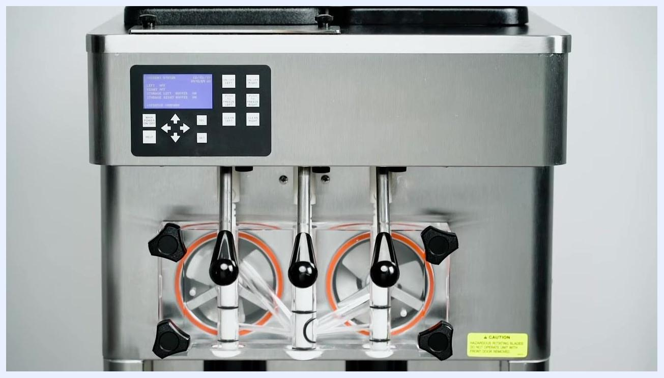
A person's hands removing the black drip tray from the lower section of a stainless steel soft serve machine. The environment is a clean, industrial kitchen setting.

- Remove the drip tray and drain trays from the machine, clean them thoroughly, then replace them in their original positions.
- Note that the machine is constructed from high-grade stainless steel to facilitate easy cleanup.
- To remove spilled or dried mix from the exterior, wash it with mild detergent water heated to 90–110°F and wipe it dry with a clean cloth.
Text screen: "While other only require a three sink process. Without the pre-wash step. The following is a general guideline only."

- Do not use highly abrasive materials, as they will mar the finish. Use a soft cloth or sponge to apply the cleaning solution, and for best results wipe with the grain of the steel.
A hand holding a white cloth wrapped around a brush, drying the area around the dispensing levers of a stainless steel soft serve machine. A green bucket with soapy water is positioned below the levers.
Front view of the same stainless steel soft serve machine, emphasizing the clean exterior and control panel.
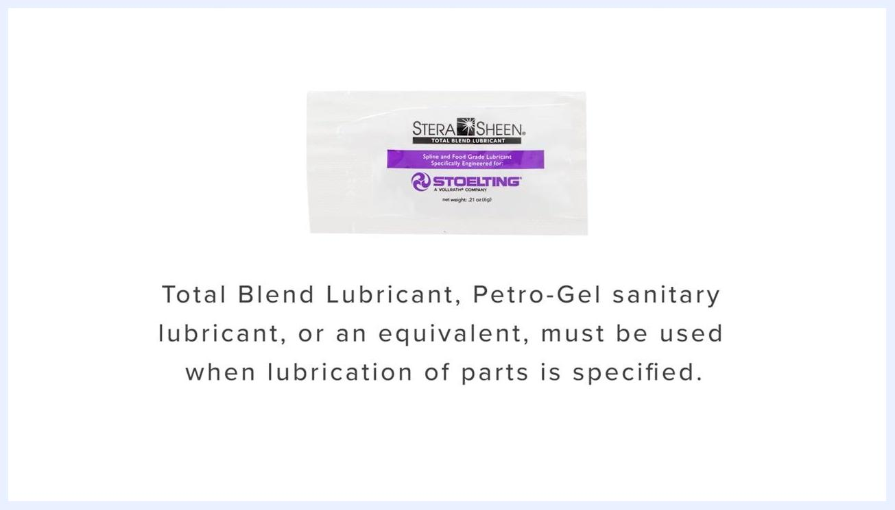
Text instructions: "Do not use highly abrasive materials, as they will mar the finish. Use a soft cloth or sponge to apply the solution. For best results, wipe with the grain of the steel."

Step 7: Lubricate and reassemble the auger and rear seals

- Lubricate the outside of the O-ring on the rear seal with a generous amount of Total Blend lubricant, and lubricate the inside metal surface of the rear seal thoroughly. Install the lubricated rear seals onto the auger shafts.
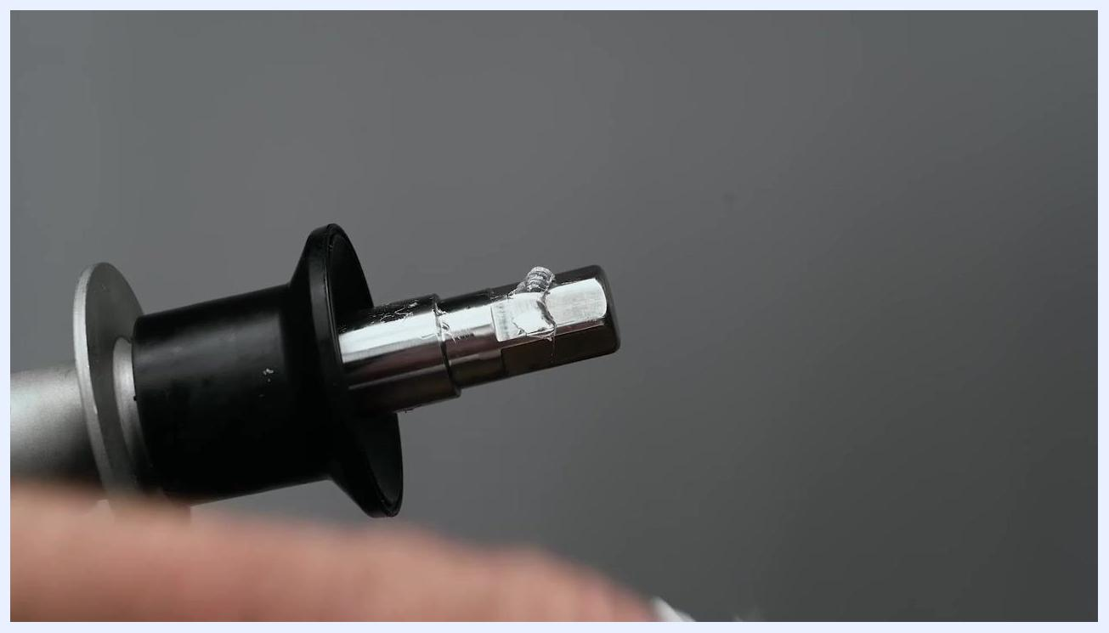
A close-up of a stainless steel auger shaft with a black rear seal installed. The seal and the shaft are coated with a visible layer of clear lubricant. The background is neutral gray, and a hand is partially visible holding the shaft.
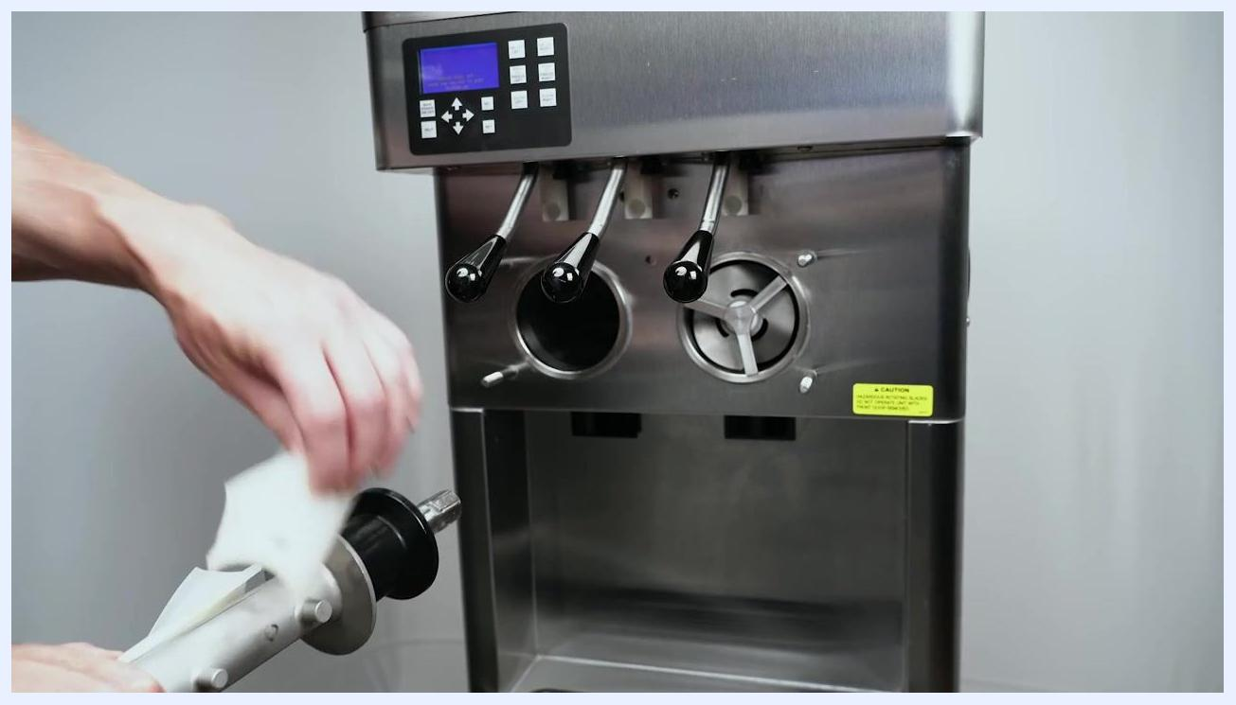
A close-up of the hex drive end of an auger shaft, partially inserted into a black rear seal. The hex end is coated with a small amount of clear lubricant. A hand is visible in the foreground.

- Apply a small amount of Total Blend lubricant to the hex drive ends of the augers.
- Screw the springs completely into the plastic flights to ensure proper compression.
- Install two plastic flights onto the auger shaft and insert the shaft partway into the freezing cylinder.
- Install the remaining plastic flights onto the auger shaft and push the auger fully into the freezing cylinder.
- Apply a thin layer of sanitary lubricant to both the inside and outside surfaces of the auger support bushings.
A packet of Stera-Sheen Total Blend Lubricant with the same text as above, emphasizing its use as a substitute for two products.
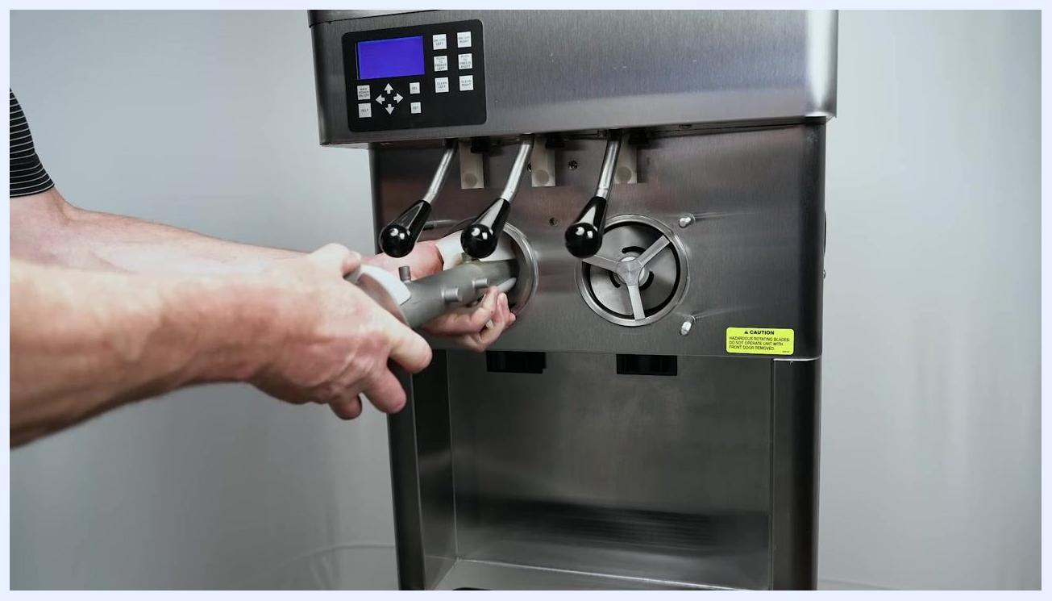
Hands assembling a metal spring into a white plastic flight. Several other flights and orange O-rings are organized in a black tray on the work surface.
A person's hands installing two white plastic flights onto an auger shaft and preparing to insert it into the left freezing cylinder of a stainless steel soft serve machine. The machine's control panel and dispensing levers are visible.
A close-up of a hand pushing the auger assembly with white plastic flights into the freezing cylinder of the machine. The dispensing levers are visible above.

Step 8: Assemble the front door

- Install the spigot bodies by inserting them through the bottom openings of the clear front door assembly.
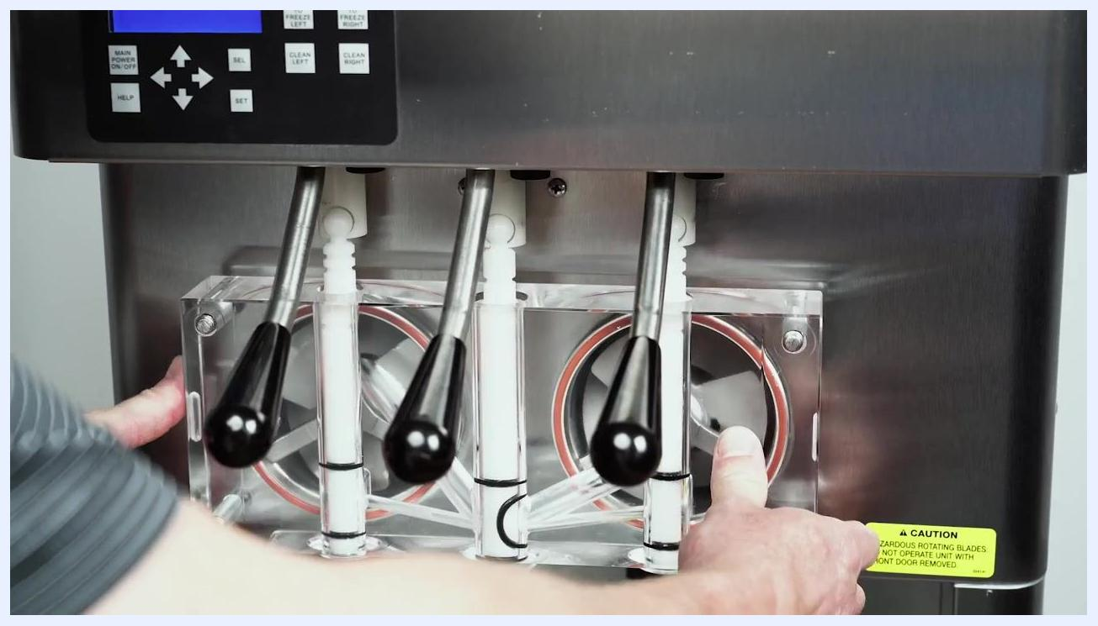
White screen with centered black text: "FRONT DOOR ASSEMBLY"

- Place the assembled front door onto the mounting studs of the machine and carefully push it against the machine, ensuring it is flush and properly aligned.
A clear plastic front door assembly is placed on a white towel. A hand is inserting a cylindrical spigot body through one of the bottom holes. Other spigot bodies and O-rings are visible.

- Visually confirm the metal pins extending from the front door are not in contact with the white auger support legs inside the machine; this prevents mechanical interference and ensures proper operation.
Hands applying lubricant to a white auger support bushing in front of the machine's dispensing area. The bushing is held between the fingers, and the machine's levers are visible in the background.

- Hand-tighten the black plastic knobs at the corners of the front door assembly, alternating between opposite corners in a criss-cross pattern for even pressure and a proper seal. Do not over-tighten.
- Install rosette caps or spigot extensions, if desired, onto the ends of the spigots on the front door assembly, ensuring each cap or extension is securely fitted.
A close-up of the clear front door assembly installed on the soft serve machine. The dispensing levers and auger supports are visible through the transparent door. The machine's control panel is at the top, and a yellow caution label is on the lower right. Hands are visible at the bottom, adjusting the assembly.
The front door assembly is now secured with four black plastic knobs, one at each corner. The knobs are tightened in a criss-cross pattern. The dispensing levers and auger supports are visible through the clear door.
Hands are shown near the front of the machine, preparing to install additional components (rosette caps or spigot extensions) onto the spigots of the clear front door assembly. All knobs are tightened and the assembly is complete.

Step 9: Final reset

- Confirm the assembly is complete and all parts are properly installed and secured.
- Review all steps to ensure proper installation and safety before operating the machine.
A person's hands are positioning the clear front door assembly onto the front of the stainless steel soft serve machine. The assembly is aligned with the dispensing levers and freezing cylinder openings. A yellow caution label is visible on the machine.

Inspection
Confirm the following acceptance criteria before the machine returns to service:
- [ ] Drained rinse water runs clear; if not, refill and repeat the cleaning cycle.
- [ ] All parts are completely cleaned, sanitized, and fully air dried before reassembly.
- [ ] The drying rack and surrounding area are clean and free of debris or contaminants.
- [ ] No parts show wear beyond the auger flight wear line; any worn or broken parts have been replaced.
- [ ] Only certified, food-equipment-approved lubricants have been used, applied per manufacturer instructions.
- [ ] Front door pins do not contact the auger support legs.
- [ ] Front door knobs are tightened evenly in a criss-cross pattern, without over-tightening.
- [ ] Exterior stainless steel surfaces are clean, wiped with the grain, and free of abrasive damage.
- [ ] Drip tray and drain trays are clean and correctly reinstalled.
All disassembled machine parts laid out on a white surface, including augers, O-rings, bushings, and trays for organization and inspection
The source procedure does not describe a formal supervisor sign-off step or a specific failed-inspection escalation path beyond repeating the wash cycle when water is not clear and replacing worn parts immediately; facilities should define supervisor verification and escalation steps according to their own health code requirements.

Frequency
Complete machine disassembly, cleaning, and sanitizing must be performed before the machine is used for the first time. After that, routine cleaning intervals and procedures must comply with local and state health regulations. The source procedure does not specify exact daily, weekly, or monthly intervals; each facility must set its cleaning schedule according to the health codes applicable in its jurisdiction (three-sink or four-sink process, as required locally).
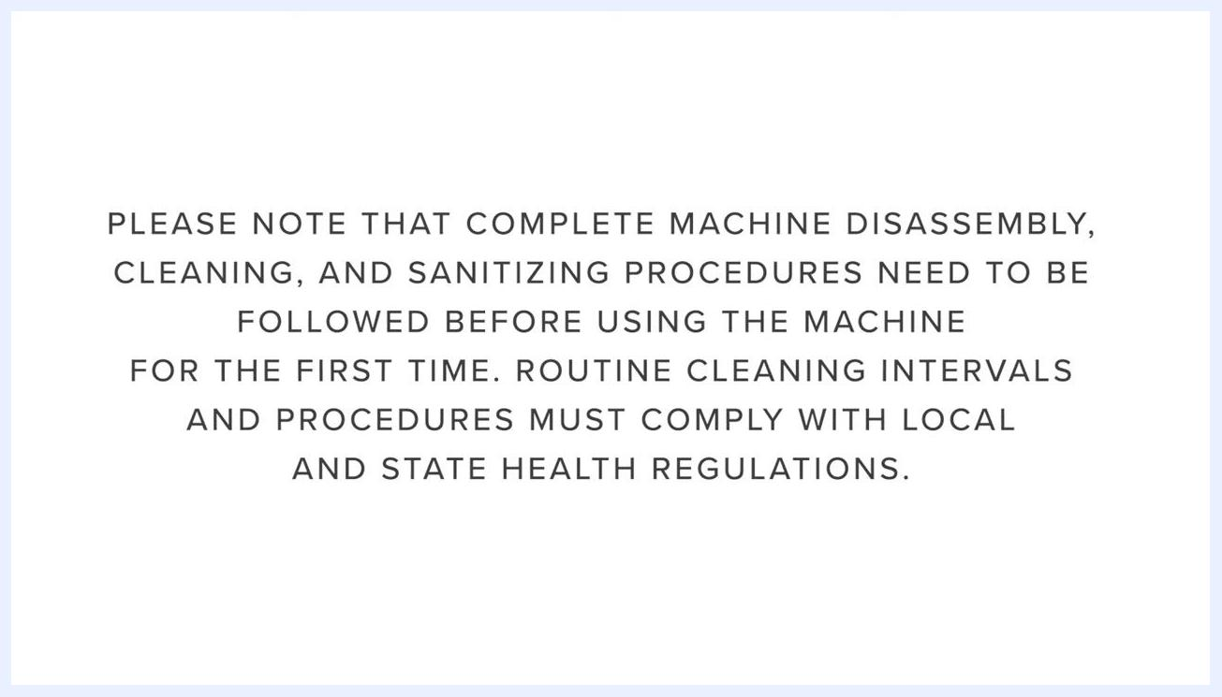
Close-up of the control panel with the display showing "LEFT OFF" and "RIGHT OFF", and the ON/OFF buttons visible

